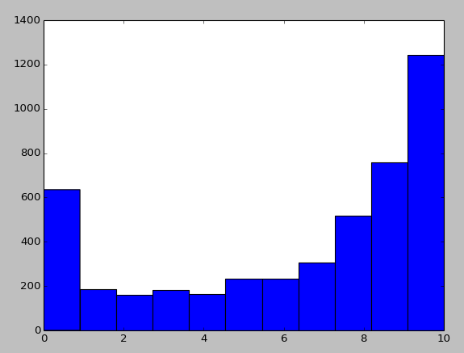
Analysis of Game Reviews with a Natural Language Model

Daniel Shumway  Rochester Institute of Technology  drs7453@rit.edu | Jennifer Stanton  Rochester Institute of Technology  jas2715@rit.edu | Jascha Wilcox  Rochester Institute of Technology  jcw8139@rit.edu

Abstract
The industry and culture of video games is full of opinions, ambiguities, and questions about what makes a game worth playing. Online resources of journalism such as IGN, and more casual user-based counterparts such as MetaCritic are abundant with written reviews of games. How do reviewers talk about games? What trends can be found within the language of game reviews? This article reports on the results of building a natural language model around analyzing the content of a review as compared to its associated numerical score. The model, once trained on a corpus, can then predict the assigned score of a review.
- Introduction
...
- Data Set
A list of games released in 2013 was pulled from Wikipedia. The titles of these games were used to search the review site MetaCritic, via the Mashape API. A total of 26,619 reviews was used for the data set. The data set was split into a 22,000 reviews for training and 4,619 for test data.
- Experiment
In facilitating the goal of providing an examination into the features and quirks of review analyzation, a simple model was incorporated that could be easily replicated. This was preferred over an an in-depth study of which statistical methods yielded the better results.

  - Training the Data
The text of the training data reviews scores are first pre-processed by lowercasing, tokenizing, and removing all punctuation and stop words. Next, the program loops through each word found in the review and, as necessary, adds it to an internal dictionary. This dictionary tracks the number of times a word has been encountered overall, and how many of those encounters were matched with each review score (0-10).
In order to adjust for inherent biases in the training data (see above distribution of scores), the program subtracts the base likelihood of the review having a given score from each word. For example, if the program finds the word ‘good’ 30% of the time in 10 star reviews, the word would be assigned a likelihood of 3% (30-27). If it found the word ‘bad’ 10% of the time in a 10 star review, it would be assigned a likelihood of -17%. Unknown words are counted as 0 likelihood for all scores.

  - Testing the Data
For each review in the test set, the program uses the above collection of words and their likelihoods to calculate total likelihood sums by adding the likelihood of each word in the review. As an example, if the review consisted of the words, “I liked this game,” the total likelihoods of each score, 0-10 would be calculated by adding the likelihoods of “I,” “liked,” “this,” and “game” for each possible score.

- Results
The overall accuracy of the model predicting the exact review score is 20%, compared to the baseline of review score 10 at 27%. This is, unfortunately, a clear loss in overall accuracy. However, there are significant gains in other areas, namely the standard deviation of predictions vs. the correct scores, or put more simply, how far off of the correct answer the model tended to guess.
To measure this accuracy, a weighted scoring system was devised and was used alongside a more traditional calculation of standard deviation. Below is the standard deviation calculation, where pScore denotes the predicted score, and aScore denotes the actual score.

√(((pScore - aScore)² +(pScore - aScore)² + ... (pScoreN - aScoreN)2 ) / N)

A traditional calculation of accuracy can be said to weight correct guesses at 1.0 and incorrect guesses at 0.0, where the sum of all guesses is divided by the number of guesses.
The modified version used in this experiment weights “almost-correct” guesses for partial accuracy. While correct guesses are weighted as 1.0, partial credit is given for incorrect guesses as 1/(k+1) for k < 3, where k is the distance to the correct answer. For k >= 3, the weight is dropped to 0.0.
This partial-correctness is implemented to account for the large quantity of review scores that were assigned predictions close to their actual score. (For example, many scores were predicted as 8 but were actually 10; reviewers are likely to use similar words in nearby scores).
The formula for the weighted accuracy is calculated by taking the mean of all correctness values, where correctness is as follows:

Correctness = 1.0, for k=0
Correctness = 1/(k+1), for 0 < k < 3
Correctness = 0.0, for k >= 3

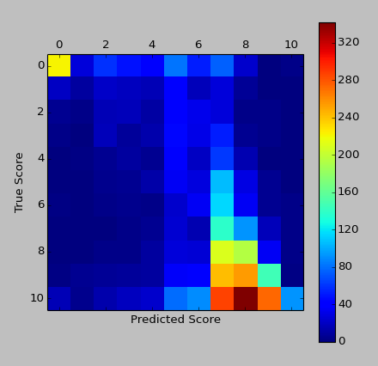
- Discussion
...
- Future Work
...
- Limitations
...
- Conclusion
...

  - Sections
Headings: Type and label section and subsection headings in the style shown on the present document. Use numbered sections (Arabic numerals) in order to facilitate cross references. Number subsections with the section number and the subsection number separated by a dot, in Arabic numerals. Do not number subsubsections.
Citations: Citations within the text appear in parentheses as (Gusfield, 1997) or, if the author's name appears in the text itself, as Gusfield (1997). Append lowercase letters to the year in cases of ambiguities. Treat double authors as in (Aho and Ullman, 1972), but write as in (Chandra et al., 1981) when more than two authors are involved. Collapse multiple citations as in (Gusfield, 1997; Aho and Ullman, 1972).
References: Gather the full set of references together under the heading References; place the section before any Appendices, unless they contain references. Arrange the references alphabetically by first author, rather than by order of occurrence in the text. Provide as complete a citation as possible, using a consistent format, such as the one for Computational Linguistics or the one in the Publication Manual of the American Psychological Association (American Psychological Association, 1983). Use of full names for authors rather than initials is preferred. A list of abbreviations for common computer science journals can be found in the ACM Computing Reviews (Association for Computing Machinery, 1983).
The LATEX2e and BibTEX style files provided roughly fit the American Psychological Association format, allowing regular citations, short citations and multiple citations as described above.
Appendices: Appendices, if any, directly follow the text and the references (but see above). Letter them in sequence and provide an informative title: Appendix A. Title of Appendix.
Acknowledgement sections should go as a last section immediately before the references. Do not number the acknowledgement section.
  - Footnotes
Footnotes: Put footnotes at the bottom of the page and use 9 points text. They may be numbered or referred to by asterisks or other symbols. Footnotes should be separated from the main text by a line.
  - Graphics
Illustrations: Place figures, tables, and photo-graphs in the paper near where they are first discussed, rather than at the end, if possible. Wide illustrations may run across both columns. Do not use color illustrations as they may reproduce poorly.
Captions: Provide a caption for every illustration; number each one sequentially in the form: “Figure 1. Caption of the Figure.” “Table 1. Caption of the Table.” Type the captions of the figures and tables below the body, using 11 point text.
References
Alfred. V. Aho and Jeffrey D. Ullman. 1972. The Theory of Parsing, Translation and Compiling, volume 1. Prentice-Hall, Englewood Cliffs, NJ.
American Psychological Association. 1983. Publications Manual. American Psychological Association, Washington, DC.
Association for Computing Machinery. 1983. Computing Reviews, 24(11):503-512.
Ashok K. Chandra, Dexter C. Kozen, and Larry J.Stockmeyer. 1981. Alternation. Journal of the Association for Computing Machinery, 28(1):114-133.
Dan Gusfield. 1997. Algorithms on Strings, Trees and Sequences. Cambridge University Press, Cambridge, UK.

This is how a footnote should appear.
Note the line separating the footnotes from the text.

