Rest Api Example Project
Location | C:\wamp\www\rest_api2
Tutorials I looked at | https://medium.com/@dharshithasrimal/php-rest-api-7441197312d7  https://wpwebinfotech.com/blog/how-to-build-simple-rest-api-in-php/  https://www.arubanetworks.com/techdocs/AOS-CX/10.08/HTML/rest_v1/Content/Chp_ts/res-api-res-cod-10.htm  https://phpdelusions.net/pdo_examples/select  https://stackoverflow.com/questions/8263371/how-can-prepared-statements-protect-from-sql-injection-attacks
Github link | https://github.com/dana-tal/employee_rest_api
Local database | http://localhost/phpmyadmin/sql.php?db=itemapi&table=employee&pos=0  Database name: itemapi  Table : employee  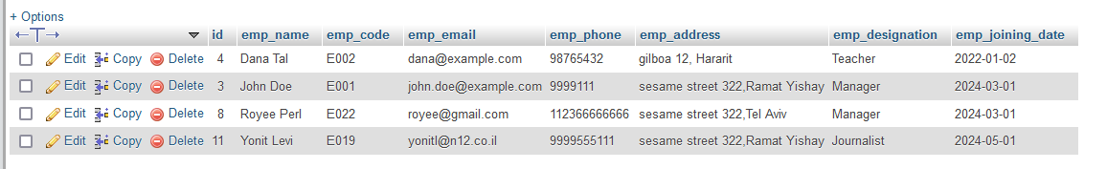
Tested  with | Postman
Introduction | A simple, object oriented rest api that handles CRUD requests on employee database table. The database interface is using PDO , to prevent sql injections.  The api expects the input data to be in JSON format and returns JSON response as well.  The data provided by the api user is checked and tested. In case of invalid data the api throws exceptions that are caught and served back as an object containg explanation of the error, rest api code and status.  The project also contains examples of sending requests through code at index.php

Endpoints
method | url | Description
GET | localhost/rest_api2/api.php/employees | Retrieves all the employees
GET | localhost/rest_api2/api.php/employees/4 | Retrives specific employee,  For example with id=4
POST | url: localhost/rest_api2/api.php/employees | Add a new employee
POST | data:  {  "emp_name": "Dana Tal",  "emp_code": "E002",  "emp_email": "dana@example.com",  "emp_phone": "98765432",  "emp_address": "gilboa 12, Hararit",  "emp_designation": "Teacher",  "emp_joining_date": "2022-01-02"  } | Add a new employee
PUT | url:  localhost/rest_api2/api.php/employees/10 | Update a specific employee.  You can supply a partial list of fields.
PUT | data:  {  "emp_email":"tomer@n12.co.il",  "emp_address":"sesame street 500,Ramat Yishay",  "emp_phone":"9999555333",  "emp_joining_date":"2024-06-01"  }
DELETE | localhost/rest_api2/api.php/employees/4 | Delete a specific employee

Files
api.php | The main gateway through which the request is handled. According to the http method and entrypoint, it dispatches the request to the proper handler.
curl_helper.php | Contains a function : sendRequest by which one can send a rest api request programatically.
db_access.php | Contains a class named DbAccess. The class offers public methods, each dedicated to a single entry point . The methods perform the actual required action in the database. For example, for the GET all entrypoint it offers the method getAllEmployees which reads and returns all the employees in the table.
dbconfig.php | The file contains the database credentials.
index.php | Examples of sending this rest api requests.
responses.php | functions for returning the api json responses.
rest.php | Contains a class Rest that offers methods , one for each entry point. The class methods are called directly from api.php
rest_exception.php | Contains a class RestException that is derived from php regular Exception and it extends it with a status field and getStatus method.
validator.php | Contains a class Validator that offers validation methods such as validating an email, phone etc.
employee table structure:
CREATE TABLE `employee` (
`id` int(11) NOT NULL AUTO_INCREMENT,
`emp_name` varchar(100) NOT NULL,
`emp_code` varchar(20) NOT NULL,
`emp_email` varchar(100) NOT NULL,
`emp_phone` varchar(20) NOT NULL,
`emp_address` varchar(255) NOT NULL,
`emp_designation` varchar(100) NOT NULL,
`emp_joining_date` date NOT NULL,
PRIMARY KEY (`id`)
) ENGINE=MyISAM AUTO_INCREMENT=15 DEFAULT CHARSET=latin1

