|  |  |  |
| --- | --- | --- |
| jkhjkhjk | College of Computer and Information Sciences  Information Technology Department  2nd Semester 1444  IT 474- Network Security  **Lab#7 Evaluation Sheet** |  |

**___________________________________________**

To be filled by the Student “The Network Security Engineer”:

|  |  |  |  |
| --- | --- | --- | --- |
| **Section** |  | | |
| **Team#** | **الاسم** | **Serial#** | **Individual Evaluation / 2** |
| **12** | **ديمه الفعيم** | **8** |  |
| **مي السلامة** | **6** |  |
|  |  |  |
|  |  |  |

To be filled by the Instructor:

|  |  |  |  |
| --- | --- | --- | --- |
| **Lab Component** | **Task1** | **Task2** | **Total** |
| **Practical** |  |  |  |
| **Review Question** |  |  |  |
| **Lab Total Mark** |

**Task1:**

1. What information does an SSL certificate contain?
2. Domain Name.
3. Name of the Organization/Individual to Whom It Is Issued.
4. Issuing Authority Name.
5. The Certificate Authority's Digital Signature.
6. Associated Subdomains.
7. Date of Issue.
8. Expiration Date.
9. The Public Key.

Lab7Task1a:

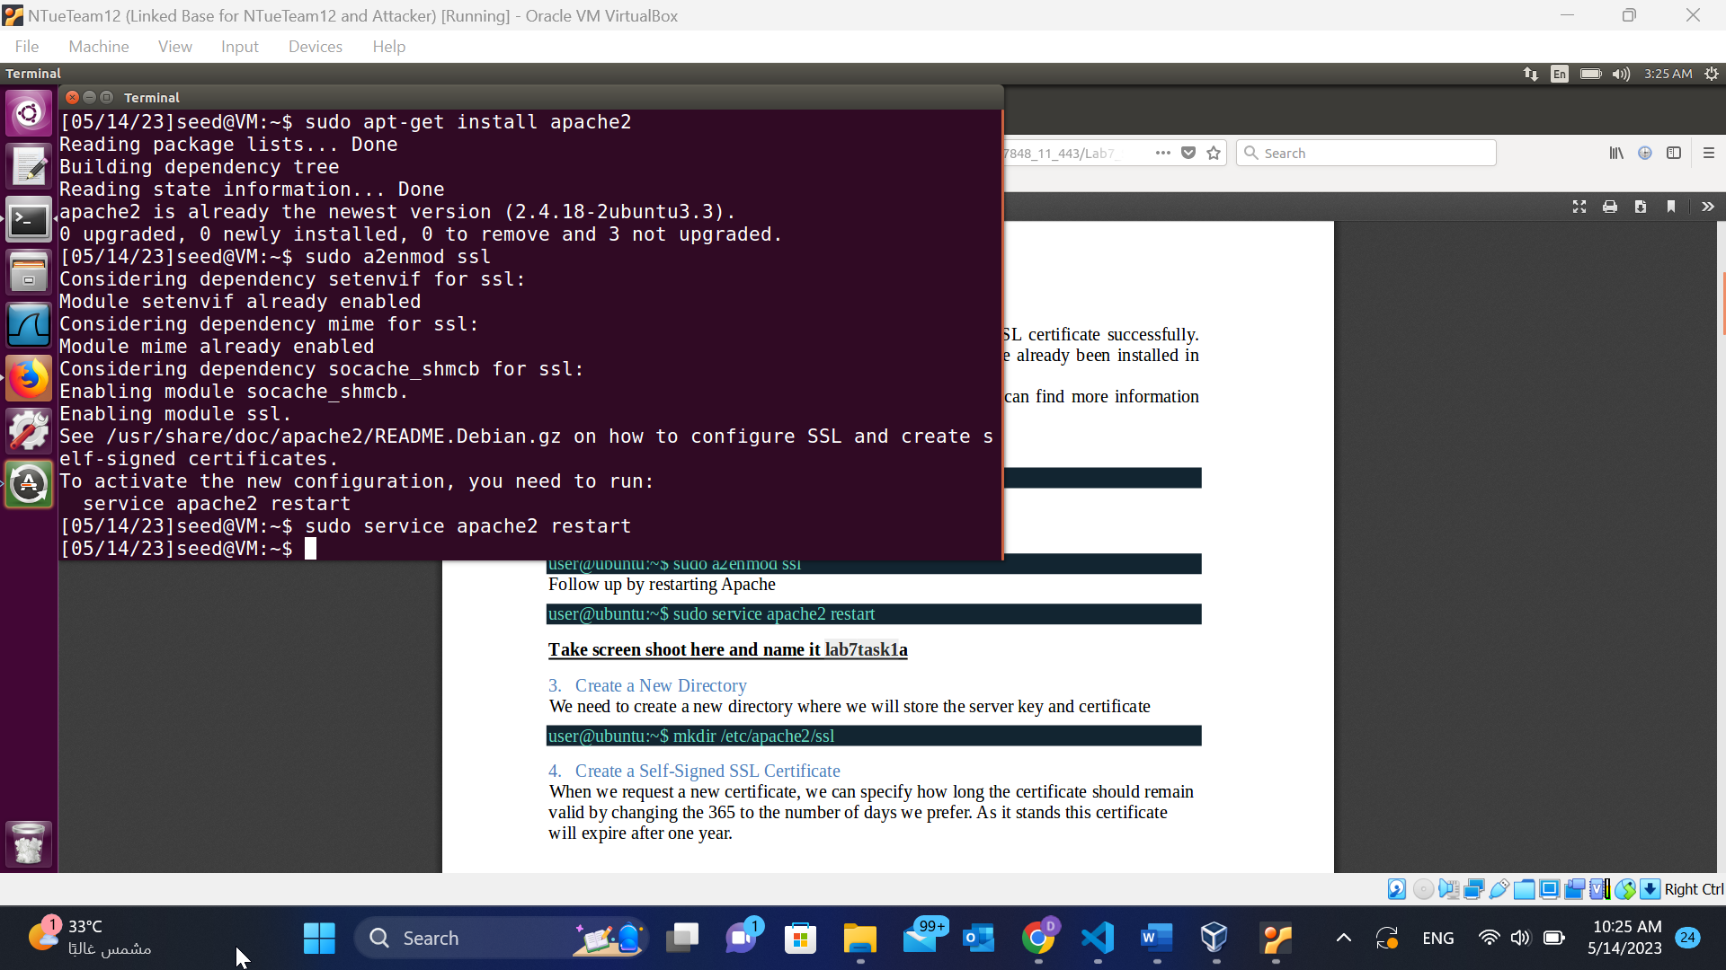

Lab7Task1b:

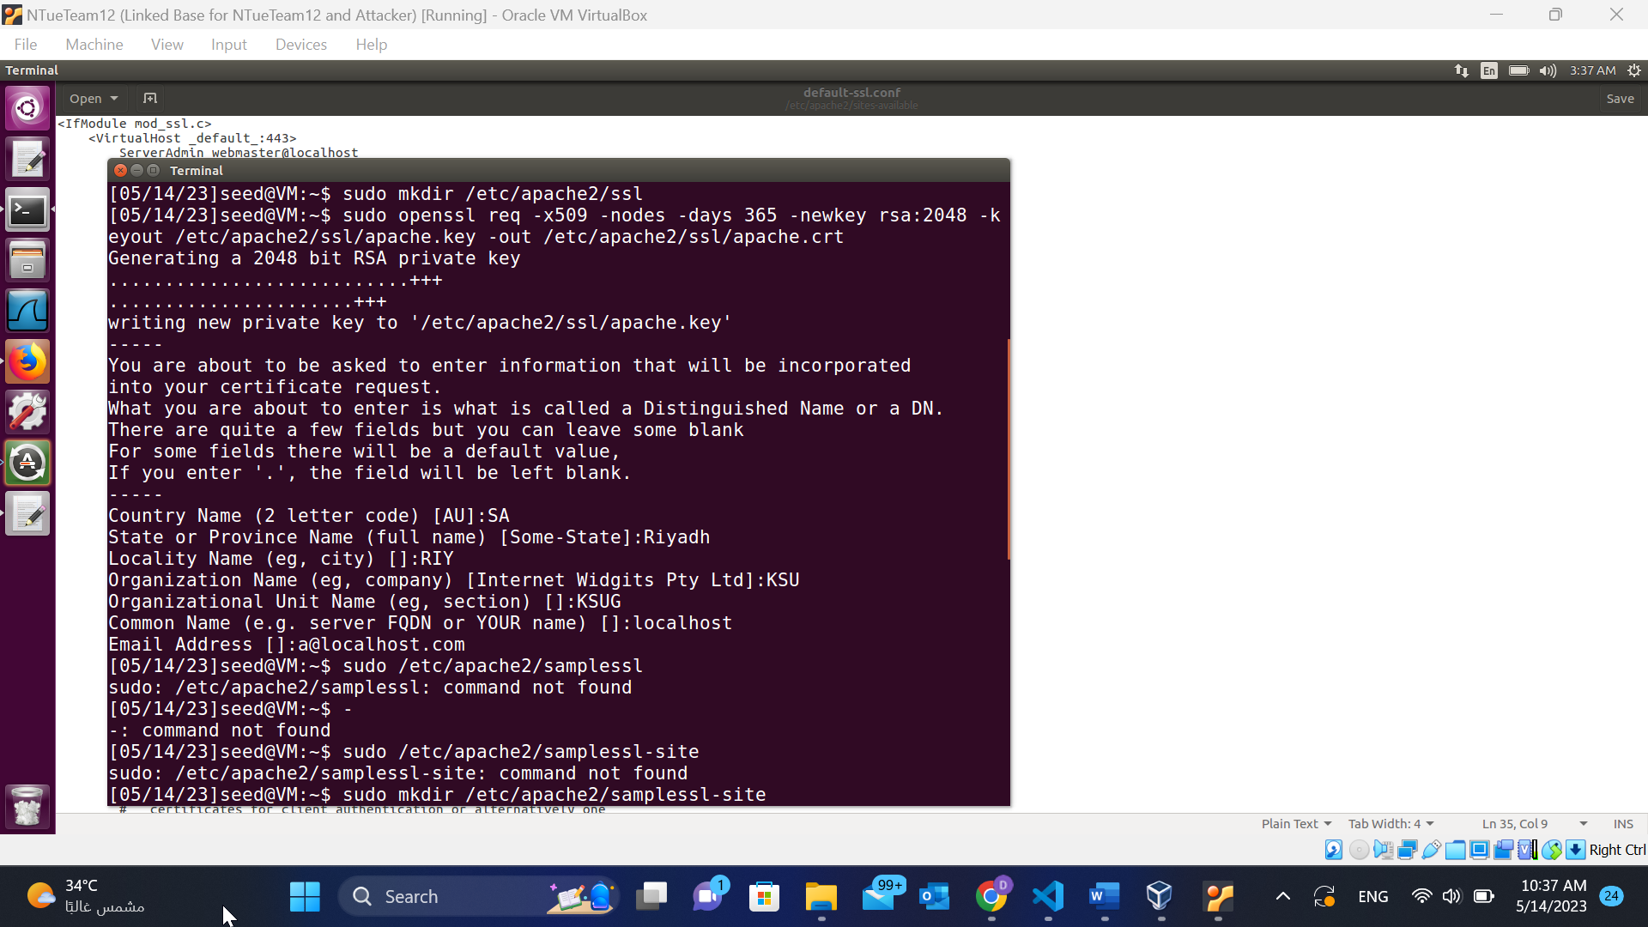

Lab7Task1c:

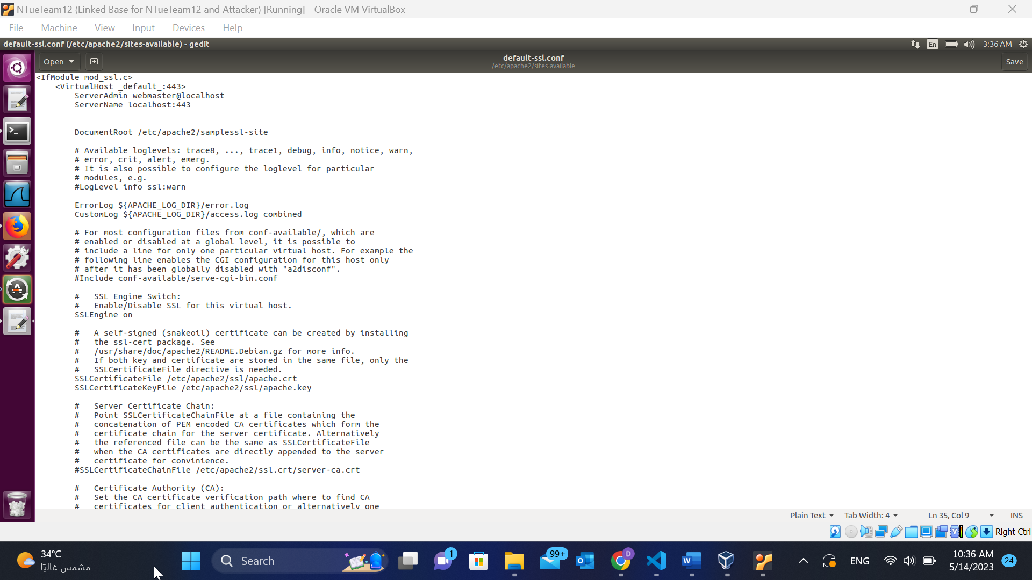

Lab7T1d:

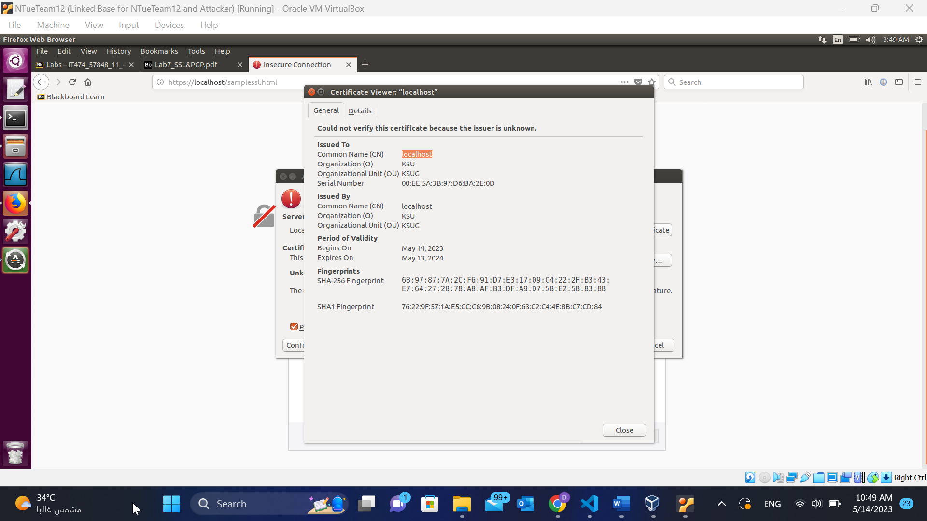

1. What types of attack can be prevented by using SSL?

Mitm, phishing, data tampering, eavesdropping(encryption)

**Task2:**

Lab7Task2a:

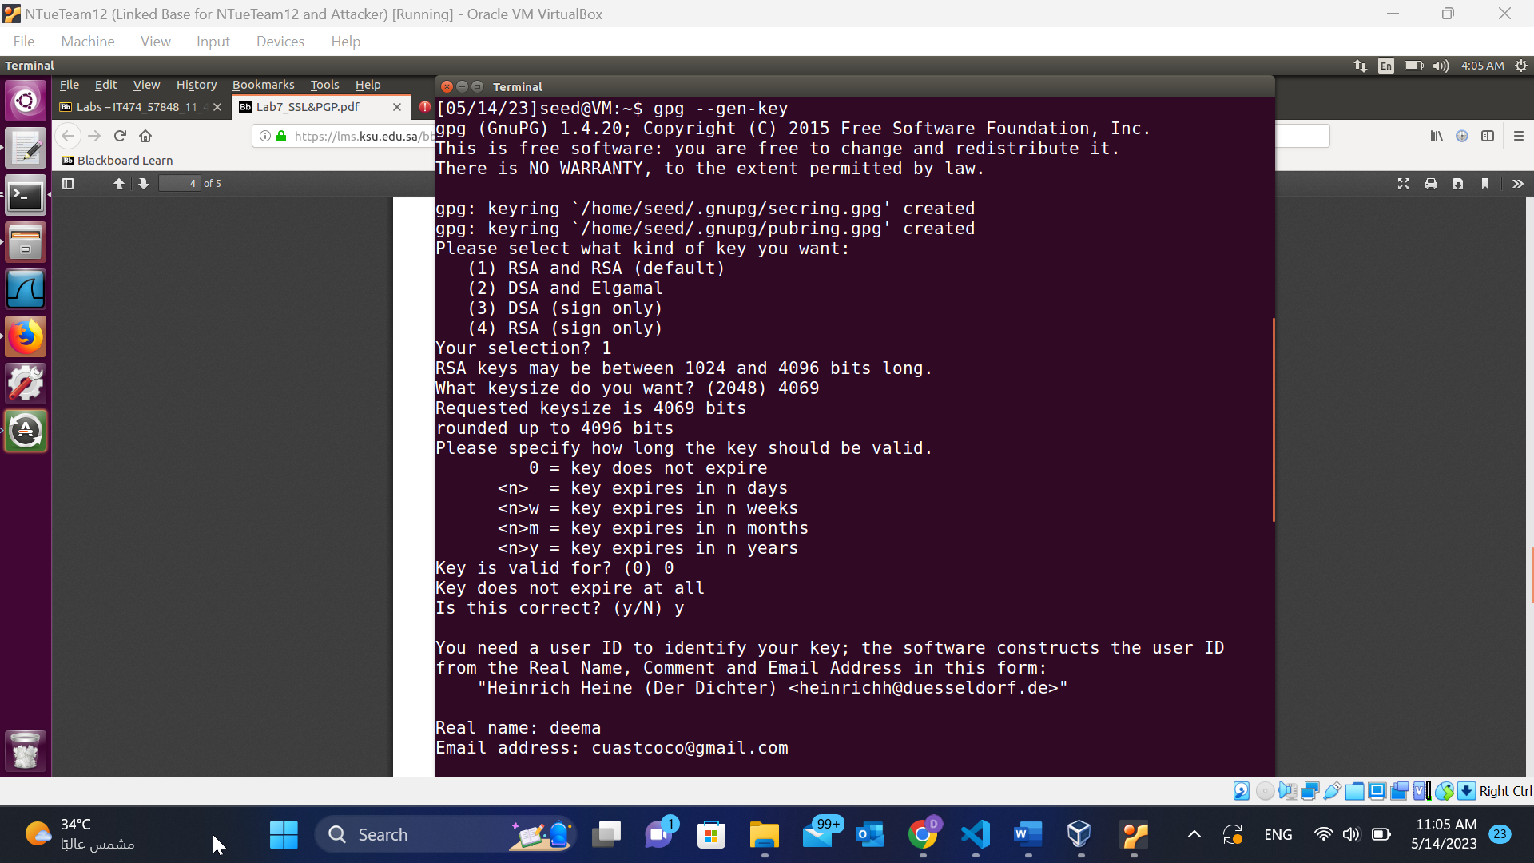

Lab7Task2b:

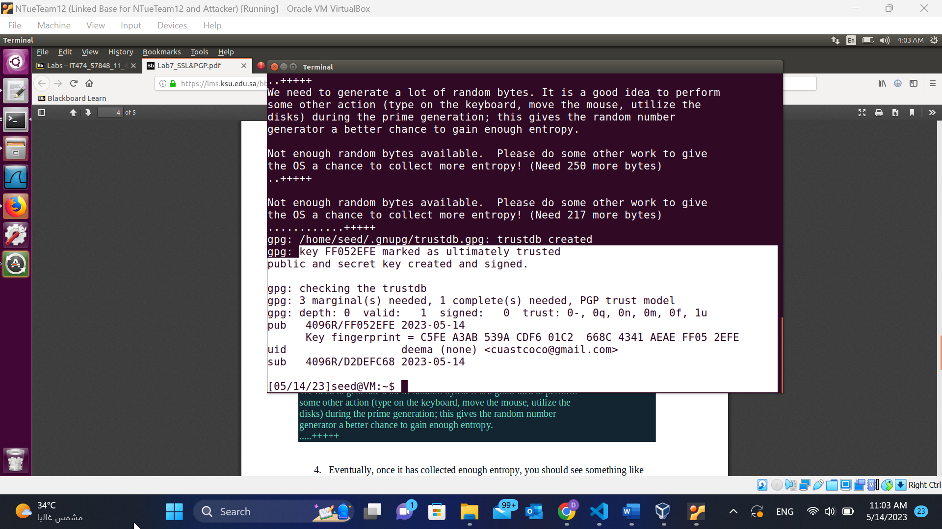

Lab7Task2c:

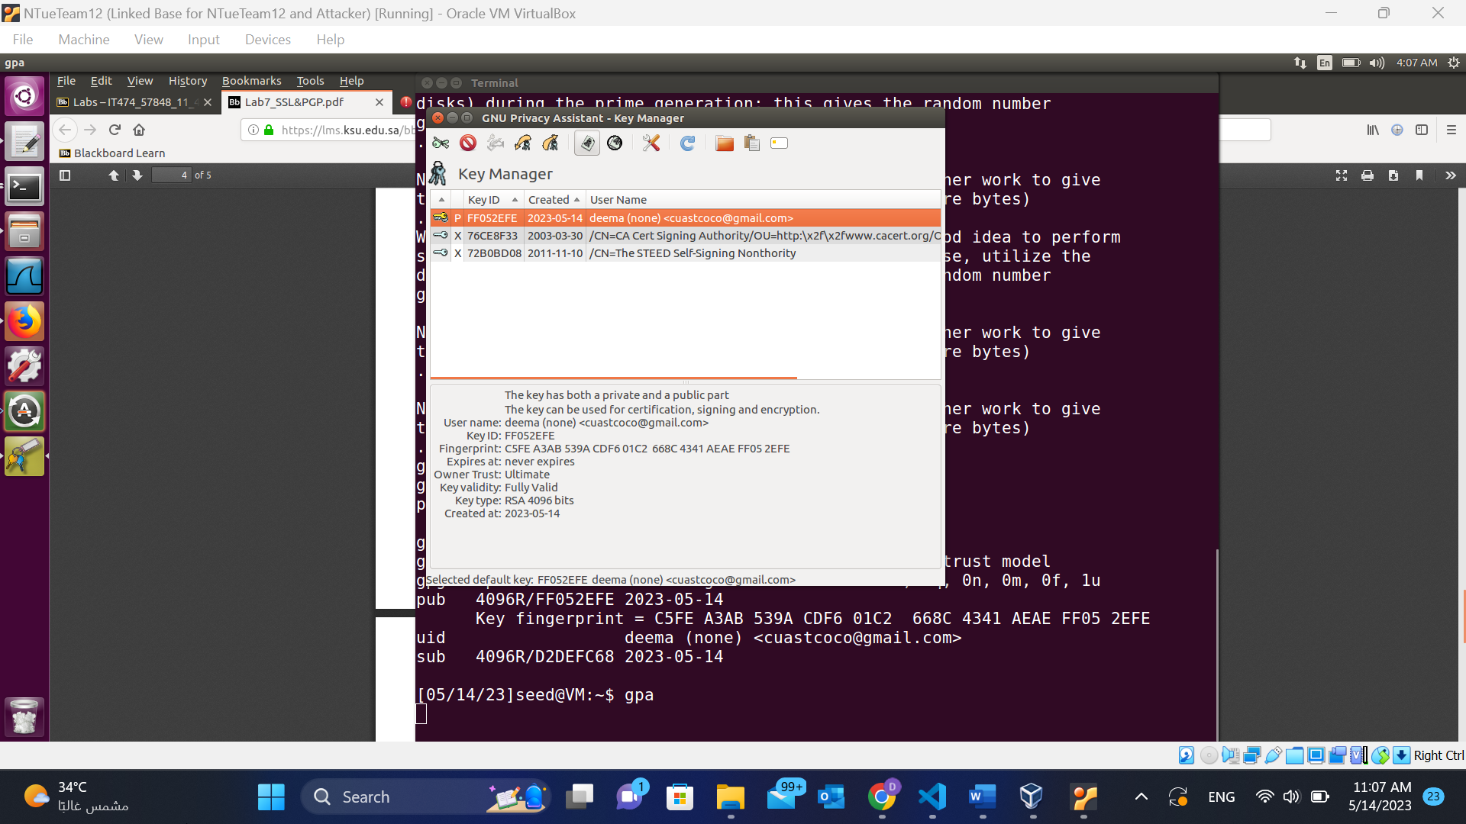

1. How do we use PGP to encrypt emails?

Encrypt my email using the recipient's public key.