Project
  - Deadline: Monday 09/08/2026 @ 23:59
[Total Mark is 20]

Introduction to Database
xxxxx
Instructions:
- You must submit two separate copies (one Word file and one PDF file) using the Assignment Template on Blackboard via the allocated folder. These files must not be in compressed format.
- It is your responsibility to check and make sure that you have uploaded both the correct files.
- Zero mark will be given if you try to bypass the SafeAssign (e.g. misspell words, remove spaces between words, hide characters, use different character sets, convert text into image or languages other than English or any kind of manipulation).
- Email submission will not be accepted.
- You are advised to make your work clear and well-presented. This includes filling your information on the cover page.
- You must use this template, failing which will result in zero mark.
- You MUST show all your work, and text must not be converted into an image, unless specified otherwise by the question.
- Late submission will result in ZERO mark.
- The work should be your own, copying from students or other resources will result in ZERO mark.
- Use Times New Roman font for all your answers.
Student Details: CRN:50246
Name: Dana Mohammed Alajmi  Name: Amani Barjas  Name: Dareen Alanazi  Name: Manar Mutaib Al- Harbi |  | ID: 240040990  ID: 240047827  ID: 240022387  ID: 240061219

Project Instructions
- You can work on this project as a group (minimum 3 and maximum 4 students). Each group member must submit the project individually with all group member names mentioned on the cover page.
- This project worth 20 marks and will be distributed as in the following:
  - Database Design. (6 marks)
  - Database Implementation. (6 marks)
  - SQL Operations. (6 marks)
  - Project Reflection. (2 marks)
- Each leader in the group must submit one report about their chosen Project via the Blackboard (Email submission will not be accepted and will be awarded ZERO marks) containing the following:
- Task 1 : database design
- Task 2: database implementation
- All requested queries/results
- Screenshots from MySQL (or any other software you use) of all the tables after population and query results.
- Reflection (300–500 words) describing the team's experience, challenges, design decisions, and AI usage (if applicable).
- Submit one SQL file containing the complete database implementation, including database creation, tables, data insertion, required queries, VIEW, and TRIGGER.
- Submit a GitHub (or GitLab) repository containing the complete project with regular commits and meaningful commit messages.
- Submit a progress report describing the completed work, key decisions, challenges, future plan, and contribution of each group member.
- Include links to the live report document, GitHub/GitLab repository, and Google Colab notebook (if applicable) in the Project Artifacts section of the final report.
- You are advised to make your work clear and well presented; marks may be reduced for poor presentation. This includes filling in your information on the cover page.
- You MUST show all your work, and text must not be converted into an image unless specified otherwise by the question.
- Late submission will result in ZERO marks being awarded.
- The work should be your own. Copying from students or other resources, including AI software, will result in ZERO marks.

Project Description
Design and Implementation of a Smart Clinic Database System
Learning Outcome(s):

CLO1, CLO2, CLO3, CLO4, CLO5

A private clinic currently manages its patient information manually, making it difficult to organize appointments, treatments, and payments. The clinic has decided to develop a database system to improve data organization and retrieval.
Your team is required to design, implement, and test a complete relational database using the concepts learned throughout this course. The project should demonstrate your understanding of database design, ER/EER modeling, relational mapping, SQL implementation, and advanced SQL queries. The project must be completed using MySQL.

Task 1 – Database Design (6 Marks)
- Design a complete database for the clinic that includes at least six entities such as Patients, Doctors, Appointments, Treatments, Medicines, Payments, or any other appropriate entities.
- A complete ER/EER diagram.
- Primary and foreign keys.
- Appropriate relationships with cardinality.
- At least one specialization/generalization (EER feature).
- Any assumptions made during the design process.

Task 2 – Database Implementation (6 Marks)
Complete the following tasks using MySQL. Include screenshots of both your SQL code and the corresponding output (results) for each task:
- Create the database and all required tables.
- Use appropriate data types and constraints (PRIMARY KEY, FOREIGN KEY, NOT NULL, UNIQUE, etc.).
- Insert at least 5 records into each main table.

Task 3 – SQL Operations (6 Marks)
Complete the following tasks using MySQL. For each task, include screenshots of both your SQL code and the corresponding output (results), along with a brief description (one to two sentences) explaining the purpose of the query and the information it is intended to retrieve.
- Write SELECT statements.
- Write JOIN queries.
- Write nested queries.
- Use aggregate functions with GROUP BY.
- Write UPDATE and DELETE statements.
- Create one VIEW.
- Create one TRIGGER.

Task 4 – Reflection (2 Marks)
Write a 300–500-word reflection on your experience while completing this project by
answering the following questions. Your responses should be clear, concise, and
supported with specific examples from your own work.
- Describe one specific challenge or obstacle you encountered during this project and explain in detail how you identified and resolved it.
- Explain why you chose your specific approach/method/model over at least one alternative you considered, and what tradeoffs informed that decision.
- If you used any AI tools during this project (e.g., ChatGPT, Claude, Copilot), disclose which tool(s), for what specific purpose (e.g., debugging, grammar checking, brainstorming), and how you verified or modified the output.
- What would you do differently if you were to redo this project with more time or resources?

Deliverables
- Project Report (PDF) – System description, ER/EER diagram, relational schema, SQL code, screenshots, and reflection.
- SQL Script (.sql) – Complete SQL implementation of the project.
- GitHub Repository – Repository link with the complete project and commit history.
- Mid-Project Progress Report – Summary of progress, challenges, decisions, and team contributions.
- Project Artifacts
  - Live report document (with edit history): [link]
  - GitHub/GitLab repository (with commit history): [link]
  - Google Colab notebook (if applicable): [link]

[ Project Solutions ]

Table of Contents
Project Instructions 1
Project Description 2
Task 1 – Database Design (6 Marks) 3
Task 2 – Database Implementation (6 Marks) 4
Task 3 – SQL Operations (6 Marks) 5
Task 4 – Reflection (2 Marks) 6
Deliverables 7
Table of Contents 8
Project Overview 10
Background 10
Project Objective and Scope 10
Team Task Distribution 10
1. Task 1 - Database Design 11
1.1 Entity Catalogue 11
1.2 EER Specialization/Generalization 12
1.3 Relationships and Cardinalities 12
1.4 Relational Schema 13
1.5 Complete ER/EER Diagram 14
1.6 Design Assumptions 15
2. Task 2 - Database Implementation 16
2.1 Implementation Environment 16
2.2 Data Types and Integrity Constraints 16
2.3 Sample Data Population 17
2.4 Execution Sequence 17
2.5 MySQL Workbench Evidence 18
3. Task 3 - SQL Operations 22
3.1 Verified Result Summary 22
3.2 SELECT Statements 23
3.3 JOIN Query - Appointment Details 24
3.4 JOIN Query - Patient Prescriptions 25
3.5 Nested Query 26
3.6 Aggregate Functions with GROUP BY 27
3.7 UPDATE Statement 28
3.8 DELETE Statement and Rollback Verification 28
3.9 VIEW Creation and Result 30
4.10 TRIGGER Creation and Stock-Control Test 32
4. Task 4 – Project Reflection 35
5. Project Artifacts 37
6. Appendix A - Mid-Project Progress Report 38
7. Appendix B - Complete SQL Implementation 43
8. Appendix C - Screenshot Evidence Index 58

Project Overview

Background
A private clinic that manages patient information manually can face difficulty organizing appointments, treatments, medicines, and payments. The Smart Clinic Database System replaces fragmented records with a structured relational database that centralizes the clinic's core information and preserves the relationships between clinical and financial activities.

Project Objective and Scope
The project designs, implements, and tests a complete MySQL database using ER/EER modeling, relational mapping, integrity constraints, fictional Saudi-context data, retrieval and reporting queries, controlled data changes, a reusable view, and an inventory-protection trigger.

Team Task Distribution
Student | ID | Primary Assignment | Primary Evidence
Dana. Alajmi | 240040990 | Group Leader and Repository Manager | Integrated report, evidence register, package structure, and repository preparation.
Amani Barjas | 240047827 | Task 1: Database Design | ER/EER diagram, entity catalogue, relationships, cardinalities, assumptions, and relational schema.
Dareen Alanazi | 240022387 | Task 2: Database Implementation | MySQL table definitions, constraints, sample data, and eight populated-table screenshots.
Manar Al-Harbi | 240061219 | Task 3: SQL Operations | SQL operations, purpose statements, and twelve matching MySQL Workbench evidence images.
All members | ______ | Task 4: Project reflection | Project Reflection and final technical/document review.

Task 1 - Database Design

Entity Catalogue
The design contains eight connected relations. PERSON stores shared identity data, while PATIENT and DOCTOR extend it through an EER specialization. Transactional tables then represent appointments, treatments, prescribed medicines, and payments.
Entity | Primary Key | Purpose
PERSON | person_id | Supertype for shared personal and contact details.
PATIENT | patient_id | Patient-specific registration, blood type, insurance, and emergency contact data.
DOCTOR | doctor_id | Professional license, specialty, room, fee, and hire date.
APPOINTMENT | appointment_id | Scheduled interaction linking one patient with one doctor.
TREATMENT | treatment_id | Diagnosis, clinical notes, date, and treatment cost for an appointment.
MEDICINE | medicine_id | Medicine catalogue, strength, dosage form, price, and stock.
TREATMENT_MEDICINE | treatment_id + medicine_id | Associative relation storing prescription details.
PAYMENT | payment_id | Financial transactions associated with appointments.

EER Specialization/Generalization
PERSON is modeled as the supertype because patients and doctors share national identification, full name, birth date, gender, phone, email, and address attributes. PATIENT and DOCTOR are disjoint subtypes whose primary keys also act as foreign keys referencing PERSON. The specialization is documented as total and disjoint: every stored clinic person belongs to one subtype, and the same person is not assigned to both roles.

Relationships and Cardinalities
Relationship | Cardinality | Business Rule
PERSON - PATIENT | 1 : 0..1 | A person may appear once as a patient subtype.
PERSON - DOCTOR | 1 : 0..1 | A person may appear once as a doctor subtype.
PATIENT - APPOINTMENT | 1 : 0..N | A patient may book many appointments; each appointment has one patient.
DOCTOR - APPOINTMENT | 1 : 0..N | A doctor may attend many appointments; each appointment has one doctor.
APPOINTMENT - TREATMENT | 1 : 0..1 | An appointment may produce at most one treatment.
APPOINTMENT - PAYMENT | 1 : 0..N | An appointment may have several payment transactions.
TREATMENT - MEDICINE | M : N | TREATMENT_MEDICINE resolves the many-to-many relationship.

Relational Schema
Relation | Relational Schema Notation
PERSON | PERSON(person_id PK, national_id UQ, full_name, date_of_birth, gender, phone UQ, email UQ, address)
PATIENT | PATIENT(patient_id PK/FK -> PERSON.person_id, blood_type, insurance_provider, emergency_contact_name, emergency_contact_phone, registration_date)
DOCTOR | DOCTOR(doctor_id PK/FK -> PERSON.person_id, license_number UQ, specialty, room_number UQ, consultation_fee, hire_date)
APPOINTMENT | APPOINTMENT(appointment_id PK, patient_id FK -> PATIENT.patient_id, doctor_id FK -> DOCTOR.doctor_id, scheduled_at, appointment_duration_minutes, status, reason, created_at)
TREATMENT | TREATMENT(treatment_id PK, appointment_id FK/UQ -> APPOINTMENT.appointment_id, treatment_date, diagnosis, treatment_notes, treatment_cost)
MEDICINE | MEDICINE(medicine_id PK, medicine_name + strength UQ, dosage_form, unit_price, stock_quantity, prescription_required)
TREATMENT_MEDICINE | TREATMENT_MEDICINE(treatment_id PK/FK -> TREATMENT.treatment_id, medicine_id PK/FK -> MEDICINE.medicine_id, dosage, frequency, duration_days, quantity, instructions)
PAYMENT | PAYMENT(payment_id PK, appointment_id FK -> APPOINTMENT.appointment_id, amount, payment_date, payment_method, payment_status, reference_no UQ)

Complete ER/EER Diagram
Figure 1 presents the complete model, including the PERSON specialization, entity attributes, keys, relationship labels, and cardinalities used in the relational implementation.
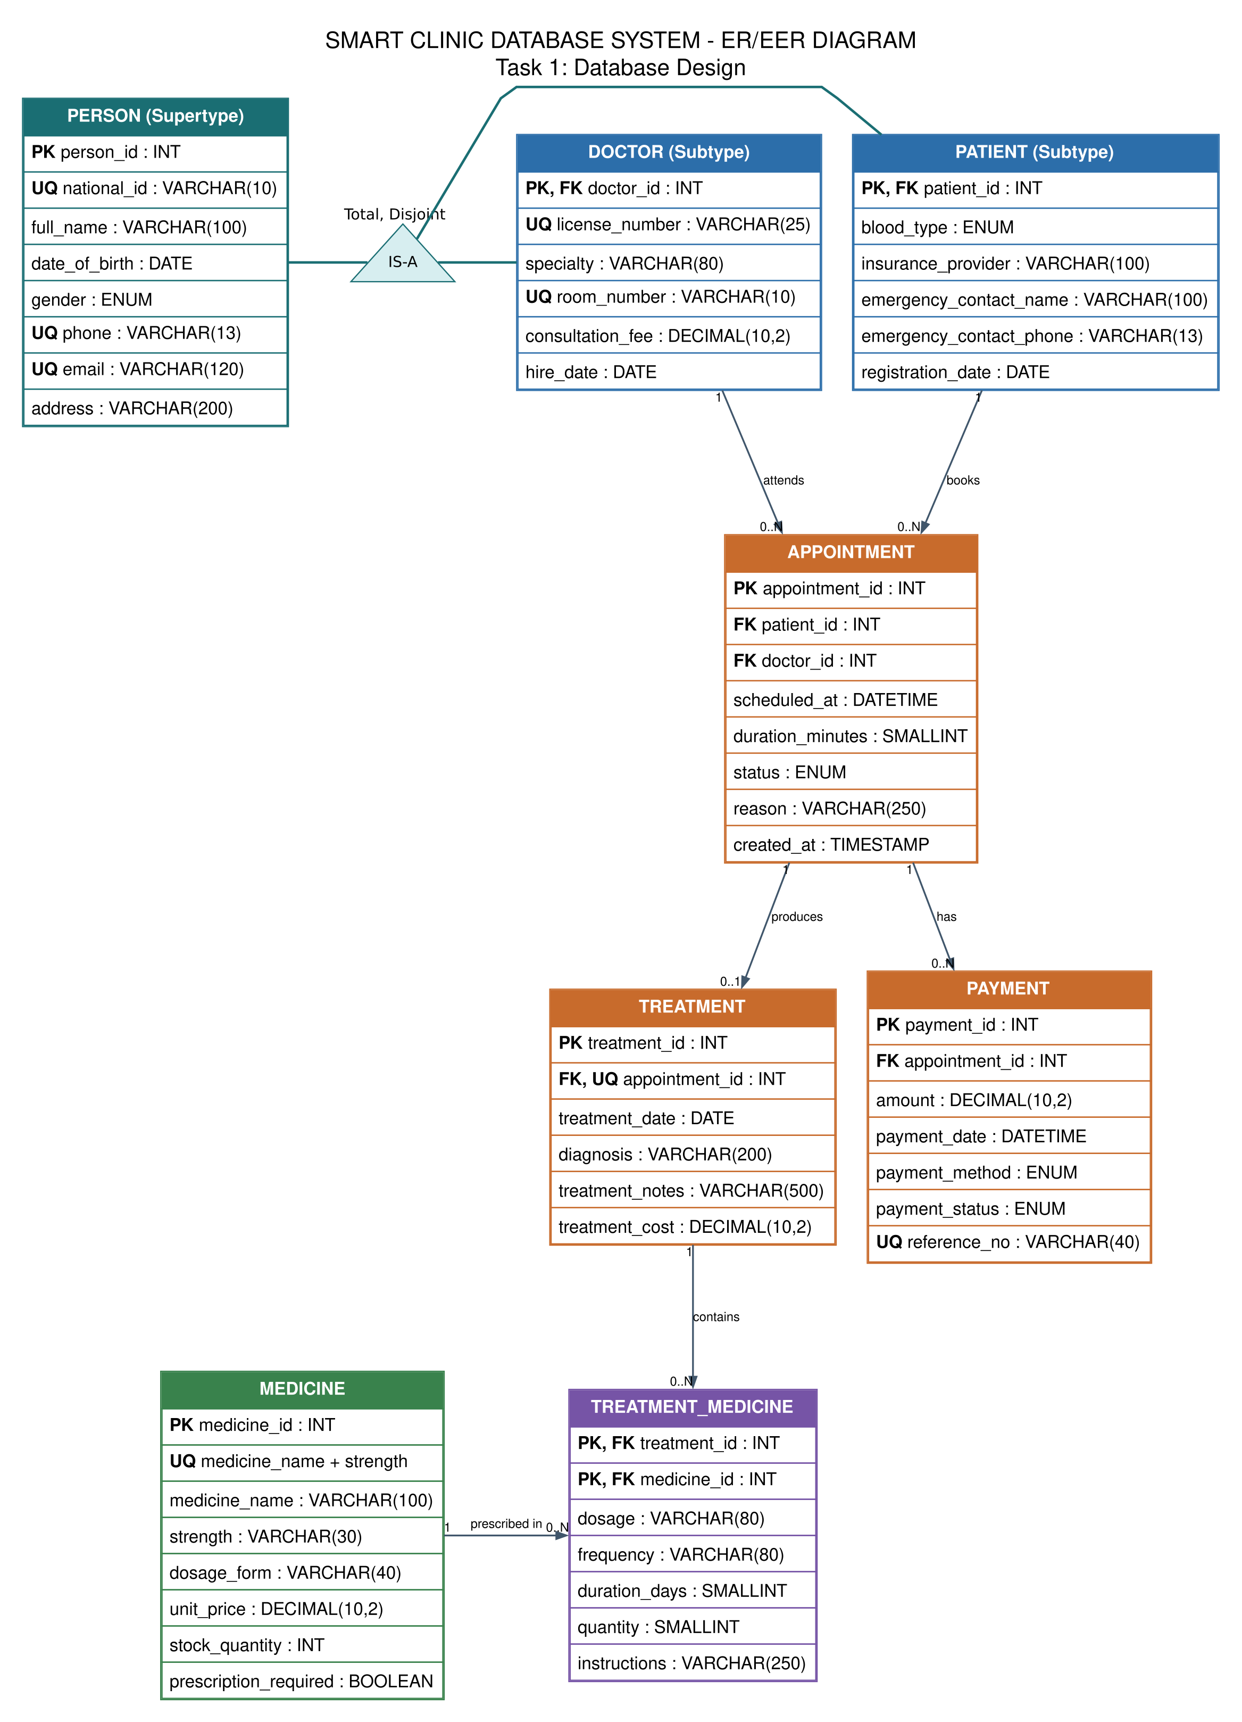
Figure 1. Complete ER/EER diagram for the Smart Clinic Database System.

Design Assumptions
- All monetary values are recorded in Saudi riyals (SAR).
- All names, identifiers, contact data, diagnoses, and payments are fictional and used only for academic work.
- A clinic person is assigned to exactly one subtype: PATIENT or DOCTOR.
- A doctor and a patient cannot each hold two appointments at the same scheduled date and time.
- An appointment may generate no more than one treatment record.
- A treatment can include several medicines, and a medicine can be used in several treatments.
- An appointment may have multiple payment transactions to support installments or insurance processing.
- The sum of payments is not forced to equal treatment and consultation charges because insurance adjustments may apply.
- Deletion is restricted for historical clinic transactions, while treatment-medicine rows follow their parent treatment.

Task 2 - Database Implementation

Implementation Environment
Item | Implementation
Database management system | MySQL 8.0 or newer
Development interface | MySQL Workbench
Database name | smart_clinic_db
Storage engine | InnoDB
Character set | utf8mb4
Collation | utf8mb4_0900_ai_ci
Implementation file | database/smart_clinic_database.sql

Data Types and Integrity Constraints
Constraint | Purpose in the Database
PRIMARY KEY | Uniquely identifies every entity and transaction.
FOREIGN KEY | Preserves valid references between related tables.
NOT NULL | Requires essential personal, clinical, and financial values.
UNIQUE | Prevents repeated national IDs, phones, licenses, rooms, payment references, and appointment slots.
CHECK | Rejects negative amounts or stock, invalid durations, and incorrectly formatted Saudi identifiers.
ENUM | Limits gender, blood type, appointment status, payment method, and payment status to approved values.

Sample Data Population
Table | Rows | Population Summary
PERSON | 10 | Five patients and five doctors share the supertype.
PATIENT | 5 | Five fictional clinic patients.
DOCTOR | 5 | Five doctors representing different specialties.
APPOINTMENT | 5 | Five completed appointments.
TREATMENT | 5 | One treatment for each completed appointment.
MEDICINE | 5 | Five medicines with stock and price data.
TREATMENT_MEDICINE | 7 | Seven prescription-detail combinations.
PAYMENT | 5 | Five completed payment records.

Execution Sequence
- Drop and recreate smart_clinic_db so the script can be tested repeatedly in a clean environment.
- Create PERSON first, followed by the PATIENT and DOCTOR subtypes.
- Create APPOINTMENT, TREATMENT, MEDICINE, TREATMENT_MEDICINE, and PAYMENT in foreign-key dependency order.
- Insert the fictional records inside a transaction, using the same parent-to-child dependency order.
- Commit the sample data and run the table-display statements used for MySQL Workbench evidence.

MySQL Workbench Evidence
The following screenshots were captured from the completed MySQL Workbench execution. Together they demonstrate all eight populated tables and the SQL definitions associated with the implementation.
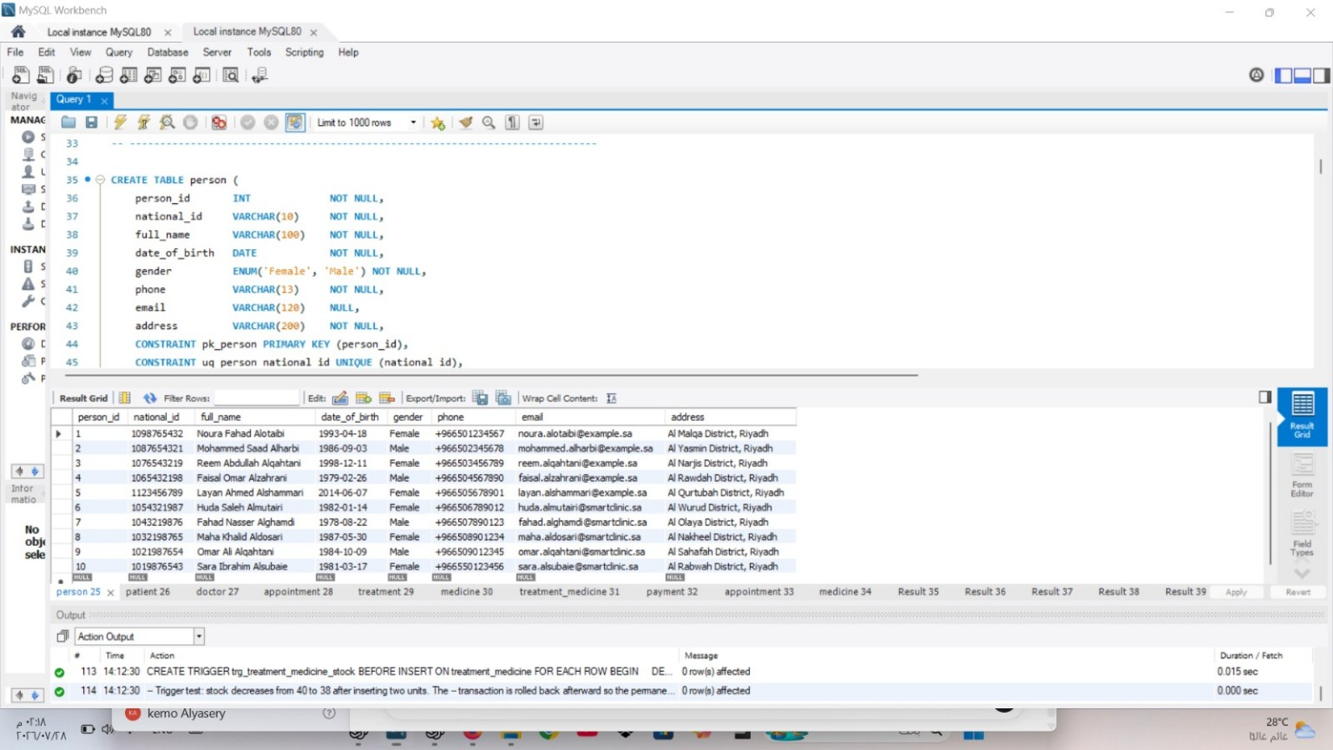
Screenshot 2.1. PERSON table definition and ten populated person records.
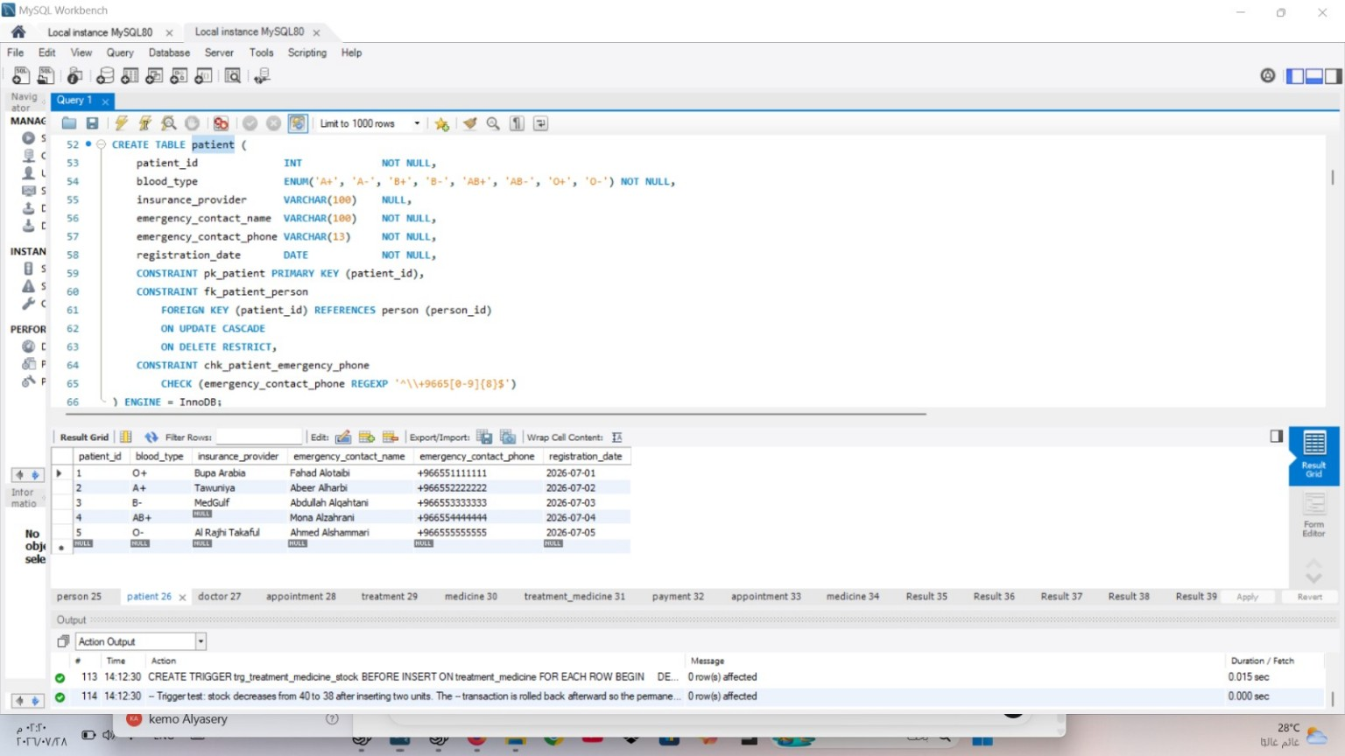
Screenshot 2.2. PATIENT subtype definition and five populated patient records.
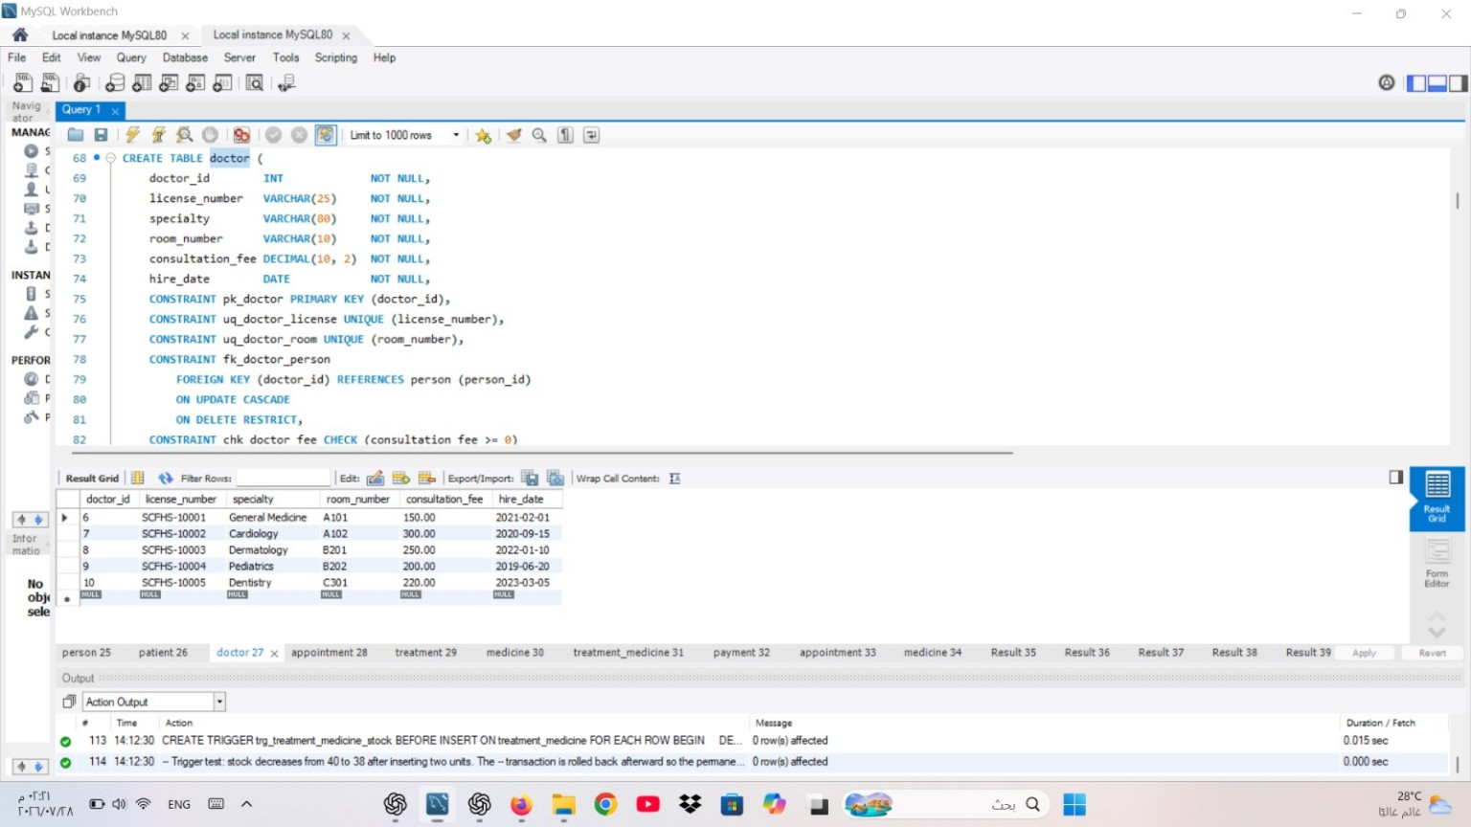
Screenshot 2.3. DOCTOR subtype definition and five populated doctor records.
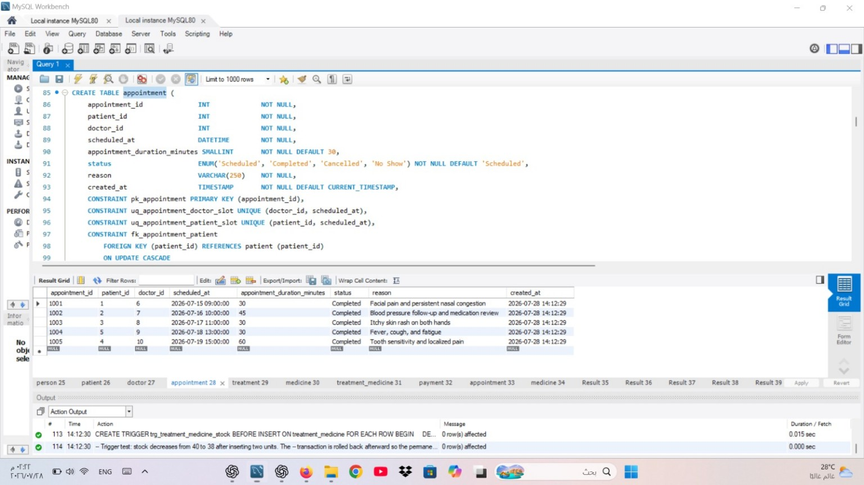
Screenshot 2.4. APPOINTMENT table definition and five populated appointment records.

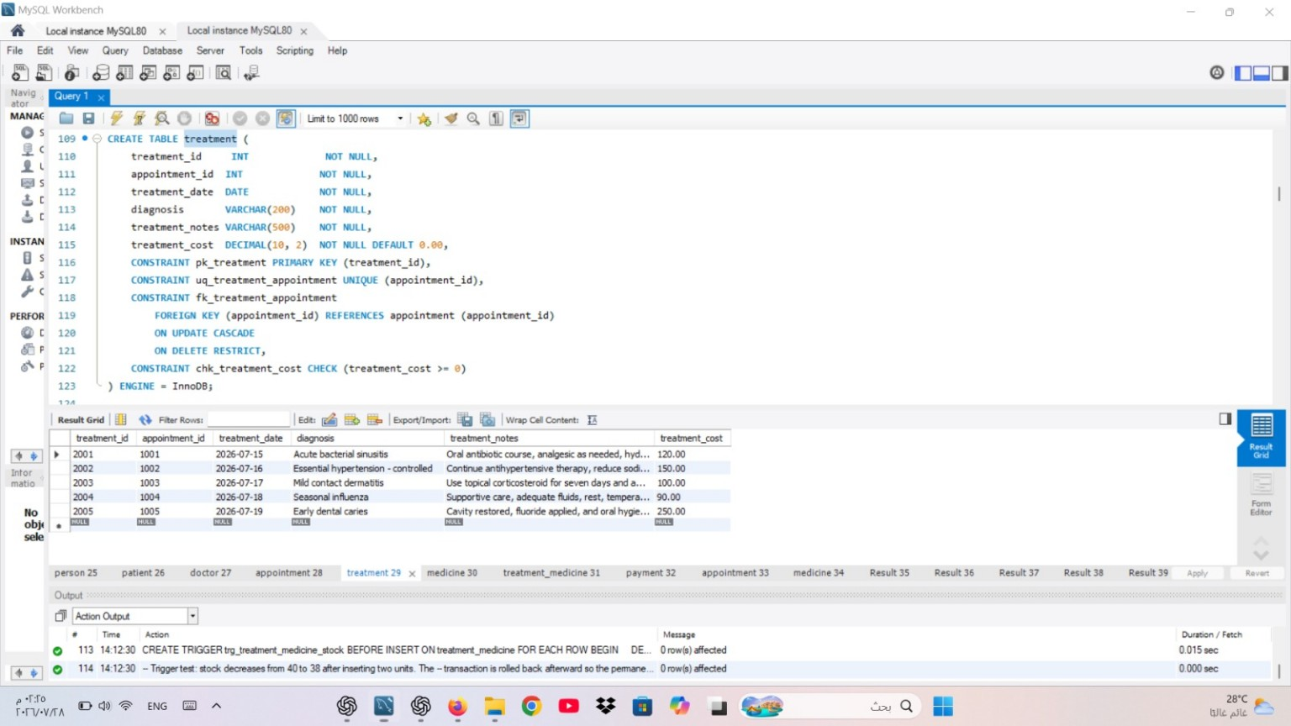
Screenshot 2.5. TREATMENT table definition and five populated treatment records.
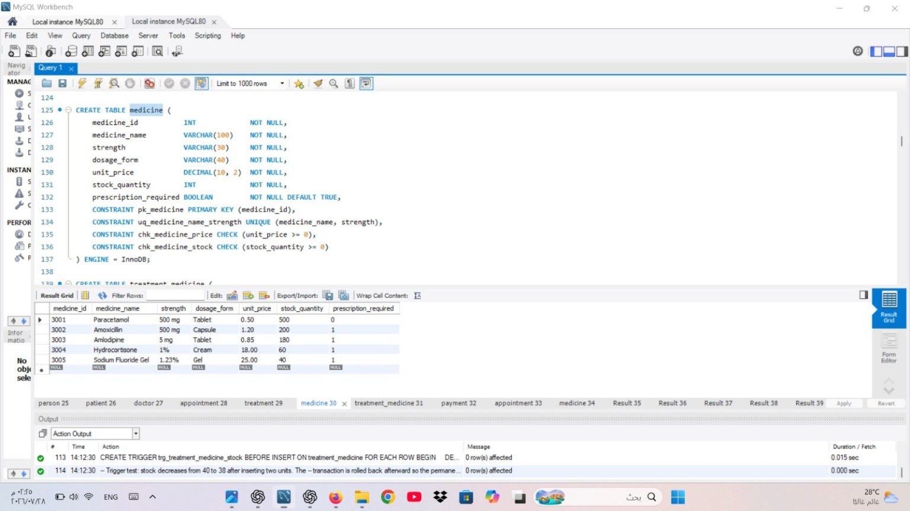
Screenshot 2.6. MEDICINE table definition and five populated medicine records.

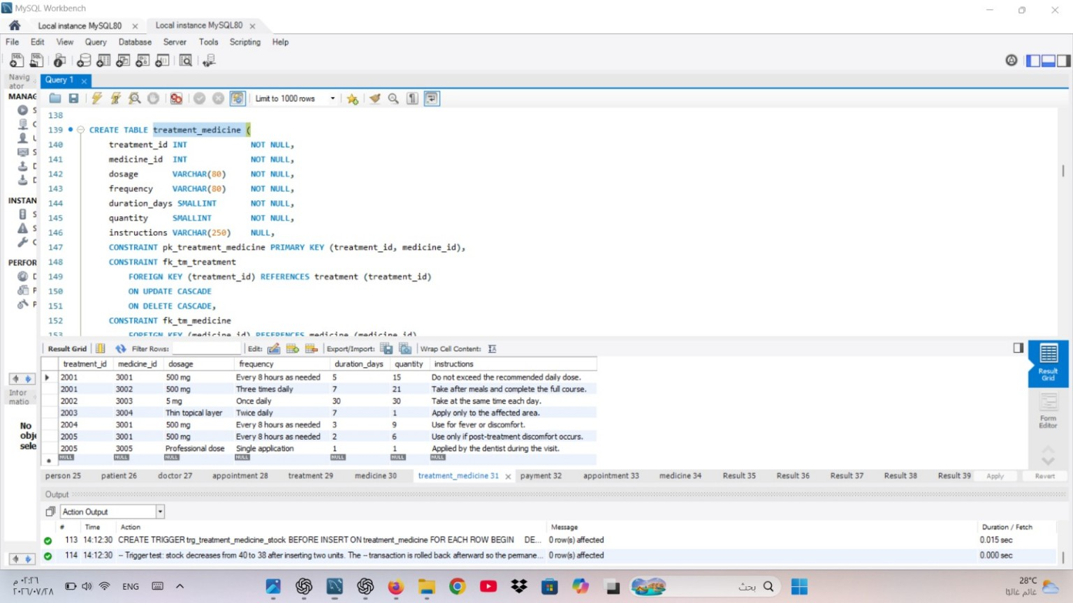
Screenshot 2.7. TREATMENT_MEDICINE definition and seven populated prescription-detail records.
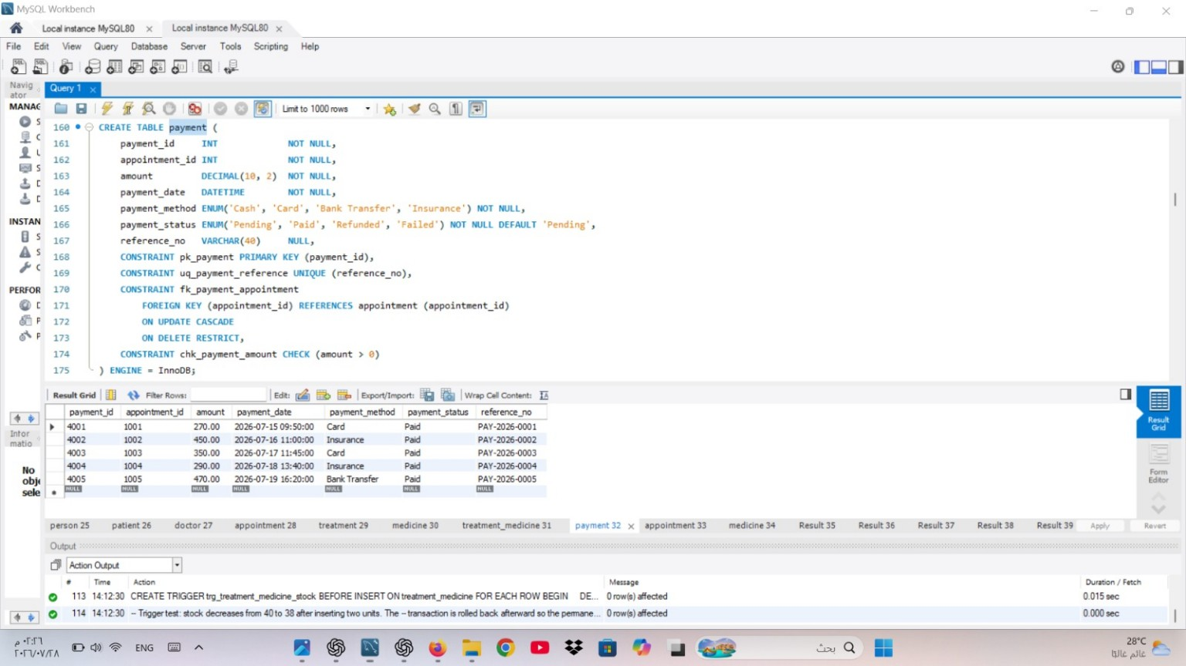
Screenshot 2.8. PAYMENT table definition and five completed payment records.

Task 3 - SQL Operations
Every assessed operation was executed in MySQL Workbench. Purpose statements, SQL excerpts, and matching outputs are provided below. UPDATE, DELETE, and trigger demonstrations use transactions and ROLLBACK so the original academic dataset remains unchanged.

Verified Result Summary
Operation | Verified MySQL Result
SELECT | Five completed appointments; two medicines with stock at or below 100.
JOIN | Five appointment summaries and seven patient-prescription rows.
Nested query | Faisal (SAR 470.00) and Mohammed (SAR 450.00).
GROUP BY | Five doctor workload and financial summary rows.
UPDATE | Hydrocortisone price 18.00 -> 18.90; restored by rollback.
DELETE | Matching row count 1 -> 0 -> 1 after rollback.
VIEW | vw_appointment_summary exists and returns five complete rows.
TRIGGER | Trigger exists; stock 40 -> 38 -> 40 after rollback.

SELECT Statements
Purpose: List completed appointments chronologically and identify medicines requiring closer stock monitoring.
SQL code
SELECT
appointment_id,
scheduled_at,
appointment_duration_minutes,
status,
reason
FROM appointment
WHERE status = 'Completed'
ORDER BY scheduled_at;

SELECT
medicine_id,
medicine_name,
strength,
stock_quantity,
unit_price
FROM medicine
WHERE stock_quantity <= 100
ORDER BY stock_quantity ASC, medicine_name ASC;
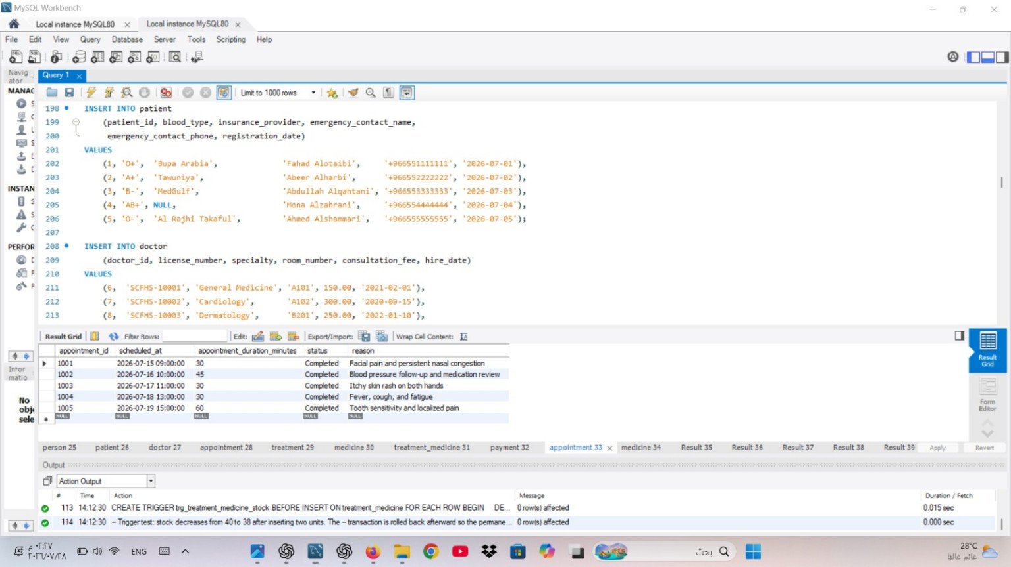
Screenshot 3.1A. Completed appointments returned by the SELECT statement.

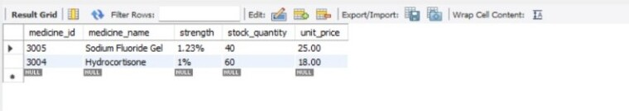
Screenshot 3.1B. Medicines with stock quantities of 100 units or fewer.

JOIN Query - Appointment Details
Purpose: Combine each appointment with readable patient, doctor, and specialty details.
SQL code
SELECT
a.appointment_id,
a.scheduled_at,
patient_person.full_name AS patient_name,
doctor_person.full_name AS doctor_name,
d.specialty,
a.status
FROM appointment AS a
JOIN patient AS pat ON pat.patient_id = a.patient_id
JOIN person AS patient_person ON patient_person.person_id = pat.patient_id
JOIN doctor AS d ON d.doctor_id = a.doctor_id
JOIN person AS doctor_person ON doctor_person.person_id = d.doctor_id
ORDER BY a.scheduled_at;
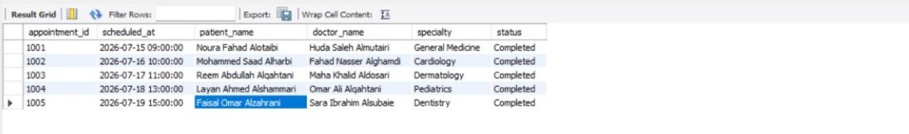
Screenshot 3.2A. Appointment details JOIN result.

JOIN Query - Patient Prescriptions
Purpose: Connect patients to diagnoses and prescribed medicines, including dosage, frequency, and duration.
SQL code
SELECT
patient_person.full_name AS patient_name,
t.diagnosis,
m.medicine_name,
m.strength,
tm.dosage,
tm.frequency,
tm.duration_days
FROM patient AS pat
JOIN person AS patient_person ON patient_person.person_id = pat.patient_id
JOIN appointment AS a ON a.patient_id = pat.patient_id
JOIN treatment AS t ON t.appointment_id = a.appointment_id
JOIN treatment_medicine AS tm ON tm.treatment_id = t.treatment_id
JOIN medicine AS m ON m.medicine_id = tm.medicine_id
ORDER BY patient_person.full_name, m.medicine_name;
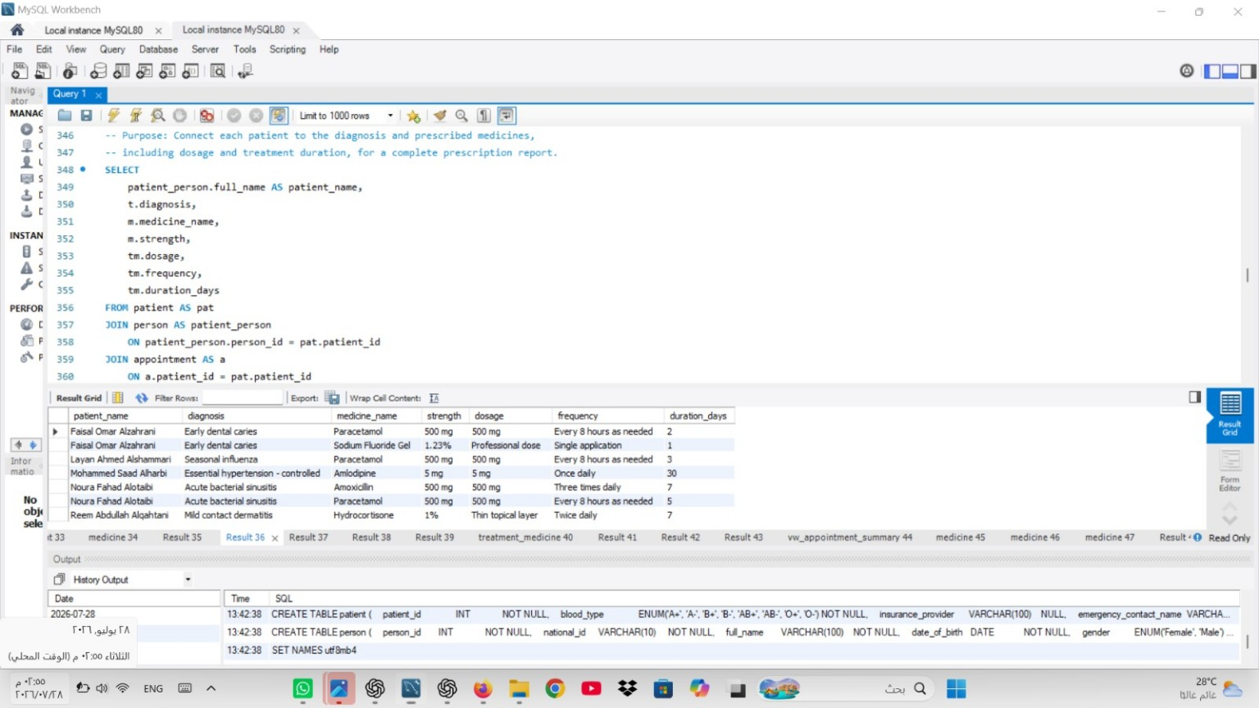
Screenshot 3.2B. Patient prescription JOIN query and result.

Nested Query
Purpose: Identify patients whose total paid amount is greater than the average paid transaction.
SQL code
SELECT
pat.patient_id,
patient_person.full_name AS patient_name,
SUM(pay.amount) AS total_paid
FROM patient AS pat
JOIN person AS patient_person ON patient_person.person_id = pat.patient_id
JOIN appointment AS a ON a.patient_id = pat.patient_id
JOIN payment AS pay ON pay.appointment_id = a.appointment_id
WHERE pay.payment_status = 'Paid'
GROUP BY pat.patient_id, patient_person.full_name
HAVING SUM(pay.amount) > (
SELECT AVG(paid_payment.amount)
FROM payment AS paid_payment
WHERE paid_payment.payment_status = 'Paid'
)
ORDER BY total_paid DESC;
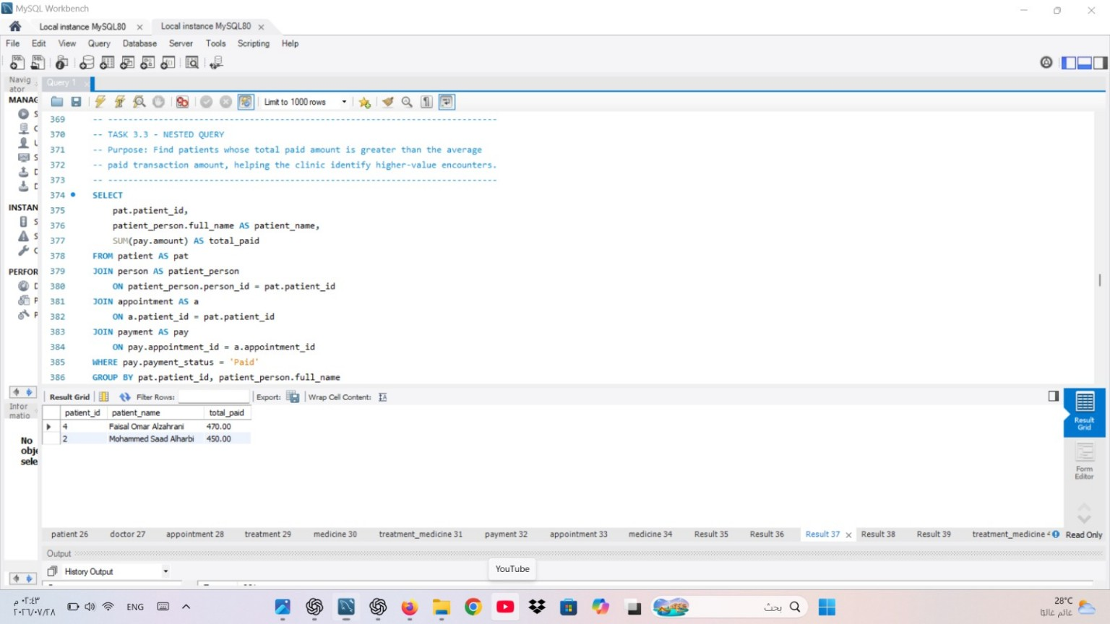
Screenshot 3.3. Nested query and the two qualifying patients.

Aggregate Functions with GROUP BY
Purpose: Summarize doctor workload, average appointment duration, treatment cost, and collected payments.
SQL code
SELECT
d.doctor_id,
doctor_person.full_name AS doctor_name,
d.specialty,
COUNT(DISTINCT a.appointment_id) AS appointment_count,
ROUND(AVG(a.appointment_duration_minutes), 2) AS average_duration_minutes,
SUM(t.treatment_cost) AS total_treatment_cost,
SUM(CASE WHEN pay.payment_status = 'Paid' THEN pay.amount ELSE 0 END)
AS total_collected
FROM doctor AS d
JOIN person AS doctor_person ON doctor_person.person_id = d.doctor_id
LEFT JOIN appointment AS a ON a.doctor_id = d.doctor_id
LEFT JOIN treatment AS t ON t.appointment_id = a.appointment_id
LEFT JOIN payment AS pay ON pay.appointment_id = a.appointment_id
GROUP BY d.doctor_id, doctor_person.full_name, d.specialty
ORDER BY appointment_count DESC, doctor_name;
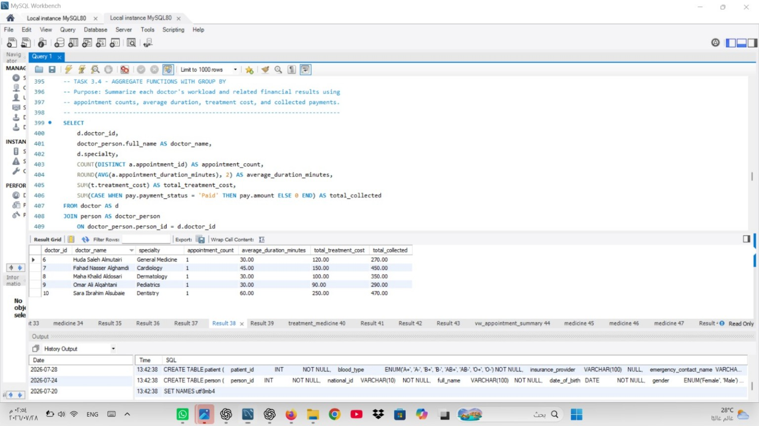
Screenshot 3.4. Aggregate query with GROUP BY and five doctor summaries.

UPDATE Statement
Purpose: Demonstrate a five-percent Hydrocortisone price adjustment without permanently changing the academic dataset.
SQL code
START TRANSACTION;

SET @original_hydrocortisone_price = (
SELECT unit_price FROM medicine WHERE medicine_id = 3004
);

UPDATE medicine
SET unit_price = ROUND(unit_price * 1.05, 2)
WHERE medicine_id = 3004;

SELECT
medicine_id,
medicine_name,
@original_hydrocortisone_price AS price_before_update,
unit_price AS price_after_update
FROM medicine
WHERE medicine_id = 3004;

ROLLBACK;
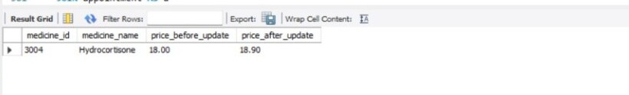
Screenshot 3.5. Hydrocortisone price before and after the UPDATE statement.

DELETE Statement and Rollback Verification
Purpose: Demonstrate removal of one optional treatment-medicine detail row and restore it after verification.
Evidence verification SQL
SET @before_count = (
SELECT COUNT(*) FROM treatment_medicine
WHERE treatment_id = 2005 AND medicine_id = 3001
);

START TRANSACTION;
DELETE FROM treatment_medicine
WHERE treatment_id = 2005 AND medicine_id = 3001;
SET @deleted_rows = ROW_COUNT();

SET @after_delete_count = (
SELECT COUNT(*) FROM treatment_medicine
WHERE treatment_id = 2005 AND medicine_id = 3001
);
ROLLBACK;
SET @after_rollback_count = (
SELECT COUNT(*) FROM treatment_medicine
WHERE treatment_id = 2005 AND medicine_id = 3001
);

SELECT
@before_count AS matching_rows_before_delete,
@deleted_rows AS deleted_rows,
@after_delete_count AS matching_rows_after_delete,
@after_rollback_count AS matching_rows_after_rollback;
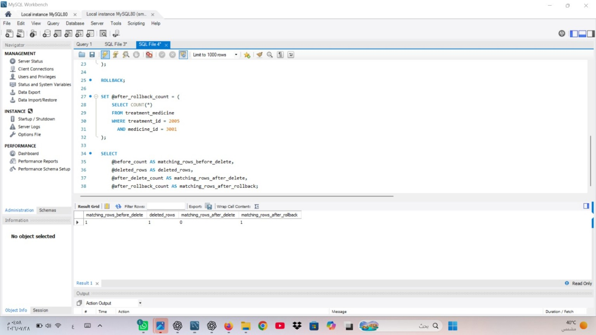
Screenshot 3.6. DELETE execution and rollback verification (1 | 1 | 0 | 1).

VIEW Creation and Result
Purpose: Create a reusable appointment summary combining patient, doctor, treatment, and paid-payment information.
SQL code
DROP VIEW IF EXISTS vw_appointment_summary;

CREATE VIEW vw_appointment_summary AS
SELECT
a.appointment_id,
a.scheduled_at,
patient_person.full_name AS patient_name,
doctor_person.full_name AS doctor_name,
d.specialty,
a.status,
t.diagnosis,
t.treatment_cost,
COALESCE(SUM(CASE WHEN pay.payment_status = 'Paid'
THEN pay.amount ELSE 0 END), 0.00) AS paid_amount
FROM appointment AS a
JOIN patient AS pat ON pat.patient_id = a.patient_id
JOIN person AS patient_person ON patient_person.person_id = pat.patient_id
JOIN doctor AS d ON d.doctor_id = a.doctor_id
JOIN person AS doctor_person ON doctor_person.person_id = d.doctor_id
LEFT JOIN treatment AS t ON t.appointment_id = a.appointment_id
LEFT JOIN payment AS pay ON pay.appointment_id = a.appointment_id
GROUP BY
a.appointment_id, a.scheduled_at, patient_person.full_name,
doctor_person.full_name, d.specialty, a.status,
t.diagnosis, t.treatment_cost;

SELECT *
FROM vw_appointment_summary
ORDER BY scheduled_at;
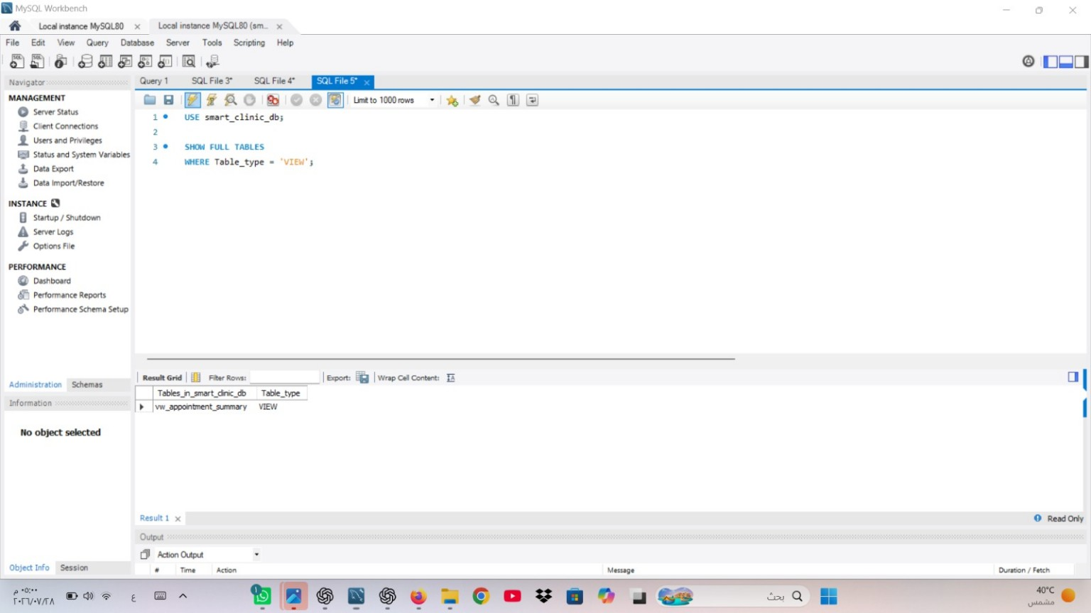
Screenshot 3.7A. MySQL confirms vw_appointment_summary as a VIEW.
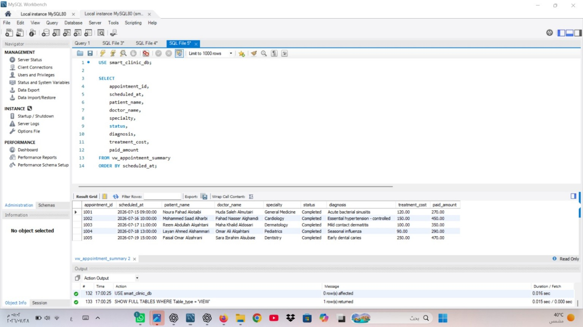
Screenshot 3.7B. Full five-row result returned from vw_appointment_summary.

4.10 TRIGGER Creation and Stock-Control Test
Purpose: Protect medicine inventory by validating stock and automatically reducing it before a treatment-medicine insert.
Trigger definition
DROP TRIGGER IF EXISTS trg_treatment_medicine_stock;

DELIMITER $$
CREATE TRIGGER trg_treatment_medicine_stock
BEFORE INSERT ON treatment_medicine
FOR EACH ROW
BEGIN
DECLARE v_available_stock INT DEFAULT -1;

SELECT COALESCE(MAX(stock_quantity), -1)
INTO v_available_stock
FROM medicine
WHERE medicine_id = NEW.medicine_id;

IF v_available_stock = -1 THEN
SIGNAL SQLSTATE '45000'
SET MESSAGE_TEXT = 'The selected medicine does not exist.';
ELSEIF NEW.quantity > v_available_stock THEN
SIGNAL SQLSTATE '45000'
SET MESSAGE_TEXT = 'Insufficient medicine stock for this treatment.';
ELSE
UPDATE medicine
SET stock_quantity = stock_quantity - NEW.quantity
WHERE medicine_id = NEW.medicine_id;
END IF;
END$$
DELIMITER ;
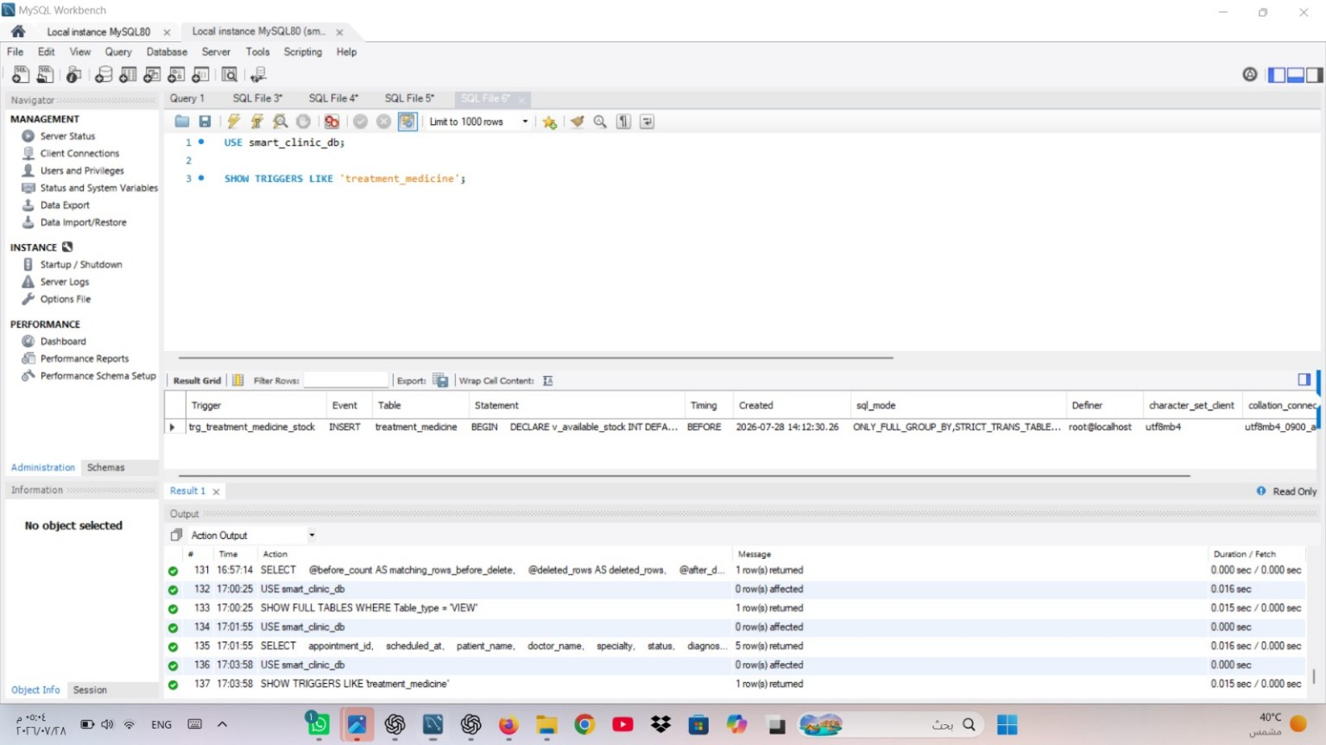
Screenshot 3.8A. SHOW TRIGGERS result confirming trg_treatment_medicine_stock.

Trigger test and rollback verification
SET @stock_before_trigger = (
SELECT stock_quantity FROM medicine WHERE medicine_id = 3005
);

START TRANSACTION;

INSERT INTO treatment_medicine
(treatment_id, medicine_id, dosage, frequency,
duration_days, quantity, instructions)
VALUES
(2004, 3005, 'Professional dose', 'Single application',
1, 2, 'Temporary row used to verify the stock-control trigger.');

SET @stock_after_trigger = (
SELECT stock_quantity FROM medicine WHERE medicine_id = 3005
);

ROLLBACK;

SET @stock_after_rollback = (
SELECT stock_quantity FROM medicine WHERE medicine_id = 3005
);

SELECT
@stock_before_trigger AS stock_before_trigger,
@stock_after_trigger AS stock_after_trigger,
@stock_after_rollback AS stock_after_rollback;
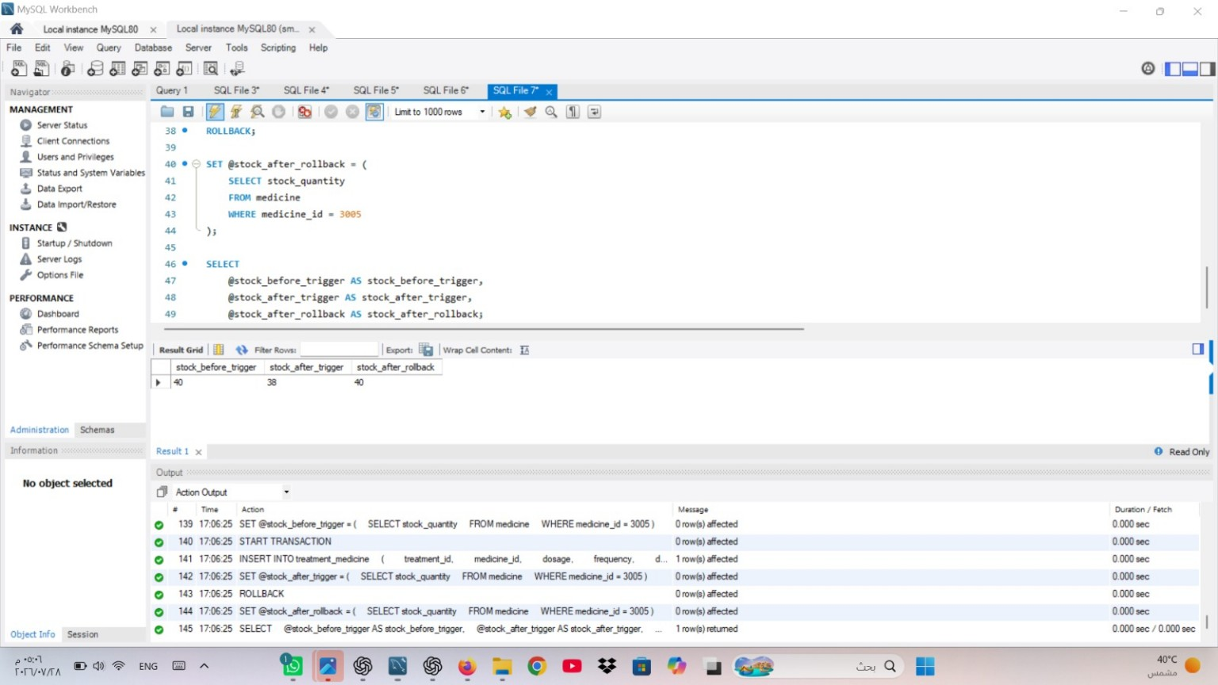
Screenshot 3.8B. Trigger test result showing stock 40 -> 38 -> 40.

Task 4 – Project Reflection
Developing the Smart Clinic Database System was a practical team experience that required us to connect database theory with a realistic clinic workflow. Our most significant shared challenge was preserving consistency while integrating design, implementation, SQL operations, and screenshot evidence into one repeatable MySQL script.
We identified the problem when foreign-key dependencies, result tabs, and temporary UPDATE, DELETE, and trigger tests had to remain synchronized. We resolved it by creating and inserting data in parent-to-child order, testing the complete script in MySQL Workbench, using transactions for reversible changes, and reviewing every screenshot against its corresponding SQL operation.
Dana Mohammed Alajmi: As Group Leader and Repository Manager, Dana coordinated the work, reviewed the integrated files, organized the evidence, and prepared the submission structure. She chose one evolving SQL file instead of separate scripts for each task. Separate files would have been easier for individual editing, but they could have produced conflicting table definitions or sample data. The single-file approach required more careful merging, yet it met the submission requirement and gave the team one authoritative implementation.
AMANI BARJAS: Amani completed the database design and selected PERSON as a supertype specialized into PATIENT and DOCTOR. The alternative was to store repeated identity and contact fields separately in both tables. The selected approach introduced additional joins when retrieving full records, but it reduced redundancy, improved consistency, and demonstrated the required EER specialization. She also reviewed keys, cardinalities, assumptions, and the relational mapping before implementation.
Dareen Alanazi: Dareen implemented the database tables, constraints, and fictional Saudi-context records. Her main obstacle was maintaining valid references across eight tables. She resolved it by creating parent tables first, inserting consistent identifiers in dependency order, and verifying every populated table. UNIQUE, CHECK, and foreign-key constraints were used to detect invalid or duplicated values early.
Manar Mutaib Al-Harbi: Manar prepared and tested the SELECT, JOIN, nested, GROUP BY, UPDATE, DELETE, VIEW, and TRIGGER operations. Because UPDATE, DELETE, and trigger tests could alter the original dataset, she used START TRANSACTION and ROLLBACK. The final evidence confirmed the DELETE sequence 1 to 0 to 1 and the trigger stock sequence 40 to 38 to 40.
If we repeated the project with more time, we would create a formal test checklist before implementation, capture screenshots during the first verified execution, and add audit logging or stored procedures for common clinic operations. AI-based tools were used only for limited wording review, document organization, and SQL syntax suggestions. The team made the design decisions, executed the database, verified the results, and captured the MySQL evidence.

Project Artifacts
The final URLs should be inserted in the highlighted cells before the report is exported to PDF and submitted through Blackboard.
Artifact | Final Entry
Live report document (with edit history) | https://drive.google.com/drive/folders/1m4mQ34nHjkG3mkRDAtZNPv_B7Xkpg7DG
GitHub/GitLab repository (with commit history) | https://github.com/dana2002-cell/IT244-Project-
SQL script | database/smart_clinic_database.sql
ER/EER diagram | diagrams/er_diagram.png
MySQL evidence | evidence/screenshots/ 20 jpg

Appendix A - Mid-Project Progress Report
Smart_Clinic_Mid_Project_Progres_Report
Students Details
Student Name | Student ID | Primary Contribution
Dana Mohammed Alajmi | 240040990 | Group Leader and Repository Manager
Amani Barjas | 240047827 | Task 1: Database Design
Dareen Alanazi | 240022387 | Task 2: Database Implementation
Manar Mutaib Al-Harbi | 240061219 | Task 3: SQL Operations

Progress Summary
The project has completed the Task 3 preparation stage. The single MySQL file now contains the required SELECT, JOIN, nested, GROUP BY, UPDATE, DELETE, VIEW, and TRIGGER operations with purpose statements. The file passed MySQL parsing and internal data checks, and equivalent operations returned coherent results in an isolated Supabase PostgreSQL validation schema. Actual MySQL Workbench execution and course-compliant screenshot capture remain required before final approval

Workstream | Status | Evidence/Output
Task 1 - Design | Prepared for team review | ER/EER diagram, relational schema, keys, cardinalities, assumptions
Task 2 - Implementation | Prepared for MySQL execution | Database, eight tables, constraints, and sample records
Task 2 Evidence | Pending actual capture | MySQL Workbench code, table outputs, and execution status
Task 3 - SQL Operations | Implemented and support-validated | MySQL code plus eight genuine, clearly labeled Supabase result panels
Task 3 MySQL Evidence | Pending actual capture | MySQL Workbench code and output screenshots for every assessed operation
Task 4 - Reflection | Deferred by instruction | Will be written only after the full project is complete

Completed Work
- Defined eight relational tables covering people, patients, doctors, appointments, treatments, medicines, prescriptions, and payments.
- Modeled PERSON as a supertype specialized into the PATIENT and DOCTOR subtypes.
- Specified primary keys, foreign keys, uniqueness constraints, checks, and controlled ENUM values.
- Produced a complete ER/EER diagram with entity attributes and relationship cardinalities.
- Prepared a repeatable MySQL 8.0 script with a transaction-based insertion sequence.
- Inserted at least five logically connected records into every main table.
- Added SELECT, JOIN, nested, GROUP BY, UPDATE, DELETE, VIEW, and TRIGGER operations to the same SQL file.
- Executed equivalent Task 3 operations in an isolated Supabase schema and restored all temporary data changes.
- Created eight genuine evidence panels that identify their platform and do not impersonate MySQL Workbench.

Key Design Decisions
Decision | Reason
Shared person supertype | Avoids repeated identity and contact attributes in separate patient and doctor tables.
Disjoint, total specialization | Makes each clinic person one clear role while demonstrating the required EER feature.
Associative prescription table | Stores dosage and duration while resolving the treatment-medicine many-to-many relationship.
Multiple payments per appointment | Supports insurance, installments, and future mixed payment scenarios.
Restrictive transactional deletion | Protects clinical and financial history from accidental parent-record deletion.
One evolving SQL file | Meets the final requirement for a single implementation file and prevents inconsistent copies.

Challenges and Responses
Design-Stage Challenge | Response
Representing specialization relationally | Used PERSON as the supertype and made each subtype key a foreign key to PERSON.
Maintaining referential insertion order | Created and populated tables from parent entities to dependent transactional entities inside one transaction.
Preventing schedule conflicts | Added unique doctor-time and patient-time constraints to APPOINTMENT.
Protecting evidence integrity | Kept MySQL placeholders, added visibly labeled supporting Supabase results, and avoided presenting them as Workbench evidence.
Trigger portability | Qualified the PostgreSQL validation function's schema, set an immutable search path, and retained the correct MySQL trigger syntax in the assessed file.

Team Contributions
Member | Current Contribution | Status
Dana Mohammed Alajmi | Project coordination, file organization, repository management, integration review | In progress
Amani Barjas | Task 1 entity analysis, keys, relationships, cardinalities, EER feature, assumptions, relational schema | Prepared for review
Dareen Alanazi | Task 2 database creation, table definitions, constraints, data insertion, and testing preparation | Prepared for MySQL execution
Manar Mutaib Al-Harbi | Task 3 SELECT, JOIN, nested, aggregate, UPDATE, DELETE, VIEW, TRIGGER, purposes, and evidence specification | Prepared for team review
All members | Task 4 Reflection, Cross-review, testing, evidence, progress report, final report. | Ongoing

Next-Stage Plan
- We will review the ER/EER model, assumptions, relational schema, sample data, and Task 3 purposes as a team.
- We will run the complete Tasks 1–3 script in MySQL Workbench and correct any environment-specific issues.
- We will capture and organize all required Task 2 and Task 3 MySQL Workbench screenshots.
- We will compare the MySQL results with the supporting validation evidence and approve the final technical results.
- We will review the actual MySQL query results before writing the 300–500-word Project Reflection.
- We will assemble and verify the final DOCX, PDF, correct repository link, and compressed submission package.

Appendix B - Complete SQL Implementation
The following is the complete MySQL implementation submitted with the project. It includes database creation, eight tables, sample data, verification queries, required Task 3 operations, the view, and the trigger.
database/smart_clinic_database.sql
/* ===============================================================================
Smart Clinic Database System IT244 - Database Design and Implementation Project Stage 2 Scope: Task 1 (Design), Task 2 (Implementation), and Task 3 (SQL Operations) Task 4 Project Reflection remains intentionally excluded until final review.

Team Members
1. Dana Mohammed Alajmi -240040990 - Group Leader and Repository Manager
2. AMANI BARJAS - 240047827 - Task 1: Database Design
3. Dareen Alanazi - 240022387 - Task 2: Database Implementation
4. Manar Mutaib Al-Harbi - 240061219 - Task 3: SQL Operations

Target DBMS: MySQL 8.0+ All personal and clinical data below are fictional and created for academic use. =============================================================================== */

-- Recreate the database so the script can be executed repeatedly during testing.
DROP DATABASE IF EXISTS smart_clinic_db;
CREATE DATABASE smart_clinic_db
CHARACTER SET utf8mb4
COLLATE utf8mb4_0900_ai_ci;

USE smart_clinic_db;
SET NAMES utf8mb4;

-- -----------------------------------------------------------------------------
-- TASK 1 RELATIONAL MAPPING AND TASK 2 TABLE IMPLEMENTATION
-- EER feature: PERSON is a supertype specialized into PATIENT and DOCTOR.
-- The specialization is total and disjoint as an application-level rule.

-- -----------------------------------------------------------------------------

CREATE TABLE person (
person_id INT NOT NULL,
national_id VARCHAR(10) NOT NULL,
full_name VARCHAR(100) NOT NULL,
date_of_birth DATE NOT NULL,
gender ENUM('Female', 'Male') NOT NULL,
phone VARCHAR(13) NOT NULL,
email VARCHAR(120) NULL,
address VARCHAR(200) NOT NULL,
CONSTRAINT pk_person PRIMARY KEY (person_id),
CONSTRAINT uq_person_national_id UNIQUE (national_id),
CONSTRAINT uq_person_phone UNIQUE (phone),
CONSTRAINT uq_person_email UNIQUE (email),
CONSTRAINT chk_person_national_id CHECK (national_id REGEXP '^[12][0-9]{9}$'),
CONSTRAINT chk_person_phone CHECK (phone REGEXP '^\\+9665[0-9]{8}$')
) ENGINE = InnoDB;

CREATE TABLE patient (
patient_id INT NOT NULL,
blood_type ENUM('A+', 'A-', 'B+', 'B-', 'AB+', 'AB-', 'O+', 'O-') NOT NULL,
insurance_provider VARCHAR(100) NULL,
emergency_contact_name VARCHAR(100) NOT NULL,
emergency_contact_phone VARCHAR(13) NOT NULL,
registration_date DATE NOT NULL,
CONSTRAINT pk_patient PRIMARY KEY (patient_id),
CONSTRAINT fk_patient_person
FOREIGN KEY (patient_id) REFERENCES person (person_id)
ON UPDATE CASCADE
ON DELETE RESTRICT,
CONSTRAINT chk_patient_emergency_phone
CHECK (emergency_contact_phone REGEXP '^\\+9665[0-9]{8}$')
) ENGINE = InnoDB;

CREATE TABLE doctor (
doctor_id INT NOT NULL,
license_number VARCHAR(25) NOT NULL,
specialty VARCHAR(80) NOT NULL,
room_number VARCHAR(10) NOT NULL,
consultation_fee DECIMAL(10, 2) NOT NULL,
hire_date DATE NOT NULL,
CONSTRAINT pk_doctor PRIMARY KEY (doctor_id),
CONSTRAINT uq_doctor_license UNIQUE (license_number),
CONSTRAINT uq_doctor_room UNIQUE (room_number),
CONSTRAINT fk_doctor_person
FOREIGN KEY (doctor_id) REFERENCES person (person_id)
ON UPDATE CASCADE
ON DELETE RESTRICT,
CONSTRAINT chk_doctor_fee CHECK (consultation_fee >= 0)
) ENGINE = InnoDB;

CREATE TABLE appointment (
appointment_id INT NOT NULL,
patient_id INT NOT NULL,
doctor_id INT NOT NULL,
scheduled_at DATETIME NOT NULL,
appointment_duration_minutes SMALLINT NOT NULL DEFAULT 30,
status ENUM('Scheduled', 'Completed', 'Cancelled', 'No Show') NOT NULL DEFAULT 'Scheduled',
reason VARCHAR(250) NOT NULL,
created_at TIMESTAMP NOT NULL DEFAULT CURRENT_TIMESTAMP,
CONSTRAINT pk_appointment PRIMARY KEY (appointment_id),
CONSTRAINT uq_appointment_doctor_slot UNIQUE (doctor_id, scheduled_at),
CONSTRAINT uq_appointment_patient_slot UNIQUE (patient_id, scheduled_at),
CONSTRAINT fk_appointment_patient
FOREIGN KEY (patient_id) REFERENCES patient (patient_id)
ON UPDATE CASCADE
ON DELETE RESTRICT,
CONSTRAINT fk_appointment_doctor
FOREIGN KEY (doctor_id) REFERENCES doctor (doctor_id)
ON UPDATE CASCADE
ON DELETE RESTRICT,
CONSTRAINT chk_appointment_duration
CHECK (appointment_duration_minutes BETWEEN 15 AND 180)
) ENGINE = InnoDB;

CREATE TABLE treatment (
treatment_id INT NOT NULL,
appointment_id INT NOT NULL,
treatment_date DATE NOT NULL,
diagnosis VARCHAR(200) NOT NULL,
treatment_notes VARCHAR(500) NOT NULL,
treatment_cost DECIMAL(10, 2) NOT NULL DEFAULT 0.00,
CONSTRAINT pk_treatment PRIMARY KEY (treatment_id),
CONSTRAINT uq_treatment_appointment UNIQUE (appointment_id),
CONSTRAINT fk_treatment_appointment
FOREIGN KEY (appointment_id) REFERENCES appointment (appointment_id)
ON UPDATE CASCADE
ON DELETE RESTRICT,
CONSTRAINT chk_treatment_cost CHECK (treatment_cost >= 0)
) ENGINE = InnoDB;

CREATE TABLE medicine (
medicine_id INT NOT NULL,
medicine_name VARCHAR(100) NOT NULL,
strength VARCHAR(30) NOT NULL,
dosage_form VARCHAR(40) NOT NULL,
unit_price DECIMAL(10, 2) NOT NULL,
stock_quantity INT NOT NULL,
prescription_required BOOLEAN NOT NULL DEFAULT TRUE,
CONSTRAINT pk_medicine PRIMARY KEY (medicine_id),
CONSTRAINT uq_medicine_name_strength UNIQUE (medicine_name, strength),
CONSTRAINT chk_medicine_price CHECK (unit_price >= 0),
CONSTRAINT chk_medicine_stock CHECK (stock_quantity >= 0)
) ENGINE = InnoDB;

CREATE TABLE treatment_medicine (
treatment_id INT NOT NULL,
medicine_id INT NOT NULL,
dosage VARCHAR(80) NOT NULL,
frequency VARCHAR(80) NOT NULL,
duration_days SMALLINT NOT NULL,
quantity SMALLINT NOT NULL,
instructions VARCHAR(250) NULL,
CONSTRAINT pk_treatment_medicine PRIMARY KEY (treatment_id, medicine_id),
CONSTRAINT fk_tm_treatment
FOREIGN KEY (treatment_id) REFERENCES treatment (treatment_id)
ON UPDATE CASCADE
ON DELETE CASCADE,
CONSTRAINT fk_tm_medicine
FOREIGN KEY (medicine_id) REFERENCES medicine (medicine_id)
ON UPDATE CASCADE
ON DELETE RESTRICT,
CONSTRAINT chk_tm_duration CHECK (duration_days > 0),
CONSTRAINT chk_tm_quantity CHECK (quantity > 0)
) ENGINE = InnoDB;

CREATE TABLE payment (
payment_id INT NOT NULL,
appointment_id INT NOT NULL,
amount DECIMAL(10, 2) NOT NULL,
payment_date DATETIME NOT NULL,
payment_method ENUM('Cash', 'Card', 'Bank Transfer', 'Insurance') NOT NULL,
payment_status ENUM('Pending', 'Paid', 'Refunded', 'Failed') NOT NULL DEFAULT 'Pending',
reference_no VARCHAR(40) NULL,
CONSTRAINT pk_payment PRIMARY KEY (payment_id),
CONSTRAINT uq_payment_reference UNIQUE (reference_no),
CONSTRAINT fk_payment_appointment
FOREIGN KEY (appointment_id) REFERENCES appointment (appointment_id)
ON UPDATE CASCADE
ON DELETE RESTRICT,
CONSTRAINT chk_payment_amount CHECK (amount > 0)
) ENGINE = InnoDB;

-- -----------------------------------------------------------------------------
-- TASK 2 SAMPLE DATA
-- Ten PERSON rows support five PATIENT subtypes and five DOCTOR subtypes.
-- -----------------------------------------------------------------------------

START TRANSACTION;

INSERT INTO person
(person_id, national_id, full_name, date_of_birth, gender, phone, email, address)
VALUES
(1, '1098765432', 'Noura Fahad Alotaibi', '1993-04-18', 'Female', '+966501234567', 'noura.alotaibi@example.sa', 'Al Malqa District, Riyadh'),
(2, '1087654321', 'Mohammed Saad Alharbi', '1986-09-03', 'Male', '+966502345678', 'mohammed.alharbi@example.sa', 'Al Yasmin District, Riyadh'),
(3, '1076543219', 'Reem Abdullah Alqahtani', '1998-12-11', 'Female', '+966503456789', 'reem.alqahtani@example.sa', 'Al Narjis District, Riyadh'),
(4, '1065432198', 'Faisal Omar Alzahrani', '1979-02-26', 'Male', '+966504567890', 'faisal.alzahrani@example.sa', 'Al Rawdah District, Riyadh'),
(5, '1123456789', 'Layan Ahmed Alshammari', '2014-06-07', 'Female', '+966505678901', 'layan.alshammari@example.sa', 'Al Qurtubah District, Riyadh'),
(6, '1054321987', 'Huda Saleh Almutairi', '1982-01-14', 'Female', '+966506789012', 'huda.almutairi@smartclinic.sa', 'Al Wurud District, Riyadh'),
(7, '1043219876', 'Fahad Nasser Alghamdi', '1978-08-22', 'Male', '+966507890123', 'fahad.alghamdi@smartclinic.sa', 'Al Olaya District, Riyadh'),
(8, '1032198765', 'Maha Khalid Aldosari', '1987-05-30', 'Female', '+966508901234', 'maha.aldosari@smartclinic.sa', 'Al Nakheel District, Riyadh'),
(9, '1021987654', 'Omar Ali Alqahtani', '1984-10-09', 'Male', '+966509012345', 'omar.alqahtani@smartclinic.sa', 'Al Sahafah District, Riyadh'),
(10, '1019876543', 'Sara Ibrahim Alsubaie', '1981-03-17', 'Female', '+966550123456', 'sara.alsubaie@smartclinic.sa', 'Al Rabwah District, Riyadh');

INSERT INTO patient
(patient_id, blood_type, insurance_provider, emergency_contact_name,
emergency_contact_phone, registration_date)
VALUES
(1, 'O+', 'Bupa Arabia', 'Fahad Alotaibi', '+966551111111', '2026-07-01'),
(2, 'A+', 'Tawuniya', 'Abeer Alharbi', '+966552222222', '2026-07-02'),
(3, 'B-', 'MedGulf', 'Abdullah Alqahtani', '+966553333333', '2026-07-03'),
(4, 'AB+', NULL, 'Mona Alzahrani', '+966554444444', '2026-07-04'),
(5, 'O-', 'Al Rajhi Takaful', 'Ahmed Alshammari', '+966555555555', '2026-07-05');

INSERT INTO doctor
(doctor_id, license_number, specialty, room_number, consultation_fee, hire_date)
VALUES
(6, 'SCFHS-10001', 'General Medicine', 'A101', 150.00, '2021-02-01'),
(7, 'SCFHS-10002', 'Cardiology', 'A102', 300.00, '2020-09-15'),
(8, 'SCFHS-10003', 'Dermatology', 'B201', 250.00, '2022-01-10'),
(9, 'SCFHS-10004', 'Pediatrics', 'B202', 200.00, '2019-06-20'),
(10, 'SCFHS-10005', 'Dentistry', 'C301', 220.00, '2023-03-05');

INSERT INTO appointment
(appointment_id, patient_id, doctor_id, scheduled_at,
appointment_duration_minutes, status, reason)
VALUES
(1001, 1, 6, '2026-07-15 09:00:00', 30, 'Completed', 'Facial pain and persistent nasal congestion'),
(1002, 2, 7, '2026-07-16 10:00:00', 45, 'Completed', 'Blood pressure follow-up and medication review'),
(1003, 3, 8, '2026-07-17 11:00:00', 30, 'Completed', 'Itchy skin rash on both hands'),
(1004, 5, 9, '2026-07-18 13:00:00', 30, 'Completed', 'Fever, cough, and fatigue'),
(1005, 4, 10, '2026-07-19 15:00:00', 60, 'Completed', 'Tooth sensitivity and localized pain');

INSERT INTO treatment
(treatment_id, appointment_id, treatment_date, diagnosis, treatment_notes, treatment_cost)
VALUES
(2001, 1001, '2026-07-15', 'Acute bacterial sinusitis',
'Oral antibiotic course, analgesic as needed, hydration, and follow-up if symptoms persist.', 120.00),
(2002, 1002, '2026-07-16', 'Essential hypertension - controlled',
'Continue antihypertensive therapy, reduce sodium intake, and record home blood pressure readings.', 150.00),
(2003, 1003, '2026-07-17', 'Mild contact dermatitis',
'Use topical corticosteroid for seven days and avoid the suspected irritant.', 100.00),
(2004, 1004, '2026-07-18', 'Seasonal influenza',
'Supportive care, adequate fluids, rest, temperature monitoring, and return if breathing worsens.', 90.00),
(2005, 1005, '2026-07-19', 'Early dental caries',
'Cavity restored, fluoride applied, and oral hygiene instructions provided.', 250.00);

INSERT INTO medicine
(medicine_id, medicine_name, strength, dosage_form, unit_price,
stock_quantity, prescription_required)
VALUES
(3001, 'Paracetamol', '500 mg', 'Tablet', 0.50, 500, FALSE),
(3002, 'Amoxicillin', '500 mg', 'Capsule', 1.20, 200, TRUE),
(3003, 'Amlodipine', '5 mg', 'Tablet', 0.85, 180, TRUE),
(3004, 'Hydrocortisone', '1%', 'Cream', 18.00, 60, TRUE),
(3005, 'Sodium Fluoride Gel', '1.23%', 'Gel', 25.00, 40, TRUE);

INSERT INTO treatment_medicine
(treatment_id, medicine_id, dosage, frequency, duration_days,
quantity, instructions)
VALUES
(2001, 3002, '500 mg', 'Three times daily', 7, 21, 'Take after meals and complete the full course.'),
(2001, 3001, '500 mg', 'Every 8 hours as needed', 5, 15, 'Do not exceed the recommended daily dose.'),
(2002, 3003, '5 mg', 'Once daily', 30, 30, 'Take at the same time each day.'),
(2003, 3004, 'Thin topical layer','Twice daily', 7, 1, 'Apply only to the affected area.'),
(2004, 3001, '500 mg', 'Every 8 hours as needed', 3, 9, 'Use for fever or discomfort.'),
(2005, 3005, 'Professional dose', 'Single application', 1, 1, 'Applied by the dentist during the visit.'),
(2005, 3001, '500 mg', 'Every 8 hours as needed', 2, 6, 'Use only if post-treatment discomfort occurs.');

INSERT INTO payment
(payment_id, appointment_id, amount, payment_date, payment_method,
payment_status, reference_no)
VALUES
(4001, 1001, 270.00, '2026-07-15 09:50:00', 'Card', 'Paid', 'PAY-2026-0001'),
(4002, 1002, 450.00, '2026-07-16 11:00:00', 'Insurance', 'Paid', 'PAY-2026-0002'),
(4003, 1003, 350.00, '2026-07-17 11:45:00', 'Card', 'Paid', 'PAY-2026-0003'),
(4004, 1004, 290.00, '2026-07-18 13:40:00', 'Insurance', 'Paid', 'PAY-2026-0004'),
(4005, 1005, 470.00, '2026-07-19 16:20:00', 'Bank Transfer', 'Paid', 'PAY-2026-0005');

COMMIT;

-- -----------------------------------------------------------------------------
-- TASK 2 VERIFICATION QUERIES
-- These basic table displays are provided for population screenshots.
-- -----------------------------------------------------------------------------

SELECT * FROM person ORDER BY person_id;
SELECT * FROM patient ORDER BY patient_id;
SELECT * FROM doctor ORDER BY doctor_id;
SELECT * FROM appointment ORDER BY appointment_id;
SELECT * FROM treatment ORDER BY treatment_id;
SELECT * FROM medicine ORDER BY medicine_id;
SELECT * FROM treatment_medicine ORDER BY treatment_id, medicine_id;
SELECT * FROM payment ORDER BY payment_id;

-- =============================================================================
-- TASK 3 - SQL OPERATIONS
-- Every assessed operation includes a short purpose statement. UPDATE, DELETE,
-- and trigger demonstrations use ROLLBACK so the original academic dataset is
-- preserved after the evidence queries are executed.
-- =============================================================================

-- -----------------------------------------------------------------------------
-- TASK 3.1 - SELECT STATEMENTS
-- Purpose: List the completed clinic appointments in chronological order so the
-- clinic can review the encounter schedule and the reason for each visit.
-- -----------------------------------------------------------------------------
SELECT
appointment_id,
scheduled_at,
appointment_duration_minutes,
status,
reason
FROM appointment
WHERE status = 'Completed'
ORDER BY scheduled_at;

-- Purpose: Identify medicines with 100 units or fewer so clinic staff can
-- prioritize stock monitoring and replenishment.
SELECT
medicine_id,
medicine_name,
strength,
stock_quantity,
unit_price
FROM medicine
WHERE stock_quantity <= 100
ORDER BY stock_quantity ASC, medicine_name ASC;

-- -----------------------------------------------------------------------------
-- TASK 3.2 - JOIN QUERIES
-- Purpose: Combine appointments with the related patient, doctor, and specialty
-- details to produce a readable appointment summary.
-- -----------------------------------------------------------------------------
SELECT
a.appointment_id,
a.scheduled_at,
patient_person.full_name AS patient_name,
doctor_person.full_name AS doctor_name,
d.specialty,
a.status
FROM appointment AS a
JOIN patient AS pat
ON pat.patient_id = a.patient_id
JOIN person AS patient_person
ON patient_person.person_id = pat.patient_id
JOIN doctor AS d
ON d.doctor_id = a.doctor_id
JOIN person AS doctor_person
ON doctor_person.person_id = d.doctor_id
ORDER BY a.scheduled_at;

-- Purpose: Connect each patient to the diagnosis and prescribed medicines,
-- including dosage and treatment duration, for a complete prescription report.
SELECT
patient_person.full_name AS patient_name,
t.diagnosis,
m.medicine_name,
m.strength,
tm.dosage,
tm.frequency,
tm.duration_days
FROM patient AS pat
JOIN person AS patient_person
ON patient_person.person_id = pat.patient_id
JOIN appointment AS a
ON a.patient_id = pat.patient_id
JOIN treatment AS t
ON t.appointment_id = a.appointment_id
JOIN treatment_medicine AS tm
ON tm.treatment_id = t.treatment_id
JOIN medicine AS m
ON m.medicine_id = tm.medicine_id
ORDER BY patient_person.full_name, m.medicine_name;

-- -----------------------------------------------------------------------------
-- TASK 3.3 - NESTED QUERY
-- Purpose: Find patients whose total paid amount is greater than the average
-- paid transaction amount, helping the clinic identify higher-value encounters.
-- -----------------------------------------------------------------------------
SELECT
pat.patient_id,
patient_person.full_name AS patient_name,
SUM(pay.amount) AS total_paid
FROM patient AS pat
JOIN person AS patient_person
ON patient_person.person_id = pat.patient_id
JOIN appointment AS a
ON a.patient_id = pat.patient_id
JOIN payment AS pay
ON pay.appointment_id = a.appointment_id
WHERE pay.payment_status = 'Paid'
GROUP BY pat.patient_id, patient_person.full_name
HAVING SUM(pay.amount) > (
SELECT AVG(paid_payment.amount)
FROM payment AS paid_payment
WHERE paid_payment.payment_status = 'Paid'
)
ORDER BY total_paid DESC;

-- -----------------------------------------------------------------------------
-- TASK 3.4 - AGGREGATE FUNCTIONS WITH GROUP BY
-- Purpose: Summarize each doctor's workload and related financial results using
-- appointment counts, average duration, treatment cost, and collected payments.
-- -----------------------------------------------------------------------------
SELECT
d.doctor_id,
doctor_person.full_name AS doctor_name,
d.specialty,
COUNT(DISTINCT a.appointment_id) AS appointment_count,
ROUND(AVG(a.appointment_duration_minutes), 2) AS average_duration_minutes,
SUM(t.treatment_cost) AS total_treatment_cost,
SUM(CASE WHEN pay.payment_status = 'Paid' THEN pay.amount ELSE 0 END) AS total_collected
FROM doctor AS d
JOIN person AS doctor_person
ON doctor_person.person_id = d.doctor_id
LEFT JOIN appointment AS a
ON a.doctor_id = d.doctor_id
LEFT JOIN treatment AS t
ON t.appointment_id = a.appointment_id
LEFT JOIN payment AS pay
ON pay.appointment_id = a.appointment_id
GROUP BY d.doctor_id, doctor_person.full_name, d.specialty
ORDER BY appointment_count DESC, doctor_name;

-- -----------------------------------------------------------------------------
-- TASK 3.5 - UPDATE STATEMENT
-- Purpose: Demonstrate a five-percent price adjustment for Hydrocortisone. The
-- transaction is rolled back after displaying the before-and-after values.
-- -----------------------------------------------------------------------------
START TRANSACTION;

SET @original_hydrocortisone_price = (
SELECT unit_price
FROM medicine
WHERE medicine_id = 3004
);

UPDATE medicine
SET unit_price = ROUND(unit_price * 1.05, 2)
WHERE medicine_id = 3004;

SELECT
medicine_id,
medicine_name,
@original_hydrocortisone_price AS price_before_update,
unit_price AS price_after_update
FROM medicine
WHERE medicine_id = 3004;

ROLLBACK;

-- -----------------------------------------------------------------------------
-- TASK 3.6 - DELETE STATEMENT
-- Purpose: Demonstrate removing one optional treatment-medicine detail record.
-- ROLLBACK restores the deleted row so later queries keep the original dataset.
-- -----------------------------------------------------------------------------
START TRANSACTION;

SELECT
treatment_id,
medicine_id,
dosage,
quantity
FROM treatment_medicine
WHERE treatment_id = 2005
AND medicine_id = 3001;

DELETE FROM treatment_medicine
WHERE treatment_id = 2005
AND medicine_id = 3001;

SELECT ROW_COUNT() AS deleted_rows;

SELECT COUNT(*) AS matching_rows_after_delete
FROM treatment_medicine
WHERE treatment_id = 2005
AND medicine_id = 3001;

ROLLBACK;

SELECT COUNT(*) AS matching_rows_after_rollback
FROM treatment_medicine
WHERE treatment_id = 2005
AND medicine_id = 3001;

-- -----------------------------------------------------------------------------
-- TASK 3.7 - VIEW
-- Purpose: Provide a reusable appointment summary that combines patient,
-- doctor, treatment, and paid-payment information for reporting.
-- -----------------------------------------------------------------------------
DROP VIEW IF EXISTS vw_appointment_summary;

CREATE VIEW vw_appointment_summary AS
SELECT
a.appointment_id,
a.scheduled_at,
patient_person.full_name AS patient_name,
doctor_person.full_name AS doctor_name,
d.specialty,
a.status,
t.diagnosis,
t.treatment_cost,
COALESCE(SUM(CASE WHEN pay.payment_status = 'Paid' THEN pay.amount ELSE 0 END), 0.00)
AS paid_amount
FROM appointment AS a
JOIN patient AS pat
ON pat.patient_id = a.patient_id
JOIN person AS patient_person
ON patient_person.person_id = pat.patient_id
JOIN doctor AS d
ON d.doctor_id = a.doctor_id
JOIN person AS doctor_person
ON doctor_person.person_id = d.doctor_id
LEFT JOIN treatment AS t
ON t.appointment_id = a.appointment_id
LEFT JOIN payment AS pay
ON pay.appointment_id = a.appointment_id
GROUP BY
a.appointment_id,
a.scheduled_at,
patient_person.full_name,
doctor_person.full_name,
d.specialty,
a.status,
t.diagnosis,
t.treatment_cost;

SELECT *
FROM vw_appointment_summary
ORDER BY scheduled_at;

-- -----------------------------------------------------------------------------
-- TASK 3.8 - TRIGGER
-- Purpose: Protect medicine inventory by rejecting an excessive prescription
-- quantity and automatically reducing stock when a new detail row is inserted.
-- -----------------------------------------------------------------------------
DROP TRIGGER IF EXISTS trg_treatment_medicine_stock;

DELIMITER $$

CREATE TRIGGER trg_treatment_medicine_stock
BEFORE INSERT ON treatment_medicine
FOR EACH ROW
BEGIN
DECLARE v_available_stock INT DEFAULT -1;

SELECT COALESCE(MAX(stock_quantity), -1)
INTO v_available_stock
FROM medicine
WHERE medicine_id = NEW.medicine_id;

IF v_available_stock = -1 THEN
SIGNAL SQLSTATE '45000'
SET MESSAGE_TEXT = 'The selected medicine does not exist.';
ELSEIF NEW.quantity > v_available_stock THEN
SIGNAL SQLSTATE '45000'
SET MESSAGE_TEXT = 'Insufficient medicine stock for this treatment.';
ELSE
UPDATE medicine
SET stock_quantity = stock_quantity - NEW.quantity
WHERE medicine_id = NEW.medicine_id;
END IF;
END$$

DELIMITER ;

-- Trigger test: stock decreases from 40 to 38 after inserting two units. The
-- transaction is rolled back afterward so the permanent stock returns to 40.
START TRANSACTION;

SELECT
medicine_id,
medicine_name,
stock_quantity AS stock_before_trigger
FROM medicine
WHERE medicine_id = 3005;

INSERT INTO treatment_medicine
(treatment_id, medicine_id, dosage, frequency, duration_days, quantity, instructions)
VALUES
(2004, 3005, 'Professional dose', 'Single application', 1, 2,
'Temporary row used to verify the stock-control trigger.');

SELECT
medicine_id,
medicine_name,
stock_quantity AS stock_after_trigger
FROM medicine
WHERE medicine_id = 3005;

ROLLBACK;

SELECT
medicine_id,
medicine_name,
stock_quantity AS stock_after_rollback
FROM medicine
WHERE medicine_id = 3005;

SHOW TRIGGERS LIKE 'treatment_medicine';

Appendix C - Screenshot Evidence Index
This index maps every embedded MySQL Workbench screenshot to the Task 2 or Task 3 requirement it supports.
Screenshot | Evidence Purpose | Source File
2.1 | PERSON table | 09-1000380028.jpg
2.2 | PATIENT table | 03-1000380014.jpg
2.3 | DOCTOR table | 04-1000380018.jpg
2.4 | APPOINTMENT table | 10-1000380030.jpg
2.5 | TREATMENT table | 05-1000380020.jpg
2.6 | MEDICINE table | 01-1000380032.jpg
2.7 | TREATMENT_MEDICINE table | 02-1000380034.jpg
2.8 | PAYMENT table | 03-1000380036.jpg
3.1A | Completed appointments SELECT | 04-1000380040.jpg
3.1B | Low-stock medicines SELECT | task3_01_select_low_stock.jpg
3.2A | Appointment details JOIN | task3_02_join_appointments.jpg
3.2B | Patient prescription JOIN | 06-1000380072.jpg
3.3 | Nested query | 05-1000380070.jpg
3.4 | Aggregate functions with GROUP BY | 07-1000380024.jpg
3.5 | UPDATE before/after | task3_05_update_result.jpg
3.6 | DELETE and rollback | 01-1000380161.jpg
3.7A | VIEW existence | 01-1000380170.jpg
3.7B | VIEW full result | 02-1000380171.jpg
3.8A | TRIGGER definition | 03-1000380172.jpg
3.8B | TRIGGER stock test and rollback | 04-1000380173.jpg

