FOUNDER NETWORK · MEMBER RESOURCE
Founder Capital Access Toolkit Workbook
Match your company to the right capital paths and build an outreach-ready funding plan.
Resource ID: CAP-01 · Version 1.1 · August 13, 2026
WHO IT'S FOR
Founders preparing to raise non-dilutive, debt, or investor capital.
WHEN TO USE IT
Before any grant, lender, or investor outreach.
WHAT IT PRODUCES
A completed capital-path match, readiness gap list, and outreach action plan.
NEXT STEP INSIDE THE ECOSYSTEM
Work the plan with your Funding Pipeline Tracker (CAP-04). When you need capital strategy tailored to your company, book a VGP advisory session; Growth OS can turn your funding pipeline into a managed operating dashboard.
© 2026 Value Growth Partners. Provided to Founder Network members for their own use. Not legal, financial, investment, or tax advice. Do not redistribute, resell, or share outside your organization.
Capital & funding content is educational. It is not an offer of, or advice on, securities or financing; verify eligibility, terms, and deadlines independently before applying or committing.
THE BRAND BLUEPRINT · Powered by Value Growth Partners · Growth OS

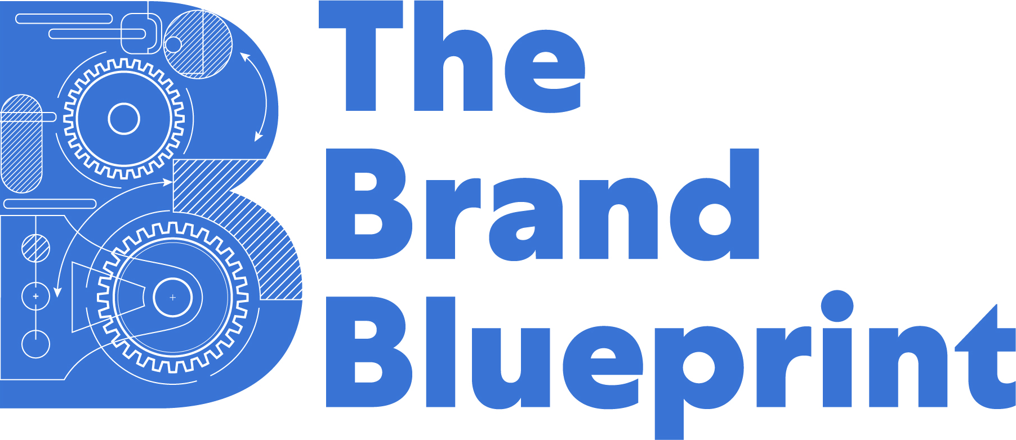 | 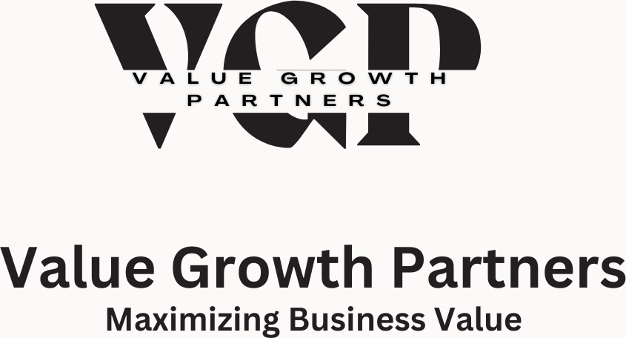

Founder Capital Access Toolkit
Right Capital. Right Time. Right Purpose.
BB-08 | Capital Readiness & Funding Strategy
Prepared for The Brand Blueprint Founder Resource Toolkit by Value Growth Partners. Version 1.0

This toolkit is designed to help founders determine whether they are funding ready, identify the best-fit capital pathway, organize required materials, prepare outreach, and track funding opportunities without duplicating existing Brand Blueprint resources. Use it alongside the Forecasting + KPI Workbook, Pitch Deck Builder, Retail Readiness Toolkit, and Growth OS resources.

How to Use This Toolkit
STEP | TOOL | PURPOSE
01 | Capital Readiness Scorecard | Assess whether the business is ready to pursue funding now.
02 | Capital Fit Matrix | Match stage, revenue, funding need, and risk tolerance to the right pathway.
03 | Capital Data Room Checklist | Organize the documents funders expect before outreach.
04 | Funding Outreach Library | Customize channel-specific emails for lenders, accelerators, investors, and partners.
05 | Funding Pipeline Tracker | Track deadlines, contacts, status, next steps, probability, and capital pipeline value.

01 | Capital Readiness Scorecard
Score each area from 0 to 2. A score of 0 means not ready, 1 means partially ready, and 2 means ready. Total score guides the recommended next step.
AREA | WHAT TO REVIEW | 0 | 1 | 2
Business Foundation | Legal entity, EIN, business bank account, licenses, insurance | ☐ | ☐ | ☐
Revenue Proof | Sales history, ecommerce exports, invoices, purchase orders, contracts, or paid pilots | ☐ | ☐ | ☐
Financial Clarity | P&L, cashflow forecast, revenue summary, bank statements, margin understanding | ☐ | ☐ | ☐
Use of Funds | Clear capital objective, amount needed, timeline, and deployment plan | ☐ | ☐ | ☐
Repayment / Return Logic | Debt repayment plan, investor return story, or impact/outcome logic | ☐ | ☐ | ☐
Channel Strategy | Clear sales channels, customer acquisition path, retail/distribution plan, or recurring revenue engine | ☐ | ☐ | ☐
Operations Readiness | Inventory, vendors, fulfillment, staffing, systems, and capacity to execute after funding | ☐ | ☐ | ☐
Founder Preparedness | Pitch clarity, coachability, responsiveness, follow-up discipline, and realistic expectations | ☐ | ☐ | ☐
Scoring Guide: 0-6 = Strengthen the business before outreach. 7-11 = Prepare materials and pursue selective opportunities. 12-16 = Begin targeted outreach and pipeline tracking.

02 | Capital Fit Matrix
Use this matrix to narrow funding lanes before applying. The objective is to avoid chasing every opportunity and instead focus on the most realistic capital pathway for your current business model.
STAGE / MODEL | COMMON NEED | BEST-FIT CAPITAL PATHS | WATCHOUT
Pre-revenue / prototype | Product development, testing, market validation | Grants, pitch competitions, accelerators, friends/family, catalytic pilot dollars | Avoid debt until demand is clearer.
Early revenue under $50K | Working capital, small equipment, early inventory | CDFI, SBA microloan, local grants, accelerator programs | Prepare basic financials and use-of-funds.
$50K-$250K revenue | Inventory, marketing, retail prep, production scale | CDFI, revenue-based financing, supplier programs, purchase order financing | Check margins and repayment pressure.
$250K-$1M revenue | Retail expansion, wholesale, hiring, operations | RBF, receivables financing, bank line, angel, corporate programs | Use forecasts and channel economics.
$1M+ revenue | Scale, national retail, acquisitions, growth team | Bank financing, strategic investors, family offices, venture, PRI if impact aligned | Prepare diligence-ready data room.
SaaS / recurring revenue | Hiring, product roadmap, customer acquisition | Receivables, subscription monetization, angels, VC if scale profile fits | Prepare MRR, churn, cohorts, CAC, LTV.
Impact / community model | Pilot, program expansion, community outcomes | PRI, recoverable grants, impact investors, foundations, CDFI | Define impact metrics and repayment path.

03 | Capital Data Room Checklist
Create a clean folder before outreach. Funders should not have to chase basic documents. Use the existing Brand Blueprint resources where noted instead of creating duplicate files.
01 Company Documents
☐ Formation documents
☐ EIN confirmation
☐ Operating agreement or bylaws
☐ Business licenses
☐ Insurance certificates
02 Financials
☐ Profit and loss statement
☐ Balance sheet
☐ 12-month cashflow forecast
☐ Business bank statements
☐ Existing debt or financing obligations
03 Revenue + Traction
☐ Shopify, Stripe, Amazon, Faire, wholesale, or POS exports
☐ Customer contracts or purchase orders
☐ AR aging report
☐ Top SKU or service revenue summary
☐ Customer testimonials or case studies
04 Operations
☐ Inventory report
☐ Vendor and manufacturer agreements
☐ 3PL or fulfillment documents
☐ Team or contractor roster
☐ Systems, tools, and operating workflow
05 Capital Materials
☐ Use-of-funds summary
☐ Pitch deck or lender package
☐ Executive summary
☐ Capital ask and timeline
☐ Repayment, return, or impact logic

04 | Funding Outreach Library
Use these templates as starting points. Customize every message with your revenue, capital need, use of funds, and reason for fit. Keep outreach specific, concise, and easy to respond to.
Revenue-Based Financing / Ecommerce Advance
Hello [Name],
We are exploring non-dilutive working capital for [Brand Name]. We currently generate approximately $[monthly revenue] through [Shopify/Amazon/wholesale] and are seeking $[amount] to support [inventory/marketing/PO fulfillment].
Please share your initial qualification requirements, estimated funding range, fee structure, repayment mechanics, and required platform integrations. We can provide sales exports, SKU performance, marketing performance, and bank statements for review.
Best regards,
[Founder Name]
CDFI / SBA Microloan
Hello [Name],
I am reaching out to determine fit for a CDFI or SBA Microloan for [Company Name]. We are seeking approximately $[amount] to support [working capital/equipment/inventory/operations].
We are prepared to share our business overview, use-of-funds summary, cashflow forecast, business financials, and owner background. I would appreciate guidance on eligibility, documentation, timeline, and next steps.
Best regards,
[Founder Name]
Receivables / Subscription Financing
Hello [Name],
[Company Name] is evaluating financing options tied to receivables or recurring revenue. We currently have [MRR/ARR/contract revenue] and are seeking $[amount] to support [hiring/growth/product/customer acquisition].
We can provide MRR/ARR schedule, churn data, AR aging, customer contracts, and revenue history. Please share your advance rates, fees, repayment structure, covenants, and qualification criteria.
Best regards,
[Founder Name]
Mission / PRI Capital
Hello [Name],
I am reaching out to explore whether [Company Name/Initiative] may align with your mission investing or catalytic capital priorities. Our work focuses on [impact area], and we are seeking $[amount] to support [pilot/expansion/program growth].
Attached is a short memo outlining the opportunity, impact metrics, use of funds, repayment or recoverable structure, and expected outcomes. I would welcome a brief fit conversation.
Best regards,
[Founder Name]
Corporate Accelerator / Supplier Program
Hello [Name],
My name is [Founder Name], founder of [Brand Name], a [category] brand focused on [positioning]. We would like to be considered for [program/supplier opportunity].
We can provide our buyer brief, UPC list, pricing, MOQ, product spec sheet, current traction, and promotional support plan. Please let us know the best submission path and whether RangeMe or a direct review is preferred.
Best regards,
[Founder Name]

05 | 30-Day Capital Access Action Plan
TIMING | ACTION | OWNER | STATUS
Week 1 | Complete readiness scorecard; identify the top three gaps; update business financials. |  | ☐ Not Started ☐ In Progress ☐ Complete
Week 2 | Complete the fit matrix; select one primary capital path and one secondary path. |  | ☐ Not Started ☐ In Progress ☐ Complete
Week 3 | Build the capital data room; update use of funds; gather platform exports and financials. |  | ☐ Not Started ☐ In Progress ☐ Complete
Week 4 | Customize outreach; enter opportunities into tracker; send first targeted applications or introductions. |  | ☐ Not Started ☐ In Progress ☐ Complete

Module Integration Notes
Forecasting + KPI Workbook: Use for revenue assumptions, margins, cash needs, and repayment planning.
Pitch Deck Builder: Use for investor, accelerator, family office, and strategic partner conversations.
Retail Readiness Toolkit: Use when supplier programs, retail accelerators, or buyer-facing opportunities are the funding path.
Growth OS: Use after funding to manage execution, accountability, and operating cadence.
Final Thought: The goal is not simply to raise money. The goal is to secure the right capital, at the right time, for the right purpose.

