Review Spec
Usual Drink 1: capture the daily cup
Axis & Bloom · backend/src/features/usual_drink · 2026-10-24
You are reviewing, not building. You have no prior context on this repo; everything you need is listed under "Read first". Do not edit any file. Your output is one report, in the format at the end.
Two review modes; Dana tells you which:
- Mode A, design review. The brief CLAUDE_CODE_PROMPT_USUAL_DRINK_1_CAPTURE.md has not been executed. You check the brief against the repo and the rules.
- Mode B, result review. Claude Code executed the brief and wrote CLOSING_REPORT_1.md. You check the code, the schema and the report against the brief and the rules.

1. What is under review
The brief adds one brew-profile field, usual_drink (the drink a customer makes at home most days), captured from three places through the existing brew-profile rails, and moves the brew-profile field definitions from Firestore config and a CHECK constraint into brew_* reference tables. A drink × archetype offset table is seeded as a hypothesis and read by nothing. Matching does not change.

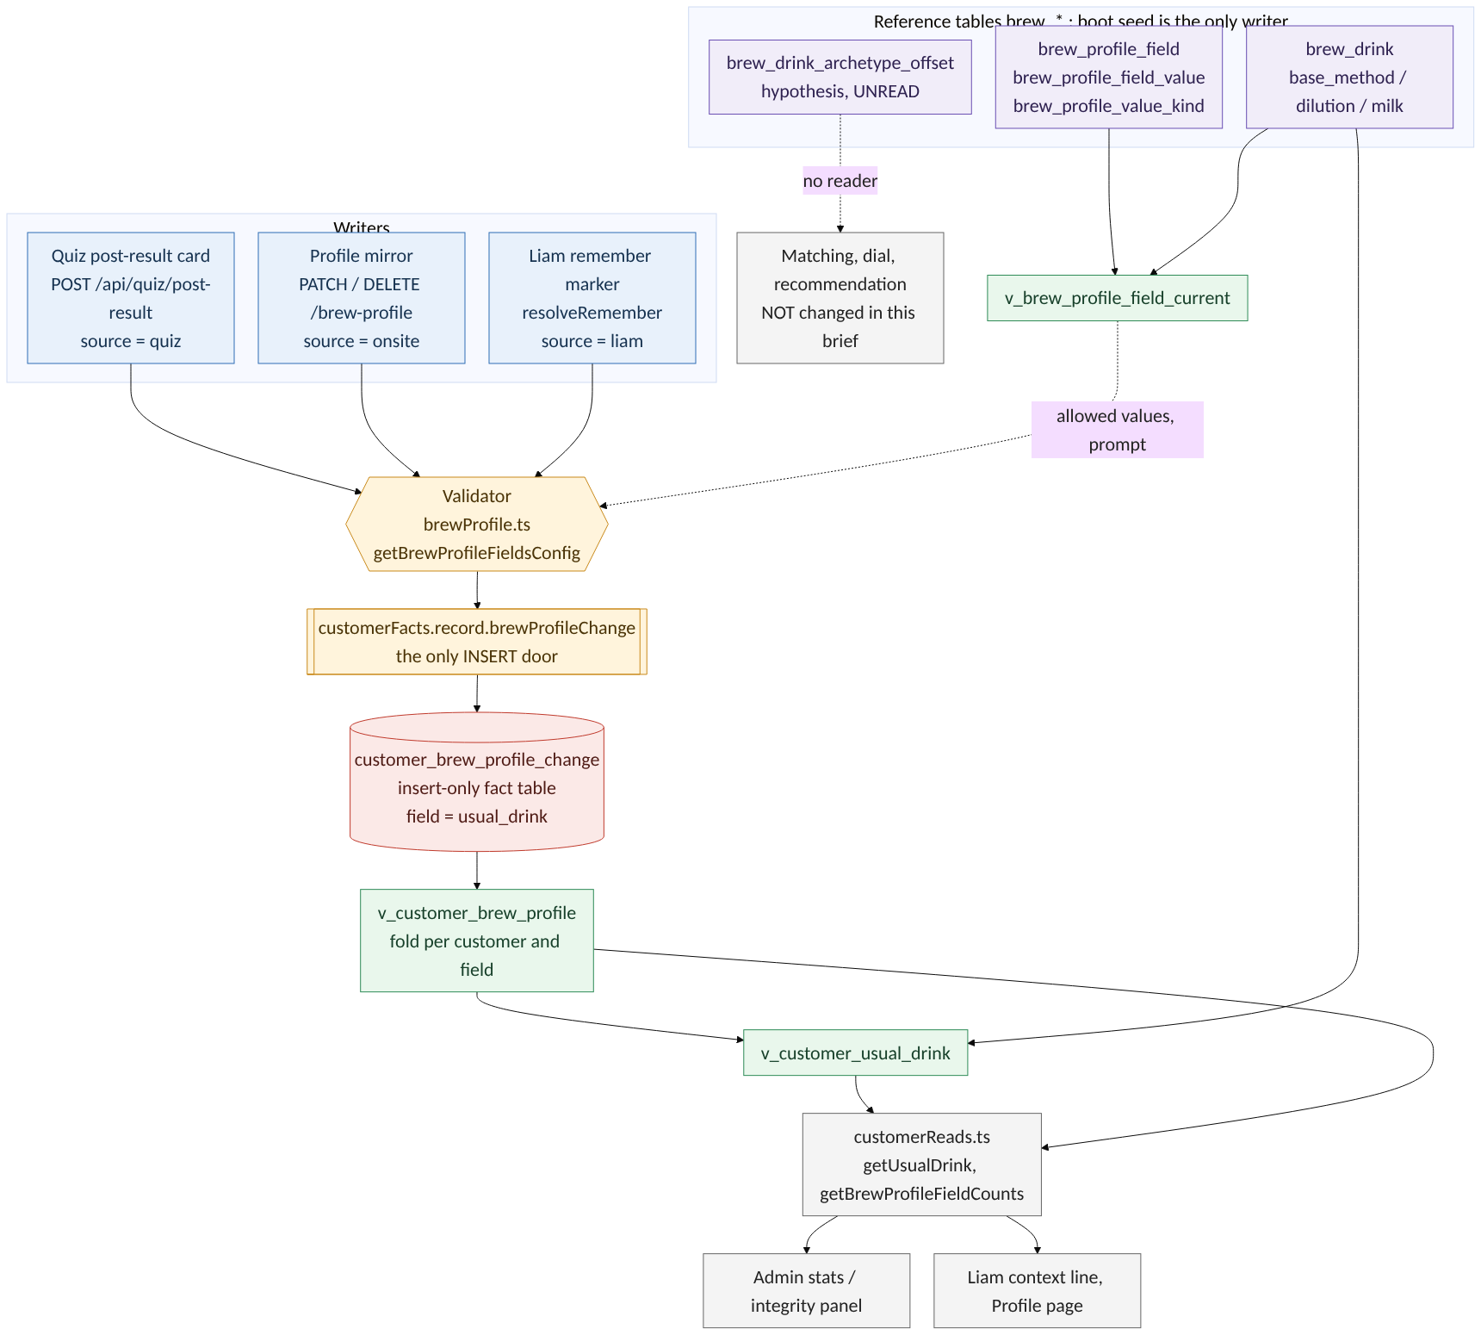
Figure 1. Writers, the single insert door, the fact table, views and readers for usual_drink. Dotted lines are read-only dependencies; the offset table has no reader.

2. Read first (in this order)
- backend/src/features/usual_drink/CLAUDE_CODE_PROMPT_USUAL_DRINK_1_CAPTURE.md (the brief).
- CLAUDE.md at the repo root (repo rules), OBSERVABILITY_POLICY.md, GAPS.md.
- backend/src/features/customer_blueprint/README.md and the C1–C3 briefs there: the fact-table discipline this brief must obey (insert-only door customerFacts.record.*, reads only through customerReads.ts and views, lint-customer.mjs rules 1–7, integrity checks in customerIntegrity.ts).
- backend/src/db/schema.sql: the brew-profile fact table (customer_brew_profile_change), v_customer_brew_profile and customer_brew_profile_fold(), the prefix-driven grant blocks near the end, quiz_funnel_event, evidence_parameter, coffee_dial_slot, coffee_archetype.
- backend/src/services/brewProfile.ts, customerFacts.ts, customerReads.ts, customerIntegrity.ts; backend/src/routes/users.ts (/brew-profile), routes/sommelier.ts (resolveRemember, getBrewProfile), routes/quiz.ts; backend/src/db/seeds/sommelier_config_seed.ts (brewProfile.fields).
- frontend/src/app/components/FlavorQuiz.tsx, frontend/src/app/components/profile/BrewProfileMirror.tsx.
- backend/scripts/lint-customer.mjs, backend/scripts/lint-catalog.mjs.
- Mode B only: CLOSING_REPORT_1.md, git log since the commit the report names, git diff <base>..HEAD --stat, WHAT_WE_BUILT_DB.md and CATALOG.md entries the report claims.

3. Fixed decisions
Do not re-open these. Flag only if the brief or the code contradicts them.
- Preparation never enters the quiz questions or changes the quiz result. Capture is post-result, optional.
- One field, usual_drink, the drink made at home most days, single value, from a lookup (brew_drink) that includes buy_out and other.
- Offset hypothesis is drink × archetype in brew_drink_archetype_offset, seeded as basis='hypothesis', and nothing reads it in this brief. Matching, the dial, Liam's recommendation and the profile line are unchanged.
- Field definitions move from Firestore config, a CHECK constraint and a TS union into tables (brew_profile_field, brew_profile_field_value, brew_profile_value_kind).
- Naming: customer_* only for insert-only facts; user_* per-user operating state; coffee_* catalog; operational brew-preparation reference data is brew_*. Per-customer derived reads stay v_customer_*.
- Repo rules: nothing hard coded (names, lists, thresholds, mappings live in tables); every table has a surrogate id PK, natural keys are UNIQUE; facts insert-only; no strict mode anywhere (checks report, never fail boot); COMMENT ON everything, CATALOG.md regenerated; no PR, Dana merges to main; push deploys.

4. What to check
Work through every item. For each, answer pass / fail / cannot tell, with file:line evidence. "Cannot tell" is a valid answer and must say what would settle it.

4.1 Writers and readers (the rules that matter most here)
- Every write of usual_drink (quiz card route, Profile PATCH/DELETE, Liam resolveRemember) goes through customerFacts.record.brewProfileChange. No other INSERT into customer_brew_profile_change. No UPDATE/DELETE on any fact table.
- v_brew_profile_field_current has exactly one reader function; the validator, mirror field list, quiz options endpoint and prompt builder all call it. No route SELECTs brew_drink or brew_profile_field directly.
- customer_* tables and v_customer_* views are read only from customerReads.ts (lint rule 4). The admin stats distribution goes through a customerReads function.
- The new lookup tables have no app writer: grants give ab_app SELECT only (explicit list; brew_card_view_event keeps its INSERT). Seeds are ON CONFLICT DO NOTHING.
- Firestore: no new write to any users/ path (lint rule 3); the brewProfile.fields key is retired from the seed and from the read path, and the brief/report removes it from the prod config doc with read-back.

4.2 Data integrity
- customer_brew_profile_change.field and quiz_funnel_event.event: CHECK replaced by FK to a lookup, DDL idempotent, pre-checks violators and never fails boot; backups of both tables with before/after row count + md5 (Mode B: the numbers are in the report and match).
- value encoding for usual_drink matches the existing writers (JSON string) so customer_brew_profile_fold() and the brew_drink join resolve. Mode B: a test proves it for all three writers.
- source_id for the quiz writer includes the value, so a changed answer on the same card is a new row and a resubmit is a no-op.
- Lookup rows are never deleted, only deactivated; views join regardless of is_active; only pickers filter to active.
- brew_drink_archetype_offset: partial unique index on current rows; a change is a new row that supersedes; seeds match D4 exactly (+1 only for water/ice-diluted drinks on the intensity-line archetypes, 0 elsewhere, no rows for buy_out/other). slot_offset comment states the sort_order direction found in Task 0.
- The new integrity checks (fields resolve, values resolve, offset rows well-formed, seed coverage, Firestore key absent, FK state, grants) exist, are informational, and appear on the admin panel.
- No inference: nothing derives usual_drink from takes_it/brew_methods (no backfill, no view, no prompt rule). Liam saves only a named drink or a full preparation.

4.3 Security and identity
- POST /api/quiz/post-result verifies the caller owns quiz_session.user_id (403 otherwise) and is rate-limited. Anonymous guests can use it; the Profile /brew-profile routes keep blockAnonymousAuth.
- Guest answers then signs up: v_customer_brew_profile folds across v_customer_identity. Mode B: the test-DB case exists and passes.
- Unknown field or value: dropped, counted in brew_profile.failures, never a 500.

4.4 Nothing hard coded
- Drink names, labels, the question text (brew_profile_field.prompt), allowed values, the Liam topic map, the funnel event names, cache TTL: all from tables or config, none as literals in code or components. List any literal you find with file:line.

4.5 Naming and catalog
- Every new table/column/view follows the prefix rule above and has id PK + UNIQUE natural key.
- COMMENT ON for each, in the Purpose | Class | Writer | Readers | Since format; Writer says boot seed (owner role) for lookups; Readers name the exact functions. CATALOG.md regenerated and consistent.
- New views sit outside the Customer Blueprint C3 block (lint rule 7).

4.6 Scope
- Anything in the brief (Mode A) or the diff (Mode B) that is not needed for capture: a matching change, a dial change, a Liam recommendation change, a new fact table, a backfill of usual_drink. Any of these is a finding.
- Anything missing that capture needs and the brief does not say. Say what and why.

4.7 Mode B only: the closing report
- Every Task 0 item answered with file:line; every deviation from the brief stated with a reason.
- Definition-of-done items each have evidence (command output, row counts, grep output for the unread offset table, test names).
- Prod smoke rows exist for the test user and are excluded from analysis.
- npm run lint:catalog && npm run lint:customer && npm test output included; pre-existing failure count unchanged and stated.

5. Output format
One markdown report, REVIEW_<A|B>_<yyyy-mm-dd>.md, printed in your reply (do not write files). Four sections:
- Verdict. One line from the table below, then one sentence why.
- Findings, ranked by severity, each as [S1|S2|S3] <one-line claim> followed by evidence (file:line or report section), what breaks if ignored, and the smallest fix.
- Checklist. Every item in section 4, each pass / fail (→ finding n) / cannot tell (needs X).
- Not findings. Anything you considered and judged fine where a reader might worry. Keep it short.
Verdicts
Mode | Verdict options
A, design review | ready to run / run after fixes / do not run
B, result review | done / done with follow-ups / not done
Severity
Level | Meaning
S1 | Data loss, drift, security, or a rule violation
S2 | Will cause a bug or a boot problem
S3 | Naming, docs, clarity
Do not propose new features, new workstreams or process. Do not restate the brief. If the brief and the repo disagree, the repo is the fact and the brief is wrong.

