Dana Chermesh ([dcr346@nyu.edu](mailto:dcr346@nyu.edu))

**Data Vis Class**

March 22, 2018

**HW2.1**

*Please identify a plot or visualization that are available through online media, or in printed materials, where:*

*1. It makes use of any of the data sets available on NYC Open Data, and*

*2. You believe that the visualization can be improved based on two or more of the plotting principles that we have discussed in class (i.e. the 4 principles for improving the vision, and the 5 principles for improving the understanding).*

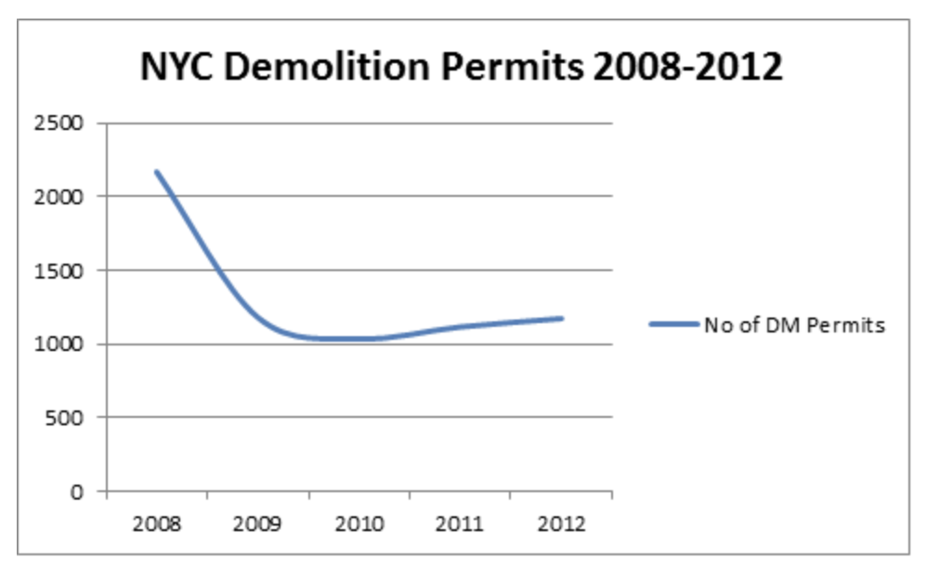* Retrieved from: [*https://www.propertyshark.com/Real-Estate-Reports/2013/02/26/nyc-demolition-permits-slowly-rising-new-building-permits-level/*](https://www.propertyshark.com/Real-Estate-Reports/2013/02/26/nyc-demolition-permits-slowly-rising-new-building-permits-level/)

** The plot makes use of [DOB permit issuance dataset](https://data.cityofnewyork.us/Housing-Development/DOB-Permit-Issuance/ipu4-2q9a/data), available through NYC open data. For reproducing the data, I will use 2013-2017 permits.

**Plot Critique:**

1. Firstly, it is not obvious whether the data is per day (and then the continuous line makes sense) or is it no. of demolition permits for each year (and then a *bar chart* would be more appropriate). I assume the latter is the case, which means the choice of a continuous line is not the best choice.
2. Second, the legend is on the right side + the title above all (with no y axis lines continuing) looks unproportioned / wrong. We should make the y axis lines more light-weighted and continue them for the whole width of the plot, making sure the legend and title are well positioned.
3. The x axis ticks should be above the year and not between every pair of years. Also, x label and y label are missing.

Link to the improved plot:

<https://jsbin.com/royewer/edit?css,js,console,output>

Screenshot:

