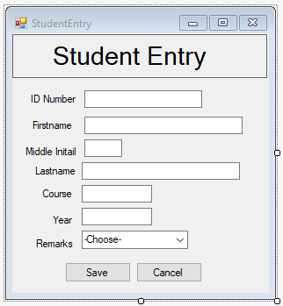

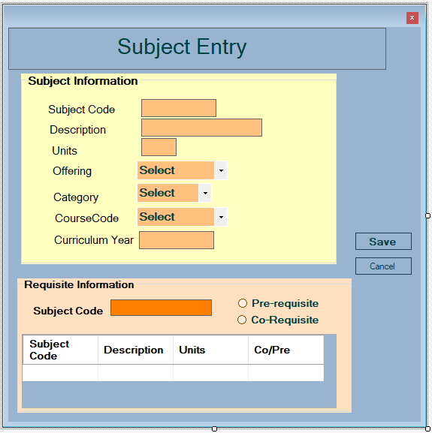

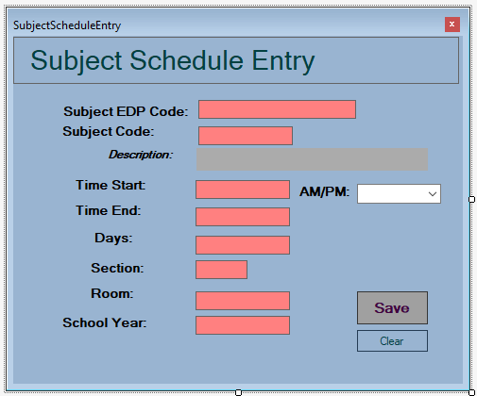

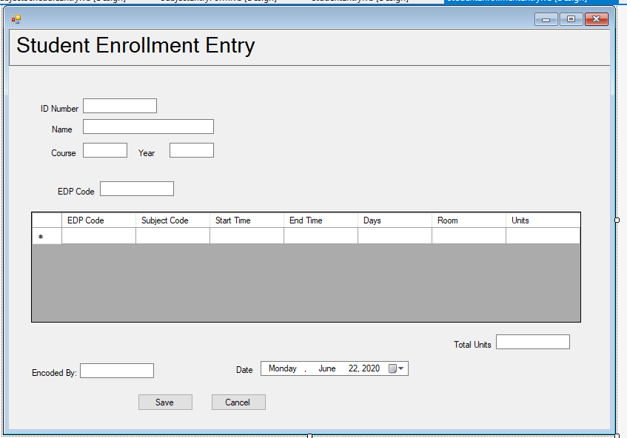

How to check your Subject Entry application.
- Preliminaries: Empty your SubjectFile and SubjectPreqFile tables.
- Set the connection string (path) properly to avoid runtime errors and point deductions.
- Run the Subject Entry program.
- Enter the following records one at a time in the Subject Information group.
Subject Code | Description | Units | Offering | Category | Course Code | Curriculum Year
ENGL1R | Grammar and Composition | 3 | 1 | LEC | IT | 2011
ENGL1 | Study and Thinking Skills | 3 | 1 | LEC | IT | 2011
FIL1D | Komunikayon sa Akademiyang Filipino | 3 | 1 | LEC | IT | 2011
ITFUND11 | IT Fundamentals with Productivity Tools | 3 | 1 | LEC | IT | 2011
ITFUND11L | IT Fundamentals with Productivity Tools Lab | 0 | 1 | LAB | IT | 2011
PSYCH1 | General Psychology | 3 | 1 | LEC | IT | 2011
COMPROG11 | Problem Solving and Programming 1 | 3 | 1 | LEC | IT | 2011
COMPROG11L | Problem Solving and Programming 1 LAB | 0 | 1 | LAB | IT | 2011
RIZAL | Life and Works of Dr. Jose Rizal | 3 | 1 | LEC | IT | 2011
PE1 | Self-Testing Activities | 2 | 1 | LEC | IT | 2011
NSTP | National Service Training Program | 3 | 1 | LEC | IT | 2011
ACCTG1C | Accounting Principles | 3 | 1 | LEC | IT | 2011
DBSYS31 | Database Systems 1 | 3 | 1 | LEC | IT | 2011
DBSYS31 | Database Systems 1LAB | 0 | 1 | LAB | IT | 2011
- Save the record. (2 points). _____
Expected Output: Message-> Entries Recorded.
Is there a runtime error occurred during saving? ________. If NO, proceed to Step 6.
If yes please specify the error: _______________________________________________. Proceed to Step 8.
- Go to the database and open the SubjectFile table.
- List the data found in the SubjectFile table. Tablenames and fieldnames must be strictly followed. Any deviations are automatically given no credits/points.
Expected Output: (10 points).__________
SFSUBJCODE | SFSUBJDESC | SFSUBJUNITS | SFSUBJREGOFRNG | SFSUBJCATEGORY | SFSUBJCOURSECODE | SFSUBJSTATUS | SFSUBJCURRCODE
 |  |  |  |  |  | AC
 |  |  |  |  |  | AC
 |  |  |  |  |  | AC
 |  |  |  |  |  | AC
 |  |  |  |  |  | AC
 |  |  |  |  |  | AC
 |  |  |  |  |  | AC
 |  |  |  |  |  | AC
 |  |  |  |  |  | AC
 |  |  |  |  |  | AC
 |  |  |  |  |  | AC
 |  |  |  |  |  | AC
 |  |  |  |  |  | AC
 |  |  |  |  |  | AC
- Stop the application.
- Rerun the application.
- Re-enter the first record.
- Click the Save button. (2 points). _______
Expected Output: Message -> Duplicate entries found!
- Click Clear/Cancel button. (2 point). _______
Expected Output: Clears all the data in the textboxes on the form. Data should not be recorded in the table.
- Click the Save button. (2 points). _______
Expected Output: Message-> Some fields are missing!
- Stop the application.
- Rerun the application.
- Enter the following new data in the Subject Information group:
Subject Code | Description | Units | Offering | Category | Course Code | Curriculum Year
AIS32 | Accounting Information Systems | 3 | 1 | LEC | IT | 2011
- Enter the following data in Requisite Information group.
Requisite Subject Code | Description | Units | Category
ACCTG1C | Accounting Principles | 3 | PR
DBSYS31 | Database Systems 1 | 3 | PR
- Input ACCTG1C subject code and press the Enter key. (2 points). ______
Expected Output: Message-> Subject Code already In the Grid (or any activities performed for duplicate values in the grid like override the subject code in the grid)
- Click the Save button. (2 points). ________
Expected Output: Message-> Entries Recorded.
Is there a runtime error occurred during saving? ________. If NO, proceed to Step 20.
If YES, please specify the error: _______________________________________________. Proceed to Step 27.
- Repeat Steps 14 to 15 using your own data from the prospectus.
Subject Code | Description | Units | Offering | Category | Course Code | Curriculum Year

Requisite Subject Code | Description | Units | Category

- Go to the ENROLLMENT database. Open the SubjectFile table.
- List the newly added record. Table names and field names must be strictly followed. Any deviations will not earn credits.
Expected Output. (5 points)
SFSUBJCODE | SFSUBJDESC | SFSUBJUNITS | SFSUBJREGOFRNG | SFSUBJCATEGORY | SFSUBJCOURSECODE | SFSUBJSTATUS | SFSUBJCURRCODE
 |  |  |  |  |  | AC
 |  |  |  |  |  | AC
- Open the SubjectPreqFile table.
- List the records found in the table.
Expected Output. (3 points)
SUBJCODE | SUBJPRECODE | SUBJCATEGORY
- Stop the application.
- Rerun the application.
- Enter the following data in the Subject Information group:
Subject Code | Description | Units | Offering | Category | Course Code | Curriculum Year
ENGL1R | Grammar and Composition | 3 | 1 | LEC | IS | 2011

- Click the Save button. (2 points).
Expected Output: Message-> Entries Recorded.
Is there a runtime error occurred during saving? ________.
If yes please specify the error: _______________________________________________.

- Go to the SubjectFile table. List the new data found.(2 points)
SFSUBJCODE | SFSUBJDESC | SFSUBJUNITS | SFSUBJREGOFRNG | SFSUBJCATEGORY | SFSUBJCOURSECODE | SFSUBJSTATUS | SFSUBJCURRCODE
 |  |  |  |  |  | AC
 |  |  |  |  |  | AC

- Click the Clear button.
- Enter new date into the Requisite Information group leaving the Subject Information textboxes empty.
- Click Save. (3 points). ________
Expected Output: Message-> Error! Data Discrepancy.
Is there a runtime error occurred during saving? ________.
If yes please specify the error: _______________________________________________.
- Click the Clear/Cancel button.
- Fill in the Subject Information with the values from Step 16 and 17.
- Click the Save Button.(2 points)
Expected Output: Message-> Error! Duplicate Entries found!
Is there a runtime error occurred during saving? ________.
If yes please specify the error: _______________________________________________.
- Stop the application.
- User Interface aesthetics/Presentable UI. (2 points). _______
- Use of Tabs for easy navigation. Insertion Point is in the right focus. (2 points). _____

