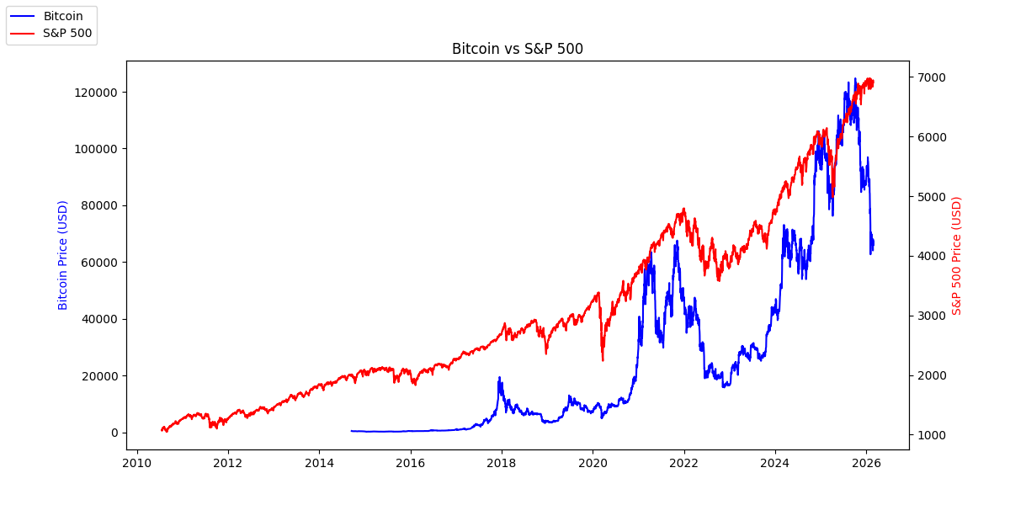
Five why’s?
- The correlation of S&P 500 and BTC from the years of 2010-Present is 0.23. Very low.
- Why? It's low because we are comparing data from multiple years, rather than from specific cycles? if we compare and attempt to correlate within those cycles we can probably find higher correlations or answers that can help us make investment decisions.
- Rolling Correlation – Correlation is not static, it changes depending on the market cycle you’re in.
- Why? would the correlation be higher within specific cycles than across all years? no one believed in crypto early on, and no one knew what it would be. After, policies were created around it, we had major companies invest in it, and institutions, we now have trading platforms for it, and we have people in tech as well.
- Institutional adoption – this is the key to understanding why the correlation changed over time. Those that bought BTC are people like BlackRock, fidelity, microstrategy, tesla. Those institutions own S&P 500. So, when they panic and sell, they sell everything together.
- Why? Why does it matter for investment decisions to know When the correlation is high vs low? well one if you own those two investments, you probably want to know when you should buy more of each if it's long term you are looking towards, or sell depending where in the cycle for crypto, in a way if they are in different correlations you could also plan financially and if you know what's going to come next you can predict and either save yourself from losing, or missing the opportunity to gain more? if I had these numbers this is what i would want to know.
"If they're uncorrelated during calm periods" → you can hold both and reduce overall portfolio risk. When one zigs the other zags. That's diversification.
"Know when to buy more during cycles" → that's cycle timing strategy. Buying Bitcoin during crypto winter while stocks are stable.
"Predict and save yourself from losing" → that's risk management. Knowing correlation spikes during crises means you can prepare before the panic hits.
"Missing the opportunity to gain" → that's asymmetric opportunity. Using one market's signal to time entry into another.
- This is my value proposition of my project. README intro.
- Why? Why don’t most regular investors have access to this kind of analysis. they don't have access to it becuase platforms for trading are either specific to crypto or stock, or if they do both they still separate them so it's harder to see correlations or patterns?
- The gap isn't intelligence. The gap isn't access to data. The gap is that no platform shows you the full picture in one place.
- Why? Why does it matter that regular investors can’t see these correlations? because when you can't see both pictures, then you don't make informed decisions and you lose everything like in 2022.

What my 5 why’s built
Why 1: Low correlation because we're looking across all years instead of specific cycles
Why 2: Cycles changed because institutional money entered crypto and connected it to traditional markets
Why 3: Knowing when correlation is high vs low helps investors time buying, selling and protect themselves
Why 4: Regular investors can't see this because platforms deliberately separate crypto and stocks
Why 5: When you can't see the full picture you make uninformed decisions and lose everything like 2022

Correlations run between -1 to +1
+1.0 = Perfect twins, they move together.
0.0 = Strangers, zero relationship.
-1.0 = Opposites, when bitcoin goes up, the other goes down. Perfect opposites.

0.0 - 0.3 – weak
0.3 - 0.6 – moderate
0.6 - 0.8 – strong
0.8 - 1.0 – very strong

S&P 500 – 2010-present – 0.23
S&P 500 – 2020-present – 0.38
Dow Jones – 2020-present – 0.35
NASDAQ – 2020-present – 0.41
NASDAQ highest – tech investors and crypto investors are the same people
Dow Jones middle – Some overlap but older industries dilute the relationship
S&P 500 lowest – dragged down by pre-institutional era data before 2020.

