Predicting Short-Form Video Addiction Using Machine Learning

By:
ID | Name
445008600 | Lama Abdulaziz Alrashidi
445008558 | Danah Yousef Almansour
445008609 | Lama Hameed Alanazi
445008543 | Jinan Mahdi Alanazi
445008567 | Hana Sulaiman Alsalman

Section: 62S

Table of Contents
1. Problem Statement 3
2. Project Aim & Objectives 3
3. Methodology 3
4. AI Ethics 5
5. Dataset Description 5
6. Exploratory Data Analysis 6
7. Model Selection 6
8. Model Estimation 7
9. Model Evaluation 8
10. Deployment 12
11. Conclusion 15
References 16
Appendices 17

Problem Statement
With the rapid growth of short-form video platforms such as TikTok, Instagram Reels, and YouTube Shorts, excessive usage has become a significant issue affecting users’ daily lives. Many individuals spend extended hours watching short videos, frequently opening these applications and losing track of time, which may lead to addictive behavior. However, there is a lack of data-driven analysis to understand which behavioral factors contribute most to this excessive usage. Without this understanding, it is difficult to identify users at risk or propose effective solutions. Therefore, this project aims to analyze user behavior data and develop a classification model that can predict the level of short-video usage or addiction based on different behavioral features.

Project Aim & Objectives
  - Project Aim
The aim of this project is to develop a machine learning model that can predict the level of short-video usage or potential addiction based on user behavior data collected through a survey.

  - Project Objectives
- To analyze user behavior related to short-video usage.
- To identify the key factors influencing excessive usage and potential addiction.
- To ensure the dataset is properly structured and ready for modeling.
- To build and compare multiple classification models.
- To evaluate model performance using metrics such as accuracy, precision, recall, and F1-score.
- To improve model performance using techniques such as parameter tuning.

Methodology
This project follows the Machine Learning lifecycle based on the CRISP-DM methodology[6].
- Problem Specification
The project aims to analyse and predict short video addiction based on user behaviour and usage patterns collected through a survey. The goal is to classify users according to their level of addiction.
- Data Understanding
The dataset contains 215 survey responses and includes demographic and behavioural features such as gender, age_group,daily_hours, open_freq, reduce_try, time_loss, hard_stop, long_vid_bored, escape_use and sleep_impact. These variables help identify patterns related to excessive usage.
- Data Preparation
The dataset was prepared by removing irrelevant features such as the Timestamp column, converting categorical variables into numerical values, checking for missing or inconsistent data, and ensuring the dataset is suitable for machine learning modelling .
- Modelling
Multiple machine learning models were implemented to improve prediction performance and allow comparison:
• Logistic Regression was used as a baseline model to provide an initial understanding of the dataset
• Support Vector Machine (SVM) with Grid Search was applied to optimize hyperparameters and improve performance
• Random Forest was used as an advanced model to enhance accuracy and reduce overfitting
Using multiple models ensures robustness and allows for fair comparison in selecting the optimal model
- Model Evaluation
The models were evaluated using accuracy, precision, recall, and F1-score. Training and testing accuracy were compared to detect overfitting or underfitting. The results showed that SVM achieved the most balanced performance and was selected as the final model.
- Deployment and Monitoring
The selected model was deployed using Streamlit to create an interactive web application. Users can enter their behavioral data, and the system predicts the addiction level in real time. Future improvements include collecting more data, adding new behavioral features, testing advanced models, and improving the application interface to enhance user experience.

AI Ethics
In this project, AI ethics were considered during data preprocessing to ensure data quality and reliable results. The dataset was checked for missing values and duplicates, and none were found. Data types were verified for consistency, and irrelevant features such as the “Timestamp” column were removed. Since most variables are categorical, no significant outliers were detected. These steps help ensure the dataset is clean and suitable for building a reliable machine learning model.

Dataset Description
Resource: The dataset was specifically collected for this project through a structured online survey. The survey was designed to target users of short-form video platforms (such as TikTok, Instagram Reels, and YouTube Shorts) to capture real-world behavioral patterns.
Size: The dataset consists of 11 features (columns) and currently contains 215 responses. Each row represents an individual user's response to the survey questions.
Features: The features consist of a mix of demographic, usage-based, and psychological-behavioral attributes:
- gender: Categorical (Male, Female).
- age_group: Ordinal categorical (e.g., 18-22, 23-27, etc.).
- daily_hours: Numerical/Ordinal representing the duration of daily consumption.
- open_freq: Numerical/Ordinal measuring how many times apps are opened per hour.
- reduce_try: Categorical (Yes/No) regarding whether the user tried to limit usage.
- time_loss: Behavioral metric measuring the loss of track of time during scrolling.
- hard_stop: Measures difficulty in stopping even when urgent tasks are present.
- long_vid_bored: Measures annoyance with long-form content (>10 mins).
- escape_use: Evaluates usage of short videos to escape stress or boredom.
- sleep_impact: Measures the effect of usage on sleep quality or bedtime.
Target: The Target variable is a categorical label representing the Short-Video Addiction Level. It is classified into three levels:
- 0 (Low/No Addiction): Minimal impact on daily life.
- 1 (Moderate Addiction): Noticeable behavioral shifts and frequent usage.
- 2 (High Addiction): Significant disruption to sleep, tasks, and time management.

Exploratory Data Analysis
The dataset was prepared carefully before applying any machine learning techniques to ensure its quality and consistency. Initially, the data was explored using functions such as info(), describe(), and head() to understand its structure and data types. The dataset was checked for missing values using isnull().sum(), and no missing values were found. Duplicate records were also examined using duplicated().sum(), and no duplicates were identified, confirming that all entries are unique. Outliers were analyzed using boxplot visualization; however, since the data consists of predefined categorical responses encoded as numerical values within fixed ranges (e.g., 0–3), no significant outliers were detected. During the data cleaning stage, column names were standardized by removing extra spaces, and the "timestamp" column was removed as it is not relevant for analysis or prediction. After completing the preprocessing steps, the dataset became clean and ready for analysis, as shown in Figure 6.1.
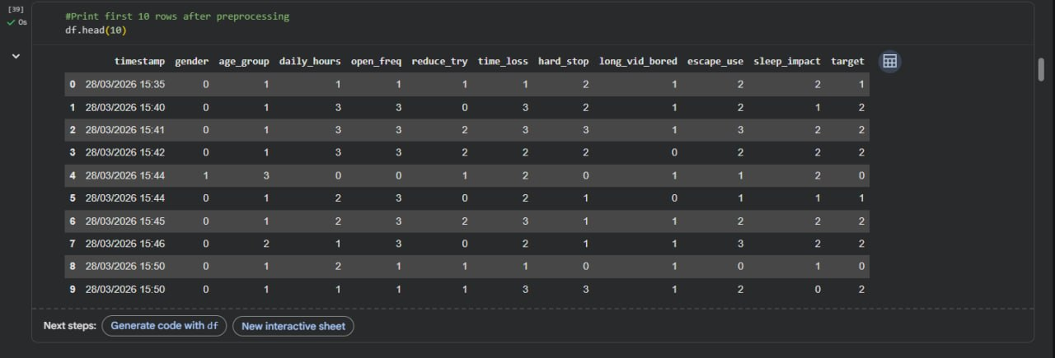
Figure 6.1: First 10 rows of the cleaned dataset.

Model Selection
we chose three different models to see which one works best for predicting addiction levels. We will start with a basic Logistic Regression to get a baseline score, and then moved on to more advanced models like SVM and Random Forest. This way, we can compare how simple models perform against more complex ones when dealing with our survey data.

Model 1: Logistic Regression
- Reason for Selection: Logistic Regression is a fundamental classification algorithm used to establish a performance baseline. Based on our initial data review, we want to determine if there are linear relationships between usage habits (like daily hours) and addiction levels. It provides a simple, interpretable benchmark to measure the added value of more complex models. [1]

Model 2: Support Vector Machine (SVM) with GridSearchCV
- Reason for Selection: SVM is highly effective for datasets with high-dimensional features, such as our 11 behavioral attributes. It works by finding the optimal hyperplane that maximizes the margin between different addiction classes. Because behavioral data can be noisy, we use GridSearchCV to automatically tune hyperparameters, ensuring the model is mathematically optimized for our specific distribution. [2] [3]

Model 3: Random Forest (Ensemble Learning)
- Reason for Selection: Random Forest is an ensemble method that builds multiple decision trees and merges their results. This model is specifically chosen because survey data often contains complex, non-linear human behaviors (e.g., the interaction between sleep impact and escapism). Random Forest is robust against overfitting and is widely recognized in behavioral research for providing the highest accuracy in classification tasks. [4]

Model Estimation
The dataset was divided into two parts: training set and testing set.
80% of the data was used for training the models, and 20% was used for testing.
Three machine learning models were built to solve the problem:
- Logistic Regression
- Support Vector Machine (SVM)
- Random Forest
Each model was trained using the training data (X_train, y_train). After training, predictions were made on both training and testing datasets to evaluate performance.
The evaluation was based on comparing the training accuracy and testing accuracy to understand how well each model performs. [5]

Model Evaluation
- The models were evaluated using their default parameters.
The performance of each model was measured using training and testing accuracy.
The Logistic Regression model performance is shown in Figure 9.1. The model achieved a training accuracy of 1.00 and a testing accuracy of 0.953. This indicates that the model learned the training data very well and also performed strongly on unseen data. Although the training accuracy is perfect, the small difference between training and testing accuracy suggests that the model does not suffer from significant overfitting.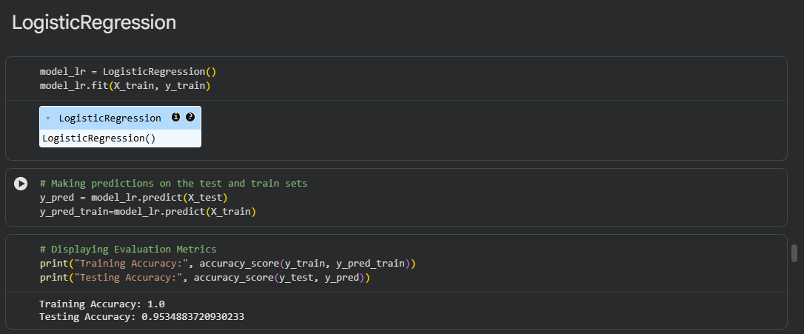
Figure 9.1: Logistic Regression model training and testing accuracy.

The SVM model performance is shown in Figure 9.2. The model achieved a training accuracy of 0.9884 and a testing accuracy of 0.9535. The results show that the training and testing performance are very close, indicating that the model generalizes well and does not suffer from overfitting or underfitting.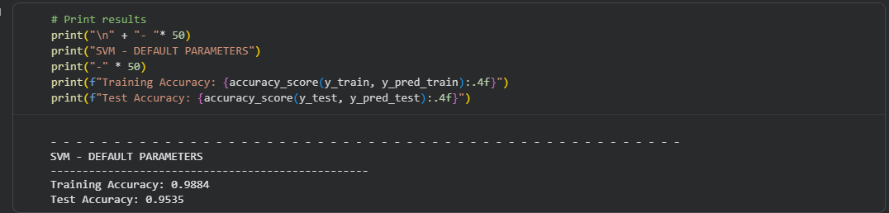
Figure 9.2: SVM model training and testing accuracy.

The Random Forest model performance is shown in Figure 9.3. The model achieved a training accuracy of 0.9884 and a testing accuracy of 0.9535. This indicates strong performance on both training and testing data. However, the slightly higher training accuracy may suggest a small level of overfitting, but it is still acceptable.

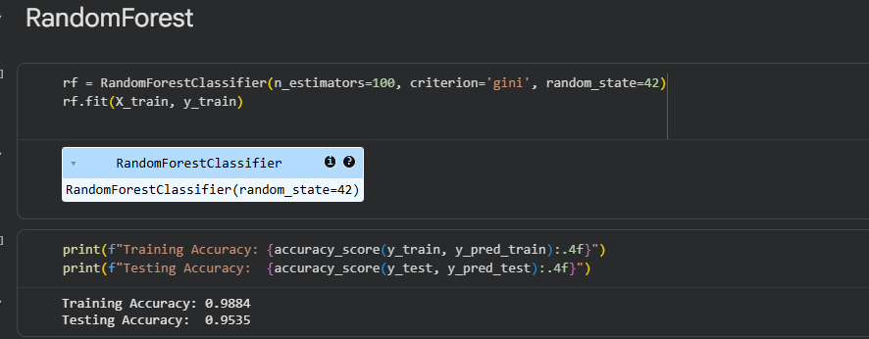
Figure 9.3: Random Forest model training and testing accuracy.

The performance comparison of the models is shown in Table 9.4.
ML Algorithms | Models’ Performance
 | Accuracy | Precision | Recall | F1-Score
Logistic Regression | 0.95 | 0.96 | 0.95 | 0.95
SVM | 0.95 | 0.96 | 0.95 | 0.95
Random Forest | 0.91 | 0.93 | 0.91 | 0.91
Table 9.4. Performance Comparison of Machine Learning Models
SVM was selected as the best model because it showed more balanced training and testing performance.

- To improve model performance, GridSearchCV was used to tune the hyperparameters of the SVM model. Different parameter combinations were tested to find the best configuration

The hyperparameter tuning results are shown in Figure 9.5.
Figure 9.5: SVM hyperparameter tuning using GridSearchCV showing best score and parameters.

After trying different values using GridSearchCV, the best combination we got was:
- C = 100
- gamma = 0.01
The best score was around 0.93.
This means that these values gave the model the best performance compared to the other combinations we tested. It also shows that changing the parameters can help improve the model results.

c. Compare their performance using default parameter values and after tuning some parameters. The comparison of the SVM model performance before and after tuning is shown in Figures 9.6 and 9.7. Before tuning, the model achieved a testing accuracy of 0.9535, while after tuning, the accuracy became 0.9534. The difference between the two results is very small, indicating that tuning did not significantly improve the model performance. This may be because the model was already performing well before tuning.
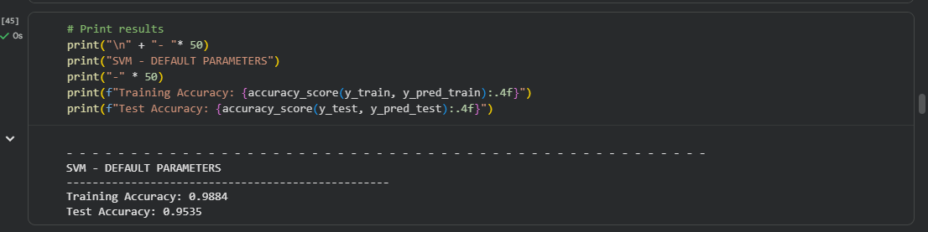
Figure 9.6: SVM model performance before tuning.

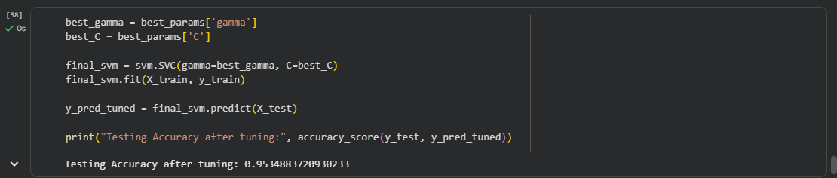
Figure 9.7: SVM model performance after tuning.

The difference between the results is very small, indicating that tuning did not significantly improve performance. However, it helped in identifying the best parameter values.

d. To check if the models suffer from underfitting or overfitting, we compared the training accuracy with the testing accuracy for each model.
Logistic Regression:
The training accuracy was 1.00, while the testing accuracy was 0.953. This shows a small gap between the two values, which may indicate slight overfitting, but it is not a serious issue.
SVM:
The training accuracy was 0.9884 and the testing accuracy was 0.9535. The results are very close, indicating that the model is well balanced and does not suffer from underfitting or overfitting.
Random Forest:
The training accuracy was 0.9884, while the testing accuracy was 0.9535. The difference between the two values is relatively small, indicating slight overfitting, but the model still generalizes well.

Overall, SVM performed the best in terms of balance, while Random Forest showed slightly more signs of overfitting. Therefore, SVM was chosen as the final model due to its stronger generalization ability, not because it had the highest accuracy score.

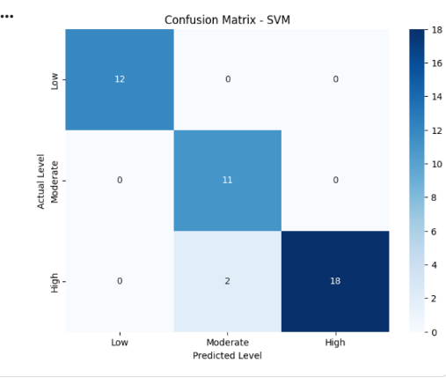
The confusion matrix of the selected best-generalizing model (SVM) is shown in Figure 9.8. Although Random Forest achieved slightly higher accuracy, SVM was selected because it provided a better balance between training and testing performance.

Figure 9.8. Confusion Matrix for the Best-Generalizing SVM Model

Deployment
The machine learning model was deployed using Streamlit to create an interactive web application. The project file structure used for deployment is shown in Figure 10.1. The structure includes the main application file (app.py), the trained model file (model.pkl), the requirements file (requirements.txt), and a README file. This simple structure ensures easy execution and deployment of the application.
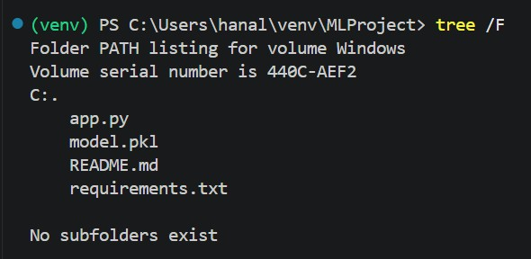
Figure 10.1: Project file structure for Streamlit deployment.

The Streamlit application provides a simple and user-friendly interface that allows users to input their personal and behavioral data related to short-video usage. The interface is designed to be intuitive so that even non-technical users can easily interact with the system.
The main widgets used in the application are selectbox widgets, which allow users to choose predefined values for each feature. These inputs include gender, age group, daily watching hours, frequency of app usage, attempts to reduce usage, time awareness, difficulty in stopping, boredom with long videos, usage for escaping stress, and sleep impact.
A button widget ("Predict") is used to trigger the prediction process. Once clicked, the application converts the selected inputs into numerical values that match the format used during model training. The trained model is then loaded using the pickle library, and a prediction is generated in real-time.
The result is displayed clearly under the “Prediction Result” section, where the user is classified into one of three categories: Not Addicted, At Risk, or Addicted. The output is presented using visual indicators such as colored messages to improve readability and enhance the user experience.
The use of interactive widgets enhances user engagement and allows users to interact with the machine learning model without requiring any programming knowledge. This demonstrates how machine learning models can be successfully integrated into real-world applications.
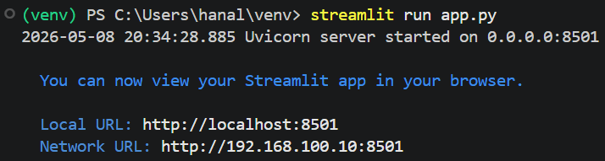
The process of running the application locally is shown in Figure 10.2.

Figure 10.2: Running the Streamlit application locally.

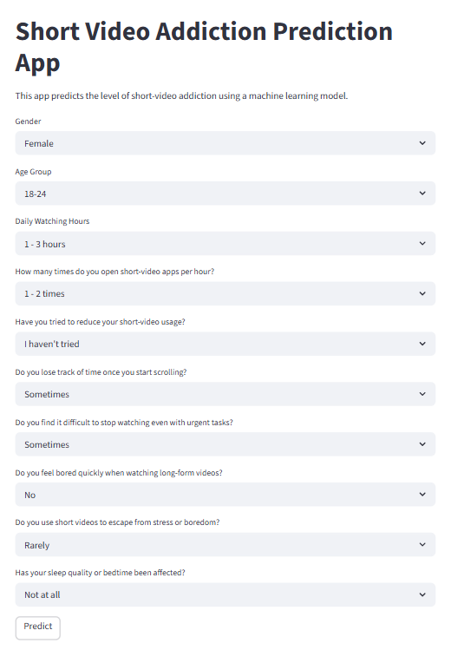
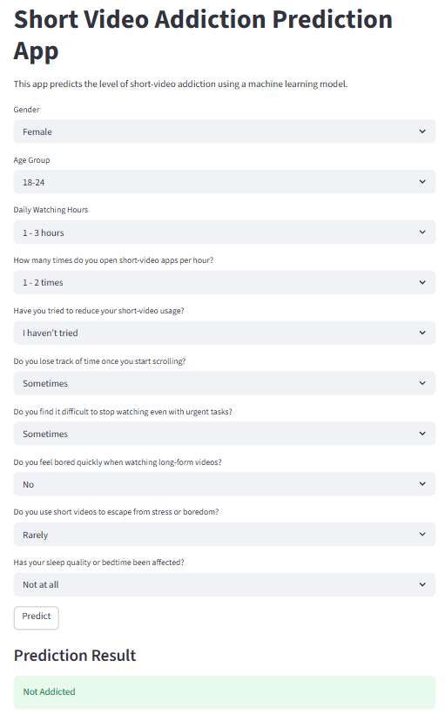
The Streamlit application interface before and after prediction is shown in Figure 10.3.
Figure 10.3: Streamlit application interface before and after prediction.

Conclusion
In this project, we developed a machine learning system to predict the level of short-video addiction based on user behavior data collected from a survey. The dataset included different features such as daily usage time, app opening frequency, sleep impact, and other behavioral factors that help explain how users interact with short-video platforms.
We applied three different models: Logistic Regression, Support Vector Machine (SVM), and Random Forest. The results showed that all models performed well, with testing accuracy around 95%. Although all models performed well, SVM showed the most balanced performance and better generalization ability. Therefore, SVM was selected as the final model due to its stronger generalization capability.
From the evaluation, we also observed that Logistic Regression showed slight signs of overfitting due to its perfect training accuracy, while Random Forest showed slight signs of overfitting. On the other hand, SVM was the most stable model and generalized well to unseen data.
This project can benefit the community by helping users understand their behavior and recognize early signs of short-video addiction. It can also be used as a tool to raise awareness and support better digital habits, especially for younger users who are more affected by excessive screen time.
For future work, the project can be improved by collecting a larger and more diverse dataset, adding more features such as psychological or social factors, and testing more advanced machine learning or deep learning models. In addition, the application can be enhanced by improving the user interface and adding more interactive features to provide personalized recommendations

References

[1] | C. Molnar, "Interpretable Machine Learning - Logistic Regression," GitHub Pages, 2022. [Online]. Available: https://christophm.github.io/interpretable-ml-book/logistic.html. [Accessed 9 5 2026].
[2] | C. Cortes and V. Vapnik, "Support-Vector Networks," Springer, 1995. [Online]. Available: https://link.springer.com/article/10.1007/BF00994018?. [Accessed 9 5 2026].
[3] | Scikit-learn Developers, "GridSearchCV," Scikit-learn, 2025. [Online]. Available: https://scikit-learn.org/stable/modules/generated/sklearn.model_selection.GridSearchCV.html. [Accessed 9 5 2026].
[4] | L. Breiman, "Random Forests," Springer, 2001. [Online]. Available: https://link.springer.com/article/10.1023/A:1010933404324?. [Accessed 9 5 2026].
[5] | J. Brownlee, "Train-Test Split for Evaluating Machine Learning Algorithms," Machine Learning Mastery, 26 8 2020. [Online]. Available: https://machinelearningmastery.com/train-test-split-for-evaluating-machine-learning-algorithms/. [Accessed 9 5 2026].

Appendices

Appendix A: Short-Video Behavior Survey
This appendix includes the link to the online survey used for data collection in this project:
https://docs.google.com/forms/d/e/1FAIpQLSc-8Ij886ydHxGx0jqPz86RYBaEDd3z7miURHeEfpPN4vY0tw/viewform?usp=sharing&ouid=114928005617559060379

Appendix B: Streamlit Application Link
This appendix includes the link to the deployed Streamlit application used in this project: https://short-video-addiction-app-h23k2xrlcqk4mlqmjbqenu.streamlit.app/

