**Comfort Home**

**System Design Document**

**Class:** T-CB2 Group 7

**Members:**

* Omar Shekho, SN
* Danail, SN 3781496
* Ilian Stoev, SN
* Viktor Rumenov, SN

**Hardware components used**

* EMbedded board - STM Nucleo64
* Ventilation box - simulated in C# on a computer
* Airios shield including:

1. CO2 sensor - CM1106H
2. VOC sensor - SPS30
3. Temperature and humidity sensor - Sensirion SHT20x
4. ZigBee module

**Wiring diagrams**

**System Context Diagram**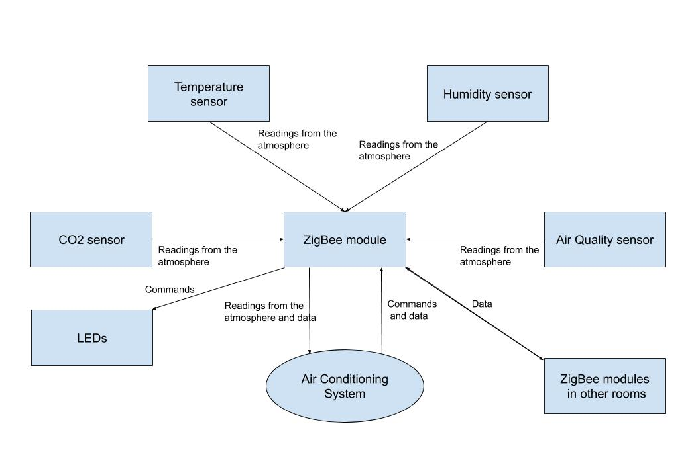

*Figure 1: System Context Diagram*

**System Architecture Diagram**

**State diagram**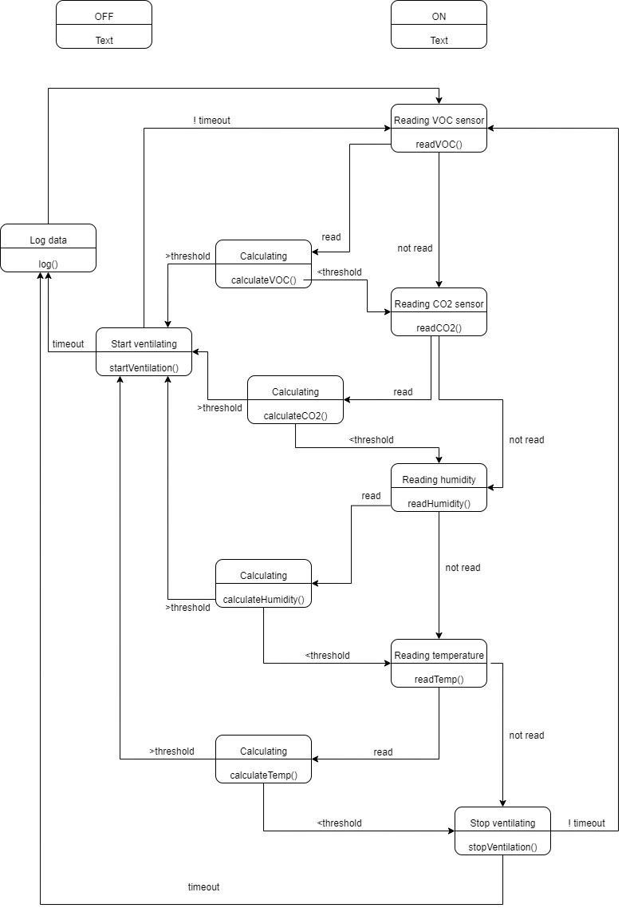

**Communication Protocols:**

Both UART and I2C communication protocols will be used in the system depending on each sensor. The syntax of the protocol used with ZigBee to communicate with other systems will be defined later on with other groups.

**Control Flow Chart**

