Robot swarm project

A project about making an autonomous robot

Fontys University of Applied Sciences

Stefan Teeuwen, Kevin Vissenberg and Danail Georgiev

Table of Contents

Introduction 2

Requirements 2

Components 2

Research 2

Findings 3

Implementation 3

Servo motors implementation 3

Ultrasonic sound implementation 3

Caveats 3

Testing 3

Recommendations 3

Role division 4

Challenges 4

Conclusions 4

# Introduction

The robot follows a pre-programmed route without human help. This document explains how we are going to achieve this.

# Requirements

The basic requirements are as follows:

* Robot will move straight forward until it reaches the end of the allowed field of the movement.
* Robot will move straight forward until it encounters an obstacle at 10 centimetres distance.
* Robot will change its movement direction randomly if it encounters an obstacle
* The robot will send its distance of the nearest obstacles in centimetres to a dashboard
* The robot will send its current speed to the dashboard

There are also optional functionalities which can be implemented when all basic requirements are fulfilled:

* Using multithreading to run the control of the ultrasonic sensor and motors in different threads
* Smoothly decrease the robot’s speed when an obstacle is near
* Keep the initial speed when the robot is more than 10 centimetres from an obstacle
* Using odometry to estimate change in position of the robot
* Enhancing the dashboard with additional data
* Integrate information of multiple robots in one dashboard

# Components

This project consists of multiple sensors, which are:

The basic requirements can be programmed with the following sensors:

* HC-SR04 ultrasonic sensor to measure distance to other objects
* 360 degree servo motors for spinning the wheels

The optional functionalities can be made with the following sensors:

* Accelerometer to measure proper acceleration
* 360 degree servo motors for spinning the wheels
* Gyroscope for measuring or maintaining orientation and angular velocity

# Research

The project group will use the teacher’s explanation and online research as sources. These online resources consists mostly of datasheets and websites of the manufactures about the different sensors.

# Findings

The main part of the project consist of coding the wheels. Our findings are that the wheels are not difficult to program. In addition, programming the ultrasonic sensor is quite simple. However, we found that using the STM32 Cube IDE was difficult to use, as it has a lot of buttons and functionalities. Although this is nice for advanced developers, we found that these functionalities can cause confusion.

# Implementation

## Servo motors implementation

The servo motor has a feedback pin, which was used to measure the speed of the robot. The feedback pin returns a PWM signal whose duty cycle corresponds to a wheel angle. The servo’s are also used in combination with the ultrasonic sensor to change to a random direction when an obstacle is near.

## Ultrasonic sound implementation

The ultrasonic sound measures on its own. It only requires a timed measuring pulse, but returns a wave which is easy to parse. By measuring the time the line has been kept HIGH by the sensor we can determine the distance to an object. The sensor is polled at an interval and the value is compared to a threshold value. The wheels are programmed to make a turn to a random direction when the distance becomes lower than the threshold.

# Caveats

The main caveat is the power supply, as the robot will stop working once the power supply is empty. Another caveat is that the robot doesn’t know where to go once an obstacle is neared. This can cause the robot to drive to the same obstacle multiple times over an extended period of time.

# Testing

Each individual component is tested before assembling. This was done by uploading and running code for each specific component and checking if it would output correct values. Then, all parts were assembled and code was combined and ran in order to test if the robot would output the correct behaviour as specified by the requirements.

# Recommendations

The easiest approach to this project is to program all components individually and then to combine everything. The robot can be powered by an external power supply.

# Role division

Everyone has their part in the project. Kevin worked mostly on the wheels, Danail worked on the ultrasonic sensor and Stefan worked on communication between the STM32NUCLEO-F303RE and ESP32. Stefan was also the project leader and made the planning and tasks in a scrum board on GitLab.

# Challenges

The biggest challenge was working together during times of COVID19, which until this day is persevering and limiting the way students can work together. Only communicating over the internet limits the possibilities of working together, as you can’t as easily reach out to fellow students for code reviews and discussing the current state of the project. However, we were able to communicate and work together using platforms such as Microsoft Teams, Discord, GitLab and Google Docs.

# Conclusions

We would say that our product meets at least all basic requirements and expectations. It took quite some time and effort to reach our desired product.

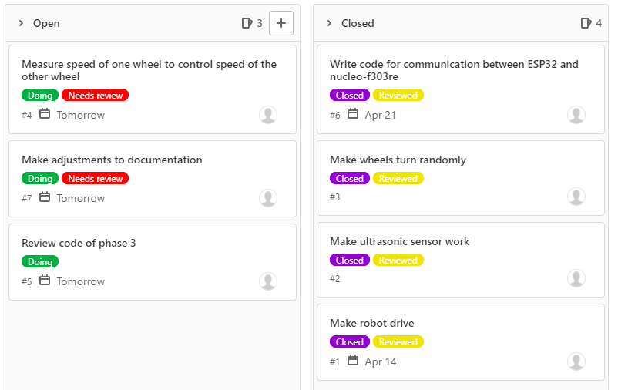

*Picture 1: the planning in a scrum board*