**Student House**

**System Design Document**

**Class:** PCT02 group 3

**Members:**

* Alexandru, SN 3806405
* Danail, SN 3781496
* Kees, SN 3972852
* Martin, SN 3780090

**Hardware components used**

* Arduino Uno boards
* Breadboard
* Wires
* Resistors
* DHT11 temperature and humidity sensor
* Buzzers
* Buttons
* Servo
* 5V fan
* MOSFET transistor board
* (RGB) LED's
* Motion detector
* LDR light sensor
* RFID tag reader chip

**Wiring diagrams**

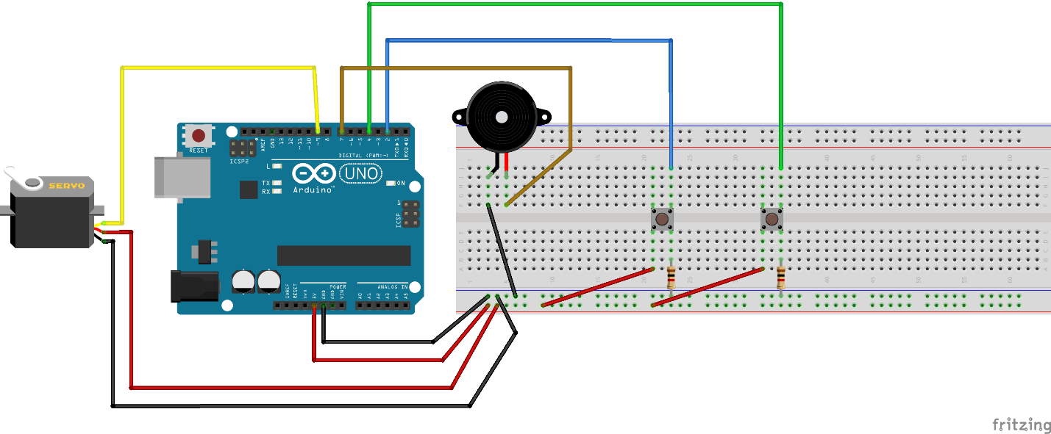

Figure 1 - RFID & door lock mechanism wiring diagram

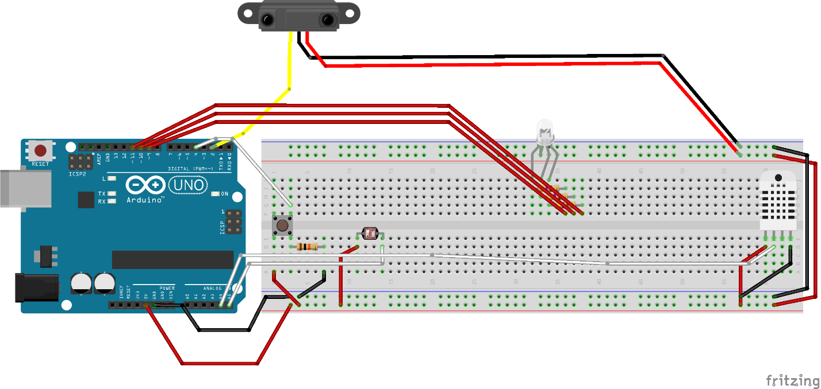

Figure 2 - Smart lighting system wiring diagram

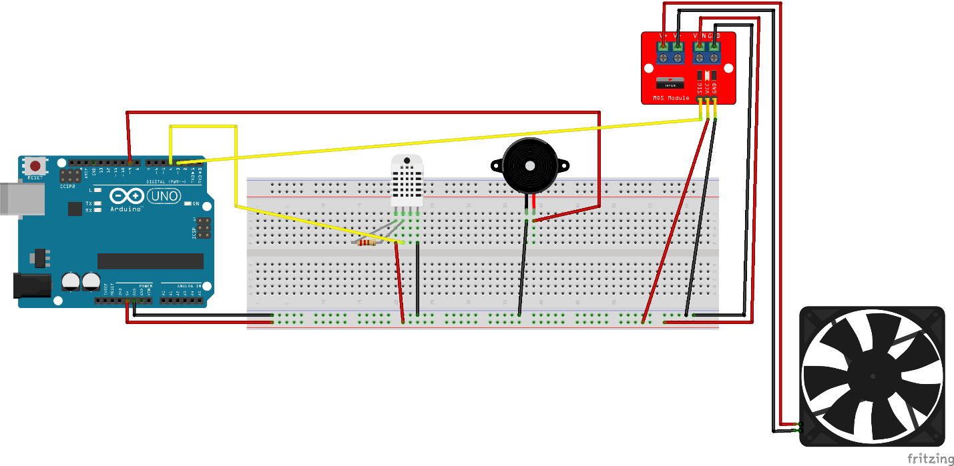

Figure 3 - Fan & alarm system wiring diagram

**State diagrams**

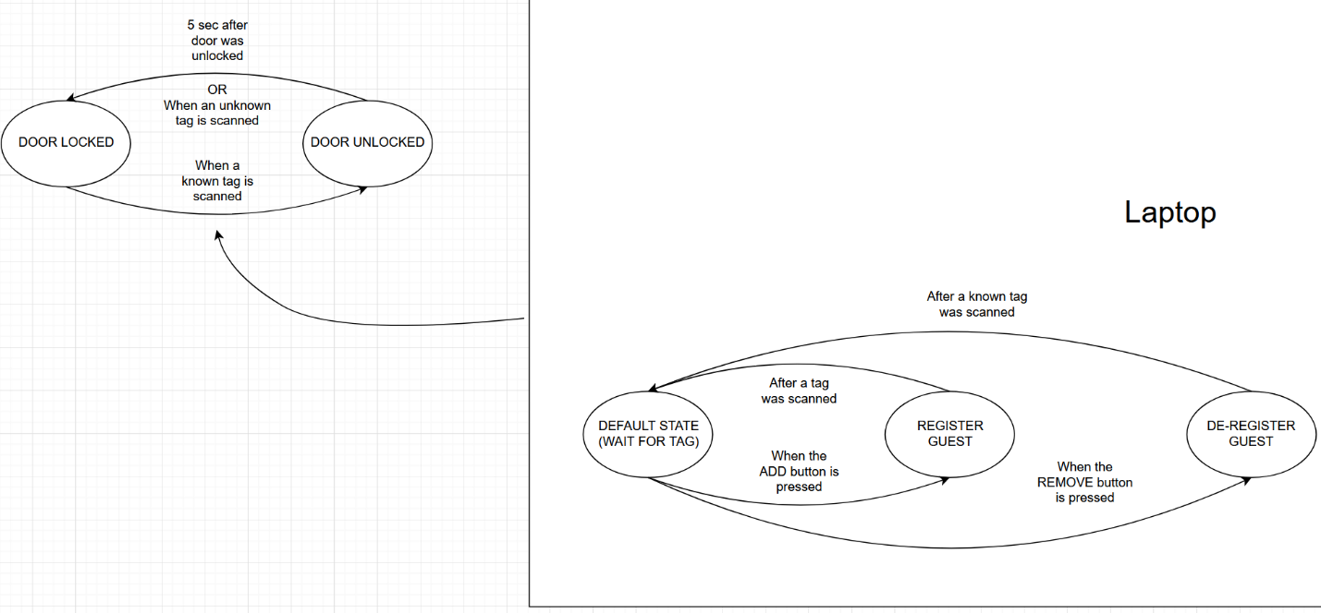

Figure 4 - RFID & door lock mechanism state diagram

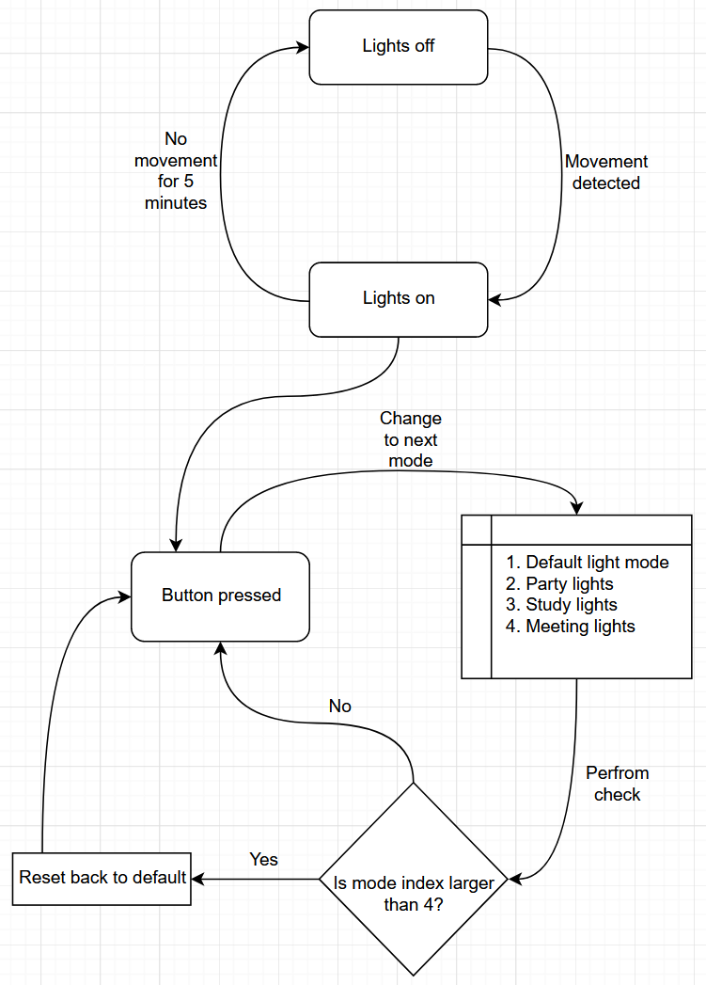

Figure 5 - Smart lighting system state diagram

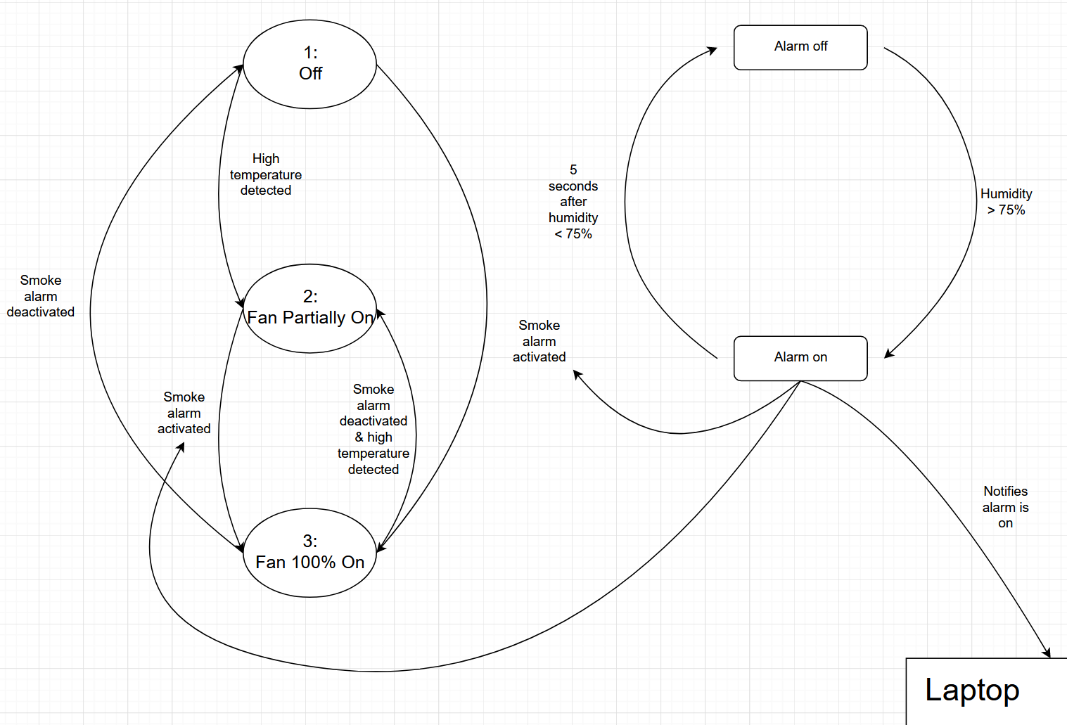

Figure 6 - Fan & alarm system state diagram