a4a final runs - draft
D. Mantopoulou-Palouka and G. Tserpes
5/27/2020

Data input for the assessment

Catch Data
- Catch-at-age data since 1985
- plus group 5
- fbar at 2 - 4

CPUE Data
- Six standardized CPUE series
  - Greek longliners since 1987
  - Moroccan longliners since 2012
  - Spanish longliners since 1988
  - Ligurian longliners since 2010
  - Sicilian longliners from 1991 to 2009
  - Ligurian surface longliners 1991 to 2009
- Representative of age groups 2 - 4

CPUE indices
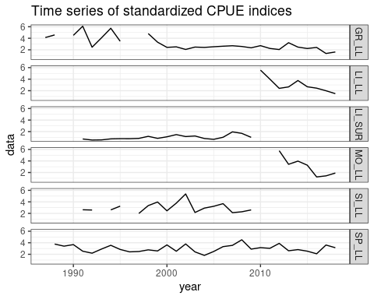

Model setup
- Fishing mortality $F$
$$F: ∼s(year,k=17)+s(age,k=3)$$
- Recruitment $R$
$$R: ∼s(year,k=15)$$
- catchability $Q$
$$Q:\left\{\begin{matrix}∼1, & Greek longline \\ ∼1, & Spanish longline \\ ∼s(year,k=3), & Moroccan longline \\ ∼s(year,k=3), & Ligurian longline \\ ∼1, & Sicilian longline \\ ∼s(year,k=9), & Ligurian surface longline\end{matrix}\right.$$
- observation variance $σ^{2}$ of the catches
$$σ^{2}∼s(age,k=3)$$
- variance of the indices
$$τ_{s}^{2}∼1, for all indices s$$
- initial age structure $N_{1}$
$$N: ∼s(age,k=3)$$

final run | assuming constant M
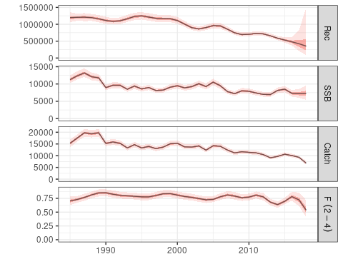

Diagnostics | final run assuming constant M
res <- residuals(fit9, stk, idx_bio)
res_Df <- as.data.frame(res)
res_Df <- res_Df[,c(1,2,7,8)]
Standardized residuals of the catch numbers by age 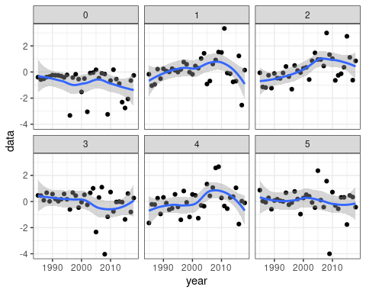

Diagnostics | final run assuming constant M
Standardized residuals of the CPUE series 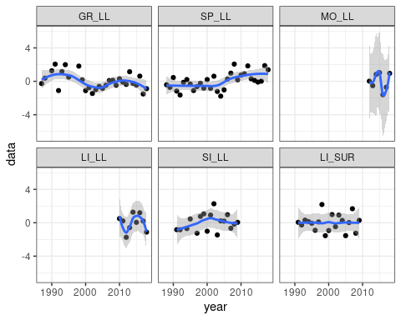

Retrospective plot | final run assuming constant M
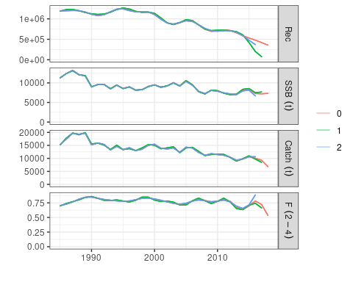

final run | assuming constant M discards included
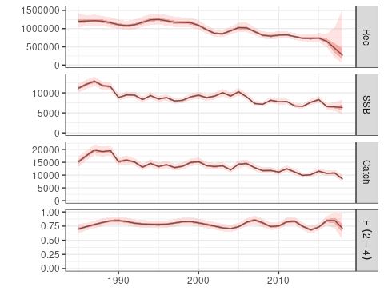

Diagnostics | final run assuming constant M discards included
res <- residuals(fit9_disc, stk_disc, idx_bio)
res_Df <- as.data.frame(res)
res_Df <- res_Df[,c(1,2,7,8)]
Standardized residuals of the catch numbers by age
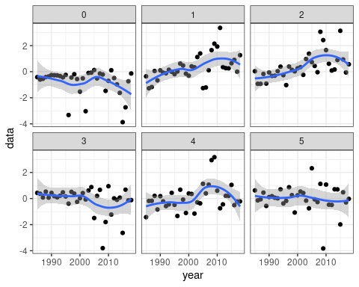

Diagnostics | final run assuming constant M discards included
Standardized residuals of the CPUE series
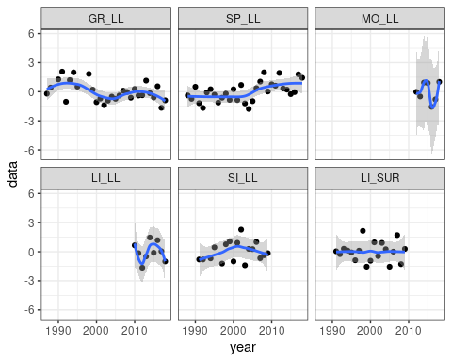

Retrospective plot | final run assuming constant M discards included
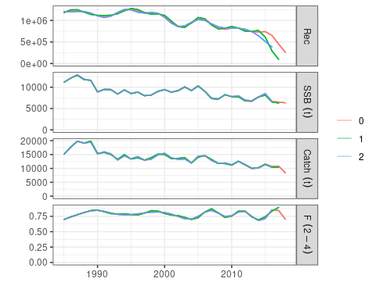

Comparison plot
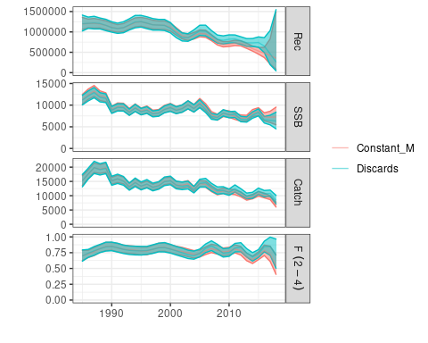

Reference points
value | constantM | Disc_constM
Fmsy | 3.833524e-01 | 3.753627e-01
Bmsy | 4.586190e+04 | 4.351330e+04
F2018 | 5.355717e-01 | 7.024563e-01
SSB | 7.312521e+03 | 6.331603e+03
FFmsy | 1.397074e+00 | 1.871407e+00
FF0.1 | 2.618664e+00 | 3.535289e+00
BBmsy | 5.001516e-01 | 5.177004e-01

MCMC | constant M
load("~/pCloudDrive/ICCAT/runs/a4a/MCMC/final_constM.RData")
plot(FLStocks(MLE = a4a.stk9_sim, MCMC = aa.stk + fit20))
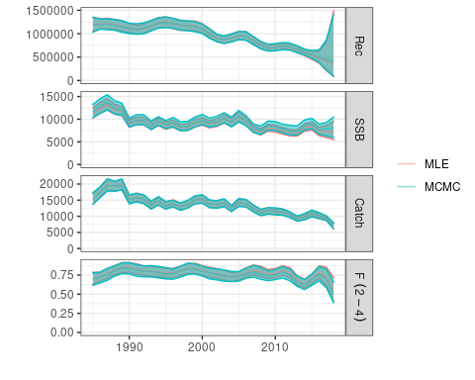

MCMC | constant M discards included
load("~/pCloudDrive/ICCAT/runs/a4a/MCMC/final_constM_disc.RData")
plot(FLStocks(MLE = a4a.stk9_disc_sim, MCMC = aa.stk + fit40))
