APPENDIX - A4A FINAL RUNS
D. Mantopoulou-Palouka and G. Tserpes
1. Introduction
The final runs of the Mediterranean Swordfish, using statistical catch-at-age method a4a, are presented in the current document. Following the recommendation of the Group, the assessments assuming a constant natural mortality considered adequate to assess the status of the stock. The Group requested for two final a4a runs, assuming constant mortality vector with and without discards. The final runs took into consideration an additional standardized CPUE index, the one of the Ligurian surface longliners, expressed in biomass.
2. Materials and Methods
The final a4a runs used CAA data from 1985 to 2018 and five standardized CPUE biomass indices were considered. The first run assumed a constant mortality vector M = 0.2, while the second assumed also a constant M including discards estimates as derived from the SCRS/2020/028. The six CPUE indices are: Greek longliners (SCRS/2020/021), Moroccan longliners (SCRS 2020/026), Spanish longliners (SCRS 2020/043), Ligurian longliners (SCRS 2020/027), Sicilian longliners (Tserpes et al. 2011) and Ligurian surface longliners (SCRS 2020/???) as suggested by the Group. All indices were considered representative of ages 2 – 4. The standardized CPUE indices are shown in Figure 1.
The same final model setup was applied in the two runs and the structure of submodels can be found in Table 1. Age plus group was set to 5 and the F range was set to ages 2 – 4.
3. Results
The results among the runs were considered similar, besides the estimated recruitment in recent years where the discards run estimation was a bit higher. A downward trend in the residuals, begging in the mid 1990s is present in both runs. Moreover the uncertainty around estimates of the recruitment appeared high in both cases at the end of the time series. The trajectory of SSB revealed a slight declining trend and after the mid-2000s fluctuated around 7,500 t. The results of the two final runs can are plotted in Figures 2 and 3. Diagnostic tests were performed for both CAA and standardized CPUE indices residuals and are presented in Figures 4 - 7. A negative pattern in the recruitment residuals is present in both runs, where it should be noted that this was probably the result of lack of a tuning index for age 0. Quantile – quantile plots for both CAA and standardized CPUE indices showed some heavy tails in the recruitment and are presented in Figures 8 and 9. Retrospective analysis conducted for both cases did not show any particular pattern except for the recruitment were some discrepancies were observed. Retrospective analysis for each run is presented in Figures 10 and 11. MCMC runs were performed for the two final runs as an alternative to the maximum likelihood estimation (MLE) that is being used as a default estimation procedure in the assessment. The plots comparing maximum likelihood estimation and MCMC are presented in Figures 12 and 13. Comparisons of the results between the two approaches are presented in Figure 14. For the estimation of biological reference points, a Beverton Holt Stock Recruitment relationship was assumed. Given the lack of sufficient data, an empirical relationship with high steepness value was developed. The reference points values along the final year’s estimation for the SSB and F are presented in Table 2.

Table 1. Submodels set up for the final a4a runs assuming constant M and discards run. ~1 stands for the constant model while ~s( ) are thin plate regression splines.
F-at-age | F | ~s(year, k =17) + s(age, k = 3)
Recruitment | R | ~s(year, k =15)
Catchability | Q | ~1 for GG_LL, SP_LL, SI_LL  ~s(year, k = 3) for MO_LL  ~s(year, k = 3) for LI_LL  ~s(year, k = 9) for LI_SUR
Observation Variance of the catch | σ² | ~s(age, k = 3)
Observation Variance of the indices | τ² | ~1 for all indices
Initial age structure | Ν | ~s(age, k = 3)

Table 2. Biological reference points and terminal values for F and SSB for the two a4a final runs.
Estimates | Constant M | Discards
F₂₀₁₈ | 0.536 | 0.702
SSB | 7312 | 6332
MSY | 14548 | 13783
F_{MSY} | 0.383 | 0.375
B_{MSY} | 45862 | 43513
F/F_{MSY} | 1.397 | 1.871
B/B_{MSY} | 0.500 | 0.518

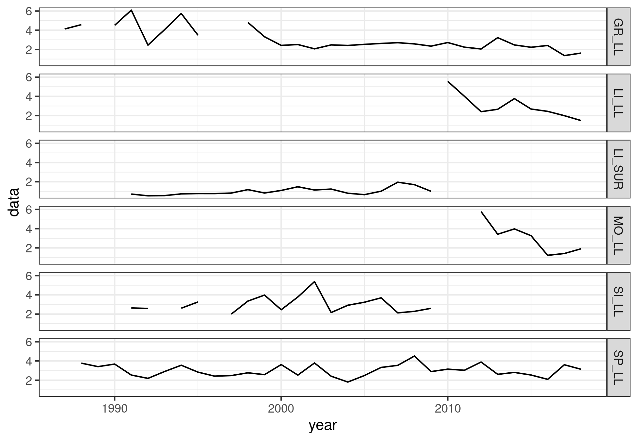
Figure 1. Time series of scaled standardized CPUE indices by fleet: GR_LL = Greek longline, SP_LL = Spanish longline, MO_LL = Moroccan longline, LI_LL = Ligurian longline, SI_LL = Sicilian longline. LI_SUR = Ligurian Surface longline.
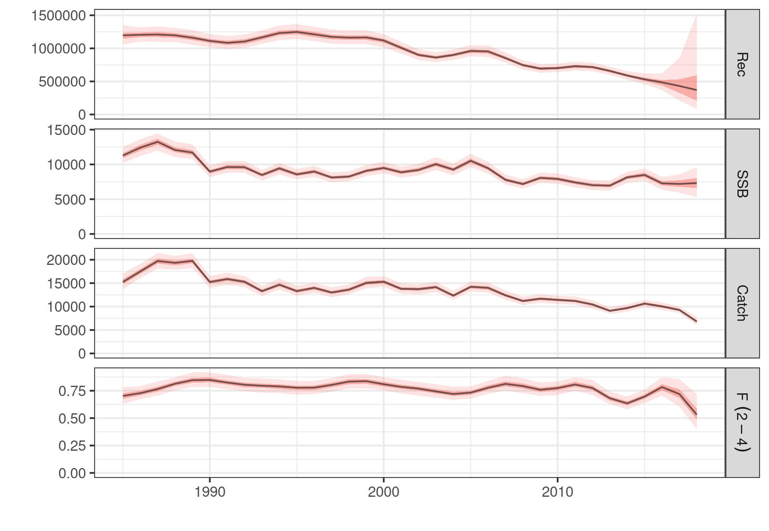
Figure 2. Estimated time series for the Constant M run. 50% and 90% CIs.

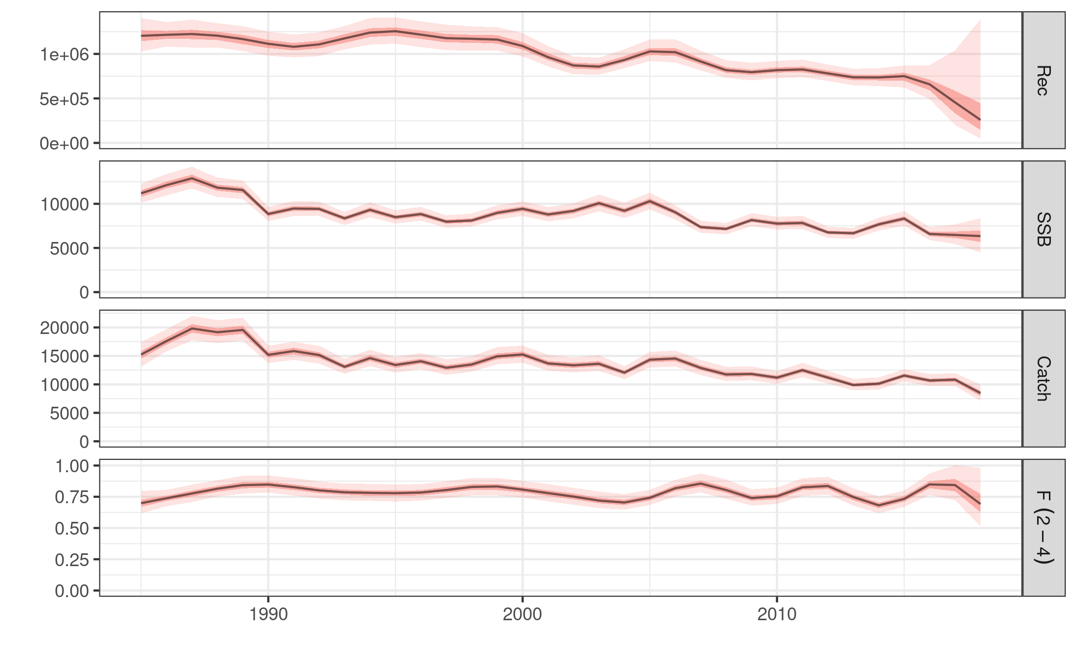
Figure 3. Estimated time series for the Discards run. 50% and 90% CIs.
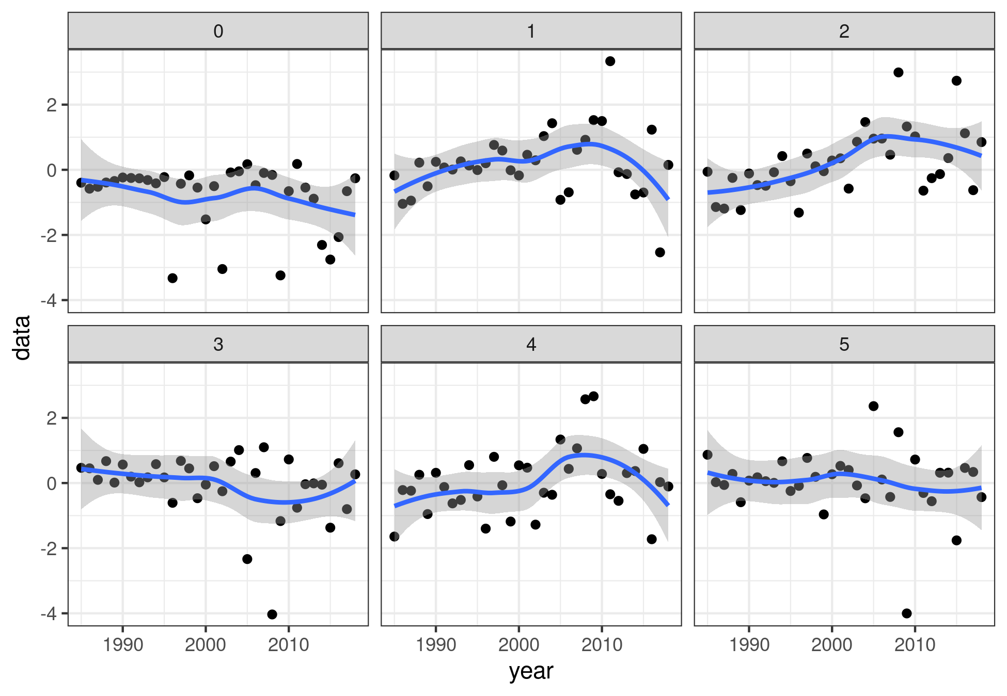
Figure 4. Standardized residuals for catch numbers for Constant M run.
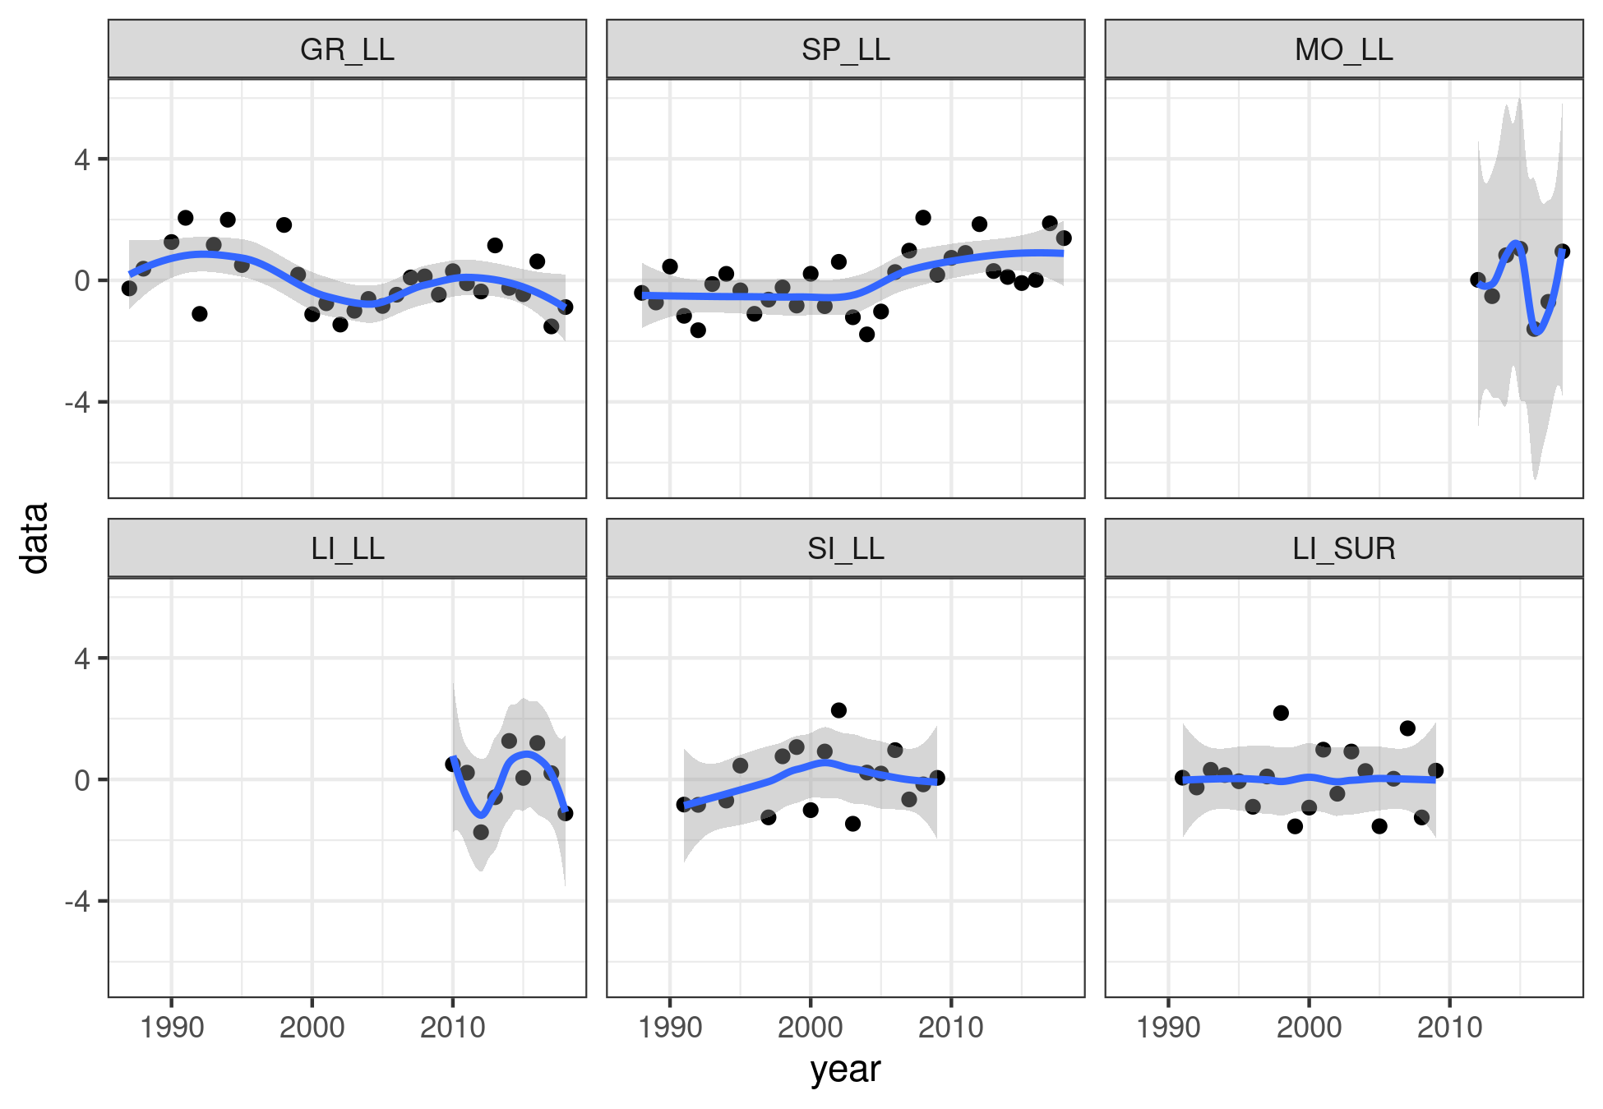
Figure 5. Standardized residuals for biomass indices for Constant M run.
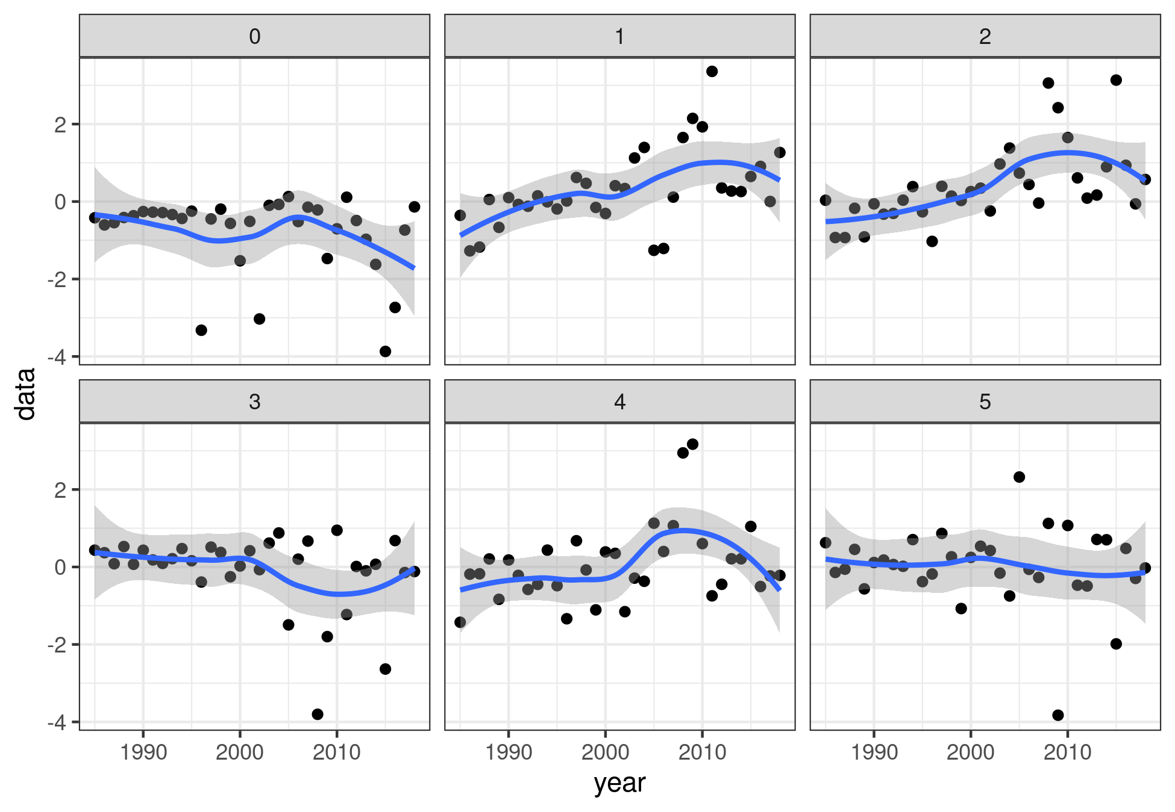
Figure 6. Standardized residuals for catch numbers for Discards run.
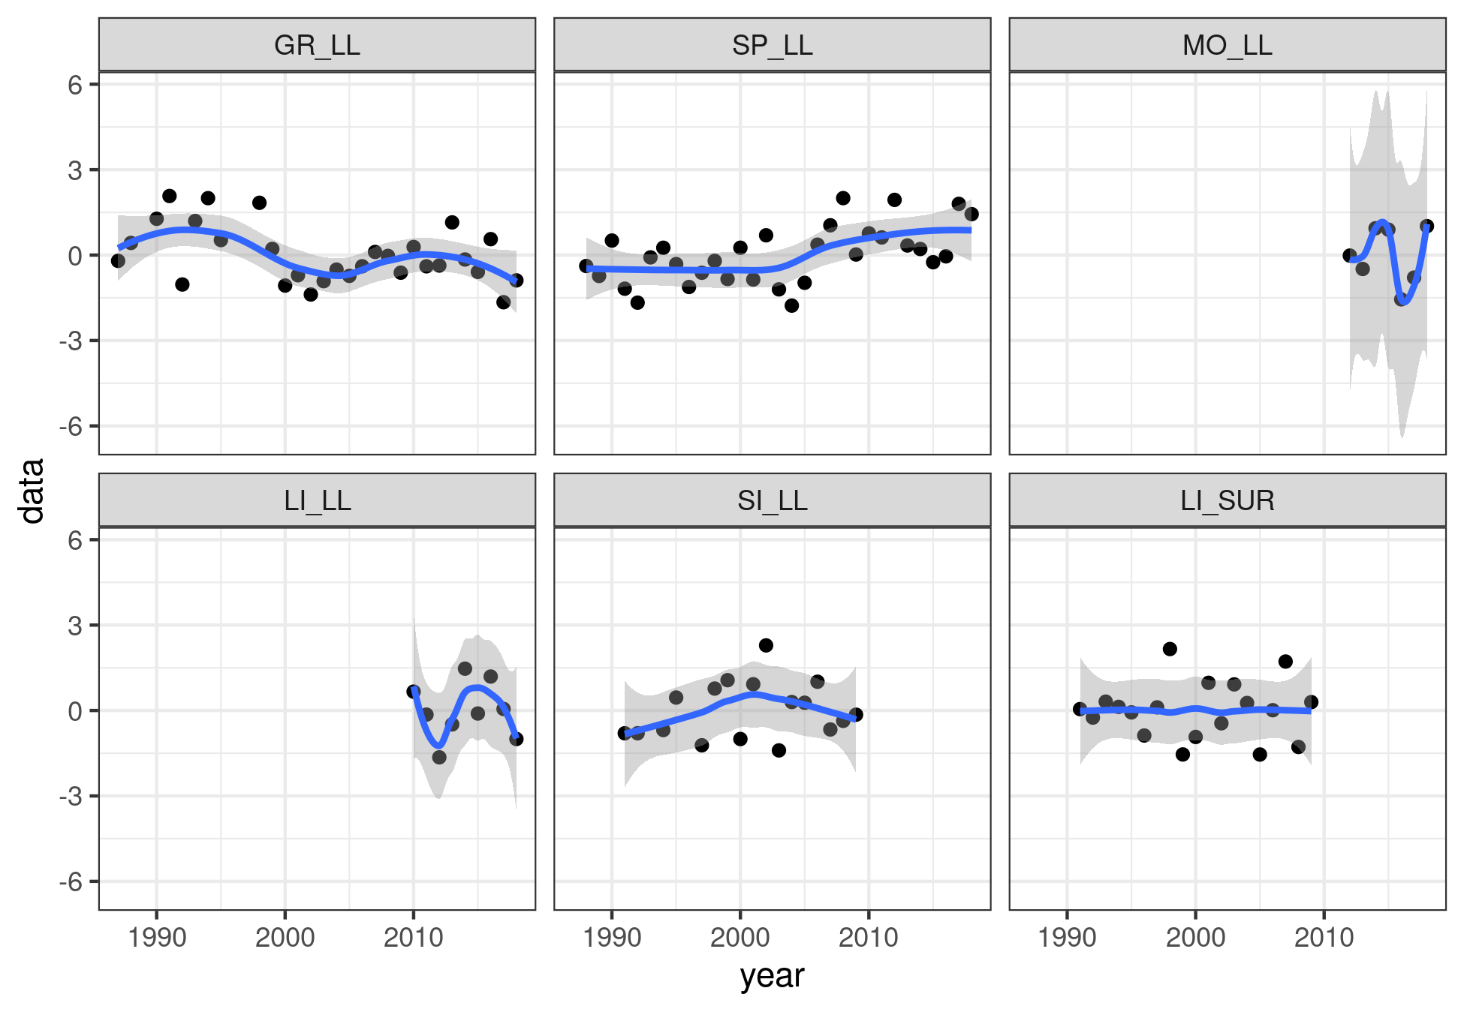
Figure 7. Standardized residuals for biomass indices for Discards run.
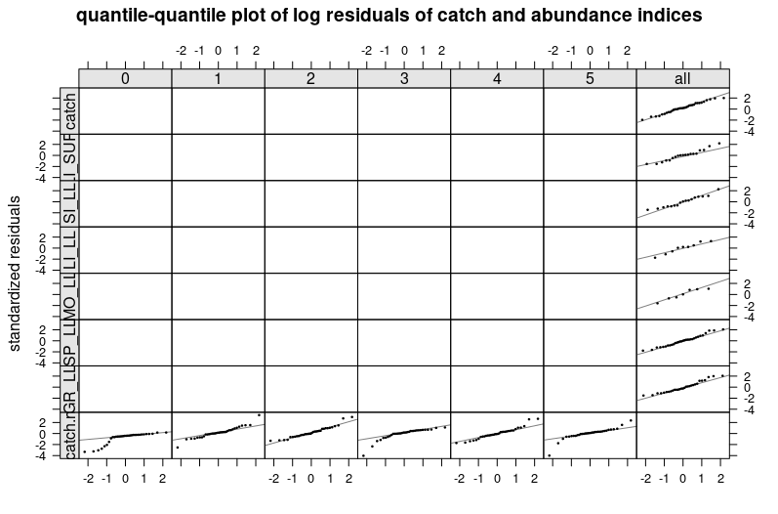
Figure 8. Quantile – quantile plots for catch numbers and biomass indices for Constant M run.
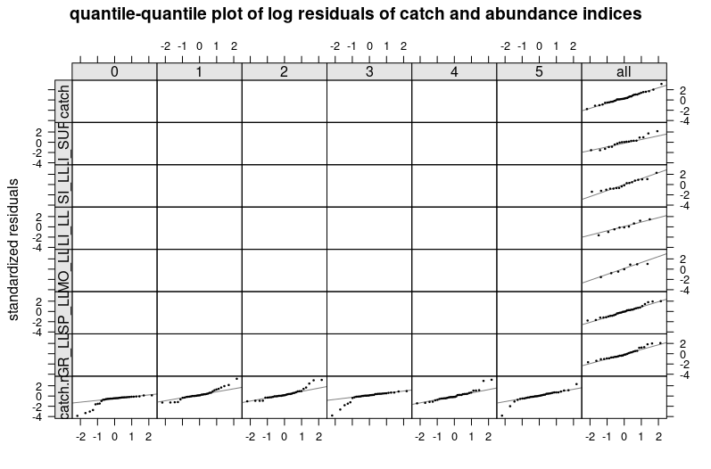
Figure 8. Quantile – quantile plots for catch numbers and biomass indices for Discards run.
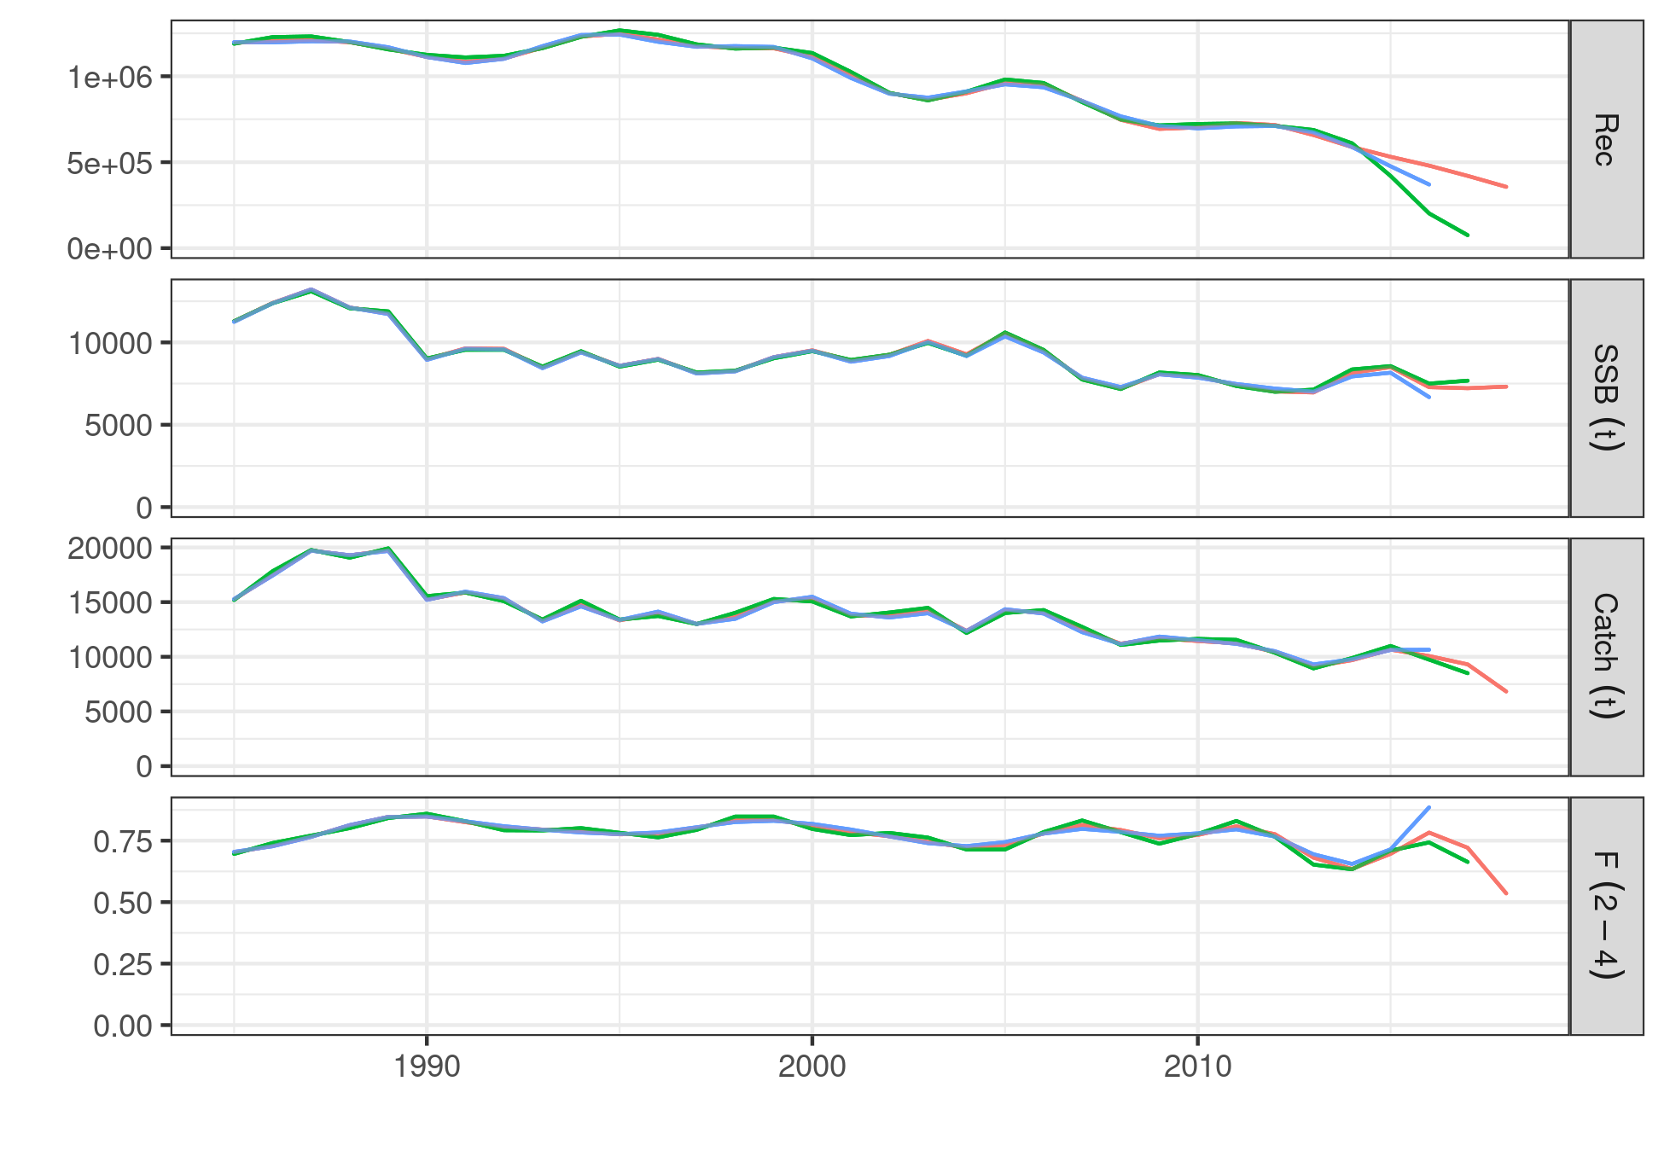
Figure 10. Retrospective plots for Constant M run.
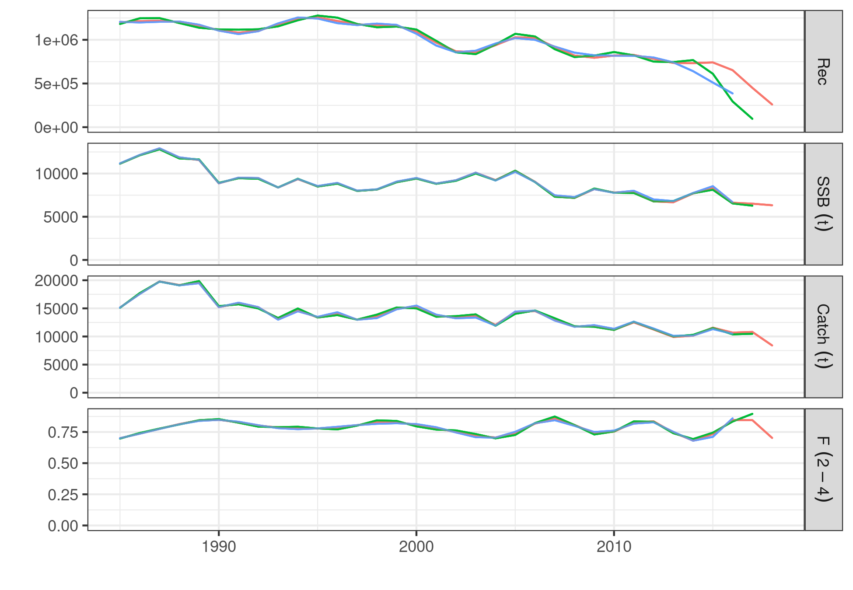
Figure 11. Retrospective plots for Discards run.
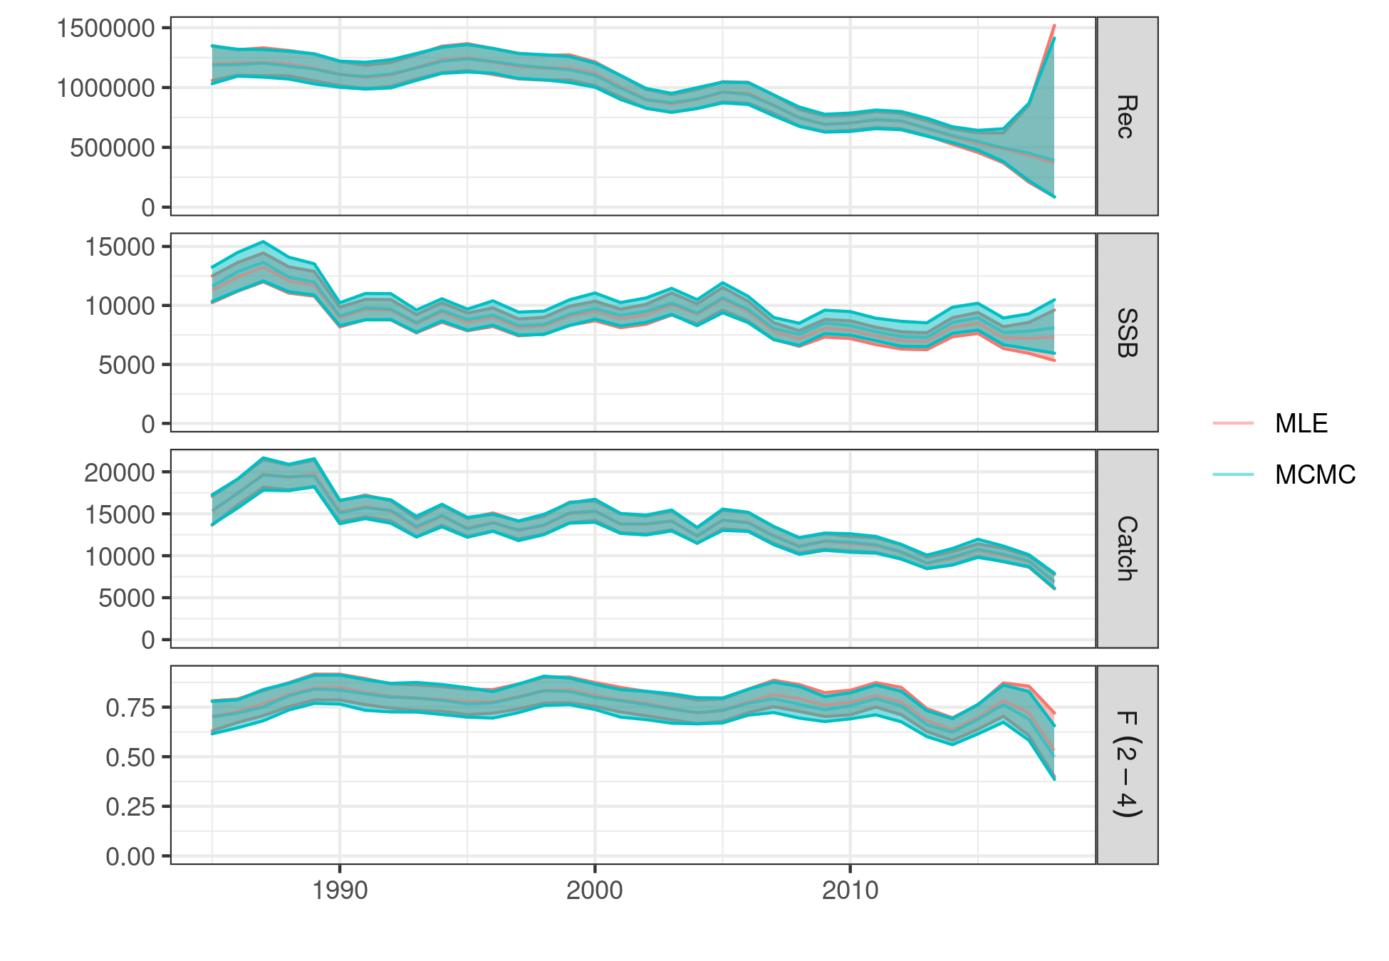
Figure 12. Comparative plot between MLE fit and MCMC for Constant M run.
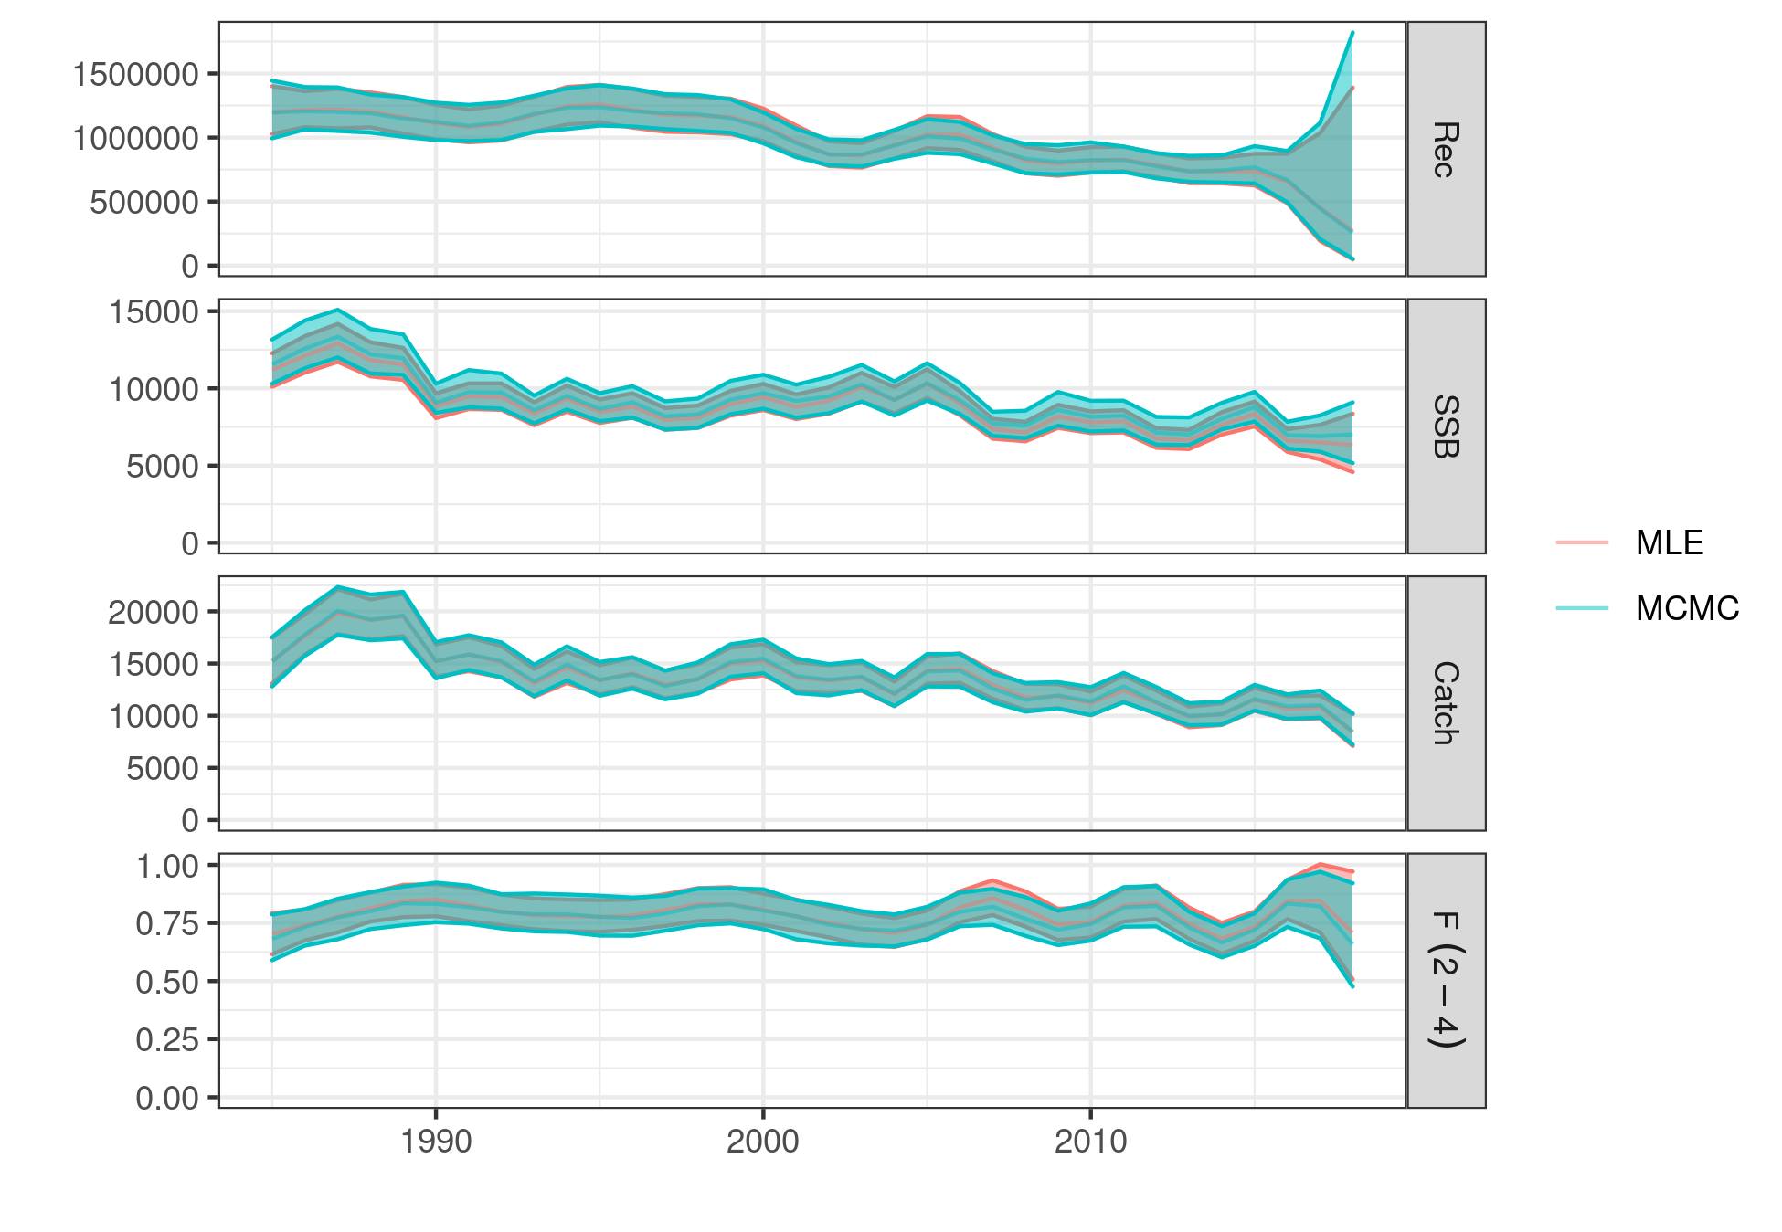
Figure 13. Comparative plot between MLE fit and MCMC for Discards run.
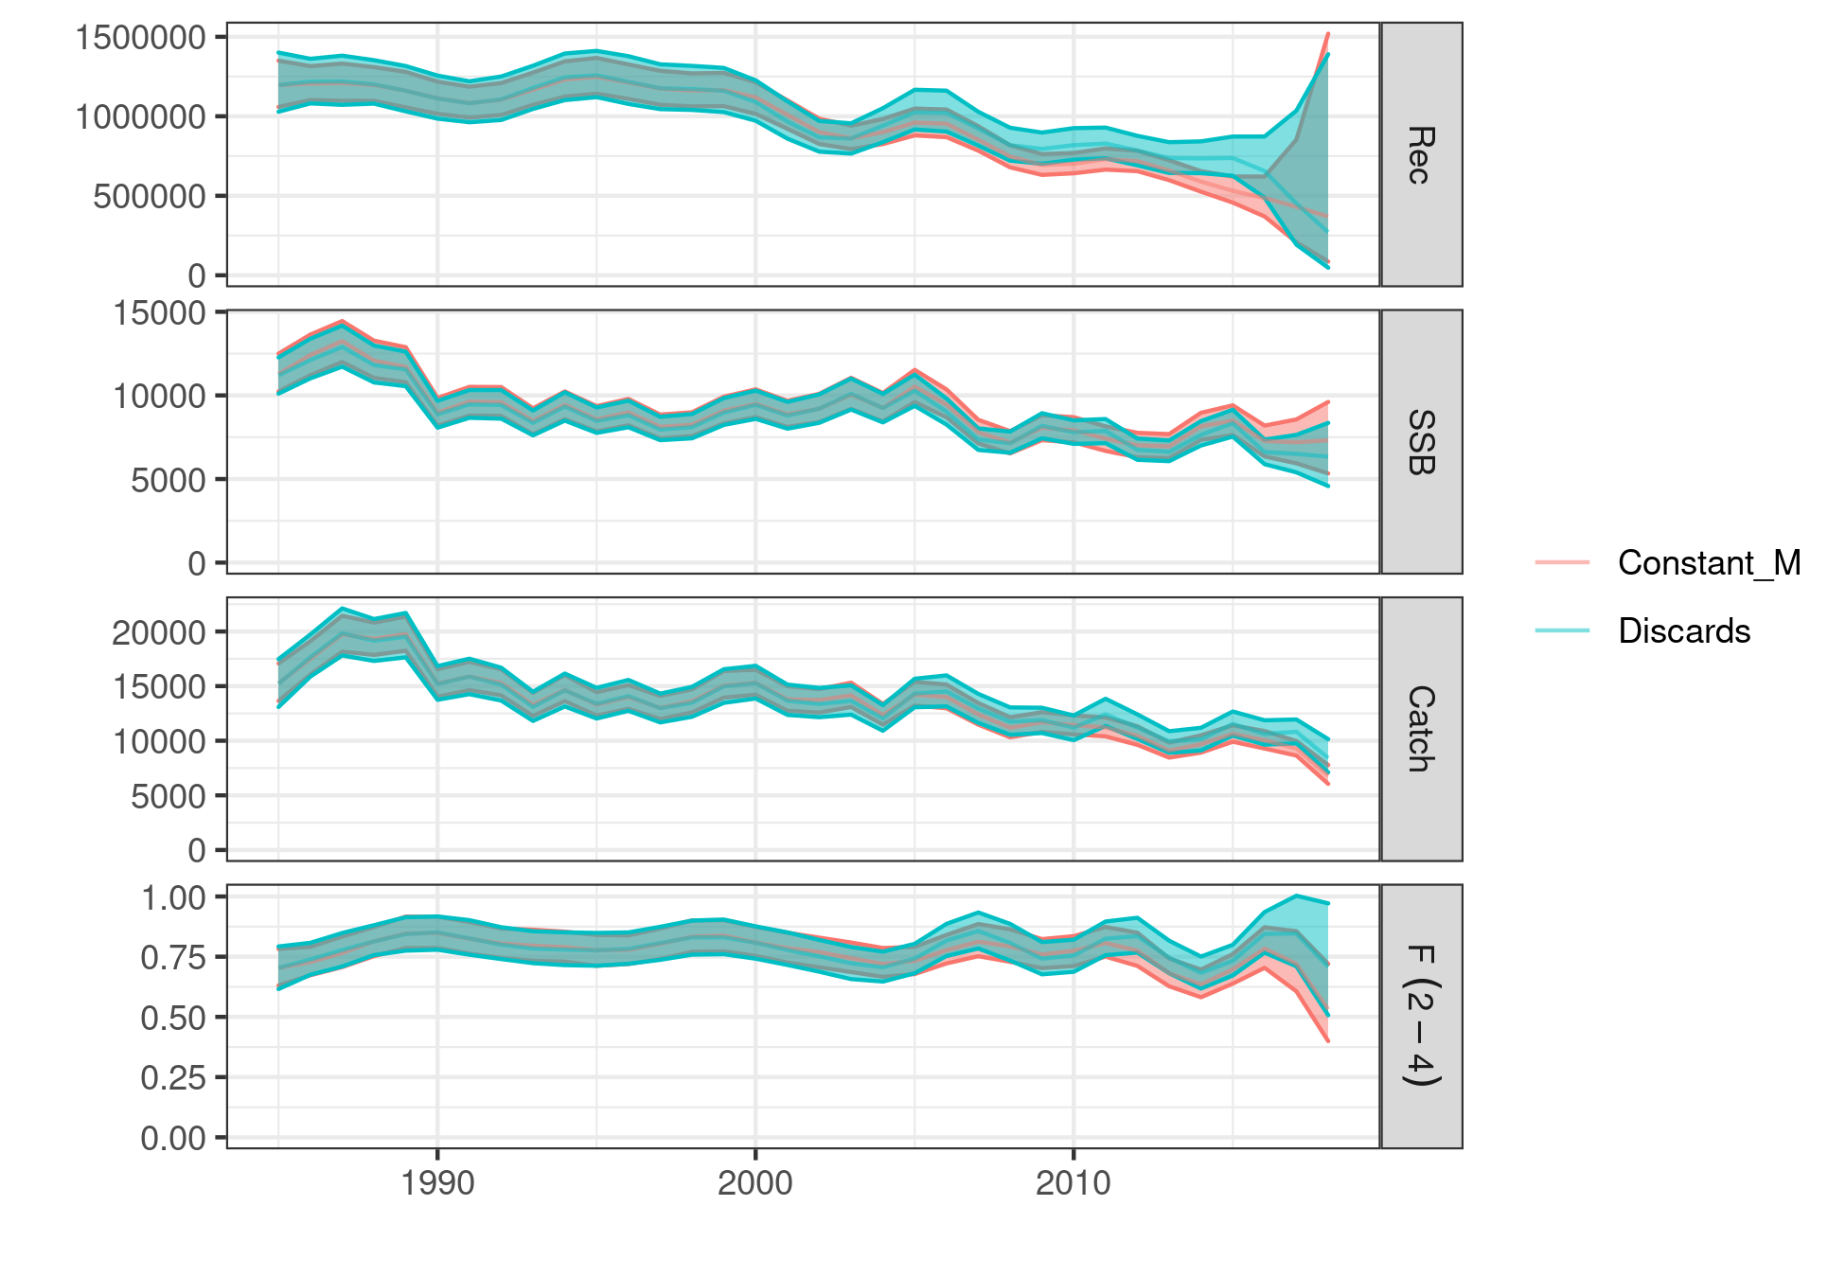
Figure 14. Comparative plot between Constant M run and Discards.

