EVIDENCE PACKAGE
Garage GFCI receptacle below required elevation
Cooper Residence Renovation / CR-2026-017 / BUI-1042
Priority | Classification | Evidence | Control
HIGH | UNAPPROVED DEVIATION | SUFFICIENT | DRAFT

Verification finding
Observed | Required / expected | Difference
GFCI box centerline measures 12 inches above finished floor at the garage east wall. | E1.1 Electrical Note 3 requires garage receptacle centerline at a minimum 18 inches AFF. | Installed centerline is 6 inches below the explicit approved drawing requirement.

Recommended route
Route | Reviewer note
FIELD CORRECTION PUNCH | Installed centerline is 6 inches below the explicit approved drawing requirement.

Evidence register
Type | Evidence | Location / capture
PHOTO | Garage east wall context Open stud wall near the garage entry door; GFCI rough-in visible. | Building: Residence / Space: Garage / Wall: East wall / Near: Entry door 2026-07-12T10:18:00-07:00
MEASUREMENT | GFCI centerline tape measurement Tape shows receptacle centerline at approximately 12 inches AFF. | Building: Residence / Space: Garage / Wall: East wall / Near: Entry door 2026-07-12T10:18:20-07:00
PHOTO | Receptacle rough-in detail Close view of the installed box before wall close-in. | Building: Residence / Space: Garage / Wall: East wall / Near: Entry door 2026-07-12T10:18:38-07:00

Field image review
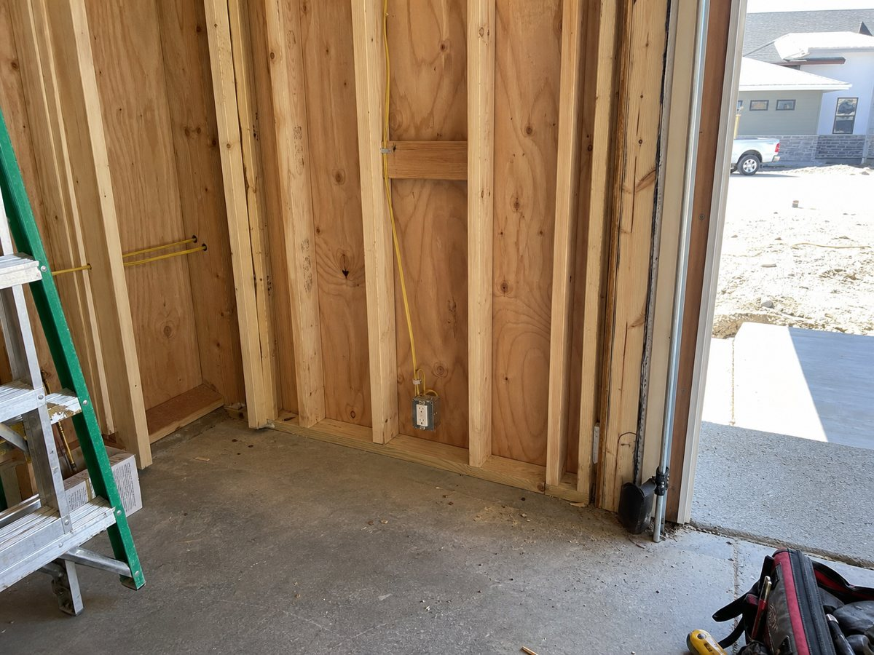
Garage east wall context / Building: Residence / Space: Garage / Wall: East wall / Near: Entry door
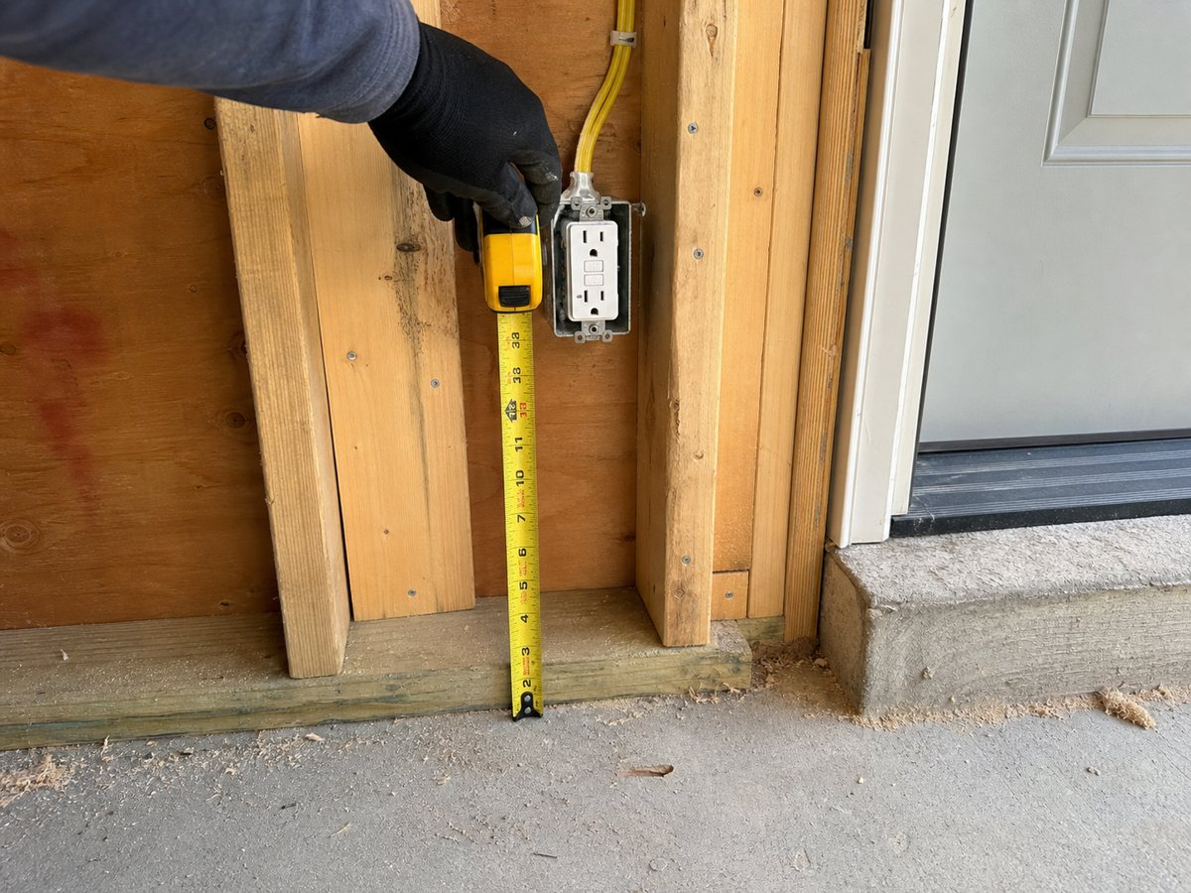
GFCI centerline tape measurement / Building: Residence / Space: Garage / Wall: East wall / Near: Entry door
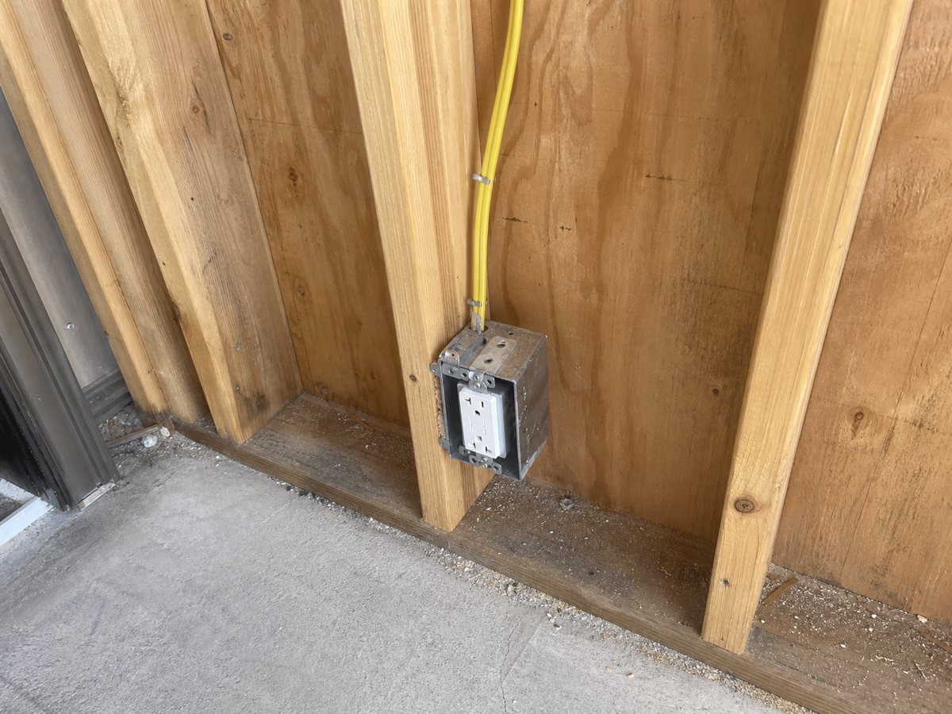
Receptacle rough-in detail / Building: Residence / Space: Garage / Wall: East wall / Near: Entry door

Source index
Every requirement statement must be checked against the exact document revision below. Superseded or unapproved sources cannot authorize work.
# | Document / revision | Page | Cited requirement
1 | E1.1 / Rev IFC-1 / APPROVED SHA-256: 50be9d19503471862a14e1383cbb5c4cf04a8cd97c237521cc324221e104bec1 | 1 | Electrical Note 3: Garage receptacle centerline shall be minimum 18 inches above finished floor.

Review control
Report ID | Version | Generated | Status
rpt_demo_bui_1042 | 1 | 2026-07-12 17:25 UTC | DRAFT / REVIEW REQUIRED
BUILI assembles a traceable review record. It does not make a design decision, authorize a change, determine contractual entitlement, or replace review by the responsible architect, engineer, contractor, or authority having jurisdiction.

