DAILY REPORT
Daily field report - electrical rough-in
Cooper Residence Renovation / CR-2026-017 / DR-2026-07-12
Report date | Prepared by | Weather | Safety
2026-07-12 | Jordan Cho / Project Manager | Clear, 72-84 °F; dry access and no weather delay. | Pre-task plan completed. No incidents, near misses, or failed inspections reported.

Work completed
Work completed
Electrical branch rough-in at garage and living areas; laundry supply rough-in; office partition layout verification.

Weather and site conditions
Weather and site conditions
Clear, 72-84 °F; dry access and no weather delay.

Safety and inspections
Safety and inspections
Pre-task plan completed. No incidents, near misses, or failed inspections reported.

Open field observation
Open field observation
Garage GFCI elevation was documented and routed to punch before wall close-in.

Manpower
Company | Trade | Workers | Hours
Northstar Builders | General | 3 | 24
Delta Electrical | Electrical | 4 | 32
ClearFlow Plumbing | Plumbing | 2 | 16

Activity and chronology
Time | Actor | Event
07:00 PDT | Mike Alvarez | Daily huddle and pre-task plan completed.
10:18 PDT | Mike Alvarez | GFCI elevation evidence captured in garage.
15:30 PDT | Jordan Cho | Daily report reviewed and marked complete.

Evidence register
Type | Evidence | Location / capture
PHOTO | Garage east wall context Open stud wall near the garage entry door; GFCI rough-in visible. | Residence / Garage / East wall / Entry door 2026-07-12T10:18:00-07:00
MEASUREMENT | GFCI centerline tape measurement Tape shows receptacle centerline at approximately 12 inches AFF. | Residence / Garage / East wall / Entry door 2026-07-12T10:18:20-07:00
PHOTO | Receptacle rough-in detail Close view of the installed box before wall close-in. | Residence / Garage / East wall / Entry door 2026-07-12T10:18:38-07:00

Field image review
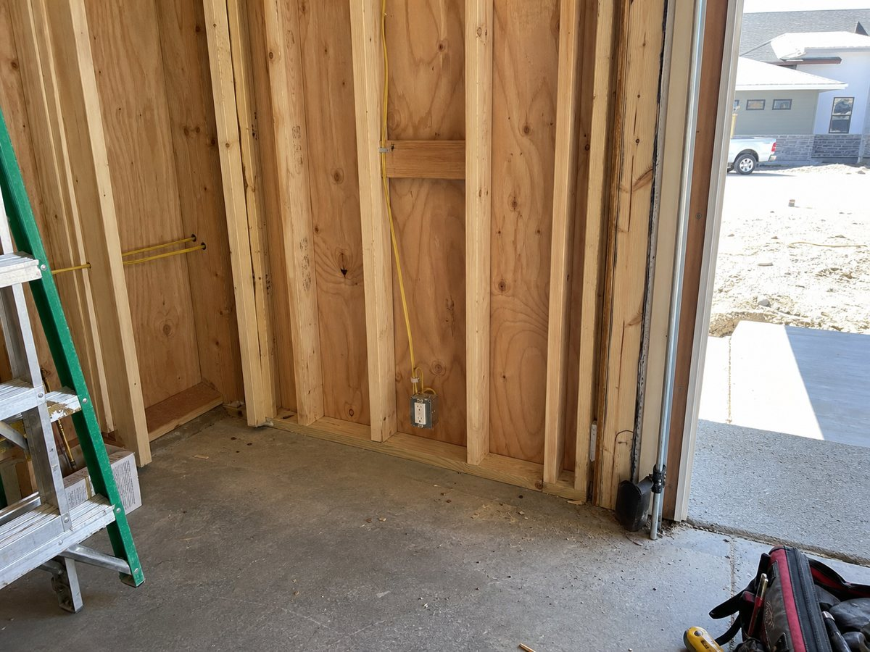
Garage east wall context / Residence / Garage / East wall / Entry door
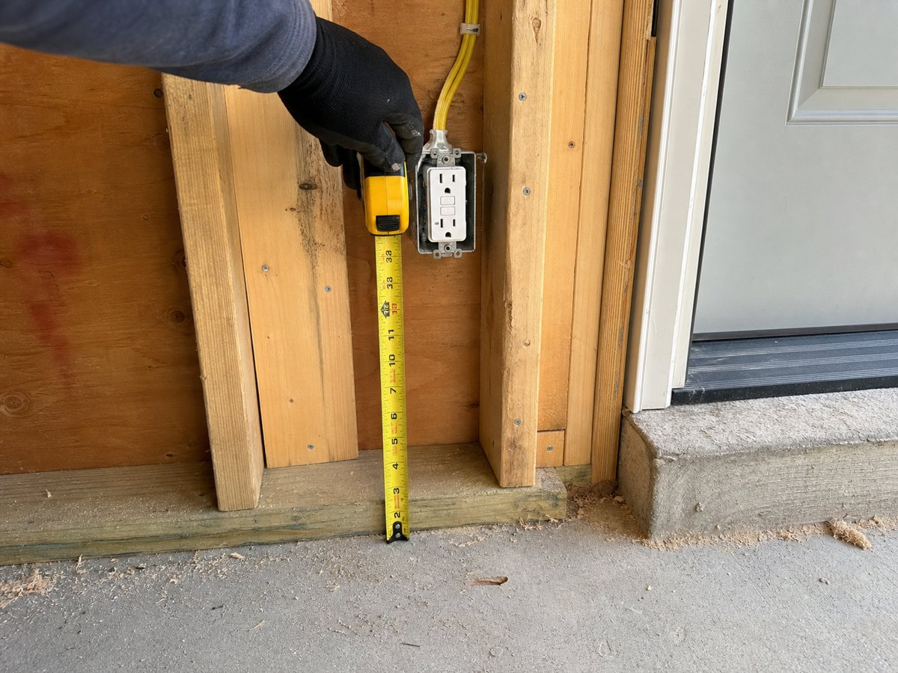
GFCI centerline tape measurement / Residence / Garage / East wall / Entry door
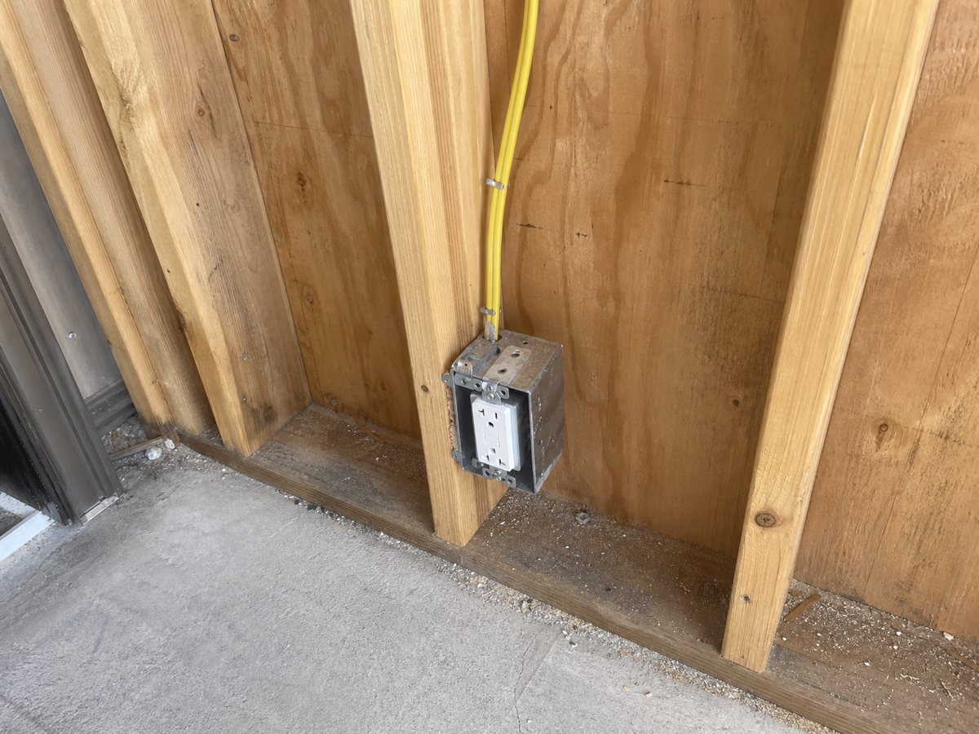
Receptacle rough-in detail / Residence / Garage / East wall / Entry door

Source index
Every requirement statement must be checked against the exact document revision below. Superseded or unapproved sources cannot authorize work.
# | Document / revision | Page | Cited requirement
- | No source linked | - | Official approval is blocked until a source is linked.

Review control
Report ID | Version | Generated | Status
rpt_demo_daily_20260712 | 1 | 2026-07-12 17:25 UTC | DRAFT / REVIEW REQUIRED
BUILI assembles a traceable review record. It does not make a design decision, authorize a change, determine contractual entitlement, or replace review by the responsible architect, engineer, contractor, or authority having jurisdiction.

