PUNCH ITEM
Raise garage GFCI rough-in before wall close-in
Cooper Residence Renovation / CR-2026-017 / P-024
Responsible trade | Punch manager | Final approver | Due date
Delta Electrical | Jordan Cho / Project Manager | Jordan Cho / Project Manager | 2026-07-14

Deficiency
Deficiency
GFCI box centerline measures 12 inches above finished floor at the garage east wall.

Contract requirement
Contract requirement
E1.1 Electrical Note 3 requires garage receptacle centerline at a minimum 18 inches AFF.

Required correction
Required correction
Relocate the box so its centerline is at least 18 inches AFF before gypsum board installation.

Completion proof
Completion proof
Provide a completion photo showing the full wall context and a readable tape measurement from finished floor to box centerline.

Activity and chronology
Time | Actor | Event
2026-07-12 10:18 PDT | Mike Alvarez | Field observation and three evidence assets captured.
2026-07-12 10:24 PDT | BUILI | E1.1 Rev 03 requirement linked; evidence package marked sufficient.

Evidence register
Type | Evidence | Location / capture
PHOTO | Garage east wall context Open stud wall near the garage entry door; GFCI rough-in visible. | Residence / Garage / East wall / Entry door 2026-07-12T10:18:00-07:00
MEASUREMENT | GFCI centerline tape measurement Tape shows receptacle centerline at approximately 12 inches AFF. | Residence / Garage / East wall / Entry door 2026-07-12T10:18:20-07:00
PHOTO | Receptacle rough-in detail Close view of the installed box before wall close-in. | Residence / Garage / East wall / Entry door 2026-07-12T10:18:38-07:00

Field image review
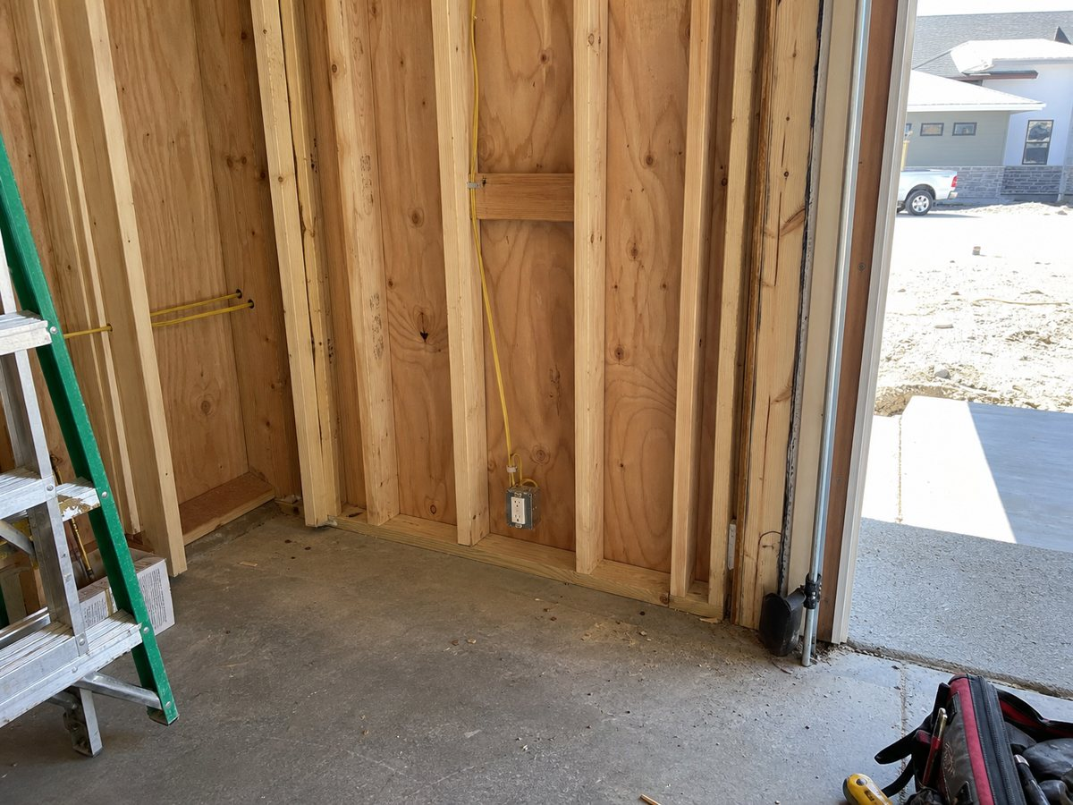
Garage east wall context / Residence / Garage / East wall / Entry door
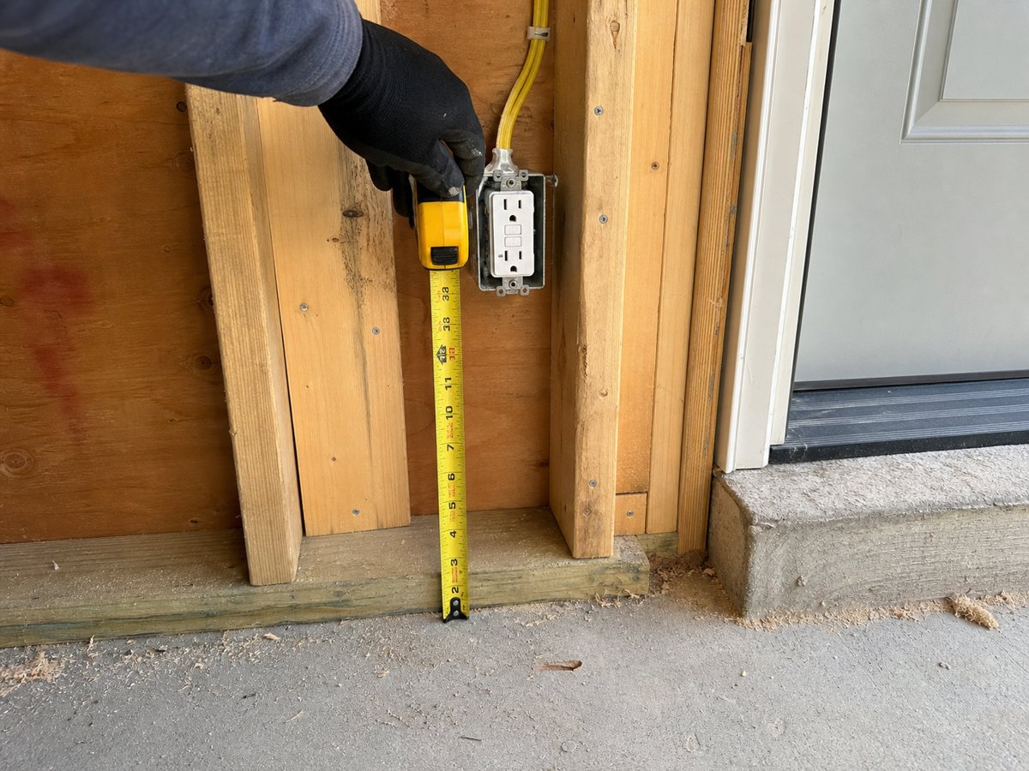
GFCI centerline tape measurement / Residence / Garage / East wall / Entry door
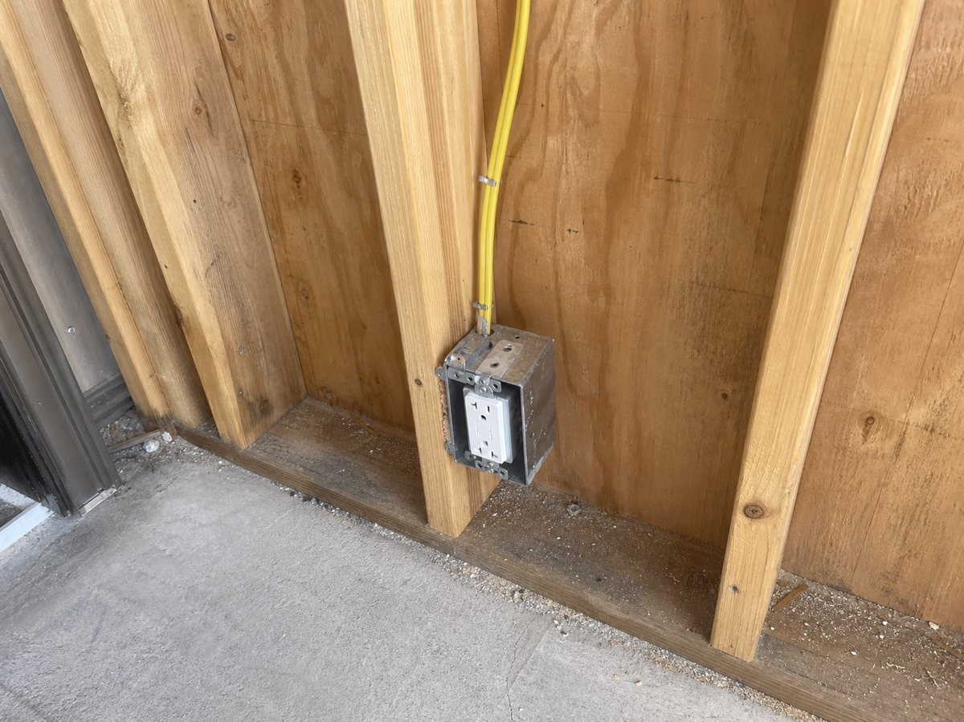
Receptacle rough-in detail / Residence / Garage / East wall / Entry door

Source index
Every requirement statement must be checked against the exact document revision below. Superseded or unapproved sources cannot authorize work.
# | Document / revision | Page | Cited requirement
1 | E1.1 / Rev 03 / APPROVED SHA-256: 85dceb1e6df4016fed87d520fd9c22a6049e351927123c6b587d697310a77fda | 1 | Electrical Note 3: Garage receptacle centerline shall be minimum 18 inches above finished floor.

Review control
Report ID | Version | Generated | Status
rpt_demo_p024 | 1 | 2026-07-12 17:25 UTC | DRAFT / REVIEW REQUIRED
BUILI assembles a traceable review record. It does not make a design decision, authorize a change, determine contractual entitlement, or replace review by the responsible architect, engineer, contractor, or authority having jurisdiction.

