Laboratory work #6

Please write SQL queries for following tasks and save as .sql file.

**Use only joins.**

1. Create database called «lab6»
2. Create following tables: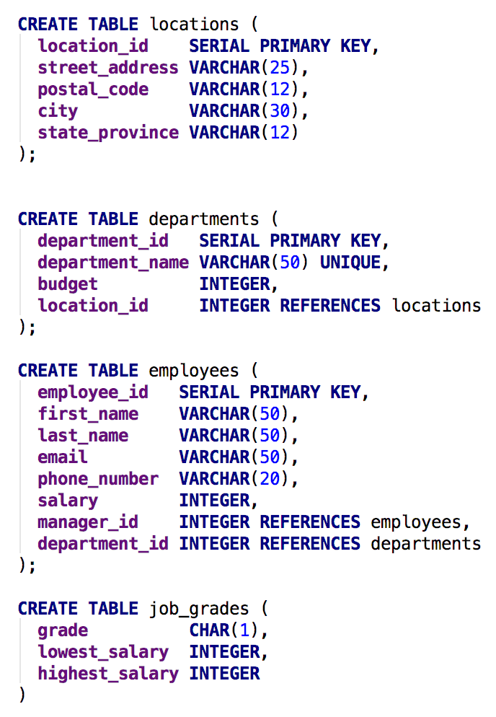
3. Select those employees who contain a letter b to their last name and also display their first name, department_id, city, and state province.
4. Select the department name, city, and state province for each department.
5. Select the first name of all employees and the first name of their manager including those who does not working under any manager.
6. Select the grade level and average salary of employees for each grade.
7. Select the first and last name of those employees who working in any department located in London.