Laboratory work #9

Please write SQL queries for following tasks and save as .sql file.

1. Create database called «lab9»
2. Create following tables «salesman», «customers» and «orders»:

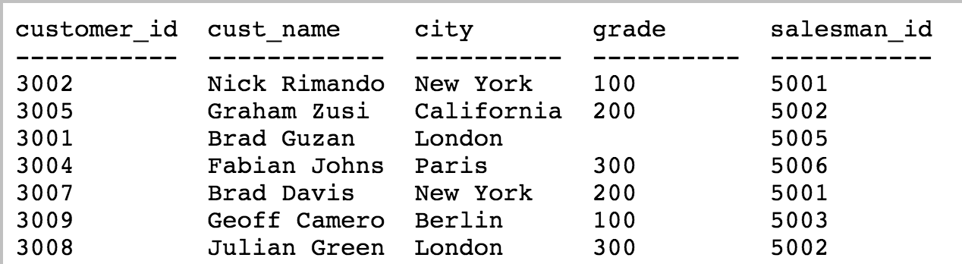

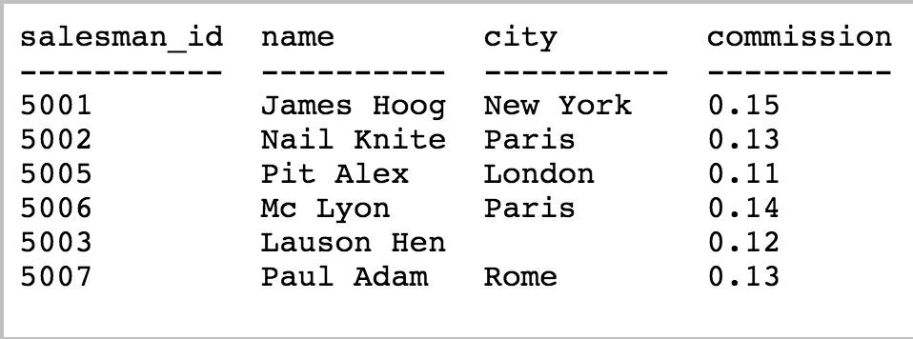

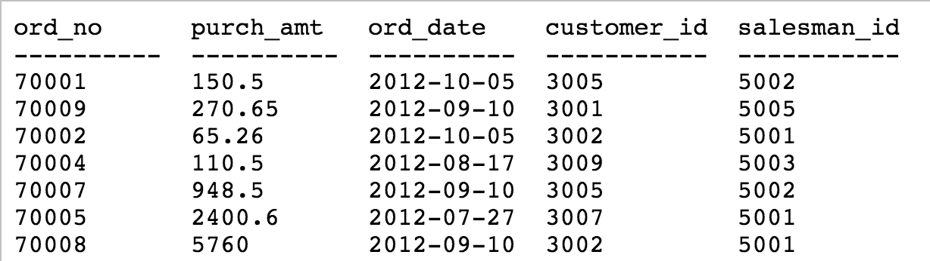

1. Create role named «junior_dev» with login privilege and some password.
2. Create a view that shows the average and total orders for each salesman with his or her name.
3. Create a view that shows the number of orders in each city. Grant all privileges to «junior_dev»
4. Create a view that shows all of the customers who have the lowest grade. Grant only select statements to «junior_dev»
5. Create a view that shows the number of the salesman for each grade.
6. Create a view that shows each salesman with more than one order.
7. Create role «intern» and assign all objects of «junior_dev» to «intern».