Laboratory work #4

Please write SQL queries for following tasks and save as .sql file.

1. Create database called «lab4».

2. Create following tables «Warehouses» and «Boxes»:

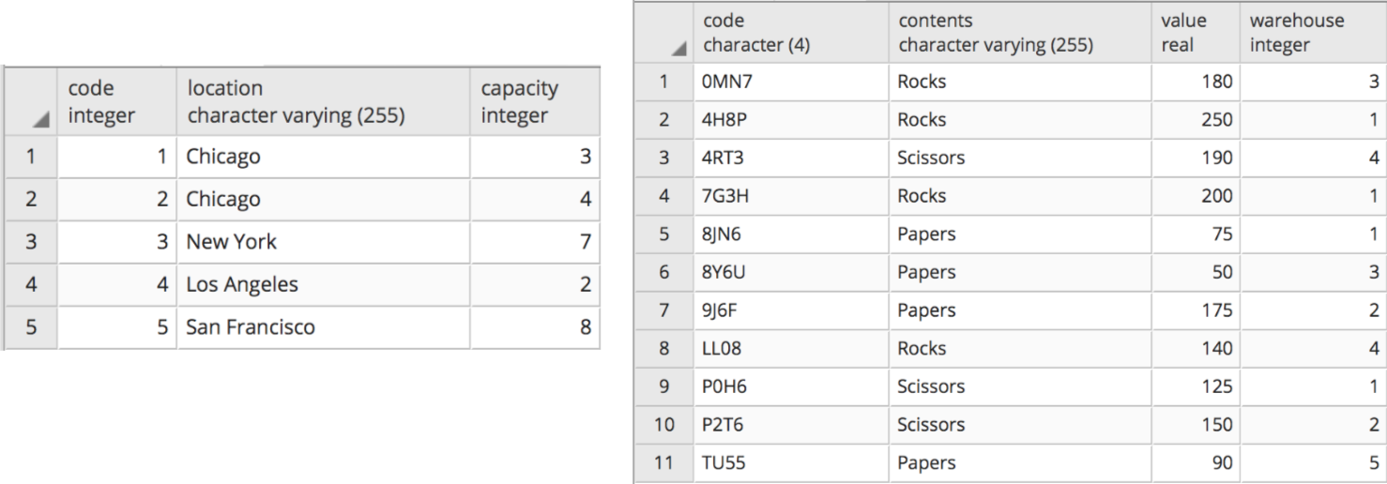

3. Download lab4.sql file from intranet. Copy content of the file and run using Query Tool (check if tables created).

4. Select all warehouses located in Chicago.

5. Select all boxes with a value greater than 140 and less or equal to 200.

6. Select total amount of distinct contents in each warehouse.

7. Select all distinct warehouses that have Rocks less than 220.

8. Increase the value of Papers by 20% of the warehouses located in San Francisco or New York.

9. Decrese twice the even values of Scissors in each warehouse and 5 times the odd values of Papers in warehouses located in Chicago.

10. Select all codes of boxes that are located in a warehouse, which location ends with 'o' and has a capacity greater than 3.

11. Select all distinct types of contents that is missing in each warehouse.

12. Select 2nd largest box which is not located in warehouse of Chicago

13. Select 3rd lowest box which has no remainder when divided by 3.