Laboratory work #5

Please write SQL queries for following tasks and save as .sql file.

1. Create database called «lab5»
2. Create following table «customers» and «orders»: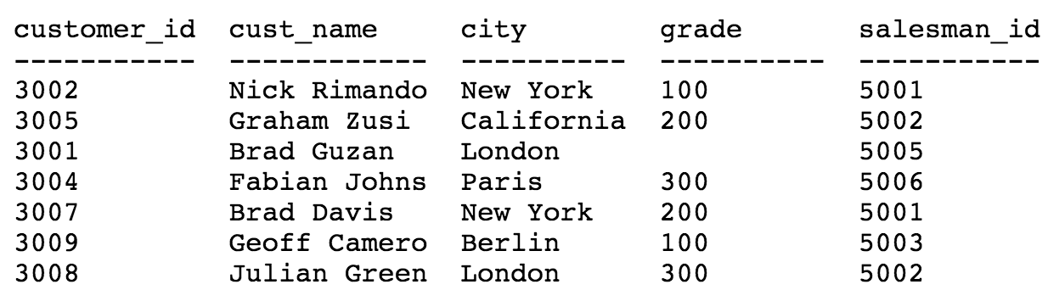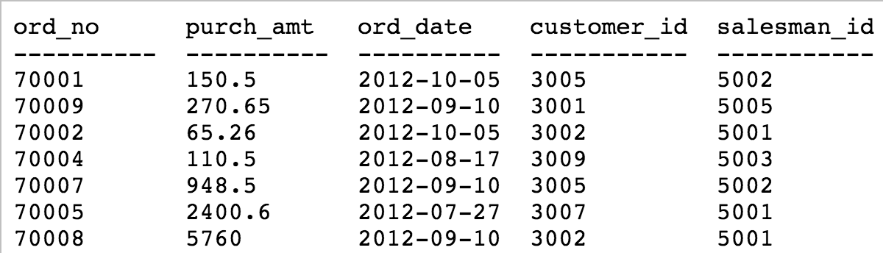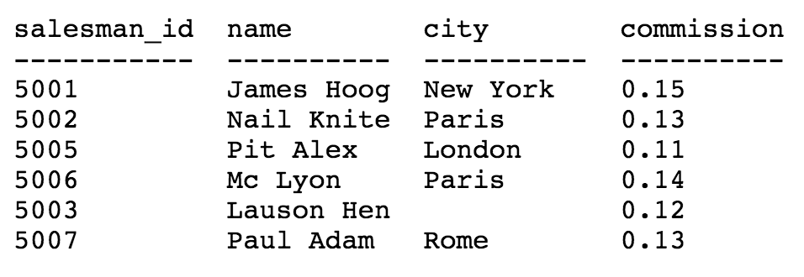
3. Select the total purchase amount of all orders.
4. Select the average purchase amount of all orders.
5. Select how many customer have listed their names.
6. Select the minimum purchase amount of all the orders.
7. Select customer with all information whose name ends with the letter 'b'.
8. Select orders which made by customers from ‘New York’.
9. Select customers with all information who has order with purchase amount more than 10.
10. Select total grade of all customers.
11. Select all customers who have listed their names.
12. Select the maximum grade of all the customers.