**Results**

**Descriptive Statistics**

| **Descriptive Statistics** | | | | | |
| --- | --- | --- | --- | --- | --- |
|  | | **highA** | | **lowA** | |
| **Valid** |  | 30 |  | 30 |  |
| **Missing** |  | 0 |  | 0 |  |
| **Mean** |  | 68.514 |  | 45.813 |  |
| **Std. Deviation** |  | 12.614 |  | 13.442 |  |
| **Minimum** |  | 44.720 |  | 21.390 |  |
| **Maximum** |  | 92.530 |  | 72.110 |  |
|  | | | | | |

**Correlation plot**

**Boxplots**

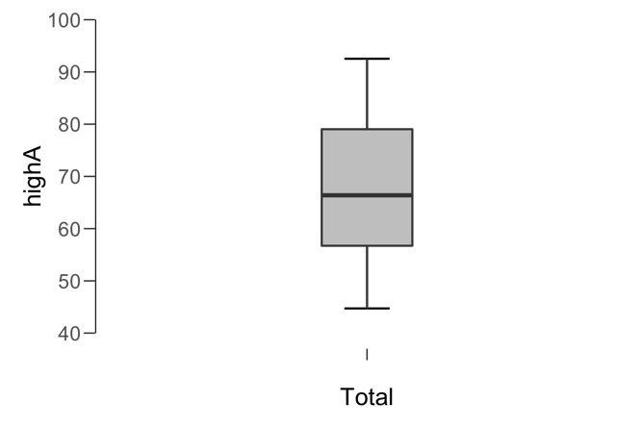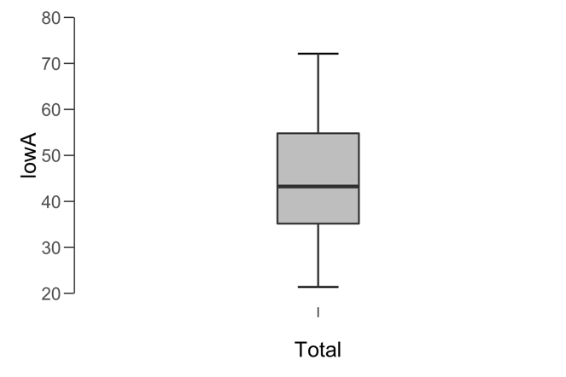

**Paired Samples T-Test**

| **Paired Samples T-Test** | | | | | | | | | | | | | | | | | | | | | | | | | |
| --- | --- | --- | --- | --- | --- | --- | --- | --- | --- | --- | --- | --- | --- | --- | --- | --- | --- | --- | --- | --- | --- | --- | --- | --- | --- |
|  | | | | | | | | | | | | | | | | **95% CI for Mean Difference** | | | |  | | **95% CI for Cohen's d** | | | |
|  | |  | |  | | **t** | | **df** | | **p** | | **Mean Difference** | | **SE Difference** | | **Lower** | | **Upper** | | **Cohen's d** | | **Lower** | | **Upper** | |
| highA |  | - |  | lowA |  | 8.026 |  | 29 |  | 7.511e -9 |  | 22.701 |  | 2.829 |  | 16.916 |  | 28.486 |  | 1.465 |  | 0.941 |  | 1.978 |  |
|  | | | | | | | | | | | | | | | | | | | | | | | | | |
| *Note.*  Student's t-test. | | | | | | | | | | | | | | | | | | | | | | | | | |

**Assumption Checks**

| **Test of Normality (Shapiro-Wilk)** | | | | | | | | | |
| --- | --- | --- | --- | --- | --- | --- | --- | --- | --- |
|  | |  | |  | | **W** | | **p** | |
| highA |  | - |  | lowA |  | 0.935 |  | 0.065 |  |
|  | | | | | | | | | |
| *Note.*  Significant results suggest a deviation from normality. | | | | | | | | | |

**Descriptives**

| **Descriptives** | | | | | | | | | |
| --- | --- | --- | --- | --- | --- | --- | --- | --- | --- |
|  | | **N** | | **Mean** | | **SD** | | **SE** | |
| highA |  | 30 |  | 68.514 |  | 12.614 |  | 2.303 |  |
| lowA |  | 30 |  | 45.813 |  | 13.442 |  | 2.454 |  |
|  | | | | | | | | | |

**Descriptives Plot**

**Bayesian Paired Samples T-Test**

| **Bayesian Paired Samples T-Test** | | | | | | | | | |
| --- | --- | --- | --- | --- | --- | --- | --- | --- | --- |
|  | |  | |  | | **Log(BF₁₀)** | | **error %** | |
| highA |  | - |  | lowA |  | 14.345 |  | 5.583e -10 |  |
|  | | | | | | | | | |

**Inferential Plots**

**highA - lowA**

**Prior and Posterior**

