**Results**

**Descriptive Statistics**

| **Descriptive Statistics** | | | | | |
| --- | --- | --- | --- | --- | --- |
|  | | **highL** | | **lowL** | |
| **Valid** |  | 30 |  | 30 |  |
| **Missing** |  | 0 |  | 0 |  |
| **Mean** |  | 84.472 |  | 15.413 |  |
| **Std. Deviation** |  | 6.580 |  | 8.285 |  |
| **Minimum** |  | 68.360 |  | 0.140 |  |
| **Maximum** |  | 96.390 |  | 34.080 |  |
|  | | | | | |

**Correlation plot**

**Boxplots**

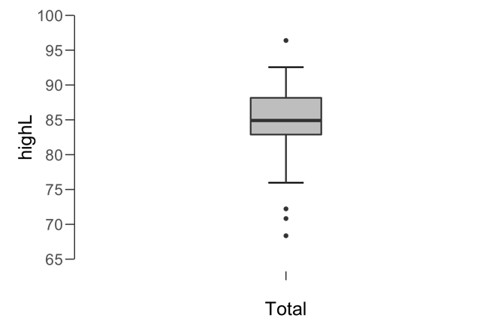

**Paired Samples T-Test**

| **Paired Samples T-Test** | | | | | | | | | | | | | | | | | | | | | | | | | |
| --- | --- | --- | --- | --- | --- | --- | --- | --- | --- | --- | --- | --- | --- | --- | --- | --- | --- | --- | --- | --- | --- | --- | --- | --- | --- |
|  | | | | | | | | | | | | | | | | **95% CI for Mean Difference** | | | |  | | **95% CI for Cohen's d** | | | |
|  | |  | |  | | **t** | | **df** | | **p** | | **Mean Difference** | | **SE Difference** | | **Lower** | | **Upper** | | **Cohen's d** | | **Lower** | | **Upper** | |
| highL |  | - |  | lowL |  | 30.382 |  | 29 |  | 1.539e -23 |  | 69.060 |  | 2.273 |  | 64.411 |  | 73.709 |  | 5.547 |  | 4.079 |  | 6.971 |  |
|  | | | | | | | | | | | | | | | | | | | | | | | | | |
| *Note.*  Student's t-test. | | | | | | | | | | | | | | | | | | | | | | | | | |

**Assumption Checks**

| **Test of Normality (Shapiro-Wilk)** | | | | | | | | | |
| --- | --- | --- | --- | --- | --- | --- | --- | --- | --- |
|  | |  | |  | | **W** | | **p** | |
| highL |  | - |  | lowL |  | 0.977 |  | 0.744 |  |
|  | | | | | | | | | |
| *Note.*  Significant results suggest a deviation from normality. | | | | | | | | | |

**Descriptives**

| **Descriptives** | | | | | | | | | |
| --- | --- | --- | --- | --- | --- | --- | --- | --- | --- |
|  | | **N** | | **Mean** | | **SD** | | **SE** | |
| highL |  | 30 |  | 84.472 |  | 6.580 |  | 1.201 |  |
| lowL |  | 30 |  | 15.413 |  | 8.285 |  | 1.513 |  |
|  | | | | | | | | | |

**Descriptives Plot**

**Bayesian Paired Samples T-Test**

| **Bayesian Paired Samples T-Test** | | | | | | | | | |
| --- | --- | --- | --- | --- | --- | --- | --- | --- | --- |
|  | |  | |  | | **Log(BF₁₀)** | | **error %** | |
| highL |  | - |  | lowL |  | 46.690 |  | 2.265e -23 |  |
|  | | | | | | | | | |

**Inferential Plots**

**highL - lowL**

**Prior and Posterior**

