# Results

## Descriptive Statistics

| **Descriptive Statistics** | | | | | |
| --- | --- | --- | --- | --- | --- |
|  | | **affect** | | **likableness** | |
| **Valid** |  | 540 |  | 540 |  |
| **Missing** |  | 0 |  | 0 |  |
| **Median** |  | 22.000 |  | 72.250 |  |
| **IQR** |  | 44.000 |  | 26.500 |  |
| **Variance** |  | 1259.814 |  | 406.740 |  |
| **Minimum** |  | -95.000 |  | -18.500 |  |
| **Maximum** |  | 100.000 |  | 100.000 |  |
|  | | | | | |

### Distribution Plots

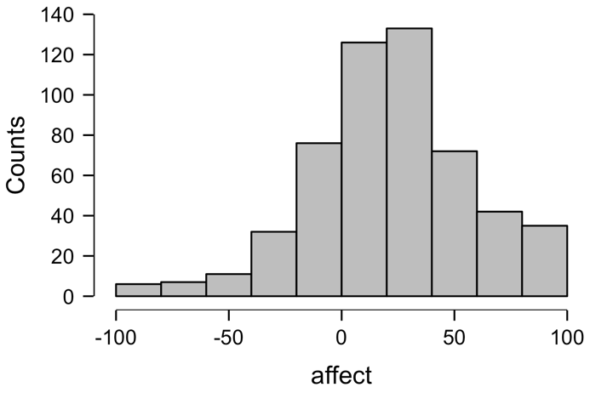

### Boxplots

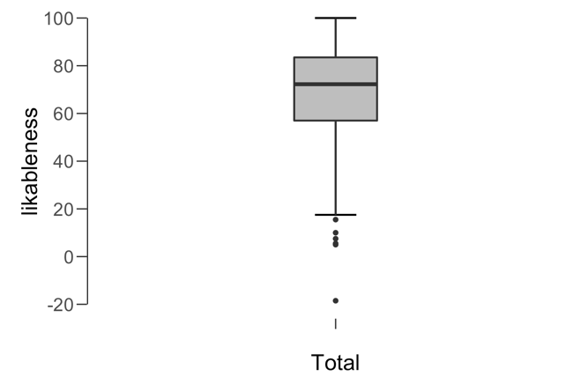

## Paired Samples T-Test

| **Paired Samples T-Test** | | | | | | | | | | | | | | | | | |
| --- | --- | --- | --- | --- | --- | --- | --- | --- | --- | --- | --- | --- | --- | --- | --- | --- | --- |
|  | | | | | | | | | | | | | | **95% CI for Cohen's d** | | | |
|  | |  | |  | | **t** | | **df** | | **p** | | **Cohen's d** | | **Lower** | | **Upper** | |
| affect |  | - |  | likableness |  | -26.728 |  | 539 |  | < .001 |  | -1.150 |  | -1.259 |  | -1.041 |  |
|  | | | | | | | | | | | | | | | | | |
| Note.  Student's t-test. | | | | | | | | | | | | | | | | | |

### Assumption Checks

| **Test of Normality (Shapiro-Wilk)** | | | | | | | | | |
| --- | --- | --- | --- | --- | --- | --- | --- | --- | --- |
|  | |  | |  | | **W** | | **p** | |
| affect |  | - |  | likableness |  | 0.998 |  | 0.884 |  |
|  | | | | | | | | | |
| Note.  Significant results suggest a deviation from normality. | | | | | | | | | |

### Descriptives

| **Descriptives** | | | | | | | | | |
| --- | --- | --- | --- | --- | --- | --- | --- | --- | --- |
|  | | **N** | | **Mean** | | **SD** | | **SE** | |
| affect |  | 540 |  | 22.702 |  | 35.494 |  | 1.527 |  |
| likableness |  | 540 |  | 69.059 |  | 20.168 |  | 0.868 |  |
|  | | | | | | | | | |

#### Descriptives Plot

##### affect - likableness

## Bayesian Paired Samples T-Test

| **Bayesian Paired Samples T-Test** | | | | | | | | | |
| --- | --- | --- | --- | --- | --- | --- | --- | --- | --- |
|  | |  | |  | | **BF₁₀** | | **error %** | |
| affect |  | - |  | likableness |  | 1.207e +97 |  | 8.277e -100 |  |
|  | | | | | | | | | |

### Inferential Plots

#### affect - likableness

##### Prior and Posterior

