**Results**

**Descriptive Statistics**

| **Descriptive Statistics** | | | | | |
| --- | --- | --- | --- | --- | --- |
|  | | **high** | | **low** | |
| **Valid** |  | 540 |  | 540 |  |
| **Missing** |  | 0 |  | 0 |  |
| **Median** |  | 87.000 |  | 12.000 |  |
| **IQR** |  | 16.500 |  | 17.500 |  |
| **Variance** |  | 166.503 |  | 199.571 |  |
| **Minimum** |  | 20.000 |  | 0.000 |  |
| **Maximum** |  | 100.000 |  | 85.000 |  |
|  | | | | | |

**Distribution Plots**

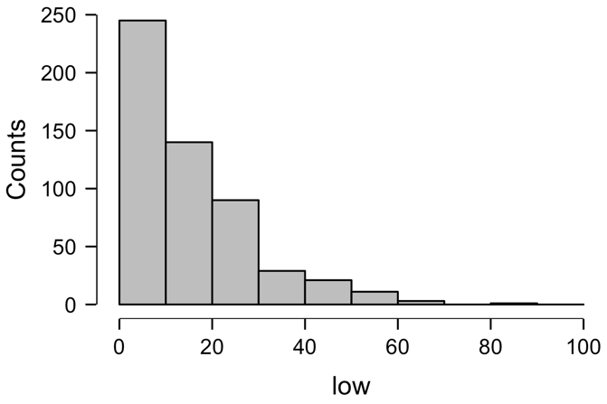

**Boxplots**

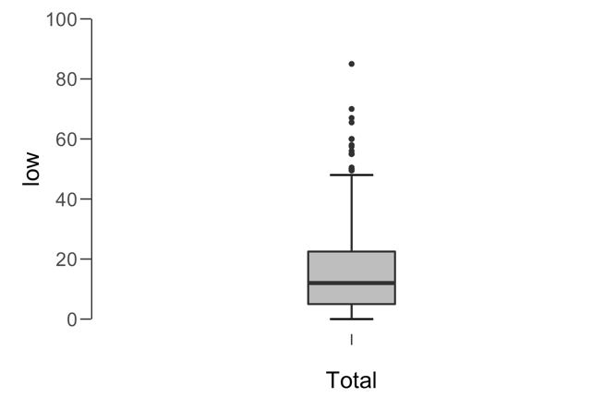

**Paired Samples T-Test**

| **Paired Samples T-Test** | | | | | | | | | | | | | | | | | |
| --- | --- | --- | --- | --- | --- | --- | --- | --- | --- | --- | --- | --- | --- | --- | --- | --- | --- |
|  | | | | | | | | | | | | | | **95% CI for Cohen's d** | | | |
|  | |  | |  | | **t** | | **df** | | **p** | | **Cohen's d** | | **Lower** | | **Upper** | |
| high |  | - |  | low |  | 79.572 |  | 539 |  | < .001 |  | 3.424 |  | 3.202 |  | 3.644 |  |
|  | | | | | | | | | | | | | | | | | |
| *Note.*  Student's t-test. | | | | | | | | | | | | | | | | | |

**Assumption Checks**

| **Test of Normality (Shapiro-Wilk)** | | | | | | | | | |
| --- | --- | --- | --- | --- | --- | --- | --- | --- | --- |
|  | |  | |  | | **W** | | **p** | |
| high |  | - |  | low |  | 0.961 |  | < .001 |  |
|  | | | | | | | | | |
| *Note.*  Significant results suggest a deviation from normality. | | | | | | | | | |

**Descriptives**

| **Descriptives** | | | | | | | | | |
| --- | --- | --- | --- | --- | --- | --- | --- | --- | --- |
|  | | **N** | | **Mean** | | **SD** | | **SE** | |
| high |  | 540 |  | 84.472 |  | 12.904 |  | 0.555 |  |
| low |  | 540 |  | 15.413 |  | 14.127 |  | 0.608 |  |
|  | | | | | | | | | |

**Descriptives Plot**

**high - low**

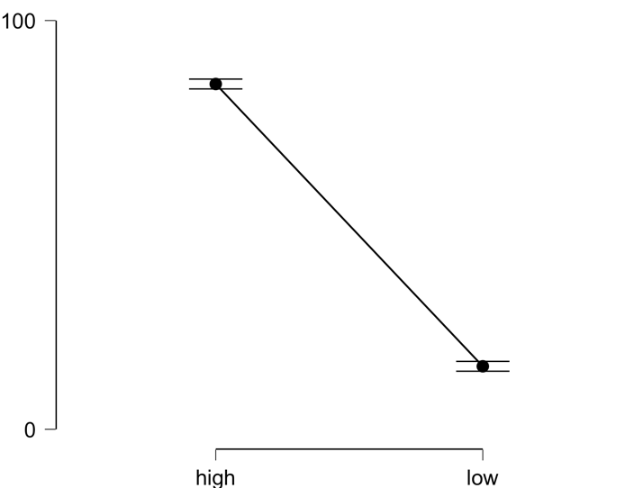

**Bayesian Paired Samples T-Test**

| **Bayesian Paired Samples T-Test** | | | | | | | | | |
| --- | --- | --- | --- | --- | --- | --- | --- | --- | --- |
|  | |  | |  | | **BF₁₀** | | **error %** | |
| high |  | - |  | low |  | 5.759e +295 |  | 2.447e -302 |  |
|  | | | | | | | | | |

**Inferential Plots**

**high - low**

**Prior and Posterior**

