**Results**

**Repeated Measures ANOVA**

| **Within Subjects Effects** | | | | | | | | | | | | | | | | | |
| --- | --- | --- | --- | --- | --- | --- | --- | --- | --- | --- | --- | --- | --- | --- | --- | --- | --- |
|  | | **Sphericity Correction** | | **Sum of Squares** | | **df** | | **Mean Square** | | **F** | | **p** | | **η² p** | | **ω²** | |
| ROI |  | Greenhouse-Geisser |  | 0.187 | ᵃ | 4.314 | ᵃ | 0.043 | ᵃ | 28.663 | ᵃ | 1.094e -17 | ᵃ | 0.497 |  | 0.232 |  |
| Residual |  | Greenhouse-Geisser |  | 0.190 |  | 125.111 |  | 0.002 |  |  |  |  |  |  |  |  |  |
|  | | | | | | | | | | | | | | | | | |
| *Note.*  Type III Sum of Squares | | | | | | | | | | | | | | | | | |
| ᵃ Mauchly's test of sphericity indicates that the assumption of sphericity is violated (p < .05). | | | | | | | | | | | | | | | | | |

| **Between Subjects Effects** | | | | | | | | | | | | | | | |
| --- | --- | --- | --- | --- | --- | --- | --- | --- | --- | --- | --- | --- | --- | --- | --- |
|  | | **Sum of Squares** | | **df** | | **Mean Square** | | **F** | | **p** | | **η² p** | | **ω²** | |
| Residual |  | 0.390 |  | 29 |  | 0.013 |  |  |  |  |  |  |  |  |  |
|  | | | | | | | | | | | | | | | |
| *Note.*  Type III Sum of Squares | | | | | | | | | | | | | | | |

**Post Hoc Tests**

| **Post Hoc Comparisons - ROI** | | | | | | | | | | | | | | | | | | | |
| --- | --- | --- | --- | --- | --- | --- | --- | --- | --- | --- | --- | --- | --- | --- | --- | --- | --- | --- | --- |
|  | | | | | | **95% CI of Mean Difference** | | | |  | | | | | | | | | |
|  | |  | | **Mean Difference** | | **Lower** | | **Upper** | | **SE** | | **t** | | **Cohen's d** | | **p holm** | | **p bonf** | |
| ACC |  | ATL |  | 0.036 |  | 0.007 |  | 0.066 |  | 0.008 |  | 4.311 |  | 0.787 |  | 0.003 |  | 0.006 |  |
|  |  | IFG |  | -0.008 |  | -0.029 |  | 0.013 |  | 0.006 |  | -1.359 |  | -0.248 |  | 0.674 |  | 1.000 |  |
|  |  | Ins |  | 0.015 |  | -0.008 |  | 0.038 |  | 0.006 |  | 2.292 |  | 0.418 |  | 0.264 |  | 1.000 |  |
|  |  | LTL |  | -0.038 |  | -0.064 |  | -0.012 |  | 0.007 |  | -5.245 |  | -0.958 |  | 3.209e -4 |  | 4.621e -4 |  |
|  |  | PCC |  | 0.025 |  | 0.004 |  | 0.047 |  | 0.006 |  | 4.143 |  | 0.756 |  | 0.004 |  | 0.010 |  |
|  |  | Prec |  | -0.009 |  | -0.028 |  | 0.010 |  | 0.005 |  | -1.638 |  | -0.299 |  | 0.674 |  | 1.000 |  |
|  |  | V1 |  | 0.057 |  | 0.024 |  | 0.090 |  | 0.009 |  | 6.084 |  | 1.111 |  | 3.543e -5 |  | 4.556e -5 |  |
|  |  | aPFC |  | 0.013 |  | -0.009 |  | 0.034 |  | 0.006 |  | 2.051 |  | 0.374 |  | 0.346 |  | 1.000 |  |
| ATL |  | IFG |  | -0.044 |  | -0.071 |  | -0.018 |  | 0.007 |  | -5.894 |  | -1.076 |  | 5.753e -5 |  | 7.670e -5 |  |
|  |  | Ins |  | -0.021 |  | -0.044 |  | 0.002 |  | 0.007 |  | -3.255 |  | -0.594 |  | 0.037 |  | 0.104 |  |
|  |  | LTL |  | -0.074 |  | -0.108 |  | -0.040 |  | 0.010 |  | -7.746 |  | -1.414 |  | 5.050e -7 |  | 5.509e -7 |  |
|  |  | PCC |  | -0.011 |  | -0.034 |  | 0.013 |  | 0.007 |  | -1.619 |  | -0.296 |  | 0.674 |  | 1.000 |  |
|  |  | Prec |  | -0.045 |  | -0.074 |  | -0.016 |  | 0.008 |  | -5.507 |  | -1.005 |  | 1.615e -4 |  | 2.236e -4 |  |
|  |  | V1 |  | 0.021 |  | -0.004 |  | 0.046 |  | 0.007 |  | 2.918 |  | 0.533 |  | 0.071 |  | 0.242 |  |
|  |  | aPFC |  | -0.024 |  | -0.052 |  | 0.005 |  | 0.008 |  | -2.937 |  | -0.536 |  | 0.071 |  | 0.231 |  |
| IFG |  | Ins |  | 0.023 |  | 0.006 |  | 0.040 |  | 0.005 |  | 4.669 |  | 0.852 |  | 0.001 |  | 0.002 |  |
|  |  | LTL |  | -0.030 |  | -0.054 |  | -0.006 |  | 0.007 |  | -4.476 |  | -0.817 |  | 0.002 |  | 0.004 |  |
|  |  | PCC |  | 0.033 |  | 0.010 |  | 0.057 |  | 0.007 |  | 4.975 |  | 0.908 |  | 6.522e -4 |  | 9.783e -4 |  |
|  |  | Prec |  | -8.036e -4 |  | -0.022 |  | 0.020 |  | 0.006 |  | -0.134 |  | -0.024 |  | 1.000 |  | 1.000 |  |
|  |  | V1 |  | 0.065 |  | 0.033 |  | 0.096 |  | 0.009 |  | 7.299 |  | 1.333 |  | 1.557e -6 |  | 1.752e -6 |  |
|  |  | aPFC |  | 0.021 |  | -0.003 |  | 0.044 |  | 0.007 |  | 3.120 |  | 0.570 |  | 0.049 |  | 0.147 |  |
| Ins |  | LTL |  | -0.053 |  | -0.081 |  | -0.025 |  | 0.008 |  | -6.589 |  | -1.203 |  | 9.639e -6 |  | 1.157e -5 |  |
|  |  | PCC |  | 0.011 |  | -0.007 |  | 0.028 |  | 0.005 |  | 2.115 |  | 0.386 |  | 0.345 |  | 1.000 |  |
|  |  | Prec |  | -0.024 |  | -0.047 |  | -2.401e -4 |  | 0.007 |  | -3.572 |  | -0.652 |  | 0.018 |  | 0.045 |  |
|  |  | V1 |  | 0.042 |  | 0.021 |  | 0.063 |  | 0.006 |  | 7.192 |  | 1.313 |  | 1.999e -6 |  | 2.322e -6 |  |
|  |  | aPFC |  | -0.002 |  | -0.029 |  | 0.025 |  | 0.008 |  | -0.293 |  | -0.053 |  | 1.000 |  | 1.000 |  |
| LTL |  | PCC |  | 0.064 |  | 0.029 |  | 0.098 |  | 0.010 |  | 6.558 |  | 1.197 |  | 1.012e -5 |  | 1.256e -5 |  |
|  |  | Prec |  | 0.029 |  | 0.007 |  | 0.052 |  | 0.006 |  | 4.606 |  | 0.841 |  | 0.002 |  | 0.003 |  |
|  |  | V1 |  | 0.095 |  | 0.059 |  | 0.131 |  | 0.010 |  | 9.369 |  | 1.711 |  | 1.019e -8 |  | 1.019e -8 |  |
|  |  | aPFC |  | 0.051 |  | 0.029 |  | 0.073 |  | 0.006 |  | 8.075 |  | 1.474 |  | 2.320e -7 |  | 2.386e -7 |  |
| PCC |  | Prec |  | -0.034 |  | -0.058 |  | -0.010 |  | 0.007 |  | -4.971 |  | -0.908 |  | 6.522e -4 |  | 9.904e -4 |  |
|  |  | V1 |  | 0.032 |  | 0.005 |  | 0.058 |  | 0.007 |  | 4.246 |  | 0.775 |  | 0.003 |  | 0.007 |  |
|  |  | aPFC |  | -0.013 |  | -0.043 |  | 0.017 |  | 0.008 |  | -1.515 |  | -0.277 |  | 0.674 |  | 1.000 |  |
| Prec |  | V1 |  | 0.066 |  | 0.036 |  | 0.095 |  | 0.008 |  | 7.920 |  | 1.446 |  | 3.337e -7 |  | 3.534e -7 |  |
|  |  | aPFC |  | 0.021 |  | 9.485e -4 |  | 0.042 |  | 0.006 |  | 3.700 |  | 0.675 |  | 0.013 |  | 0.032 |  |
| V1 |  | aPFC |  | -0.044 |  | -0.080 |  | -0.009 |  | 0.010 |  | -4.402 |  | -0.804 |  | 0.003 |  | 0.005 |  |
|  | | | | | | | | | | | | | | | | | | | |
| *Note.*  Cohen's d does not correct for multiple comparisons. | | | | | | | | | | | | | | | | | | | |
| *Note.*  Bonferroni adjusted confidence intervals. | | | | | | | | | | | | | | | | | | | |

**Descriptives**

| **Descriptives** | | | | | | | |
| --- | --- | --- | --- | --- | --- | --- | --- |
| **ROI** | | **Mean** | | **SD** | | **N** | |
| LTL |  | 0.466 |  | 0.067 |  | 30 |  |
| IFG |  | 0.436 |  | 0.051 |  | 30 |  |
| Prec |  | 0.436 |  | 0.049 |  | 30 |  |
| ATL |  | 0.392 |  | 0.039 |  | 30 |  |
| aPFC |  | 0.415 |  | 0.059 |  | 30 |  |
| Ins |  | 0.413 |  | 0.034 |  | 30 |  |
| ACC |  | 0.428 |  | 0.052 |  | 30 |  |
| PCC |  | 0.402 |  | 0.030 |  | 30 |  |
| V1 |  | 0.371 |  | 0.030 |  | 30 |  |
|  | | | | | | | |

**Descriptives Plot**

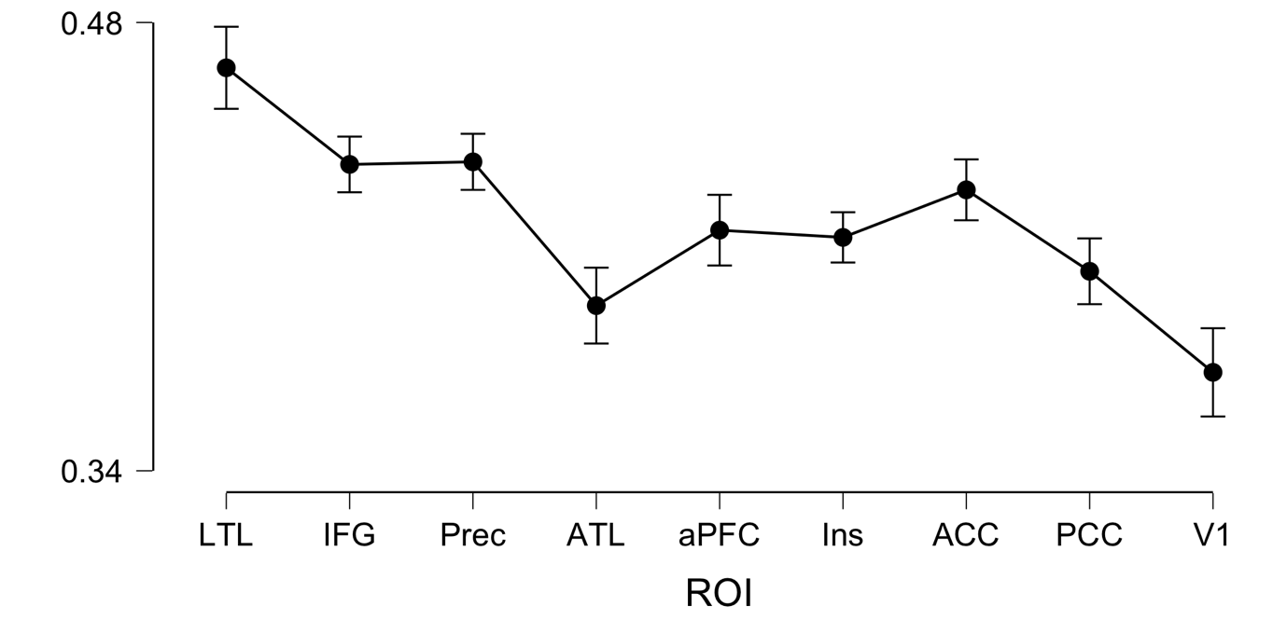

**Descriptive Statistics**

**Repeated Measures ANOVA**

| **Within Subjects Effects** | | | | | | | | | | | |
| --- | --- | --- | --- | --- | --- | --- | --- | --- | --- | --- | --- |
|  | | **Sum of Squares** | | **df** | | **Mean Square** | | **F** | | **p** | |
| ROI |  | 0.095 |  | 8 |  | 0.012 |  | 24.114 |  | 8.625e -27 |  |
| Residual |  | 0.114 |  | 232 |  | 4.924e -4 |  |  |  |  |  |
| Condition |  | 2.331 |  | 1 |  | 2.331 |  | 273.462 |  | 2.645e -16 |  |
| Residual |  | 0.247 |  | 29 |  | 0.009 |  |  |  |  |  |
| ROI ✻ Condition |  | 0.096 | ᵃ | 8 | ᵃ | 0.012 | ᵃ | 20.719 | ᵃ | 1.426e -23 | ᵃ |
| Residual |  | 0.134 |  | 232 |  | 5.762e -4 |  |  |  |  |  |
|  | | | | | | | | | | | |
| *Note.*  Type III Sum of Squares | | | | | | | | | | | |
| ᵃ Mauchly's test of sphericity indicates that the assumption of sphericity is violated (p < .05). | | | | | | | | | | | |

| **Between Subjects Effects** | | | | | | | | | | | |
| --- | --- | --- | --- | --- | --- | --- | --- | --- | --- | --- | --- |
|  | | **Sum of Squares** | | **df** | | **Mean Square** | | **F** | | **p** | |
| Residual |  | 0.191 |  | 29 |  | 0.007 |  |  |  |  |  |
|  | | | | | | | | | | | |
| *Note.*  Type III Sum of Squares | | | | | | | | | | | |

**Descriptives**

**Descriptives Plot**

