**Results**

**Paired Samples T-Test**

| **Paired Samples T-Test** | | | | | | | | | | | | | | | | | | | | | | | | | |
| --- | --- | --- | --- | --- | --- | --- | --- | --- | --- | --- | --- | --- | --- | --- | --- | --- | --- | --- | --- | --- | --- | --- | --- | --- | --- |
|  | | | | | | | | | | | | | | | | **95% CI for Mean Difference** | | | |  | | **95% CI for Cohen's d** | | | |
|  | |  | |  | | **t** | | **df** | | **p** | | **Mean Difference** | | **SE Difference** | | **Lower** | | **Upper** | | **Cohen's d** | | **Lower** | | **Upper** | |
| LTL_em |  | - |  | LTL_ch |  | 12.365 |  | 29 |  | 4.361e -13 |  | 0.176 |  | 0.014 |  | 0.147 |  | 0.205 |  | 2.258 |  | 1.572 |  | 2.932 |  |
|  | | | | | | | | | | | | | | | | | | | | | | | | | |
| *Note.*  Student's t-test. | | | | | | | | | | | | | | | | | | | | | | | | | |

**Assumption Checks**

| **Test of Normality (Shapiro-Wilk)** | | | | | | | | | |
| --- | --- | --- | --- | --- | --- | --- | --- | --- | --- |
|  | |  | |  | | **W** | | **p** | |
| LTL_em |  | - |  | LTL_ch |  | 0.977 |  | 0.751 |  |
|  | | | | | | | | | |
| *Note.*  Significant results suggest a deviation from normality. | | | | | | | | | |

**Descriptives**

| **Descriptives** | | | | | | | | | |
| --- | --- | --- | --- | --- | --- | --- | --- | --- | --- |
|  | | **N** | | **Mean** | | **SD** | | **SE** | |
| LTL_em |  | 30 |  | 0.466 |  | 0.067 |  | 0.012 |  |
| LTL_ch |  | 30 |  | 0.290 |  | 0.021 |  | 0.004 |  |
|  | | | | | | | | | |

**Descriptives Plot**

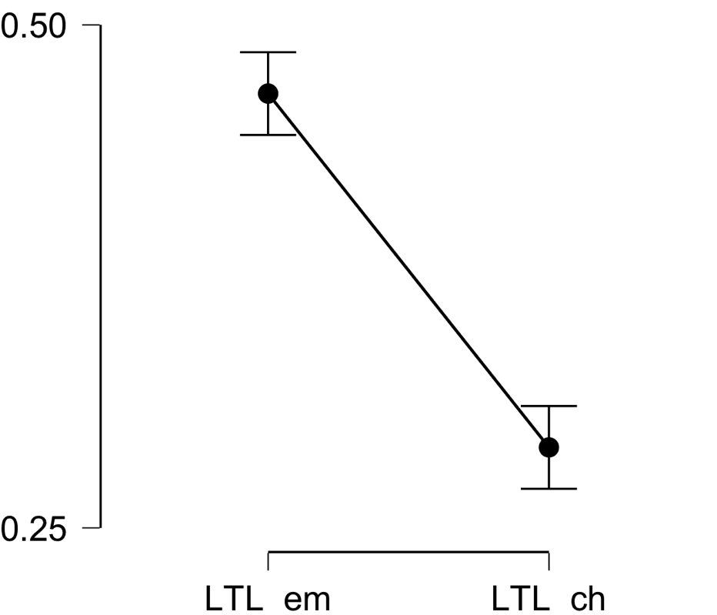

**Bayesian Paired Samples T-Test**

| **Bayesian Paired Samples T-Test** | | | | | | | | | |
| --- | --- | --- | --- | --- | --- | --- | --- | --- | --- |
|  | |  | |  | | **BF₁₀** | | **error %** | |
| LTL_em |  | - |  | LTL_ch |  | 1.756e +10 |  | 1.396e -14 |  |
|  | | | | | | | | | |

**Inferential Plots**

**LTL_em - LTL_ch**

**Prior and Posterior**

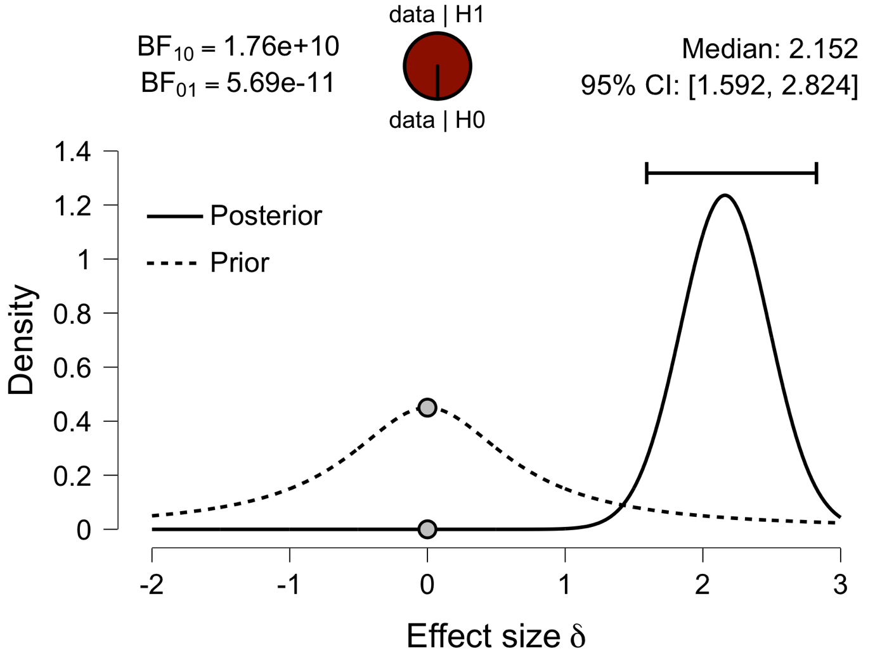

**Paired Samples T-Test**

| **Paired Samples T-Test** | | | | | | | | | | | | | | | | | | | | | | | | | |
| --- | --- | --- | --- | --- | --- | --- | --- | --- | --- | --- | --- | --- | --- | --- | --- | --- | --- | --- | --- | --- | --- | --- | --- | --- | --- |
|  | | | | | | | | | | | | | | | | **95% CI for Mean Difference** | | | |  | | **95% CI for Cohen's d** | | | |
|  | |  | |  | | **t** | | **df** | | **p** | | **Mean Difference** | | **SE Difference** | | **Lower** | | **Upper** | | **Cohen's d** | | **Lower** | | **Upper** | |
| IFG_em |  | - |  | IFG_ch |  | 15.920 |  | 29 |  | 7.159e -16 |  | 0.153 |  | 0.010 |  | 0.134 |  | 0.173 |  | 2.907 |  | 2.076 |  | 3.727 |  |
|  | | | | | | | | | | | | | | | | | | | | | | | | | |
| *Note.*  Student's t-test. | | | | | | | | | | | | | | | | | | | | | | | | | |

**Assumption Checks**

| **Test of Normality (Shapiro-Wilk)** | | | | | | | | | |
| --- | --- | --- | --- | --- | --- | --- | --- | --- | --- |
|  | |  | |  | | **W** | | **p** | |
| IFG_em |  | - |  | IFG_ch |  | 0.971 |  | 0.557 |  |
|  | | | | | | | | | |
| *Note.*  Significant results suggest a deviation from normality. | | | | | | | | | |

**Descriptives**

| **Descriptives** | | | | | | | | | |
| --- | --- | --- | --- | --- | --- | --- | --- | --- | --- |
|  | | **N** | | **Mean** | | **SD** | | **SE** | |
| IFG_em |  | 30 |  | 0.436 |  | 0.051 |  | 0.009 |  |
| IFG_ch |  | 30 |  | 0.282 |  | 0.017 |  | 0.003 |  |
|  | | | | | | | | | |

**Descriptives Plot**

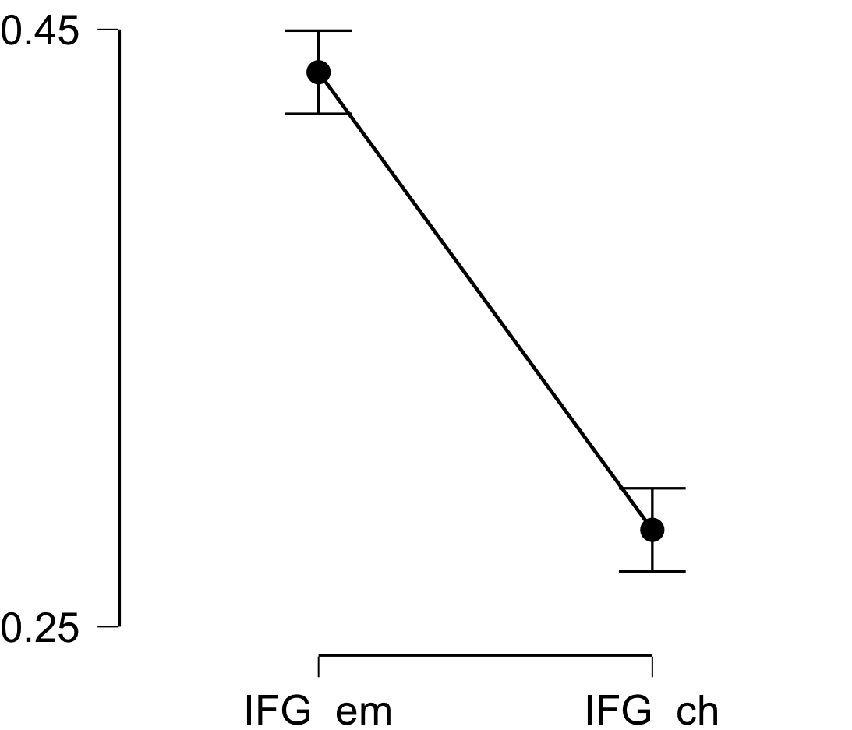

**Bayesian Paired Samples T-Test**

| **Bayesian Paired Samples T-Test** | | | | | | | | | |
| --- | --- | --- | --- | --- | --- | --- | --- | --- | --- |
|  | |  | |  | | **BF₁₀** | | **error %** | |
| IFG_em |  | - |  | IFG_ch |  | 8.071e +12 |  | 1.229e -17 |  |
|  | | | | | | | | | |

**Inferential Plots**

**IFG_em - IFG_ch**

**Prior and Posterior**

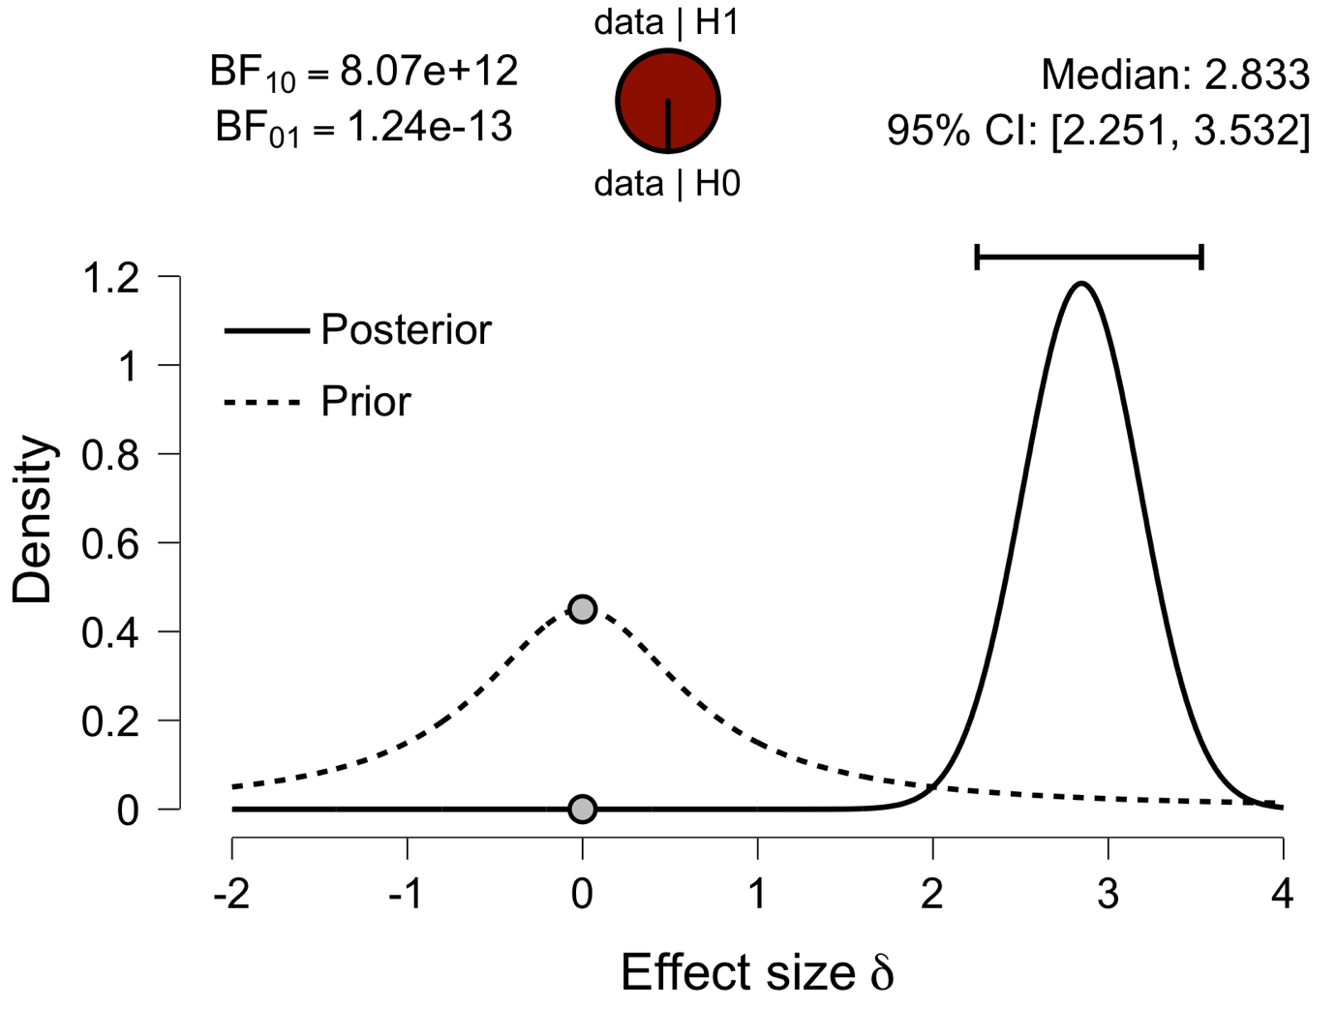

**Paired Samples T-Test**

| **Paired Samples T-Test** | | | | | | | | | | | | | | | | | | | | | | | | | |
| --- | --- | --- | --- | --- | --- | --- | --- | --- | --- | --- | --- | --- | --- | --- | --- | --- | --- | --- | --- | --- | --- | --- | --- | --- | --- |
|  | | | | | | | | | | | | | | | | **95% CI for Mean Difference** | | | |  | | **95% CI for Cohen's d** | | | |
|  | |  | |  | | **t** | | **df** | | **p** | | **Mean Difference** | | **SE Difference** | | **Lower** | | **Upper** | | **Cohen's d** | | **Lower** | | **Upper** | |
| Prec_em |  | - |  | Prec_ch |  | 15.142 |  | 29 |  | 2.634e -15 |  | 0.150 |  | 0.010 |  | 0.130 |  | 0.171 |  | 2.765 |  | 1.966 |  | 3.552 |  |
|  | | | | | | | | | | | | | | | | | | | | | | | | | |
| *Note.*  Student's t-test. | | | | | | | | | | | | | | | | | | | | | | | | | |

**Assumption Checks**

| **Test of Normality (Shapiro-Wilk)** | | | | | | | | | |
| --- | --- | --- | --- | --- | --- | --- | --- | --- | --- |
|  | |  | |  | | **W** | | **p** | |
| Prec_em |  | - |  | Prec_ch |  | 0.971 |  | 0.572 |  |
|  | | | | | | | | | |
| *Note.*  Significant results suggest a deviation from normality. | | | | | | | | | |

**Descriptives**

| **Descriptives** | | | | | | | | | |
| --- | --- | --- | --- | --- | --- | --- | --- | --- | --- |
|  | | **N** | | **Mean** | | **SD** | | **SE** | |
| Prec_em |  | 30 |  | 0.436 |  | 0.049 |  | 0.009 |  |
| Prec_ch |  | 30 |  | 0.286 |  | 0.019 |  | 0.004 |  |
|  | | | | | | | | | |

**Descriptives Plot**

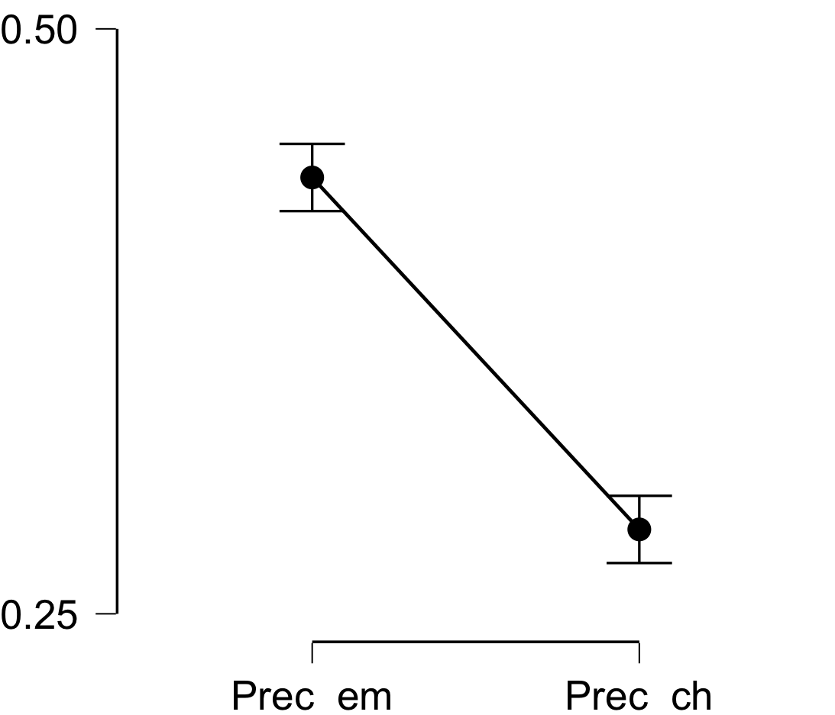

**Bayesian Paired Samples T-Test**

| **Bayesian Paired Samples T-Test** | | | | | | | | | |
| --- | --- | --- | --- | --- | --- | --- | --- | --- | --- |
|  | |  | |  | | **BF₁₀** | | **error %** | |
| Prec_em |  | - |  | Prec_ch |  | 2.318e +12 |  | 1.907e -17 |  |
|  | | | | | | | | | |

**Inferential Plots**

**Prec_em - Prec_ch**

**Prior and Posterior**

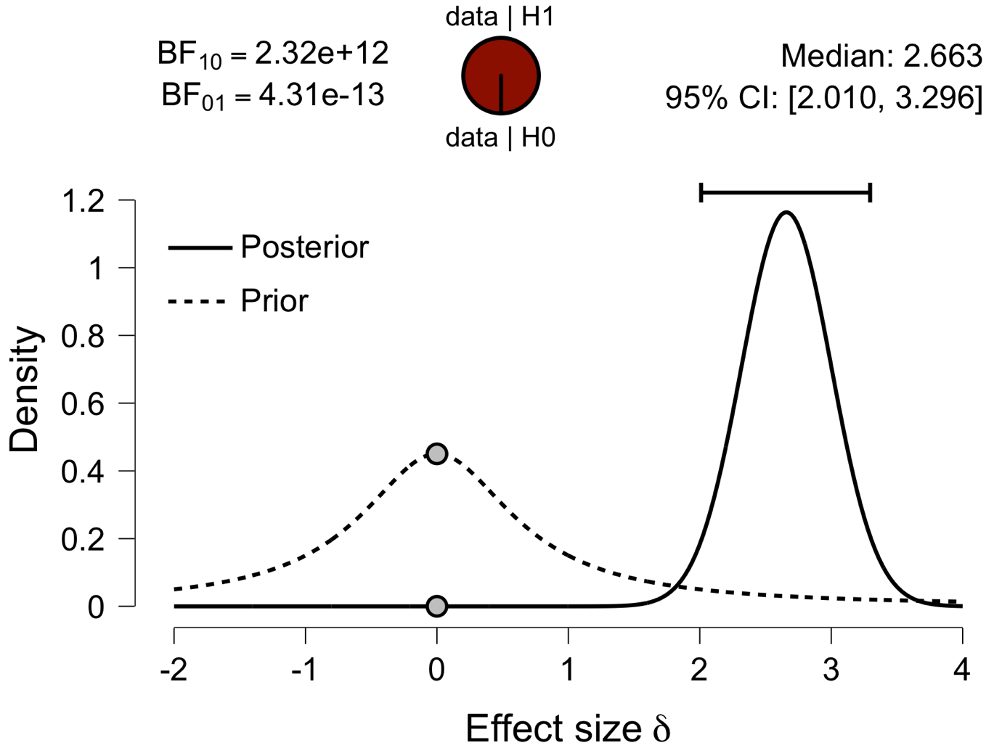

**Paired Samples T-Test**

| **Paired Samples T-Test** | | | | | | | | | | | | | | | | | | | | | | | | | |
| --- | --- | --- | --- | --- | --- | --- | --- | --- | --- | --- | --- | --- | --- | --- | --- | --- | --- | --- | --- | --- | --- | --- | --- | --- | --- |
|  | | | | | | | | | | | | | | | | **95% CI for Mean Difference** | | | |  | | **95% CI for Cohen's d** | | | |
|  | |  | |  | | **t** | | **df** | | **p** | | **Mean Difference** | | **SE Difference** | | **Lower** | | **Upper** | | **Cohen's d** | | **Lower** | | **Upper** | |
| ATL_em |  | - |  | ATL_ch |  | 14.757 |  | 29 |  | 5.120e -15 |  | 0.108 |  | 0.007 |  | 0.093 |  | 0.123 |  | 2.694 |  | 1.912 |  | 3.466 |  |
|  | | | | | | | | | | | | | | | | | | | | | | | | | |
| *Note.*  Student's t-test. | | | | | | | | | | | | | | | | | | | | | | | | | |

**Assumption Checks**

| **Test of Normality (Shapiro-Wilk)** | | | | | | | | | |
| --- | --- | --- | --- | --- | --- | --- | --- | --- | --- |
|  | |  | |  | | **W** | | **p** | |
| ATL_em |  | - |  | ATL_ch |  | 0.947 |  | 0.140 |  |
|  | | | | | | | | | |
| *Note.*  Significant results suggest a deviation from normality. | | | | | | | | | |

**Descriptives**

| **Descriptives** | | | | | | | | | |
| --- | --- | --- | --- | --- | --- | --- | --- | --- | --- |
|  | | **N** | | **Mean** | | **SD** | | **SE** | |
| ATL_em |  | 30 |  | 0.392 |  | 0.039 |  | 0.007 |  |
| ATL_ch |  | 30 |  | 0.284 |  | 0.018 |  | 0.003 |  |
|  | | | | | | | | | |

**Descriptives Plot**

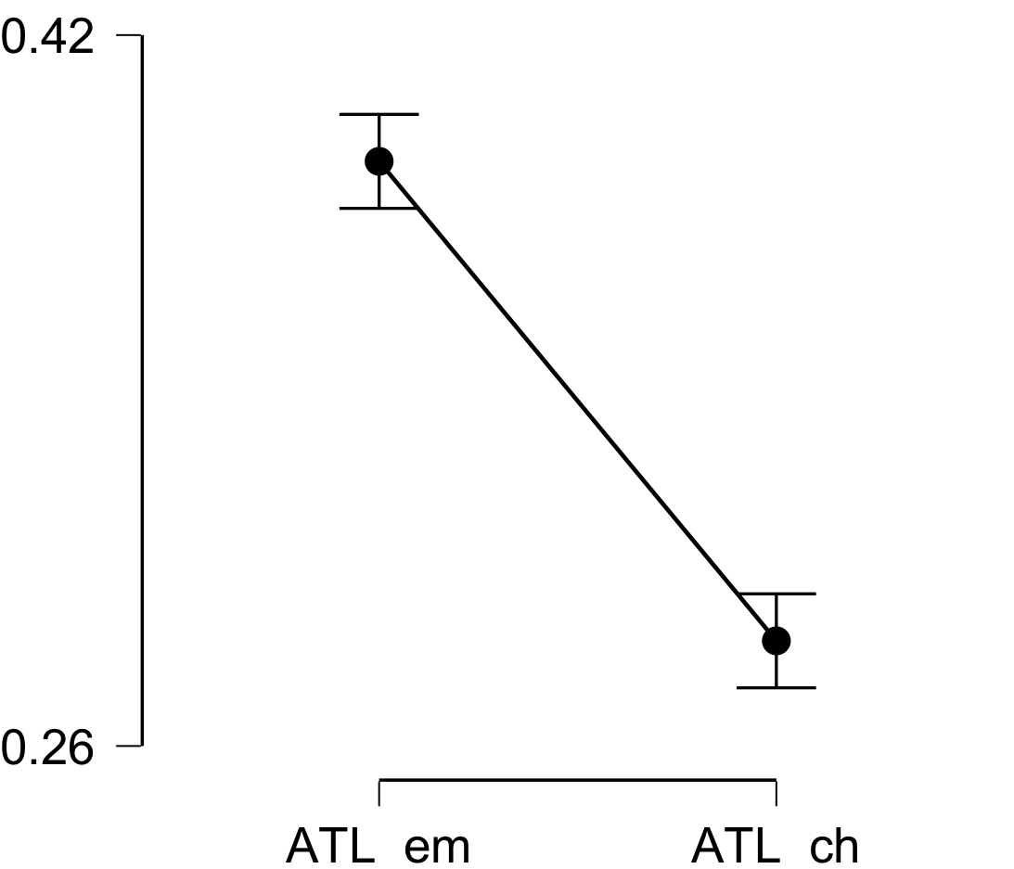

**Bayesian Paired Samples T-Test**

| **Bayesian Paired Samples T-Test** | | | | | | | | | |
| --- | --- | --- | --- | --- | --- | --- | --- | --- | --- |
|  | |  | |  | | **BF₁₀** | | **error %** | |
| ATL_em |  | - |  | ATL_ch |  | 1.227e +12 |  | 3.770e -15 |  |
|  | | | | | | | | | |

**Inferential Plots**

**ATL_em - ATL_ch**

**Prior and Posterior**

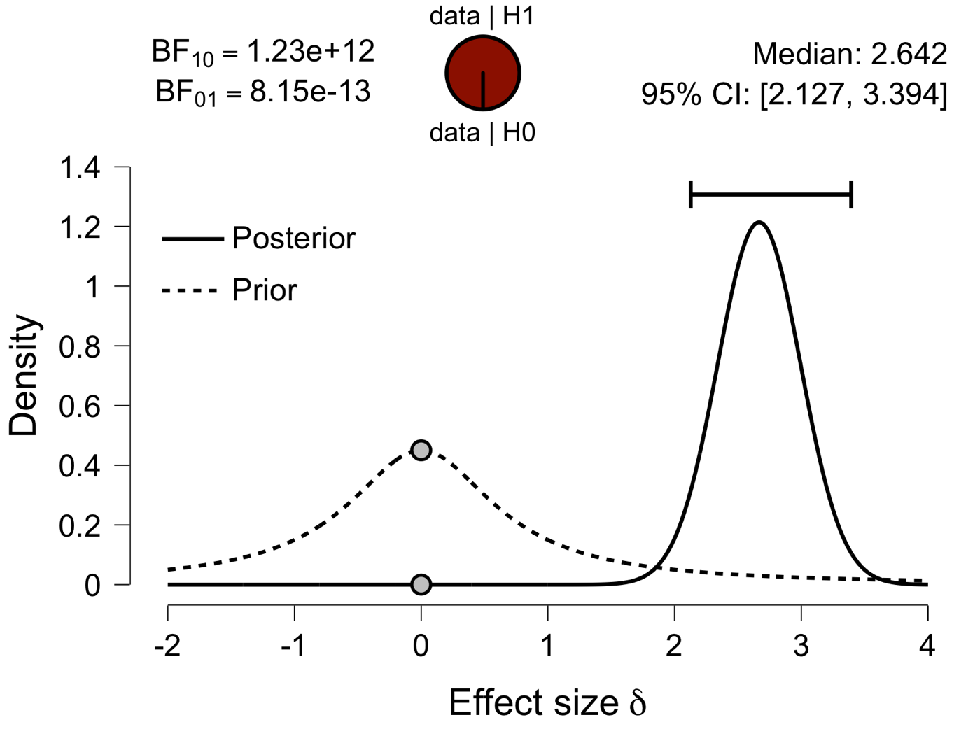

**Paired Samples T-Test**

| **Paired Samples T-Test** | | | | | | | | | | | | | | | | | | | | | | | | | |
| --- | --- | --- | --- | --- | --- | --- | --- | --- | --- | --- | --- | --- | --- | --- | --- | --- | --- | --- | --- | --- | --- | --- | --- | --- | --- |
|  | | | | | | | | | | | | | | | | **95% CI for Mean Difference** | | | |  | | **95% CI for Cohen's d** | | | |
|  | |  | |  | | **t** | | **df** | | **p** | | **Mean Difference** | | **SE Difference** | | **Lower** | | **Upper** | | **Cohen's d** | | **Lower** | | **Upper** | |
| aPFC_em |  | - |  | aPFC_ch |  | 10.969 |  | 29 |  | 7.773e -12 |  | 0.131 |  | 0.012 |  | 0.107 |  | 0.156 |  | 2.003 |  | 1.371 |  | 2.622 |  |
|  | | | | | | | | | | | | | | | | | | | | | | | | | |
| *Note.*  Student's t-test. | | | | | | | | | | | | | | | | | | | | | | | | | |

**Assumption Checks**

| **Test of Normality (Shapiro-Wilk)** | | | | | | | | | |
| --- | --- | --- | --- | --- | --- | --- | --- | --- | --- |
|  | |  | |  | | **W** | | **p** | |
| aPFC_em |  | - |  | aPFC_ch |  | 0.933 |  | 0.058 |  |
|  | | | | | | | | | |
| *Note.*  Significant results suggest a deviation from normality. | | | | | | | | | |

**Descriptives**

| **Descriptives** | | | | | | | | | |
| --- | --- | --- | --- | --- | --- | --- | --- | --- | --- |
|  | | **N** | | **Mean** | | **SD** | | **SE** | |
| aPFC_em |  | 30 |  | 0.415 |  | 0.059 |  | 0.011 |  |
| aPFC_ch |  | 30 |  | 0.284 |  | 0.019 |  | 0.004 |  |
|  | | | | | | | | | |

**Descriptives Plot**

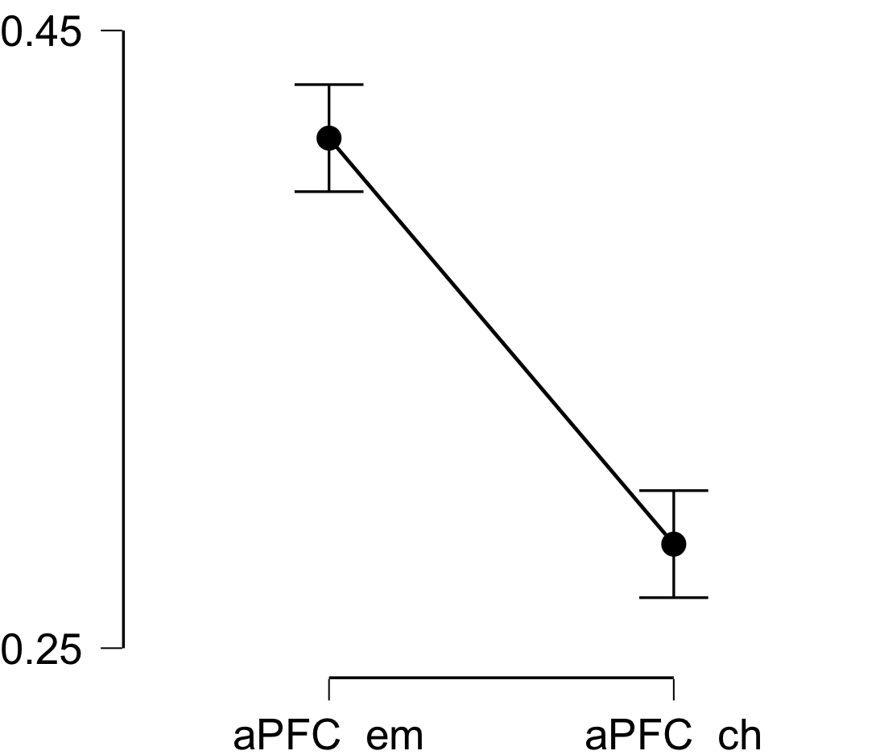

**Bayesian Paired Samples T-Test**

| **Bayesian Paired Samples T-Test** | | | | | | | | | |
| --- | --- | --- | --- | --- | --- | --- | --- | --- | --- |
|  | |  | |  | | **BF₁₀** | | **error %** | |
| aPFC_em |  | - |  | aPFC_ch |  | 1.131e +9 |  | 3.508e -13 |  |
|  | | | | | | | | | |

**Inferential Plots**

**aPFC_em - aPFC_ch**

**Prior and Posterior**

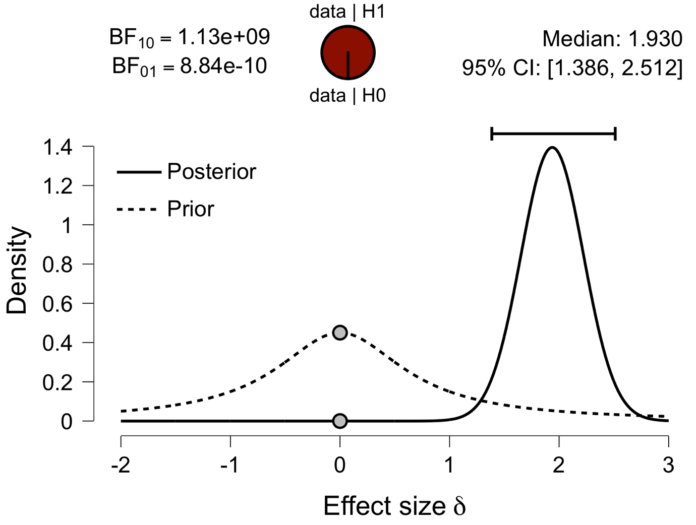

**Paired Samples T-Test**

| **Paired Samples T-Test** | | | | | | | | | | | | | | | | | | | | | | | | | |
| --- | --- | --- | --- | --- | --- | --- | --- | --- | --- | --- | --- | --- | --- | --- | --- | --- | --- | --- | --- | --- | --- | --- | --- | --- | --- |
|  | | | | | | | | | | | | | | | | **95% CI for Mean Difference** | | | |  | | **95% CI for Cohen's d** | | | |
|  | |  | |  | | **t** | | **df** | | **p** | | **Mean Difference** | | **SE Difference** | | **Lower** | | **Upper** | | **Cohen's d** | | **Lower** | | **Upper** | |
| Ins_em |  | - |  | Ins_ch |  | 15.374 |  | 29 |  | 1.778e -15 |  | 0.121 |  | 0.008 |  | 0.105 |  | 0.137 |  | 2.807 |  | 1.999 |  | 3.604 |  |
|  | | | | | | | | | | | | | | | | | | | | | | | | | |
| *Note.*  Student's t-test. | | | | | | | | | | | | | | | | | | | | | | | | | |

**Assumption Checks**

| **Test of Normality (Shapiro-Wilk)** | | | | | | | | | |
| --- | --- | --- | --- | --- | --- | --- | --- | --- | --- |
|  | |  | |  | | **W** | | **p** | |
| Ins_em |  | - |  | Ins_ch |  | 0.980 |  | 0.836 |  |
|  | | | | | | | | | |
| *Note.*  Significant results suggest a deviation from normality. | | | | | | | | | |

**Descriptives**

| **Descriptives** | | | | | | | | | |
| --- | --- | --- | --- | --- | --- | --- | --- | --- | --- |
|  | | **N** | | **Mean** | | **SD** | | **SE** | |
| Ins_em |  | 30 |  | 0.413 |  | 0.034 |  | 0.006 |  |
| Ins_ch |  | 30 |  | 0.292 |  | 0.023 |  | 0.004 |  |
|  | | | | | | | | | |

**Descriptives Plot**

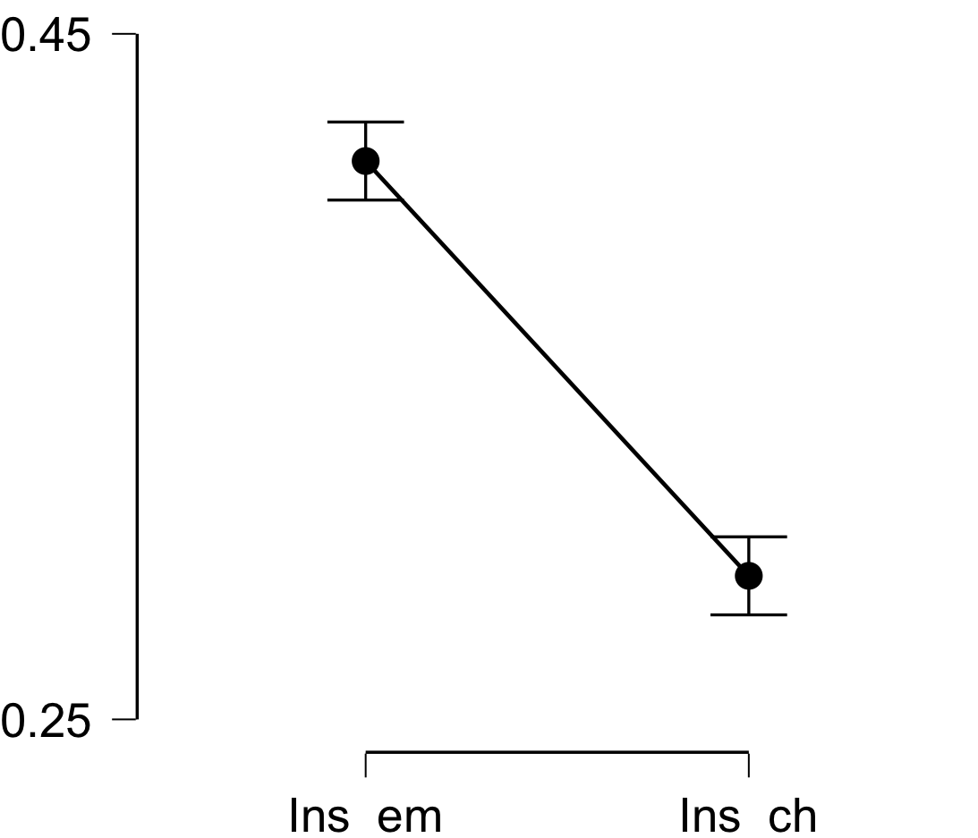

**Bayesian Paired Samples T-Test**

| **Bayesian Paired Samples T-Test** | | | | | | | | | |
| --- | --- | --- | --- | --- | --- | --- | --- | --- | --- |
|  | |  | |  | | **BF₁₀** | | **error %** | |
| Ins_em |  | - |  | Ins_ch |  | 3.377e +12 |  | 1.894e -17 |  |
|  | | | | | | | | | |

**Inferential Plots**

**Ins_em - Ins_ch**

**Prior and Posterior**

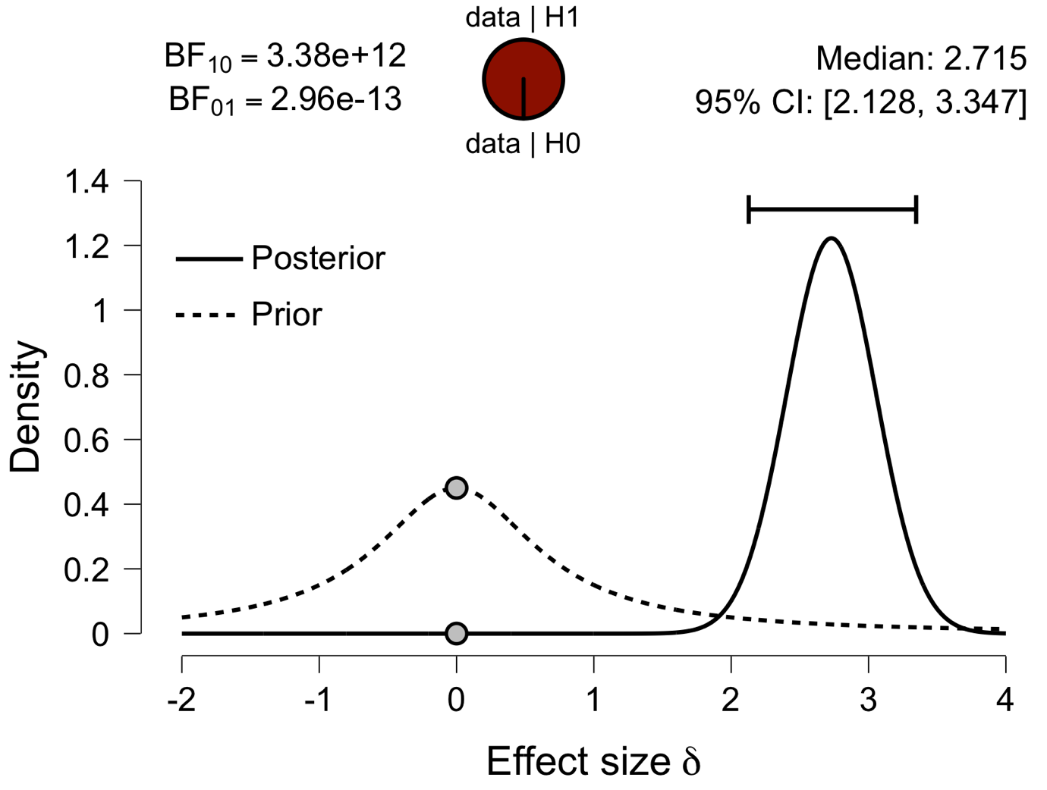

**Paired Samples T-Test**

| **Paired Samples T-Test** | | | | | | | | | | | | | | | | | | | | | | | | | |
| --- | --- | --- | --- | --- | --- | --- | --- | --- | --- | --- | --- | --- | --- | --- | --- | --- | --- | --- | --- | --- | --- | --- | --- | --- | --- |
|  | | | | | | | | | | | | | | | | **95% CI for Mean Difference** | | | |  | | **95% CI for Cohen's d** | | | |
|  | |  | |  | | **t** | | **df** | | **p** | | **Mean Difference** | | **SE Difference** | | **Lower** | | **Upper** | | **Cohen's d** | | **Lower** | | **Upper** | |
| ACC_em |  | - |  | ACC_ch |  | 12.792 |  | 29 |  | 1.888e -13 |  | 0.144 |  | 0.011 |  | 0.121 |  | 0.167 |  | 2.336 |  | 1.633 |  | 3.027 |  |
|  | | | | | | | | | | | | | | | | | | | | | | | | | |
| *Note.*  Student's t-test. | | | | | | | | | | | | | | | | | | | | | | | | | |

**Assumption Checks**

| **Test of Normality (Shapiro-Wilk)** | | | | | | | | | |
| --- | --- | --- | --- | --- | --- | --- | --- | --- | --- |
|  | |  | |  | | **W** | | **p** | |
| ACC_em |  | - |  | ACC_ch |  | 0.970 |  | 0.549 |  |
|  | | | | | | | | | |
| *Note.*  Significant results suggest a deviation from normality. | | | | | | | | | |

**Descriptives**

| **Descriptives** | | | | | | | | | |
| --- | --- | --- | --- | --- | --- | --- | --- | --- | --- |
|  | | **N** | | **Mean** | | **SD** | | **SE** | |
| ACC_em |  | 30 |  | 0.428 |  | 0.052 |  | 0.009 |  |
| ACC_ch |  | 30 |  | 0.284 |  | 0.021 |  | 0.004 |  |
|  | | | | | | | | | |

**Descriptives Plot**

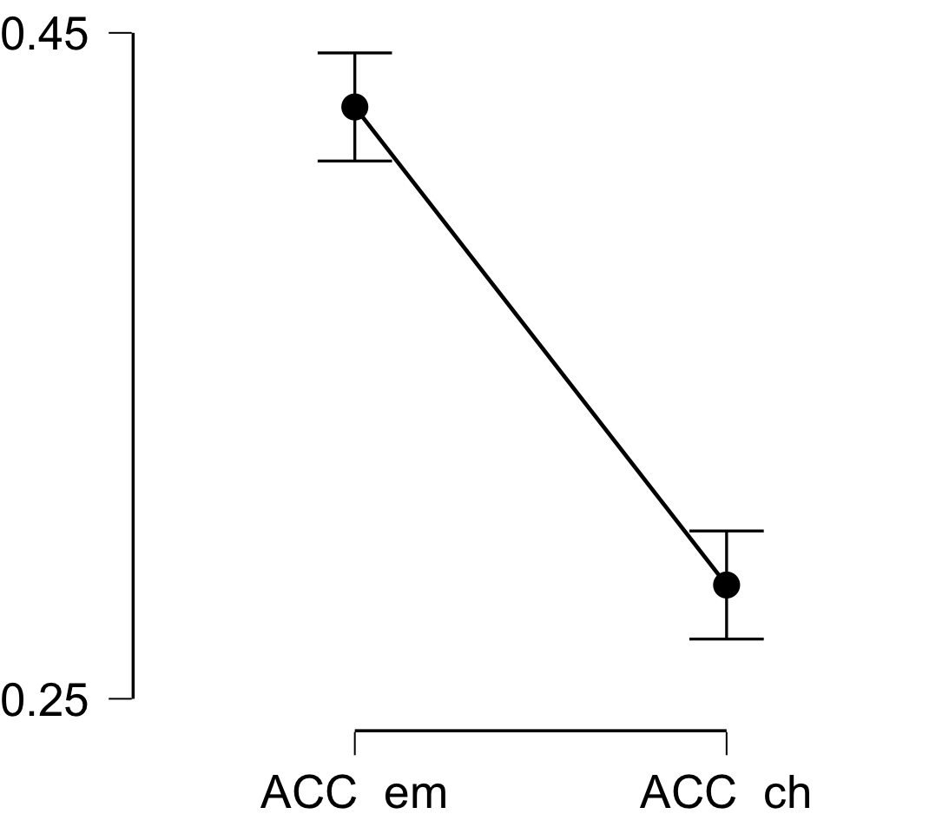

**Bayesian Paired Samples T-Test**

| **Bayesian Paired Samples T-Test** | | | | | | | | | |
| --- | --- | --- | --- | --- | --- | --- | --- | --- | --- |
|  | |  | |  | | **BF₁₀** | | **error %** | |
| ACC_em |  | - |  | ACC_ch |  | 3.905e +10 |  | 4.820e -15 |  |
|  | | | | | | | | | |

**Inferential Plots**

**ACC_em - ACC_ch**

**Prior and Posterior**

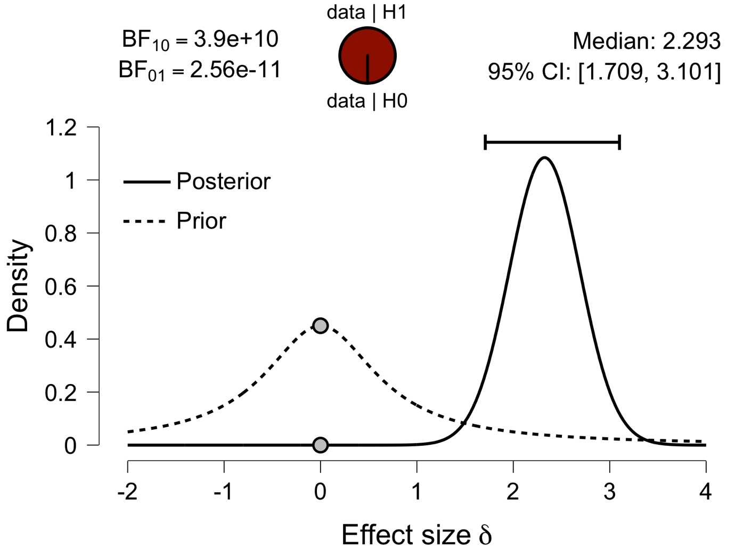

**Paired Samples T-Test**

| **Paired Samples T-Test** | | | | | | | | | | | | | | | | | | | | | | | | | |
| --- | --- | --- | --- | --- | --- | --- | --- | --- | --- | --- | --- | --- | --- | --- | --- | --- | --- | --- | --- | --- | --- | --- | --- | --- | --- |
|  | | | | | | | | | | | | | | | | **95% CI for Mean Difference** | | | |  | | **95% CI for Cohen's d** | | | |
|  | |  | |  | | **t** | | **df** | | **p** | | **Mean Difference** | | **SE Difference** | | **Lower** | | **Upper** | | **Cohen's d** | | **Lower** | | **Upper** | |
| PCC_em |  | - |  | PCC_ch |  | 15.188 |  | 29 |  | 2.433e -15 |  | 0.119 |  | 0.008 |  | 0.103 |  | 0.135 |  | 2.773 |  | 1.973 |  | 3.563 |  |
|  | | | | | | | | | | | | | | | | | | | | | | | | | |
| *Note.*  Student's t-test. | | | | | | | | | | | | | | | | | | | | | | | | | |

**Assumption Checks**

| **Test of Normality (Shapiro-Wilk)** | | | | | | | | | |
| --- | --- | --- | --- | --- | --- | --- | --- | --- | --- |
|  | |  | |  | | **W** | | **p** | |
| PCC_em |  | - |  | PCC_ch |  | 0.918 |  | 0.024 |  |
|  | | | | | | | | | |
| *Note.*  Significant results suggest a deviation from normality. | | | | | | | | | |

**Descriptives**

| **Descriptives** | | | | | | | | | |
| --- | --- | --- | --- | --- | --- | --- | --- | --- | --- |
|  | | **N** | | **Mean** | | **SD** | | **SE** | |
| PCC_em |  | 30 |  | 0.402 |  | 0.030 |  | 0.005 |  |
| PCC_ch |  | 30 |  | 0.284 |  | 0.024 |  | 0.004 |  |
|  | | | | | | | | | |

**Descriptives Plot**

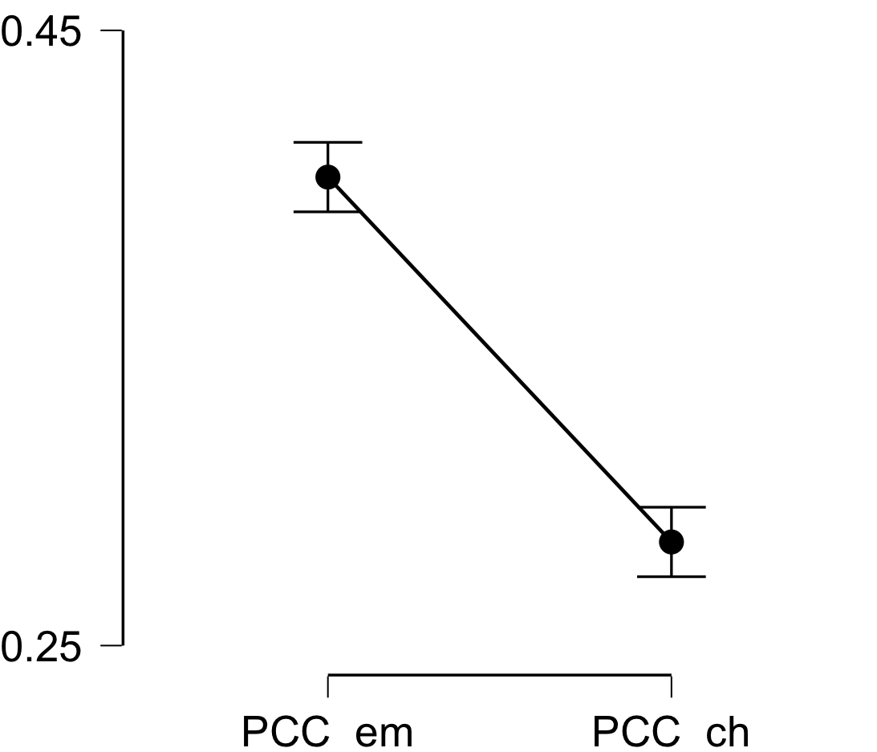

**Bayesian Paired Samples T-Test**

| **Bayesian Paired Samples T-Test** | | | | | | | | | |
| --- | --- | --- | --- | --- | --- | --- | --- | --- | --- |
|  | |  | |  | | **BF₁₀** | | **error %** | |
| PCC_em |  | - |  | PCC_ch |  | 2.501e +12 |  | 1.930e -17 |  |
|  | | | | | | | | | |

**Inferential Plots**

**PCC_em - PCC_ch**

**Prior and Posterior**

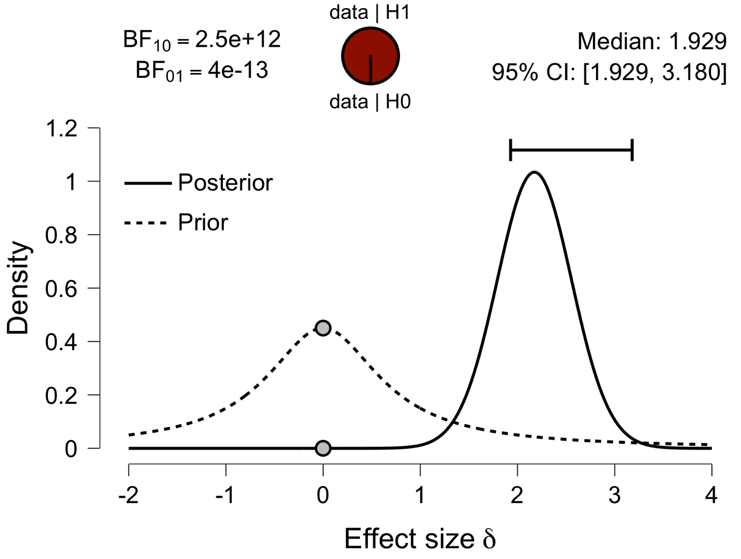

**Paired Samples T-Test**

| **Paired Samples T-Test** | | | | | | | | | | | | | | | | | | | | | | | | | |
| --- | --- | --- | --- | --- | --- | --- | --- | --- | --- | --- | --- | --- | --- | --- | --- | --- | --- | --- | --- | --- | --- | --- | --- | --- | --- |
|  | | | | | | | | | | | | | | | | **95% CI for Mean Difference** | | | |  | | **95% CI for Cohen's d** | | | |
|  | |  | |  | | **t** | | **df** | | **p** | | **Mean Difference** | | **SE Difference** | | **Lower** | | **Upper** | | **Cohen's d** | | **Lower** | | **Upper** | |
| V1_em |  | - |  | V1_ch |  | 13.426 |  | 29 |  | 5.651e -14 |  | 0.081 |  | 0.006 |  | 0.068 |  | 0.093 |  | 2.451 |  | 1.723 |  | 3.168 |  |
|  | | | | | | | | | | | | | | | | | | | | | | | | | |
| *Note.*  Student's t-test. | | | | | | | | | | | | | | | | | | | | | | | | | |

**Assumption Checks**

| **Test of Normality (Shapiro-Wilk)** | | | | | | | | | |
| --- | --- | --- | --- | --- | --- | --- | --- | --- | --- |
|  | |  | |  | | **W** | | **p** | |
| V1_em |  | - |  | V1_ch |  | 0.944 |  | 0.115 |  |
|  | | | | | | | | | |
| *Note.*  Significant results suggest a deviation from normality. | | | | | | | | | |

**Descriptives**

| **Descriptives** | | | | | | | | | |
| --- | --- | --- | --- | --- | --- | --- | --- | --- | --- |
|  | | **N** | | **Mean** | | **SD** | | **SE** | |
| V1_em |  | 30 |  | 0.371 |  | 0.030 |  | 0.005 |  |
| V1_ch |  | 30 |  | 0.290 |  | 0.017 |  | 0.003 |  |
|  | | | | | | | | | |

**Descriptives Plot**

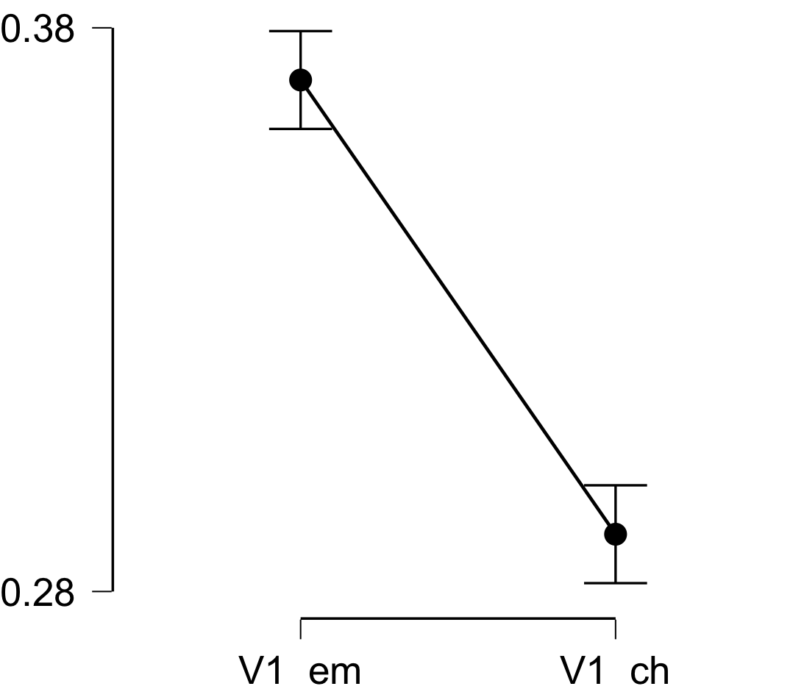

**Bayesian Paired Samples T-Test**

| **Bayesian Paired Samples T-Test** | | | | | | | | | |
| --- | --- | --- | --- | --- | --- | --- | --- | --- | --- |
|  | |  | |  | | **BF₁₀** | | **error %** | |
| V1_em |  | - |  | V1_ch |  | 1.235e +11 |  | 8.282e -16 |  |
|  | | | | | | | | | |

**Inferential Plots**

**V1_em - V1_ch**

**Prior and Posterior**

