**Results**

**Repeated Measures ANOVA**

| **Within Subjects Effects** | | | | | | | | | | | | | | | |
| --- | --- | --- | --- | --- | --- | --- | --- | --- | --- | --- | --- | --- | --- | --- | --- |
|  | | **Sum of Squares** | | **df** | | **Mean Square** | | **F** | | **p** | | **η² p** | | **ω²** | |
| ROI |  | 0.086 |  | 8 |  | 0.011 |  | 19.505 |  | 2.263e -22 |  | 0.402 |  | 0.244 |  |
| Residual |  | 0.128 |  | 232 |  | 5.508e -4 |  |  |  |  |  |  |  |  |  |
|  | | | | | | | | | | | | | | | |
| *Note.*  Type III Sum of Squares | | | | | | | | | | | | | | | |

| **Between Subjects Effects** | | | | | | | | | | | | | | | |
| --- | --- | --- | --- | --- | --- | --- | --- | --- | --- | --- | --- | --- | --- | --- | --- |
|  | | **Sum of Squares** | | **df** | | **Mean Square** | | **F** | | **p** | | **η² p** | | **ω²** | |
| Residual |  | 0.116 |  | 29 |  | 0.004 |  |  |  |  |  |  |  |  |  |
|  | | | | | | | | | | | | | | | |
| *Note.*  Type III Sum of Squares | | | | | | | | | | | | | | | |

**Post Hoc Tests**

| **Post Hoc Comparisons - ROI** | | | | | | | | | | | | | | | | | | | |
| --- | --- | --- | --- | --- | --- | --- | --- | --- | --- | --- | --- | --- | --- | --- | --- | --- | --- | --- | --- |
|  | | | | | | **95% CI of Mean Difference** | | | |  | | | | | | | | | |
|  | |  | | **Mean Difference** | | **Lower** | | **Upper** | | **SE** | | **t** | | **Cohen's d** | | **p holm** | | **p bonf** | |
| ACC |  | ATL |  | 0.029 |  | 0.005 |  | 0.053 |  | 0.007 |  | 4.219 |  | 0.770 |  | 0.005 |  | 0.008 |  |
|  |  | IFG |  | -0.015 |  | -0.039 |  | 0.010 |  | 0.007 |  | -2.143 |  | -0.391 |  | 0.406 |  | 1.000 |  |
|  |  | Ins |  | -0.005 |  | -0.028 |  | 0.017 |  | 0.006 |  | -0.833 |  | -0.152 |  | 1.000 |  | 1.000 |  |
|  |  | LTL |  | -0.030 |  | -0.051 |  | -0.010 |  | 0.006 |  | -5.167 |  | -0.943 |  | 4.148e -4 |  | 5.744e -4 |  |
|  |  | PCC |  | 0.011 |  | -0.010 |  | 0.032 |  | 0.006 |  | 1.830 |  | 0.334 |  | 0.698 |  | 1.000 |  |
|  |  | Prec |  | -0.012 |  | -0.028 |  | 0.005 |  | 0.005 |  | -2.525 |  | -0.461 |  | 0.225 |  | 0.623 |  |
|  |  | V1 |  | 0.025 |  | 3.201e -4 |  | 0.049 |  | 0.007 |  | 3.582 |  | 0.654 |  | 0.023 |  | 0.044 |  |
|  |  | aPFC |  | 0.002 |  | -0.020 |  | 0.023 |  | 0.006 |  | 0.252 |  | 0.046 |  | 1.000 |  | 1.000 |  |
| ATL |  | IFG |  | -0.044 |  | -0.066 |  | -0.021 |  | 0.006 |  | -6.777 |  | -1.237 |  | 6.400e -6 |  | 6.982e -6 |  |
|  |  | Ins |  | -0.034 |  | -0.054 |  | -0.015 |  | 0.006 |  | -6.165 |  | -1.126 |  | 3.142e -5 |  | 3.649e -5 |  |
|  |  | LTL |  | -0.059 |  | -0.084 |  | -0.035 |  | 0.007 |  | -8.446 |  | -1.542 |  | 9.456e -8 |  | 9.456e -8 |  |
|  |  | PCC |  | -0.018 |  | -0.040 |  | 0.003 |  | 0.006 |  | -2.991 |  | -0.546 |  | 0.090 |  | 0.203 |  |
|  |  | Prec |  | -0.041 |  | -0.060 |  | -0.021 |  | 0.006 |  | -7.392 |  | -1.350 |  | 1.298e -6 |  | 1.375e -6 |  |
|  |  | V1 |  | -0.004 |  | -0.025 |  | 0.016 |  | 0.006 |  | -0.758 |  | -0.138 |  | 1.000 |  | 1.000 |  |
|  |  | aPFC |  | -0.027 |  | -0.052 |  | -0.003 |  | 0.007 |  | -3.996 |  | -0.730 |  | 0.008 |  | 0.015 |  |
| IFG |  | Ins |  | 0.009 |  | -0.010 |  | 0.029 |  | 0.005 |  | 1.716 |  | 0.313 |  | 0.775 |  | 1.000 |  |
|  |  | LTL |  | -0.016 |  | -0.039 |  | 0.007 |  | 0.006 |  | -2.417 |  | -0.441 |  | 0.266 |  | 0.797 |  |
|  |  | PCC |  | 0.025 |  | 0.003 |  | 0.048 |  | 0.006 |  | 4.048 |  | 0.739 |  | 0.008 |  | 0.013 |  |
|  |  | Prec |  | 0.003 |  | -0.015 |  | 0.021 |  | 0.005 |  | 0.599 |  | 0.109 |  | 1.000 |  | 1.000 |  |
|  |  | V1 |  | 0.039 |  | 0.015 |  | 0.063 |  | 0.007 |  | 5.823 |  | 1.063 |  | 7.522e -5 |  | 9.337e -5 |  |
|  |  | aPFC |  | 0.016 |  | -0.004 |  | 0.037 |  | 0.006 |  | 2.779 |  | 0.507 |  | 0.142 |  | 0.341 |  |
| Ins |  | LTL |  | -0.025 |  | -0.047 |  | -0.004 |  | 0.006 |  | -4.148 |  | -0.757 |  | 0.006 |  | 0.010 |  |
|  |  | PCC |  | 0.016 |  | -0.002 |  | 0.034 |  | 0.005 |  | 3.129 |  | 0.571 |  | 0.068 |  | 0.143 |  |
|  |  | Prec |  | -0.006 |  | -0.024 |  | 0.011 |  | 0.005 |  | -1.302 |  | -0.238 |  | 1.000 |  | 1.000 |  |
|  |  | V1 |  | 0.030 |  | 0.014 |  | 0.046 |  | 0.005 |  | 6.613 |  | 1.207 |  | 9.632e -6 |  | 1.084e -5 |  |
|  |  | aPFC |  | 0.007 |  | -0.016 |  | 0.030 |  | 0.006 |  | 1.055 |  | 0.193 |  | 1.000 |  | 1.000 |  |
| LTL |  | PCC |  | 0.041 |  | 0.015 |  | 0.068 |  | 0.007 |  | 5.503 |  | 1.005 |  | 1.696e -4 |  | 2.261e -4 |  |
|  |  | Prec |  | 0.019 |  | 0.002 |  | 0.036 |  | 0.005 |  | 3.920 |  | 0.716 |  | 0.010 |  | 0.018 |  |
|  |  | V1 |  | 0.055 |  | 0.031 |  | 0.079 |  | 0.007 |  | 8.030 |  | 1.466 |  | 2.602e -7 |  | 2.676e -7 |  |
|  |  | aPFC |  | 0.032 |  | 0.012 |  | 0.052 |  | 0.006 |  | 5.679 |  | 1.037 |  | 1.080e -4 |  | 1.388e -4 |  |
| PCC |  | Prec |  | -0.022 |  | -0.040 |  | -0.005 |  | 0.005 |  | -4.457 |  | -0.814 |  | 0.003 |  | 0.004 |  |
|  |  | V1 |  | 0.014 |  | -0.008 |  | 0.035 |  | 0.006 |  | 2.274 |  | 0.415 |  | 0.336 |  | 1.000 |  |
|  |  | aPFC |  | -0.009 |  | -0.033 |  | 0.015 |  | 0.007 |  | -1.345 |  | -0.246 |  | 1.000 |  | 1.000 |  |
| Prec |  | V1 |  | 0.036 |  | 0.014 |  | 0.058 |  | 0.006 |  | 5.837 |  | 1.066 |  | 7.486e -5 |  | 8.983e -5 |  |
|  |  | aPFC |  | 0.013 |  | -0.005 |  | 0.032 |  | 0.005 |  | 2.560 |  | 0.467 |  | 0.223 |  | 0.574 |  |
| V1 |  | aPFC |  | -0.023 |  | -0.047 |  | 6.760e -4 |  | 0.007 |  | -3.435 |  | -0.627 |  | 0.033 |  | 0.065 |  |
|  | | | | | | | | | | | | | | | | | | | |
| *Note.*  Cohen's d does not correct for multiple comparisons. | | | | | | | | | | | | | | | | | | | |
| *Note.*  Bonferroni adjusted confidence intervals. | | | | | | | | | | | | | | | | | | | |

**Descriptives**

| **Descriptives** | | | | | | | |
| --- | --- | --- | --- | --- | --- | --- | --- |
| **ROI** | | **Mean** | | **SD** | | **N** | |
| LTL |  | 0.653 |  | 0.038 |  | 30 |  |
| IFG |  | 0.637 |  | 0.034 |  | 30 |  |
| Prec |  | 0.634 |  | 0.028 |  | 30 |  |
| ATL |  | 0.594 |  | 0.025 |  | 30 |  |
| aPFC |  | 0.621 |  | 0.037 |  | 30 |  |
| Ins |  | 0.628 |  | 0.024 |  | 30 |  |
| ACC |  | 0.623 |  | 0.034 |  | 30 |  |
| PCC |  | 0.612 |  | 0.027 |  | 30 |  |
| V1 |  | 0.598 |  | 0.024 |  | 30 |  |
|  | | | | | | | |

**Descriptives Plot**

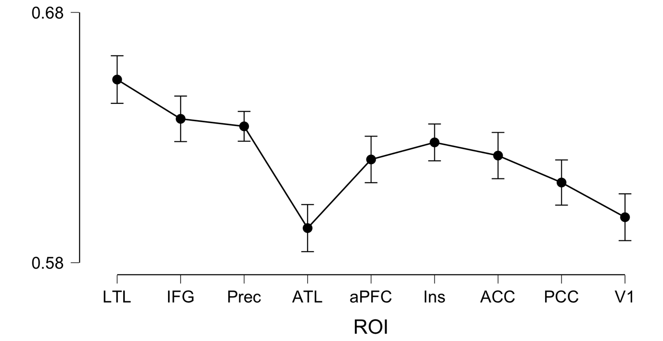

**Repeated Measures ANOVA**

| **Within Subjects Effects** | | | | | | | | | | | |
| --- | --- | --- | --- | --- | --- | --- | --- | --- | --- | --- | --- |
|  | | **Sum of Squares** | | **df** | | **Mean Square** | | **F** | | **p** | |
| ROI |  | 0.066 |  | 8 |  | 0.008 |  | 18.265 |  | 4.052e -21 |  |
| Residual |  | 0.105 |  | 232 |  | 4.517e -4 |  |  |  |  |  |
| Condition |  | 1.057 |  | 1 |  | 1.057 |  | 272.996 |  | 2.705e -16 |  |
| Residual |  | 0.112 |  | 29 |  | 0.004 |  |  |  |  |  |
| ROI ✻ Condition |  | 0.028 | ᵃ | 8 | ᵃ | 0.003 | ᵃ | 8.209 | ᵃ | 8.932e -10 | ᵃ |
| Residual |  | 0.098 |  | 232 |  | 4.207e -4 |  |  |  |  |  |
|  | | | | | | | | | | | |
| *Note.*  Type III Sum of Squares | | | | | | | | | | | |
| ᵃ Mauchly's test of sphericity indicates that the assumption of sphericity is violated (p < .05). | | | | | | | | | | | |

| **Between Subjects Effects** | | | | | | | | | | | |
| --- | --- | --- | --- | --- | --- | --- | --- | --- | --- | --- | --- |
|  | | **Sum of Squares** | | **df** | | **Mean Square** | | **F** | | **p** | |
| Residual |  | 0.189 |  | 29 |  | 0.007 |  |  |  |  |  |
|  | | | | | | | | | | | |
| *Note.*  Type III Sum of Squares | | | | | | | | | | | |

**Descriptives**

**Descriptives Plot**

