**Results**

**Paired Samples T-Test**

| **Paired Samples T-Test** | | | | | | | | | | | | | | | | | | | | | | | | | |
| --- | --- | --- | --- | --- | --- | --- | --- | --- | --- | --- | --- | --- | --- | --- | --- | --- | --- | --- | --- | --- | --- | --- | --- | --- | --- |
|  | | | | | | | | | | | | | | | | **95% CI for Mean Difference** | | | |  | | **95% CI for Cohen's d** | | | |
|  | |  | |  | | **t** | | **df** | | **p** | | **Mean Difference** | | **SE Difference** | | **Lower** | | **Upper** | | **Cohen's d** | | **Lower** | | **Upper** | |
| a_LTL_em |  | - |  | a_LTL_ch |  | 5.966 |  | 29 |  | 1.748e -6 |  | 0.061 |  | 0.010 |  | 0.040 |  | 0.082 |  | 1.089 |  | 0.630 |  | 1.537 |  |
|  | | | | | | | | | | | | | | | | | | | | | | | | | |
| *Note.*  Student's t-test. | | | | | | | | | | | | | | | | | | | | | | | | | |

**Assumption Checks**

| **Test of Normality (Shapiro-Wilk)** | | | | | | | | | |
| --- | --- | --- | --- | --- | --- | --- | --- | --- | --- |
|  | |  | |  | | **W** | | **p** | |
| a_LTL_em |  | - |  | a_LTL_ch |  | 0.967 |  | 0.462 |  |
|  | | | | | | | | | |
| *Note.*  Significant results suggest a deviation from normality. | | | | | | | | | |

**Descriptives**

| **Descriptives** | | | | | | | | | |
| --- | --- | --- | --- | --- | --- | --- | --- | --- | --- |
|  | | **N** | | **Mean** | | **SD** | | **SE** | |
| a_LTL_em |  | 30 |  | 0.604 |  | 0.039 |  | 0.007 |  |
| a_LTL_ch |  | 30 |  | 0.543 |  | 0.030 |  | 0.006 |  |
|  | | | | | | | | | |

**Descriptives Plot**

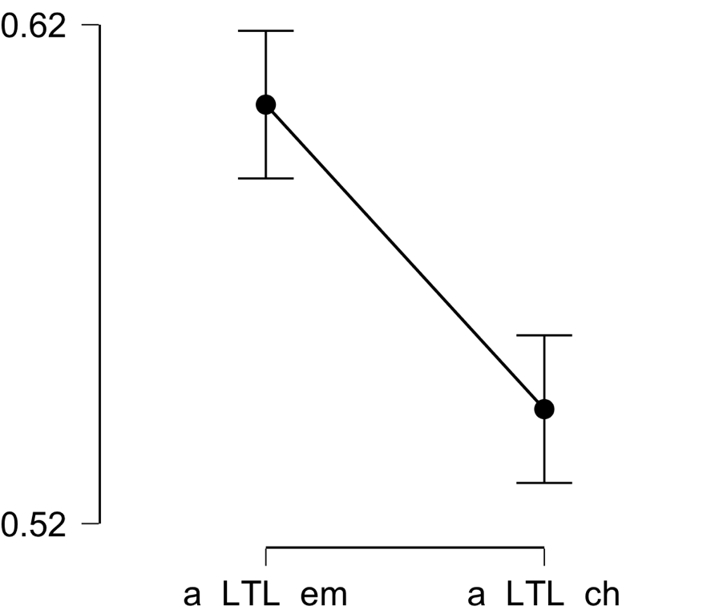

**Bayesian Paired Samples T-Test**

| **Bayesian Paired Samples T-Test** | | | | | | | | | |
| --- | --- | --- | --- | --- | --- | --- | --- | --- | --- |
|  | |  | |  | | **BF₁₀** | | **error %** | |
| a_LTL_em |  | - |  | a_LTL_ch |  | 10520.801 |  | 4.522e -7 |  |
|  | | | | | | | | | |

**Inferential Plots**

**a_LTL_em - a_LTL_ch**

**Prior and Posterior**

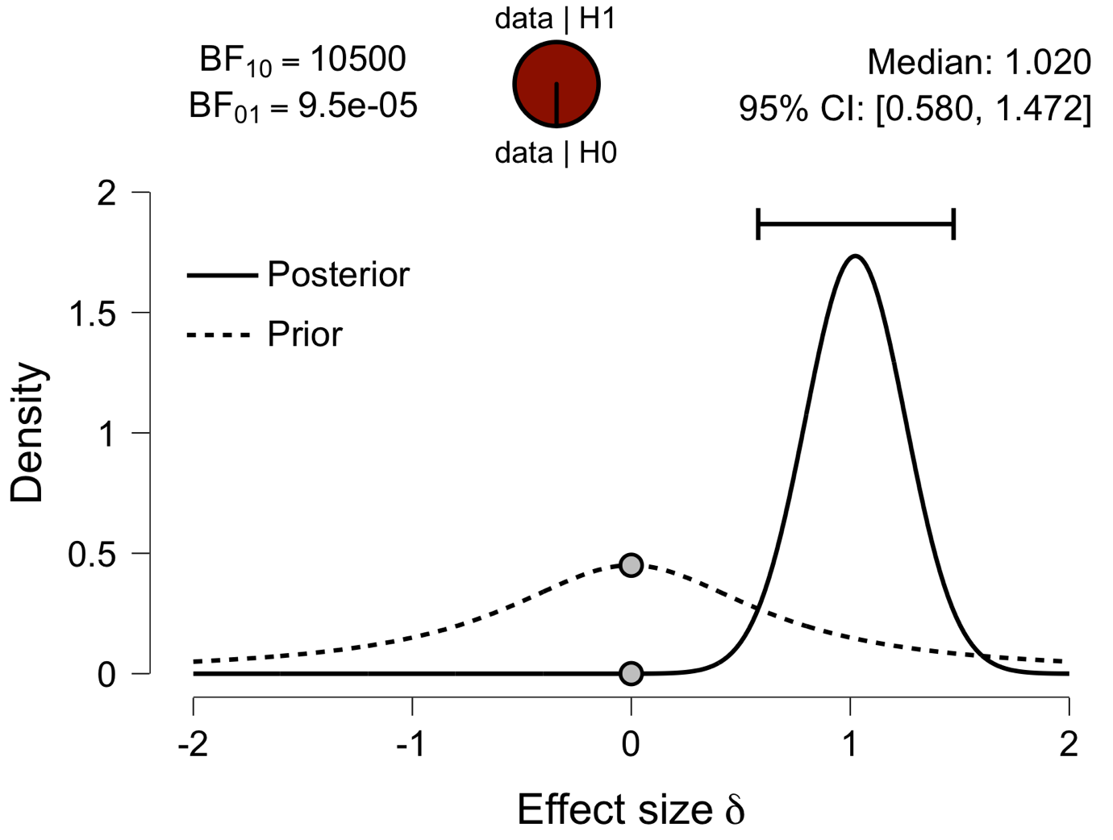

**Paired Samples T-Test**

| **Paired Samples T-Test** | | | | | | | | | | | | | | | | | | | | | | | | | |
| --- | --- | --- | --- | --- | --- | --- | --- | --- | --- | --- | --- | --- | --- | --- | --- | --- | --- | --- | --- | --- | --- | --- | --- | --- | --- |
|  | | | | | | | | | | | | | | | | **95% CI for Mean Difference** | | | |  | | **95% CI for Cohen's d** | | | |
|  | |  | |  | | **t** | | **df** | | **p** | | **Mean Difference** | | **SE Difference** | | **Lower** | | **Upper** | | **Cohen's d** | | **Lower** | | **Upper** | |
| a_IFG_em |  | - |  | a_IFG_ch |  | 6.802 |  | 29 |  | 1.815e -7 |  | 0.064 |  | 0.009 |  | 0.045 |  | 0.084 |  | 1.242 |  | 0.757 |  | 1.714 |  |
|  | | | | | | | | | | | | | | | | | | | | | | | | | |
| *Note.*  Student's t-test. | | | | | | | | | | | | | | | | | | | | | | | | | |

**Assumption Checks**

| **Test of Normality (Shapiro-Wilk)** | | | | | | | | | |
| --- | --- | --- | --- | --- | --- | --- | --- | --- | --- |
|  | |  | |  | | **W** | | **p** | |
| a_IFG_em |  | - |  | a_IFG_ch |  | 0.990 |  | 0.993 |  |
|  | | | | | | | | | |
| *Note.*  Significant results suggest a deviation from normality. | | | | | | | | | |

**Descriptives**

| **Descriptives** | | | | | | | | | |
| --- | --- | --- | --- | --- | --- | --- | --- | --- | --- |
|  | | **N** | | **Mean** | | **SD** | | **SE** | |
| a_IFG_em |  | 30 |  | 0.598 |  | 0.033 |  | 0.006 |  |
| a_IFG_ch |  | 30 |  | 0.534 |  | 0.032 |  | 0.006 |  |
|  | | | | | | | | | |

**Descriptives Plot**

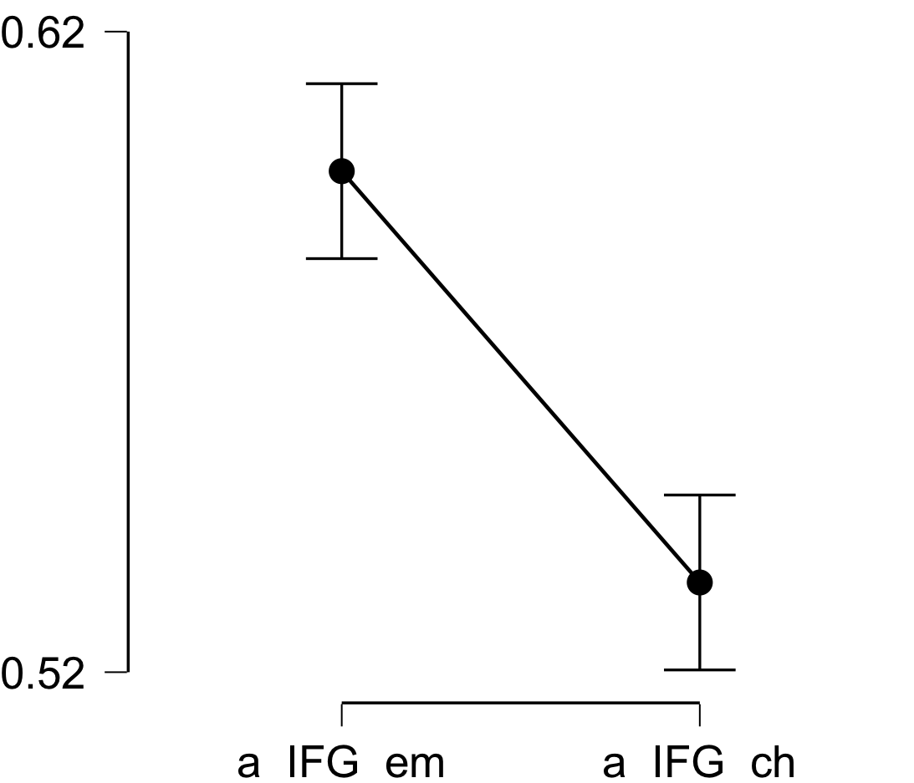

**Bayesian Paired Samples T-Test**

| **Bayesian Paired Samples T-Test** | | | | | | | | | |
| --- | --- | --- | --- | --- | --- | --- | --- | --- | --- |
|  | |  | |  | | **BF₁₀** | | **error %** | |
| a_IFG_em |  | - |  | a_IFG_ch |  | 86148.303 |  | 4.397e -8 |  |
|  | | | | | | | | | |

**Inferential Plots**

**a_IFG_em - a_IFG_ch**

**Prior and Posterior**

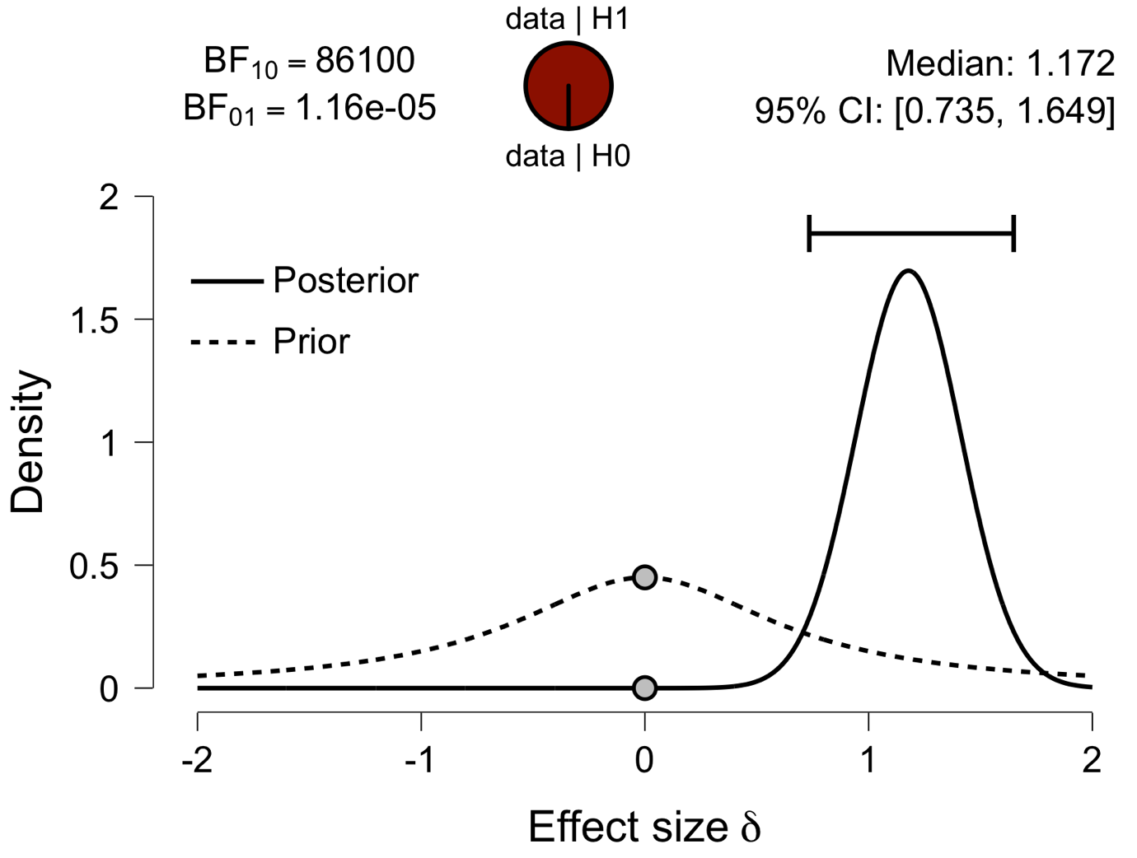

**Paired Samples T-Test**

| **Paired Samples T-Test** | | | | | | | | | | | | | | | | | | | | | | | | | |
| --- | --- | --- | --- | --- | --- | --- | --- | --- | --- | --- | --- | --- | --- | --- | --- | --- | --- | --- | --- | --- | --- | --- | --- | --- | --- |
|  | | | | | | | | | | | | | | | | **95% CI for Mean Difference** | | | |  | | **95% CI for Cohen's d** | | | |
|  | |  | |  | | **t** | | **df** | | **p** | | **Mean Difference** | | **SE Difference** | | **Lower** | | **Upper** | | **Cohen's d** | | **Lower** | | **Upper** | |
| a_Prec_em |  | - |  | a_Prec_ch |  | 8.153 |  | 29 |  | 5.448e -9 |  | 0.057 |  | 0.007 |  | 0.043 |  | 0.071 |  | 1.489 |  | 0.959 |  | 2.005 |  |
|  | | | | | | | | | | | | | | | | | | | | | | | | | |
| *Note.*  Student's t-test. | | | | | | | | | | | | | | | | | | | | | | | | | |

**Assumption Checks**

| **Test of Normality (Shapiro-Wilk)** | | | | | | | | | |
| --- | --- | --- | --- | --- | --- | --- | --- | --- | --- |
|  | |  | |  | | **W** | | **p** | |
| a_Prec_em |  | - |  | a_Prec_ch |  | 0.964 |  | 0.393 |  |
|  | | | | | | | | | |
| *Note.*  Significant results suggest a deviation from normality. | | | | | | | | | |

**Descriptives**

| **Descriptives** | | | | | | | | | |
| --- | --- | --- | --- | --- | --- | --- | --- | --- | --- |
|  | | **N** | | **Mean** | | **SD** | | **SE** | |
| a_Prec_em |  | 30 |  | 0.595 |  | 0.024 |  | 0.004 |  |
| a_Prec_ch |  | 30 |  | 0.538 |  | 0.030 |  | 0.006 |  |
|  | | | | | | | | | |

**Descriptives Plot**

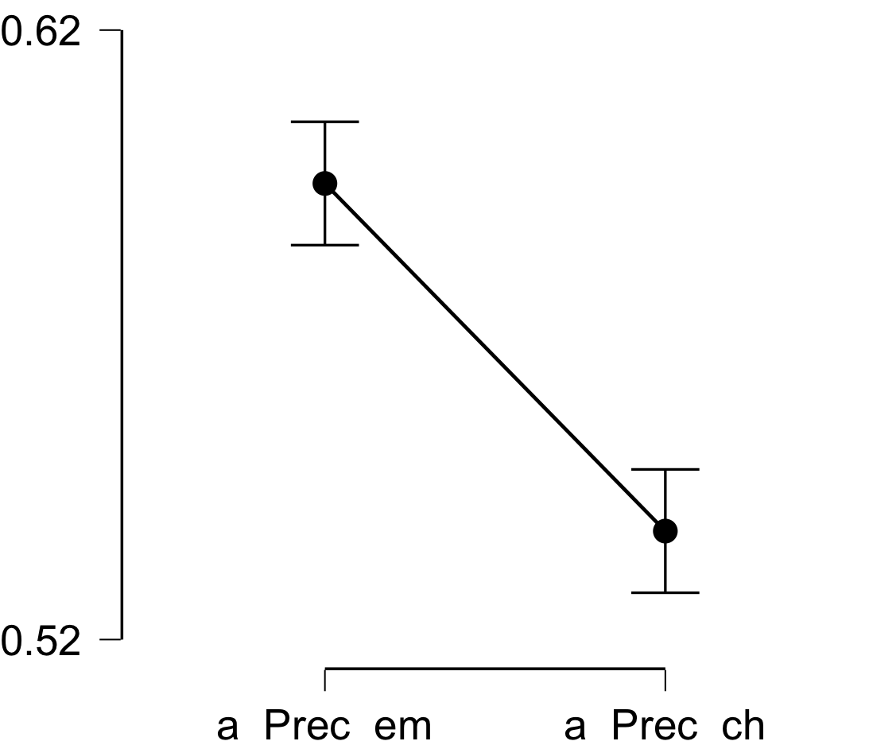

**Bayesian Paired Samples T-Test**

| **Bayesian Paired Samples T-Test** | | | | | | | | | |
| --- | --- | --- | --- | --- | --- | --- | --- | --- | --- |
|  | |  | |  | | **BF₁₀** | | **error %** | |
| a_Prec_em |  | - |  | a_Prec_ch |  | 2.297e +6 |  | 3.374e -10 |  |
|  | | | | | | | | | |

**Inferential Plots**

**a_Prec_em - a_Prec_ch**

**Prior and Posterior**

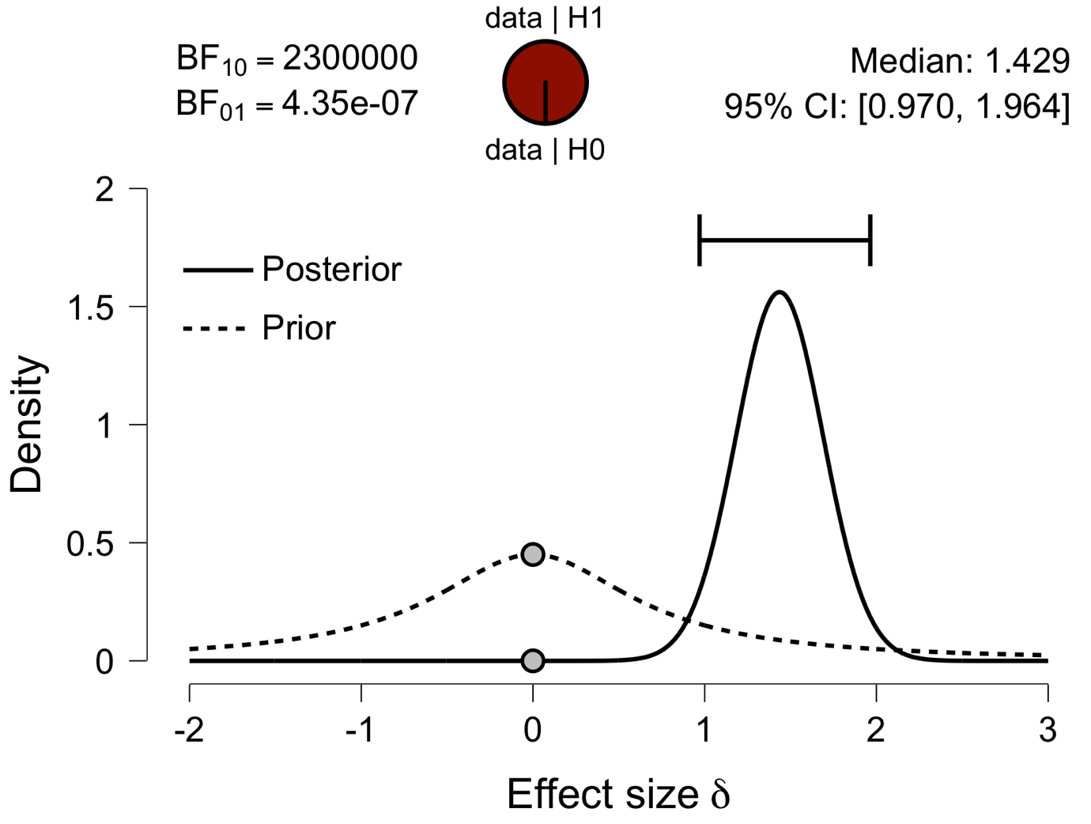

**Paired Samples T-Test**

| **Paired Samples T-Test** | | | | | | | | | | | | | | | | | | | | | | | | | |
| --- | --- | --- | --- | --- | --- | --- | --- | --- | --- | --- | --- | --- | --- | --- | --- | --- | --- | --- | --- | --- | --- | --- | --- | --- | --- |
|  | | | | | | | | | | | | | | | | **95% CI for Mean Difference** | | | |  | | **95% CI for Cohen's d** | | | |
|  | |  | |  | | **t** | | **df** | | **p** | | **Mean Difference** | | **SE Difference** | | **Lower** | | **Upper** | | **Cohen's d** | | **Lower** | | **Upper** | |
| a_ATL_em |  | - |  | a_ATL_ch |  | 4.294 |  | 29 |  | 1.792e -4 |  | 0.034 |  | 0.008 |  | 0.018 |  | 0.050 |  | 0.784 |  | 0.368 |  | 1.189 |  |
|  | | | | | | | | | | | | | | | | | | | | | | | | | |
| *Note.*  Student's t-test. | | | | | | | | | | | | | | | | | | | | | | | | | |

**Assumption Checks**

| **Test of Normality (Shapiro-Wilk)** | | | | | | | | | |
| --- | --- | --- | --- | --- | --- | --- | --- | --- | --- |
|  | |  | |  | | **W** | | **p** | |
| a_ATL_em |  | - |  | a_ATL_ch |  | 0.976 |  | 0.699 |  |
|  | | | | | | | | | |
| *Note.*  Significant results suggest a deviation from normality. | | | | | | | | | |

**Descriptives**

| **Descriptives** | | | | | | | | | |
| --- | --- | --- | --- | --- | --- | --- | --- | --- | --- |
|  | | **N** | | **Mean** | | **SD** | | **SE** | |
| a_ATL_em |  | 30 |  | 0.565 |  | 0.031 |  | 0.006 |  |
| a_ATL_ch |  | 30 |  | 0.531 |  | 0.030 |  | 0.005 |  |
|  | | | | | | | | | |

**Descriptives Plot**

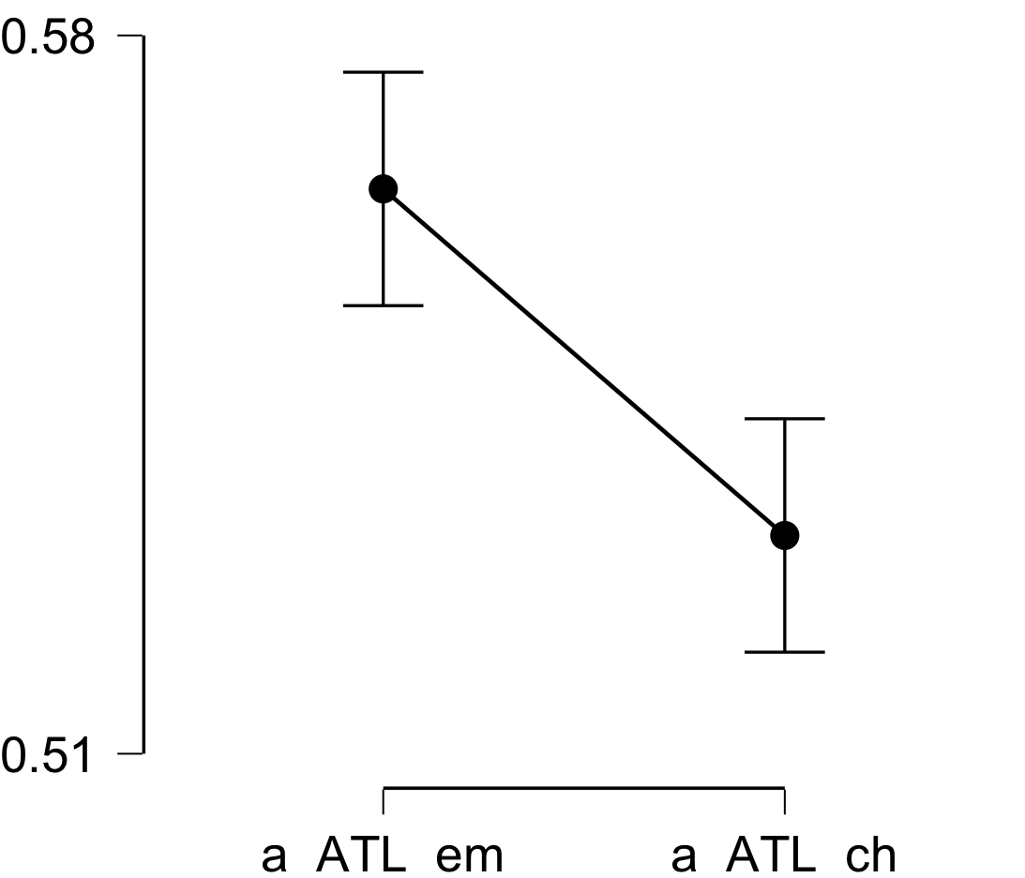

**Bayesian Paired Samples T-Test**

| **Bayesian Paired Samples T-Test** | | | | | | | | | |
| --- | --- | --- | --- | --- | --- | --- | --- | --- | --- |
|  | |  | |  | | **BF₁₀** | | **error %** | |
| a_ATL_em |  | - |  | a_ATL_ch |  | 153.449 |  | 1.423e -5 |  |
|  | | | | | | | | | |

**Inferential Plots**

**a_ATL_em - a_ATL_ch**

**Prior and Posterior**

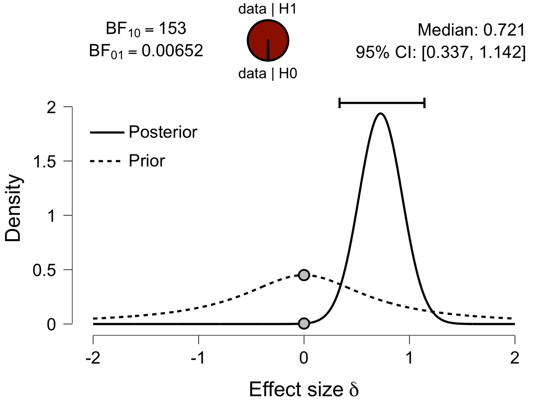

**Paired Samples T-Test**

| **Paired Samples T-Test** | | | | | | | | | | | | | | | | | | | | | | | | | |
| --- | --- | --- | --- | --- | --- | --- | --- | --- | --- | --- | --- | --- | --- | --- | --- | --- | --- | --- | --- | --- | --- | --- | --- | --- | --- |
|  | | | | | | | | | | | | | | | | **95% CI for Mean Difference** | | | |  | | **95% CI for Cohen's d** | | | |
|  | |  | |  | | **t** | | **df** | | **p** | | **Mean Difference** | | **SE Difference** | | **Lower** | | **Upper** | | **Cohen's d** | | **Lower** | | **Upper** | |
| a_aPFC_em |  | - |  | a_aPFC_ch |  | 4.758 |  | 29 |  | 4.973e -5 |  | 0.043 |  | 0.009 |  | 0.024 |  | 0.061 |  | 0.869 |  | 0.442 |  | 1.285 |  |
|  | | | | | | | | | | | | | | | | | | | | | | | | | |
| *Note.*  Student's t-test. | | | | | | | | | | | | | | | | | | | | | | | | | |

**Assumption Checks**

| **Test of Normality (Shapiro-Wilk)** | | | | | | | | | |
| --- | --- | --- | --- | --- | --- | --- | --- | --- | --- |
|  | |  | |  | | **W** | | **p** | |
| a_aPFC_em |  | - |  | a_aPFC_ch |  | 0.986 |  | 0.951 |  |
|  | | | | | | | | | |
| *Note.*  Significant results suggest a deviation from normality. | | | | | | | | | |

**Descriptives**

| **Descriptives** | | | | | | | | | |
| --- | --- | --- | --- | --- | --- | --- | --- | --- | --- |
|  | | **N** | | **Mean** | | **SD** | | **SE** | |
| a_aPFC_em |  | 30 |  | 0.582 |  | 0.034 |  | 0.006 |  |
| a_aPFC_ch |  | 30 |  | 0.540 |  | 0.031 |  | 0.006 |  |
|  | | | | | | | | | |

**Descriptives Plot**

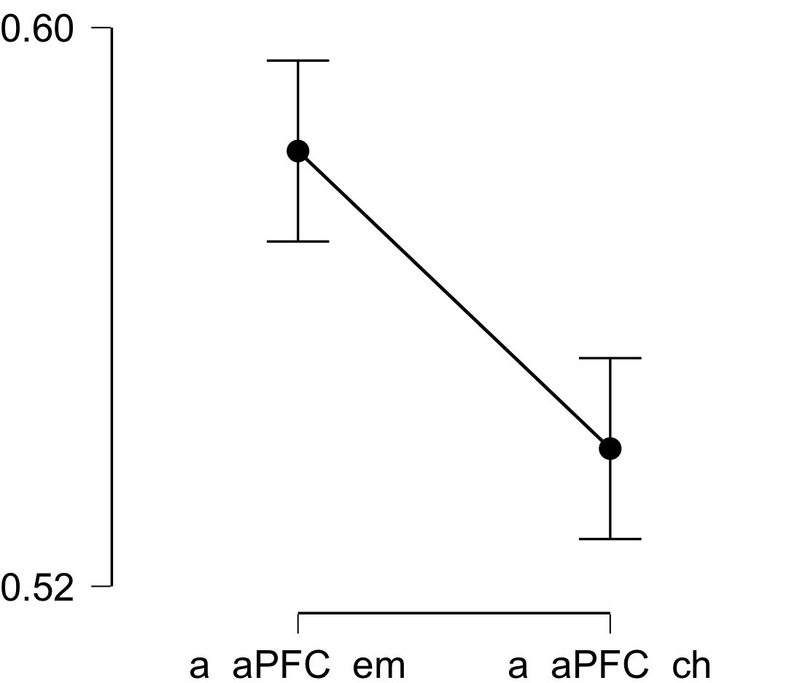

**Bayesian Paired Samples T-Test**

| **Bayesian Paired Samples T-Test** | | | | | | | | | |
| --- | --- | --- | --- | --- | --- | --- | --- | --- | --- |
|  | |  | |  | | **BF₁₀** | | **error %** | |
| a_aPFC_em |  | - |  | a_aPFC_ch |  | 488.591 |  | 7.005e -7 |  |
|  | | | | | | | | | |

**Inferential Plots**

**a_aPFC_em - a_aPFC_ch**

**Prior and Posterior**

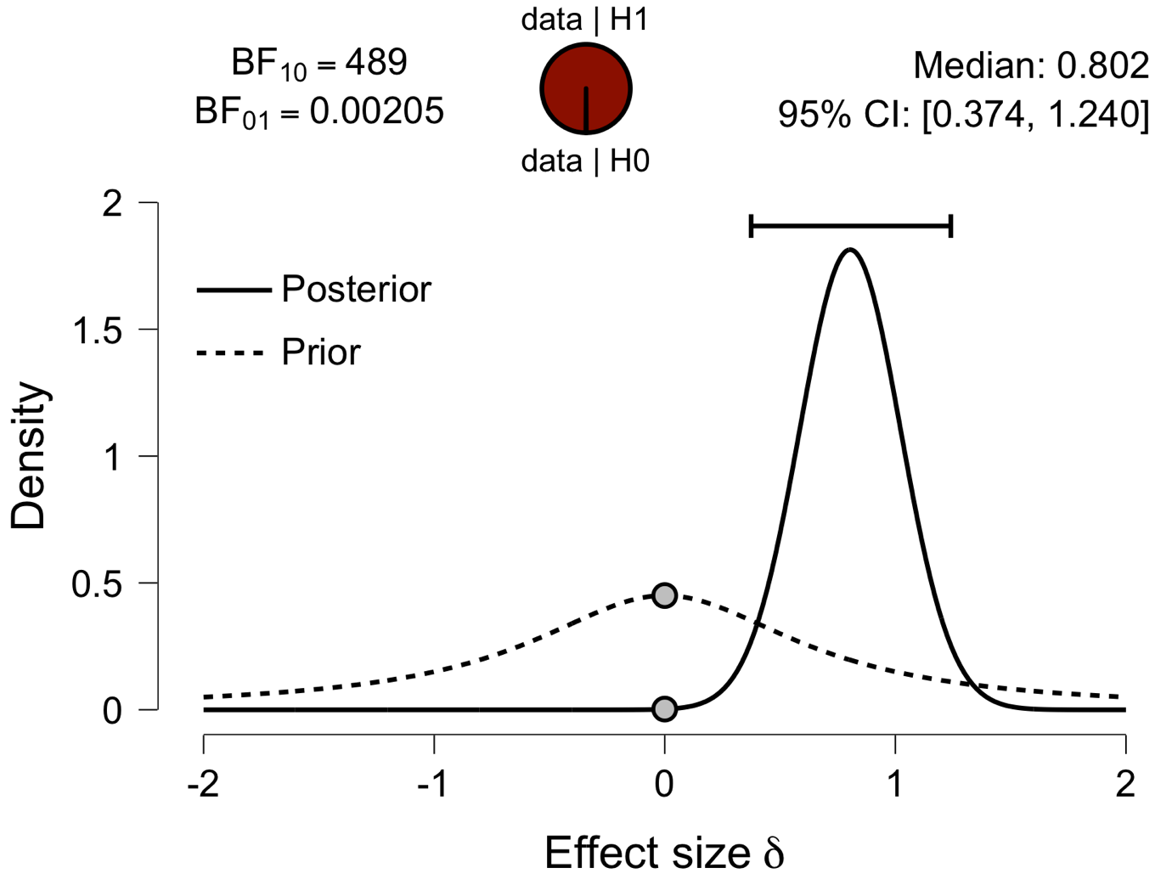

**Paired Samples T-Test**

| **Paired Samples T-Test** | | | | | | | | | | | | | | | | | | | | | | | | | |
| --- | --- | --- | --- | --- | --- | --- | --- | --- | --- | --- | --- | --- | --- | --- | --- | --- | --- | --- | --- | --- | --- | --- | --- | --- | --- |
|  | | | | | | | | | | | | | | | | **95% CI for Mean Difference** | | | |  | | **95% CI for Cohen's d** | | | |
|  | |  | |  | | **t** | | **df** | | **p** | | **Mean Difference** | | **SE Difference** | | **Lower** | | **Upper** | | **Cohen's d** | | **Lower** | | **Upper** | |
| a_Ins_em |  | - |  | a_Ins_ch |  | 7.129 |  | 29 |  | 7.613e -8 |  | 0.052 |  | 0.007 |  | 0.037 |  | 0.067 |  | 1.302 |  | 0.806 |  | 1.784 |  |
|  | | | | | | | | | | | | | | | | | | | | | | | | | |
| *Note.*  Student's t-test. | | | | | | | | | | | | | | | | | | | | | | | | | |

**Assumption Checks**

| **Test of Normality (Shapiro-Wilk)** | | | | | | | | | |
| --- | --- | --- | --- | --- | --- | --- | --- | --- | --- |
|  | |  | |  | | **W** | | **p** | |
| a_Ins_em |  | - |  | a_Ins_ch |  | 0.928 |  | 0.042 |  |
|  | | | | | | | | | |
| *Note.*  Significant results suggest a deviation from normality. | | | | | | | | | |

**Descriptives**

| **Descriptives** | | | | | | | | | |
| --- | --- | --- | --- | --- | --- | --- | --- | --- | --- |
|  | | **N** | | **Mean** | | **SD** | | **SE** | |
| a_Ins_em |  | 30 |  | 0.595 |  | 0.023 |  | 0.004 |  |
| a_Ins_ch |  | 30 |  | 0.543 |  | 0.028 |  | 0.005 |  |
|  | | | | | | | | | |

**Descriptives Plot**

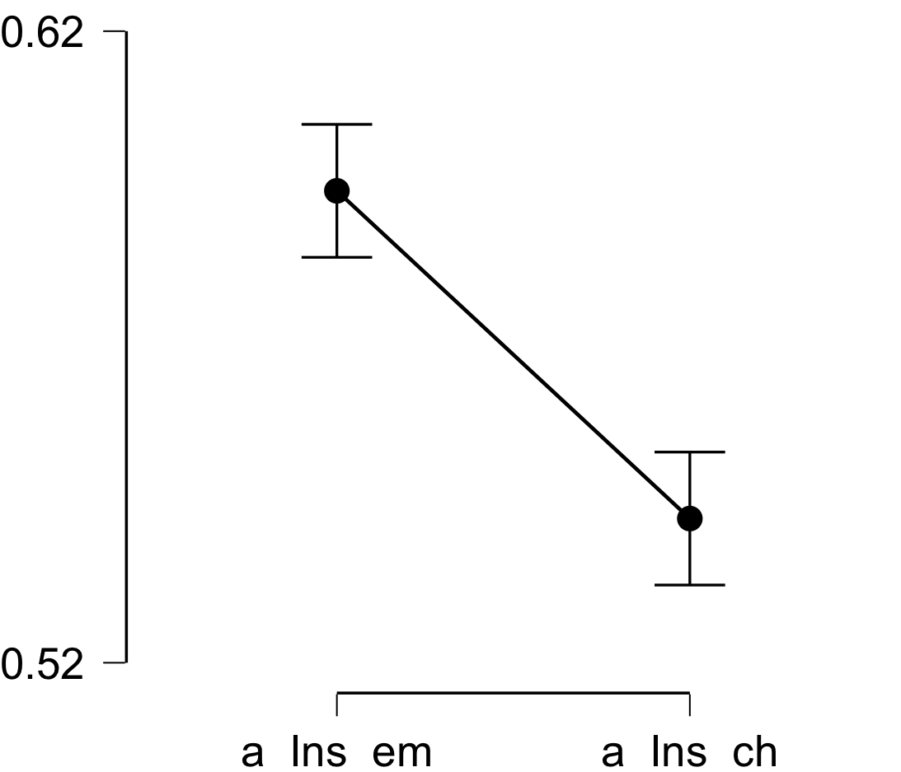

**Bayesian Paired Samples T-Test**

| **Bayesian Paired Samples T-Test** | | | | | | | | | |
| --- | --- | --- | --- | --- | --- | --- | --- | --- | --- |
|  | |  | |  | | **BF₁₀** | | **error %** | |
| a_Ins_em |  | - |  | a_Ins_ch |  | 193762.766 |  | 3.321e -8 |  |
|  | | | | | | | | | |

**Inferential Plots**

**a_Ins_em - a_Ins_ch**

**Prior and Posterior**

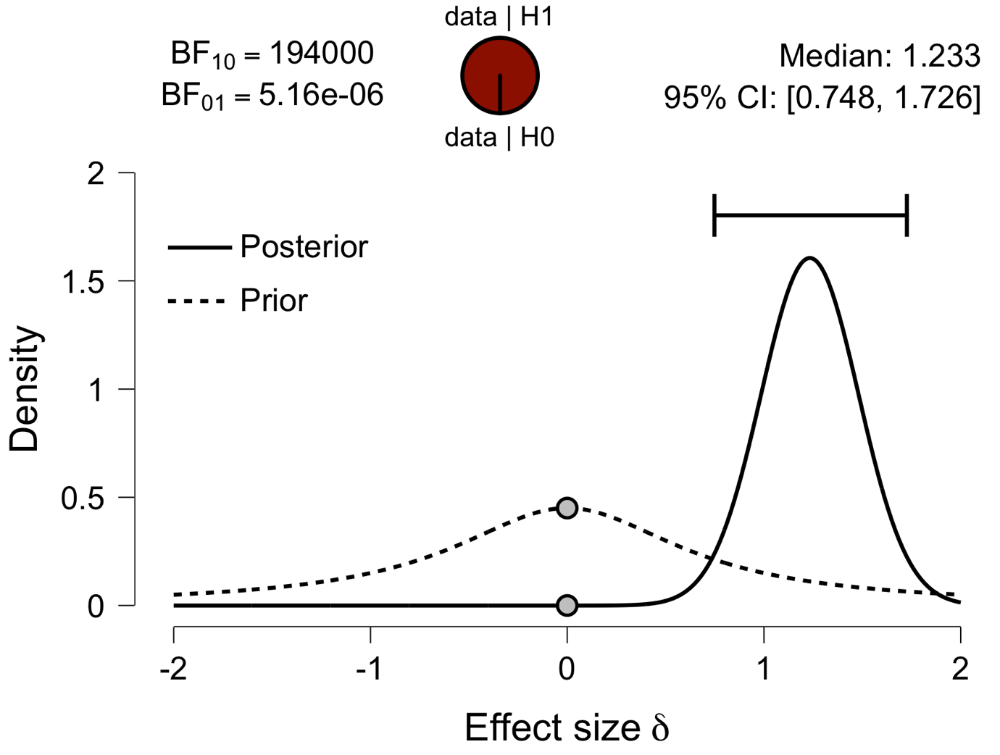

**Paired Samples T-Test**

| **Paired Samples T-Test** | | | | | | | | | | | | | | | | | | | | | | | | | |
| --- | --- | --- | --- | --- | --- | --- | --- | --- | --- | --- | --- | --- | --- | --- | --- | --- | --- | --- | --- | --- | --- | --- | --- | --- | --- |
|  | | | | | | | | | | | | | | | | **95% CI for Mean Difference** | | | |  | | **95% CI for Cohen's d** | | | |
|  | |  | |  | | **t** | | **df** | | **p** | | **Mean Difference** | | **SE Difference** | | **Lower** | | **Upper** | | **Cohen's d** | | **Lower** | | **Upper** | |
| a_ACC_em |  | - |  | a_ACC_ch |  | 7.453 |  | 29 |  | 3.258e -8 |  | 0.054 |  | 0.007 |  | 0.040 |  | 0.069 |  | 1.361 |  | 0.855 |  | 1.854 |  |
|  | | | | | | | | | | | | | | | | | | | | | | | | | |
| *Note.*  Student's t-test. | | | | | | | | | | | | | | | | | | | | | | | | | |

**Assumption Checks**

| **Test of Normality (Shapiro-Wilk)** | | | | | | | | | |
| --- | --- | --- | --- | --- | --- | --- | --- | --- | --- |
|  | |  | |  | | **W** | | **p** | |
| a_ACC_em |  | - |  | a_ACC_ch |  | 0.916 |  | 0.021 |  |
|  | | | | | | | | | |
| *Note.*  Significant results suggest a deviation from normality. | | | | | | | | | |

**Descriptives**

| **Descriptives** | | | | | | | | | |
| --- | --- | --- | --- | --- | --- | --- | --- | --- | --- |
|  | | **N** | | **Mean** | | **SD** | | **SE** | |
| a_ACC_em |  | 30 |  | 0.592 |  | 0.034 |  | 0.006 |  |
| a_ACC_ch |  | 30 |  | 0.537 |  | 0.028 |  | 0.005 |  |
|  | | | | | | | | | |

**Descriptives Plot**

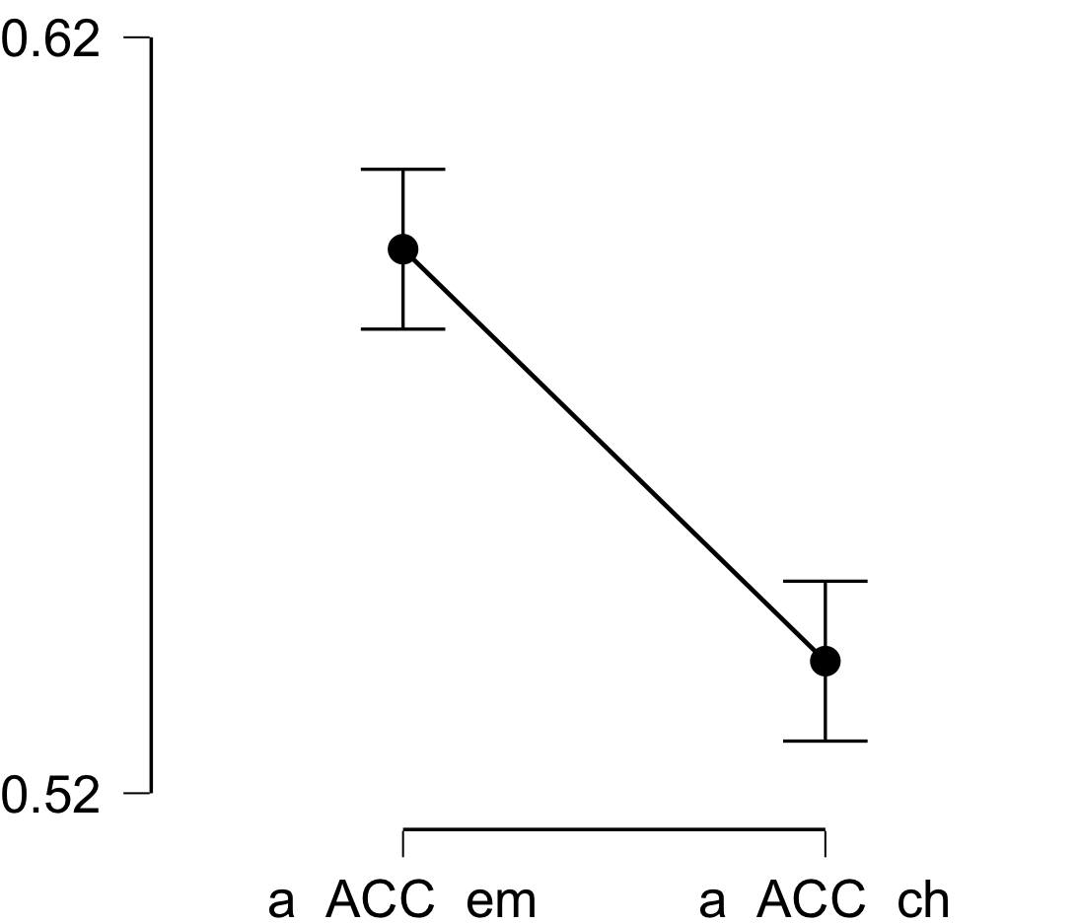

**Paired Samples T-Test**

**Bayesian Paired Samples T-Test**

| **Bayesian Paired Samples T-Test** | | | | | | | | | |
| --- | --- | --- | --- | --- | --- | --- | --- | --- | --- |
|  | |  | |  | | **BF₁₀** | | **error %** | |
| a_ACC_em |  | - |  | a_ACC_ch |  | 428629.357 |  | 2.416e -8 |  |
|  | | | | | | | | | |

**Inferential Plots**

**a_ACC_em - a_ACC_ch**

**Prior and Posterior**

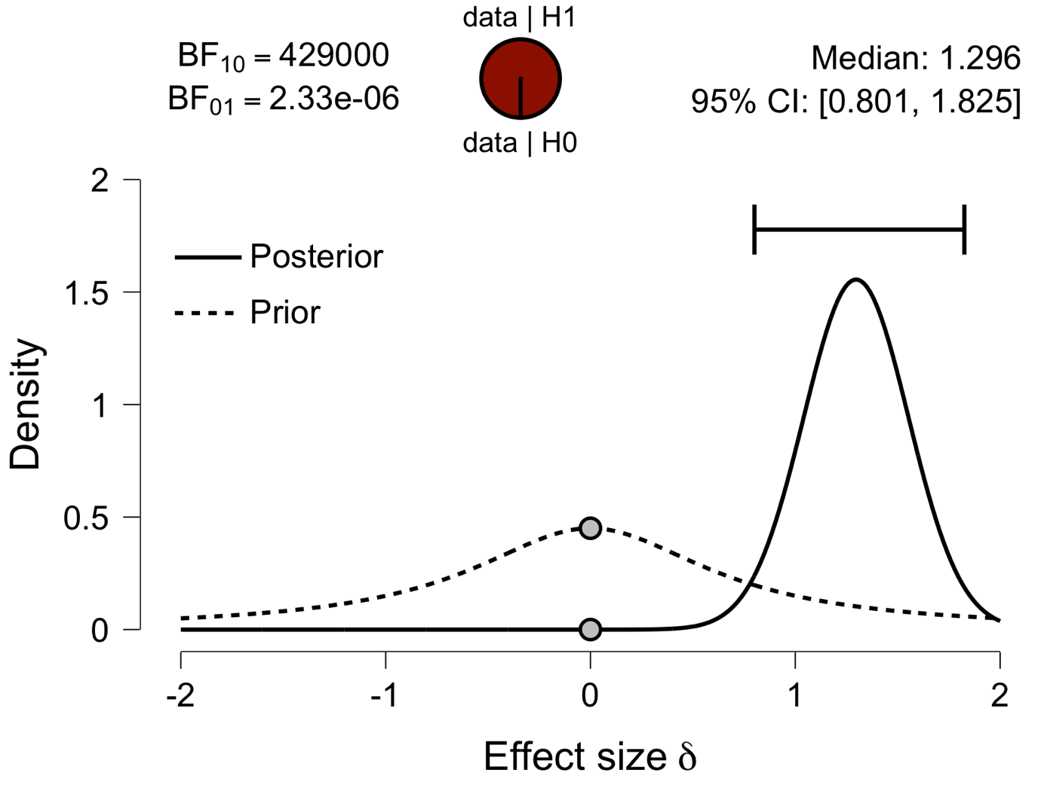

**Paired Samples T-Test**

| **Paired Samples T-Test** | | | | | | | | | | | | | | | | | | | | | | | | | |
| --- | --- | --- | --- | --- | --- | --- | --- | --- | --- | --- | --- | --- | --- | --- | --- | --- | --- | --- | --- | --- | --- | --- | --- | --- | --- |
|  | | | | | | | | | | | | | | | | **95% CI for Mean Difference** | | | |  | | **95% CI for Cohen's d** | | | |
|  | |  | |  | | **t** | | **df** | | **p** | | **Mean Difference** | | **SE Difference** | | **Lower** | | **Upper** | | **Cohen's d** | | **Lower** | | **Upper** | |
| a_PCC_em |  | - |  | a_PCC_ch |  | 9.983 |  | 29 |  | 6.863e -11 |  | 0.058 |  | 0.006 |  | 0.046 |  | 0.070 |  | 1.823 |  | 1.228 |  | 2.405 |  |
|  | | | | | | | | | | | | | | | | | | | | | | | | | |
| *Note.*  Student's t-test. | | | | | | | | | | | | | | | | | | | | | | | | | |

**Assumption Checks**

| **Test of Normality (Shapiro-Wilk)** | | | | | | | | | |
| --- | --- | --- | --- | --- | --- | --- | --- | --- | --- |
|  | |  | |  | | **W** | | **p** | |
| a_PCC_em |  | - |  | a_PCC_ch |  | 0.981 |  | 0.858 |  |
|  | | | | | | | | | |
| *Note.*  Significant results suggest a deviation from normality. | | | | | | | | | |

**Descriptives**

| **Descriptives** | | | | | | | | | |
| --- | --- | --- | --- | --- | --- | --- | --- | --- | --- |
|  | | **N** | | **Mean** | | **SD** | | **SE** | |
| a_PCC_em |  | 30 |  | 0.585 |  | 0.026 |  | 0.005 |  |
| a_PCC_ch |  | 30 |  | 0.527 |  | 0.027 |  | 0.005 |  |
|  | | | | | | | | | |

**Descriptives Plot**

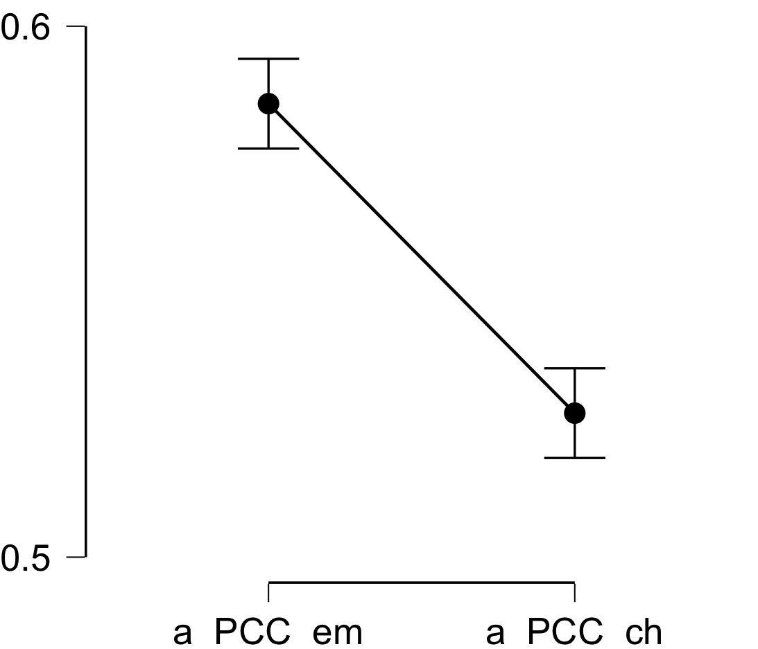

**Bayesian Paired Samples T-Test**

| **Bayesian Paired Samples T-Test** | | | | | | | | | |
| --- | --- | --- | --- | --- | --- | --- | --- | --- | --- |
|  | |  | |  | | **BF₁₀** | | **error %** | |
| a_PCC_em |  | - |  | a_PCC_ch |  | 1.430e +8 |  | 4.908e -11 |  |
|  | | | | | | | | | |

**Inferential Plots**

**a_PCC_em - a_PCC_ch**

**Prior and Posterior**

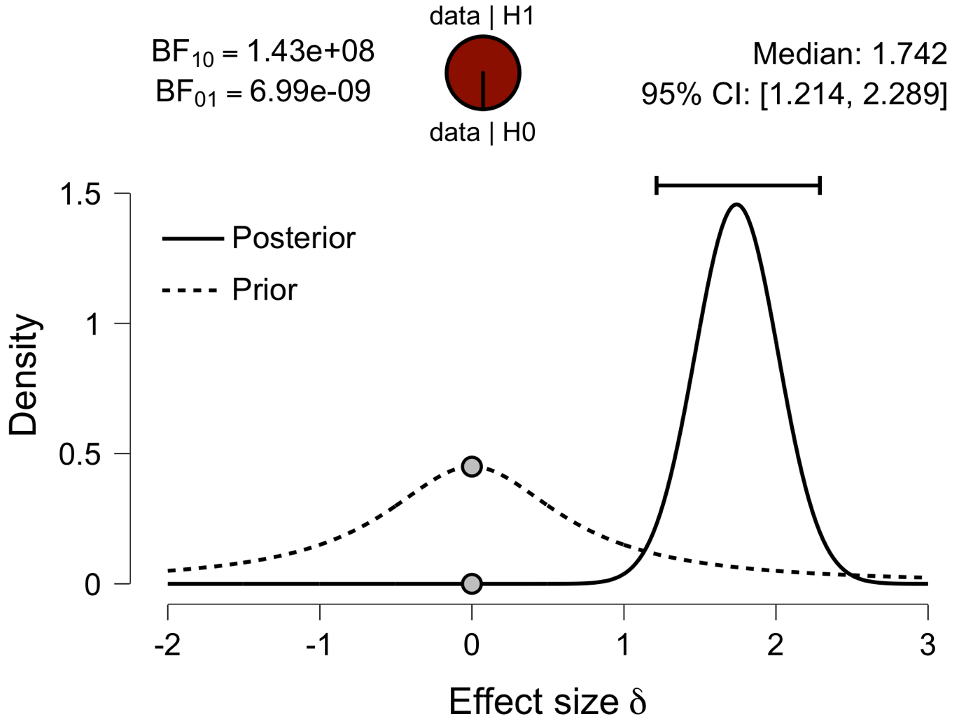

**Paired Samples T-Test**

| **Paired Samples T-Test** | | | | | | | | | | | | | | | | | | | | | | | | | |
| --- | --- | --- | --- | --- | --- | --- | --- | --- | --- | --- | --- | --- | --- | --- | --- | --- | --- | --- | --- | --- | --- | --- | --- | --- | --- |
|  | | | | | | | | | | | | | | | | **95% CI for Mean Difference** | | | |  | | **95% CI for Cohen's d** | | | |
|  | |  | |  | | **t** | | **df** | | **p** | | **Mean Difference** | | **SE Difference** | | **Lower** | | **Upper** | | **Cohen's d** | | **Lower** | | **Upper** | |
| a_V1_em |  | - |  | a_V1_ch |  | 6.356 |  | 29 |  | 6.022e -7 |  | 0.043 |  | 0.007 |  | 0.029 |  | 0.056 |  | 1.161 |  | 0.689 |  | 1.620 |  |
|  | | | | | | | | | | | | | | | | | | | | | | | | | |
| *Note.*  Student's t-test. | | | | | | | | | | | | | | | | | | | | | | | | | |

**Assumption Checks**

| **Test of Normality (Shapiro-Wilk)** | | | | | | | | | |
| --- | --- | --- | --- | --- | --- | --- | --- | --- | --- |
|  | |  | |  | | **W** | | **p** | |
| a_V1_em |  | - |  | a_V1_ch |  | 0.973 |  | 0.623 |  |
|  | | | | | | | | | |
| *Note.*  Significant results suggest a deviation from normality. | | | | | | | | | |

**Descriptives**

| **Descriptives** | | | | | | | | | |
| --- | --- | --- | --- | --- | --- | --- | --- | --- | --- |
|  | | **N** | | **Mean** | | **SD** | | **SE** | |
| a_V1_em |  | 30 |  | 0.571 |  | 0.025 |  | 0.005 |  |
| a_V1_ch |  | 30 |  | 0.528 |  | 0.028 |  | 0.005 |  |
|  | | | | | | | | | |

**Descriptives Plot**

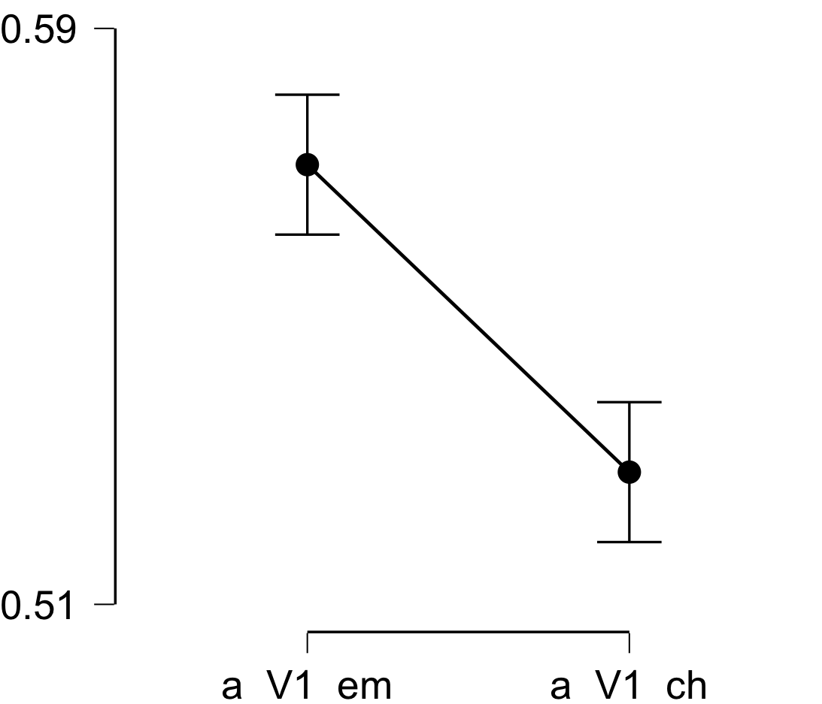

**Bayesian Paired Samples T-Test**

| **Bayesian Paired Samples T-Test** | | | | | | | | | |
| --- | --- | --- | --- | --- | --- | --- | --- | --- | --- |
|  | |  | |  | | **BF₁₀** | | **error %** | |
| a_V1_em |  | - |  | a_V1_ch |  | 28231.721 |  | 1.255e -7 |  |
|  | | | | | | | | | |

**Inferential Plots**

**a_V1_em - a_V1_ch**

**Prior and Posterior**

