**Results**

**Repeated Measures ANOVA**

| **Within Subjects Effects** | | | | | | | | | | | | | | | |
| --- | --- | --- | --- | --- | --- | --- | --- | --- | --- | --- | --- | --- | --- | --- | --- |
|  | | **Sum of Squares** | | **df** | | **Mean Square** | | **F** | | **p** | | **η² p** | | **ω²** | |
| ROI |  | 0.240 | ᵃ | 8 | ᵃ | 0.030 | ᵃ | 30.888 | ᵃ | 1.127e -32 | ᵃ | 0.516 |  | 0.267 |  |
| Residual |  | 0.225 |  | 232 |  | 9.700e -4 |  |  |  |  |  |  |  |  |  |
|  | | | | | | | | | | | | | | | |
| *Note.*  Type III Sum of Squares | | | | | | | | | | | | | | | |
| ᵃ Mauchly's test of sphericity indicates that the assumption of sphericity is violated (p < .05). | | | | | | | | | | | | | | | |

| **Between Subjects Effects** | | | | | | | | | | | | | | | |
| --- | --- | --- | --- | --- | --- | --- | --- | --- | --- | --- | --- | --- | --- | --- | --- |
|  | | **Sum of Squares** | | **df** | | **Mean Square** | | **F** | | **p** | | **η² p** | | **ω²** | |
| Residual |  | 0.392 |  | 29 |  | 0.014 |  |  |  |  |  |  |  |  |  |
|  | | | | | | | | | | | | | | | |
| *Note.*  Type III Sum of Squares | | | | | | | | | | | | | | | |

**Post Hoc Tests**

| **Post Hoc Comparisons - ROI** | | | | | | | | | | | | | | | | | | | |
| --- | --- | --- | --- | --- | --- | --- | --- | --- | --- | --- | --- | --- | --- | --- | --- | --- | --- | --- | --- |
|  | | | | | | **95% CI of Mean Difference** | | | |  | | | | | | | | | |
|  | |  | | **Mean Difference** | | **Lower** | | **Upper** | | **SE** | | **t** | | **Cohen's d** | | **p holm** | | **p bonf** | |
| ACC |  | ATL |  | 0.058 |  | 0.029 |  | 0.088 |  | 0.008 |  | 7.025 |  | 1.283 |  | 3.001e -6 |  | 3.602e -6 |  |
|  |  | IFG |  | 0.016 |  | -0.012 |  | 0.044 |  | 0.008 |  | 2.004 |  | 0.366 |  | 0.424 |  | 1.000 |  |
|  |  | Ins |  | 0.035 |  | 0.004 |  | 0.067 |  | 0.009 |  | 3.976 |  | 0.726 |  | 0.008 |  | 0.015 |  |
|  |  | LTL |  | -0.016 |  | -0.043 |  | 0.012 |  | 0.008 |  | -2.038 |  | -0.372 |  | 0.424 |  | 1.000 |  |
|  |  | PCC |  | 0.044 |  | 0.013 |  | 0.076 |  | 0.009 |  | 4.946 |  | 0.903 |  | 6.772e -4 |  | 0.001 |  |
|  |  | Prec |  | 0.007 |  | -0.017 |  | 0.032 |  | 0.007 |  | 1.091 |  | 0.199 |  | 0.793 |  | 1.000 |  |
|  |  | V1 |  | 0.087 |  | 0.052 |  | 0.121 |  | 0.010 |  | 8.911 |  | 1.627 |  | 2.784e -8 |  | 3.037e -8 |  |
|  |  | aPFC |  | 0.021 |  | -8.681e -4 |  | 0.043 |  | 0.006 |  | 3.396 |  | 0.620 |  | 0.026 |  | 0.072 |  |
| ATL |  | IFG |  | -0.042 |  | -0.075 |  | -0.010 |  | 0.009 |  | -4.670 |  | -0.853 |  | 0.001 |  | 0.002 |  |
|  |  | Ins |  | -0.023 |  | -0.050 |  | 0.004 |  | 0.008 |  | -3.016 |  | -0.551 |  | 0.061 |  | 0.190 |  |
|  |  | LTL |  | -0.074 |  | -0.109 |  | -0.039 |  | 0.010 |  | -7.393 |  | -1.350 |  | 1.181e -6 |  | 1.371e -6 |  |
|  |  | PCC |  | -0.014 |  | -0.042 |  | 0.014 |  | 0.008 |  | -1.756 |  | -0.321 |  | 0.538 |  | 1.000 |  |
|  |  | Prec |  | -0.051 |  | -0.079 |  | -0.023 |  | 0.008 |  | -6.379 |  | -1.165 |  | 1.583e -5 |  | 2.036e -5 |  |
|  |  | V1 |  | 0.028 |  | 0.001 |  | 0.056 |  | 0.008 |  | 3.684 |  | 0.673 |  | 0.014 |  | 0.034 |  |
|  |  | aPFC |  | -0.037 |  | -0.067 |  | -0.007 |  | 0.008 |  | -4.370 |  | -0.798 |  | 0.003 |  | 0.005 |  |
| IFG |  | Ins |  | 0.020 |  | -0.003 |  | 0.042 |  | 0.006 |  | 3.029 |  | 0.553 |  | 0.061 |  | 0.184 |  |
|  |  | LTL |  | -0.031 |  | -0.055 |  | -0.008 |  | 0.007 |  | -4.711 |  | -0.860 |  | 0.001 |  | 0.002 |  |
|  |  | PCC |  | 0.029 |  | 0.002 |  | 0.055 |  | 0.007 |  | 3.836 |  | 0.700 |  | 0.011 |  | 0.022 |  |
|  |  | Prec |  | -0.008 |  | -0.034 |  | 0.018 |  | 0.007 |  | -1.138 |  | -0.208 |  | 0.793 |  | 1.000 |  |
|  |  | V1 |  | 0.071 |  | 0.041 |  | 0.100 |  | 0.008 |  | 8.498 |  | 1.551 |  | 7.393e -8 |  | 8.317e -8 |  |
|  |  | aPFC |  | 0.005 |  | -0.019 |  | 0.030 |  | 0.007 |  | 0.784 |  | 0.143 |  | 0.793 |  | 1.000 |  |
| Ins |  | LTL |  | -0.051 |  | -0.083 |  | -0.019 |  | 0.009 |  | -5.578 |  | -1.018 |  | 1.275e -4 |  | 1.837e -4 |  |
|  |  | PCC |  | 0.009 |  | -0.013 |  | 0.031 |  | 0.006 |  | 1.460 |  | 0.267 |  | 0.635 |  | 1.000 |  |
|  |  | Prec |  | -0.028 |  | -0.054 |  | -0.002 |  | 0.007 |  | -3.811 |  | -0.696 |  | 0.011 |  | 0.024 |  |
|  |  | V1 |  | 0.051 |  | 0.033 |  | 0.069 |  | 0.005 |  | 10.080 |  | 1.840 |  | 1.927e -9 |  | 1.982e -9 |  |
|  |  | aPFC |  | -0.014 |  | -0.046 |  | 0.018 |  | 0.009 |  | -1.571 |  | -0.287 |  | 0.635 |  | 1.000 |  |
| LTL |  | PCC |  | 0.060 |  | 0.028 |  | 0.092 |  | 0.009 |  | 6.676 |  | 1.219 |  | 7.357e -6 |  | 9.133e -6 |  |
|  |  | Prec |  | 0.023 |  | -1.720e -4 |  | 0.047 |  | 0.007 |  | 3.509 |  | 0.641 |  | 0.021 |  | 0.054 |  |
|  |  | V1 |  | 0.102 |  | 0.065 |  | 0.140 |  | 0.011 |  | 9.699 |  | 1.771 |  | 4.470e -9 |  | 4.733e -9 |  |
|  |  | aPFC |  | 0.037 |  | 0.010 |  | 0.063 |  | 0.008 |  | 4.917 |  | 0.898 |  | 7.022e -4 |  | 0.001 |  |
| PCC |  | Prec |  | -0.037 |  | -0.063 |  | -0.011 |  | 0.007 |  | -4.978 |  | -0.909 |  | 6.480e -4 |  | 9.720e -4 |  |
|  |  | V1 |  | 0.042 |  | 0.017 |  | 0.068 |  | 0.007 |  | 5.880 |  | 1.073 |  | 5.763e -5 |  | 7.980e -5 |  |
|  |  | aPFC |  | -0.023 |  | -0.057 |  | 0.011 |  | 0.010 |  | -2.394 |  | -0.437 |  | 0.233 |  | 0.840 |  |
| Prec |  | V1 |  | 0.079 |  | 0.052 |  | 0.107 |  | 0.008 |  | 10.147 |  | 1.853 |  | 1.706e -9 |  | 1.706e -9 |  |
|  |  | aPFC |  | 0.014 |  | -0.010 |  | 0.037 |  | 0.007 |  | 2.073 |  | 0.379 |  | 0.424 |  | 1.000 |  |
| V1 |  | aPFC |  | -0.065 |  | -0.102 |  | -0.029 |  | 0.010 |  | -6.346 |  | -1.159 |  | 1.671e -5 |  | 2.228e -5 |  |
|  | | | | | | | | | | | | | | | | | | | |
| *Note.*  Cohen's d does not correct for multiple comparisons. | | | | | | | | | | | | | | | | | | | |
| *Note.*  Bonferroni adjusted confidence intervals. | | | | | | | | | | | | | | | | | | | |

**Descriptives**

| **Descriptives** | | | | | | | |
| --- | --- | --- | --- | --- | --- | --- | --- |
| **ROI** | | **Mean** | | **SD** | | **N** | |
| LTL |  | 0.682 |  | 0.065 |  | 30 |  |
| IFG |  | 0.651 |  | 0.048 |  | 30 |  |
| Prec |  | 0.659 |  | 0.049 |  | 30 |  |
| ATL |  | 0.608 |  | 0.047 |  | 30 |  |
| aPFC |  | 0.645 |  | 0.062 |  | 30 |  |
| Ins |  | 0.631 |  | 0.029 |  | 30 |  |
| ACC |  | 0.666 |  | 0.058 |  | 30 |  |
| PCC |  | 0.622 |  | 0.035 |  | 30 |  |
| V1 |  | 0.580 |  | 0.028 |  | 30 |  |
|  | | | | | | | |

**Descriptives Plot**

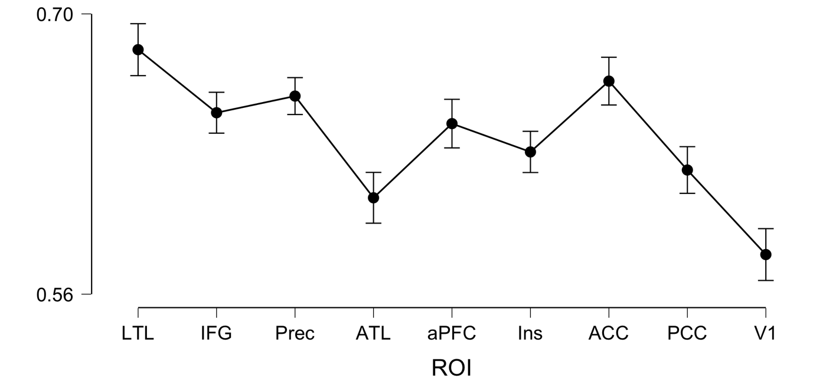

**Repeated Measures ANOVA**

| **Within Subjects Effects** | | | | | | | | | | | |
| --- | --- | --- | --- | --- | --- | --- | --- | --- | --- | --- | --- |
|  | | **Sum of Squares** | | **df** | | **Mean Square** | | **F** | | **p** | |
| ROI |  | 0.150 |  | 8 |  | 0.019 |  | 28.816 |  | 6.059e -31 |  |
| Residual |  | 0.151 |  | 232 |  | 6.504e -4 |  |  |  |  |  |
| Condition |  | 1.460 |  | 1 |  | 1.460 |  | 145.130 |  | 8.240e -13 |  |
| Residual |  | 0.292 |  | 29 |  | 0.010 |  |  |  |  |  |
| ROI ✻ Condition |  | 0.097 |  | 8 |  | 0.012 |  | 16.937 |  | 9.637e -20 |  |
| Residual |  | 0.166 |  | 232 |  | 7.162e -4 |  |  |  |  |  |
|  | | | | | | | | | | | |
| *Note.*  Type III Sum of Squares | | | | | | | | | | | |

| **Between Subjects Effects** | | | | | | | | | | | |
| --- | --- | --- | --- | --- | --- | --- | --- | --- | --- | --- | --- |
|  | | **Sum of Squares** | | **df** | | **Mean Square** | | **F** | | **p** | |
| Residual |  | 0.294 |  | 29 |  | 0.010 |  |  |  |  |  |
|  | | | | | | | | | | | |
| *Note.*  Type III Sum of Squares | | | | | | | | | | | |

**Descriptives**

**Descriptives Plot**

