**Results**

**Repeated Measures ANOVA**

| **Within Subjects Effects** | | | | | | | | | | | | | | | | | |
| --- | --- | --- | --- | --- | --- | --- | --- | --- | --- | --- | --- | --- | --- | --- | --- | --- | --- |
|  | | **Sphericity Correction** | | **Sum of Squares** | | **df** | | **Mean Square** | | **F** | | **p** | | **η² p** | | **ω²** | |
| ROI |  | Greenhouse-Geisser |  | 0.176 | ᵃ | 4.639 | ᵃ | 0.038 | ᵃ | 23.531 | ᵃ | 3.497e -16 | ᵃ | 0.448 |  | 0.218 |  |
| Residual |  | Greenhouse-Geisser |  | 0.217 |  | 134.535 |  | 0.002 |  |  |  |  |  |  |  |  |  |
|  | | | | | | | | | | | | | | | | | |
| *Note.*  Type III Sum of Squares | | | | | | | | | | | | | | | | | |
| ᵃ Mauchly's test of sphericity indicates that the assumption of sphericity is violated (p < .05). | | | | | | | | | | | | | | | | | |

| **Between Subjects Effects** | | | | | | | | | | | | | | | |
| --- | --- | --- | --- | --- | --- | --- | --- | --- | --- | --- | --- | --- | --- | --- | --- |
|  | | **Sum of Squares** | | **df** | | **Mean Square** | | **F** | | **p** | | **η² p** | | **ω²** | |
| Residual |  | 0.368 |  | 29 |  | 0.013 |  |  |  |  |  |  |  |  |  |
|  | | | | | | | | | | | | | | | |
| *Note.*  Type III Sum of Squares | | | | | | | | | | | | | | | |

**Post Hoc Tests**

| **Post Hoc Comparisons - ROI** | | | | | | | | | | | | | | | | | | | |
| --- | --- | --- | --- | --- | --- | --- | --- | --- | --- | --- | --- | --- | --- | --- | --- | --- | --- | --- | --- |
|  | | | | | | **95% CI of Mean Difference** | | | |  | | | | | | | | | |
|  | |  | | **Mean Difference** | | **Lower** | | **Upper** | | **SE** | | **t** | | **Cohen's d** | | **p holm** | | **p bonf** | |
| ACC |  | ATL |  | 0.053 |  | 0.022 |  | 0.084 |  | 0.009 |  | 5.999 |  | 1.095 |  | 4.954e -5 |  | 5.753e -5 |  |
|  |  | IFG |  | 0.026 |  | -0.006 |  | 0.058 |  | 0.009 |  | 2.907 |  | 0.531 |  | 0.102 |  | 0.250 |  |
|  |  | Ins |  | 0.045 |  | 0.011 |  | 0.079 |  | 0.010 |  | 4.623 |  | 0.844 |  | 0.002 |  | 0.003 |  |
|  |  | LTL |  | -0.003 |  | -0.030 |  | 0.024 |  | 0.008 |  | -0.349 |  | -0.064 |  | 1.000 |  | 1.000 |  |
|  |  | PCC |  | 0.042 |  | 0.007 |  | 0.078 |  | 0.010 |  | 4.270 |  | 0.780 |  | 0.004 |  | 0.007 |  |
|  |  | Prec |  | 0.012 |  | -0.011 |  | 0.036 |  | 0.007 |  | 1.833 |  | 0.335 |  | 0.569 |  | 1.000 |  |
|  |  | V1 |  | 0.082 |  | 0.045 |  | 0.119 |  | 0.010 |  | 7.827 |  | 1.429 |  | 4.227e -7 |  | 4.476e -7 |  |
|  |  | aPFC |  | 0.027 |  | 0.004 |  | 0.050 |  | 0.007 |  | 4.095 |  | 0.748 |  | 0.006 |  | 0.011 |  |
| ATL |  | IFG |  | -0.026 |  | -0.061 |  | 0.008 |  | 0.010 |  | -2.714 |  | -0.495 |  | 0.133 |  | 0.399 |  |
|  |  | Ins |  | -0.008 |  | -0.035 |  | 0.019 |  | 0.008 |  | -1.047 |  | -0.191 |  | 1.000 |  | 1.000 |  |
|  |  | LTL |  | -0.055 |  | -0.089 |  | -0.022 |  | 0.010 |  | -5.817 |  | -1.062 |  | 7.634e -5 |  | 9.477e -5 |  |
|  |  | PCC |  | -0.010 |  | -0.040 |  | 0.019 |  | 0.008 |  | -1.233 |  | -0.225 |  | 1.000 |  | 1.000 |  |
|  |  | Prec |  | -0.040 |  | -0.068 |  | -0.013 |  | 0.008 |  | -5.166 |  | -0.943 |  | 3.998e -4 |  | 5.757e -4 |  |
|  |  | V1 |  | 0.029 |  | 0.002 |  | 0.056 |  | 0.008 |  | 3.798 |  | 0.693 |  | 0.012 |  | 0.025 |  |
|  |  | aPFC |  | -0.026 |  | -0.053 |  | 0.001 |  | 0.008 |  | -3.392 |  | -0.619 |  | 0.032 |  | 0.073 |  |
| IFG |  | Ins |  | 0.018 |  | -0.004 |  | 0.041 |  | 0.006 |  | 2.915 |  | 0.532 |  | 0.102 |  | 0.244 |  |
|  |  | LTL |  | -0.029 |  | -0.051 |  | -0.007 |  | 0.006 |  | -4.666 |  | -0.852 |  | 0.002 |  | 0.002 |  |
|  |  | PCC |  | 0.016 |  | -0.009 |  | 0.042 |  | 0.007 |  | 2.238 |  | 0.409 |  | 0.330 |  | 1.000 |  |
|  |  | Prec |  | -0.014 |  | -0.041 |  | 0.012 |  | 0.007 |  | -1.873 |  | -0.342 |  | 0.569 |  | 1.000 |  |
|  |  | V1 |  | 0.056 |  | 0.027 |  | 0.084 |  | 0.008 |  | 6.926 |  | 1.264 |  | 4.168e -6 |  | 4.689e -6 |  |
|  |  | aPFC |  | 4.484e -4 |  | -0.025 |  | 0.026 |  | 0.007 |  | 0.063 |  | 0.011 |  | 1.000 |  | 1.000 |  |
| Ins |  | LTL |  | -0.047 |  | -0.077 |  | -0.018 |  | 0.008 |  | -5.657 |  | -1.033 |  | 1.066e -4 |  | 1.476e -4 |  |
|  |  | PCC |  | -0.002 |  | -0.025 |  | 0.021 |  | 0.007 |  | -0.359 |  | -0.066 |  | 1.000 |  | 1.000 |  |
|  |  | Prec |  | -0.032 |  | -0.059 |  | -0.006 |  | 0.008 |  | -4.329 |  | -0.790 |  | 0.003 |  | 0.006 |  |
|  |  | V1 |  | 0.037 |  | 0.018 |  | 0.056 |  | 0.005 |  | 7.036 |  | 1.285 |  | 3.212e -6 |  | 3.504e -6 |  |
|  |  | aPFC |  | -0.018 |  | -0.047 |  | 0.011 |  | 0.008 |  | -2.173 |  | -0.397 |  | 0.343 |  | 1.000 |  |
| LTL |  | PCC |  | 0.045 |  | 0.017 |  | 0.073 |  | 0.008 |  | 5.759 |  | 1.051 |  | 8.666e -5 |  | 1.114e -4 |  |
|  |  | Prec |  | 0.015 |  | -0.003 |  | 0.033 |  | 0.005 |  | 2.877 |  | 0.525 |  | 0.102 |  | 0.269 |  |
|  |  | V1 |  | 0.085 |  | 0.053 |  | 0.116 |  | 0.009 |  | 9.504 |  | 1.735 |  | 7.438e -9 |  | 7.438e -9 |  |
|  |  | aPFC |  | 0.029 |  | 0.004 |  | 0.055 |  | 0.007 |  | 4.125 |  | 0.753 |  | 0.005 |  | 0.010 |  |
| PCC |  | Prec |  | -0.030 |  | -0.054 |  | -0.007 |  | 0.007 |  | -4.509 |  | -0.823 |  | 0.002 |  | 0.004 |  |
|  |  | V1 |  | 0.039 |  | 0.016 |  | 0.063 |  | 0.007 |  | 5.971 |  | 1.090 |  | 5.178e -5 |  | 6.213e -5 |  |
|  |  | aPFC |  | -0.016 |  | -0.047 |  | 0.016 |  | 0.009 |  | -1.744 |  | -0.318 |  | 0.569 |  | 1.000 |  |
| Prec |  | V1 |  | 0.070 |  | 0.043 |  | 0.096 |  | 0.008 |  | 9.170 |  | 1.674 |  | 1.590e -8 |  | 1.635e -8 |  |
|  |  | aPFC |  | 0.014 |  | -0.008 |  | 0.036 |  | 0.006 |  | 2.327 |  | 0.425 |  | 0.298 |  | 0.977 |  |
| V1 |  | aPFC |  | -0.055 |  | -0.089 |  | -0.021 |  | 0.010 |  | -5.744 |  | -1.049 |  | 8.707e -5 |  | 1.161e -4 |  |
|  | | | | | | | | | | | | | | | | | | | |
| *Note.*  Cohen's d does not correct for multiple comparisons. | | | | | | | | | | | | | | | | | | | |
| *Note.*  Bonferroni adjusted confidence intervals. | | | | | | | | | | | | | | | | | | | |

**Descriptives**

| **Descriptives** | | | | | | | |
| --- | --- | --- | --- | --- | --- | --- | --- |
| **ROI** | | **Mean** | | **SD** | | **N** | |
| LTL |  | 0.606 |  | 0.057 |  | 30 |  |
| IFG |  | 0.577 |  | 0.050 |  | 30 |  |
| Prec |  | 0.591 |  | 0.047 |  | 30 |  |
| ATL |  | 0.551 |  | 0.045 |  | 30 |  |
| aPFC |  | 0.577 |  | 0.058 |  | 30 |  |
| Ins |  | 0.559 |  | 0.032 |  | 30 |  |
| ACC |  | 0.603 |  | 0.061 |  | 30 |  |
| PCC |  | 0.561 |  | 0.036 |  | 30 |  |
| V1 |  | 0.521 |  | 0.029 |  | 30 |  |
|  | | | | | | | |

**Descriptives Plot**

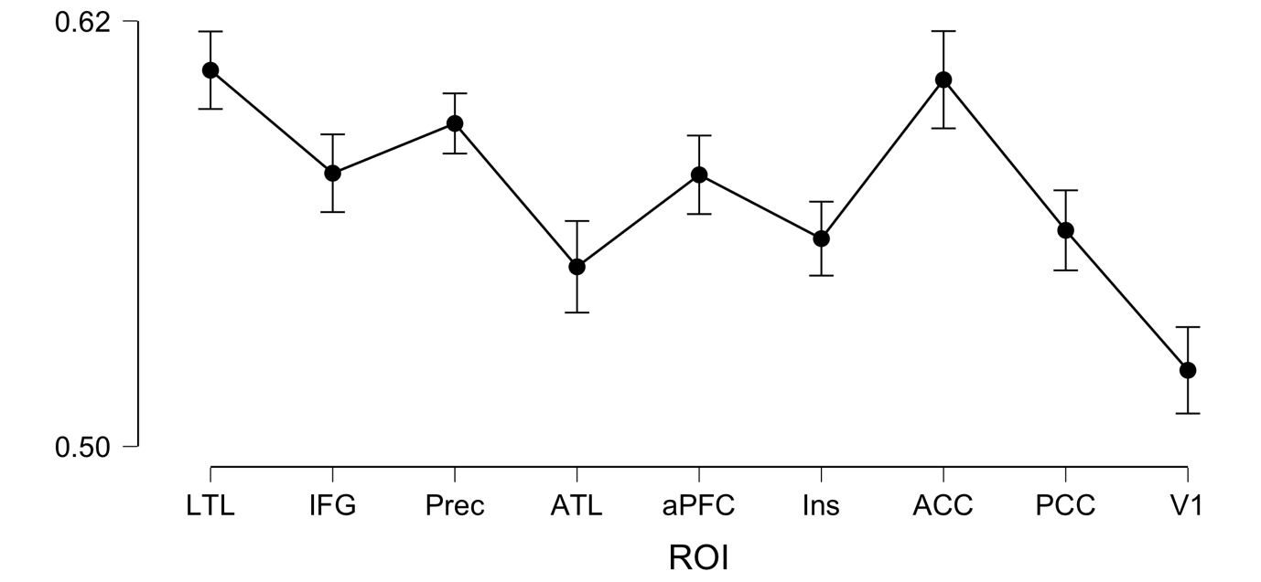

**Repeated Measures ANOVA**

| **Within Subjects Effects** | | | | | | | | | | | | | |
| --- | --- | --- | --- | --- | --- | --- | --- | --- | --- | --- | --- | --- | --- |
|  | | **Sphericity Correction** | | **Sum of Squares** | | **df** | | **Mean Square** | | **F** | | **p** | |
| ROI |  | Greenhouse-Geisser |  | 0.108 |  | 5.525 |  | 0.020 |  | 19.764 |  | 2.500e -16 |  |
| Residual |  | Greenhouse-Geisser |  | 0.158 |  | 160.232 |  | 9.868e -4 |  |  |  |  |  |
| Condition |  | Greenhouse-Geisser |  | 0.168 |  | 1.000 |  | 0.168 |  | 18.262 |  | 1.896e  -4 |  |
| Residual |  | Greenhouse-Geisser |  | 0.266 |  | 29.000 |  | 0.009 |  |  |  |  |  |
| ROI ✻ Condition |  | Greenhouse-Geisser |  | 0.076 | ᵃ | 5.443 | ᵃ | 0.014 | ᵃ | 15.354 | ᵃ | 5.543e -13 | ᵃ |
| Residual |  | Greenhouse-Geisser |  | 0.143 |  | 157.838 |  | 9.053e -4 |  |  |  |  |  |
|  | | | | | | | | | | | | | |
| *Note.*  Type III Sum of Squares | | | | | | | | | | | | | |
| ᵃ Mauchly's test of sphericity indicates that the assumption of sphericity is violated (p < .05). | | | | | | | | | | | | | |

| **Between Subjects Effects** | | | | | | | | | | | |
| --- | --- | --- | --- | --- | --- | --- | --- | --- | --- | --- | --- |
|  | | **Sum of Squares** | | **df** | | **Mean Square** | | **F** | | **p** | |
| Residual |  | 0.264 |  | 29 |  | 0.009 |  |  |  |  |  |
|  | | | | | | | | | | | |
| *Note.*  Type III Sum of Squares | | | | | | | | | | | |

**Descriptives**

**Descriptives Plot**

