**Results**

**Paired Samples T-Test**

| **Paired Samples T-Test** | | | | | | | | | | | | | | | | | | | | | | | | | |
| --- | --- | --- | --- | --- | --- | --- | --- | --- | --- | --- | --- | --- | --- | --- | --- | --- | --- | --- | --- | --- | --- | --- | --- | --- | --- |
|  | | | | | | | | | | | | | | | | **95% CI for Mean Difference** | | | |  | | **95% CI for Cohen's d** | | | |
|  | |  | |  | | **t** | | **df** | | **p** | | **Mean Difference** | | **SE Difference** | | **Lower** | | **Upper** | | **Cohen's d** | | **Lower** | | **Upper** | |
| l_LTL_em |  | - |  | l_LTL_ch |  | 5.222 |  | 29 |  | 1.370e -5 |  | 0.062 |  | 0.012 |  | 0.038 |  | 0.086 |  | 0.953 |  | 0.514 |  | 1.381 |  |
|  | | | | | | | | | | | | | | | | | | | | | | | | | |
| *Note.*  Student's t-test. | | | | | | | | | | | | | | | | | | | | | | | | | |

**Assumption Checks**

| **Test of Normality (Shapiro-Wilk)** | | | | | | | | | |
| --- | --- | --- | --- | --- | --- | --- | --- | --- | --- |
|  | |  | |  | | **W** | | **p** | |
| l_LTL_em |  | - |  | l_LTL_ch |  | 0.978 |  | 0.776 |  |
|  | | | | | | | | | |
| *Note.*  Significant results suggest a deviation from normality. | | | | | | | | | |

**Descriptives**

| **Descriptives** | | | | | | | | | |
| --- | --- | --- | --- | --- | --- | --- | --- | --- | --- |
|  | | **N** | | **Mean** | | **SD** | | **SE** | |
| l_LTL_em |  | 30 |  | 0.606 |  | 0.057 |  | 0.010 |  |
| l_LTL_ch |  | 30 |  | 0.544 |  | 0.034 |  | 0.006 |  |
|  | | | | | | | | | |

**Descriptives Plot**

**Bayesian Paired Samples T-Test**

| **Bayesian Paired Samples T-Test** | | | | | | | | | |
| --- | --- | --- | --- | --- | --- | --- | --- | --- | --- |
|  | |  | |  | | **BF₁₀** | | **error %** | |
| l_LTL_em |  | - |  | l_LTL_ch |  | 1582.901 |  | 1.238e -6 |  |
|  | | | | | | | | | |

**Inferential Plots**

**l_LTL_em - l_LTL_ch**

**Prior and Posterior**

**Paired Samples T-Test**

| **Paired Samples T-Test** | | | | | | | | | | | | | | | | | | | | | | | | | |
| --- | --- | --- | --- | --- | --- | --- | --- | --- | --- | --- | --- | --- | --- | --- | --- | --- | --- | --- | --- | --- | --- | --- | --- | --- | --- |
|  | | | | | | | | | | | | | | | | **95% CI for Mean Difference** | | | |  | | **95% CI for Cohen's d** | | | |
|  | |  | |  | | **t** | | **df** | | **p** | | **Mean Difference** | | **SE Difference** | | **Lower** | | **Upper** | | **Cohen's d** | | **Lower** | | **Upper** | |
| l_IFG_em |  | - |  | l_IFG_ch |  | 4.238 |  | 29 |  | 2.088e -4 |  | 0.040 |  | 0.009 |  | 0.021 |  | 0.059 |  | 0.774 |  | 0.360 |  | 1.178 |  |
|  | | | | | | | | | | | | | | | | | | | | | | | | | |
| *Note.*  Student's t-test. | | | | | | | | | | | | | | | | | | | | | | | | | |

**Assumption Checks**

| **Test of Normality (Shapiro-Wilk)** | | | | | | | | | |
| --- | --- | --- | --- | --- | --- | --- | --- | --- | --- |
|  | |  | |  | | **W** | | **p** | |
| l_IFG_em |  | - |  | l_IFG_ch |  | 0.963 |  | 0.375 |  |
|  | | | | | | | | | |
| *Note.*  Significant results suggest a deviation from normality. | | | | | | | | | |

**Descriptives**

| **Descriptives** | | | | | | | | | |
| --- | --- | --- | --- | --- | --- | --- | --- | --- | --- |
|  | | **N** | | **Mean** | | **SD** | | **SE** | |
| l_IFG_em |  | 30 |  | 0.577 |  | 0.050 |  | 0.009 |  |
| l_IFG_ch |  | 30 |  | 0.537 |  | 0.029 |  | 0.005 |  |
|  | | | | | | | | | |

**Descriptives Plot**

**Bayesian Paired Samples T-Test**

| **Bayesian Paired Samples T-Test** | | | | | | | | | |
| --- | --- | --- | --- | --- | --- | --- | --- | --- | --- |
|  | |  | |  | | **BF₁₀** | | **error %** | |
| l_IFG_em |  | - |  | l_IFG_ch |  | 133.738 |  | 2.000e -5 |  |
|  | | | | | | | | | |

**Inferential Plots**

**l_IFG_em - l_IFG_ch**

**Prior and Posterior**

**Paired Samples T-Test**

| **Paired Samples T-Test** | | | | | | | | | | | | | | | | | | | | | | | | | |
| --- | --- | --- | --- | --- | --- | --- | --- | --- | --- | --- | --- | --- | --- | --- | --- | --- | --- | --- | --- | --- | --- | --- | --- | --- | --- |
|  | | | | | | | | | | | | | | | | **95% CI for Mean Difference** | | | |  | | **95% CI for Cohen's d** | | | |
|  | |  | |  | | **t** | | **df** | | **p** | | **Mean Difference** | | **SE Difference** | | **Lower** | | **Upper** | | **Cohen's d** | | **Lower** | | **Upper** | |
| l_Prec_em |  | - |  | l_Prec_ch |  | 4.887 |  | 29 |  | 3.472e -5 |  | 0.054 |  | 0.011 |  | 0.031 |  | 0.076 |  | 0.892 |  | 0.462 |  | 1.311 |  |
|  | | | | | | | | | | | | | | | | | | | | | | | | | |
| *Note.*  Student's t-test. | | | | | | | | | | | | | | | | | | | | | | | | | |

**Assumption Checks**

| **Test of Normality (Shapiro-Wilk)** | | | | | | | | | |
| --- | --- | --- | --- | --- | --- | --- | --- | --- | --- |
|  | |  | |  | | **W** | | **p** | |
| l_Prec_em |  | - |  | l_Prec_ch |  | 0.962 |  | 0.339 |  |
|  | | | | | | | | | |
| *Note.*  Significant results suggest a deviation from normality. | | | | | | | | | |

**Descriptives**

| **Descriptives** | | | | | | | | | |
| --- | --- | --- | --- | --- | --- | --- | --- | --- | --- |
|  | | **N** | | **Mean** | | **SD** | | **SE** | |
| l_Prec_em |  | 30 |  | 0.591 |  | 0.047 |  | 0.009 |  |
| l_Prec_ch |  | 30 |  | 0.538 |  | 0.032 |  | 0.006 |  |
|  | | | | | | | | | |

**Descriptives Plot**

**Bayesian Paired Samples T-Test**

| **Bayesian Paired Samples T-Test** | | | | | | | | | |
| --- | --- | --- | --- | --- | --- | --- | --- | --- | --- |
|  | |  | |  | | **BF₁₀** | | **error %** | |
| l_Prec_em |  | - |  | l_Prec_ch |  | 677.416 |  | 1.037e -6 |  |
|  | | | | | | | | | |

**Inferential Plots**

**l_Prec_em - l_Prec_ch**

**Prior and Posterior**

**Paired Samples T-Test**

| **Paired Samples T-Test** | | | | | | | | | | | | | | | | | | | | | | | | | |
| --- | --- | --- | --- | --- | --- | --- | --- | --- | --- | --- | --- | --- | --- | --- | --- | --- | --- | --- | --- | --- | --- | --- | --- | --- | --- |
|  | | | | | | | | | | | | | | | | **95% CI for Mean Difference** | | | |  | | **95% CI for Cohen's d** | | | |
|  | |  | |  | | **t** | | **df** | | **p** | | **Mean Difference** | | **SE Difference** | | **Lower** | | **Upper** | | **Cohen's d** | | **Lower** | | **Upper** | |
| l_ATL_em |  | - |  | l_ATL_ch |  | 2.248 |  | 29 |  | 0.032 |  | 0.025 |  | 0.011 |  | 0.002 |  | 0.048 |  | 0.410 |  | 0.034 |  | 0.780 |  |
|  | | | | | | | | | | | | | | | | | | | | | | | | | |
| *Note.*  Student's t-test. | | | | | | | | | | | | | | | | | | | | | | | | | |

**Assumption Checks**

| **Test of Normality (Shapiro-Wilk)** | | | | | | | | | |
| --- | --- | --- | --- | --- | --- | --- | --- | --- | --- |
|  | |  | |  | | **W** | | **p** | |
| l_ATL_em |  | - |  | l_ATL_ch |  | 0.982 |  | 0.865 |  |
|  | | | | | | | | | |
| *Note.*  Significant results suggest a deviation from normality. | | | | | | | | | |

**Descriptives**

| **Descriptives** | | | | | | | | | |
| --- | --- | --- | --- | --- | --- | --- | --- | --- | --- |
|  | | **N** | | **Mean** | | **SD** | | **SE** | |
| l_ATL_em |  | 30 |  | 0.551 |  | 0.045 |  | 0.008 |  |
| l_ATL_ch |  | 30 |  | 0.526 |  | 0.030 |  | 0.005 |  |
|  | | | | | | | | | |

**Descriptives Plot**

**Bayesian Paired Samples T-Test**

| **Bayesian Paired Samples T-Test** | | | | | | | | | |
| --- | --- | --- | --- | --- | --- | --- | --- | --- | --- |
|  | |  | |  | | **BF₁₀** | | **error %** | |
| l_ATL_em |  | - |  | l_ATL_ch |  | 1.697 |  | 4.191e -6 |  |
|  | | | | | | | | | |

**Inferential Plots**

**l_ATL_em - l_ATL_ch**

**Prior and Posterior**

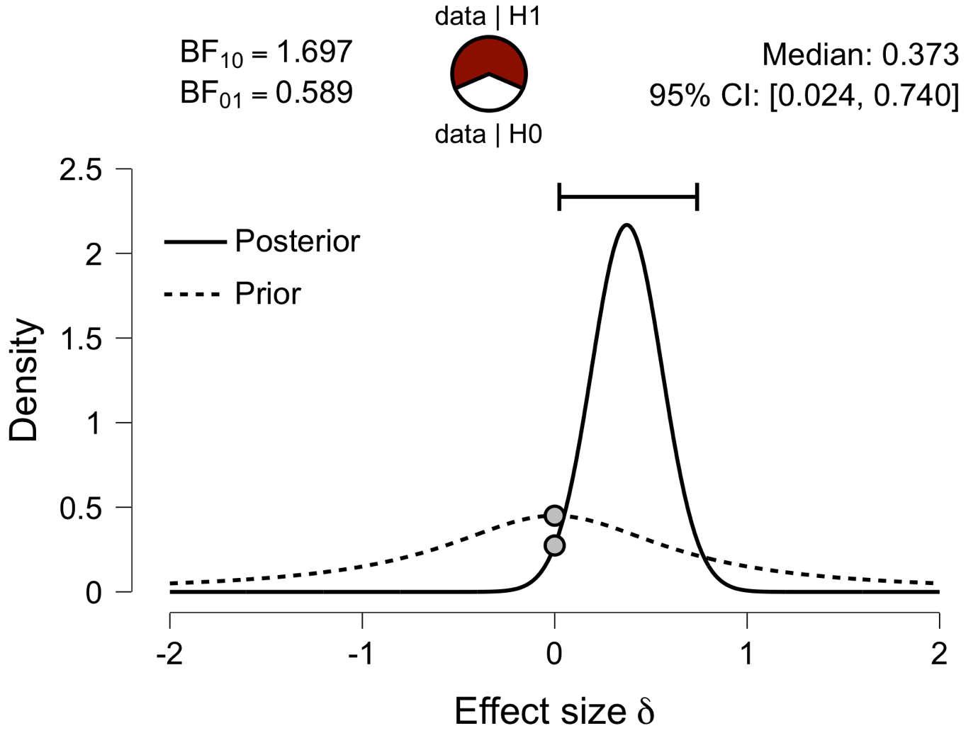

**Paired Samples T-Test**

| **Paired Samples T-Test** | | | | | | | | | | | | | | | | | | | | | | | | | |
| --- | --- | --- | --- | --- | --- | --- | --- | --- | --- | --- | --- | --- | --- | --- | --- | --- | --- | --- | --- | --- | --- | --- | --- | --- | --- |
|  | | | | | | | | | | | | | | | | **95% CI for Mean Difference** | | | |  | | **95% CI for Cohen's d** | | | |
|  | |  | |  | | **t** | | **df** | | **p** | | **Mean Difference** | | **SE Difference** | | **Lower** | | **Upper** | | **Cohen's d** | | **Lower** | | **Upper** | |
| l_aPFC_em |  | - |  | l_aPFC_ch |  | 3.717 |  | 29 |  | 8.568e -4 |  | 0.045 |  | 0.012 |  | 0.020 |  | 0.069 |  | 0.679 |  | 0.276 |  | 1.072 |  |
|  | | | | | | | | | | | | | | | | | | | | | | | | | |
| *Note.*  Student's t-test. | | | | | | | | | | | | | | | | | | | | | | | | | |

**Assumption Checks**

| **Test of Normality (Shapiro-Wilk)** | | | | | | | | | |
| --- | --- | --- | --- | --- | --- | --- | --- | --- | --- |
|  | |  | |  | | **W** | | **p** | |
| l_aPFC_em |  | - |  | l_aPFC_ch |  | 0.984 |  | 0.917 |  |
|  | | | | | | | | | |
| *Note.*  Significant results suggest a deviation from normality. | | | | | | | | | |

**Descriptives**

| **Descriptives** | | | | | | | | | |
| --- | --- | --- | --- | --- | --- | --- | --- | --- | --- |
|  | | **N** | | **Mean** | | **SD** | | **SE** | |
| l_aPFC_em |  | 30 |  | 0.577 |  | 0.058 |  | 0.011 |  |
| l_aPFC_ch |  | 30 |  | 0.532 |  | 0.032 |  | 0.006 |  |
|  | | | | | | | | | |

**Descriptives Plot**

**Bayesian Paired Samples T-Test**

| **Bayesian Paired Samples T-Test** | | | | | | | | | |
| --- | --- | --- | --- | --- | --- | --- | --- | --- | --- |
|  | |  | |  | | **BF₁₀** | | **error %** | |
| l_aPFC_em |  | - |  | l_aPFC_ch |  | 37.982 |  | 2.651e -4 |  |
|  | | | | | | | | | |

**Inferential Plots**

**l_aPFC_em - l_aPFC_ch**

**Prior and Posterior**

**Paired Samples T-Test**

| **Paired Samples T-Test** | | | | | | | | | | | | | | | | | | | | | | | | | |
| --- | --- | --- | --- | --- | --- | --- | --- | --- | --- | --- | --- | --- | --- | --- | --- | --- | --- | --- | --- | --- | --- | --- | --- | --- | --- |
|  | | | | | | | | | | | | | | | | **95% CI for Mean Difference** | | | |  | | **95% CI for Cohen's d** | | | |
|  | |  | |  | | **t** | | **df** | | **p** | | **Mean Difference** | | **SE Difference** | | **Lower** | | **Upper** | | **Cohen's d** | | **Lower** | | **Upper** | |
| l_Ins_em |  | - |  | l_Ins_ch |  | 2.244 |  | 29 |  | 0.033 |  | 0.016 |  | 0.007 |  | 0.001 |  | 0.031 |  | 0.410 |  | 0.034 |  | 0.779 |  |
|  | | | | | | | | | | | | | | | | | | | | | | | | | |
| *Note.*  Student's t-test. | | | | | | | | | | | | | | | | | | | | | | | | | |

**Assumption Checks**

| **Test of Normality (Shapiro-Wilk)** | | | | | | | | | |
| --- | --- | --- | --- | --- | --- | --- | --- | --- | --- |
|  | |  | |  | | **W** | | **p** | |
| l_Ins_em |  | - |  | l_Ins_ch |  | 0.966 |  | 0.440 |  |
|  | | | | | | | | | |
| *Note.*  Significant results suggest a deviation from normality. | | | | | | | | | |

**Descriptives**

| **Descriptives** | | | | | | | | | |
| --- | --- | --- | --- | --- | --- | --- | --- | --- | --- |
|  | | **N** | | **Mean** | | **SD** | | **SE** | |
| l_Ins_em |  | 30 |  | 0.559 |  | 0.032 |  | 0.006 |  |
| l_Ins_ch |  | 30 |  | 0.543 |  | 0.029 |  | 0.005 |  |
|  | | | | | | | | | |

**Descriptives Plot**

**Bayesian Paired Samples T-Test**

| **Bayesian Paired Samples T-Test** | | | | | | | | | |
| --- | --- | --- | --- | --- | --- | --- | --- | --- | --- |
|  | |  | |  | | **BF₁₀** | | **error %** | |
| l_Ins_em |  | - |  | l_Ins_ch |  | 1.686 |  | 4.204e -6 |  |
|  | | | | | | | | | |

**Inferential Plots**

**l_Ins_em - l_Ins_ch**

**Prior and Posterior**

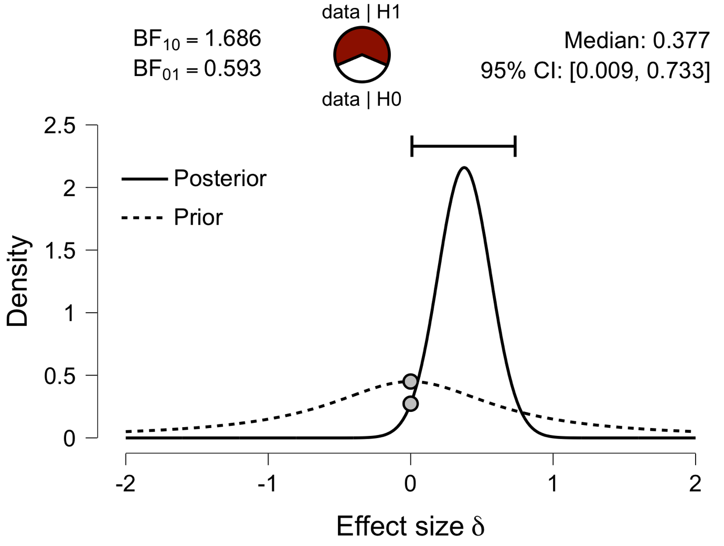

**Paired Samples T-Test**

| **Paired Samples T-Test** | | | | | | | | | | | | | | | | | | | | | | | | | |
| --- | --- | --- | --- | --- | --- | --- | --- | --- | --- | --- | --- | --- | --- | --- | --- | --- | --- | --- | --- | --- | --- | --- | --- | --- | --- |
|  | | | | | | | | | | | | | | | | **95% CI for Mean Difference** | | | |  | | **95% CI for Cohen's d** | | | |
|  | |  | |  | | **t** | | **df** | | **p** | | **Mean Difference** | | **SE Difference** | | **Lower** | | **Upper** | | **Cohen's d** | | **Lower** | | **Upper** | |
| l_ACC_em |  | - |  | l_ACC_ch |  | 5.027 |  | 29 |  | 2.350e -5 |  | 0.066 |  | 0.013 |  | 0.039 |  | 0.093 |  | 0.918 |  | 0.484 |  | 1.341 |  |
|  | | | | | | | | | | | | | | | | | | | | | | | | | |
| *Note.*  Student's t-test. | | | | | | | | | | | | | | | | | | | | | | | | | |

**Assumption Checks**

| **Test of Normality (Shapiro-Wilk)** | | | | | | | | | |
| --- | --- | --- | --- | --- | --- | --- | --- | --- | --- |
|  | |  | |  | | **W** | | **p** | |
| l_ACC_em |  | - |  | l_ACC_ch |  | 0.976 |  | 0.713 |  |
|  | | | | | | | | | |
| *Note.*  Significant results suggest a deviation from normality. | | | | | | | | | |

**Descriptives**

| **Descriptives** | | | | | | | | | |
| --- | --- | --- | --- | --- | --- | --- | --- | --- | --- |
|  | | **N** | | **Mean** | | **SD** | | **SE** | |
| l_ACC_em |  | 30 |  | 0.603 |  | 0.061 |  | 0.011 |  |
| l_ACC_ch |  | 30 |  | 0.538 |  | 0.023 |  | 0.004 |  |
|  | | | | | | | | | |

**Descriptives Plot**

**Bayesian Paired Samples T-Test**

| **Bayesian Paired Samples T-Test** | | | | | | | | | |
| --- | --- | --- | --- | --- | --- | --- | --- | --- | --- |
|  | |  | |  | | **BF₁₀** | | **error %** | |
| l_ACC_em |  | - |  | l_ACC_ch |  | 966.599 |  | 1.247e -6 |  |
|  | | | | | | | | | |

**Inferential Plots**

**l_ACC_em - l_ACC_ch**

**Prior and Posterior**

**Paired Samples T-Test**

| **Paired Samples T-Test** | | | | | | | | | | | | | | | | | | | | | | | | | |
| --- | --- | --- | --- | --- | --- | --- | --- | --- | --- | --- | --- | --- | --- | --- | --- | --- | --- | --- | --- | --- | --- | --- | --- | --- | --- |
|  | | | | | | | | | | | | | | | | **95% CI for Mean Difference** | | | |  | | **95% CI for Cohen's d** | | | |
|  | |  | |  | | **t** | | **df** | | **p** | | **Mean Difference** | | **SE Difference** | | **Lower** | | **Upper** | | **Cohen's d** | | **Lower** | | **Upper** | |
| l_PCC_em |  | - |  | l_PCC_ch |  | 3.058 |  | 29 |  | 0.005 |  | 0.023 |  | 0.008 |  | 0.008 |  | 0.039 |  | 0.558 |  | 0.169 |  | 0.940 |  |
|  | | | | | | | | | | | | | | | | | | | | | | | | | |
| *Note.*  Student's t-test. | | | | | | | | | | | | | | | | | | | | | | | | | |

**Assumption Checks**

| **Test of Normality (Shapiro-Wilk)** | | | | | | | | | |
| --- | --- | --- | --- | --- | --- | --- | --- | --- | --- |
|  | |  | |  | | **W** | | **p** | |
| l_PCC_em |  | - |  | l_PCC_ch |  | 0.981 |  | 0.854 |  |
|  | | | | | | | | | |
| *Note.*  Significant results suggest a deviation from normality. | | | | | | | | | |

**Descriptives**

| **Descriptives** | | | | | | | | | |
| --- | --- | --- | --- | --- | --- | --- | --- | --- | --- |
|  | | **N** | | **Mean** | | **SD** | | **SE** | |
| l_PCC_em |  | 30 |  | 0.561 |  | 0.036 |  | 0.007 |  |
| l_PCC_ch |  | 30 |  | 0.538 |  | 0.032 |  | 0.006 |  |
|  | | | | | | | | | |

**Descriptives Plot**

**Bayesian Paired Samples T-Test**

| **Bayesian Paired Samples T-Test** | | | | | | | | | |
| --- | --- | --- | --- | --- | --- | --- | --- | --- | --- |
|  | |  | |  | | **BF₁₀** | | **error %** | |
| l_PCC_em |  | - |  | l_PCC_ch |  | 8.505 |  | 2.298e -6 |  |
|  | | | | | | | | | |

**Inferential Plots**

**l_PCC_em - l_PCC_ch**

**Prior and Posterior**

**Paired Samples T-Test**

| **Paired Samples T-Test** | | | | | | | | | | | | | | | | | | | | | | | | | |
| --- | --- | --- | --- | --- | --- | --- | --- | --- | --- | --- | --- | --- | --- | --- | --- | --- | --- | --- | --- | --- | --- | --- | --- | --- | --- |
|  | | | | | | | | | | | | | | | | **95% CI for Mean Difference** | | | |  | | **95% CI for Cohen's d** | | | |
|  | |  | |  | | **t** | | **df** | | **p** | | **Mean Difference** | | **SE Difference** | | **Lower** | | **Upper** | | **Cohen's d** | | **Lower** | | **Upper** | |
| l_V1_em |  | - |  | l_V1_ch |  | -1.981 |  | 29 |  | 0.057 |  | -0.013 |  | 0.007 |  | -0.026 |  | 4.219e -4 |  | -0.362 |  | -0.728 |  | 0.011 |  |
|  | | | | | | | | | | | | | | | | | | | | | | | | | |
| *Note.*  Student's t-test. | | | | | | | | | | | | | | | | | | | | | | | | | |

**Assumption Checks**

| **Test of Normality (Shapiro-Wilk)** | | | | | | | | | |
| --- | --- | --- | --- | --- | --- | --- | --- | --- | --- |
|  | |  | |  | | **W** | | **p** | |
| l_V1_em |  | - |  | l_V1_ch |  | 0.977 |  | 0.744 |  |
|  | | | | | | | | | |
| *Note.*  Significant results suggest a deviation from normality. | | | | | | | | | |

**Descriptives**

| **Descriptives** | | | | | | | | | |
| --- | --- | --- | --- | --- | --- | --- | --- | --- | --- |
|  | | **N** | | **Mean** | | **SD** | | **SE** | |
| l_V1_em |  | 30 |  | 0.521 |  | 0.029 |  | 0.005 |  |
| l_V1_ch |  | 30 |  | 0.534 |  | 0.033 |  | 0.006 |  |
|  | | | | | | | | | |

**Descriptives Plot**

**Bayesian Paired Samples T-Test**

| **Bayesian Paired Samples T-Test** | | | | | | | | | |
| --- | --- | --- | --- | --- | --- | --- | --- | --- | --- |
|  | |  | |  | | **BF₁₀** | | **error %** | |
| l_V1_em |  | - |  | l_V1_ch |  | 1.076 |  | 5.071e -6 |  |
|  | | | | | | | | | |

**Inferential Plots**

**l_V1_em - l_V1_ch**

**Prior and Posterior**

