**Results**

**Paired Samples T-Test**

| **Paired Samples T-Test** | | | | | | | | | | | | | | | | | | | | | | | | | |
| --- | --- | --- | --- | --- | --- | --- | --- | --- | --- | --- | --- | --- | --- | --- | --- | --- | --- | --- | --- | --- | --- | --- | --- | --- | --- |
|  | | | | | | | | | | | | | | | | **95% CI for Mean Difference** | | | |  | | **95% CI for Cohen's d** | | | |
|  | |  | |  | | **t** | | **df** | | **p** | | **Mean Difference** | | **SE Difference** | | **Lower** | | **Upper** | | **Cohen's d** | | **Lower** | | **Upper** | |
| a_meanSEM |  | - |  | a_meanSOC |  | 5.590 |  | 29 |  | 4.930e -6 |  | 0.021 |  | 0.004 |  | 0.013 |  | 0.028 |  | 1.021 |  | 0.572 |  | 1.458 |  |
|  | | | | | | | | | | | | | | | | | | | | | | | | | |
| *Note.*  Student's t-test. | | | | | | | | | | | | | | | | | | | | | | | | | |

**Assumption Checks**

| **Test of Normality (Shapiro-Wilk)** | | | | | | | | | |
| --- | --- | --- | --- | --- | --- | --- | --- | --- | --- |
|  | |  | |  | | **W** | | **p** | |
| a_meanSEM |  | - |  | a_meanSOC |  | 0.956 |  | 0.240 |  |
|  | | | | | | | | | |
| *Note.*  Significant results suggest a deviation from normality. | | | | | | | | | |

**Descriptives**

| **Descriptives** | | | | | | | | | |
| --- | --- | --- | --- | --- | --- | --- | --- | --- | --- |
|  | | **N** | | **Mean** | | **SD** | | **SE** | |
| a_meanSEM |  | 30 |  | 0.642 |  | 0.029 |  | 0.005 |  |
| a_meanSOC |  | 30 |  | 0.621 |  | 0.022 |  | 0.004 |  |
|  | | | | | | | | | |

**Descriptives Plot**

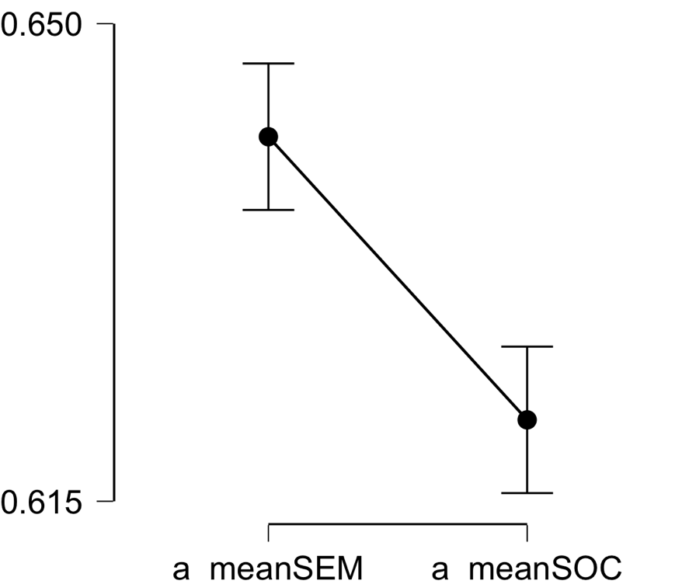

**Bayesian Paired Samples T-Test**

| **Bayesian Paired Samples T-Test** | | | | | | | | | |
| --- | --- | --- | --- | --- | --- | --- | --- | --- | --- |
|  | |  | |  | | **Log(BF₁₀)** | | **error %** | |
| a_meanSEM |  | - |  | a_meanSOC |  | 8.305 |  | 8.350e -7 |  |
|  | | | | | | | | | |

**Inferential Plots**

**a_meanSEM - a_meanSOC**

**Prior and Posterior**

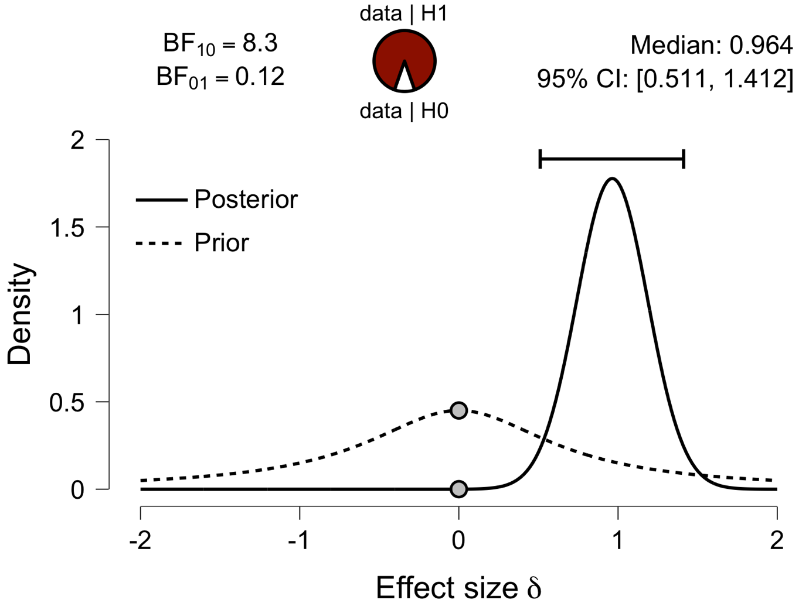

**Paired Samples T-Test**

| **Paired Samples T-Test** | | | | | | | | | | | | | | | | | | | | | | | | | |
| --- | --- | --- | --- | --- | --- | --- | --- | --- | --- | --- | --- | --- | --- | --- | --- | --- | --- | --- | --- | --- | --- | --- | --- | --- | --- |
|  | | | | | | | | | | | | | | | | **95% CI for Mean Difference** | | | |  | | **95% CI for Cohen's d** | | | |
|  | |  | |  | | **t** | | **df** | | **p** | | **Mean Difference** | | **SE Difference** | | **Lower** | | **Upper** | | **Cohen's d** | | **Lower** | | **Upper** | |
| l_meanSEM |  | - |  | l_meanSOC |  | 5.113 |  | 29 |  | 1.855e -5 |  | 0.024 |  | 0.005 |  | 0.014 |  | 0.034 |  | 0.933 |  | 0.497 |  | 1.358 |  |
|  | | | | | | | | | | | | | | | | | | | | | | | | | |
| *Note.*  Student's t-test. | | | | | | | | | | | | | | | | | | | | | | | | | |

**Assumption Checks**

| **Test of Normality (Shapiro-Wilk)** | | | | | | | | | |
| --- | --- | --- | --- | --- | --- | --- | --- | --- | --- |
|  | |  | |  | | **W** | | **p** | |
| l_meanSEM |  | - |  | l_meanSOC |  | 0.977 |  | 0.746 |  |
|  | | | | | | | | | |
| *Note.*  Significant results suggest a deviation from normality. | | | | | | | | | |

**Descriptives**

| **Descriptives** | | | | | | | | | |
| --- | --- | --- | --- | --- | --- | --- | --- | --- | --- |
|  | | **N** | | **Mean** | | **SD** | | **SE** | |
| l_meanSEM |  | 30 |  | 0.664 |  | 0.050 |  | 0.009 |  |
| l_meanSOC |  | 30 |  | 0.640 |  | 0.034 |  | 0.006 |  |
|  | | | | | | | | | |

**Descriptives Plot**

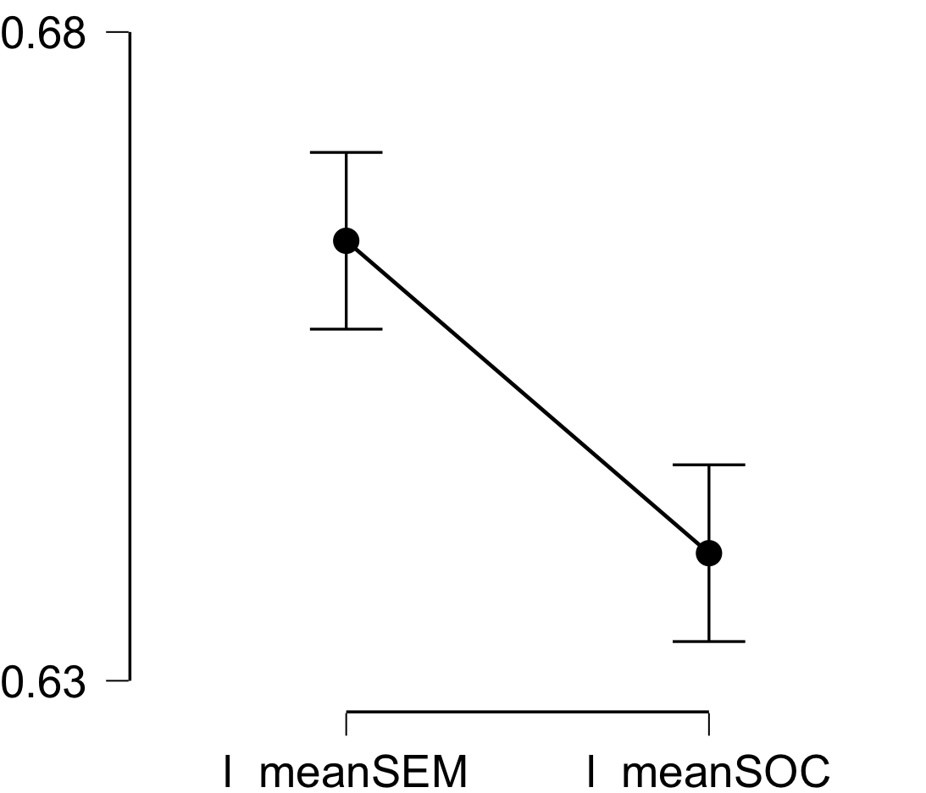

**Bayesian Paired Samples T-Test**

| **Bayesian Paired Samples T-Test** | | | | | | | | | |
| --- | --- | --- | --- | --- | --- | --- | --- | --- | --- |
|  | |  | |  | | **Log(BF₁₀)** | | **error %** | |
| l_meanSEM |  | - |  | l_meanSOC |  | 7.090 |  | 1.278e -6 |  |
|  | | | | | | | | | |

**Inferential Plots**

**l_meanSEM - l_meanSOC**

**Prior and Posterior**

