**Results**

**Paired Samples T-Test**

**Paired Samples T-Test**

| **Paired Samples T-Test** | | | | | | | | | | | | | | | | | | | | | | | | | |
| --- | --- | --- | --- | --- | --- | --- | --- | --- | --- | --- | --- | --- | --- | --- | --- | --- | --- | --- | --- | --- | --- | --- | --- | --- | --- |
|  | | | | | | | | | | | | | | | | **95% CI for Mean Difference** | | | |  | | **95% CI for Cohen's d** | | | |
|  | |  | |  | | **t** | | **df** | | **p** | | **Mean Difference** | | **SE Difference** | | **Lower** | | **Upper** | | **Cohen's d** | | **Lower** | | **Upper** | |
| l_LTL_em |  | - |  | a_LTL_em |  | 2.931 |  | 29 |  | 0.007 |  | 0.029 |  | 0.010 |  | 0.009 |  | 0.049 |  | 0.535 |  | 0.148 |  | 0.914 |  |
|  | | | | | | | | | | | | | | | | | | | | | | | | | |
| *Note.*  Student's t-test. | | | | | | | | | | | | | | | | | | | | | | | | | |

**Assumption Checks**

| **Test of Normality (Shapiro-Wilk)** | | | | | | | | | |
| --- | --- | --- | --- | --- | --- | --- | --- | --- | --- |
|  | |  | |  | | **W** | | **p** | |
| l_LTL_em |  | - |  | a_LTL_em |  | 0.984 |  | 0.913 |  |
|  | | | | | | | | | |
| *Note.*  Significant results suggest a deviation from normality. | | | | | | | | | |

**Descriptives**

| **Descriptives** | | | | | | | | | |
| --- | --- | --- | --- | --- | --- | --- | --- | --- | --- |
|  | | **N** | | **Mean** | | **SD** | | **SE** | |
| l_LTL_em |  | 30 |  | 0.682 |  | 0.065 |  | 0.012 |  |
| a_LTL_em |  | 30 |  | 0.653 |  | 0.038 |  | 0.007 |  |
|  | | | | | | | | | |

**Descriptives Plot**

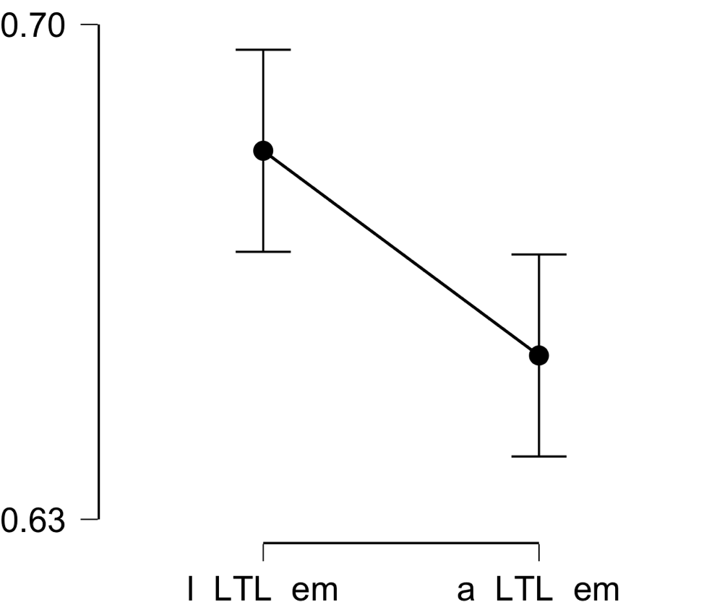

**Bayesian Paired Samples T-Test**

| **Bayesian Paired Samples T-Test** | | | | | | | | | |
| --- | --- | --- | --- | --- | --- | --- | --- | --- | --- |
|  | |  | |  | | **BF₁₀** | | **error %** | |
| l_LTL_em |  | - |  | a_LTL_em |  | 6.475 |  | 2.504e -6 |  |
|  | | | | | | | | | |

**Inferential Plots**

**l_LTL_em - a_LTL_em**

**Prior and Posterior**

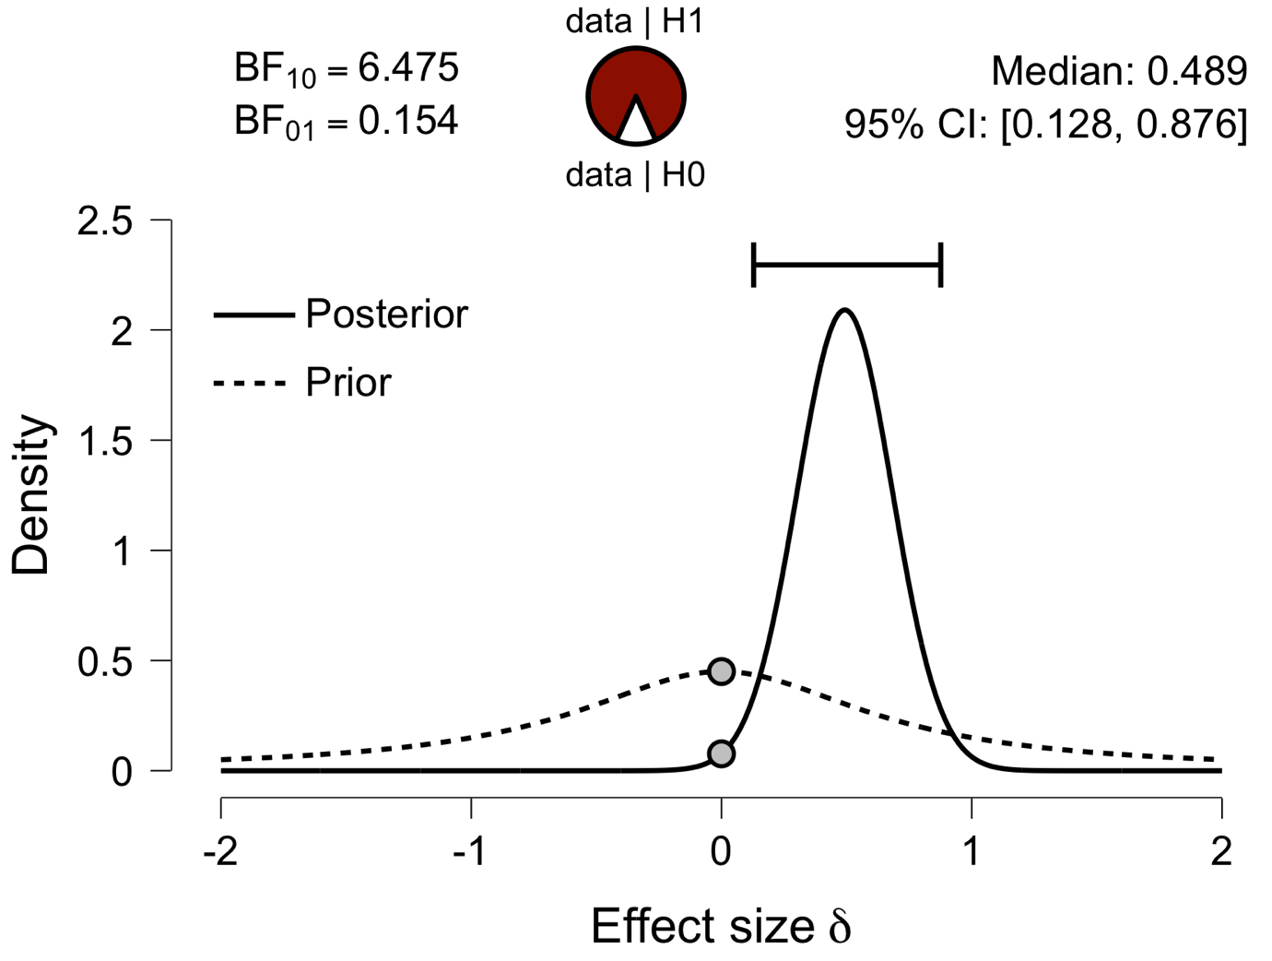

**Paired Samples T-Test**

| **Paired Samples T-Test** | | | | | | | | | | | | | | | | | | | | | | | | | |
| --- | --- | --- | --- | --- | --- | --- | --- | --- | --- | --- | --- | --- | --- | --- | --- | --- | --- | --- | --- | --- | --- | --- | --- | --- | --- |
|  | | | | | | | | | | | | | | | | **95% CI for Mean Difference** | | | |  | | **95% CI for Cohen's d** | | | |
|  | |  | |  | | **t** | | **df** | | **p** | | **Mean Difference** | | **SE Difference** | | **Lower** | | **Upper** | | **Cohen's d** | | **Lower** | | **Upper** | |
| l_IFG_em |  | - |  | a_IFG_em |  | 1.429 |  | 29 |  | 0.164 |  | 0.013 |  | 0.009 |  | -0.006 |  | 0.032 |  | 0.261 |  | -0.105 |  | 0.623 |  |
|  | | | | | | | | | | | | | | | | | | | | | | | | | |
| *Note.*  Student's t-test. | | | | | | | | | | | | | | | | | | | | | | | | | |

**Assumption Checks**

| **Test of Normality (Shapiro-Wilk)** | | | | | | | | | |
| --- | --- | --- | --- | --- | --- | --- | --- | --- | --- |
|  | |  | |  | | **W** | | **p** | |
| l_IFG_em |  | - |  | a_IFG_em |  | 0.944 |  | 0.119 |  |
|  | | | | | | | | | |
| *Note.*  Significant results suggest a deviation from normality. | | | | | | | | | |

**Descriptives**

| **Descriptives** | | | | | | | | | |
| --- | --- | --- | --- | --- | --- | --- | --- | --- | --- |
|  | | **N** | | **Mean** | | **SD** | | **SE** | |
| l_IFG_em |  | 30 |  | 0.651 |  | 0.048 |  | 0.009 |  |
| a_IFG_em |  | 30 |  | 0.637 |  | 0.034 |  | 0.006 |  |
|  | | | | | | | | | |

**Descriptives Plot**

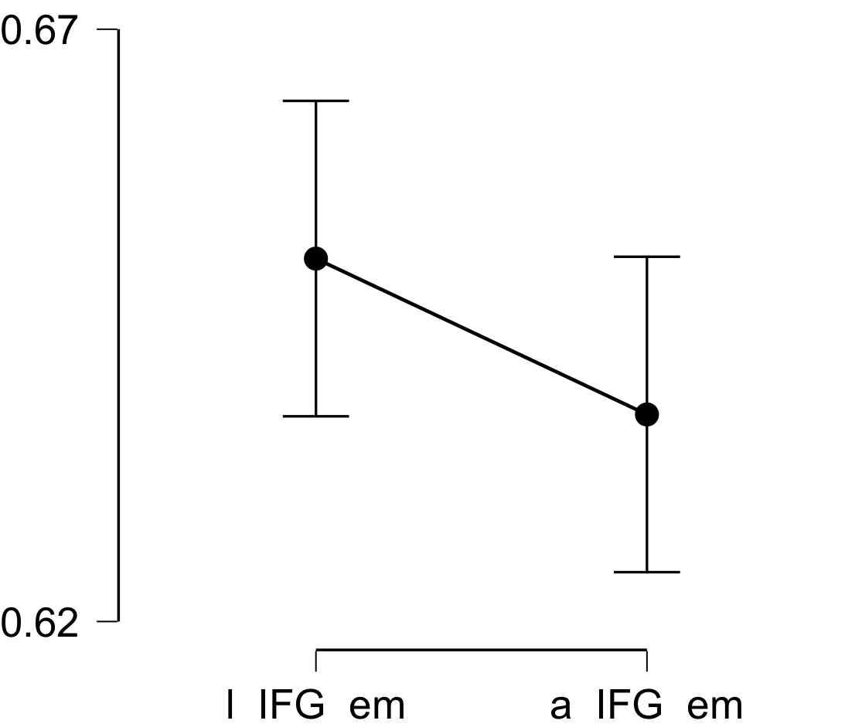

**Bayesian Paired Samples T-Test**

| **Bayesian Paired Samples T-Test** | | | | | | | | | |
| --- | --- | --- | --- | --- | --- | --- | --- | --- | --- |
|  | |  | |  | | **BF₁₀** | | **error %** | |
| l_IFG_em |  | - |  | a_IFG_em |  | 0.486 |  | 0.011 |  |
|  | | | | | | | | | |

**Inferential Plots**

**l_IFG_em - a_IFG_em**

**Prior and Posterior**

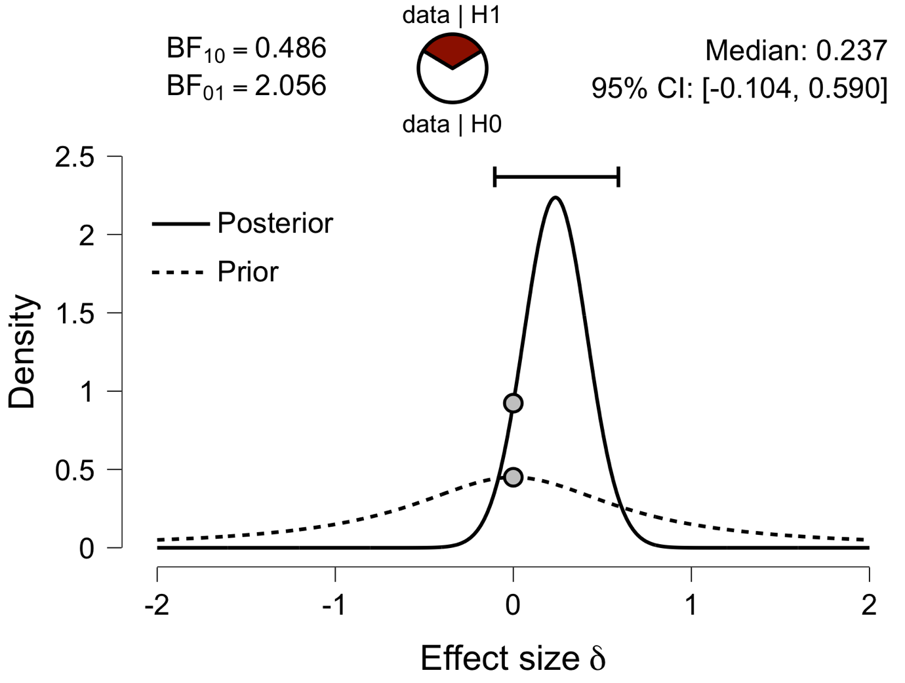

**Paired Samples T-Test**

| **Paired Samples T-Test** | | | | | | | | | | | | | | | | | | | | | | | | | |
| --- | --- | --- | --- | --- | --- | --- | --- | --- | --- | --- | --- | --- | --- | --- | --- | --- | --- | --- | --- | --- | --- | --- | --- | --- | --- |
|  | | | | | | | | | | | | | | | | **95% CI for Mean Difference** | | | |  | | **95% CI for Cohen's d** | | | |
|  | |  | |  | | **t** | | **df** | | **p** | | **Mean Difference** | | **SE Difference** | | **Lower** | | **Upper** | | **Cohen's d** | | **Lower** | | **Upper** | |
| l_Prec_em |  | - |  | a_Prec_em |  | 3.420 |  | 29 |  | 0.002 |  | 0.024 |  | 0.007 |  | 0.010 |  | 0.039 |  | 0.624 |  | 0.228 |  | 1.012 |  |
|  | | | | | | | | | | | | | | | | | | | | | | | | | |
| *Note.*  Student's t-test. | | | | | | | | | | | | | | | | | | | | | | | | | |

**Assumption Checks**

| **Test of Normality (Shapiro-Wilk)** | | | | | | | | | |
| --- | --- | --- | --- | --- | --- | --- | --- | --- | --- |
|  | |  | |  | | **W** | | **p** | |
| l_Prec_em |  | - |  | a_Prec_em |  | 0.981 |  | 0.850 |  |
|  | | | | | | | | | |
| *Note.*  Significant results suggest a deviation from normality. | | | | | | | | | |

**Descriptives**

| **Descriptives** | | | | | | | | | |
| --- | --- | --- | --- | --- | --- | --- | --- | --- | --- |
|  | | **N** | | **Mean** | | **SD** | | **SE** | |
| l_Prec_em |  | 30 |  | 0.659 |  | 0.049 |  | 0.009 |  |
| a_Prec_em |  | 30 |  | 0.634 |  | 0.028 |  | 0.005 |  |
|  | | | | | | | | | |

**Descriptives Plot**

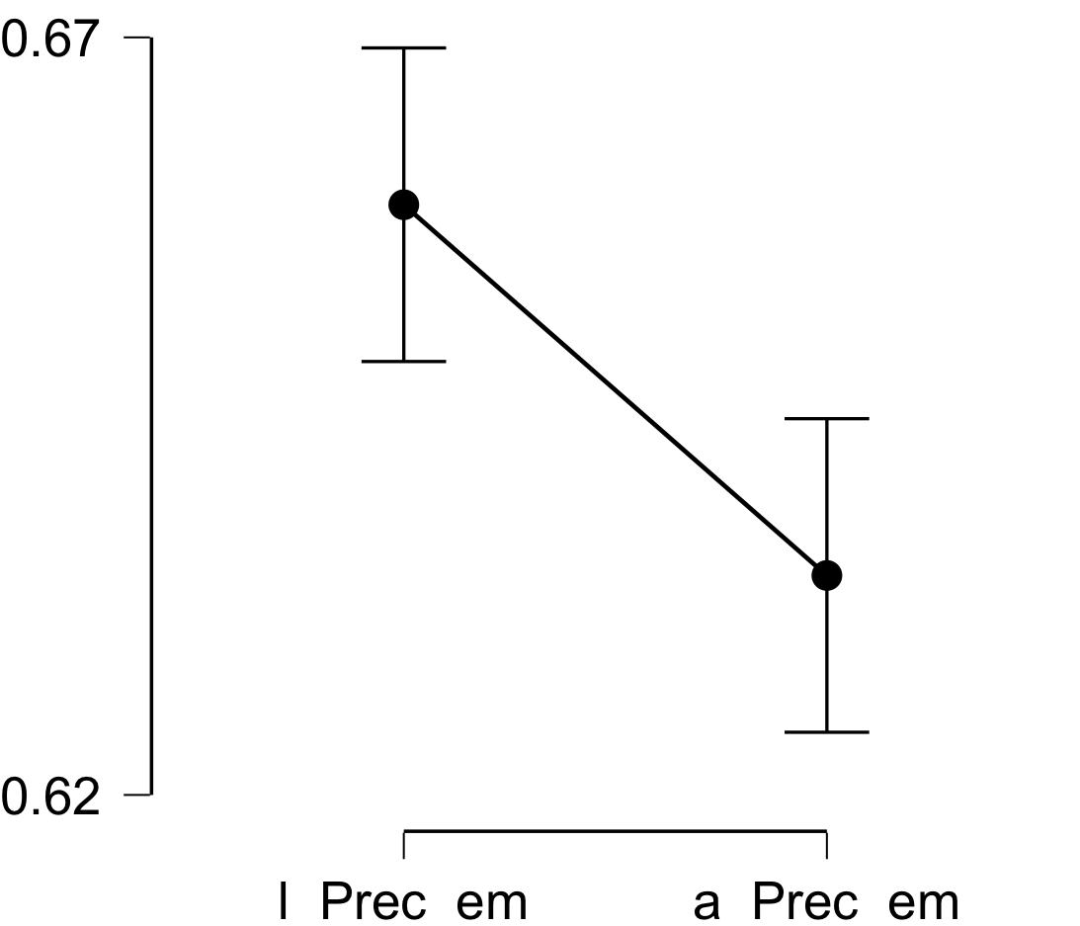

**Bayesian Paired Samples T-Test**

| **Bayesian Paired Samples T-Test** | | | | | | | | | |
| --- | --- | --- | --- | --- | --- | --- | --- | --- | --- |
|  | |  | |  | | **BF₁₀** | | **error %** | |
| l_Prec_em |  | - |  | a_Prec_em |  | 19.004 |  | 1.831e -6 |  |
|  | | | | | | | | | |

**Inferential Plots**

**l_Prec_em - a_Prec_em**

**Prior and Posterior**

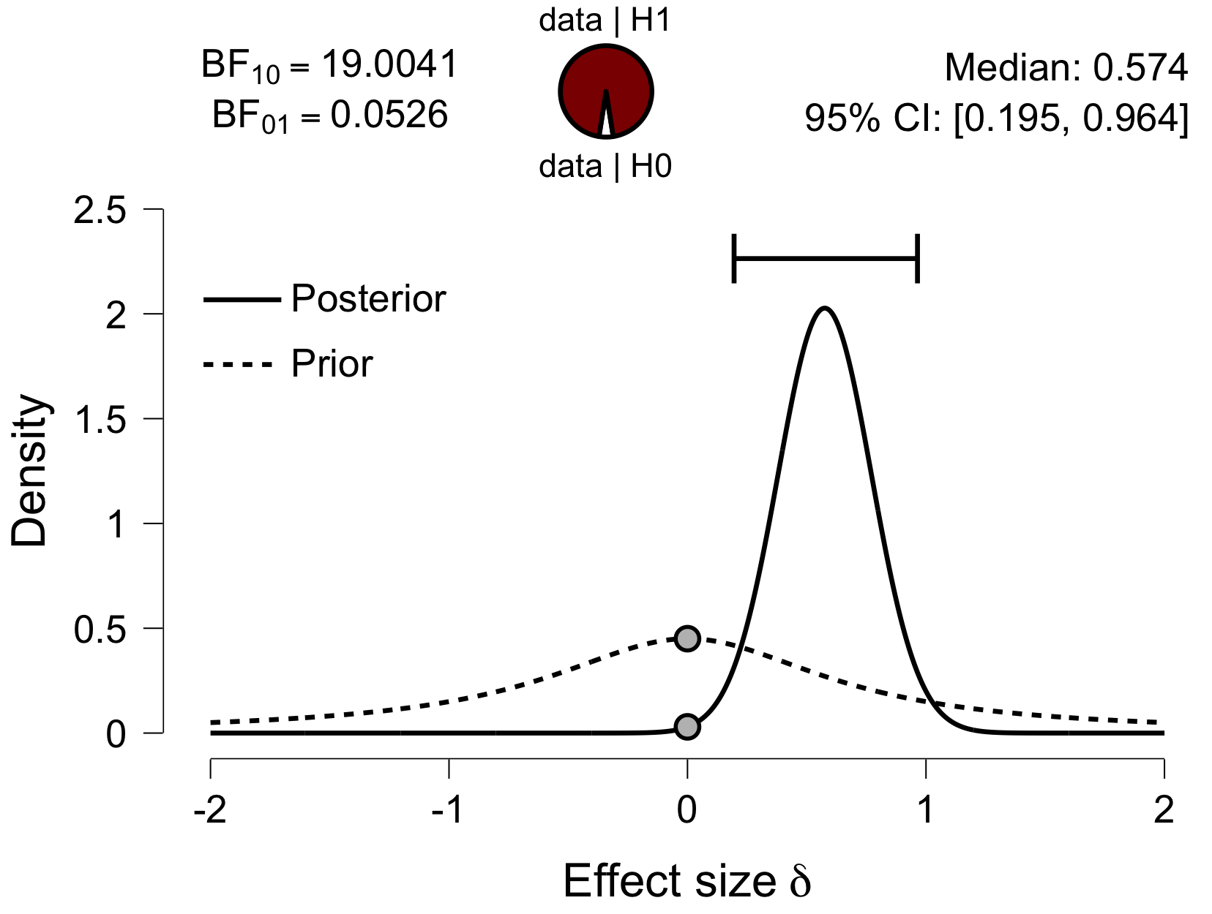

**Paired Samples T-Test**

| **Paired Samples T-Test** | | | | | | | | | | | | | | | | | | | | | | | | | |
| --- | --- | --- | --- | --- | --- | --- | --- | --- | --- | --- | --- | --- | --- | --- | --- | --- | --- | --- | --- | --- | --- | --- | --- | --- | --- |
|  | | | | | | | | | | | | | | | | **95% CI for Mean Difference** | | | |  | | **95% CI for Cohen's d** | | | |
|  | |  | |  | | **t** | | **df** | | **p** | | **Mean Difference** | | **SE Difference** | | **Lower** | | **Upper** | | **Cohen's d** | | **Lower** | | **Upper** | |
| l_ATL_em |  | - |  | a_ATL_em |  | 1.671 |  | 29 |  | 0.105 |  | 0.014 |  | 0.009 |  | -0.003 |  | 0.032 |  | 0.305 |  | -0.064 |  | 0.669 |  |
|  | | | | | | | | | | | | | | | | | | | | | | | | | |
| *Note.*  Student's t-test. | | | | | | | | | | | | | | | | | | | | | | | | | |

**Assumption Checks**

| **Test of Normality (Shapiro-Wilk)** | | | | | | | | | |
| --- | --- | --- | --- | --- | --- | --- | --- | --- | --- |
|  | |  | |  | | **W** | | **p** | |
| l_ATL_em |  | - |  | a_ATL_em |  | 0.982 |  | 0.869 |  |
|  | | | | | | | | | |
| *Note.*  Significant results suggest a deviation from normality. | | | | | | | | | |

**Descriptives**

| **Descriptives** | | | | | | | | | |
| --- | --- | --- | --- | --- | --- | --- | --- | --- | --- |
|  | | **N** | | **Mean** | | **SD** | | **SE** | |
| l_ATL_em |  | 30 |  | 0.608 |  | 0.047 |  | 0.009 |  |
| a_ATL_em |  | 30 |  | 0.594 |  | 0.025 |  | 0.005 |  |
|  | | | | | | | | | |

**Descriptives Plot**

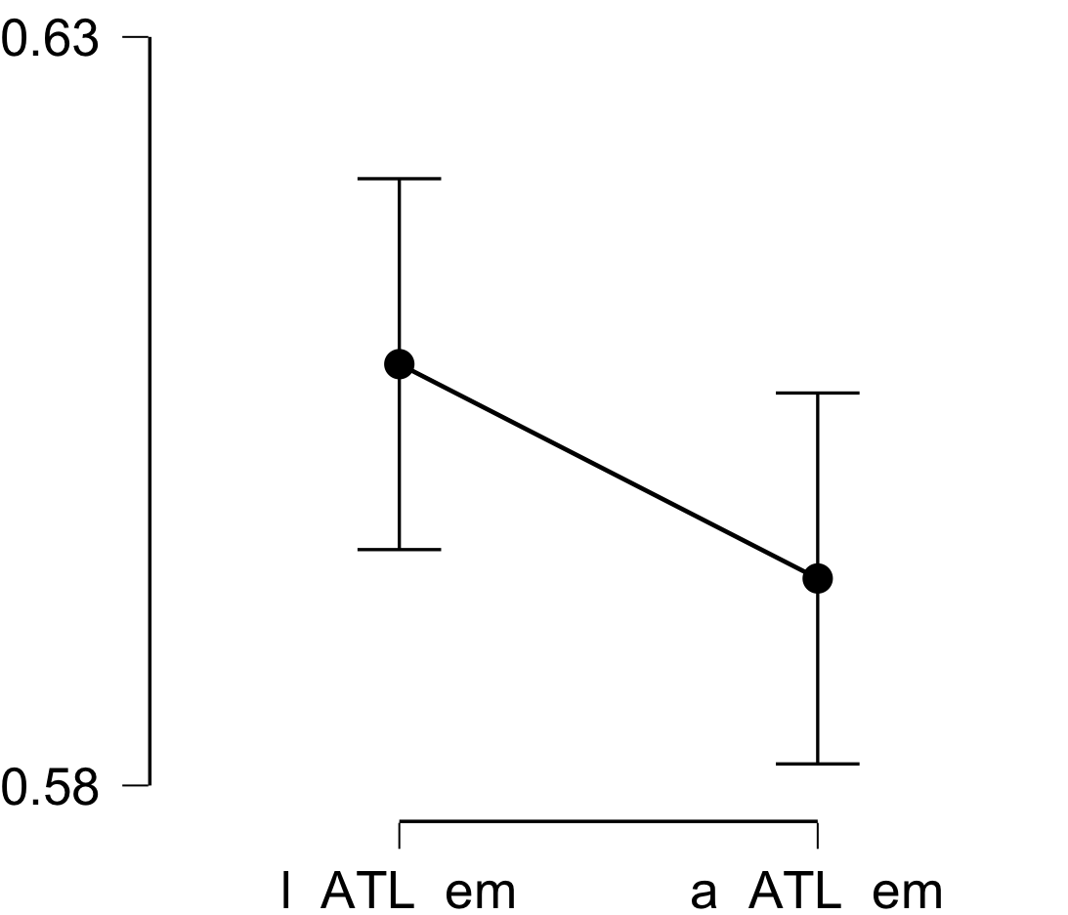

**Bayesian Paired Samples T-Test**

| **Bayesian Paired Samples T-Test** | | | | | | | | | |
| --- | --- | --- | --- | --- | --- | --- | --- | --- | --- |
|  | |  | |  | | **BF₁₀** | | **error %** | |
| l_ATL_em |  | - |  | a_ATL_em |  | 0.671 |  | 0.015 |  |
|  | | | | | | | | | |

**Inferential Plots**

**l_ATL_em - a_ATL_em**

**Prior and Posterior**

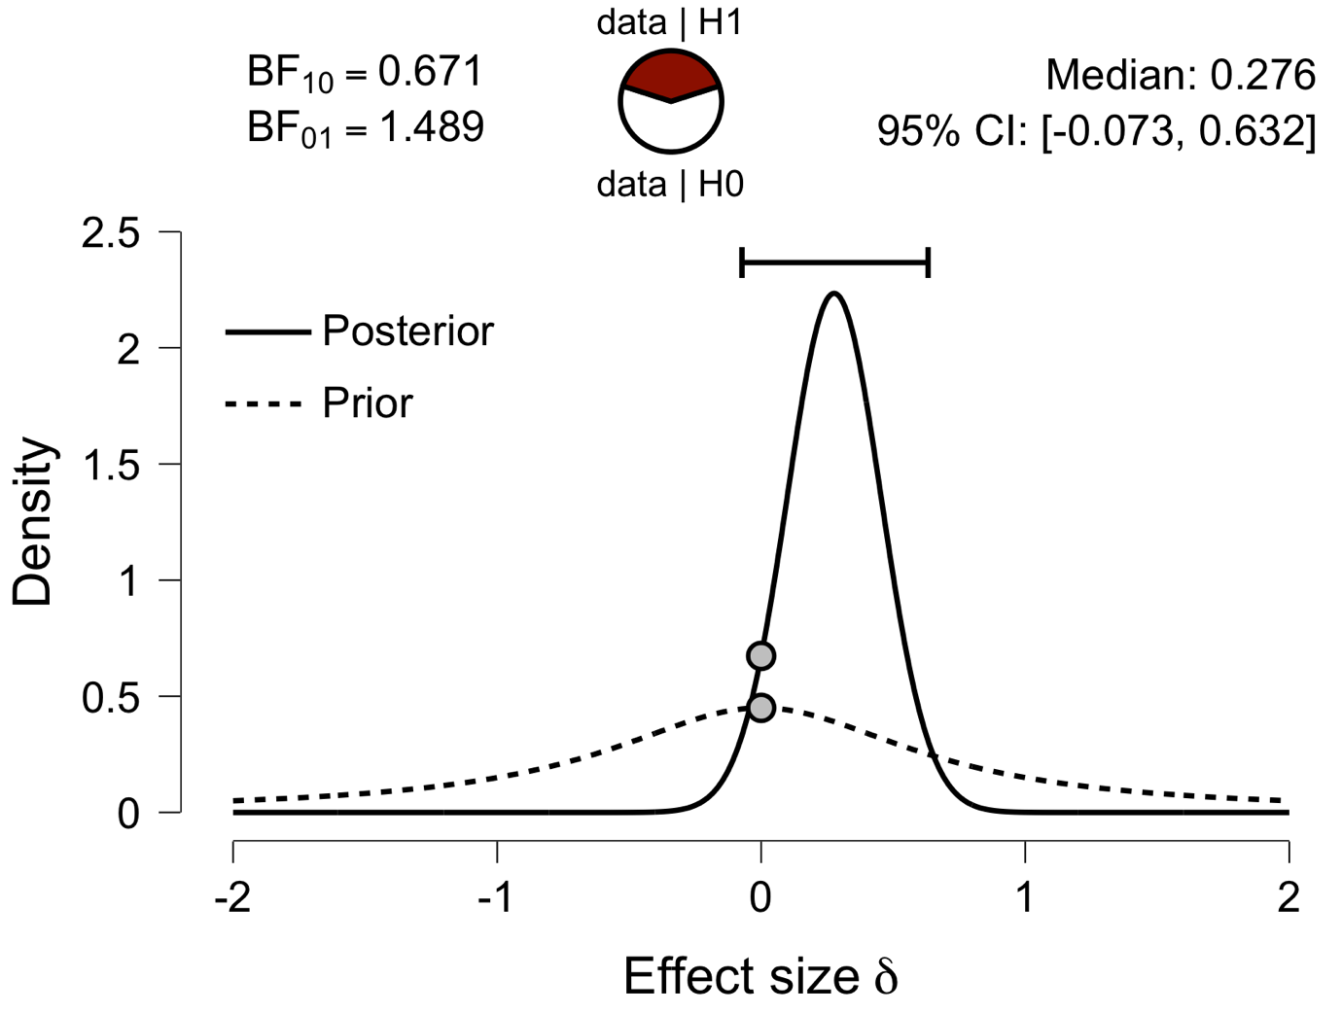

**Paired Samples T-Test**

| **Paired Samples T-Test** | | | | | | | | | | | | | | | | | | | | | | | | | |
| --- | --- | --- | --- | --- | --- | --- | --- | --- | --- | --- | --- | --- | --- | --- | --- | --- | --- | --- | --- | --- | --- | --- | --- | --- | --- |
|  | | | | | | | | | | | | | | | | **95% CI for Mean Difference** | | | |  | | **95% CI for Cohen's d** | | | |
|  | |  | |  | | **t** | | **df** | | **p** | | **Mean Difference** | | **SE Difference** | | **Lower** | | **Upper** | | **Cohen's d** | | **Lower** | | **Upper** | |
| l_aPFC_em |  | - |  | a_aPFC_em |  | 2.500 |  | 29 |  | 0.018 |  | 0.024 |  | 0.010 |  | 0.004 |  | 0.044 |  | 0.456 |  | 0.076 |  | 0.829 |  |
|  | | | | | | | | | | | | | | | | | | | | | | | | | |
| *Note.*  Student's t-test. | | | | | | | | | | | | | | | | | | | | | | | | | |

**Assumption Checks**

| **Test of Normality (Shapiro-Wilk)** | | | | | | | | | |
| --- | --- | --- | --- | --- | --- | --- | --- | --- | --- |
|  | |  | |  | | **W** | | **p** | |
| l_aPFC_em |  | - |  | a_aPFC_em |  | 0.968 |  | 0.483 |  |
|  | | | | | | | | | |
| *Note.*  Significant results suggest a deviation from normality. | | | | | | | | | |

**Descriptives**

| **Descriptives** | | | | | | | | | |
| --- | --- | --- | --- | --- | --- | --- | --- | --- | --- |
|  | | **N** | | **Mean** | | **SD** | | **SE** | |
| l_aPFC_em |  | 30 |  | 0.645 |  | 0.062 |  | 0.011 |  |
| a_aPFC_em |  | 30 |  | 0.621 |  | 0.037 |  | 0.007 |  |
|  | | | | | | | | | |

**Descriptives Plot**

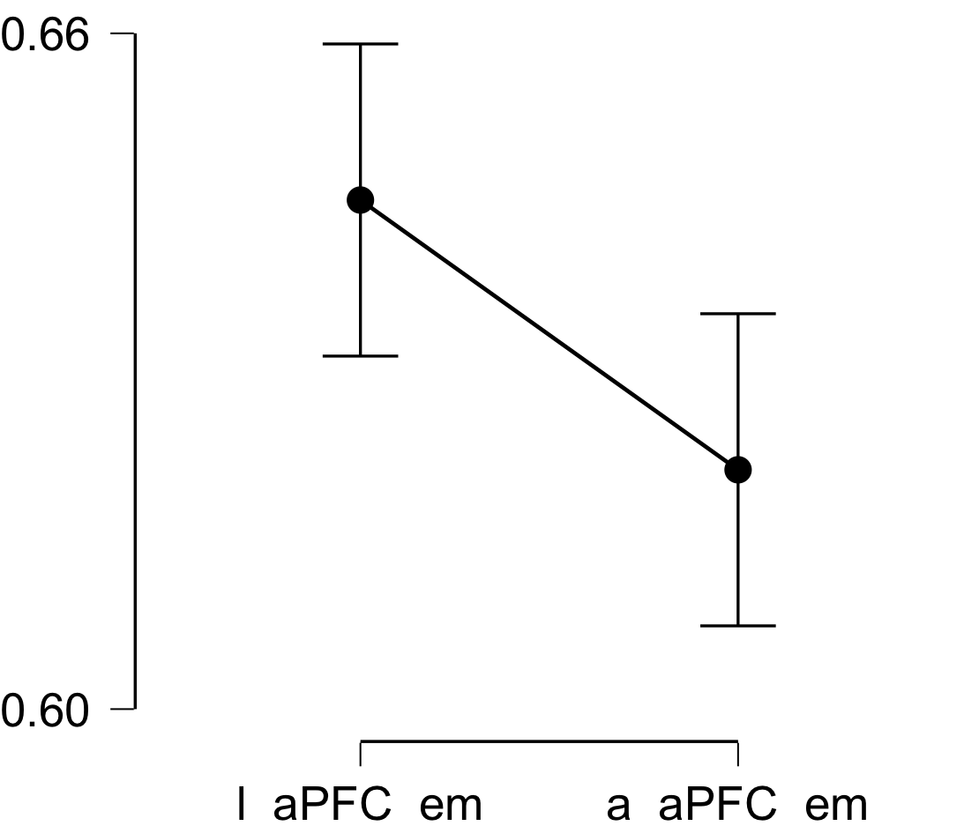

**Paired Samples T-Test**

| **Paired Samples T-Test** | | | | | | | | | | | | | | | | | | | | | | | | | |
| --- | --- | --- | --- | --- | --- | --- | --- | --- | --- | --- | --- | --- | --- | --- | --- | --- | --- | --- | --- | --- | --- | --- | --- | --- | --- |
|  | | | | | | | | | | | | | | | | **95% CI for Mean Difference** | | | |  | | **95% CI for Cohen's d** | | | |
|  | |  | |  | | **t** | | **df** | | **p** | | **Mean Difference** | | **SE Difference** | | **Lower** | | **Upper** | | **Cohen's d** | | **Lower** | | **Upper** | |
| l_Ins_em |  | - |  | a_Ins_em |  | 0.547 |  | 29 |  | 0.589 |  | 0.003 |  | 0.005 |  | -0.008 |  | 0.014 |  | 0.100 |  | -0.260 |  | 0.458 |  |
|  | | | | | | | | | | | | | | | | | | | | | | | | | |
| *Note.*  Student's t-test. | | | | | | | | | | | | | | | | | | | | | | | | | |

**Assumption Checks**

| **Test of Normality (Shapiro-Wilk)** | | | | | | | | | |
| --- | --- | --- | --- | --- | --- | --- | --- | --- | --- |
|  | |  | |  | | **W** | | **p** | |
| l_Ins_em |  | - |  | a_Ins_em |  | 0.935 |  | 0.066 |  |
|  | | | | | | | | | |
| *Note.*  Significant results suggest a deviation from normality. | | | | | | | | | |

**Descriptives**

| **Descriptives** | | | | | | | | | |
| --- | --- | --- | --- | --- | --- | --- | --- | --- | --- |
|  | | **N** | | **Mean** | | **SD** | | **SE** | |
| l_Ins_em |  | 30 |  | 0.631 |  | 0.029 |  | 0.005 |  |
| a_Ins_em |  | 30 |  | 0.628 |  | 0.024 |  | 0.004 |  |
|  | | | | | | | | | |

**Descriptives Plot**

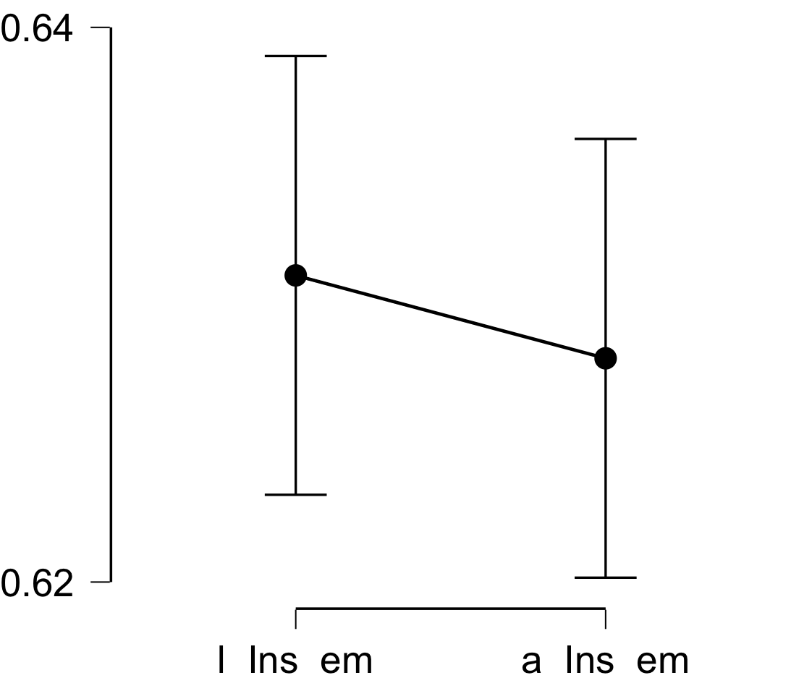

**Bayesian Paired Samples T-Test**

| **Bayesian Paired Samples T-Test** | | | | | | | | | |
| --- | --- | --- | --- | --- | --- | --- | --- | --- | --- |
|  | |  | |  | | **BF₁₀** | | **error %** | |
| l_Ins_em |  | - |  | a_Ins_em |  | 0.223 |  | 0.006 |  |
|  | | | | | | | | | |

**Inferential Plots**

**l_Ins_em - a_Ins_em**

**Prior and Posterior**

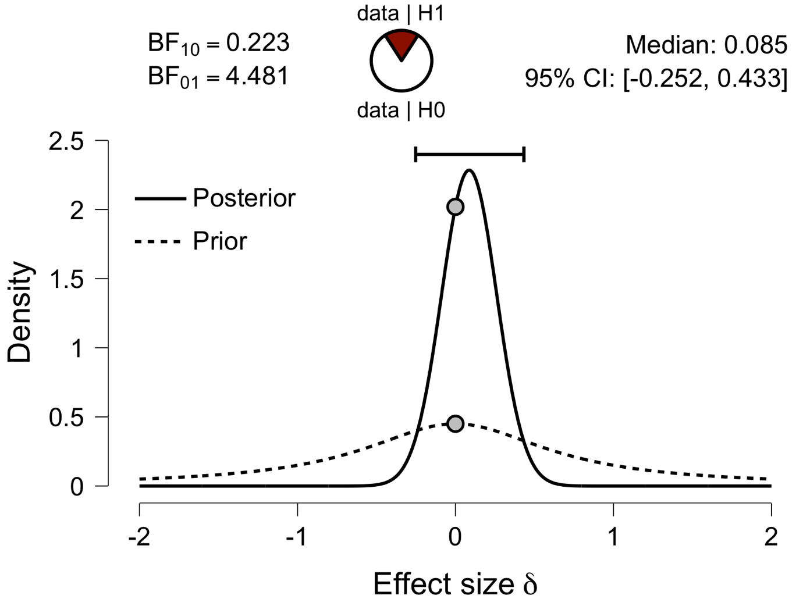

**Paired Samples T-Test**

| **Paired Samples T-Test** | | | | | | | | | | | | | | | | | | | | | | | | | |
| --- | --- | --- | --- | --- | --- | --- | --- | --- | --- | --- | --- | --- | --- | --- | --- | --- | --- | --- | --- | --- | --- | --- | --- | --- | --- |
|  | | | | | | | | | | | | | | | | **95% CI for Mean Difference** | | | |  | | **95% CI for Cohen's d** | | | |
|  | |  | |  | | **t** | | **df** | | **p** | | **Mean Difference** | | **SE Difference** | | **Lower** | | **Upper** | | **Cohen's d** | | **Lower** | | **Upper** | |
| l_ACC_em |  | - |  | a_ACC_em |  | 4.461 |  | 29 |  | 1.130e -4 |  | 0.044 |  | 0.010 |  | 0.024 |  | 0.064 |  | 0.814 |  | 0.395 |  | 1.223 |  |
|  | | | | | | | | | | | | | | | | | | | | | | | | | |
| *Note.*  Student's t-test. | | | | | | | | | | | | | | | | | | | | | | | | | |

**Assumption Checks**

| **Test of Normality (Shapiro-Wilk)** | | | | | | | | | |
| --- | --- | --- | --- | --- | --- | --- | --- | --- | --- |
|  | |  | |  | | **W** | | **p** | |
| l_ACC_em |  | - |  | a_ACC_em |  | 0.958 |  | 0.273 |  |
|  | | | | | | | | | |
| *Note.*  Significant results suggest a deviation from normality. | | | | | | | | | |

**Descriptives**

| **Descriptives** | | | | | | | | | |
| --- | --- | --- | --- | --- | --- | --- | --- | --- | --- |
|  | | **N** | | **Mean** | | **SD** | | **SE** | |
| l_ACC_em |  | 30 |  | 0.666 |  | 0.058 |  | 0.011 |  |
| a_ACC_em |  | 30 |  | 0.623 |  | 0.034 |  | 0.006 |  |
|  | | | | | | | | | |

**Descriptives Plot**

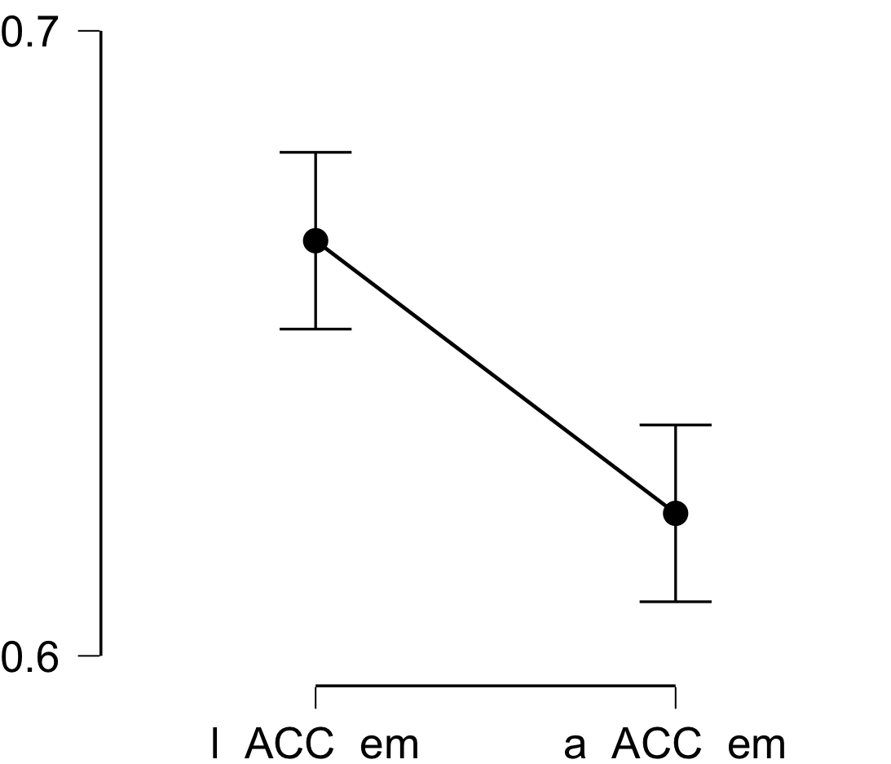

**Bayesian Paired Samples T-Test**

| **Bayesian Paired Samples T-Test** | | | | | | | | | |
| --- | --- | --- | --- | --- | --- | --- | --- | --- | --- |
|  | |  | |  | | **BF₁₀** | | **error %** | |
| l_ACC_em |  | - |  | a_ACC_em |  | 232.348 |  | 4.528e -6 |  |
|  | | | | | | | | | |

**Inferential Plots**

**l_ACC_em - a_ACC_em**

**Prior and Posterior**

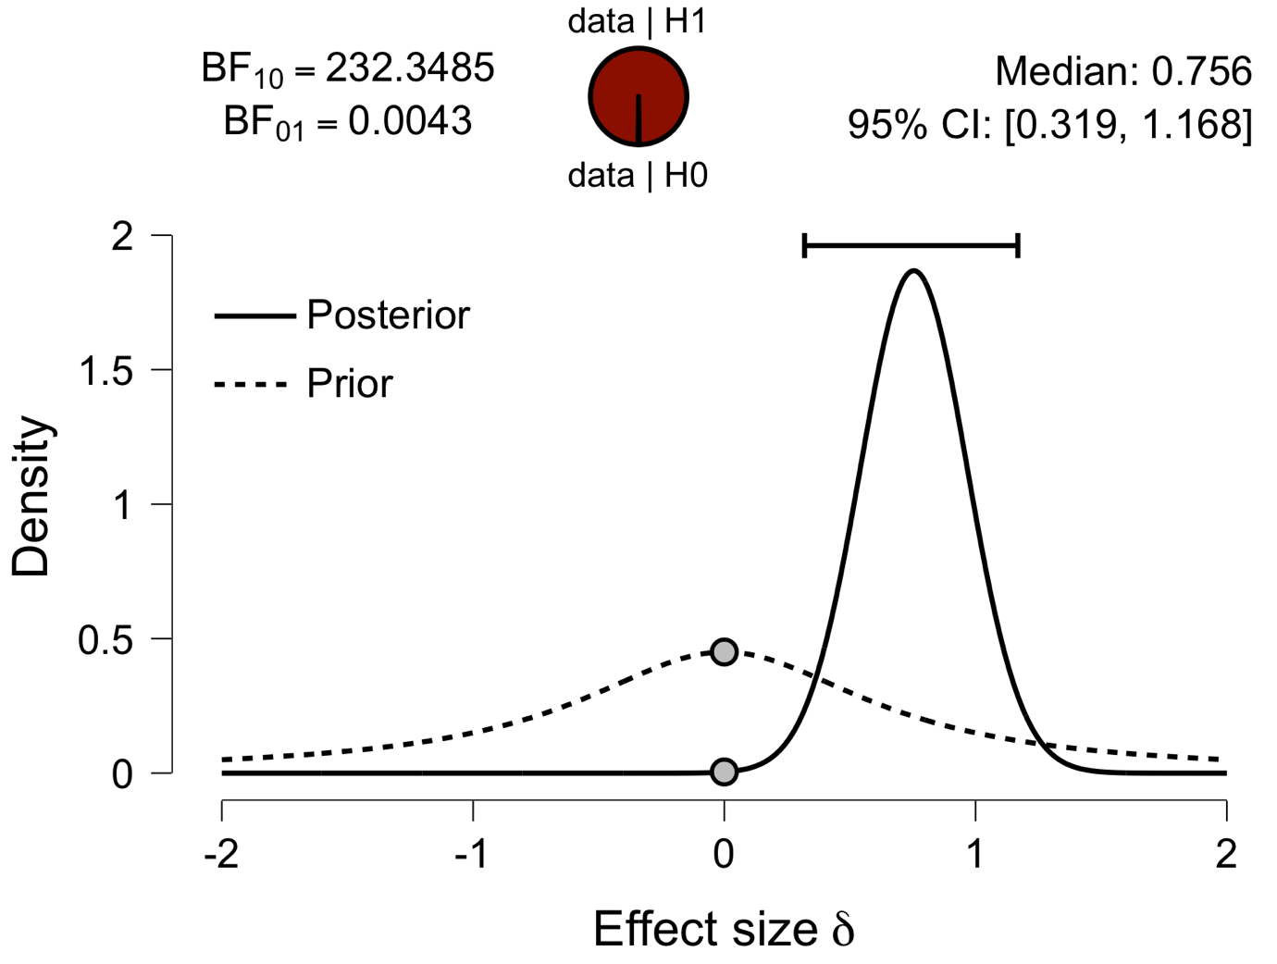

**Paired Samples T-Test**

| **Paired Samples T-Test** | | | | | | | | | | | | | | | | | | | | | | | | | |
| --- | --- | --- | --- | --- | --- | --- | --- | --- | --- | --- | --- | --- | --- | --- | --- | --- | --- | --- | --- | --- | --- | --- | --- | --- | --- |
|  | | | | | | | | | | | | | | | | **95% CI for Mean Difference** | | | |  | | **95% CI for Cohen's d** | | | |
|  | |  | |  | | **t** | | **df** | | **p** | | **Mean Difference** | | **SE Difference** | | **Lower** | | **Upper** | | **Cohen's d** | | **Lower** | | **Upper** | |
| l_PCC_em |  | - |  | a_PCC_em |  | 1.352 |  | 29 |  | 0.187 |  | 0.010 |  | 0.007 |  | -0.005 |  | 0.025 |  | 0.247 |  | -0.119 |  | 0.608 |  |
|  | | | | | | | | | | | | | | | | | | | | | | | | | |
| *Note.*  Student's t-test. | | | | | | | | | | | | | | | | | | | | | | | | | |

**Assumption Checks**

| **Test of Normality (Shapiro-Wilk)** | | | | | | | | | |
| --- | --- | --- | --- | --- | --- | --- | --- | --- | --- |
|  | |  | |  | | **W** | | **p** | |
| l_PCC_em |  | - |  | a_PCC_em |  | 0.971 |  | 0.579 |  |
|  | | | | | | | | | |
| *Note.*  Significant results suggest a deviation from normality. | | | | | | | | | |

**Descriptives**

| **Descriptives** | | | | | | | | | |
| --- | --- | --- | --- | --- | --- | --- | --- | --- | --- |
|  | | **N** | | **Mean** | | **SD** | | **SE** | |
| l_PCC_em |  | 30 |  | 0.622 |  | 0.035 |  | 0.006 |  |
| a_PCC_em |  | 30 |  | 0.612 |  | 0.027 |  | 0.005 |  |
|  | | | | | | | | | |

**Descriptives Plot**

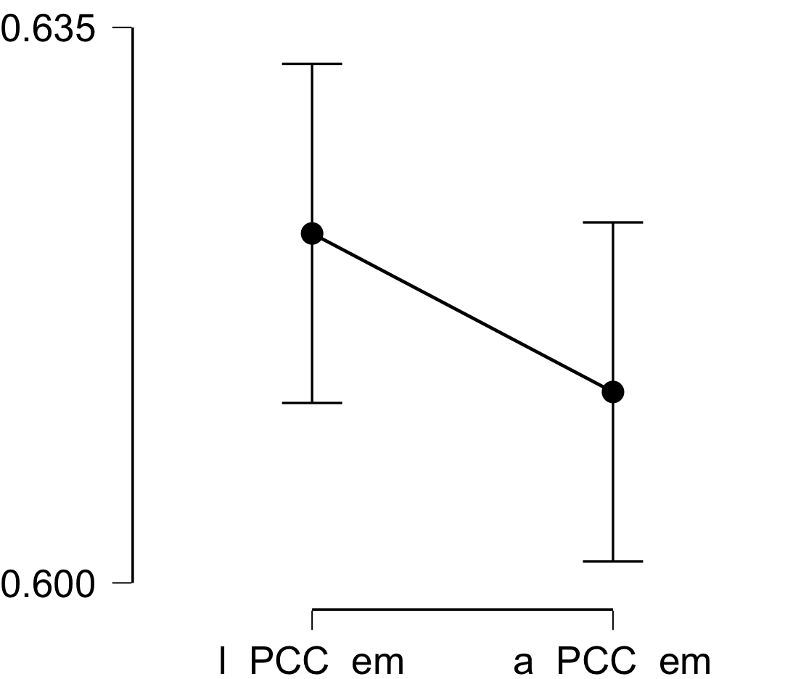

**Bayesian Paired Samples T-Test**

| **Bayesian Paired Samples T-Test** | | | | | | | | | |
| --- | --- | --- | --- | --- | --- | --- | --- | --- | --- |
|  | |  | |  | | **BF₁₀** | | **error %** | |
| l_PCC_em |  | - |  | a_PCC_em |  | 0.443 |  | 0.009 |  |
|  | | | | | | | | | |

**Inferential Plots**

**l_PCC_em - a_PCC_em**

**Prior and Posterior**

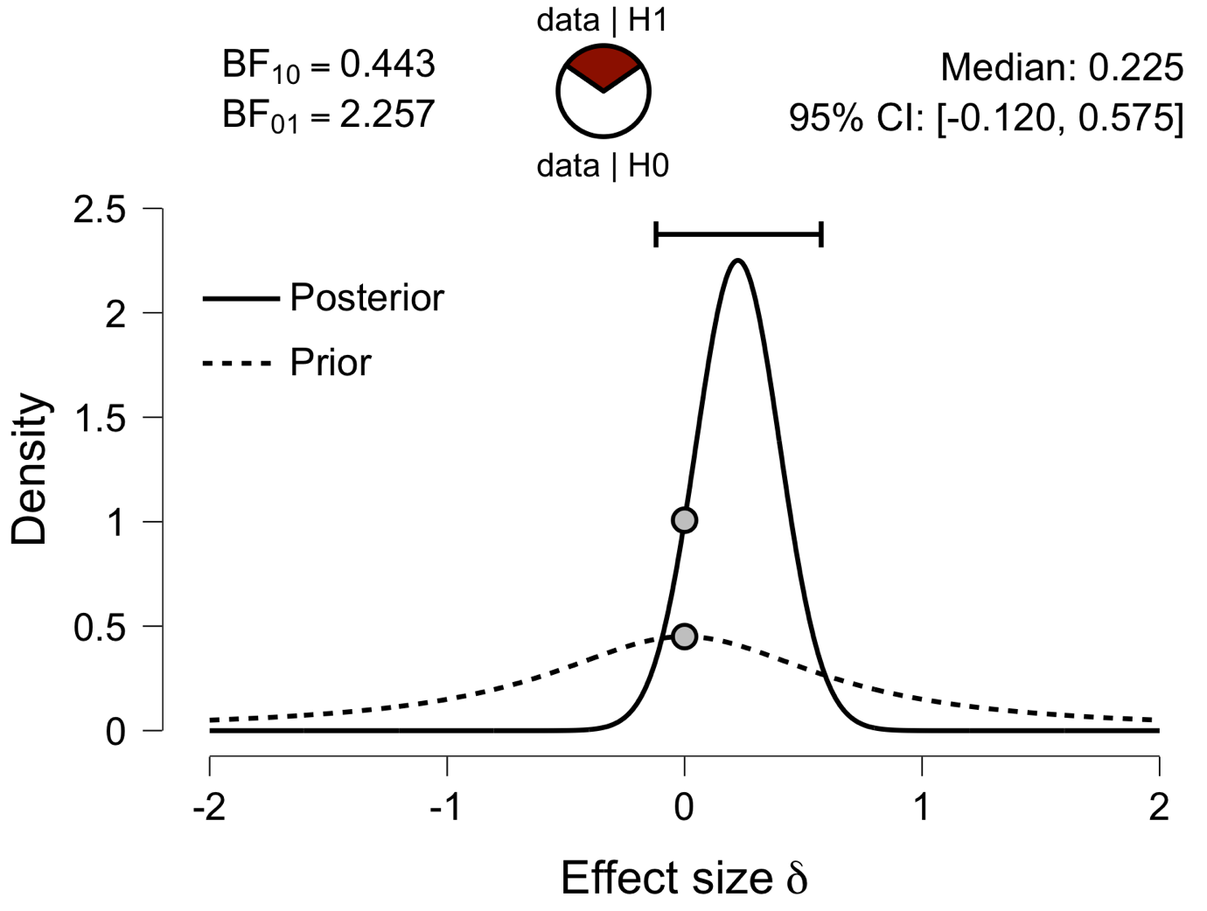

**Paired Samples T-Test**

| **Paired Samples T-Test** | | | | | | | | | | | | | | | | | | | | | | | | | |
| --- | --- | --- | --- | --- | --- | --- | --- | --- | --- | --- | --- | --- | --- | --- | --- | --- | --- | --- | --- | --- | --- | --- | --- | --- | --- |
|  | | | | | | | | | | | | | | | | **95% CI for Mean Difference** | | | |  | | **95% CI for Cohen's d** | | | |
|  | |  | |  | | **t** | | **df** | | **p** | | **Mean Difference** | | **SE Difference** | | **Lower** | | **Upper** | | **Cohen's d** | | **Lower** | | **Upper** | |
| l_V1_em |  | - |  | a_V1_em |  | -3.095 |  | 29 |  | 0.004 |  | -0.018 |  | 0.006 |  | -0.031 |  | -0.006 |  | -0.565 |  | -0.947 |  | -0.175 |  |
|  | | | | | | | | | | | | | | | | | | | | | | | | | |
| *Note.*  Student's t-test. | | | | | | | | | | | | | | | | | | | | | | | | | |

**Assumption Checks**

| **Test of Normality (Shapiro-Wilk)** | | | | | | | | | |
| --- | --- | --- | --- | --- | --- | --- | --- | --- | --- |
|  | |  | |  | | **W** | | **p** | |
| l_V1_em |  | - |  | a_V1_em |  | 0.956 |  | 0.245 |  |
|  | | | | | | | | | |
| *Note.*  Significant results suggest a deviation from normality. | | | | | | | | | |

**Descriptives**

| **Descriptives** | | | | | | | | | |
| --- | --- | --- | --- | --- | --- | --- | --- | --- | --- |
|  | | **N** | | **Mean** | | **SD** | | **SE** | |
| l_V1_em |  | 30 |  | 0.580 |  | 0.028 |  | 0.005 |  |
| a_V1_em |  | 30 |  | 0.598 |  | 0.024 |  | 0.004 |  |
|  | | | | | | | | | |

**Descriptives Plot**

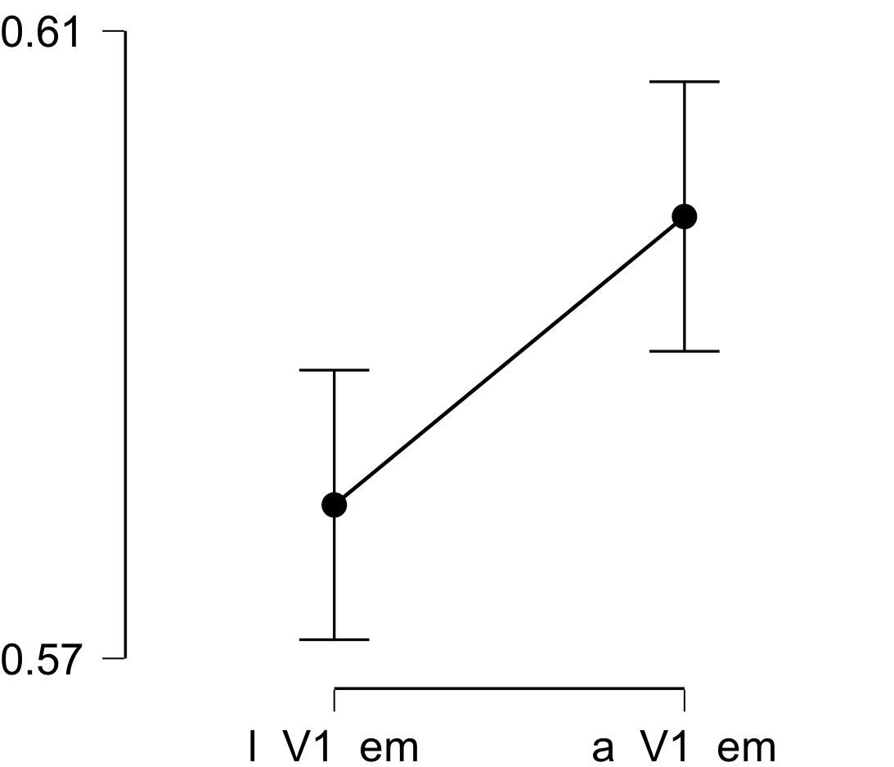

**Bayesian Paired Samples T-Test**

| **Bayesian Paired Samples T-Test** | | | | | | | | | |
| --- | --- | --- | --- | --- | --- | --- | --- | --- | --- |
|  | |  | |  | | **BF₁₀** | | **error %** | |
| l_V1_em |  | - |  | a_V1_em |  | 9.197 |  | 2.246e -6 |  |
|  | | | | | | | | | |

**Inferential Plots**

**l_V1_em - a_V1_em**

**Prior and Posterior**

