**Results**

**Paired Samples T-Test**

**Paired Samples T-Test**

| **Paired Samples T-Test** | | | | | | | | | | | | | | | | | | | | | | | | | |
| --- | --- | --- | --- | --- | --- | --- | --- | --- | --- | --- | --- | --- | --- | --- | --- | --- | --- | --- | --- | --- | --- | --- | --- | --- | --- |
|  | | | | | | | | | | | | | | | | **95% CI for Mean Difference** | | | |  | | **95% CI for Cohen's d** | | | |
|  | |  | |  | | **t** | | **df** | | **p** | | **Mean Difference** | | **SE Difference** | | **Lower** | | **Upper** | | **Cohen's d** | | **Lower** | | **Upper** | |
| l_LTL_em |  | - |  | a_LTL_em |  | 0.148 |  | 29 |  | 0.883 |  | 0.002 |  | 0.014 |  | -0.027 |  | 0.031 |  | 0.027 |  | -0.331 |  | 0.385 |  |
|  | | | | | | | | | | | | | | | | | | | | | | | | | |
| *Note.*  Student's t-test. | | | | | | | | | | | | | | | | | | | | | | | | | |

**Assumption Checks**

| **Test of Normality (Shapiro-Wilk)** | | | | | | | | | |
| --- | --- | --- | --- | --- | --- | --- | --- | --- | --- |
|  | |  | |  | | **W** | | **p** | |
| l_LTL_em |  | - |  | a_LTL_em |  | 0.935 |  | 0.069 |  |
|  | | | | | | | | | |
| *Note.*  Significant results suggest a deviation from normality. | | | | | | | | | |

**Descriptives**

| **Descriptives** | | | | | | | | | |
| --- | --- | --- | --- | --- | --- | --- | --- | --- | --- |
|  | | **N** | | **Mean** | | **SD** | | **SE** | |
| l_LTL_em |  | 30 |  | 0.606 |  | 0.057 |  | 0.010 |  |
| a_LTL_em |  | 30 |  | 0.604 |  | 0.039 |  | 0.007 |  |
|  | | | | | | | | | |

**Descriptives Plot**

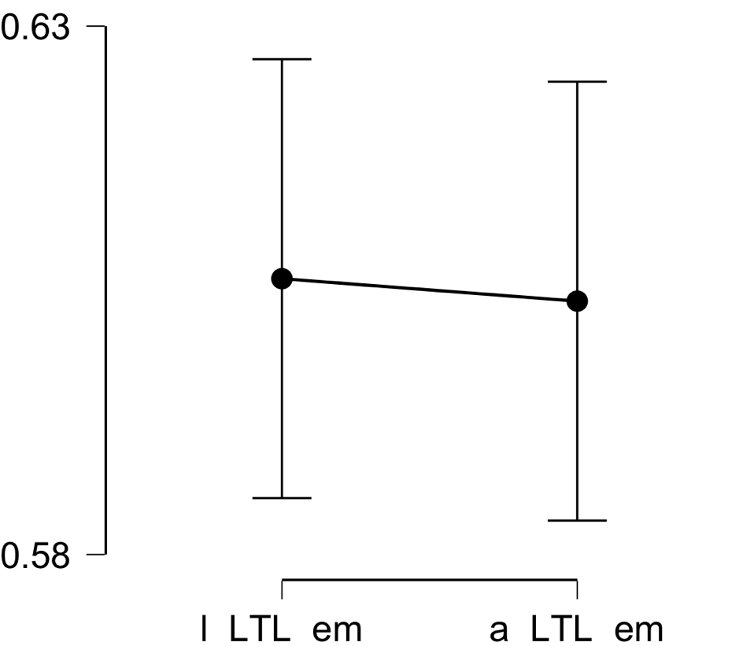

**Bayesian Paired Samples T-Test**

| **Bayesian Paired Samples T-Test** | | | | | | | | | |
| --- | --- | --- | --- | --- | --- | --- | --- | --- | --- |
|  | |  | |  | | **BF₁₀** | | **error %** | |
| l_LTL_em |  | - |  | a_LTL_em |  | 0.196 |  | 0.013 |  |
|  | | | | | | | | | |

**Inferential Plots**

**l_LTL_em - a_LTL_em**

**Prior and Posterior**

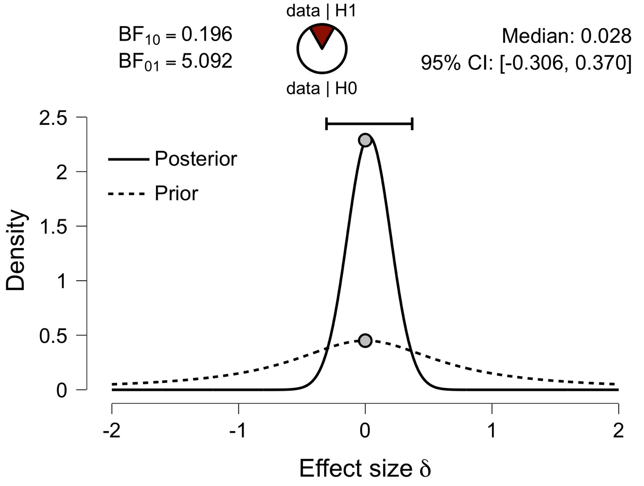

**Paired Samples T-Test**

| **Paired Samples T-Test** | | | | | | | | | | | | | | | | | | | | | | | | | |
| --- | --- | --- | --- | --- | --- | --- | --- | --- | --- | --- | --- | --- | --- | --- | --- | --- | --- | --- | --- | --- | --- | --- | --- | --- | --- |
|  | | | | | | | | | | | | | | | | **95% CI for Mean Difference** | | | |  | | **95% CI for Cohen's d** | | | |
|  | |  | |  | | **t** | | **df** | | **p** | | **Mean Difference** | | **SE Difference** | | **Lower** | | **Upper** | | **Cohen's d** | | **Lower** | | **Upper** | |
| l_IFG_em |  | - |  | a_IFG_em |  | -1.744 |  | 29 |  | 0.092 |  | -0.021 |  | 0.012 |  | -0.046 |  | 0.004 |  | -0.318 |  | -0.683 |  | 0.051 |  |
|  | | | | | | | | | | | | | | | | | | | | | | | | | |
| *Note.*  Student's t-test. | | | | | | | | | | | | | | | | | | | | | | | | | |

**Assumption Checks**

| **Test of Normality (Shapiro-Wilk)** | | | | | | | | | |
| --- | --- | --- | --- | --- | --- | --- | --- | --- | --- |
|  | |  | |  | | **W** | | **p** | |
| l_IFG_em |  | - |  | a_IFG_em |  | 0.953 |  | 0.208 |  |
|  | | | | | | | | | |
| *Note.*  Significant results suggest a deviation from normality. | | | | | | | | | |

**Descriptives**

| **Descriptives** | | | | | | | | | |
| --- | --- | --- | --- | --- | --- | --- | --- | --- | --- |
|  | | **N** | | **Mean** | | **SD** | | **SE** | |
| l_IFG_em |  | 30 |  | 0.577 |  | 0.050 |  | 0.009 |  |
| a_IFG_em |  | 30 |  | 0.598 |  | 0.033 |  | 0.006 |  |
|  | | | | | | | | | |

**Descriptives Plot**

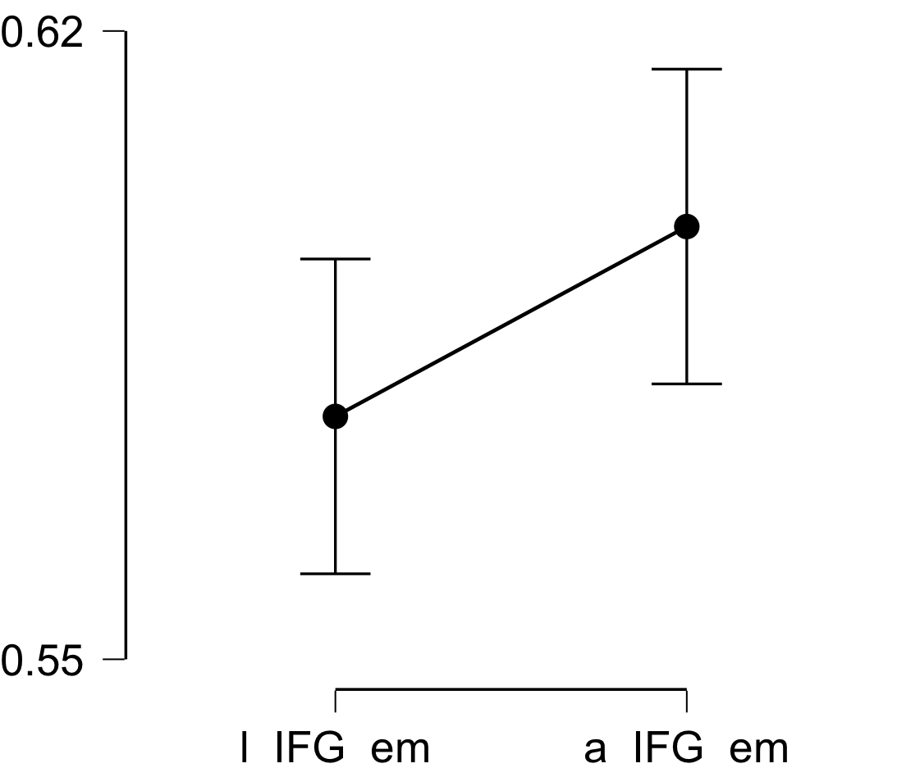

**Bayesian Paired Samples T-Test**

| **Bayesian Paired Samples T-Test** | | | | | | | | | |
| --- | --- | --- | --- | --- | --- | --- | --- | --- | --- |
|  | |  | |  | | **BF₁₀** | | **error %** | |
| l_IFG_em |  | - |  | a_IFG_em |  | 0.746 |  | 0.016 |  |
|  | | | | | | | | | |

**Inferential Plots**

**l_IFG_em - a_IFG_em**

**Prior and Posterior**

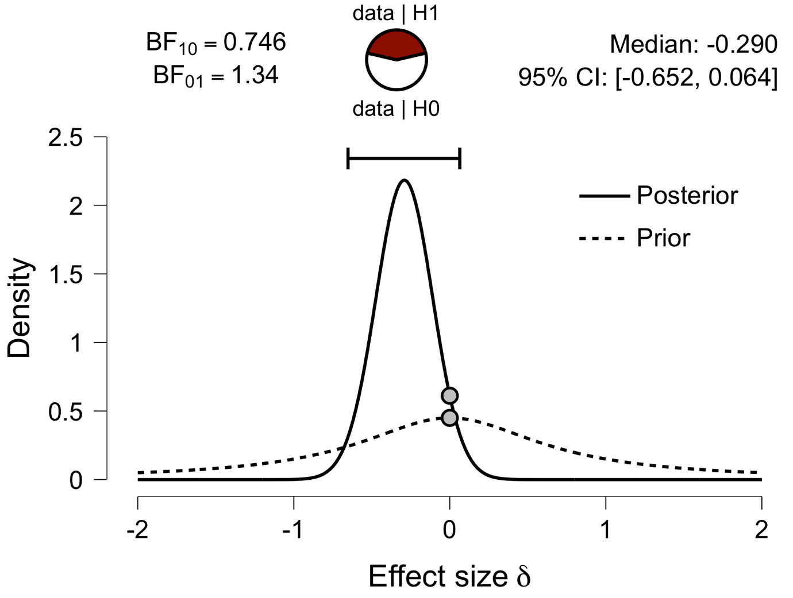

**Paired Samples T-Test**

| **Paired Samples T-Test** | | | | | | | | | | | | | | | | | | | | | | | | | |
| --- | --- | --- | --- | --- | --- | --- | --- | --- | --- | --- | --- | --- | --- | --- | --- | --- | --- | --- | --- | --- | --- | --- | --- | --- | --- |
|  | | | | | | | | | | | | | | | | **95% CI for Mean Difference** | | | |  | | **95% CI for Cohen's d** | | | |
|  | |  | |  | | **t** | | **df** | | **p** | | **Mean Difference** | | **SE Difference** | | **Lower** | | **Upper** | | **Cohen's d** | | **Lower** | | **Upper** | |
| l_Prec_em |  | - |  | a_Prec_em |  | -0.354 |  | 29 |  | 0.726 |  | -0.004 |  | 0.011 |  | -0.025 |  | 0.018 |  | -0.065 |  | -0.422 |  | 0.294 |  |
|  | | | | | | | | | | | | | | | | | | | | | | | | | |
| *Note.*  Student's t-test. | | | | | | | | | | | | | | | | | | | | | | | | | |

**Assumption Checks**

| **Test of Normality (Shapiro-Wilk)** | | | | | | | | | |
| --- | --- | --- | --- | --- | --- | --- | --- | --- | --- |
|  | |  | |  | | **W** | | **p** | |
| l_Prec_em |  | - |  | a_Prec_em |  | 0.973 |  | 0.632 |  |
|  | | | | | | | | | |
| *Note.*  Significant results suggest a deviation from normality. | | | | | | | | | |

**Descriptives**

| **Descriptives** | | | | | | | | | |
| --- | --- | --- | --- | --- | --- | --- | --- | --- | --- |
|  | | **N** | | **Mean** | | **SD** | | **SE** | |
| l_Prec_em |  | 30 |  | 0.591 |  | 0.047 |  | 0.009 |  |
| a_Prec_em |  | 30 |  | 0.595 |  | 0.024 |  | 0.004 |  |
|  | | | | | | | | | |

**Descriptives Plot**

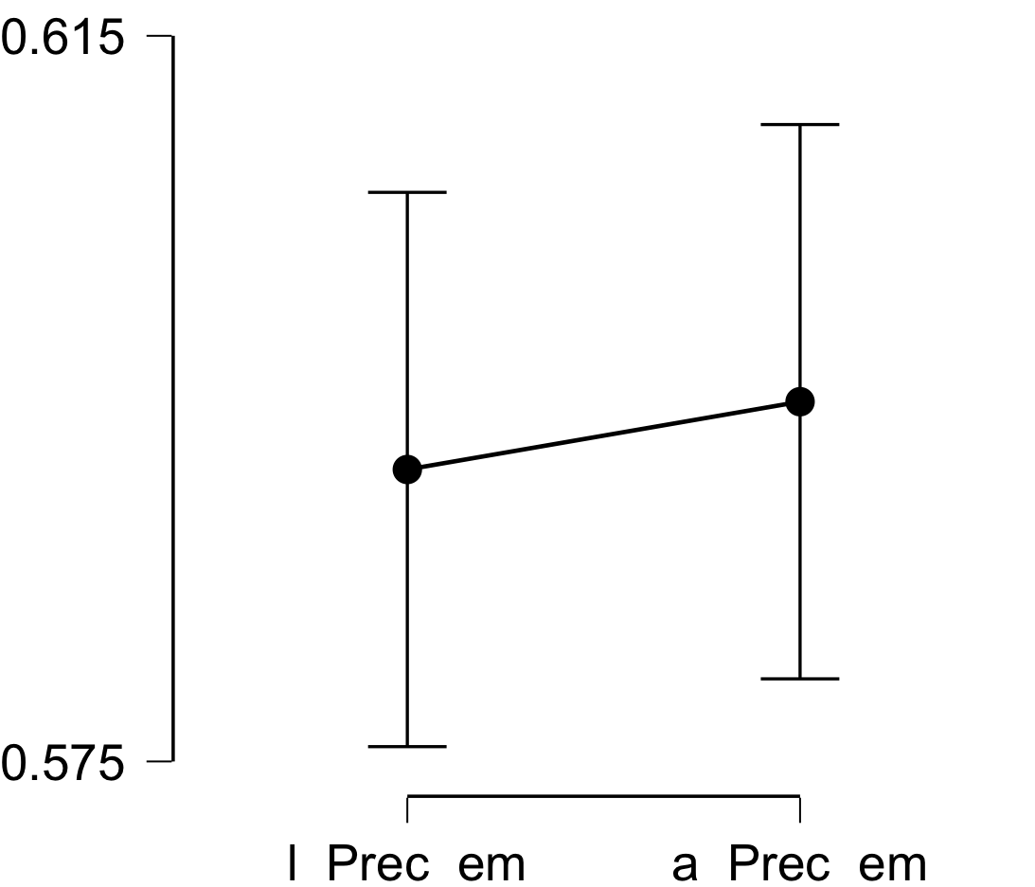

**Bayesian Paired Samples T-Test**

| **Bayesian Paired Samples T-Test** | | | | | | | | | |
| --- | --- | --- | --- | --- | --- | --- | --- | --- | --- |
|  | |  | |  | | **BF₁₀** | | **error %** | |
| l_Prec_em |  | - |  | a_Prec_em |  | 0.206 |  | 0.010 |  |
|  | | | | | | | | | |

**Inferential Plots**

**l_Prec_em - a_Prec_em**

**Prior and Posterior**

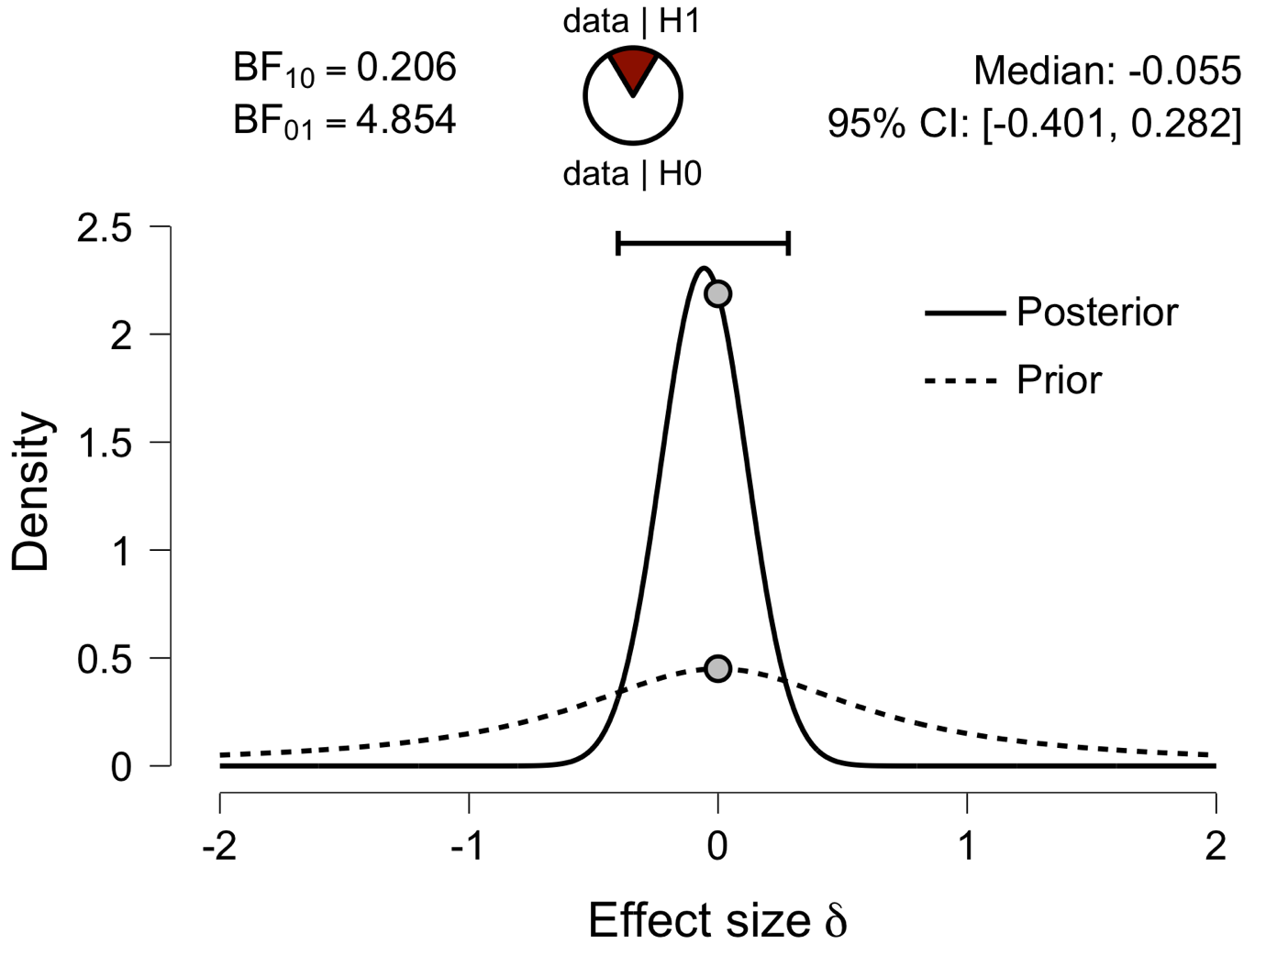

**Paired Samples T-Test**

| **Paired Samples T-Test** | | | | | | | | | | | | | | | | | | | | | | | | | |
| --- | --- | --- | --- | --- | --- | --- | --- | --- | --- | --- | --- | --- | --- | --- | --- | --- | --- | --- | --- | --- | --- | --- | --- | --- | --- |
|  | | | | | | | | | | | | | | | | **95% CI for Mean Difference** | | | |  | | **95% CI for Cohen's d** | | | |
|  | |  | |  | | **t** | | **df** | | **p** | | **Mean Difference** | | **SE Difference** | | **Lower** | | **Upper** | | **Cohen's d** | | **Lower** | | **Upper** | |
| l_ATL_em |  | - |  | a_ATL_em |  | -1.332 |  | 29 |  | 0.193 |  | -0.014 |  | 0.011 |  | -0.036 |  | 0.008 |  | -0.243 |  | -0.604 |  | 0.122 |  |
|  | | | | | | | | | | | | | | | | | | | | | | | | | |
| *Note.*  Student's t-test. | | | | | | | | | | | | | | | | | | | | | | | | | |

**Assumption Checks**

| **Test of Normality (Shapiro-Wilk)** | | | | | | | | | |
| --- | --- | --- | --- | --- | --- | --- | --- | --- | --- |
|  | |  | |  | | **W** | | **p** | |
| l_ATL_em |  | - |  | a_ATL_em |  | 0.976 |  | 0.713 |  |
|  | | | | | | | | | |
| *Note.*  Significant results suggest a deviation from normality. | | | | | | | | | |

**Descriptives**

| **Descriptives** | | | | | | | | | |
| --- | --- | --- | --- | --- | --- | --- | --- | --- | --- |
|  | | **N** | | **Mean** | | **SD** | | **SE** | |
| l_ATL_em |  | 30 |  | 0.551 |  | 0.045 |  | 0.008 |  |
| a_ATL_em |  | 30 |  | 0.565 |  | 0.031 |  | 0.006 |  |
|  | | | | | | | | | |

**Descriptives Plot**

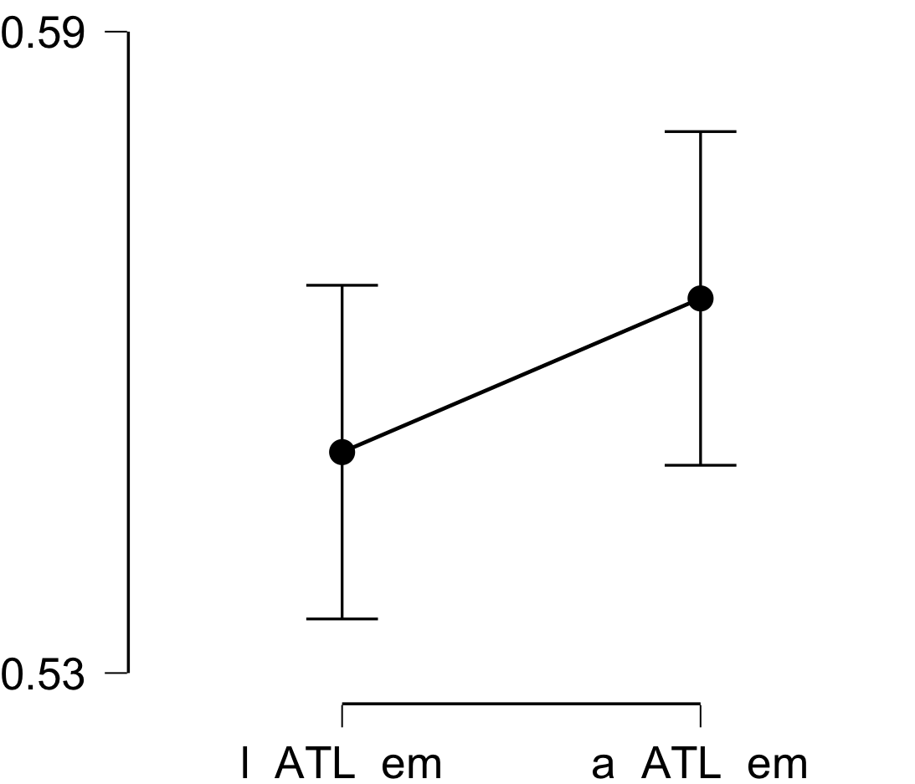

**Bayesian Paired Samples T-Test**

| **Bayesian Paired Samples T-Test** | | | | | | | | | |
| --- | --- | --- | --- | --- | --- | --- | --- | --- | --- |
|  | |  | |  | | **BF₁₀** | | **error %** | |
| l_ATL_em |  | - |  | a_ATL_em |  | 0.433 |  | 0.008 |  |
|  | | | | | | | | | |

**Inferential Plots**

**l_ATL_em - a_ATL_em**

**Prior and Posterior**

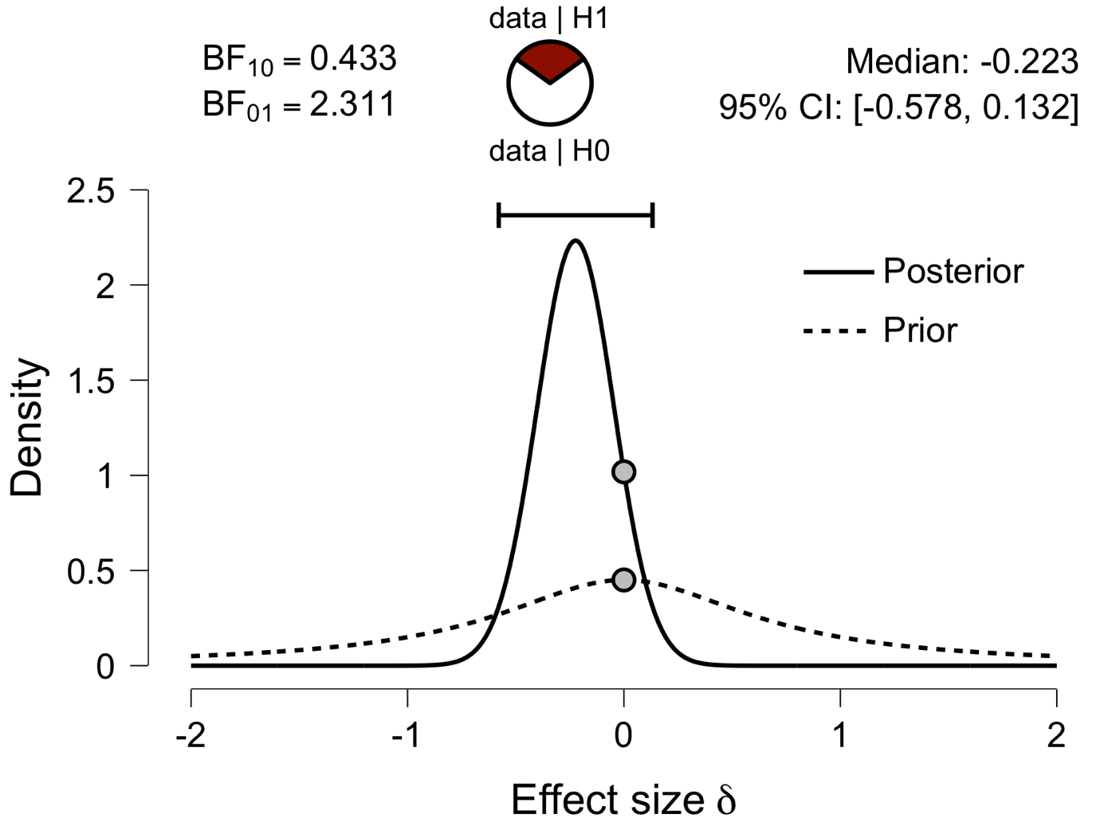

**Paired Samples T-Test**

| **Paired Samples T-Test** | | | | | | | | | | | | | | | | | | | | | | | | | |
| --- | --- | --- | --- | --- | --- | --- | --- | --- | --- | --- | --- | --- | --- | --- | --- | --- | --- | --- | --- | --- | --- | --- | --- | --- | --- |
|  | | | | | | | | | | | | | | | | **95% CI for Mean Difference** | | | |  | | **95% CI for Cohen's d** | | | |
|  | |  | |  | | **t** | | **df** | | **p** | | **Mean Difference** | | **SE Difference** | | **Lower** | | **Upper** | | **Cohen's d** | | **Lower** | | **Upper** | |
| l_aPFC_em |  | - |  | a_aPFC_em |  | -0.402 |  | 29 |  | 0.691 |  | -0.006 |  | 0.014 |  | -0.035 |  | 0.023 |  | -0.073 |  | -0.431 |  | 0.286 |  |
|  | | | | | | | | | | | | | | | | | | | | | | | | | |
| *Note.*  Student's t-test. | | | | | | | | | | | | | | | | | | | | | | | | | |

**Assumption Checks**

| **Test of Normality (Shapiro-Wilk)** | | | | | | | | | |
| --- | --- | --- | --- | --- | --- | --- | --- | --- | --- |
|  | |  | |  | | **W** | | **p** | |
| l_aPFC_em |  | - |  | a_aPFC_em |  | 0.970 |  | 0.544 |  |
|  | | | | | | | | | |
| *Note.*  Significant results suggest a deviation from normality. | | | | | | | | | |

**Descriptives**

| **Descriptives** | | | | | | | | | |
| --- | --- | --- | --- | --- | --- | --- | --- | --- | --- |
|  | | **N** | | **Mean** | | **SD** | | **SE** | |
| l_aPFC_em |  | 30 |  | 0.577 |  | 0.058 |  | 0.011 |  |
| a_aPFC_em |  | 30 |  | 0.582 |  | 0.034 |  | 0.006 |  |
|  | | | | | | | | | |

**Descriptives Plot**

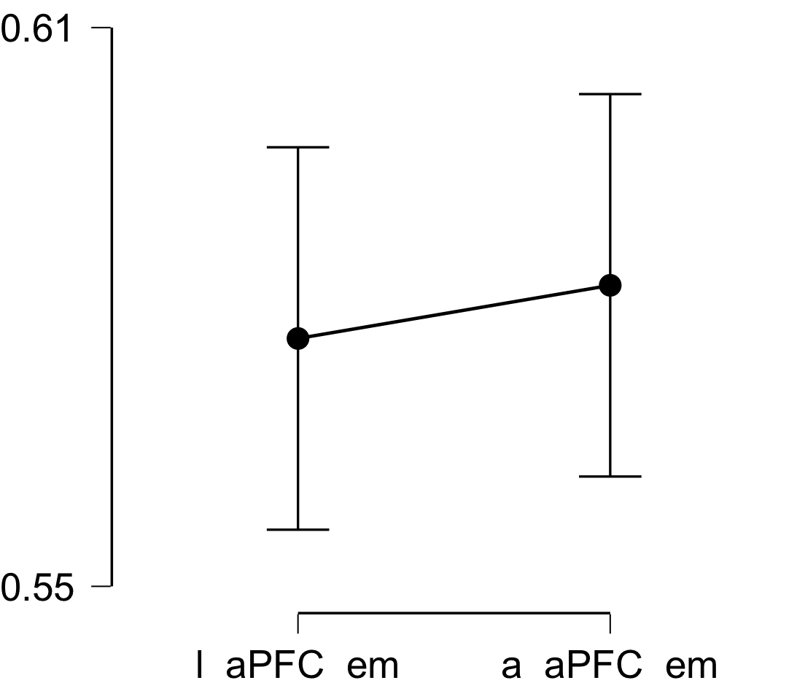

**Bayesian Paired Samples T-Test**

| **Bayesian Paired Samples T-Test** | | | | | | | | | |
| --- | --- | --- | --- | --- | --- | --- | --- | --- | --- |
|  | |  | |  | | **BF₁₀** | | **error %** | |
| a_aPFC_em |  | - |  | l_aPFC_em |  | 0.210 |  | 0.009 |  |
|  | | | | | | | | | |

**Inferential Plots**

**a_aPFC_em - l_aPFC_em**

**Prior and Posterior**

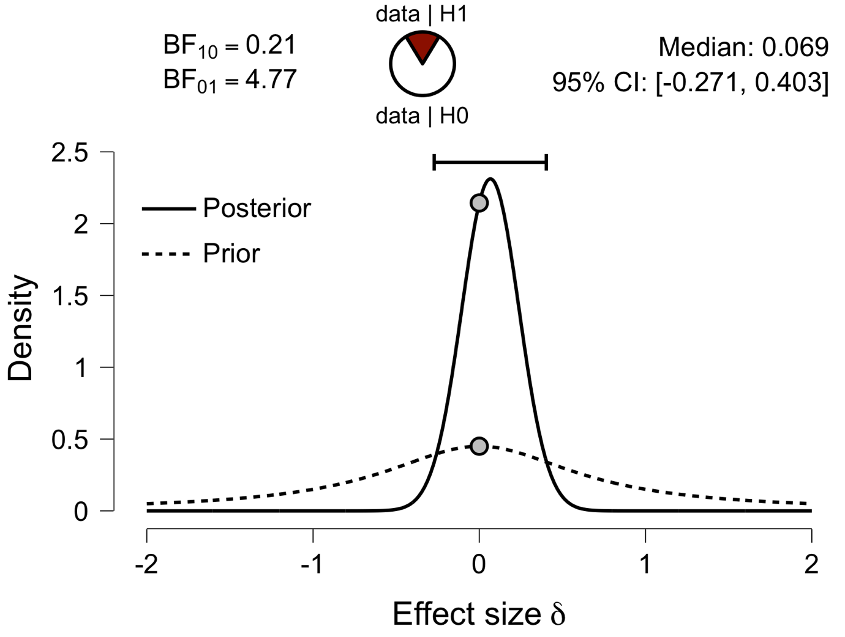

**Paired Samples T-Test**

| **Paired Samples T-Test** | | | | | | | | | | | | | | | | | | | | | | | | | |
| --- | --- | --- | --- | --- | --- | --- | --- | --- | --- | --- | --- | --- | --- | --- | --- | --- | --- | --- | --- | --- | --- | --- | --- | --- | --- |
|  | | | | | | | | | | | | | | | | **95% CI for Mean Difference** | | | |  | | **95% CI for Cohen's d** | | | |
|  | |  | |  | | **t** | | **df** | | **p** | | **Mean Difference** | | **SE Difference** | | **Lower** | | **Upper** | | **Cohen's d** | | **Lower** | | **Upper** | |
| l_Ins_em |  | - |  | a_Ins_em |  | -4.623 |  | 29 |  | 7.215e -5 |  | -0.036 |  | 0.008 |  | -0.052 |  | -0.020 |  | -0.844 |  | -1.257 |  | -0.421 |  |
|  | | | | | | | | | | | | | | | | | | | | | | | | | |
| *Note.*  Student's t-test. | | | | | | | | | | | | | | | | | | | | | | | | | |

**Assumption Checks**

| **Test of Normality (Shapiro-Wilk)** | | | | | | | | | |
| --- | --- | --- | --- | --- | --- | --- | --- | --- | --- |
|  | |  | |  | | **W** | | **p** | |
| l_Ins_em |  | - |  | a_Ins_em |  | 0.981 |  | 0.843 |  |
|  | | | | | | | | | |
| *Note.*  Significant results suggest a deviation from normality. | | | | | | | | | |

**Descriptives**

| **Descriptives** | | | | | | | | | |
| --- | --- | --- | --- | --- | --- | --- | --- | --- | --- |
|  | | **N** | | **Mean** | | **SD** | | **SE** | |
| l_Ins_em |  | 30 |  | 0.559 |  | 0.032 |  | 0.006 |  |
| a_Ins_em |  | 30 |  | 0.595 |  | 0.023 |  | 0.004 |  |
|  | | | | | | | | | |

**Descriptives Plot**

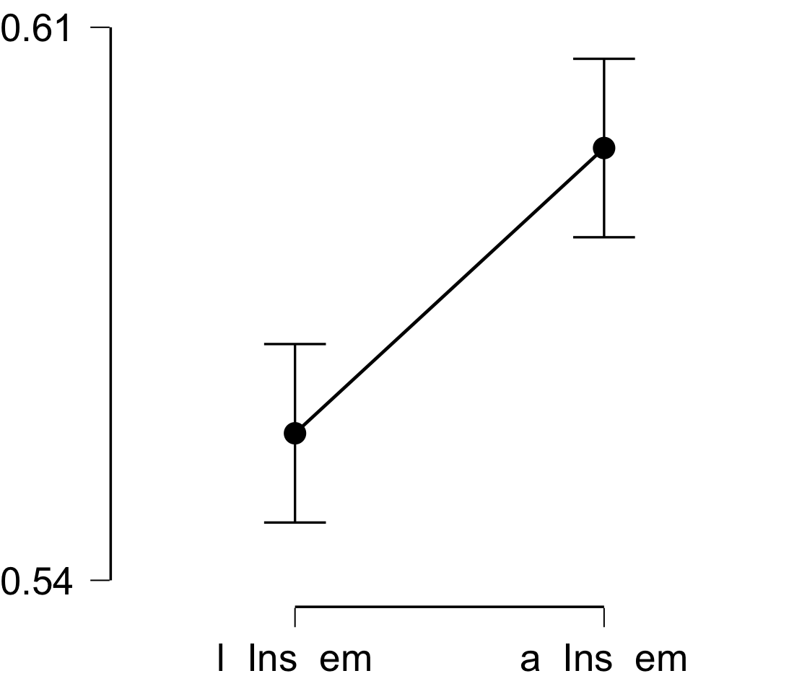

**Bayesian Paired Samples T-Test**

| **Bayesian Paired Samples T-Test** | | | | | | | | | |
| --- | --- | --- | --- | --- | --- | --- | --- | --- | --- |
|  | |  | |  | | **BF₁₀** | | **error %** | |
| l_Ins_em |  | - |  | a_Ins_em |  | 348.681 |  | 1.206e -6 |  |
|  | | | | | | | | | |

**Inferential Plots**

**l_Ins_em - a_Ins_em**

**Prior and Posterior**

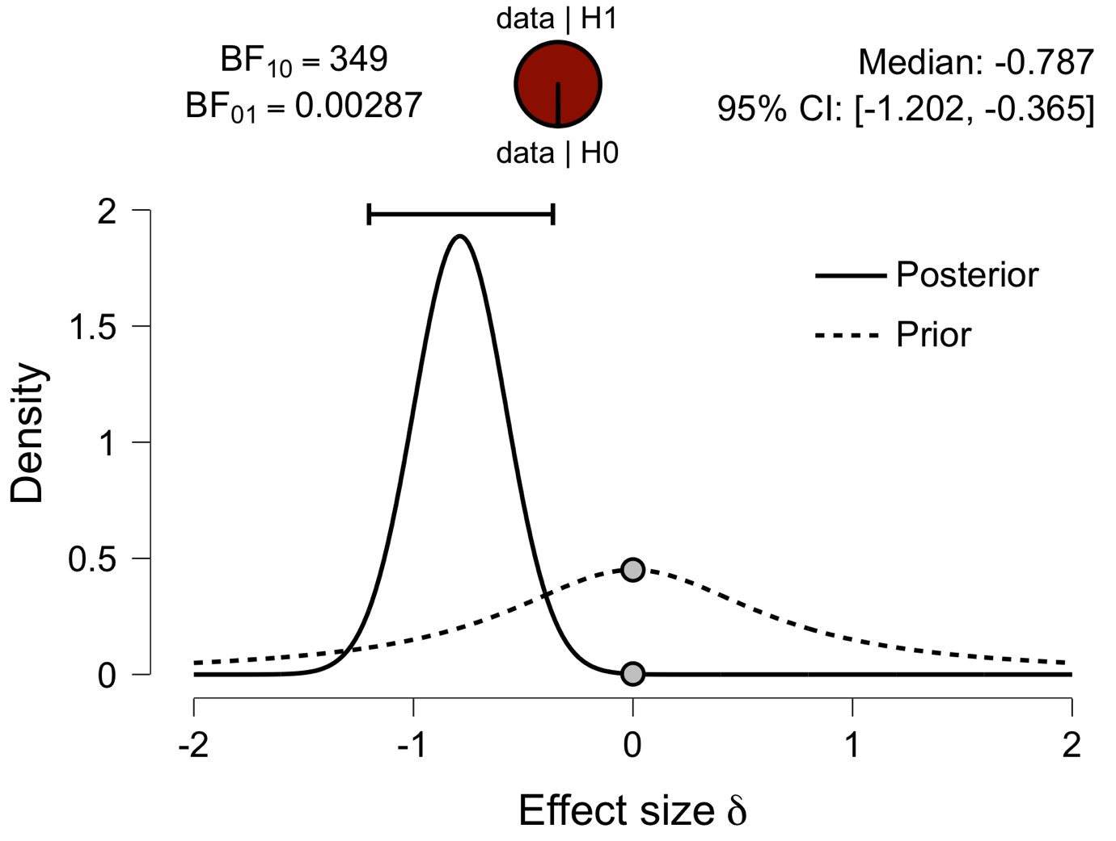

**Paired Samples T-Test**

| **Paired Samples T-Test** | | | | | | | | | | | | | | | | | | | | | | | | | |
| --- | --- | --- | --- | --- | --- | --- | --- | --- | --- | --- | --- | --- | --- | --- | --- | --- | --- | --- | --- | --- | --- | --- | --- | --- | --- |
|  | | | | | | | | | | | | | | | | **95% CI for Mean Difference** | | | |  | | **95% CI for Cohen's d** | | | |
|  | |  | |  | | **t** | | **df** | | **p** | | **Mean Difference** | | **SE Difference** | | **Lower** | | **Upper** | | **Cohen's d** | | **Lower** | | **Upper** | |
| l_ACC_em |  | - |  | a_ACC_em |  | 0.831 |  | 29 |  | 0.413 |  | 0.011 |  | 0.014 |  | -0.017 |  | 0.040 |  | 0.152 |  | -0.209 |  | 0.510 |  |
|  | | | | | | | | | | | | | | | | | | | | | | | | | |
| *Note.*  Student's t-test. | | | | | | | | | | | | | | | | | | | | | | | | | |

**Assumption Checks**

| **Test of Normality (Shapiro-Wilk)** | | | | | | | | | |
| --- | --- | --- | --- | --- | --- | --- | --- | --- | --- |
|  | |  | |  | | **W** | | **p** | |
| l_ACC_em |  | - |  | a_ACC_em |  | 0.948 |  | 0.147 |  |
|  | | | | | | | | | |
| *Note.*  Significant results suggest a deviation from normality. | | | | | | | | | |

**Descriptives**

| **Descriptives** | | | | | | | | | |
| --- | --- | --- | --- | --- | --- | --- | --- | --- | --- |
|  | | **N** | | **Mean** | | **SD** | | **SE** | |
| l_ACC_em |  | 30 |  | 0.603 |  | 0.061 |  | 0.011 |  |
| a_ACC_em |  | 30 |  | 0.592 |  | 0.034 |  | 0.006 |  |
|  | | | | | | | | | |

**Descriptives Plot**

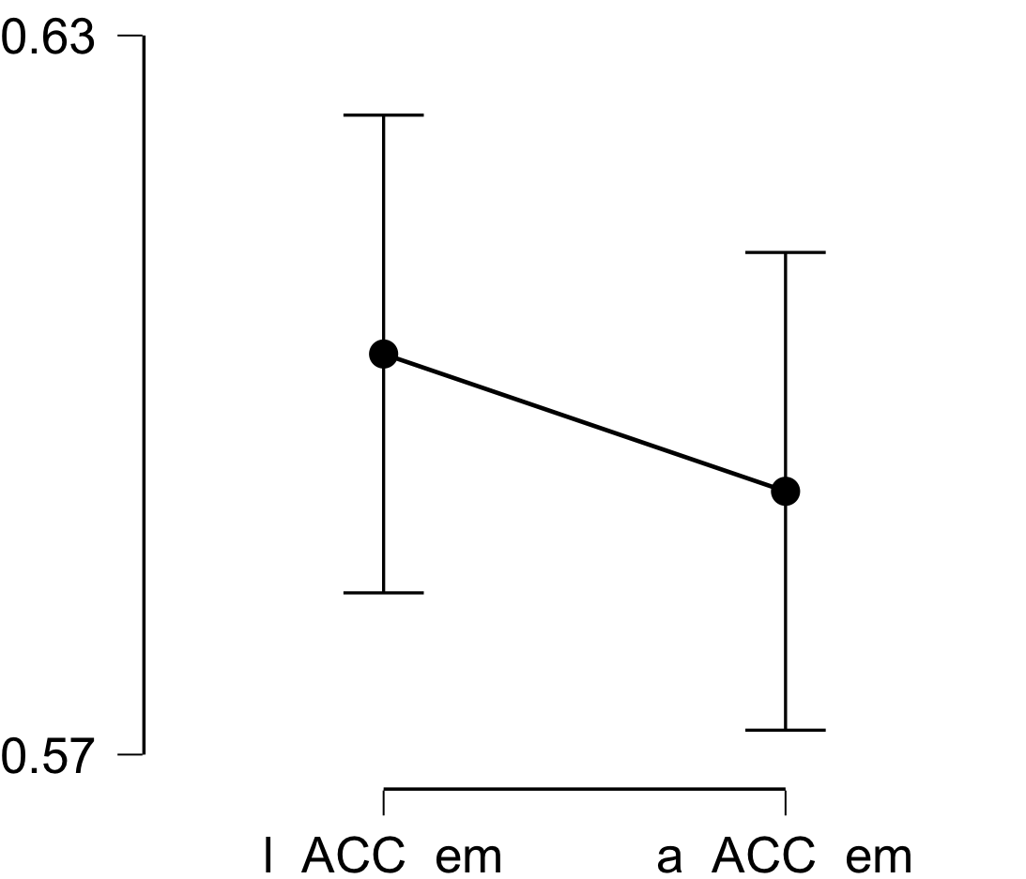

**Bayesian Paired Samples T-Test**

| **Bayesian Paired Samples T-Test** | | | | | | | | | |
| --- | --- | --- | --- | --- | --- | --- | --- | --- | --- |
|  | |  | |  | | **BF₁₀** | | **error %** | |
| l_ACC_em |  | - |  | a_ACC_em |  | 0.267 |  | 6.238e -4 |  |
|  | | | | | | | | | |

**Inferential Plots**

**l_ACC_em - a_ACC_em**

**Prior and Posterior**

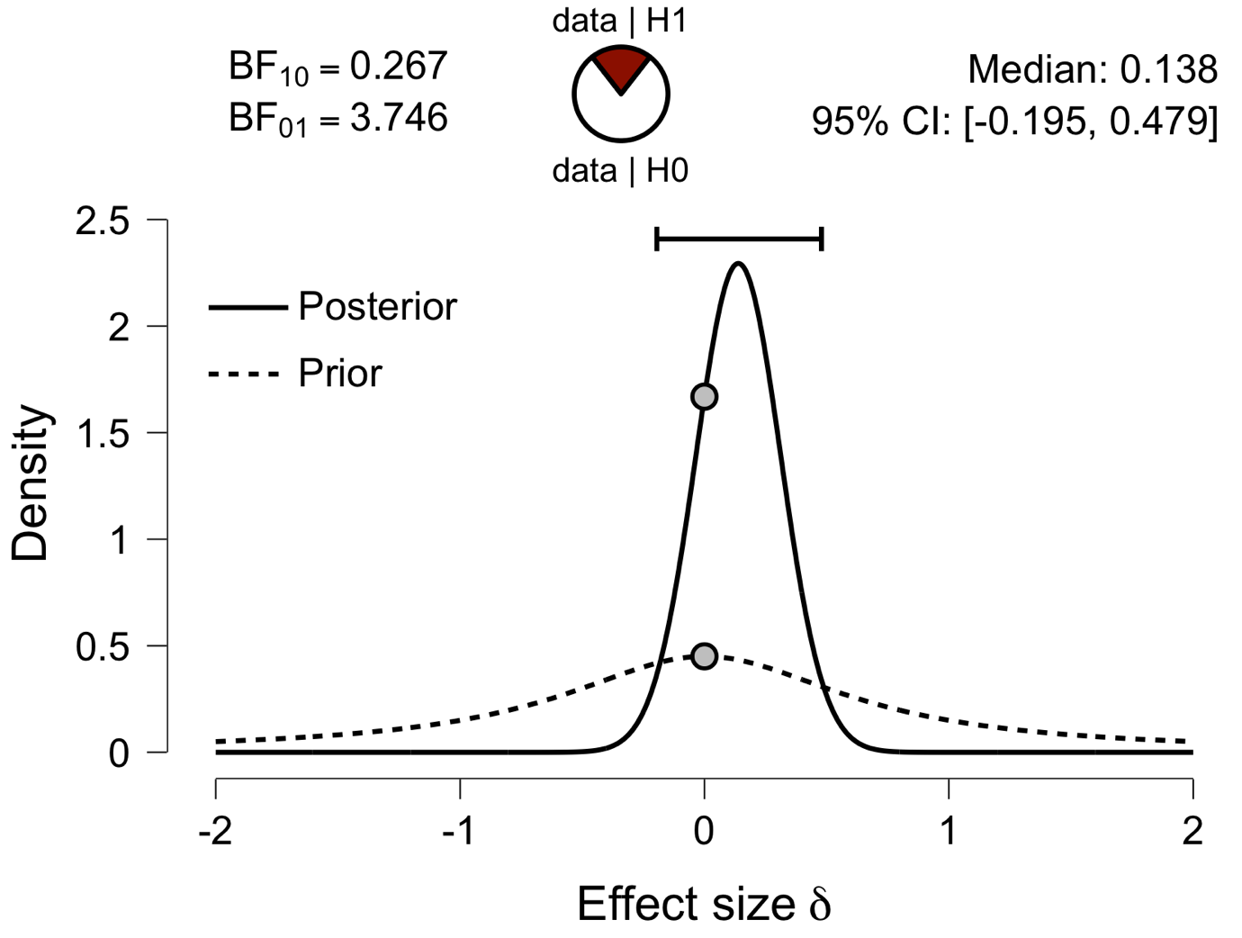

**Paired Samples T-Test**

| **Paired Samples T-Test** | | | | | | | | | | | | | | | | | | | | | | | | | |
| --- | --- | --- | --- | --- | --- | --- | --- | --- | --- | --- | --- | --- | --- | --- | --- | --- | --- | --- | --- | --- | --- | --- | --- | --- | --- |
|  | | | | | | | | | | | | | | | | **95% CI for Mean Difference** | | | |  | | **95% CI for Cohen's d** | | | |
|  | |  | |  | | **t** | | **df** | | **p** | | **Mean Difference** | | **SE Difference** | | **Lower** | | **Upper** | | **Cohen's d** | | **Lower** | | **Upper** | |
| l_PCC_em |  | - |  | a_PCC_em |  | -2.915 |  | 29 |  | 0.007 |  | -0.024 |  | 0.008 |  | -0.042 |  | -0.007 |  | -0.532 |  | -0.911 |  | -0.145 |  |
|  | | | | | | | | | | | | | | | | | | | | | | | | | |
| *Note.*  Student's t-test. | | | | | | | | | | | | | | | | | | | | | | | | | |

**Assumption Checks**

| **Test of Normality (Shapiro-Wilk)** | | | | | | | | | |
| --- | --- | --- | --- | --- | --- | --- | --- | --- | --- |
|  | |  | |  | | **W** | | **p** | |
| l_PCC_em |  | - |  | a_PCC_em |  | 0.971 |  | 0.571 |  |
|  | | | | | | | | | |
| *Note.*  Significant results suggest a deviation from normality. | | | | | | | | | |

**Descriptives**

| **Descriptives** | | | | | | | | | |
| --- | --- | --- | --- | --- | --- | --- | --- | --- | --- |
|  | | **N** | | **Mean** | | **SD** | | **SE** | |
| l_PCC_em |  | 30 |  | 0.561 |  | 0.036 |  | 0.007 |  |
| a_PCC_em |  | 30 |  | 0.585 |  | 0.026 |  | 0.005 |  |
|  | | | | | | | | | |

**Descriptives Plot**

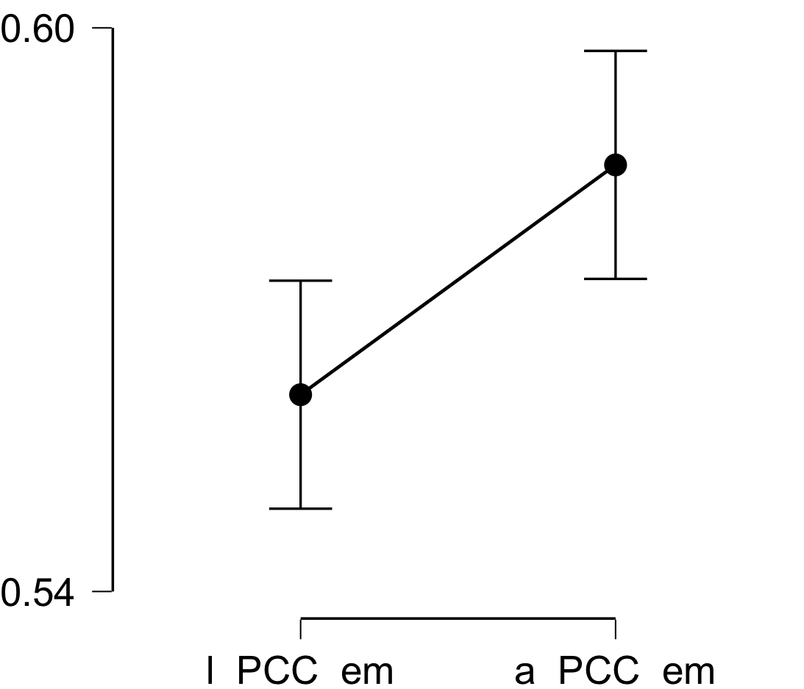

**Bayesian Paired Samples T-Test**

| **Bayesian Paired Samples T-Test** | | | | | | | | | |
| --- | --- | --- | --- | --- | --- | --- | --- | --- | --- |
|  | |  | |  | | **BF₁₀** | | **error %** | |
| l_PCC_em |  | - |  | a_PCC_em |  | 6.258 |  | 2.533e -6 |  |
|  | | | | | | | | | |

**Inferential Plots**

**l_PCC_em - a_PCC_em**

**Prior and Posterior**

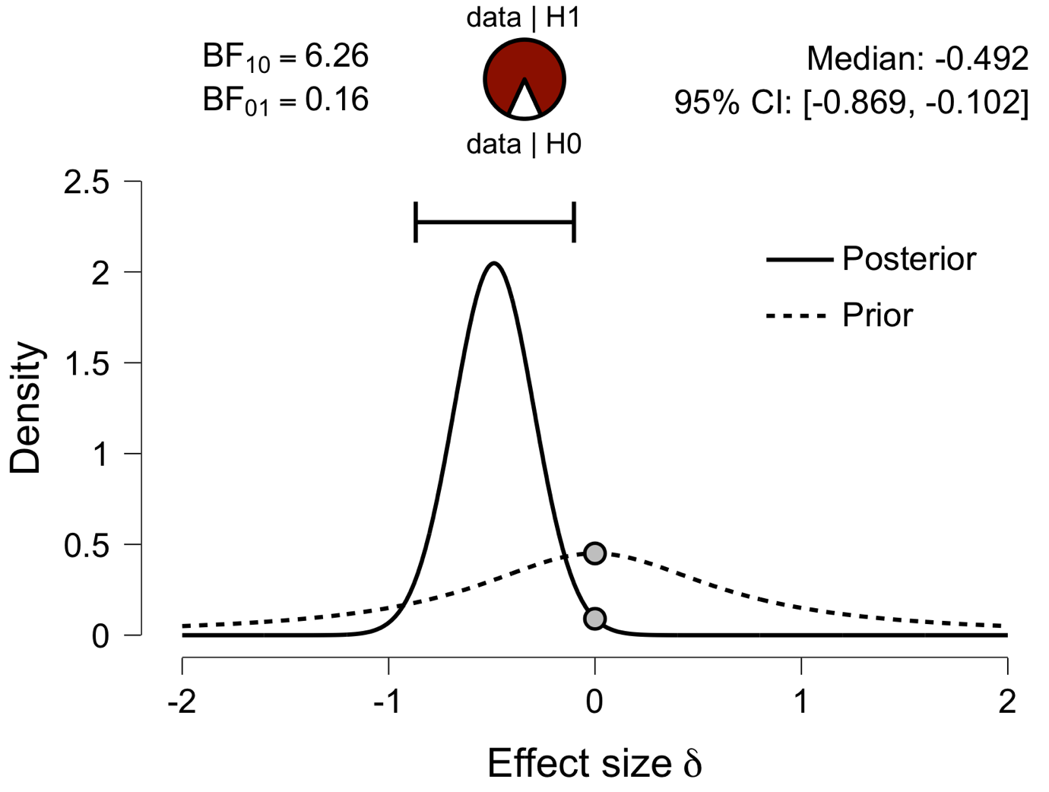

**Paired Samples T-Test**

| **Paired Samples T-Test** | | | | | | | | | | | | | | | | | | | | | | | | | |
| --- | --- | --- | --- | --- | --- | --- | --- | --- | --- | --- | --- | --- | --- | --- | --- | --- | --- | --- | --- | --- | --- | --- | --- | --- | --- |
|  | | | | | | | | | | | | | | | | **95% CI for Mean Difference** | | | |  | | **95% CI for Cohen's d** | | | |
|  | |  | |  | | **t** | | **df** | | **p** | | **Mean Difference** | | **SE Difference** | | **Lower** | | **Upper** | | **Cohen's d** | | **Lower** | | **Upper** | |
| l_V1_em |  | - |  | a_V1_em |  | -6.310 |  | 29 |  | 6.827e -7 |  | -0.050 |  | 0.008 |  | -0.066 |  | -0.034 |  | -1.152 |  | -1.610 |  | -0.682 |  |
|  | | | | | | | | | | | | | | | | | | | | | | | | | |
| *Note.*  Student's t-test. | | | | | | | | | | | | | | | | | | | | | | | | | |

**Assumption Checks**

| **Test of Normality (Shapiro-Wilk)** | | | | | | | | | |
| --- | --- | --- | --- | --- | --- | --- | --- | --- | --- |
|  | |  | |  | | **W** | | **p** | |
| l_V1_em |  | - |  | a_V1_em |  | 0.969 |  | 0.515 |  |
|  | | | | | | | | | |
| *Note.*  Significant results suggest a deviation from normality. | | | | | | | | | |

**Descriptives**

| **Descriptives** | | | | | | | | | |
| --- | --- | --- | --- | --- | --- | --- | --- | --- | --- |
|  | | **N** | | **Mean** | | **SD** | | **SE** | |
| l_V1_em |  | 30 |  | 0.521 |  | 0.029 |  | 0.005 |  |
| a_V1_em |  | 30 |  | 0.571 |  | 0.025 |  | 0.005 |  |
|  | | | | | | | | | |

**Descriptives Plot**

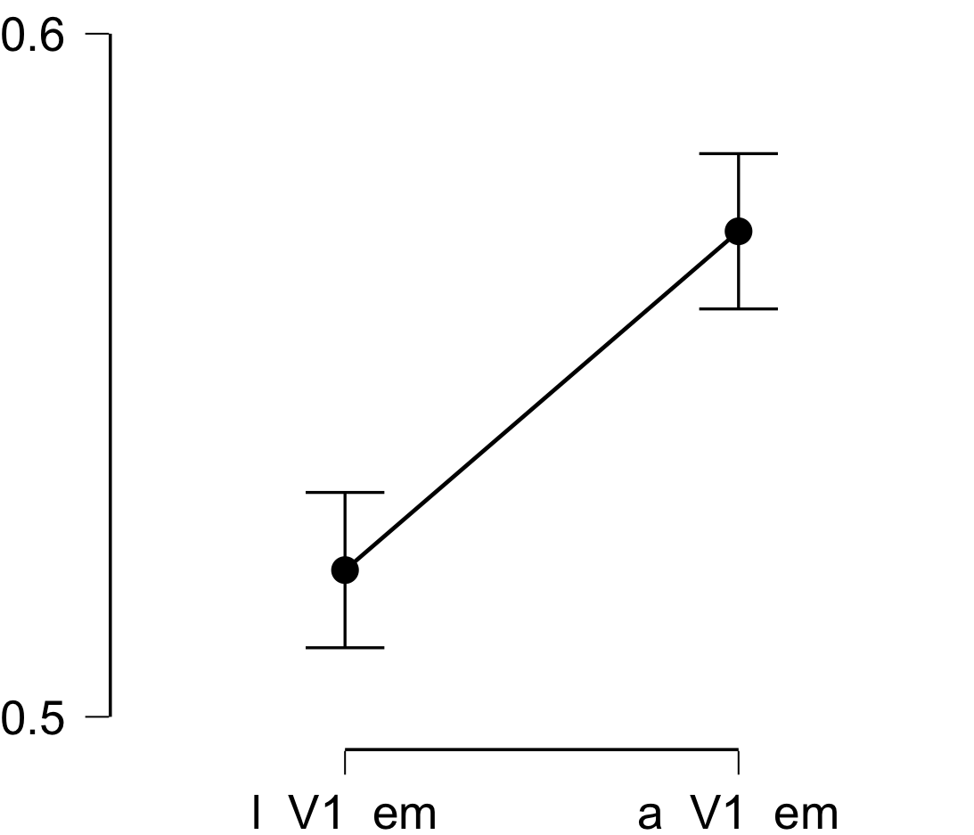

**Bayesian Paired Samples T-Test**

| **Bayesian Paired Samples T-Test** | | | | | | | | | |
| --- | --- | --- | --- | --- | --- | --- | --- | --- | --- |
|  | |  | |  | | **BF₁₀** | | **error %** | |
| l_V1_em |  | - |  | a_V1_em |  | 25125.913 |  | 1.486e -7 |  |
|  | | | | | | | | | |

**Inferential Plots**

**l_V1_em - a_V1_em**

**Prior and Posterior**

