**Results**

**Paired Samples T-Test**

**Paired Samples T-Test**

| **Paired Samples T-Test** | | | | | | | | | | | | | | | | | | | | | | | | | |
| --- | --- | --- | --- | --- | --- | --- | --- | --- | --- | --- | --- | --- | --- | --- | --- | --- | --- | --- | --- | --- | --- | --- | --- | --- | --- |
|  | | | | | | | | | | | | | | | | **95% CI for Mean Difference** | | | |  | | **95% CI for Cohen's d** | | | |
|  | |  | |  | | **t** | | **df** | | **p** | | **Mean Difference** | | **SE Difference** | | **Lower** | | **Upper** | | **Cohen's d** | | **Lower** | | **Upper** | |
| LTL_1 |  | - |  | LTL_2 |  | 12.469 |  | 29 |  | 3.550e -13 |  | 0.112 |  | 0.009 |  | 0.094 |  | 0.131 |  | 2.277 |  | 1.587 |  | 2.955 |  |
|  | | | | | | | | | | | | | | | | | | | | | | | | | |
| *Note.*  Student's t-test. | | | | | | | | | | | | | | | | | | | | | | | | | |

**Assumption Checks**

| **Test of Normality (Shapiro-Wilk)** | | | | | | | | | |
| --- | --- | --- | --- | --- | --- | --- | --- | --- | --- |
|  | |  | |  | | **W** | | **p** | |
| LTL_1 |  | - |  | LTL_2 |  | 0.956 |  | 0.251 |  |
|  | | | | | | | | | |
| *Note.*  Significant results suggest a deviation from normality. | | | | | | | | | |

**Descriptives**

| **Descriptives** | | | | | | | | | |
| --- | --- | --- | --- | --- | --- | --- | --- | --- | --- |
|  | | **N** | | **Mean** | | **SD** | | **SE** | |
| LTL_1 |  | 30 |  | 0.653 |  | 0.038 |  | 0.007 |  |
| LTL_2 |  | 30 |  | 0.541 |  | 0.034 |  | 0.006 |  |
|  | | | | | | | | | |

**Descriptives Plot**

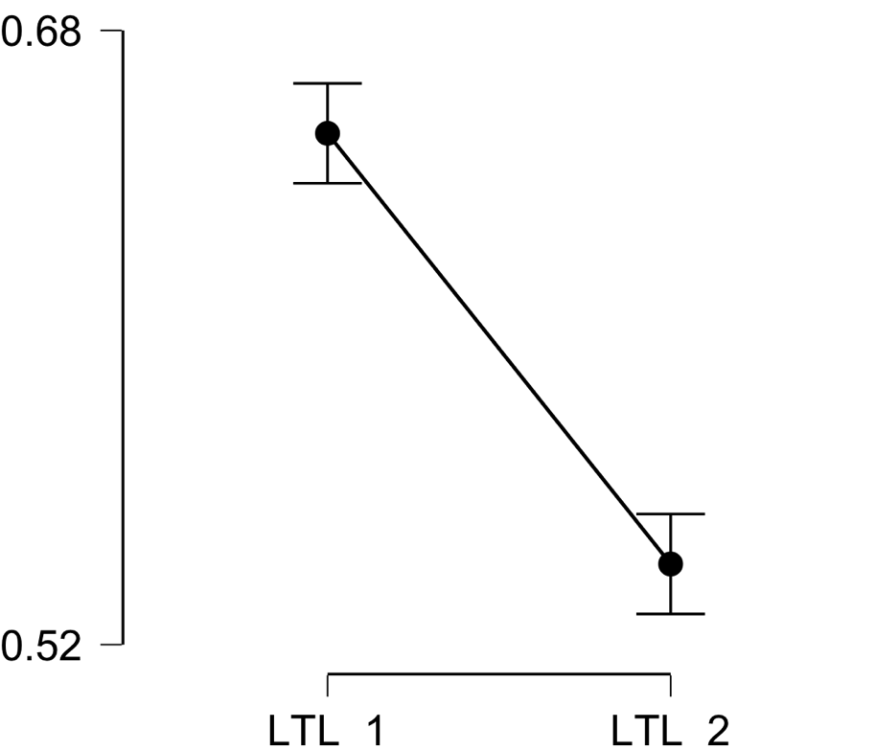

**Bayesian Paired Samples T-Test**

| **Bayesian Paired Samples T-Test** | | | | | | | | | |
| --- | --- | --- | --- | --- | --- | --- | --- | --- | --- |
|  | |  | |  | | **BF₁₀** | | **error %** | |
| LTL_1 |  | - |  | LTL_2 |  | 2.137e +10 |  | 1.083e -14 |  |
|  | | | | | | | | | |

**Inferential Plots**

**LTL_1 - LTL_2**

**Prior and Posterior**

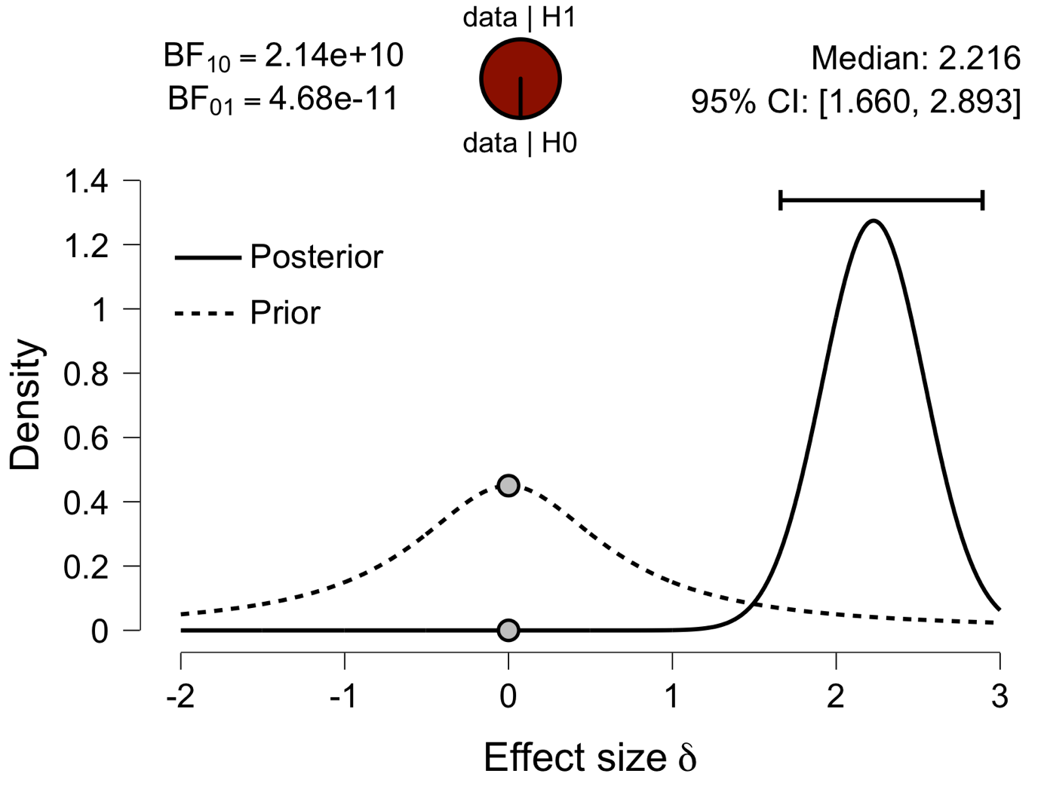

**Paired Samples T-Test**

| **Paired Samples T-Test** | | | | | | | | | | | | | | | | | | | | | | | | | |
| --- | --- | --- | --- | --- | --- | --- | --- | --- | --- | --- | --- | --- | --- | --- | --- | --- | --- | --- | --- | --- | --- | --- | --- | --- | --- |
|  | | | | | | | | | | | | | | | | **95% CI for Mean Difference** | | | |  | | **95% CI for Cohen's d** | | | |
|  | |  | |  | | **t** | | **df** | | **p** | | **Mean Difference** | | **SE Difference** | | **Lower** | | **Upper** | | **Cohen's d** | | **Lower** | | **Upper** | |
| IFG_1 |  | - |  | IFG_2 |  | 14.422 |  | 29 |  | 9.211e -15 |  | 0.107 |  | 0.007 |  | 0.092 |  | 0.122 |  | 2.633 |  | 1.864 |  | 3.391 |  |
|  | | | | | | | | | | | | | | | | | | | | | | | | | |
| *Note.*  Student's t-test. | | | | | | | | | | | | | | | | | | | | | | | | | |

**Assumption Checks**

| **Test of Normality (Shapiro-Wilk)** | | | | | | | | | |
| --- | --- | --- | --- | --- | --- | --- | --- | --- | --- |
|  | |  | |  | | **W** | | **p** | |
| IFG_1 |  | - |  | IFG_2 |  | 0.975 |  | 0.679 |  |
|  | | | | | | | | | |
| *Note.*  Significant results suggest a deviation from normality. | | | | | | | | | |

**Descriptives**

| **Descriptives** | | | | | | | | | |
| --- | --- | --- | --- | --- | --- | --- | --- | --- | --- |
|  | | **N** | | **Mean** | | **SD** | | **SE** | |
| IFG_1 |  | 30 |  | 0.637 |  | 0.034 |  | 0.006 |  |
| IFG_2 |  | 30 |  | 0.530 |  | 0.034 |  | 0.006 |  |
|  | | | | | | | | | |

**Descriptives Plot**

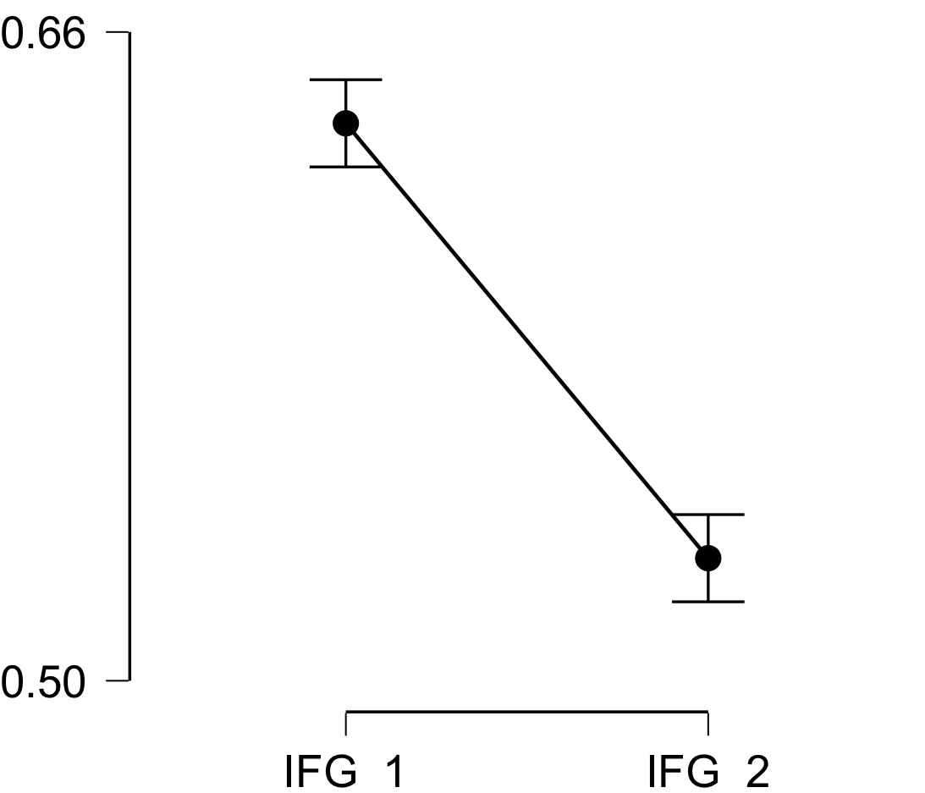

**Bayesian Paired Samples T-Test**

| **Bayesian Paired Samples T-Test** | | | | | | | | | |
| --- | --- | --- | --- | --- | --- | --- | --- | --- | --- |
|  | |  | |  | | **BF₁₀** | | **error %** | |
| IFG_1 |  | - |  | IFG_2 |  | 6.995e +11 |  | 2.232e -18 |  |
|  | | | | | | | | | |

**Inferential Plots**

**IFG_1 - IFG_2**

**Prior and Posterior**

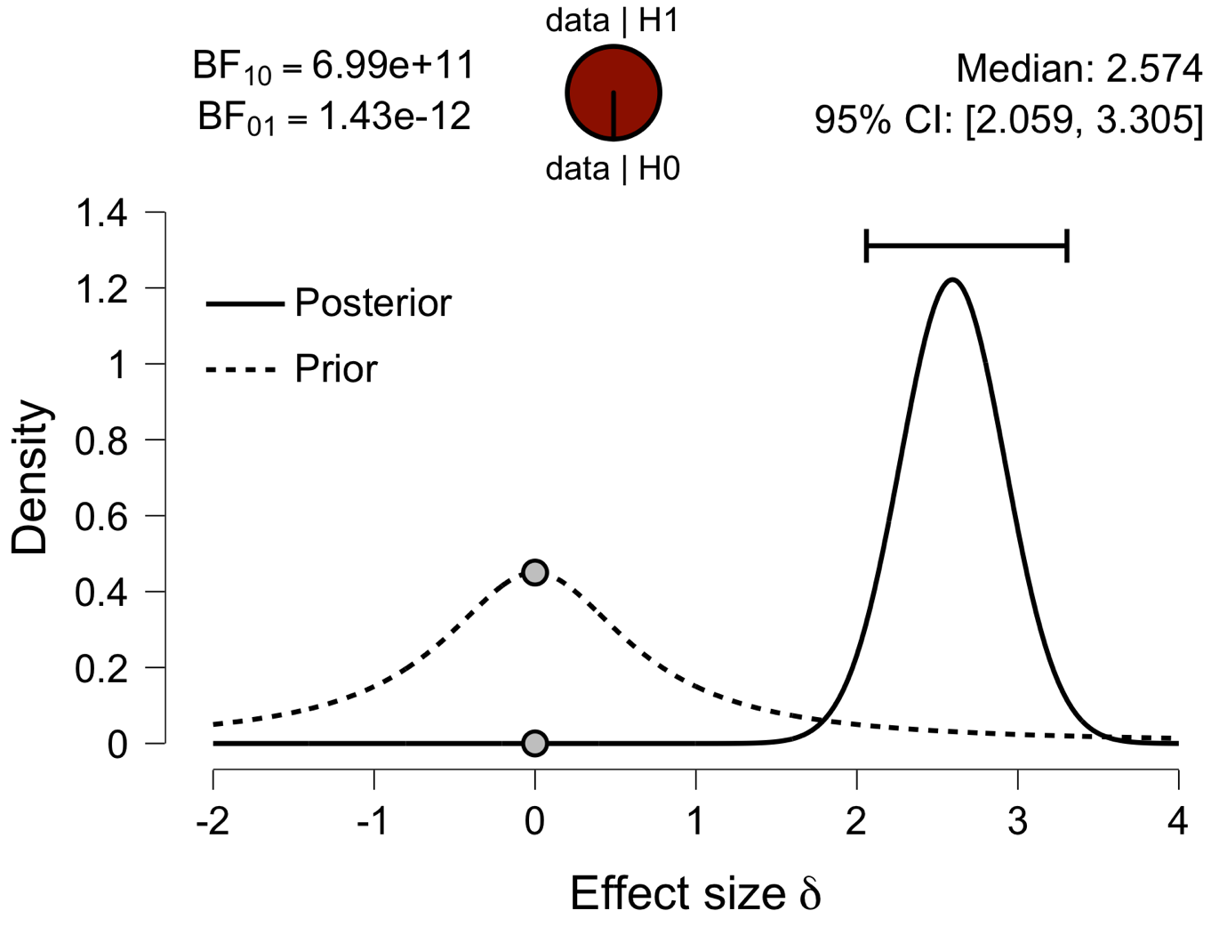

**Paired Samples T-Test**

| **Paired Samples T-Test** | | | | | | | | | | | | | | | | | | | | | | | | | |
| --- | --- | --- | --- | --- | --- | --- | --- | --- | --- | --- | --- | --- | --- | --- | --- | --- | --- | --- | --- | --- | --- | --- | --- | --- | --- |
|  | | | | | | | | | | | | | | | | **95% CI for Mean Difference** | | | |  | | **95% CI for Cohen's d** | | | |
|  | |  | |  | | **t** | | **df** | | **p** | | **Mean Difference** | | **SE Difference** | | **Lower** | | **Upper** | | **Cohen's d** | | **Lower** | | **Upper** | |
| Prec_1 |  | - |  | Prec_2 |  | 11.682 |  | 29 |  | 1.734e -12 |  | 0.095 |  | 0.008 |  | 0.079 |  | 0.112 |  | 2.133 |  | 1.474 |  | 2.780 |  |
|  | | | | | | | | | | | | | | | | | | | | | | | | | |
| *Note.*  Student's t-test. | | | | | | | | | | | | | | | | | | | | | | | | | |

**Assumption Checks**

| **Test of Normality (Shapiro-Wilk)** | | | | | | | | | |
| --- | --- | --- | --- | --- | --- | --- | --- | --- | --- |
|  | |  | |  | | **W** | | **p** | |
| Prec_1 |  | - |  | Prec_2 |  | 0.981 |  | 0.852 |  |
|  | | | | | | | | | |
| *Note.*  Significant results suggest a deviation from normality. | | | | | | | | | |

**Descriptives**

| **Descriptives** | | | | | | | | | |
| --- | --- | --- | --- | --- | --- | --- | --- | --- | --- |
|  | | **N** | | **Mean** | | **SD** | | **SE** | |
| Prec_1 |  | 30 |  | 0.634 |  | 0.028 |  | 0.005 |  |
| Prec_2 |  | 30 |  | 0.539 |  | 0.035 |  | 0.006 |  |
|  | | | | | | | | | |

**Descriptives Plot**

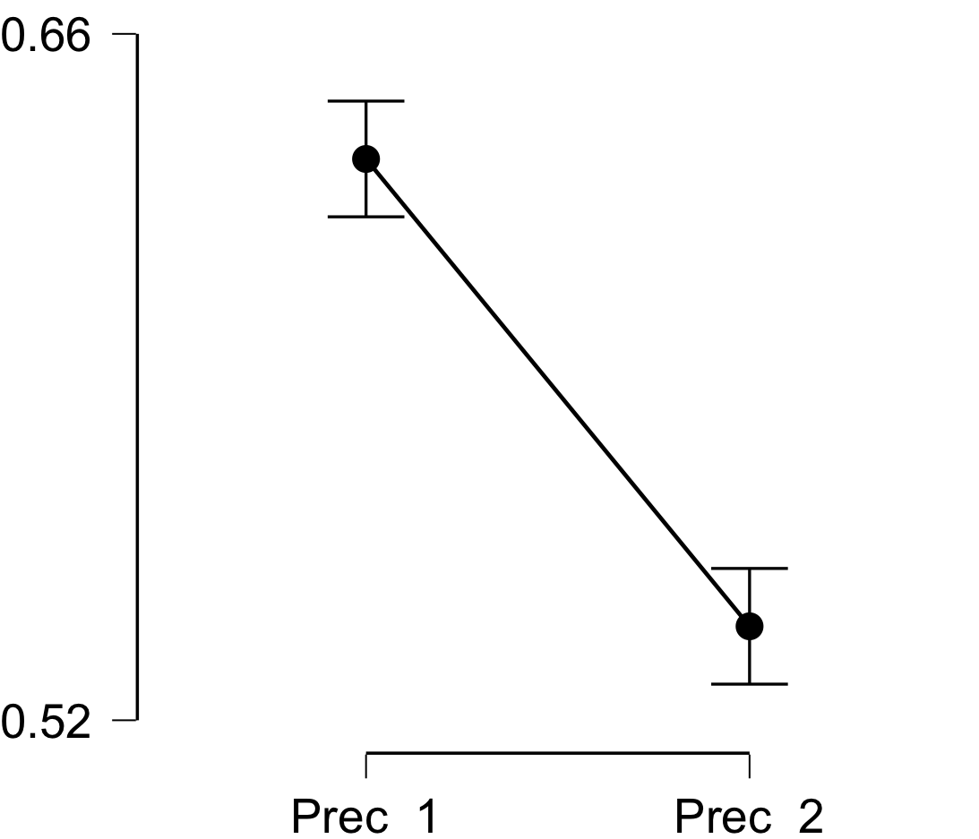

**Bayesian Paired Samples T-Test**

| **Bayesian Paired Samples T-Test** | | | | | | | | | |
| --- | --- | --- | --- | --- | --- | --- | --- | --- | --- |
|  | |  | |  | | **BF₁₀** | | **error %** | |
| Prec_1 |  | - |  | Prec_2 |  | 4.715e +9 |  | 6.998e -14 |  |
|  | | | | | | | | | |

**Inferential Plots**

**Prec_1 - Prec_2**

**Prior and Posterior**

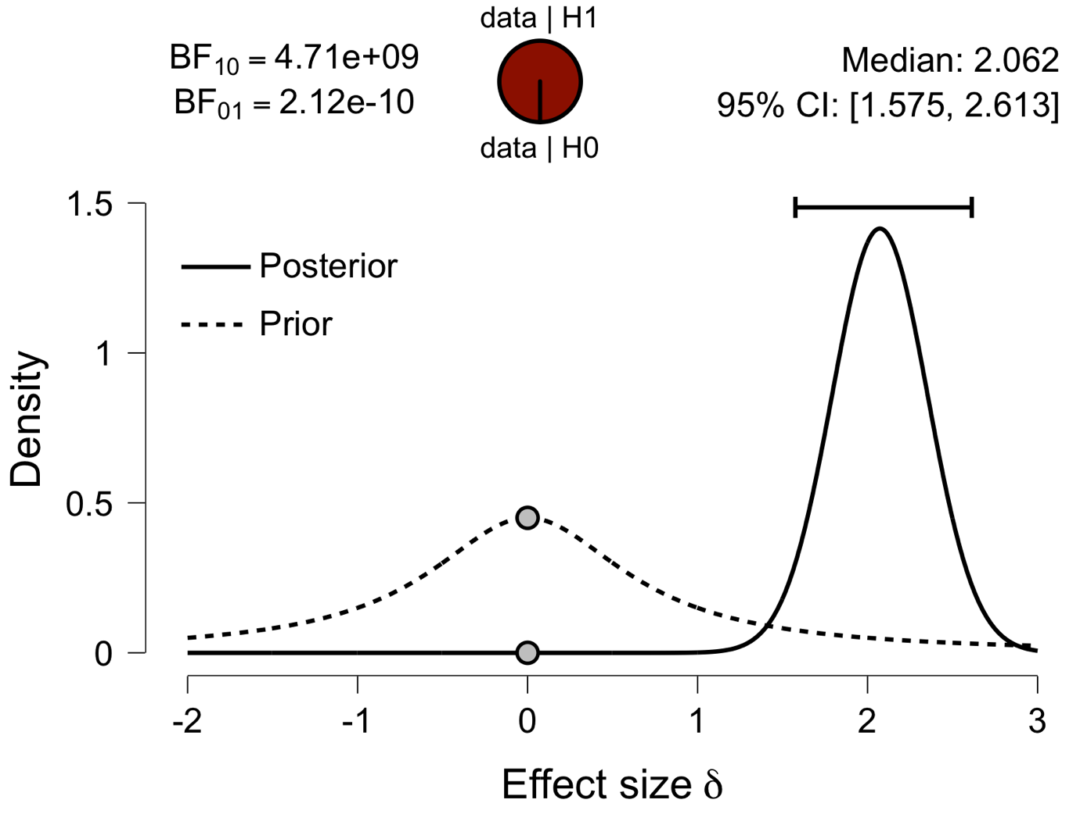

**Paired Samples T-Test**

| **Paired Samples T-Test** | | | | | | | | | | | | | | | | | | | | | | | | | |
| --- | --- | --- | --- | --- | --- | --- | --- | --- | --- | --- | --- | --- | --- | --- | --- | --- | --- | --- | --- | --- | --- | --- | --- | --- | --- |
|  | | | | | | | | | | | | | | | | **95% CI for Mean Difference** | | | |  | | **95% CI for Cohen's d** | | | |
|  | |  | |  | | **t** | | **df** | | **p** | | **Mean Difference** | | **SE Difference** | | **Lower** | | **Upper** | | **Cohen's d** | | **Lower** | | **Upper** | |
| ATL_1 |  | - |  | ATL_2 |  | 11.451 |  | 29 |  | 2.802e -12 |  | 0.068 |  | 0.006 |  | 0.056 |  | 0.080 |  | 2.091 |  | 1.441 |  | 2.729 |  |
|  | | | | | | | | | | | | | | | | | | | | | | | | | |
| *Note.*  Student's t-test. | | | | | | | | | | | | | | | | | | | | | | | | | |

**Assumption Checks**

| **Test of Normality (Shapiro-Wilk)** | | | | | | | | | |
| --- | --- | --- | --- | --- | --- | --- | --- | --- | --- |
|  | |  | |  | | **W** | | **p** | |
| ATL_1 |  | - |  | ATL_2 |  | 0.981 |  | 0.851 |  |
|  | | | | | | | | | |
| *Note.*  Significant results suggest a deviation from normality. | | | | | | | | | |

**Descriptives**

| **Descriptives** | | | | | | | | | |
| --- | --- | --- | --- | --- | --- | --- | --- | --- | --- |
|  | | **N** | | **Mean** | | **SD** | | **SE** | |
| ATL_1 |  | 30 |  | 0.594 |  | 0.025 |  | 0.005 |  |
| ATL_2 |  | 30 |  | 0.526 |  | 0.029 |  | 0.005 |  |
|  | | | | | | | | | |

**Descriptives Plot**

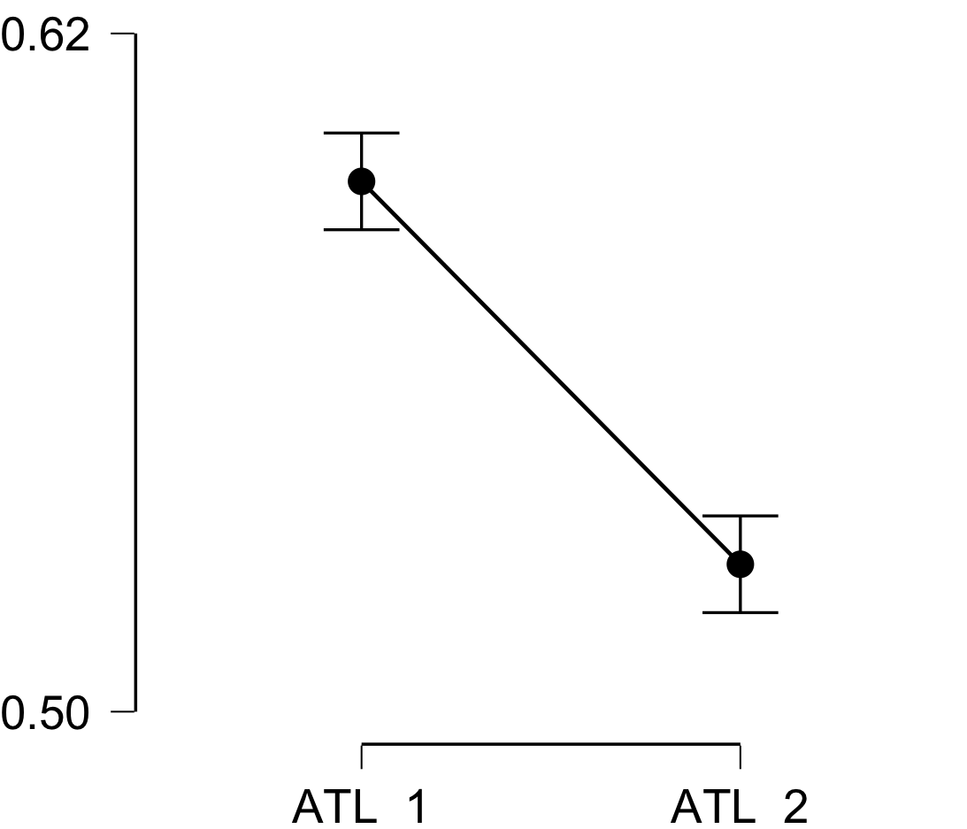

**Bayesian Paired Samples T-Test**

| **Bayesian Paired Samples T-Test** | | | | | | | | | |
| --- | --- | --- | --- | --- | --- | --- | --- | --- | --- |
|  | |  | |  | | **BF₁₀** | | **error %** | |
| ATL_1 |  | - |  | ATL_2 |  | 2.985e +9 |  | 1.190e -13 |  |
|  | | | | | | | | | |

**Inferential Plots**

**ATL_1 - ATL_2**

**Prior and Posterior**

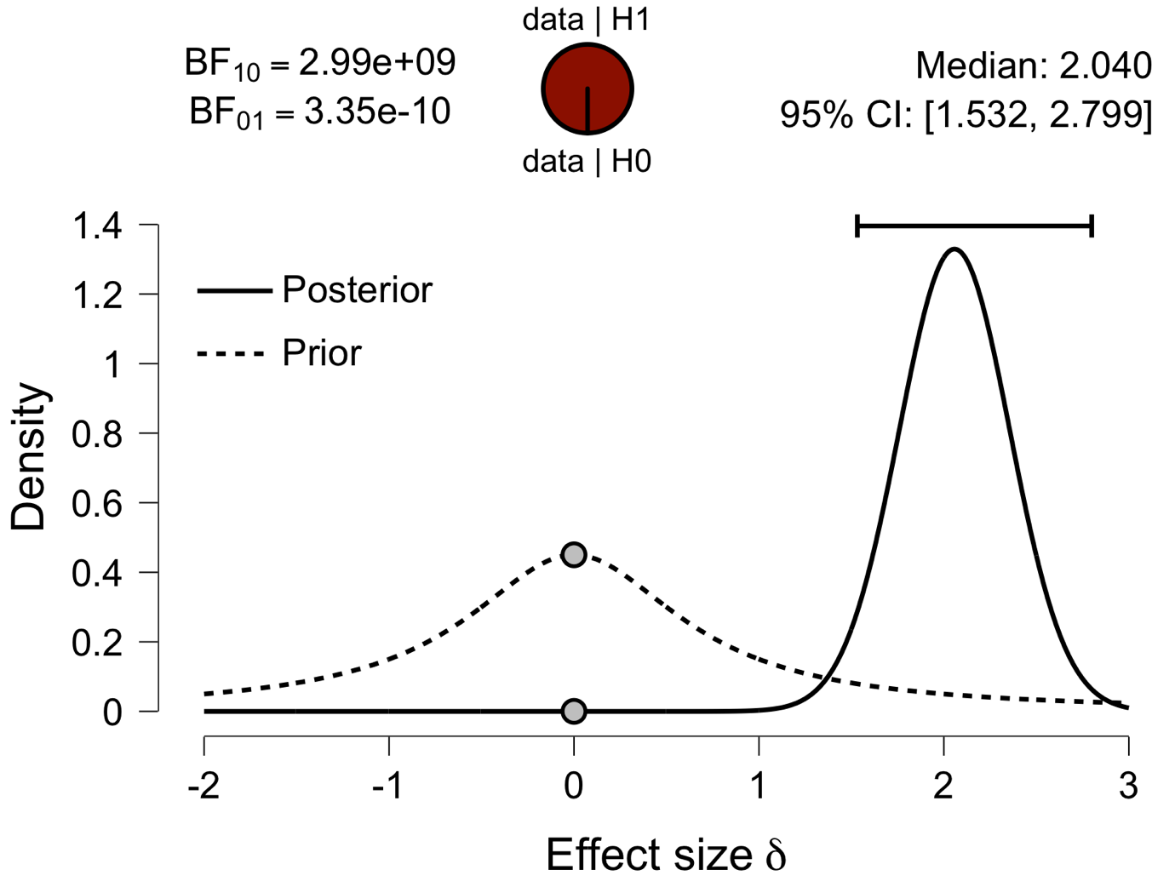

**Paired Samples T-Test**

| **Paired Samples T-Test** | | | | | | | | | | | | | | | | | | | | | | | | | |
| --- | --- | --- | --- | --- | --- | --- | --- | --- | --- | --- | --- | --- | --- | --- | --- | --- | --- | --- | --- | --- | --- | --- | --- | --- | --- |
|  | | | | | | | | | | | | | | | | **95% CI for Mean Difference** | | | |  | | **95% CI for Cohen's d** | | | |
|  | |  | |  | | **t** | | **df** | | **p** | | **Mean Difference** | | **SE Difference** | | **Lower** | | **Upper** | | **Cohen's d** | | **Lower** | | **Upper** | |
| aPFC_1 |  | - |  | aPFC_2 |  | 11.269 |  | 29 |  | 4.107e -12 |  | 0.083 |  | 0.007 |  | 0.068 |  | 0.099 |  | 2.057 |  | 1.415 |  | 2.688 |  |
|  | | | | | | | | | | | | | | | | | | | | | | | | | |
| *Note.*  Student's t-test. | | | | | | | | | | | | | | | | | | | | | | | | | |

**Assumption Checks**

| **Test of Normality (Shapiro-Wilk)** | | | | | | | | | |
| --- | --- | --- | --- | --- | --- | --- | --- | --- | --- |
|  | |  | |  | | **W** | | **p** | |
| aPFC_1 |  | - |  | aPFC_2 |  | 0.975 |  | 0.690 |  |
|  | | | | | | | | | |
| *Note.*  Significant results suggest a deviation from normality. | | | | | | | | | |

**Descriptives**

| **Descriptives** | | | | | | | | | |
| --- | --- | --- | --- | --- | --- | --- | --- | --- | --- |
|  | | **N** | | **Mean** | | **SD** | | **SE** | |
| aPFC_1 |  | 30 |  | 0.621 |  | 0.037 |  | 0.007 |  |
| aPFC_2 |  | 30 |  | 0.538 |  | 0.033 |  | 0.006 |  |
|  | | | | | | | | | |

**Descriptives Plot**

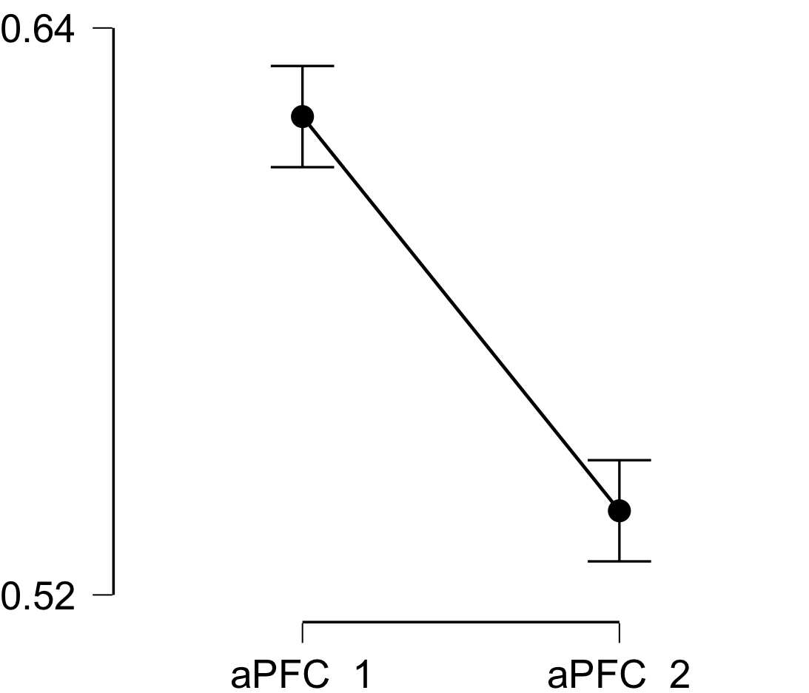

**Bayesian Paired Samples T-Test**

| **Bayesian Paired Samples T-Test** | | | | | | | | | |
| --- | --- | --- | --- | --- | --- | --- | --- | --- | --- |
|  | |  | |  | | **BF₁₀** | | **error %** | |
| aPFC_1 |  | - |  | aPFC_2 |  | 2.075e +9 |  | 1.809e -13 |  |
|  | | | | | | | | | |

**Inferential Plots**

**aPFC_1 - aPFC_2**

**Prior and Posterior**

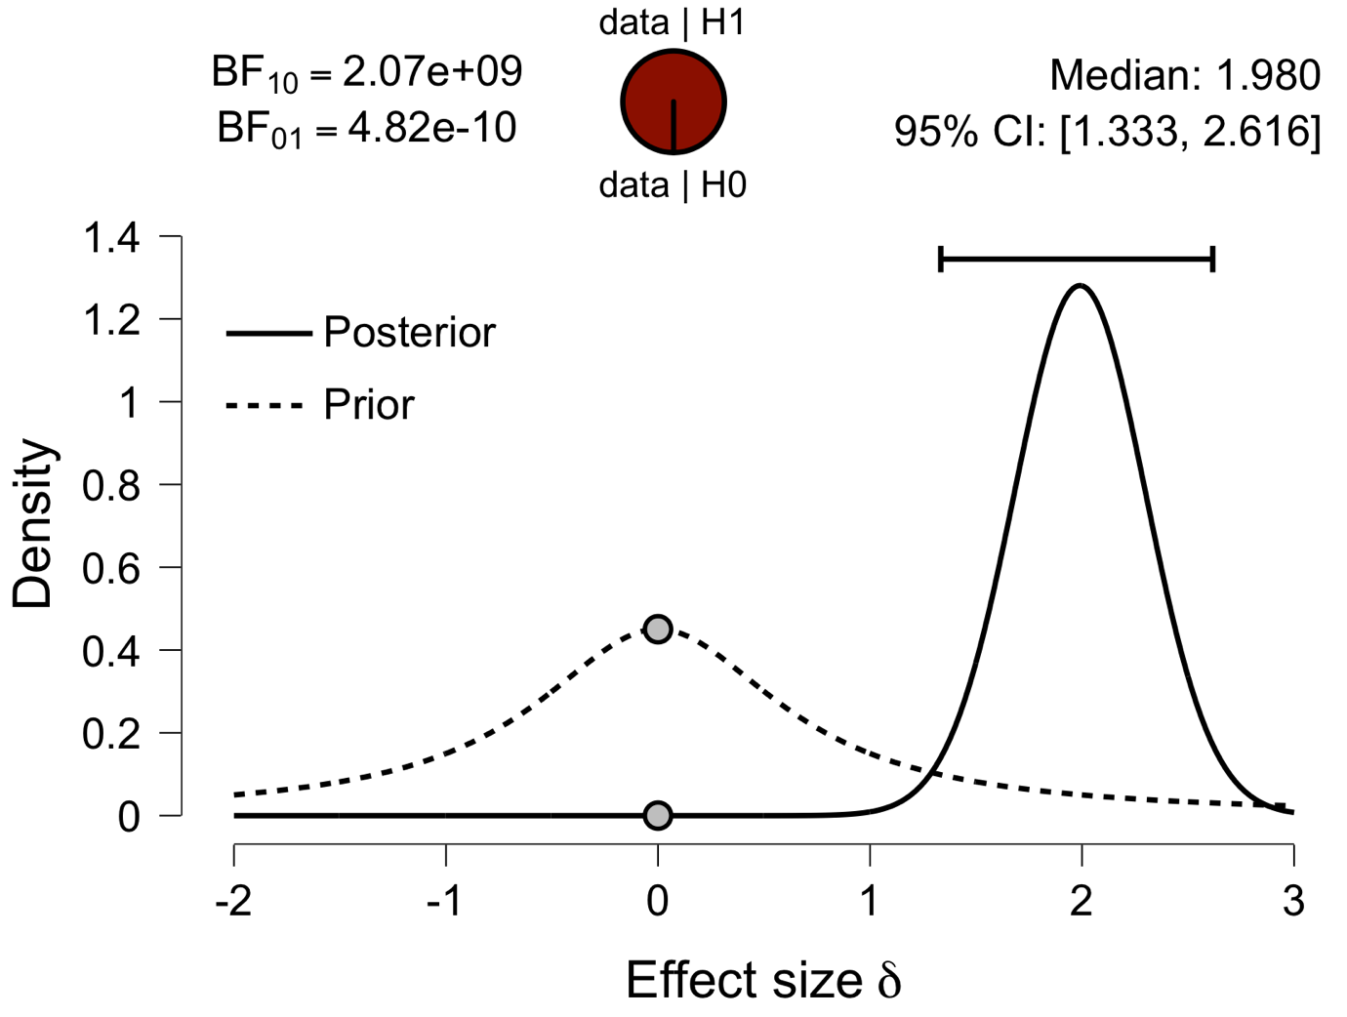

**Paired Samples T-Test**

| **Paired Samples T-Test** | | | | | | | | | | | | | | | | | | | | | | | | | |
| --- | --- | --- | --- | --- | --- | --- | --- | --- | --- | --- | --- | --- | --- | --- | --- | --- | --- | --- | --- | --- | --- | --- | --- | --- | --- |
|  | | | | | | | | | | | | | | | | **95% CI for Mean Difference** | | | |  | | **95% CI for Cohen's d** | | | |
|  | |  | |  | | **t** | | **df** | | **p** | | **Mean Difference** | | **SE Difference** | | **Lower** | | **Upper** | | **Cohen's d** | | **Lower** | | **Upper** | |
| Ins_1 |  | - |  | Ins_2 |  | 13.172 |  | 29 |  | 9.117e -14 |  | 0.090 |  | 0.007 |  | 0.076 |  | 0.105 |  | 2.405 |  | 1.687 |  | 3.111 |  |
|  | | | | | | | | | | | | | | | | | | | | | | | | | |
| *Note.*  Student's t-test. | | | | | | | | | | | | | | | | | | | | | | | | | |

**Assumption Checks**

| **Test of Normality (Shapiro-Wilk)** | | | | | | | | | |
| --- | --- | --- | --- | --- | --- | --- | --- | --- | --- |
|  | |  | |  | | **W** | | **p** | |
| Ins_1 |  | - |  | Ins_2 |  | 0.944 |  | 0.116 |  |
|  | | | | | | | | | |
| *Note.*  Significant results suggest a deviation from normality. | | | | | | | | | |

**Descriptives**

| **Descriptives** | | | | | | | | | |
| --- | --- | --- | --- | --- | --- | --- | --- | --- | --- |
|  | | **N** | | **Mean** | | **SD** | | **SE** | |
| Ins_1 |  | 30 |  | 0.628 |  | 0.024 |  | 0.004 |  |
| Ins_2 |  | 30 |  | 0.538 |  | 0.032 |  | 0.006 |  |
|  | | | | | | | | | |

**Descriptives Plot**

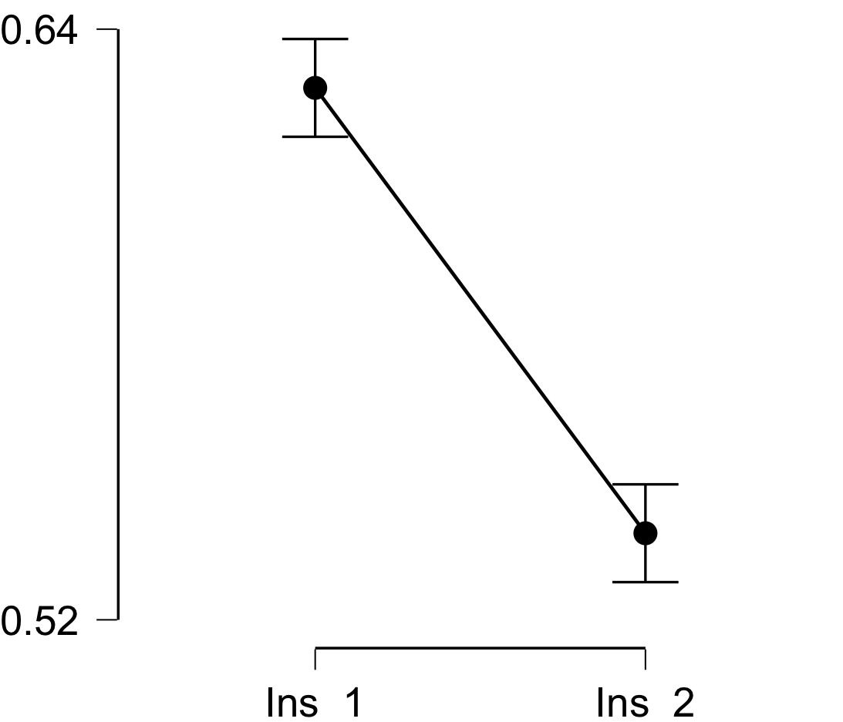

**Bayesian Paired Samples T-Test**

| **Bayesian Paired Samples T-Test** | | | | | | | | | |
| --- | --- | --- | --- | --- | --- | --- | --- | --- | --- |
|  | |  | |  | | **BF₁₀** | | **error %** | |
| Ins_1 |  | - |  | Ins_2 |  | 7.821e +10 |  | 1.745e -15 |  |
|  | | | | | | | | | |

**Inferential Plots**

**Ins_1 - Ins_2**

**Prior and Posterior**

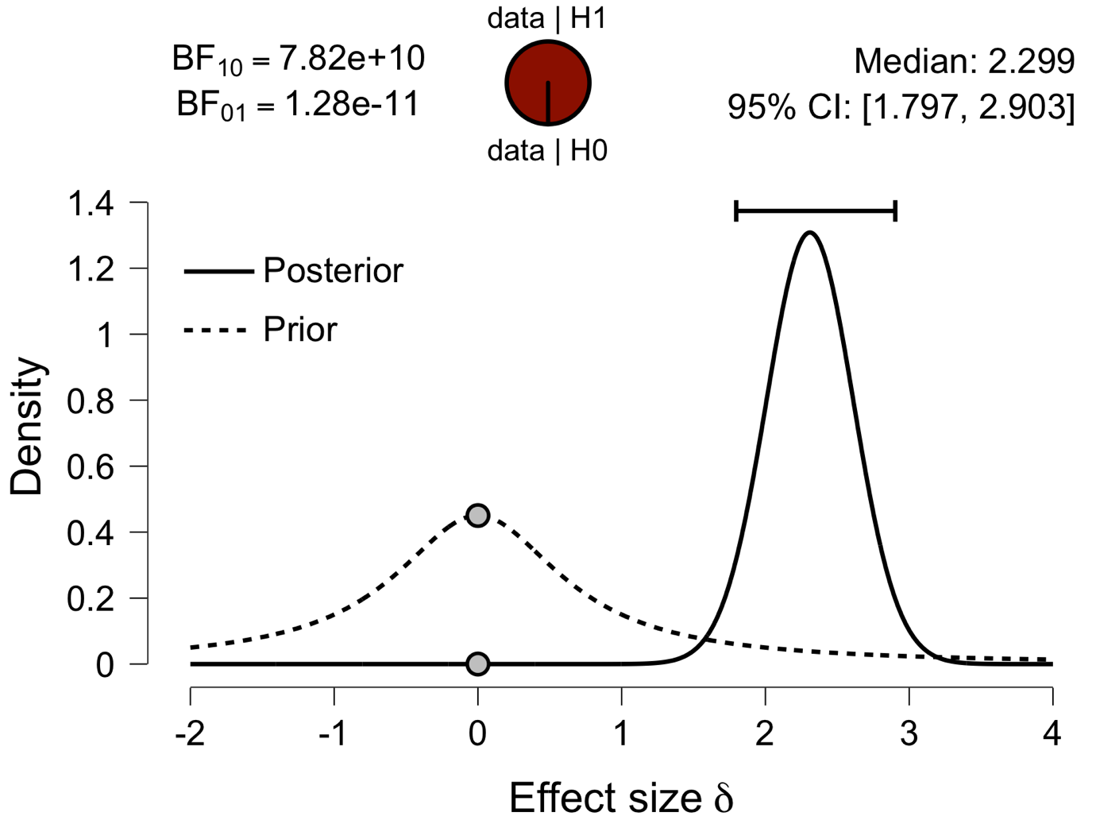

**Paired Samples T-Test**

| **Paired Samples T-Test** | | | | | | | | | | | | | | | | | | | | | | | | | |
| --- | --- | --- | --- | --- | --- | --- | --- | --- | --- | --- | --- | --- | --- | --- | --- | --- | --- | --- | --- | --- | --- | --- | --- | --- | --- |
|  | | | | | | | | | | | | | | | | **95% CI for Mean Difference** | | | |  | | **95% CI for Cohen's d** | | | |
|  | |  | |  | | **t** | | **df** | | **p** | | **Mean Difference** | | **SE Difference** | | **Lower** | | **Upper** | | **Cohen's d** | | **Lower** | | **Upper** | |
| ACC_1 |  | - |  | ACC_2 |  | 11.393 |  | 29 |  | 3.165e -12 |  | 0.086 |  | 0.008 |  | 0.071 |  | 0.102 |  | 2.080 |  | 1.432 |  | 2.716 |  |
|  | | | | | | | | | | | | | | | | | | | | | | | | | |
| *Note.*  Student's t-test. | | | | | | | | | | | | | | | | | | | | | | | | | |

**Assumption Checks**

| **Test of Normality (Shapiro-Wilk)** | | | | | | | | | |
| --- | --- | --- | --- | --- | --- | --- | --- | --- | --- |
|  | |  | |  | | **W** | | **p** | |
| ACC_1 |  | - |  | ACC_2 |  | 0.963 |  | 0.361 |  |
|  | | | | | | | | | |
| *Note.*  Significant results suggest a deviation from normality. | | | | | | | | | |

**Descriptives**

| **Descriptives** | | | | | | | | | |
| --- | --- | --- | --- | --- | --- | --- | --- | --- | --- |
|  | | **N** | | **Mean** | | **SD** | | **SE** | |
| ACC_1 |  | 30 |  | 0.623 |  | 0.034 |  | 0.006 |  |
| ACC_2 |  | 30 |  | 0.536 |  | 0.028 |  | 0.005 |  |
|  | | | | | | | | | |

**Descriptives Plot**

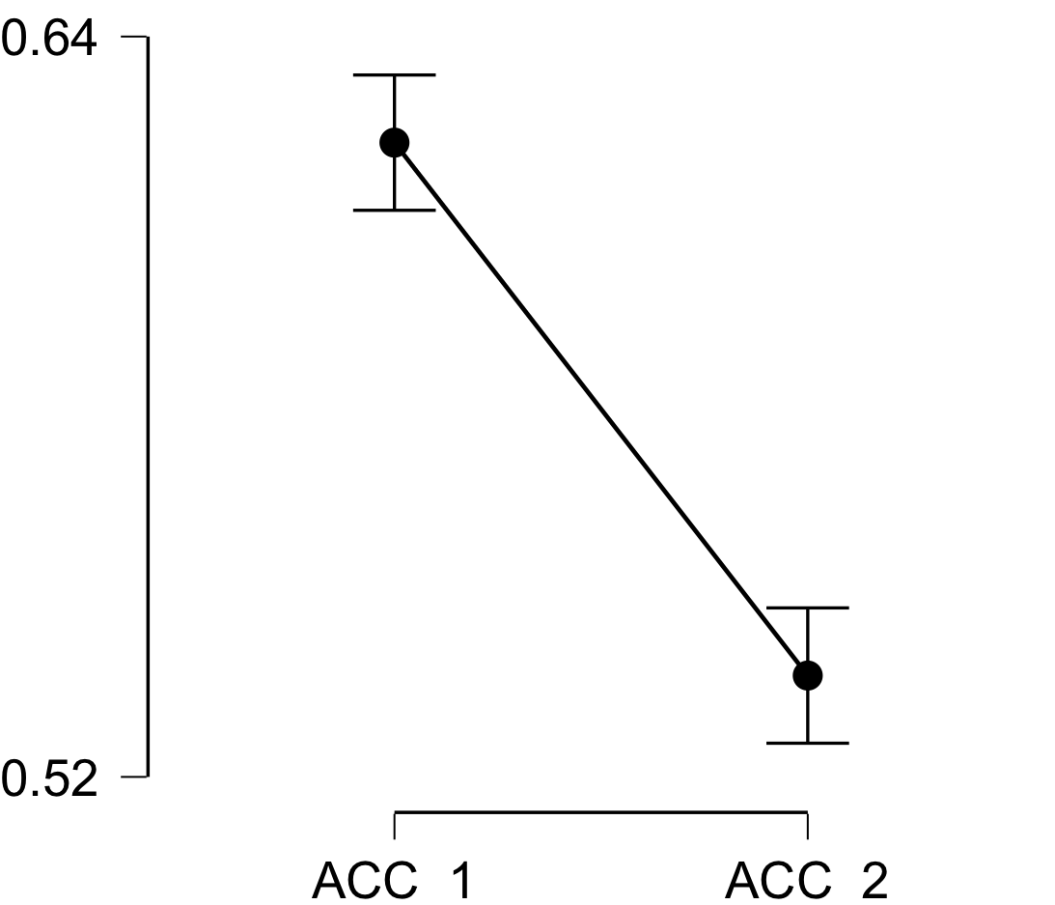

**Bayesian Paired Samples T-Test**

| **Bayesian Paired Samples T-Test** | | | | | | | | | |
| --- | --- | --- | --- | --- | --- | --- | --- | --- | --- |
|  | |  | |  | | **BF₁₀** | | **error %** | |
| ACC_1 |  | - |  | ACC_2 |  | 2.658e +9 |  | 1.362e -13 |  |
|  | | | | | | | | | |

**Inferential Plots**

**ACC_1 - ACC_2**

**Prior and Posterior**

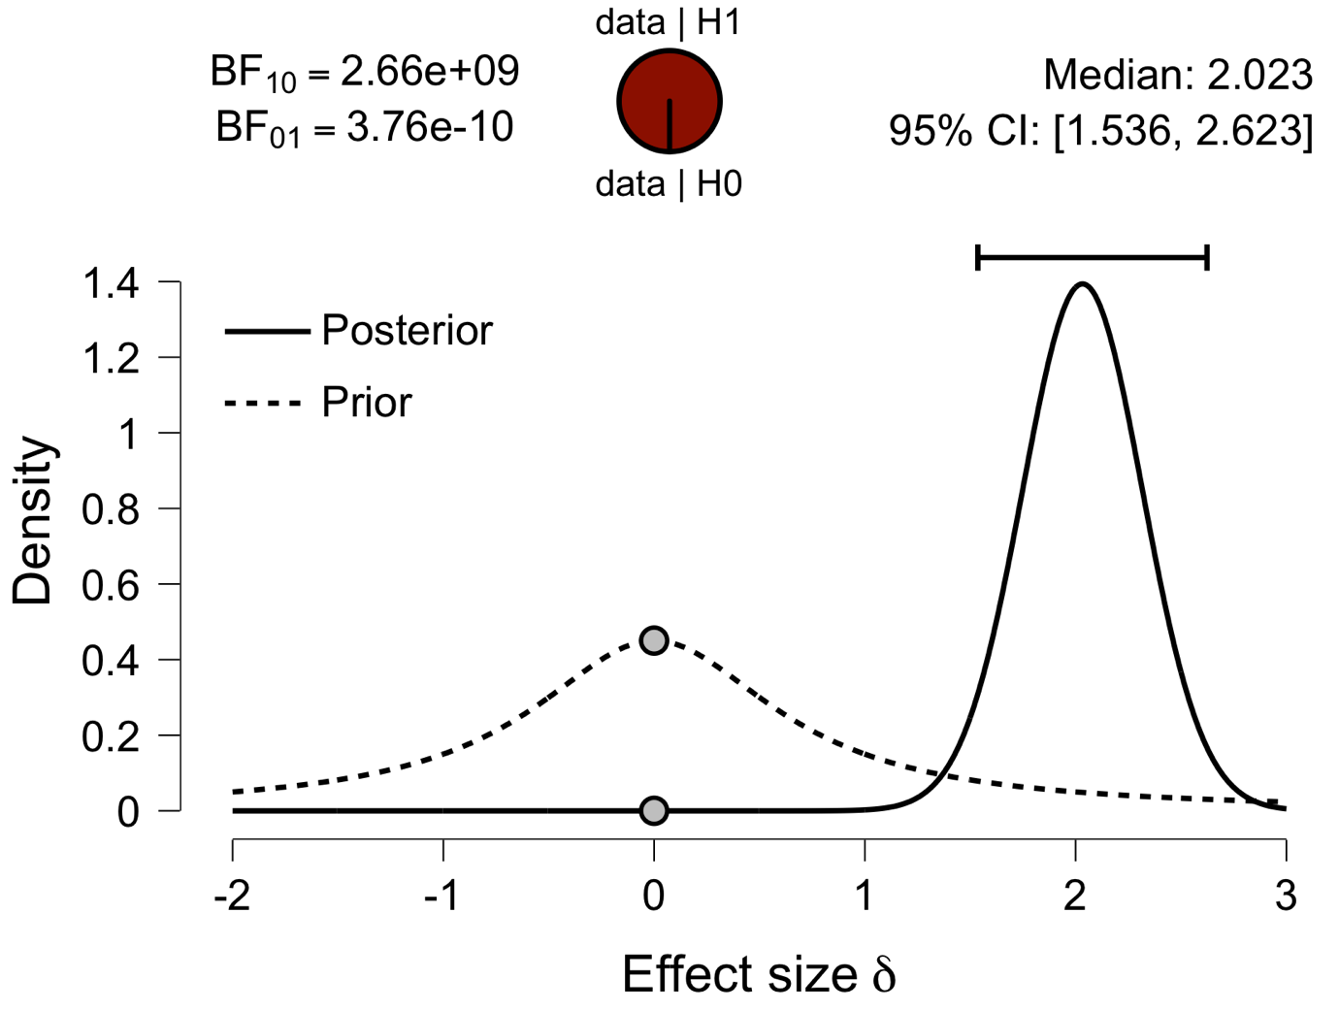

**Paired Samples T-Test**

| **Paired Samples T-Test** | | | | | | | | | | | | | | | | | | | | | | | | | |
| --- | --- | --- | --- | --- | --- | --- | --- | --- | --- | --- | --- | --- | --- | --- | --- | --- | --- | --- | --- | --- | --- | --- | --- | --- | --- |
|  | | | | | | | | | | | | | | | | **95% CI for Mean Difference** | | | |  | | **95% CI for Cohen's d** | | | |
|  | |  | |  | | **t** | | **df** | | **p** | | **Mean Difference** | | **SE Difference** | | **Lower** | | **Upper** | | **Cohen's d** | | **Lower** | | **Upper** | |
| PCC_1 |  | - |  | PCC_2 |  | 11.570 |  | 29 |  | 2.187e -12 |  | 0.085 |  | 0.007 |  | 0.070 |  | 0.100 |  | 2.112 |  | 1.458 |  | 2.755 |  |
|  | | | | | | | | | | | | | | | | | | | | | | | | | |
| *Note.*  Student's t-test. | | | | | | | | | | | | | | | | | | | | | | | | | |

**Assumption Checks**

| **Test of Normality (Shapiro-Wilk)** | | | | | | | | | |
| --- | --- | --- | --- | --- | --- | --- | --- | --- | --- |
|  | |  | |  | | **W** | | **p** | |
| PCC_1 |  | - |  | PCC_2 |  | 0.943 |  | 0.107 |  |
|  | | | | | | | | | |
| *Note.*  Significant results suggest a deviation from normality. | | | | | | | | | |

**Descriptives**

| **Descriptives** | | | | | | | | | |
| --- | --- | --- | --- | --- | --- | --- | --- | --- | --- |
|  | | **N** | | **Mean** | | **SD** | | **SE** | |
| PCC_1 |  | 30 |  | 0.612 |  | 0.027 |  | 0.005 |  |
| PCC_2 |  | 30 |  | 0.527 |  | 0.027 |  | 0.005 |  |
|  | | | | | | | | | |

**Descriptives Plot**

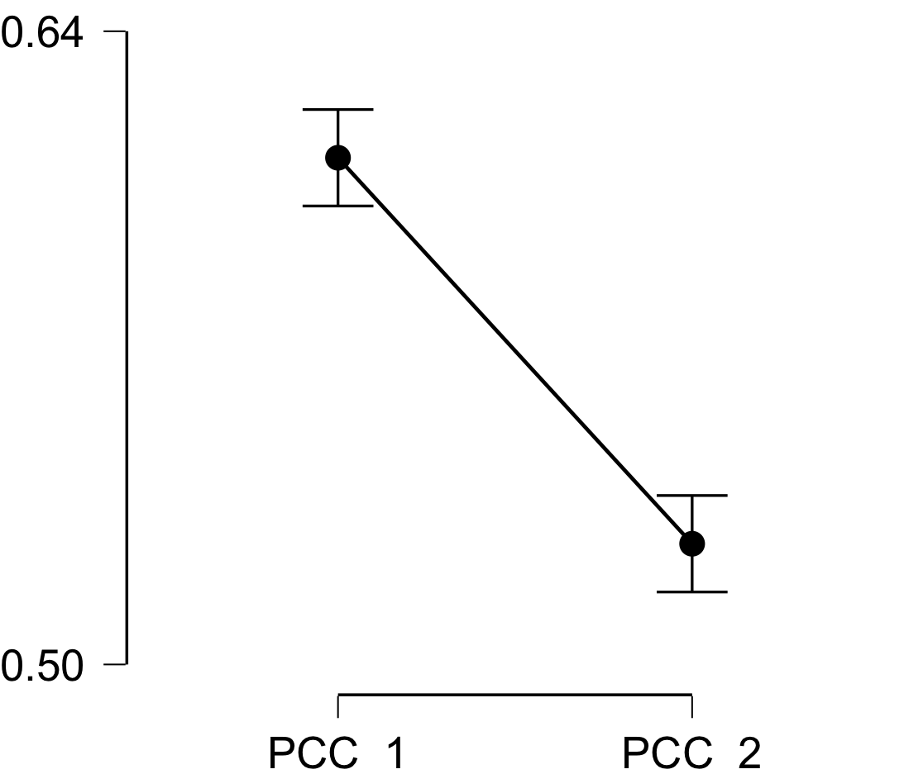

**Bayesian Paired Samples T-Test**

| **Bayesian Paired Samples T-Test** | | | | | | | | | |
| --- | --- | --- | --- | --- | --- | --- | --- | --- | --- |
|  | |  | |  | | **BF₁₀** | | **error %** | |
| PCC_1 |  | - |  | PCC_2 |  | 3.779e +9 |  | 9.061e -14 |  |
|  | | | | | | | | | |

**Inferential Plots**

**PCC_1 - PCC_2**

**Prior and Posterior**

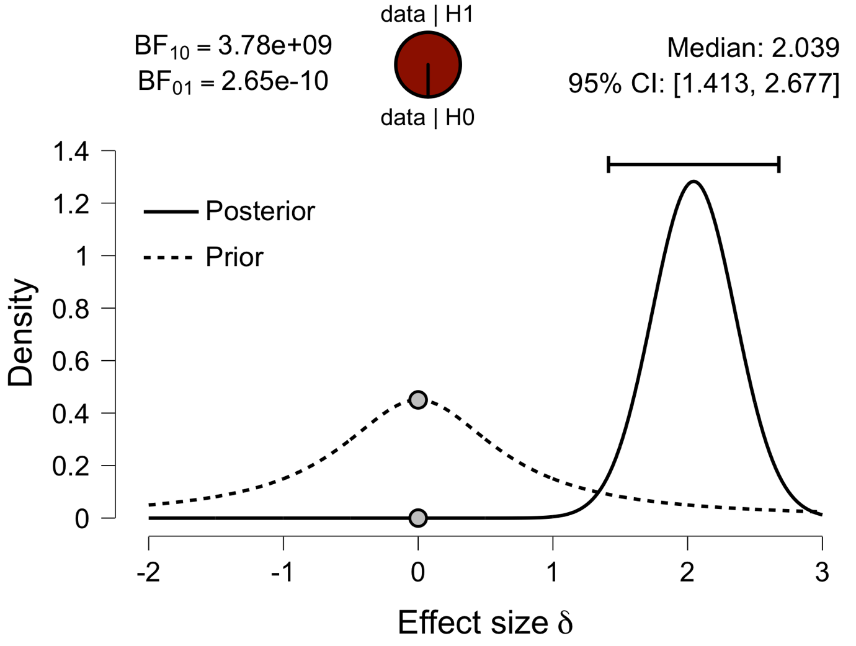

**Paired Samples T-Test**

| **Paired Samples T-Test** | | | | | | | | | | | | | | | | | | | | | | | | | |
| --- | --- | --- | --- | --- | --- | --- | --- | --- | --- | --- | --- | --- | --- | --- | --- | --- | --- | --- | --- | --- | --- | --- | --- | --- | --- |
|  | | | | | | | | | | | | | | | | **95% CI for Mean Difference** | | | |  | | **95% CI for Cohen's d** | | | |
|  | |  | |  | | **t** | | **df** | | **p** | | **Mean Difference** | | **SE Difference** | | **Lower** | | **Upper** | | **Cohen's d** | | **Lower** | | **Upper** | |
| V1_1 |  | - |  | V1_2 |  | 12.301 |  | 29 |  | 4.955e -13 |  | 0.068 |  | 0.006 |  | 0.057 |  | 0.080 |  | 2.246 |  | 1.563 |  | 2.917 |  |
|  | | | | | | | | | | | | | | | | | | | | | | | | | |
| *Note.*  Student's t-test. | | | | | | | | | | | | | | | | | | | | | | | | | |

**Assumption Checks**

| **Test of Normality (Shapiro-Wilk)** | | | | | | | | | |
| --- | --- | --- | --- | --- | --- | --- | --- | --- | --- |
|  | |  | |  | | **W** | | **p** | |
| V1_1 |  | - |  | V1_2 |  | 0.980 |  | 0.823 |  |
|  | | | | | | | | | |
| *Note.*  Significant results suggest a deviation from normality. | | | | | | | | | |

**Descriptives**

| **Descriptives** | | | | | | | | | |
| --- | --- | --- | --- | --- | --- | --- | --- | --- | --- |
|  | | **N** | | **Mean** | | **SD** | | **SE** | |
| V1_1 |  | 30 |  | 0.598 |  | 0.024 |  | 0.004 |  |
| V1_2 |  | 30 |  | 0.530 |  | 0.030 |  | 0.006 |  |
|  | | | | | | | | | |

**Descriptives Plot**

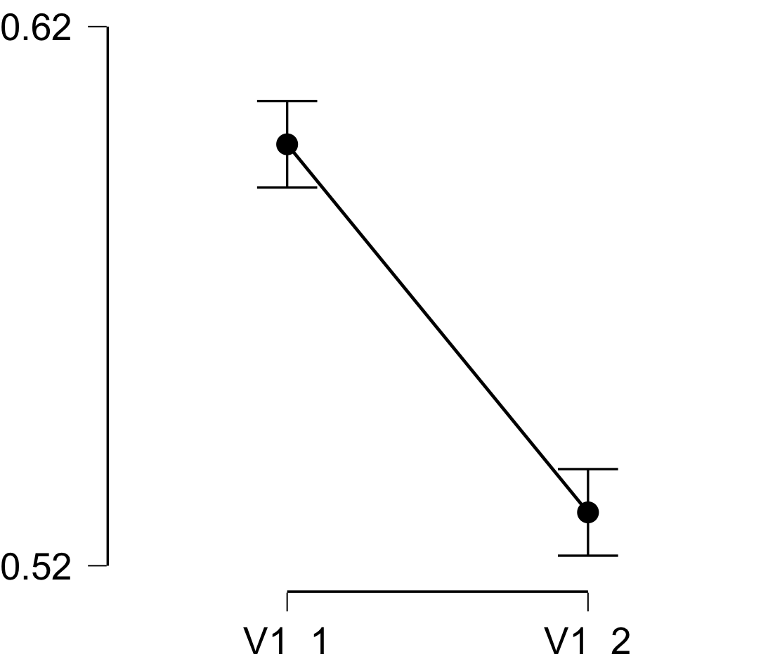

**Bayesian Paired Samples T-Test**

| **Bayesian Paired Samples T-Test** | | | | | | | | | |
| --- | --- | --- | --- | --- | --- | --- | --- | --- | --- |
|  | |  | |  | | **BF₁₀** | | **error %** | |
| V1_1 |  | - |  | V1_2 |  | 1.555e +10 |  | 1.631e -14 |  |
|  | | | | | | | | | |

**Inferential Plots**

**V1_1 - V1_2**

**Prior and Posterior**

