**Results**

**Paired Samples T-Test**

| **Paired Samples T-Test** | | | | | | | | | | | | | | | | | | | | | | | | | |
| --- | --- | --- | --- | --- | --- | --- | --- | --- | --- | --- | --- | --- | --- | --- | --- | --- | --- | --- | --- | --- | --- | --- | --- | --- | --- |
|  | | | | | | | | | | | | | | | | **95% CI for Mean Difference** | | | |  | | **95% CI for Cohen's d** | | | |
|  | |  | |  | | **t** | | **df** | | **p** | | **Mean Difference** | | **SE Difference** | | **Lower** | | **Upper** | | **Cohen's d** | | **Lower** | | **Upper** | |
| LTL |  | - |  | LTL_2 |  | 6.185 |  | 29 |  | 9.602e -7 |  | 0.063 |  | 0.010 |  | 0.042 |  | 0.084 |  | 1.129 |  | 0.663 |  | 1.583 |  |
|  | | | | | | | | | | | | | | | | | | | | | | | | | |
| *Note.*  Student's t-test. | | | | | | | | | | | | | | | | | | | | | | | | | |

**Assumption Checks**

| **Test of Normality (Shapiro-Wilk)** | | | | | | | | | |
| --- | --- | --- | --- | --- | --- | --- | --- | --- | --- |
|  | |  | |  | | **W** | | **p** | |
| LTL |  | - |  | LTL_2 |  | 0.934 |  | 0.064 |  |
|  | | | | | | | | | |
| *Note.*  Significant results suggest a deviation from normality. | | | | | | | | | |

**Descriptives**

| **Descriptives** | | | | | | | | | |
| --- | --- | --- | --- | --- | --- | --- | --- | --- | --- |
|  | | **N** | | **Mean** | | **SD** | | **SE** | |
| LTL |  | 30 |  | 0.606 |  | 0.057 |  | 0.010 |  |
| LTL_2 |  | 30 |  | 0.543 |  | 0.030 |  | 0.006 |  |
|  | | | | | | | | | |

**Descriptives Plot**

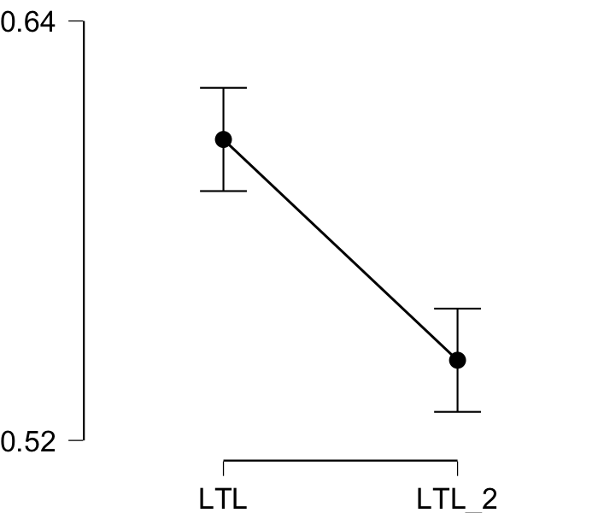

**Bayesian Paired Samples T-Test**

| **Bayesian Paired Samples T-Test** | | | | | | | | | |
| --- | --- | --- | --- | --- | --- | --- | --- | --- | --- |
|  | |  | |  | | **BF₁₀** | | **error %** | |
| LTL |  | - |  | LTL_2 |  | 18315.401 |  | 2.322e -7 |  |
|  | | | | | | | | | |

**Inferential Plots**

**LTL - LTL_2**

**Prior and Posterior**

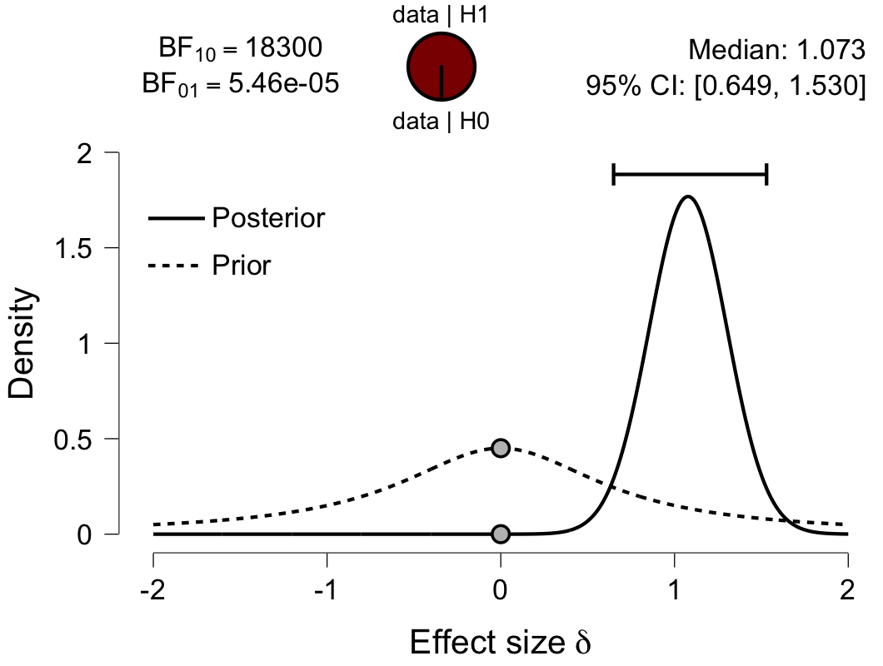

**Paired Samples T-Test**

| **Paired Samples T-Test** | | | | | | | | | | | | | | | | | | | | | | | | | |
| --- | --- | --- | --- | --- | --- | --- | --- | --- | --- | --- | --- | --- | --- | --- | --- | --- | --- | --- | --- | --- | --- | --- | --- | --- | --- |
|  | | | | | | | | | | | | | | | | **95% CI for Mean Difference** | | | |  | | **95% CI for Cohen's d** | | | |
|  | |  | |  | | **t** | | **df** | | **p** | | **Mean Difference** | | **SE Difference** | | **Lower** | | **Upper** | | **Cohen's d** | | **Lower** | | **Upper** | |
| IFG |  | - |  | IFG_2 |  | 4.383 |  | 29 |  | 1.401e -4 |  | 0.043 |  | 0.010 |  | 0.023 |  | 0.063 |  | 0.800 |  | 0.383 |  | 1.207 |  |
|  | | | | | | | | | | | | | | | | | | | | | | | | | |
| *Note.*  Student's t-test. | | | | | | | | | | | | | | | | | | | | | | | | | |

**Assumption Checks**

| **Test of Normality (Shapiro-Wilk)** | | | | | | | | | |
| --- | --- | --- | --- | --- | --- | --- | --- | --- | --- |
|  | |  | |  | | **W** | | **p** | |
| IFG |  | - |  | IFG_2 |  | 0.987 |  | 0.966 |  |
|  | | | | | | | | | |
| *Note.*  Significant results suggest a deviation from normality. | | | | | | | | | |

**Descriptives**

| **Descriptives** | | | | | | | | | |
| --- | --- | --- | --- | --- | --- | --- | --- | --- | --- |
|  | | **N** | | **Mean** | | **SD** | | **SE** | |
| IFG |  | 30 |  | 0.577 |  | 0.050 |  | 0.009 |  |
| IFG_2 |  | 30 |  | 0.534 |  | 0.032 |  | 0.006 |  |
|  | | | | | | | | | |

**Descriptives Plot**

**Bayesian Paired Samples T-Test**

| **Bayesian Paired Samples T-Test** | | | | | | | | | |
| --- | --- | --- | --- | --- | --- | --- | --- | --- | --- |
|  | |  | |  | | **BF₁₀** | | **error %** | |
| IFG |  | - |  | IFG_2 |  | 191.473 |  | 7.921e -6 |  |
|  | | | | | | | | | |

**Inferential Plots**

**IFG - IFG_2**

**Prior and Posterior**

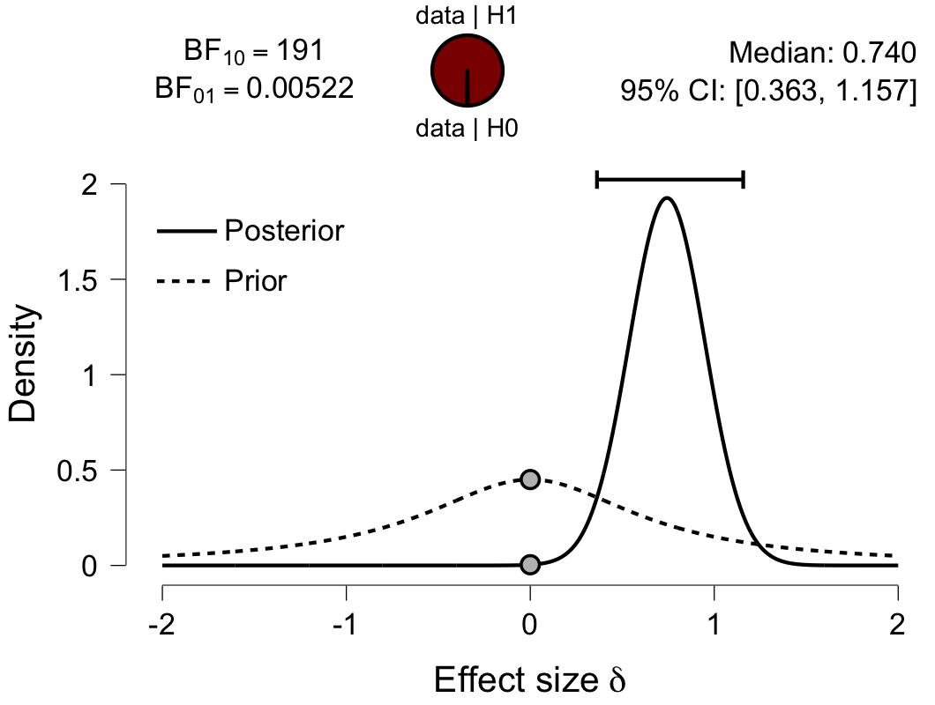

**Paired Samples T-Test**

| **Paired Samples T-Test** | | | | | | | | | | | | | | | | | | | | | | | | | |
| --- | --- | --- | --- | --- | --- | --- | --- | --- | --- | --- | --- | --- | --- | --- | --- | --- | --- | --- | --- | --- | --- | --- | --- | --- | --- |
|  | | | | | | | | | | | | | | | | **95% CI for Mean Difference** | | | |  | | **95% CI for Cohen's d** | | | |
|  | |  | |  | | **t** | | **df** | | **p** | | **Mean Difference** | | **SE Difference** | | **Lower** | | **Upper** | | **Cohen's d** | | **Lower** | | **Upper** | |
| Prec |  | - |  | Prec_2 |  | 5.749 |  | 29 |  | 3.176e -6 |  | 0.053 |  | 0.009 |  | 0.034 |  | 0.072 |  | 1.050 |  | 0.596 |  | 1.491 |  |
|  | | | | | | | | | | | | | | | | | | | | | | | | | |
| *Note.*  Student's t-test. | | | | | | | | | | | | | | | | | | | | | | | | | |

**Assumption Checks**

| **Test of Normality (Shapiro-Wilk)** | | | | | | | | | |
| --- | --- | --- | --- | --- | --- | --- | --- | --- | --- |
|  | |  | |  | | **W** | | **p** | |
| Prec |  | - |  | Prec_2 |  | 0.984 |  | 0.910 |  |
|  | | | | | | | | | |
| *Note.*  Significant results suggest a deviation from normality. | | | | | | | | | |

**Descriptives**

| **Descriptives** | | | | | | | | | |
| --- | --- | --- | --- | --- | --- | --- | --- | --- | --- |
|  | | **N** | | **Mean** | | **SD** | | **SE** | |
| Prec |  | 30 |  | 0.591 |  | 0.047 |  | 0.009 |  |
| Prec_2 |  | 30 |  | 0.538 |  | 0.030 |  | 0.006 |  |
|  | | | | | | | | | |

**Descriptives Plot**

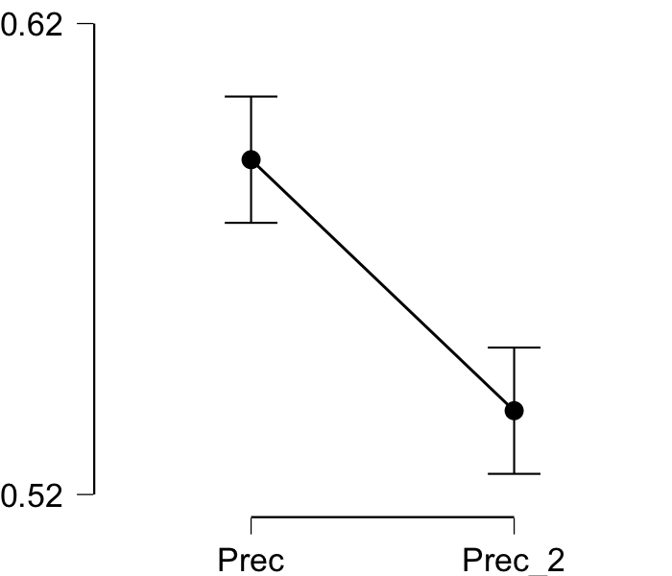

**Bayesian Paired Samples T-Test**

| **Bayesian Paired Samples T-Test** | | | | | | | | | |
| --- | --- | --- | --- | --- | --- | --- | --- | --- | --- |
|  | |  | |  | | **BF₁₀** | | **error %** | |
| Prec |  | - |  | Prec_2 |  | 6061.841 |  | 6.539e -7 |  |
|  | | | | | | | | | |

**Inferential Plots**

**Prec - Prec_2**

**Prior and Posterior**

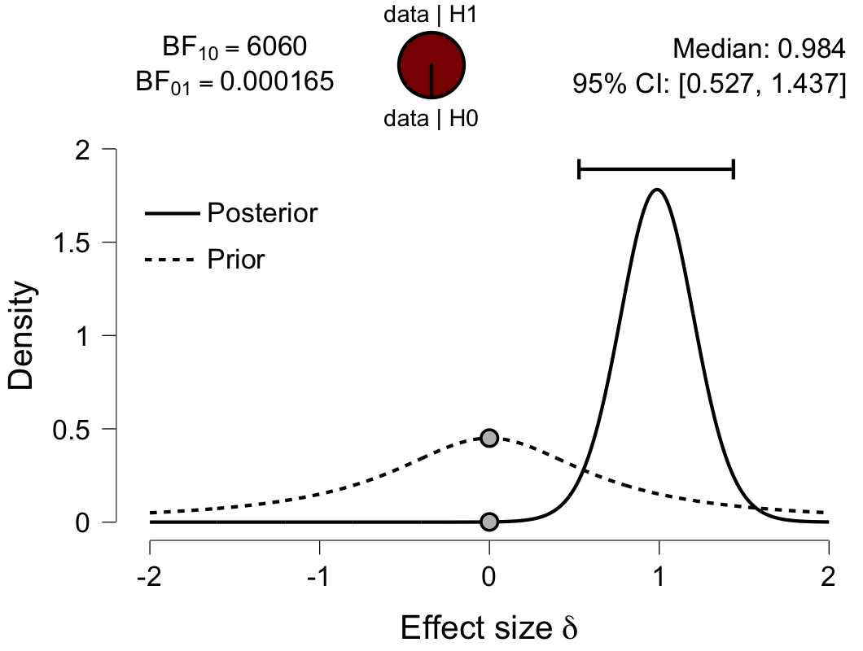

**Paired Samples T-Test**

| **Paired Samples T-Test** | | | | | | | | | | | | | | | | | | | | | | | | | |
| --- | --- | --- | --- | --- | --- | --- | --- | --- | --- | --- | --- | --- | --- | --- | --- | --- | --- | --- | --- | --- | --- | --- | --- | --- | --- |
|  | | | | | | | | | | | | | | | | **95% CI for Mean Difference** | | | |  | | **95% CI for Cohen's d** | | | |
|  | |  | |  | | **t** | | **df** | | **p** | | **Mean Difference** | | **SE Difference** | | **Lower** | | **Upper** | | **Cohen's d** | | **Lower** | | **Upper** | |
| ATL |  | - |  | ATL_2 |  | 2.272 |  | 29 |  | 0.031 |  | 0.019 |  | 0.009 |  | 0.002 |  | 0.037 |  | 0.415 |  | 0.038 |  | 0.785 |  |
|  | | | | | | | | | | | | | | | | | | | | | | | | | |
| *Note.*  Student's t-test. | | | | | | | | | | | | | | | | | | | | | | | | | |

**Assumption Checks**

| **Test of Normality (Shapiro-Wilk)** | | | | | | | | | |
| --- | --- | --- | --- | --- | --- | --- | --- | --- | --- |
|  | |  | |  | | **W** | | **p** | |
| ATL |  | - |  | ATL_2 |  | 0.968 |  | 0.488 |  |
|  | | | | | | | | | |
| *Note.*  Significant results suggest a deviation from normality. | | | | | | | | | |

**Descriptives**

| **Descriptives** | | | | | | | | | |
| --- | --- | --- | --- | --- | --- | --- | --- | --- | --- |
|  | | **N** | | **Mean** | | **SD** | | **SE** | |
| ATL |  | 30 |  | 0.551 |  | 0.045 |  | 0.008 |  |
| ATL_2 |  | 30 |  | 0.531 |  | 0.030 |  | 0.005 |  |
|  | | | | | | | | | |

**Descriptives Plot**

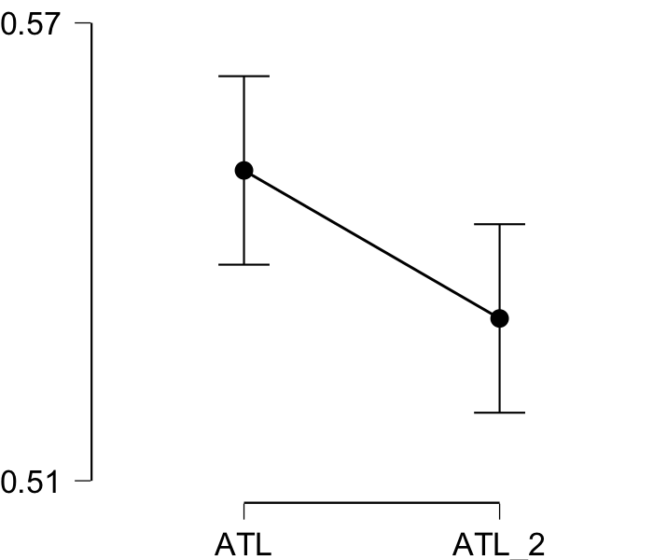

**Bayesian Paired Samples T-Test**

| **Bayesian Paired Samples T-Test** | | | | | | | | | |
| --- | --- | --- | --- | --- | --- | --- | --- | --- | --- |
|  | |  | |  | | **BF₁₀** | | **error %** | |
| ATL |  | - |  | ATL_2 |  | 1.771 |  | 4.117e -6 |  |
|  | | | | | | | | | |

**Inferential Plots**

**ATL - ATL_2**

**Prior and Posterior**

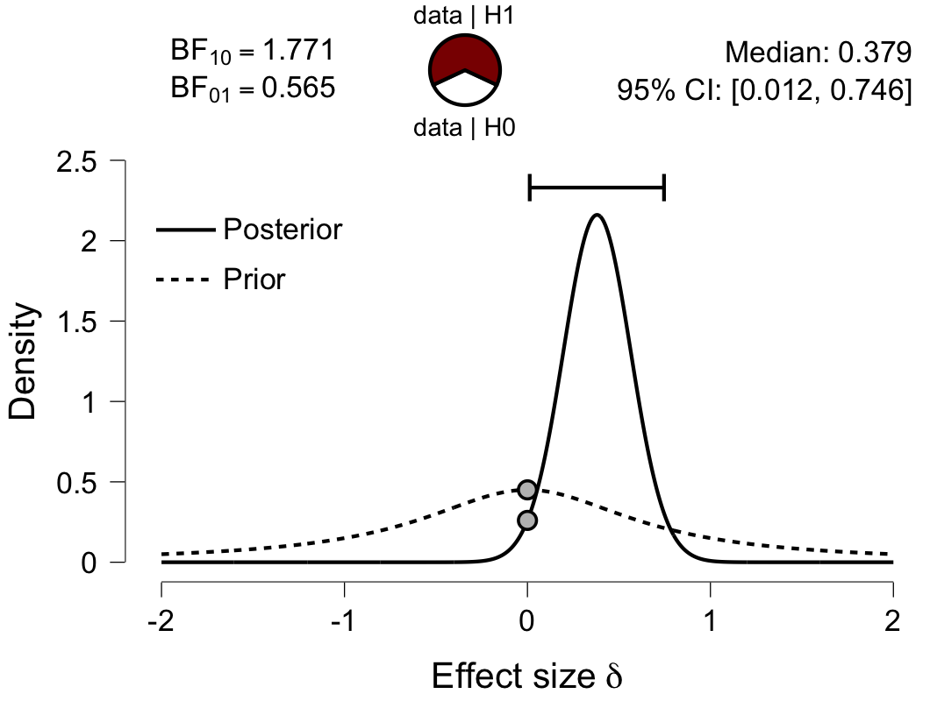

**Paired Samples T-Test**

| **Paired Samples T-Test** | | | | | | | | | | | | | | | | | | | | | | | | | |
| --- | --- | --- | --- | --- | --- | --- | --- | --- | --- | --- | --- | --- | --- | --- | --- | --- | --- | --- | --- | --- | --- | --- | --- | --- | --- |
|  | | | | | | | | | | | | | | | | **95% CI for Mean Difference** | | | |  | | **95% CI for Cohen's d** | | | |
|  | |  | |  | | **t** | | **df** | | **p** | | **Mean Difference** | | **SE Difference** | | **Lower** | | **Upper** | | **Cohen's d** | | **Lower** | | **Upper** | |
| aPFC |  | - |  | aPFC_2 |  | 3.256 |  | 29 |  | 0.003 |  | 0.037 |  | 0.011 |  | 0.014 |  | 0.060 |  | 0.594 |  | 0.201 |  | 0.979 |  |
|  | | | | | | | | | | | | | | | | | | | | | | | | | |
| *Note.*  Student's t-test. | | | | | | | | | | | | | | | | | | | | | | | | | |

**Assumption Checks**

| **Test of Normality (Shapiro-Wilk)** | | | | | | | | | |
| --- | --- | --- | --- | --- | --- | --- | --- | --- | --- |
|  | |  | |  | | **W** | | **p** | |
| aPFC |  | - |  | aPFC_2 |  | 0.966 |  | 0.425 |  |
|  | | | | | | | | | |
| *Note.*  Significant results suggest a deviation from normality. | | | | | | | | | |

**Descriptives**

| **Descriptives** | | | | | | | | | |
| --- | --- | --- | --- | --- | --- | --- | --- | --- | --- |
|  | | **N** | | **Mean** | | **SD** | | **SE** | |
| aPFC |  | 30 |  | 0.577 |  | 0.058 |  | 0.011 |  |
| aPFC_2 |  | 30 |  | 0.540 |  | 0.031 |  | 0.006 |  |
|  | | | | | | | | | |

**Descriptives Plot**

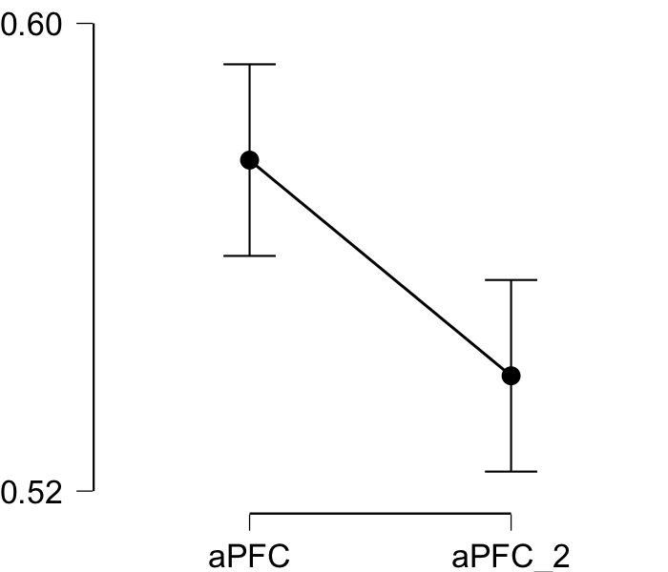

**Bayesian Paired Samples T-Test**

| **Bayesian Paired Samples T-Test** | | | | | | | | | |
| --- | --- | --- | --- | --- | --- | --- | --- | --- | --- |
|  | |  | |  | | **BF₁₀** | | **error %** | |
| aPFC |  | - |  | aPFC_2 |  | 13.135 |  | 2.033e -6 |  |
|  | | | | | | | | | |

**Inferential Plots**

**aPFC - aPFC_2**

**Prior and Posterior**

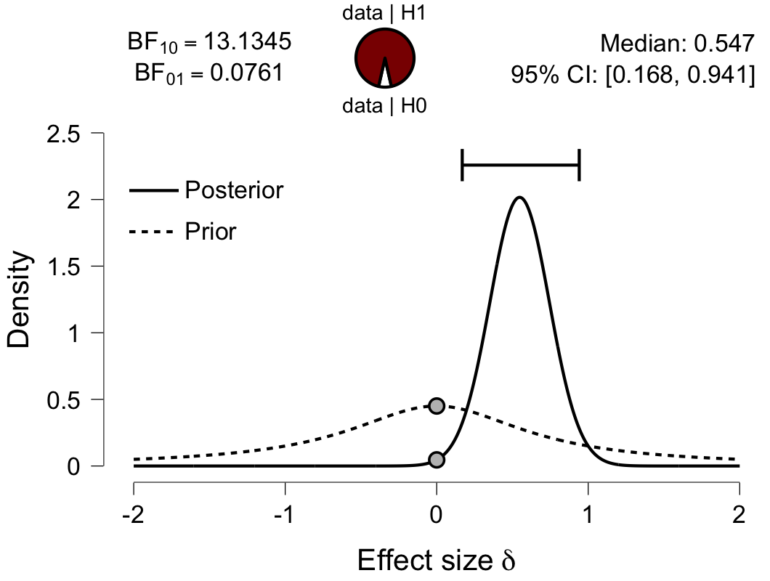

**Paired Samples T-Test**

| **Paired Samples T-Test** | | | | | | | | | | | | | | | | | | | | | | | | | |
| --- | --- | --- | --- | --- | --- | --- | --- | --- | --- | --- | --- | --- | --- | --- | --- | --- | --- | --- | --- | --- | --- | --- | --- | --- | --- |
|  | | | | | | | | | | | | | | | | **95% CI for Mean Difference** | | | |  | | **95% CI for Cohen's d** | | | |
|  | |  | |  | | **t** | | **df** | | **p** | | **Mean Difference** | | **SE Difference** | | **Lower** | | **Upper** | | **Cohen's d** | | **Lower** | | **Upper** | |
| Ins |  | - |  | Ins_2 |  | 2.149 |  | 29 |  | 0.040 |  | 0.016 |  | 0.007 |  | 7.614e -4 |  | 0.031 |  | 0.392 |  | 0.018 |  | 0.761 |  |
|  | | | | | | | | | | | | | | | | | | | | | | | | | |
| *Note.*  Student's t-test. | | | | | | | | | | | | | | | | | | | | | | | | | |

**Assumption Checks**

| **Test of Normality (Shapiro-Wilk)** | | | | | | | | | |
| --- | --- | --- | --- | --- | --- | --- | --- | --- | --- |
|  | |  | |  | | **W** | | **p** | |
| Ins |  | - |  | Ins_2 |  | 0.985 |  | 0.937 |  |
|  | | | | | | | | | |
| *Note.*  Significant results suggest a deviation from normality. | | | | | | | | | |

**Descriptives**

| **Descriptives** | | | | | | | | | |
| --- | --- | --- | --- | --- | --- | --- | --- | --- | --- |
|  | | **N** | | **Mean** | | **SD** | | **SE** | |
| Ins |  | 30 |  | 0.559 |  | 0.032 |  | 0.006 |  |
| Ins_2 |  | 30 |  | 0.543 |  | 0.028 |  | 0.005 |  |
|  | | | | | | | | | |

**Descriptives Plot**

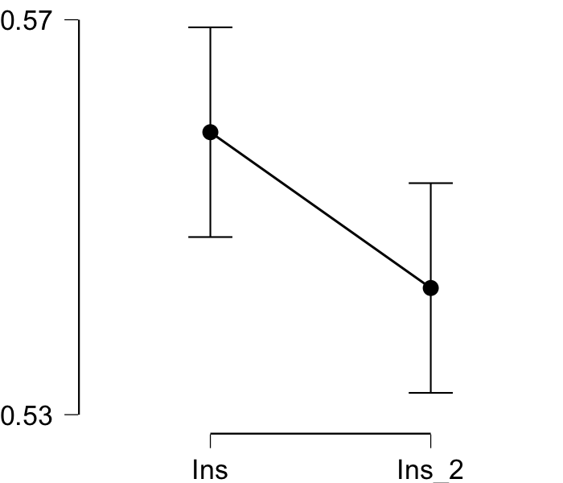

**Bayesian Paired Samples T-Test**

| **Bayesian Paired Samples T-Test** | | | | | | | | | |
| --- | --- | --- | --- | --- | --- | --- | --- | --- | --- |
|  | |  | |  | | **BF₁₀** | | **error %** | |
| Ins |  | - |  | Ins_2 |  | 1.427 |  | 4.511e -6 |  |
|  | | | | | | | | | |

**Inferential Plots**

**Ins - Ins_2**

**Prior and Posterior**

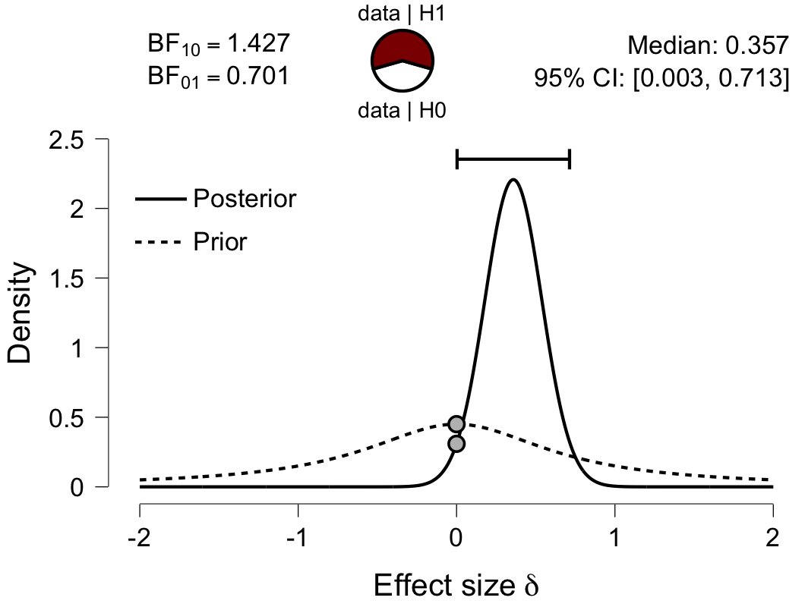

**Paired Samples T-Test**

| **Paired Samples T-Test** | | | | | | | | | | | | | | | | | | | | | | | | | |
| --- | --- | --- | --- | --- | --- | --- | --- | --- | --- | --- | --- | --- | --- | --- | --- | --- | --- | --- | --- | --- | --- | --- | --- | --- | --- |
|  | | | | | | | | | | | | | | | | **95% CI for Mean Difference** | | | |  | | **95% CI for Cohen's d** | | | |
|  | |  | |  | | **t** | | **df** | | **p** | | **Mean Difference** | | **SE Difference** | | **Lower** | | **Upper** | | **Cohen's d** | | **Lower** | | **Upper** | |
| ACC |  | - |  | ACC_2 |  | 5.343 |  | 29 |  | 9.784e -6 |  | 0.066 |  | 0.012 |  | 0.041 |  | 0.091 |  | 0.975 |  | 0.533 |  | 1.406 |  |
|  | | | | | | | | | | | | | | | | | | | | | | | | | |
| *Note.*  Student's t-test. | | | | | | | | | | | | | | | | | | | | | | | | | |

**Assumption Checks**

| **Test of Normality (Shapiro-Wilk)** | | | | | | | | | |
| --- | --- | --- | --- | --- | --- | --- | --- | --- | --- |
|  | |  | |  | | **W** | | **p** | |
| ACC |  | - |  | ACC_2 |  | 0.951 |  | 0.183 |  |
|  | | | | | | | | | |
| *Note.*  Significant results suggest a deviation from normality. | | | | | | | | | |

**Descriptives**

| **Descriptives** | | | | | | | | | |
| --- | --- | --- | --- | --- | --- | --- | --- | --- | --- |
|  | | **N** | | **Mean** | | **SD** | | **SE** | |
| ACC |  | 30 |  | 0.603 |  | 0.061 |  | 0.011 |  |
| ACC_2 |  | 30 |  | 0.537 |  | 0.028 |  | 0.005 |  |
|  | | | | | | | | | |

**Descriptives Plot**

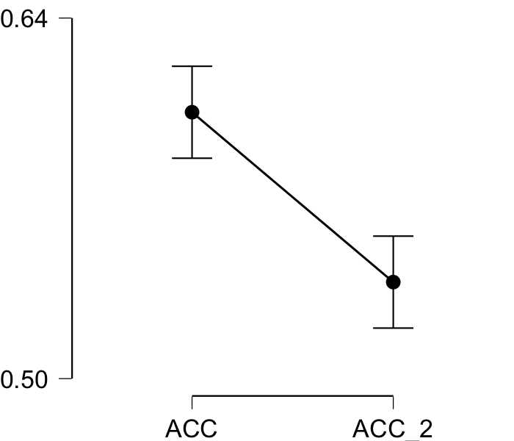

**Bayesian Paired Samples T-Test**

| **Bayesian Paired Samples T-Test** | | | | | | | | | |
| --- | --- | --- | --- | --- | --- | --- | --- | --- | --- |
|  | |  | |  | | **BF₁₀** | | **error %** | |
| ACC |  | - |  | ACC_2 |  | 2154.421 |  | 1.130e -6 |  |
|  | | | | | | | | | |

**Inferential Plots**

**ACC - ACC_2**

**Prior and Posterior**

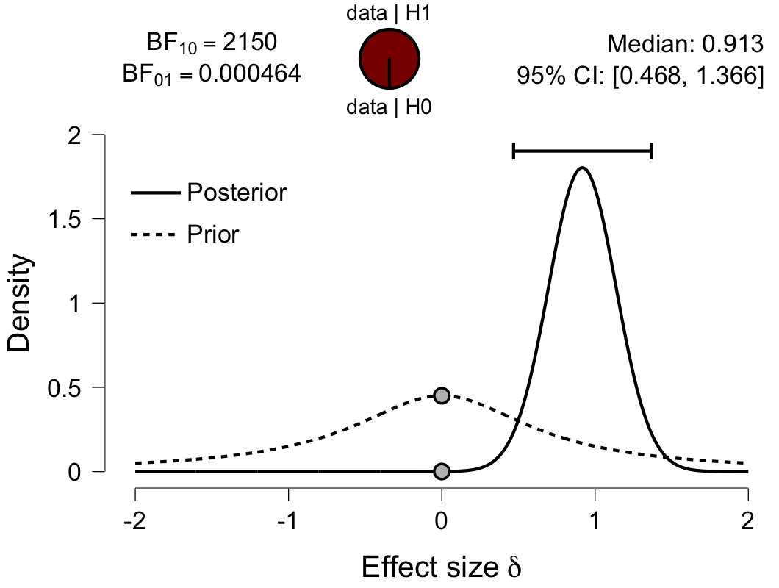

**Paired Samples T-Test**

| **Paired Samples T-Test** | | | | | | | | | | | | | | | | | | | | | | | | | |
| --- | --- | --- | --- | --- | --- | --- | --- | --- | --- | --- | --- | --- | --- | --- | --- | --- | --- | --- | --- | --- | --- | --- | --- | --- | --- |
|  | | | | | | | | | | | | | | | | **95% CI for Mean Difference** | | | |  | | **95% CI for Cohen's d** | | | |
|  | |  | |  | | **t** | | **df** | | **p** | | **Mean Difference** | | **SE Difference** | | **Lower** | | **Upper** | | **Cohen's d** | | **Lower** | | **Upper** | |
| PCC |  | - |  | PCC_2 |  | 4.762 |  | 29 |  | 4.918e -5 |  | 0.034 |  | 0.007 |  | 0.019 |  | 0.048 |  | 0.869 |  | 0.442 |  | 1.285 |  |
|  | | | | | | | | | | | | | | | | | | | | | | | | | |
| *Note.*  Student's t-test. | | | | | | | | | | | | | | | | | | | | | | | | | |

**Assumption Checks**

| **Test of Normality (Shapiro-Wilk)** | | | | | | | | | |
| --- | --- | --- | --- | --- | --- | --- | --- | --- | --- |
|  | |  | |  | | **W** | | **p** | |
| PCC |  | - |  | PCC_2 |  | 0.949 |  | 0.162 |  |
|  | | | | | | | | | |
| *Note.*  Significant results suggest a deviation from normality. | | | | | | | | | |

**Descriptives**

| **Descriptives** | | | | | | | | | |
| --- | --- | --- | --- | --- | --- | --- | --- | --- | --- |
|  | | **N** | | **Mean** | | **SD** | | **SE** | |
| PCC |  | 30 |  | 0.561 |  | 0.036 |  | 0.007 |  |
| PCC_2 |  | 30 |  | 0.527 |  | 0.027 |  | 0.005 |  |
|  | | | | | | | | | |

**Descriptives Plot**

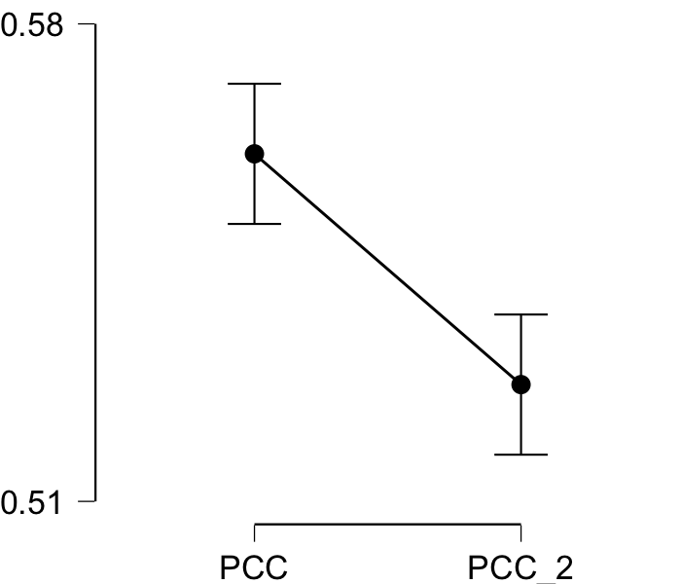

**Bayesian Paired Samples T-Test**

| **Bayesian Paired Samples T-Test** | | | | | | | | | |
| --- | --- | --- | --- | --- | --- | --- | --- | --- | --- |
|  | |  | |  | | **BF₁₀** | | **error %** | |
| PCC |  | - |  | PCC_2 |  | 493.533 |  | 7.100e -7 |  |
|  | | | | | | | | | |

**Inferential Plots**

**PCC - PCC_2**

**Prior and Posterior**

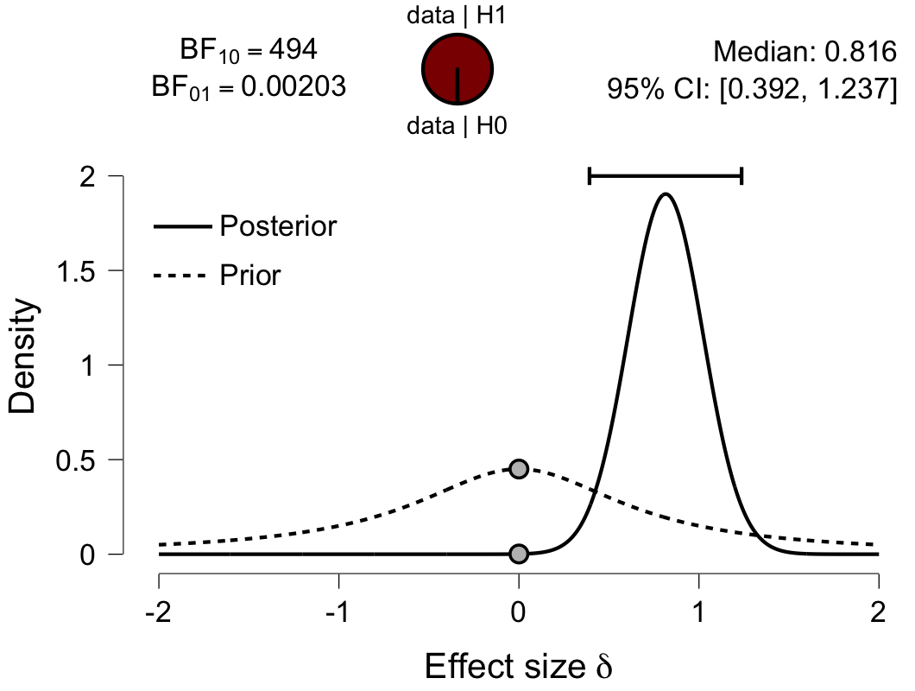

**Paired Samples T-Test**

| **Paired Samples T-Test** | | | | | | | | | | | | | | | | | | | | | | | | | |
| --- | --- | --- | --- | --- | --- | --- | --- | --- | --- | --- | --- | --- | --- | --- | --- | --- | --- | --- | --- | --- | --- | --- | --- | --- | --- |
|  | | | | | | | | | | | | | | | | **95% CI for Mean Difference** | | | |  | | **95% CI for Cohen's d** | | | |
|  | |  | |  | | **t** | | **df** | | **p** | | **Mean Difference** | | **SE Difference** | | **Lower** | | **Upper** | | **Cohen's d** | | **Lower** | | **Upper** | |
| V1 |  | - |  | V1_2 |  | -0.949 |  | 29 |  | 0.351 |  | -0.007 |  | 0.007 |  | -0.022 |  | 0.008 |  | -0.173 |  | -0.532 |  | 0.189 |  |
|  | | | | | | | | | | | | | | | | | | | | | | | | | |
| *Note.*  Student's t-test. | | | | | | | | | | | | | | | | | | | | | | | | | |

**Assumption Checks**

| **Test of Normality (Shapiro-Wilk)** | | | | | | | | | |
| --- | --- | --- | --- | --- | --- | --- | --- | --- | --- |
|  | |  | |  | | **W** | | **p** | |
| V1 |  | - |  | V1_2 |  | 0.975 |  | 0.695 |  |
|  | | | | | | | | | |
| *Note.*  Significant results suggest a deviation from normality. | | | | | | | | | |

**Descriptives**

| **Descriptives** | | | | | | | | | |
| --- | --- | --- | --- | --- | --- | --- | --- | --- | --- |
|  | | **N** | | **Mean** | | **SD** | | **SE** | |
| V1 |  | 30 |  | 0.521 |  | 0.029 |  | 0.005 |  |
| V1_2 |  | 30 |  | 0.528 |  | 0.028 |  | 0.005 |  |
|  | | | | | | | | | |

**Descriptives Plot**

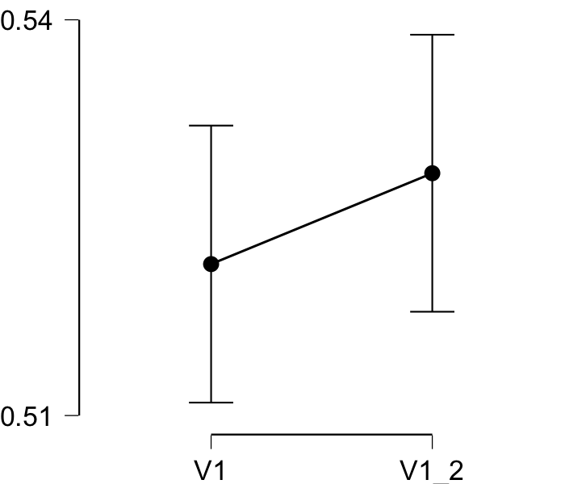

**Bayesian Paired Samples T-Test**

| **Bayesian Paired Samples T-Test** | | | | | | | | | |
| --- | --- | --- | --- | --- | --- | --- | --- | --- | --- |
|  | |  | |  | | **BF₁₀** | | **error %** | |
| V1 |  | - |  | V1_2 |  | 0.293 |  | 3.282e -4 |  |
|  | | | | | | | | | |

**Inferential Plots**

**V1 - V1_2**

**Prior and Posterior**

