**Results**

**Repeated Measures ANOVA**

**Paired Samples T-Test**

| **Paired Samples T-Test** | | | | | | | | | | | | | | | | | | | | | | | | | |
| --- | --- | --- | --- | --- | --- | --- | --- | --- | --- | --- | --- | --- | --- | --- | --- | --- | --- | --- | --- | --- | --- | --- | --- | --- | --- |
|  | | | | | | | | | | | | | | | | **95% CI for Mean Difference** | | | |  | | **95% CI for Cohen's d** | | | |
|  | |  | |  | | **t** | | **df** | | **p** | | **Mean Difference** | | **SE Difference** | | **Lower** | | **Upper** | | **Cohen's d** | | **Lower** | | **Upper** | |
| LTL |  | - |  | LTL_2 |  | 10.634 |  | 29 |  | 1.606e -11 |  | 0.139 |  | 0.013 |  | 0.113 |  | 0.166 |  | 1.942 |  | 1.323 |  | 2.548 |  |
|  | | | | | | | | | | | | | | | | | | | | | | | | | |
| *Note.*  Student's t-test. | | | | | | | | | | | | | | | | | | | | | | | | | |

**Assumption Checks**

| **Test of Normality (Shapiro-Wilk)** | | | | | | | | | |
| --- | --- | --- | --- | --- | --- | --- | --- | --- | --- |
|  | |  | |  | | **W** | | **p** | |
| LTL |  | - |  | LTL_2 |  | 0.955 |  | 0.233 |  |
|  | | | | | | | | | |
| *Note.*  Significant results suggest a deviation from normality. | | | | | | | | | |

**Descriptives**

| **Descriptives** | | | | | | | | | |
| --- | --- | --- | --- | --- | --- | --- | --- | --- | --- |
|  | | **N** | | **Mean** | | **SD** | | **SE** | |
| LTL |  | 30 |  | 0.682 |  | 0.065 |  | 0.012 |  |
| LTL_2 |  | 30 |  | 0.543 |  | 0.032 |  | 0.006 |  |
|  | | | | | | | | | |

**Descriptives Plot**

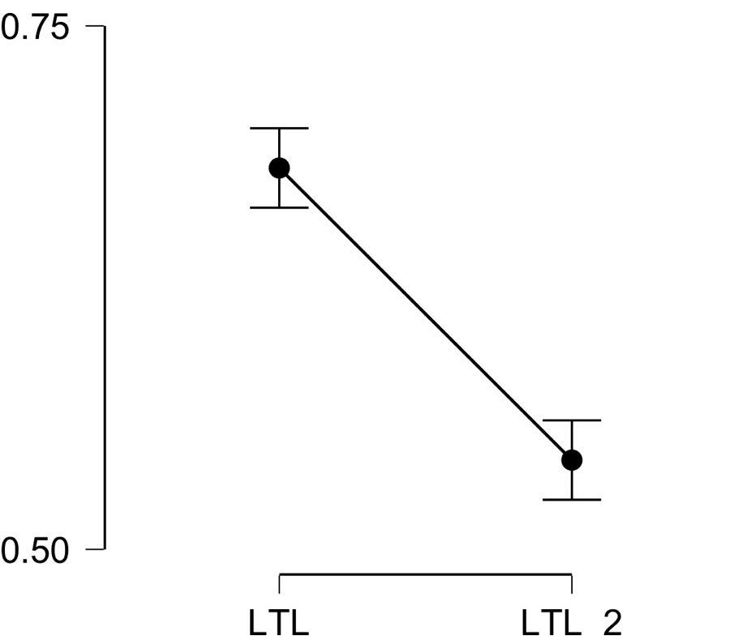

**Bayesian Paired Samples T-Test**

| **Bayesian Paired Samples T-Test** | | | | | | | | | |
| --- | --- | --- | --- | --- | --- | --- | --- | --- | --- |
|  | |  | |  | | **BF₁₀** | | **error %** | |
| LTL |  | - |  | LTL_2 |  | 5.676e +8 |  | 1.068e -11 |  |
|  | | | | | | | | | |

**Inferential Plots**

**LTL - LTL_2**

**Prior and Posterior**

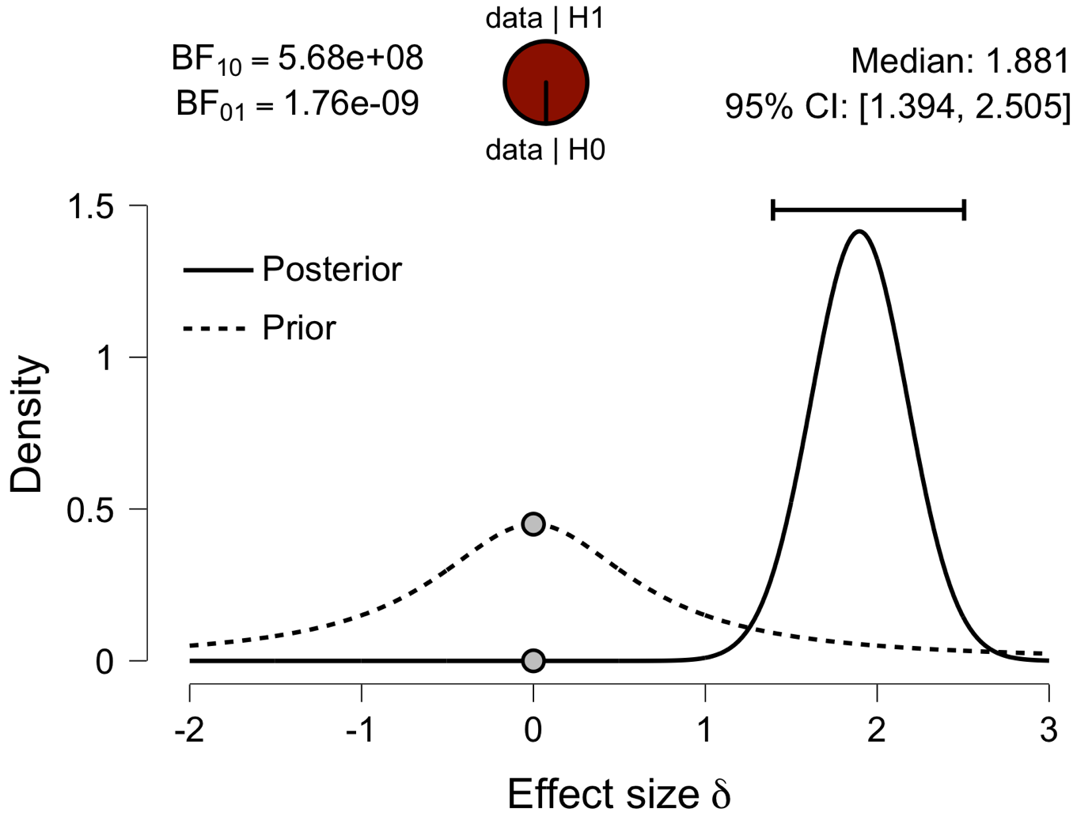

**Paired Samples T-Test**

| **Paired Samples T-Test** | | | | | | | | | | | | | | | | | | | | | | | | | |
| --- | --- | --- | --- | --- | --- | --- | --- | --- | --- | --- | --- | --- | --- | --- | --- | --- | --- | --- | --- | --- | --- | --- | --- | --- | --- |
|  | | | | | | | | | | | | | | | | **95% CI for Mean Difference** | | | |  | | **95% CI for Cohen's d** | | | |
|  | |  | |  | | **t** | | **df** | | **p** | | **Mean Difference** | | **SE Difference** | | **Lower** | | **Upper** | | **Cohen's d** | | **Lower** | | **Upper** | |
| IFG |  | - |  | IFG_2 |  | 10.799 |  | 29 |  | 1.121e -11 |  | 0.116 |  | 0.011 |  | 0.094 |  | 0.138 |  | 1.972 |  | 1.347 |  | 2.585 |  |
|  | | | | | | | | | | | | | | | | | | | | | | | | | |
| *Note.*  Student's t-test. | | | | | | | | | | | | | | | | | | | | | | | | | |

**Assumption Checks**

| **Test of Normality (Shapiro-Wilk)** | | | | | | | | | |
| --- | --- | --- | --- | --- | --- | --- | --- | --- | --- |
|  | |  | |  | | **W** | | **p** | |
| IFG |  | - |  | IFG_2 |  | 0.967 |  | 0.471 |  |
|  | | | | | | | | | |
| *Note.*  Significant results suggest a deviation from normality. | | | | | | | | | |

**Descriptives**

| **Descriptives** | | | | | | | | | |
| --- | --- | --- | --- | --- | --- | --- | --- | --- | --- |
|  | | **N** | | **Mean** | | **SD** | | **SE** | |
| IFG |  | 30 |  | 0.651 |  | 0.048 |  | 0.009 |  |
| IFG_2 |  | 30 |  | 0.535 |  | 0.032 |  | 0.006 |  |
|  | | | | | | | | | |

**Descriptives Plot**

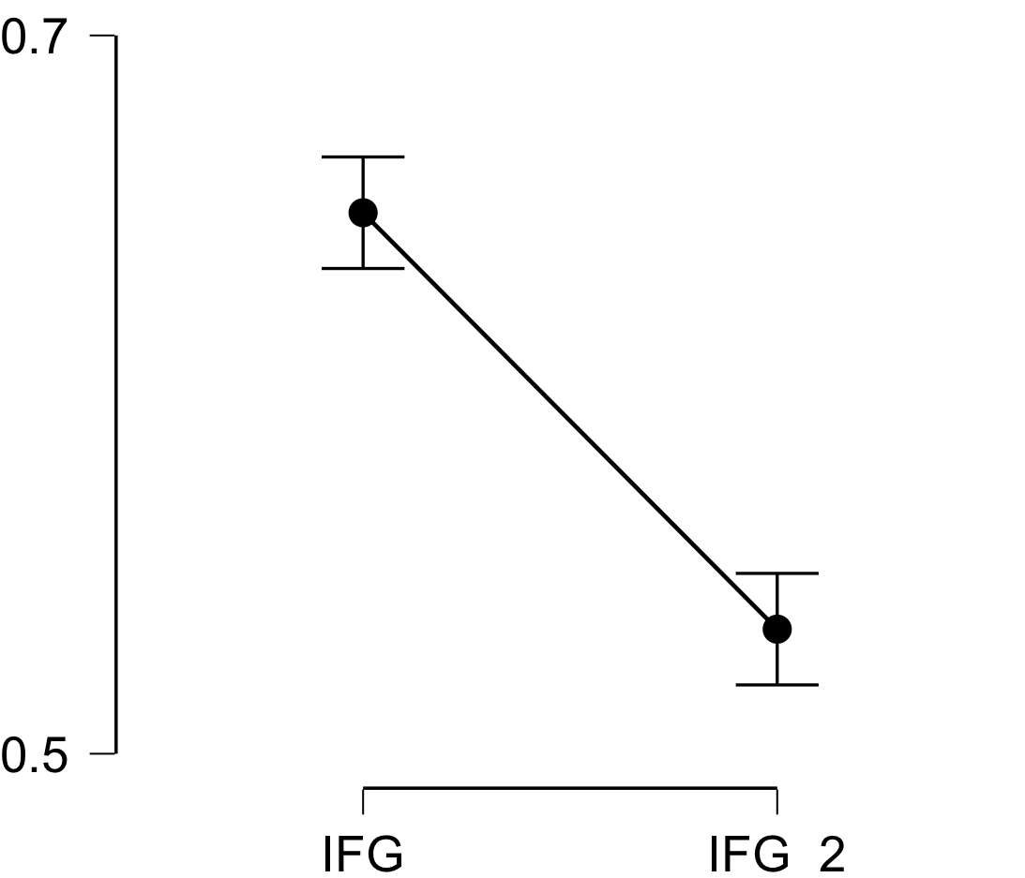

**Bayesian Paired Samples T-Test**

| **Bayesian Paired Samples T-Test** | | | | | | | | | |
| --- | --- | --- | --- | --- | --- | --- | --- | --- | --- |
|  | |  | |  | | **BF₁₀** | | **error %** | |
| IFG |  | - |  | IFG_2 |  | 7.986e +8 |  | 4.994e -13 |  |
|  | | | | | | | | | |

**Inferential Plots**

**IFG - IFG_2**

**Prior and Posterior**

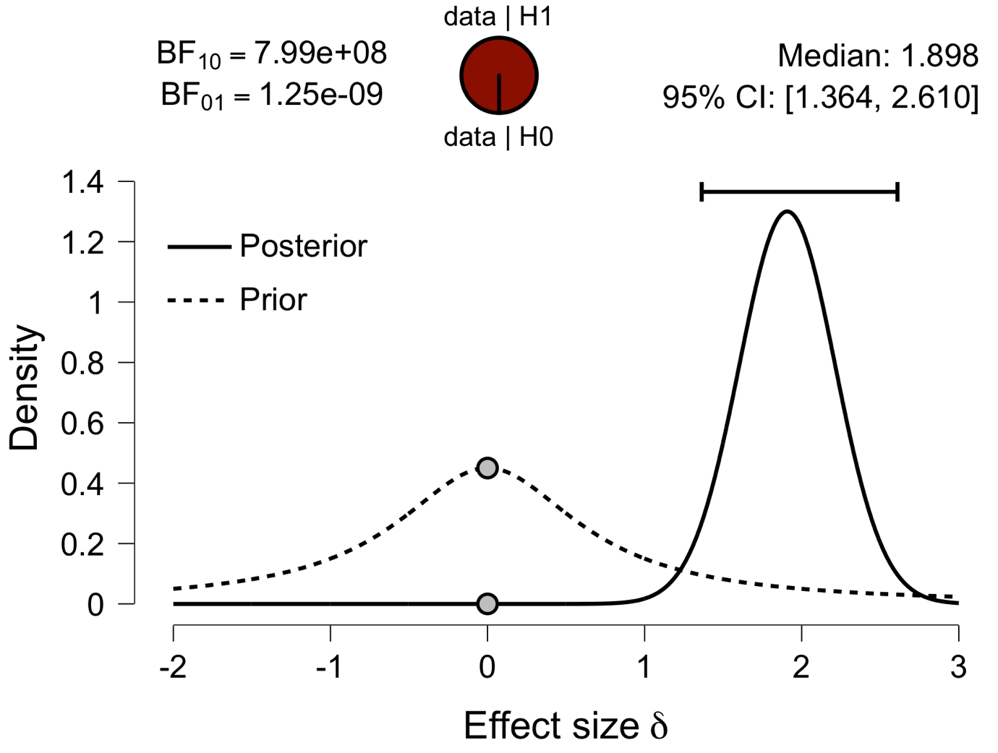

**Paired Samples T-Test**

| **Paired Samples T-Test** | | | | | | | | | | | | | | | | | | | | | | | | | |
| --- | --- | --- | --- | --- | --- | --- | --- | --- | --- | --- | --- | --- | --- | --- | --- | --- | --- | --- | --- | --- | --- | --- | --- | --- | --- |
|  | | | | | | | | | | | | | | | | **95% CI for Mean Difference** | | | |  | | **95% CI for Cohen's d** | | | |
|  | |  | |  | | **t** | | **df** | | **p** | | **Mean Difference** | | **SE Difference** | | **Lower** | | **Upper** | | **Cohen's d** | | **Lower** | | **Upper** | |
| Prec |  | - |  | Prec_2 |  | 10.952 |  | 29 |  | 8.061e -12 |  | 0.124 |  | 0.011 |  | 0.101 |  | 0.147 |  | 2.000 |  | 1.369 |  | 2.618 |  |
|  | | | | | | | | | | | | | | | | | | | | | | | | | |
| *Note.*  Student's t-test. | | | | | | | | | | | | | | | | | | | | | | | | | |

**Assumption Checks**

| **Test of Normality (Shapiro-Wilk)** | | | | | | | | | |
| --- | --- | --- | --- | --- | --- | --- | --- | --- | --- |
|  | |  | |  | | **W** | | **p** | |
| Prec |  | - |  | Prec_2 |  | 0.991 |  | 0.994 |  |
|  | | | | | | | | | |
| *Note.*  Significant results suggest a deviation from normality. | | | | | | | | | |

**Descriptives**

| **Descriptives** | | | | | | | | | |
| --- | --- | --- | --- | --- | --- | --- | --- | --- | --- |
|  | | **N** | | **Mean** | | **SD** | | **SE** | |
| Prec |  | 30 |  | 0.659 |  | 0.049 |  | 0.009 |  |
| Prec_2 |  | 30 |  | 0.535 |  | 0.037 |  | 0.007 |  |
|  | | | | | | | | | |

**Descriptives Plot**

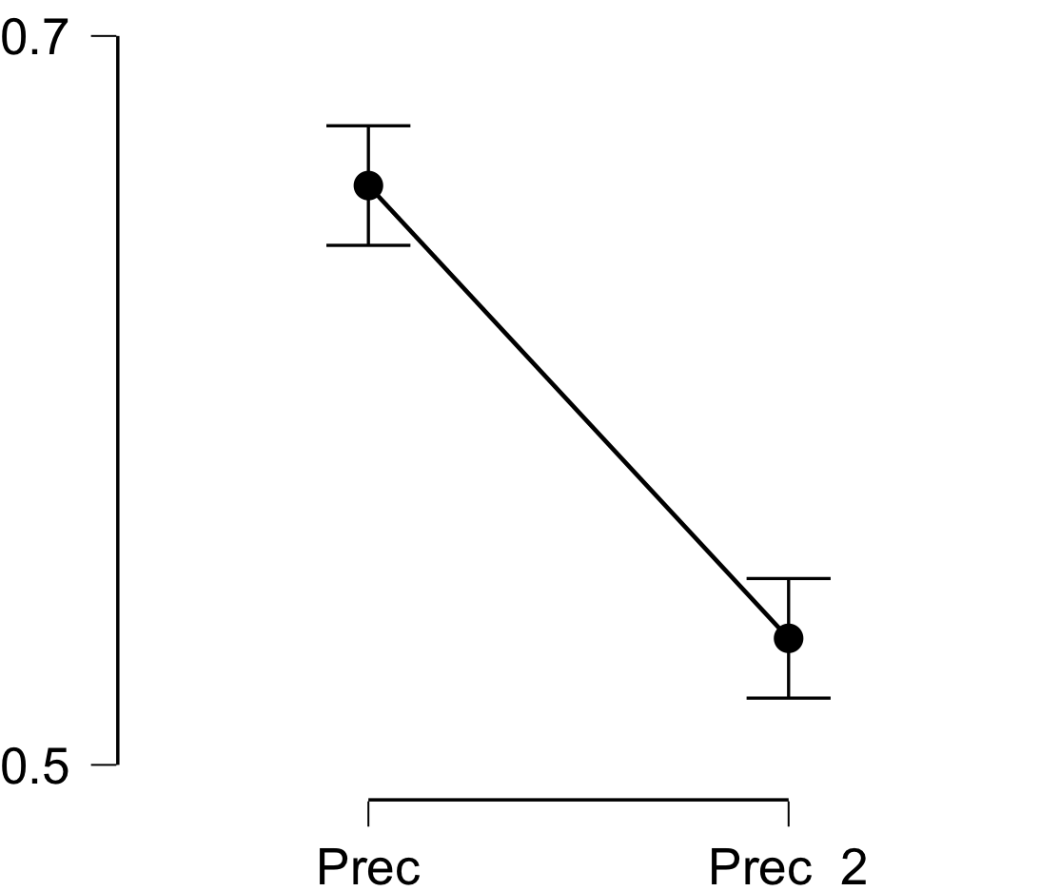

**Bayesian Paired Samples T-Test**

| **Bayesian Paired Samples T-Test** | | | | | | | | | |
| --- | --- | --- | --- | --- | --- | --- | --- | --- | --- |
|  | |  | |  | | **BF₁₀** | | **error %** | |
| Prec |  | - |  | Prec_2 |  | 1.093e +9 |  | 3.637e -13 |  |
|  | | | | | | | | | |

**Inferential Plots**

**Prec - Prec_2**

**Prior and Posterior**

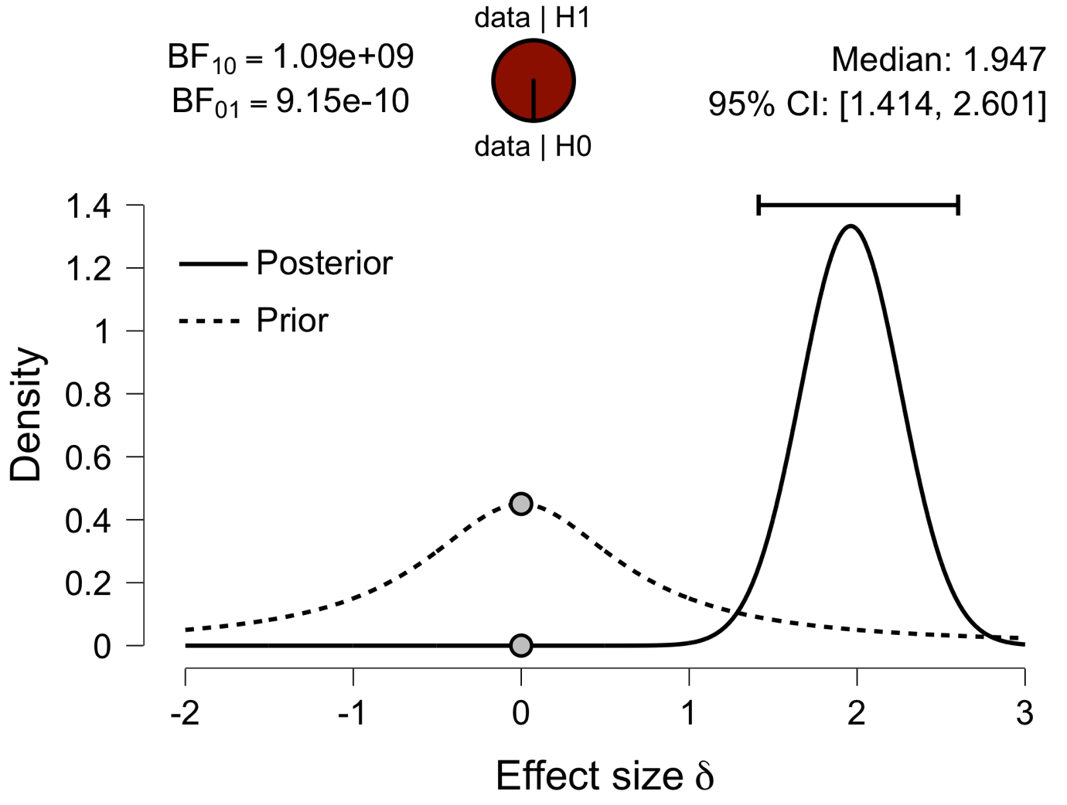

**Paired Samples T-Test**

| **Paired Samples T-Test** | | | | | | | | | | | | | | | | | | | | | | | | | |
| --- | --- | --- | --- | --- | --- | --- | --- | --- | --- | --- | --- | --- | --- | --- | --- | --- | --- | --- | --- | --- | --- | --- | --- | --- | --- |
|  | | | | | | | | | | | | | | | | **95% CI for Mean Difference** | | | |  | | **95% CI for Cohen's d** | | | |
|  | |  | |  | | **t** | | **df** | | **p** | | **Mean Difference** | | **SE Difference** | | **Lower** | | **Upper** | | **Cohen's d** | | **Lower** | | **Upper** | |
| ATL |  | - |  | ATL_2 |  | 8.290 |  | 29 |  | 3.869e -9 |  | 0.085 |  | 0.010 |  | 0.064 |  | 0.106 |  | 1.514 |  | 0.980 |  | 2.035 |  |
|  | | | | | | | | | | | | | | | | | | | | | | | | | |
| *Note.*  Student's t-test. | | | | | | | | | | | | | | | | | | | | | | | | | |

**Assumption Checks**

| **Test of Normality (Shapiro-Wilk)** | | | | | | | | | |
| --- | --- | --- | --- | --- | --- | --- | --- | --- | --- |
|  | |  | |  | | **W** | | **p** | |
| ATL |  | - |  | ATL_2 |  | 0.949 |  | 0.162 |  |
|  | | | | | | | | | |
| *Note.*  Significant results suggest a deviation from normality. | | | | | | | | | |

**Descriptives**

| **Descriptives** | | | | | | | | | |
| --- | --- | --- | --- | --- | --- | --- | --- | --- | --- |
|  | | **N** | | **Mean** | | **SD** | | **SE** | |
| ATL |  | 30 |  | 0.608 |  | 0.047 |  | 0.009 |  |
| ATL_2 |  | 30 |  | 0.523 |  | 0.032 |  | 0.006 |  |
|  | | | | | | | | | |

**Descriptives Plot**

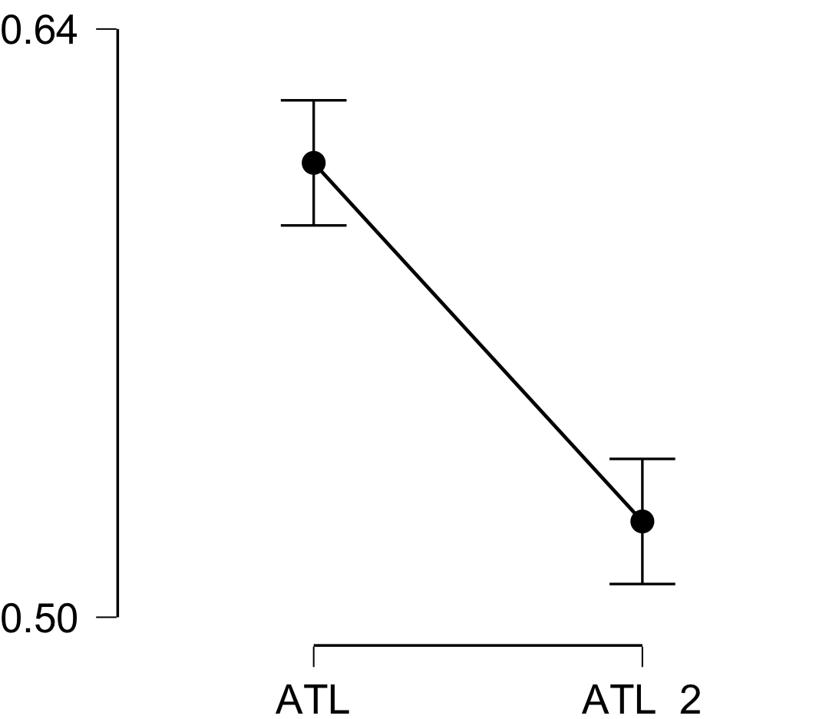

**Bayesian Paired Samples T-Test**

| **Bayesian Paired Samples T-Test** | | | | | | | | | |
| --- | --- | --- | --- | --- | --- | --- | --- | --- | --- |
|  | |  | |  | | **BF₁₀** | | **error %** | |
| ATL |  | - |  | ATL_2 |  | 3.170e +6 |  | 1.907e -10 |  |
|  | | | | | | | | | |

**Inferential Plots**

**ATL - ATL_2**

**Prior and Posterior**

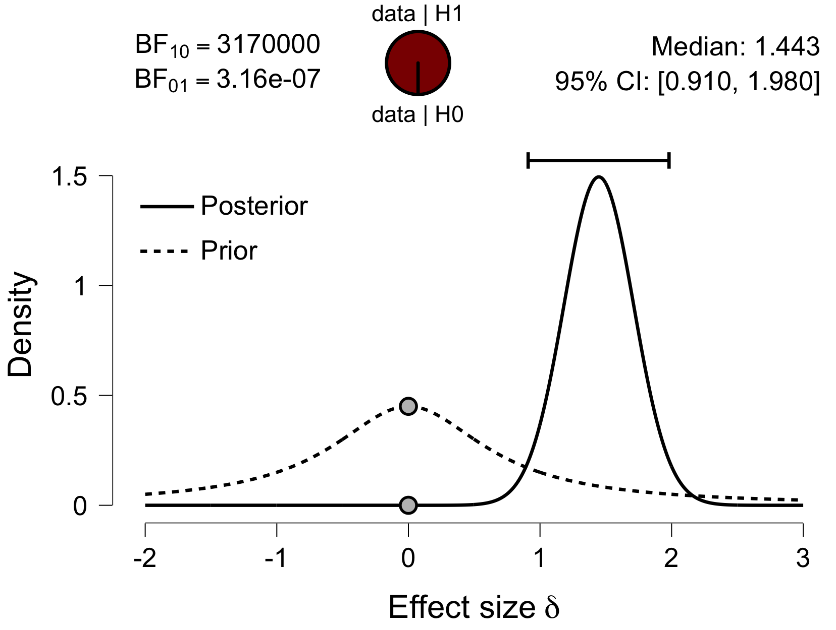

**Paired Samples T-Test**

| **Paired Samples T-Test** | | | | | | | | | | | | | | | | | | | | | | | | | |
| --- | --- | --- | --- | --- | --- | --- | --- | --- | --- | --- | --- | --- | --- | --- | --- | --- | --- | --- | --- | --- | --- | --- | --- | --- | --- |
|  | | | | | | | | | | | | | | | | **95% CI for Mean Difference** | | | |  | | **95% CI for Cohen's d** | | | |
|  | |  | |  | | **t** | | **df** | | **p** | | **Mean Difference** | | **SE Difference** | | **Lower** | | **Upper** | | **Cohen's d** | | **Lower** | | **Upper** | |
| aPFC |  | - |  | aPFC_2 |  | 8.833 |  | 29 |  | 1.019e -9 |  | 0.113 |  | 0.013 |  | 0.087 |  | 0.140 |  | 1.613 |  | 1.060 |  | 2.153 |  |
|  | | | | | | | | | | | | | | | | | | | | | | | | | |
| *Note.*  Student's t-test. | | | | | | | | | | | | | | | | | | | | | | | | | |

**Assumption Checks**

| **Test of Normality (Shapiro-Wilk)** | | | | | | | | | |
| --- | --- | --- | --- | --- | --- | --- | --- | --- | --- |
|  | |  | |  | | **W** | | **p** | |
| aPFC |  | - |  | aPFC_2 |  | 0.971 |  | 0.578 |  |
|  | | | | | | | | | |
| *Note.*  Significant results suggest a deviation from normality. | | | | | | | | | |

**Descriptives**

| **Descriptives** | | | | | | | | | |
| --- | --- | --- | --- | --- | --- | --- | --- | --- | --- |
|  | | **N** | | **Mean** | | **SD** | | **SE** | |
| aPFC |  | 30 |  | 0.645 |  | 0.062 |  | 0.011 |  |
| aPFC_2 |  | 30 |  | 0.532 |  | 0.032 |  | 0.006 |  |
|  | | | | | | | | | |

**Descriptives Plot**

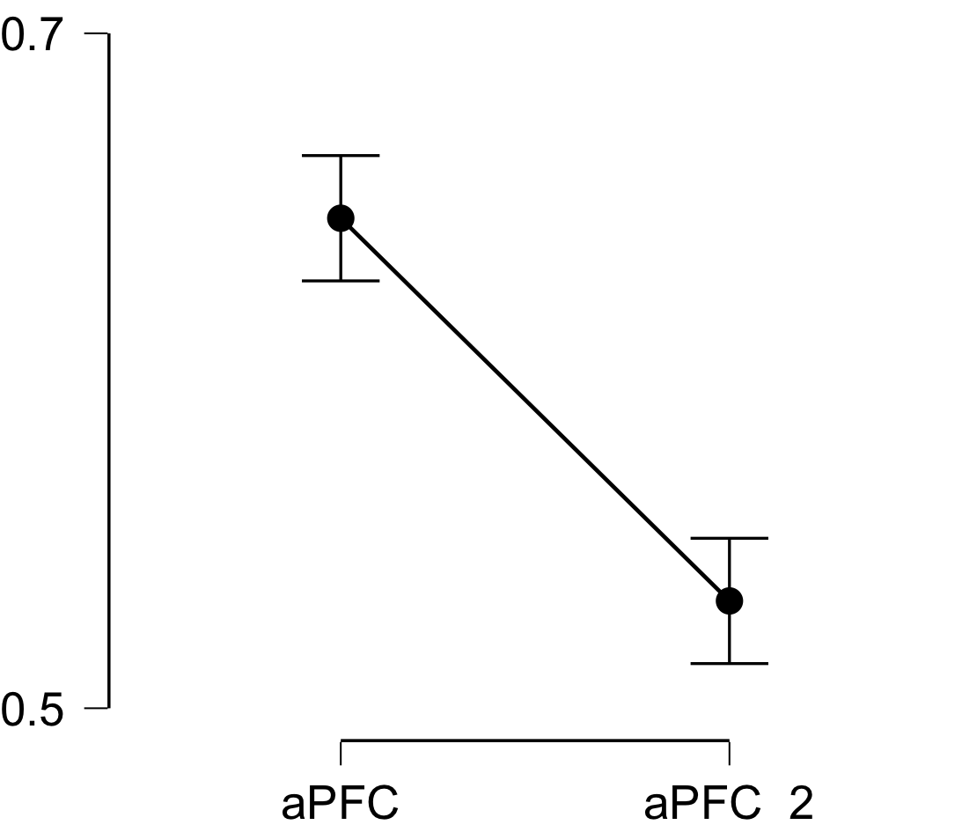

**Bayesian Paired Samples T-Test**

| **Bayesian Paired Samples T-Test** | | | | | | | | | |
| --- | --- | --- | --- | --- | --- | --- | --- | --- | --- |
|  | |  | |  | | **BF₁₀** | | **error %** | |
| aPFC |  | - |  | aPFC_2 |  | 1.115e +7 |  | 1.101e -11 |  |
|  | | | | | | | | | |

**Inferential Plots**

**aPFC - aPFC_2**

**Prior and Posterior**

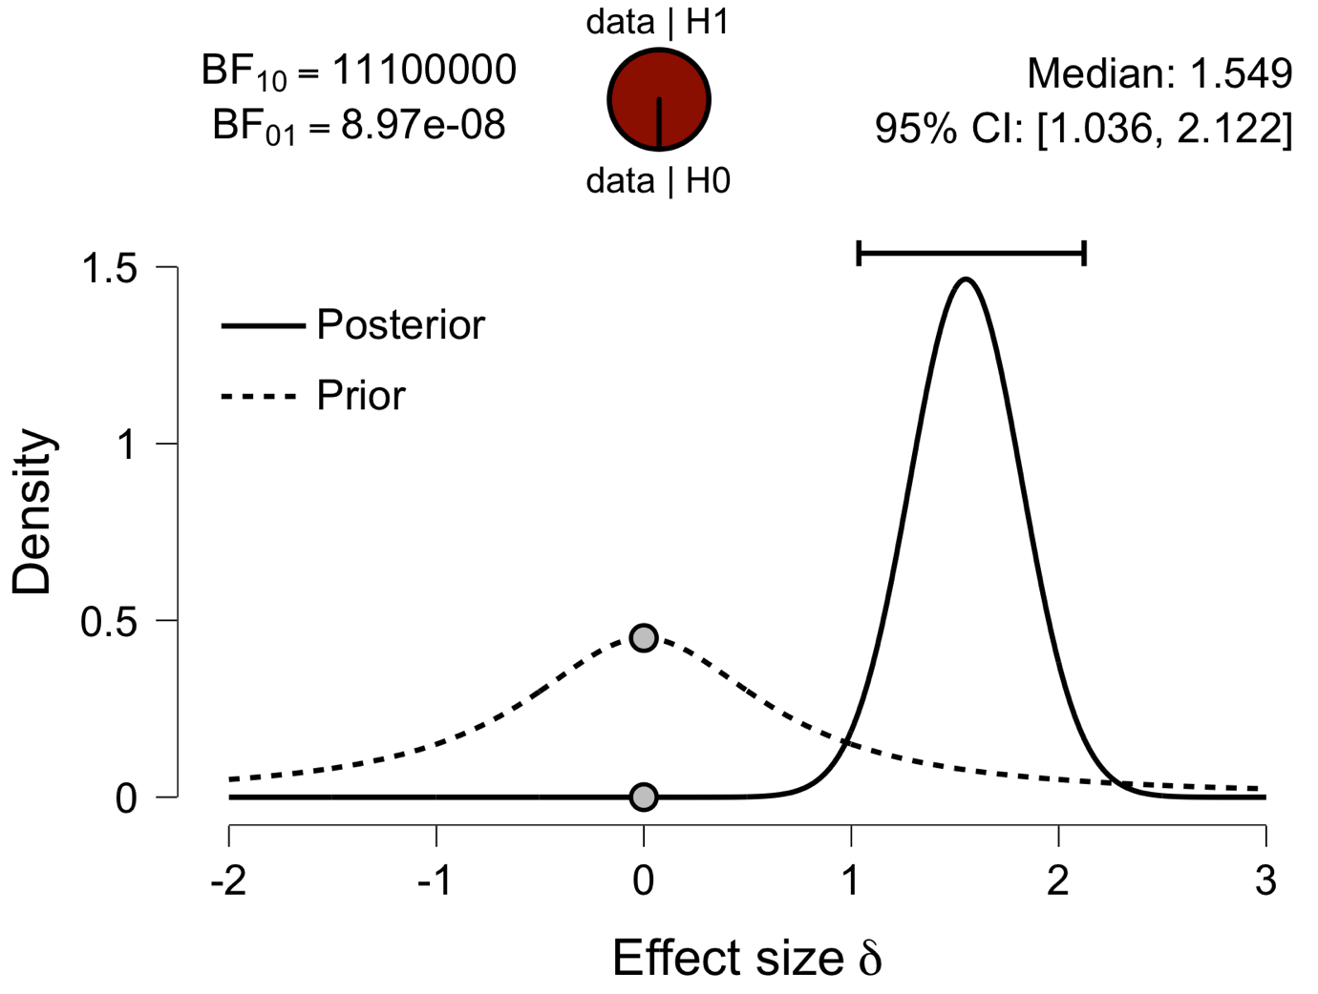

**Paired Samples T-Test**

| **Paired Samples T-Test** | | | | | | | | | | | | | | | | | | | | | | | | | |
| --- | --- | --- | --- | --- | --- | --- | --- | --- | --- | --- | --- | --- | --- | --- | --- | --- | --- | --- | --- | --- | --- | --- | --- | --- | --- |
|  | | | | | | | | | | | | | | | | **95% CI for Mean Difference** | | | |  | | **95% CI for Cohen's d** | | | |
|  | |  | |  | | **t** | | **df** | | **p** | | **Mean Difference** | | **SE Difference** | | **Lower** | | **Upper** | | **Cohen's d** | | **Lower** | | **Upper** | |
| Ins |  | - |  | Ins_2 |  | 11.051 |  | 29 |  | 6.517e -12 |  | 0.092 |  | 0.008 |  | 0.075 |  | 0.109 |  | 2.018 |  | 1.383 |  | 2.640 |  |
|  | | | | | | | | | | | | | | | | | | | | | | | | | |
| *Note.*  Student's t-test. | | | | | | | | | | | | | | | | | | | | | | | | | |

**Assumption Checks**

| **Test of Normality (Shapiro-Wilk)** | | | | | | | | | |
| --- | --- | --- | --- | --- | --- | --- | --- | --- | --- |
|  | |  | |  | | **W** | | **p** | |
| Ins |  | - |  | Ins_2 |  | 0.982 |  | 0.868 |  |
|  | | | | | | | | | |
| *Note.*  Significant results suggest a deviation from normality. | | | | | | | | | |

**Descriptives**

| **Descriptives** | | | | | | | | | |
| --- | --- | --- | --- | --- | --- | --- | --- | --- | --- |
|  | | **N** | | **Mean** | | **SD** | | **SE** | |
| Ins |  | 30 |  | 0.631 |  | 0.029 |  | 0.005 |  |
| Ins_2 |  | 30 |  | 0.539 |  | 0.033 |  | 0.006 |  |
|  | | | | | | | | | |

**Descriptives Plot**

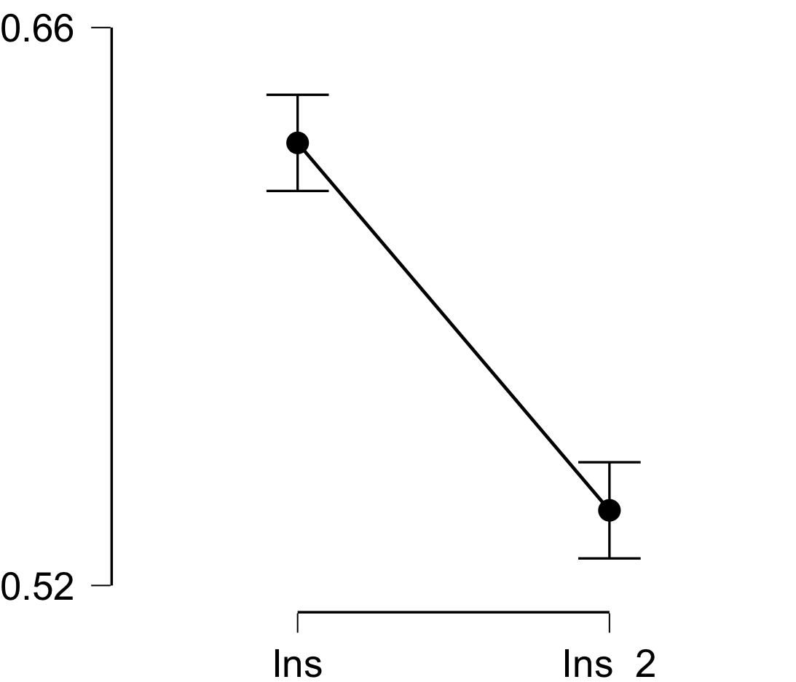

**Bayesian Paired Samples T-Test**

| **Bayesian Paired Samples T-Test** | | | | | | | | | |
| --- | --- | --- | --- | --- | --- | --- | --- | --- | --- |
|  | |  | |  | | **BF₁₀** | | **error %** | |
| Ins |  | - |  | Ins_2 |  | 1.337e +9 |  | 2.938e -13 |  |
|  | | | | | | | | | |

**Inferential Plots**

**Ins - Ins_2**

**Prior and Posterior**

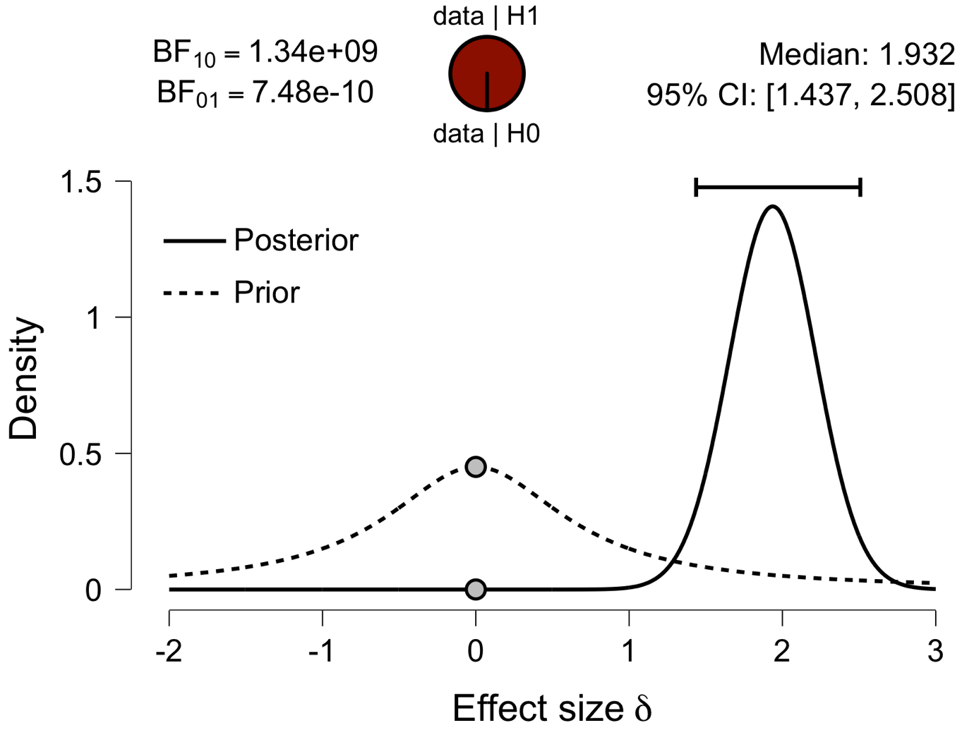

**Paired Samples T-Test**

| **Paired Samples T-Test** | | | | | | | | | | | | | | | | | | | | | | | | | |
| --- | --- | --- | --- | --- | --- | --- | --- | --- | --- | --- | --- | --- | --- | --- | --- | --- | --- | --- | --- | --- | --- | --- | --- | --- | --- |
|  | | | | | | | | | | | | | | | | **95% CI for Mean Difference** | | | |  | | **95% CI for Cohen's d** | | | |
|  | |  | |  | | **t** | | **df** | | **p** | | **Mean Difference** | | **SE Difference** | | **Lower** | | **Upper** | | **Cohen's d** | | **Lower** | | **Upper** | |
| ACC |  | - |  | ACC_2 |  | 10.648 |  | 29 |  | 1.560e -11 |  | 0.129 |  | 0.012 |  | 0.104 |  | 0.154 |  | 1.944 |  | 1.325 |  | 2.551 |  |
|  | | | | | | | | | | | | | | | | | | | | | | | | | |
| *Note.*  Student's t-test. | | | | | | | | | | | | | | | | | | | | | | | | | |

**Assumption Checks**

| **Test of Normality (Shapiro-Wilk)** | | | | | | | | | |
| --- | --- | --- | --- | --- | --- | --- | --- | --- | --- |
|  | |  | |  | | **W** | | **p** | |
| ACC |  | - |  | ACC_2 |  | 0.948 |  | 0.149 |  |
|  | | | | | | | | | |
| *Note.*  Significant results suggest a deviation from normality. | | | | | | | | | |

**Descriptives**

| **Descriptives** | | | | | | | | | |
| --- | --- | --- | --- | --- | --- | --- | --- | --- | --- |
|  | | **N** | | **Mean** | | **SD** | | **SE** | |
| ACC |  | 30 |  | 0.666 |  | 0.058 |  | 0.011 |  |
| ACC_2 |  | 30 |  | 0.537 |  | 0.027 |  | 0.005 |  |
|  | | | | | | | | | |

**Descriptives Plot**

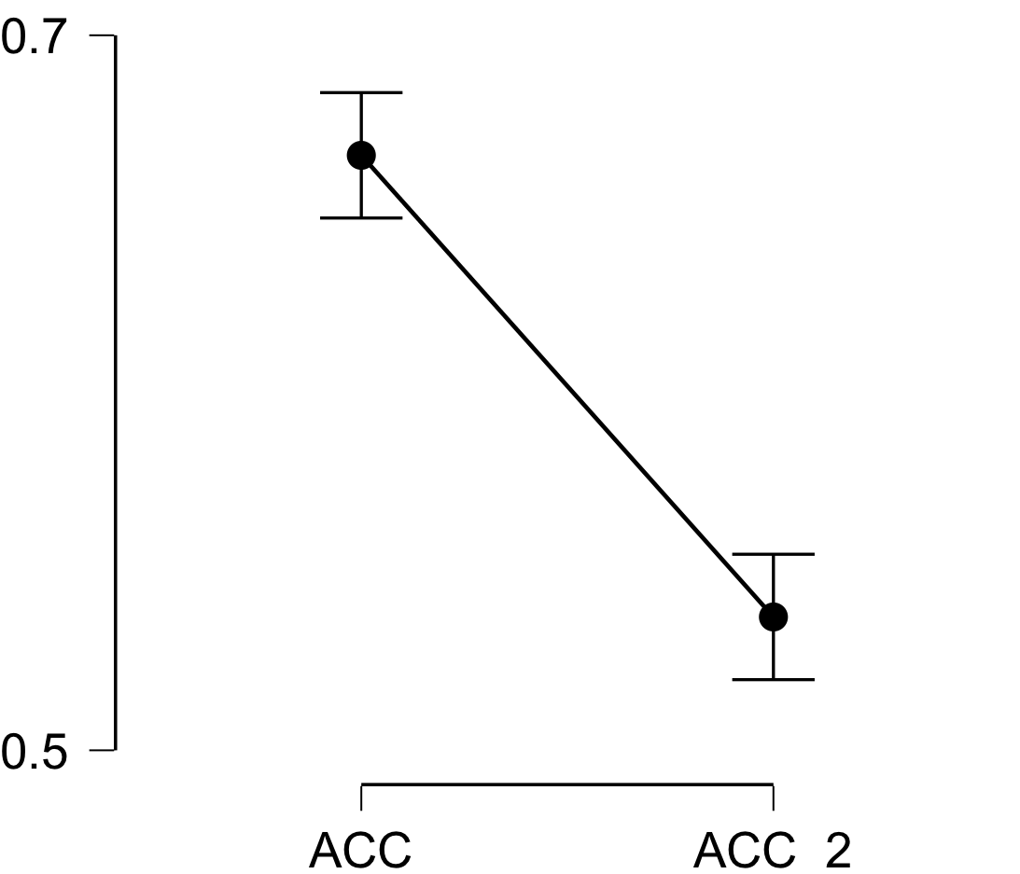

**Bayesian Paired Samples T-Test**

| **Bayesian Paired Samples T-Test** | | | | | | | | | |
| --- | --- | --- | --- | --- | --- | --- | --- | --- | --- |
|  | |  | |  | | **BF₁₀** | | **error %** | |
| ACC |  | - |  | ACC_2 |  | 5.834e +8 |  | 1.114e -11 |  |
|  | | | | | | | | | |

**Inferential Plots**

**ACC - ACC_2**

**Prior and Posterior**

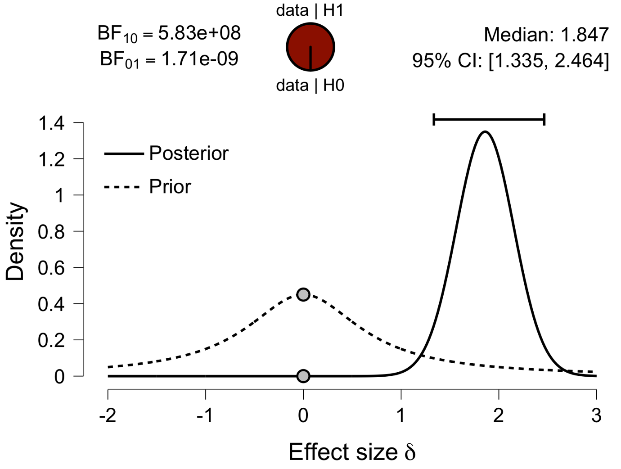

**Paired Samples T-Test**

| **Paired Samples T-Test** | | | | | | | | | | | | | | | | | | | | | | | | | |
| --- | --- | --- | --- | --- | --- | --- | --- | --- | --- | --- | --- | --- | --- | --- | --- | --- | --- | --- | --- | --- | --- | --- | --- | --- | --- |
|  | | | | | | | | | | | | | | | | **95% CI for Mean Difference** | | | |  | | **95% CI for Cohen's d** | | | |
|  | |  | |  | | **t** | | **df** | | **p** | | **Mean Difference** | | **SE Difference** | | **Lower** | | **Upper** | | **Cohen's d** | | **Lower** | | **Upper** | |
| PCC |  | - |  | PCC_2 |  | 9.633 |  | 29 |  | 1.531e -10 |  | 0.089 |  | 0.009 |  | 0.070 |  | 0.108 |  | 1.759 |  | 1.177 |  | 2.328 |  |
|  | | | | | | | | | | | | | | | | | | | | | | | | | |
| *Note.*  Student's t-test. | | | | | | | | | | | | | | | | | | | | | | | | | |

**Assumption Checks**

| **Test of Normality (Shapiro-Wilk)** | | | | | | | | | |
| --- | --- | --- | --- | --- | --- | --- | --- | --- | --- |
|  | |  | |  | | **W** | | **p** | |
| PCC |  | - |  | PCC_2 |  | 0.926 |  | 0.039 |  |
|  | | | | | | | | | |
| *Note.*  Significant results suggest a deviation from normality. | | | | | | | | | |

**Descriptives**

| **Descriptives** | | | | | | | | | |
| --- | --- | --- | --- | --- | --- | --- | --- | --- | --- |
|  | | **N** | | **Mean** | | **SD** | | **SE** | |
| PCC |  | 30 |  | 0.622 |  | 0.035 |  | 0.006 |  |
| PCC_2 |  | 30 |  | 0.533 |  | 0.033 |  | 0.006 |  |
|  | | | | | | | | | |

**Descriptives Plot**

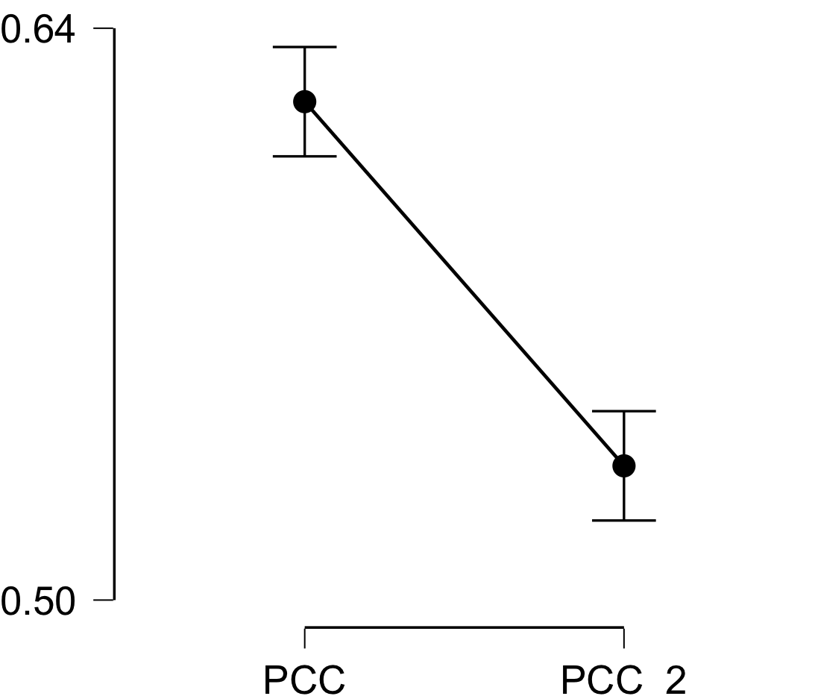

**Bayesian Paired Samples T-Test**

| **Bayesian Paired Samples T-Test** | | | | | | | | | |
| --- | --- | --- | --- | --- | --- | --- | --- | --- | --- |
|  | |  | |  | | **BF₁₀** | | **error %** | |
| PCC |  | - |  | PCC_2 |  | 6.690e +7 |  | 2.221e -12 |  |
|  | | | | | | | | | |

**Inferential Plots**

**PCC - PCC_2**

**Prior and Posterior**

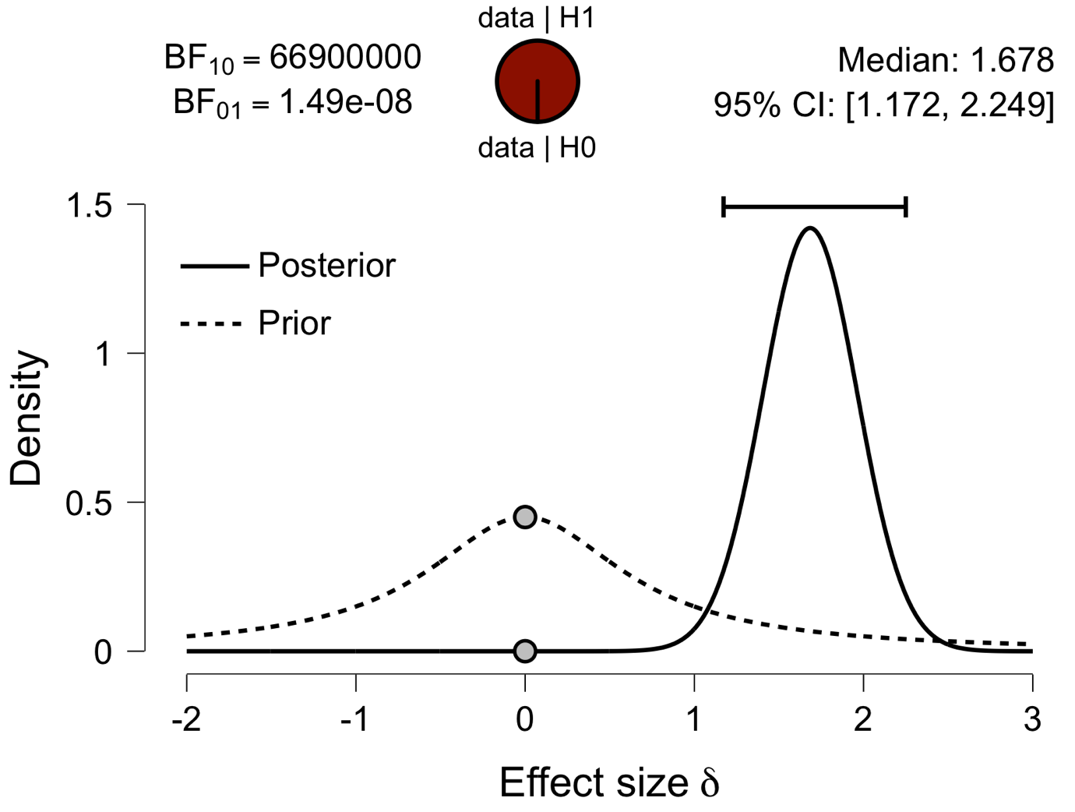

**Paired Samples T-Test**

| **Paired Samples T-Test** | | | | | | | | | | | | | | | | | | | | | | | | | |
| --- | --- | --- | --- | --- | --- | --- | --- | --- | --- | --- | --- | --- | --- | --- | --- | --- | --- | --- | --- | --- | --- | --- | --- | --- | --- |
|  | | | | | | | | | | | | | | | | **95% CI for Mean Difference** | | | |  | | **95% CI for Cohen's d** | | | |
|  | |  | |  | | **t** | | **df** | | **p** | | **Mean Difference** | | **SE Difference** | | **Lower** | | **Upper** | | **Cohen's d** | | **Lower** | | **Upper** | |
| V1 |  | - |  | V1_2 |  | 5.910 |  | 29 |  | 2.037e -6 |  | 0.047 |  | 0.008 |  | 0.031 |  | 0.063 |  | 1.079 |  | 0.621 |  | 1.525 |  |
|  | | | | | | | | | | | | | | | | | | | | | | | | | |
| *Note.*  Student's t-test. | | | | | | | | | | | | | | | | | | | | | | | | | |

**Assumption Checks**

| **Test of Normality (Shapiro-Wilk)** | | | | | | | | | |
| --- | --- | --- | --- | --- | --- | --- | --- | --- | --- |
|  | |  | |  | | **W** | | **p** | |
| V1 |  | - |  | V1_2 |  | 0.956 |  | 0.237 |  |
|  | | | | | | | | | |
| *Note.*  Significant results suggest a deviation from normality. | | | | | | | | | |

**Descriptives**

| **Descriptives** | | | | | | | | | |
| --- | --- | --- | --- | --- | --- | --- | --- | --- | --- |
|  | | **N** | | **Mean** | | **SD** | | **SE** | |
| V1 |  | 30 |  | 0.580 |  | 0.028 |  | 0.005 |  |
| V1_2 |  | 30 |  | 0.533 |  | 0.038 |  | 0.007 |  |
|  | | | | | | | | | |

**Descriptives Plot**

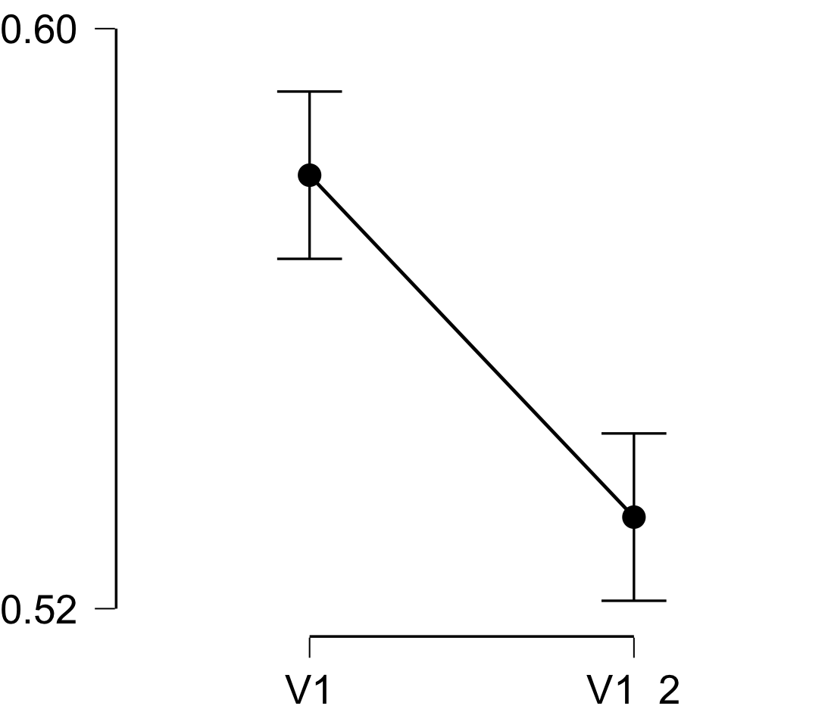

**Bayesian Paired Samples T-Test**

| **Bayesian Paired Samples T-Test** | | | | | | | | | |
| --- | --- | --- | --- | --- | --- | --- | --- | --- | --- |
|  | |  | |  | | **BF₁₀** | | **error %** | |
| V1 |  | - |  | V1_2 |  | 9133.942 |  | 4.984e -7 |  |
|  | | | | | | | | | |

**Inferential Plots**

**V1 - V1_2**

**Prior and Posterior**

