**Results**

**Paired Samples T-Test**

| **Paired Samples T-Test** | | | | | | | | | | | | | | | | | |
| --- | --- | --- | --- | --- | --- | --- | --- | --- | --- | --- | --- | --- | --- | --- | --- | --- | --- |
|  | | | | | | | | | | | | | | **95% CI for Cohen's d** | | | |
|  | |  | |  | | **t** | | **df** | | **p** | | **Cohen's d** | | **Lower** | | **Upper** | |
| semantic |  | - |  | social |  | -0.225 |  | 29 |  | 0.823 |  | -0.041 |  | -0.399 |  | 0.317 |  |
|  | | | | | | | | | | | | | | | | | |
| *Note.*  Student's t-test. | | | | | | | | | | | | | | | | | |

**Assumption Checks**

| **Test of Normality (Shapiro-Wilk)** | | | | | | | | | |
| --- | --- | --- | --- | --- | --- | --- | --- | --- | --- |
|  | |  | |  | | **W** | | **p** | |
| semantic |  | - |  | social |  | 0.959 |  | 0.295 |  |
|  | | | | | | | | | |
| *Note.*  Significant results suggest a deviation from normality. | | | | | | | | | |

**Descriptives**

| **Descriptives** | | | | | | | | | |
| --- | --- | --- | --- | --- | --- | --- | --- | --- | --- |
|  | | **N** | | **Mean** | | **SD** | | **SE** | |
| semantic |  | 30 |  | 0.416 |  | 0.034 |  | 0.006 |  |
| social |  | 30 |  | 0.417 |  | 0.035 |  | 0.006 |  |
|  | | | | | | | | | |

**Descriptives Plot**

**semantic - social**

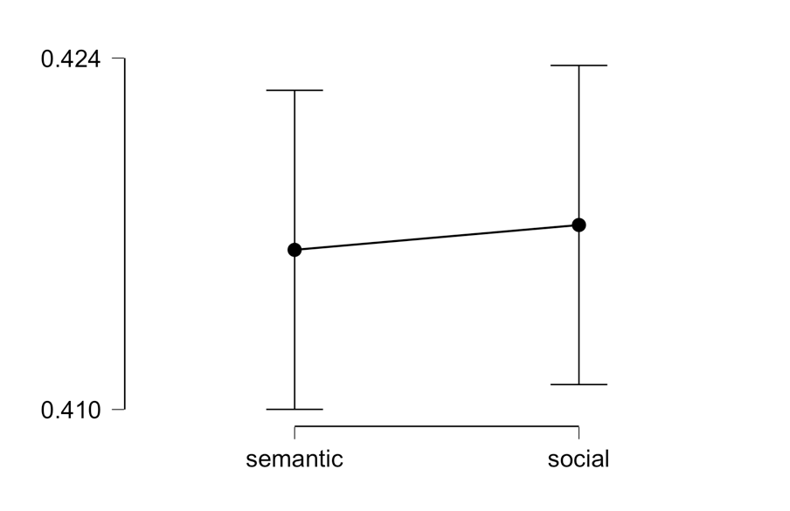

**Bayesian Paired Samples T-Test**

| **Bayesian Paired Samples T-Test** | | | | | | | | | |
| --- | --- | --- | --- | --- | --- | --- | --- | --- | --- |
|  | |  | |  | | **BF₁₀** | | **error %** | |
| semantic |  | - |  | social |  | 0.199 |  | 0.012 |  |
|  | | | | | | | | | |

**Descriptives**

| **Descriptives** | | | | | | | | | | | | | |
| --- | --- | --- | --- | --- | --- | --- | --- | --- | --- | --- | --- | --- | --- |
|  | | | | | | | | | | **95% Credible Interval** | | | |
|  | | **N** | | **Mean** | | **SD** | | **SE** | | **Lower** | | **Upper** | |
| semantic |  | 30 |  | 0.416 |  | 0.034 |  | 0.006 |  | 0.404 |  | 0.429 |  |
| social |  | 30 |  | 0.417 |  | 0.035 |  | 0.006 |  | 0.404 |  | 0.430 |  |
|  | | | | | | | | | | | | | |

**Descriptives Plot**

**semantic - social**

**Inferential Plot**

**semantic - social**

**Prior and Posterior**

