**Results**

**Paired Samples T-Test**

| **Paired Samples T-Test** | | | | | | | | | | | | | | | | | |
| --- | --- | --- | --- | --- | --- | --- | --- | --- | --- | --- | --- | --- | --- | --- | --- | --- | --- |
|  | | | | | | | | | | | | | | **95% CI for Cohen's d** | | | |
|  | |  | |  | | **t** | | **df** | | **p** | | **Cohen's d** | | **Lower** | | **Upper** | |
| affect |  | - |  | likableness |  | -2.300 |  | 29 |  | 0.029 |  | -0.420 |  | -0.790 |  | -0.043 |  |
|  | | | | | | | | | | | | | | | | | |
| *Note.*  Student's t-test. | | | | | | | | | | | | | | | | | |

**Assumption Checks**

| **Test of Normality (Shapiro-Wilk)** | | | | | | | | | |
| --- | --- | --- | --- | --- | --- | --- | --- | --- | --- |
|  | |  | |  | | **W** | | **p** | |
| affect |  | - |  | likableness |  | 0.978 |  | 0.767 |  |
|  | | | | | | | | | |
| *Note.*  Significant results suggest a deviation from normality. | | | | | | | | | |

**Descriptives**

| **Descriptives** | | | | | | | | | |
| --- | --- | --- | --- | --- | --- | --- | --- | --- | --- |
|  | | **N** | | **Mean** | | **SD** | | **SE** | |
| affect |  | 30 |  | 0.706 |  | 0.030 |  | 0.005 |  |
| likableness |  | 30 |  | 0.733 |  | 0.051 |  | 0.009 |  |
|  | | | | | | | | | |

**Descriptives Plot**

**affect - likableness**

**Bayesian Paired Samples T-Test**

| **Bayesian Paired Samples T-Test** | | | | | | | | | |
| --- | --- | --- | --- | --- | --- | --- | --- | --- | --- |
|  | |  | |  | | **BF₁₀** | | **error %** | |
| affect |  | - |  | likableness |  | 1.863 |  | 4.030e -6 |  |
|  | | | | | | | | | |

**Descriptives**

| **Descriptives** | | | | | | | | | | | | | |
| --- | --- | --- | --- | --- | --- | --- | --- | --- | --- | --- | --- | --- | --- |
|  | | | | | | | | | | **95% Credible Interval** | | | |
|  | | **N** | | **Mean** | | **SD** | | **SE** | | **Lower** | | **Upper** | |
| affect |  | 30 |  | 0.706 |  | 0.030 |  | 0.005 |  | 0.695 |  | 0.717 |  |
| likableness |  | 30 |  | 0.733 |  | 0.051 |  | 0.009 |  | 0.714 |  | 0.752 |  |
|  | | | | | | | | | | | | | |

**Descriptives Plot**

**affect - likableness**

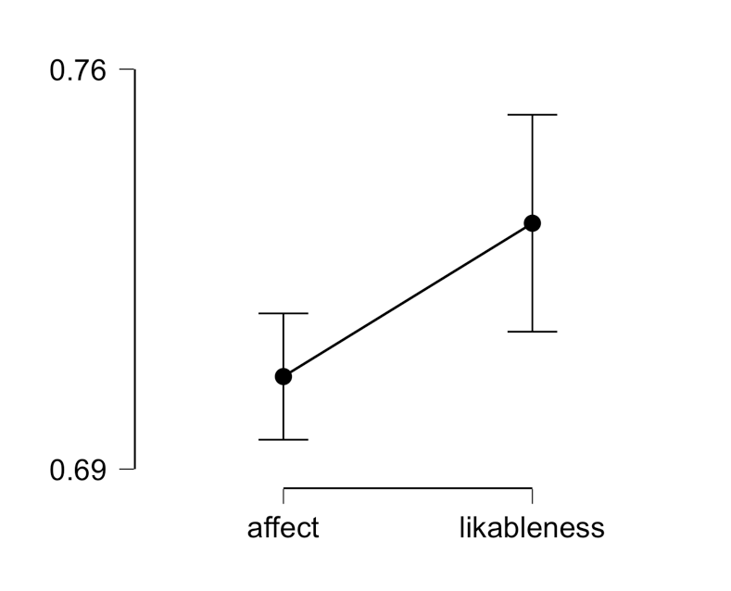

**Inferential Plot**

**affect - likableness**

**Prior and Posterior**

