GDD10 Accumulated Monthly

Dana Melamed

2023-03-09

Accumulate gdd10 from the beginning to end of each month, and apply the model.

# Prepare the data  
# Make a list of input rasters  
in_folder <- 'f:\\data\\rasters\\input_rasters\\'  
raster_names <- list('dem200m','cp200m','east200m','north200m','tpi5000m200m',  
 'asp200m','slp200m')  
ext = '.tif'  
rasters_list <- lapply(X=paste0(in_folder,raster_names,ext),FUN=raster::raster)

## Warning in showSRID(SRS_string, format = "PROJ", multiline = "NO", prefer_proj  
## = prefer_proj): Discarded datum NAD83 Canadian Spatial Reference System in Proj4  
## definition

#transform  
rasters_list[[2]]<-rasters_list[[2]]^0.5  
names(rasters_list[[2]]) <- 'cp200m'  
rasters_list[[6]] <- rasters_list[[7]]*cos(rasters_list[[6]])  
names(rasters_list[[6]]) <- 'asp200m'  
  
# brick rasters  
rasters_brick2 <- raster::brick(rasters_list)

## Warning in showSRID(uprojargs, format = "PROJ", multiline = "NO", prefer_proj  
## = prefer_proj): Discarded datum Unknown based on GRS80 ellipsoid in Proj4  
## definition

# extract rasters to dataframe  
stations_df <- swns_stations_df %>% dplyr::select(date_time,  
 stationid,  
 EASTING,  
 NORTHING,  
 temp_min,  
 temp_max)  
df_in <- stations_df %>%   
 dplyr::select(stationid,temp_min,temp_max,EASTING,NORTHING,date_time) %>%  
 extract_constant_raster_values(rasters_list) %>% add_date_columns()

Create dataframe for each year

# calculate gdd10 in dataframe  
df <- df_in %>% add_date_columns() %>%  
 # select(stationid,temp_min,temp_max,date_time)%>%  
 mutate(temp_mean=(temp_min+temp_max)/2)%>%  
 dplyr::filter(stationid %in% nscc_stations_list |  
 stationid == '47187' |  
 stationid == '6354')%>%  
 dplyr::filter(stationid!='S100') %>% # 2012  
 dplyr::filter(stationid!='S160') %>% # 2012, early in season/cold  
 dplyr::filter(stationid!='S20') %>% #2012  
 dplyr::filter(stationid != 'S60') %>% #2012  
 dplyr::filter(stationid != 'S80') %>% #2012  
 dplyr::filter(stationid != 'CL1') %>%  
 mutate(gdd10_daily=ifelse(temp_mean>10,temp_mean-10,0)) %>%  
 group_by(year,month,stationid) %>%  
 mutate(gdd10 = sum(gdd10_daily, na.rm = TRUE))  
  
df_12 <- df %>% dplyr::filter(year=='2012'&between(month,4,11)) %>%  
 group_by(month)%>%  
 filter(yday==max(yday))  
  
df_13 <- df %>% dplyr::filter(year=='2013'&between(month,4,11)) %>%  
 group_by(month)%>%  
 filter(yday==max(yday))  
  
df_14 <- df %>% dplyr::filter(year=='2014'&between(month,4,11)) %>%  
 group_by(month)%>%  
 filter(yday==max(yday))  
  
df_15 <- df %>% dplyr::filter(year=='2015'&between(month,4,11)) %>%  
 group_by(month)%>%  
 filter(yday==max(yday))  
  
df_16 <- df %>% dplyr::filter(year=='2016'&between(month,4,11)) %>%  
 group_by(month)%>%  
 filter(yday==max(yday))

Model for each month of a year. 2012

w <- 1 # sum raster counter  
sum_rasters <- list()  
months <- df_12$month %>% unique()  
  
m_list <- list()  
c = 1 # m counter  
for(month in months){  
 df_month <- df_12 %>% dplyr::filter(month== !!month)  
 m_list[[c]] <- gam(gdd10~s(dem200m,k=30,bs='cr')+s(cp200m,k=5,bs='cr')+s(east200m,north200m,k=20),data=df_month,method='REML',family=gaussian())  
 c <- c+1  
  
}  
gam_rasters <- list()  
j <- 1   
for(m in m_list){  
 gam_rasters[[j]] <- raster::predict(rasters_brick2,m)  
 plot(gam_rasters[[j]], main=m$formula, col=rev(rainbow(100)[1:70]))  
 points(swns_stations_sp)  
 par(mfrow=c(2,2))  
 plot.gam(m, residuals = TRUE, pch = 1, cex = 1, shift = coef(m)[1])  
 par(mfrow=c(1,1))  
 j <- j + 1  
}

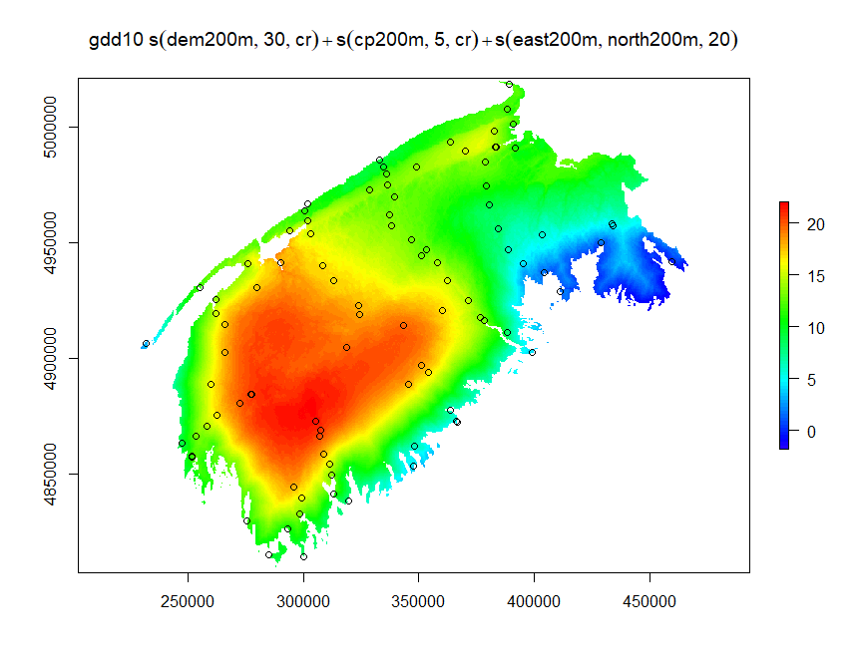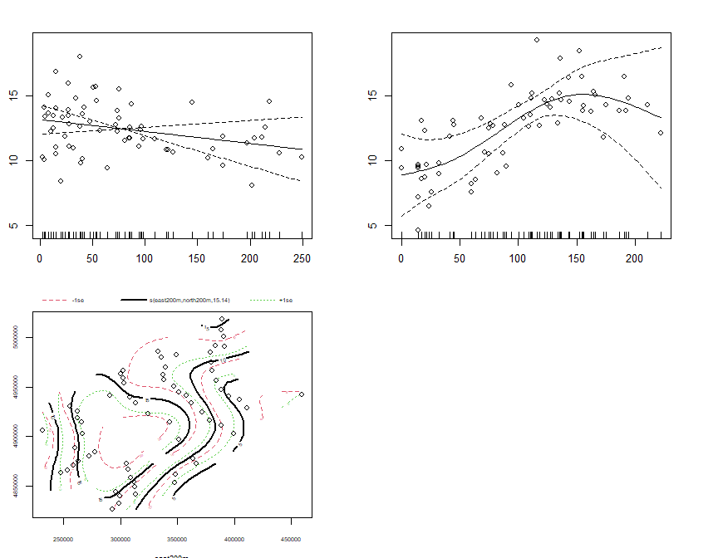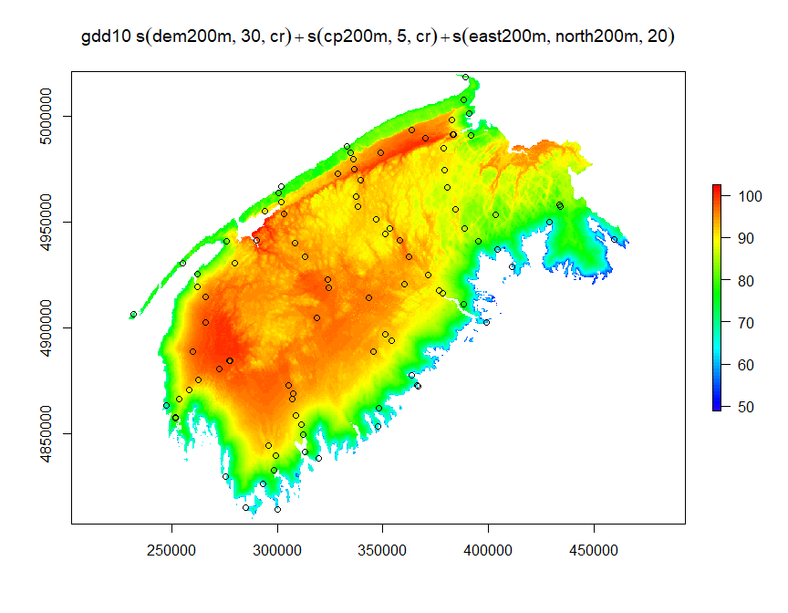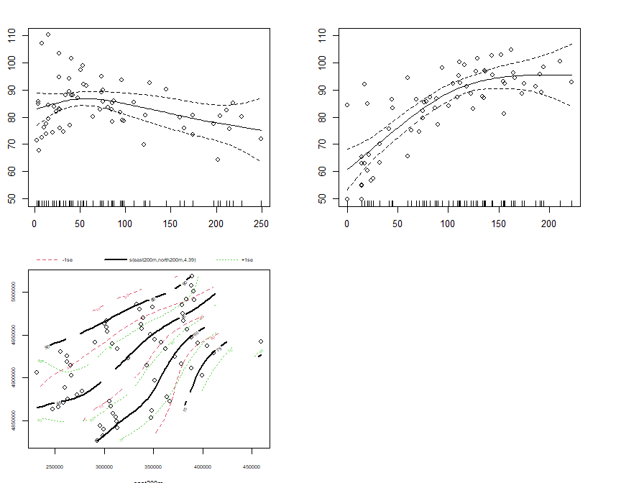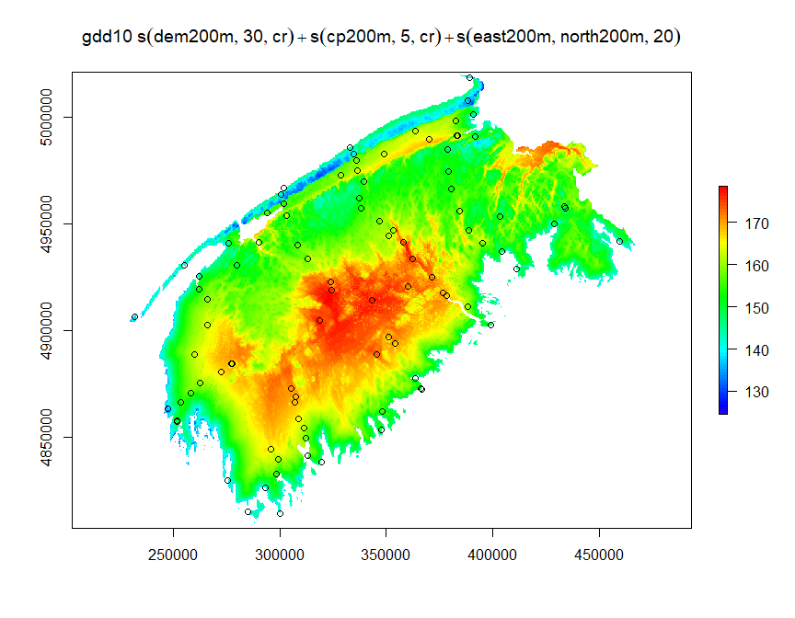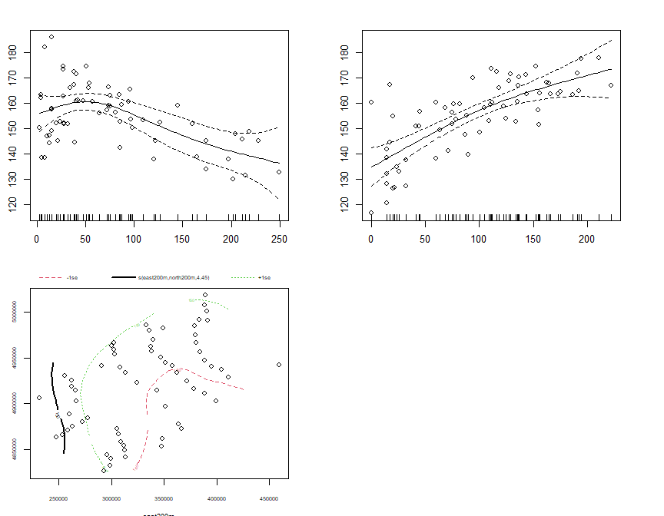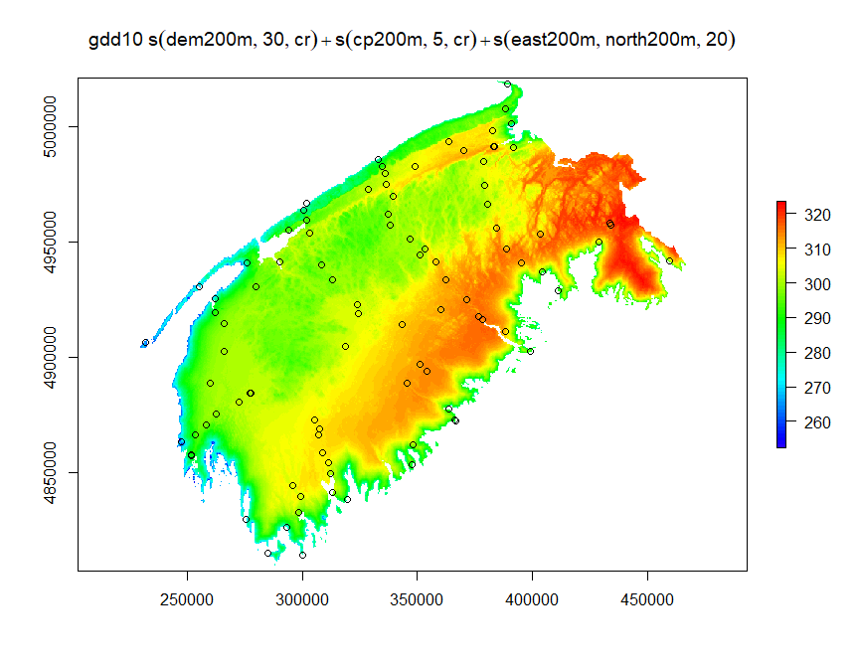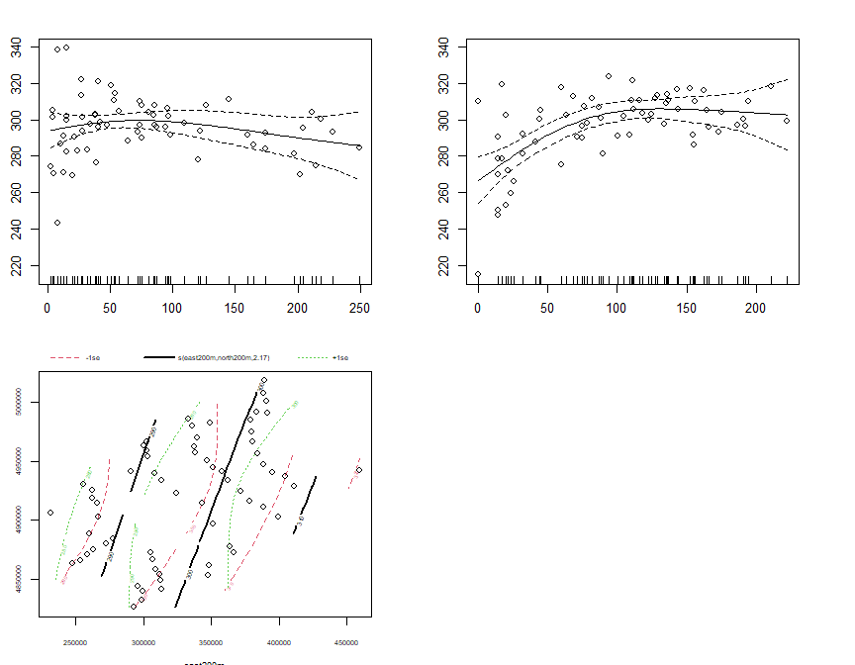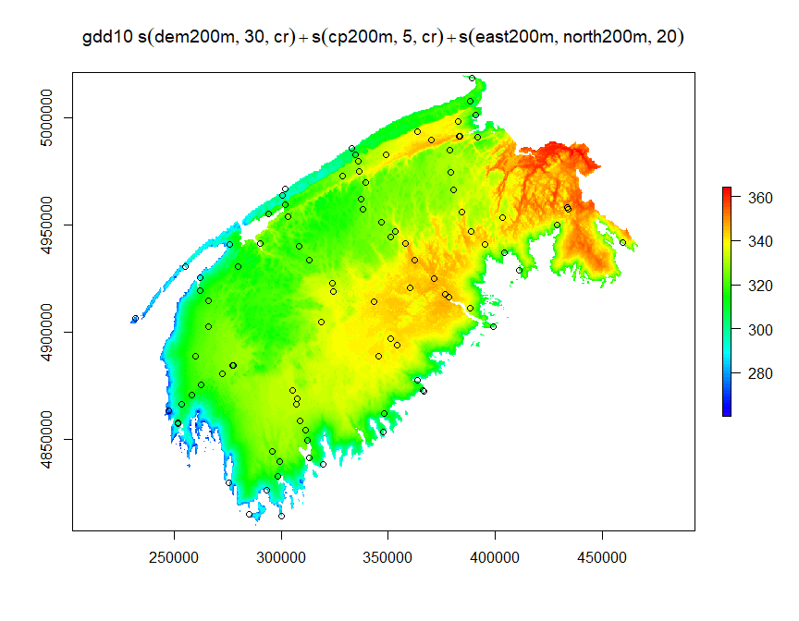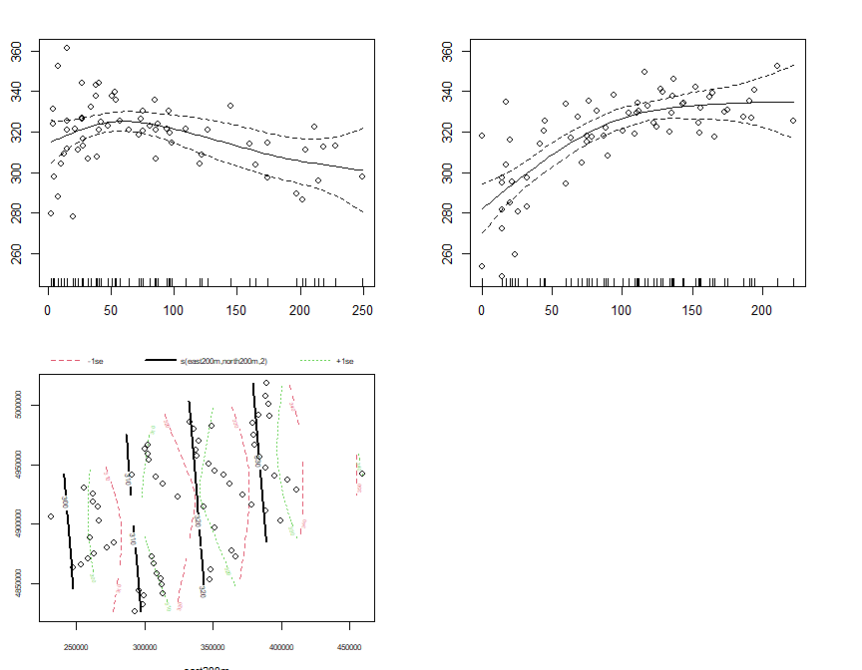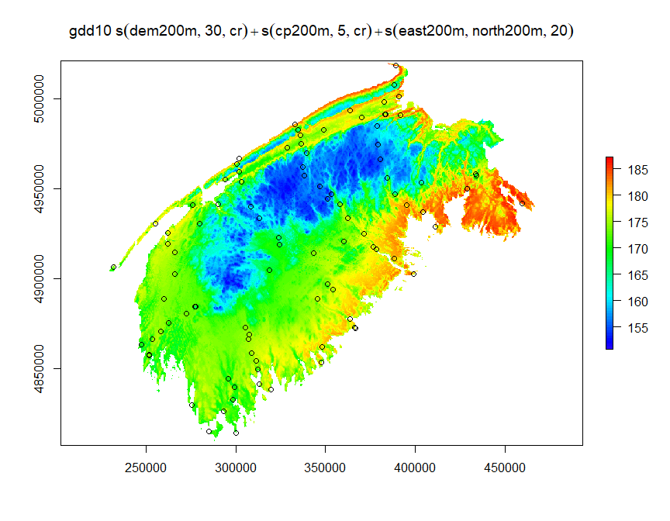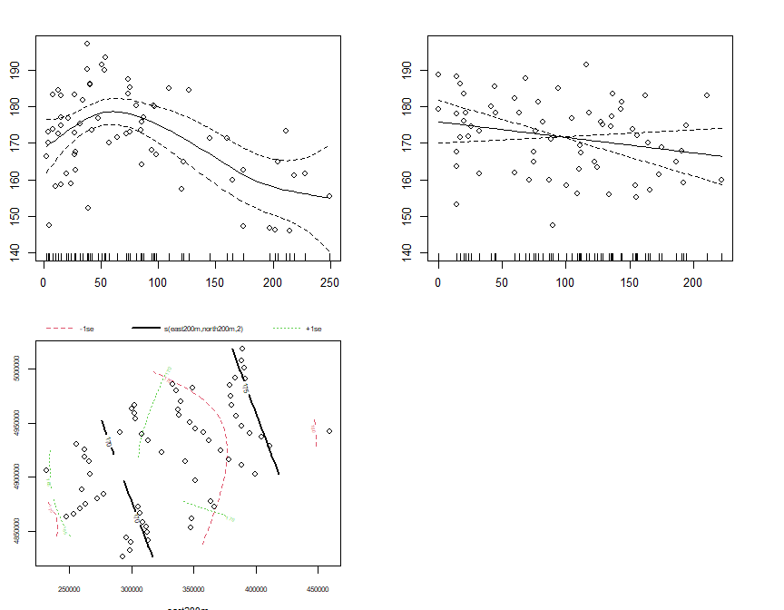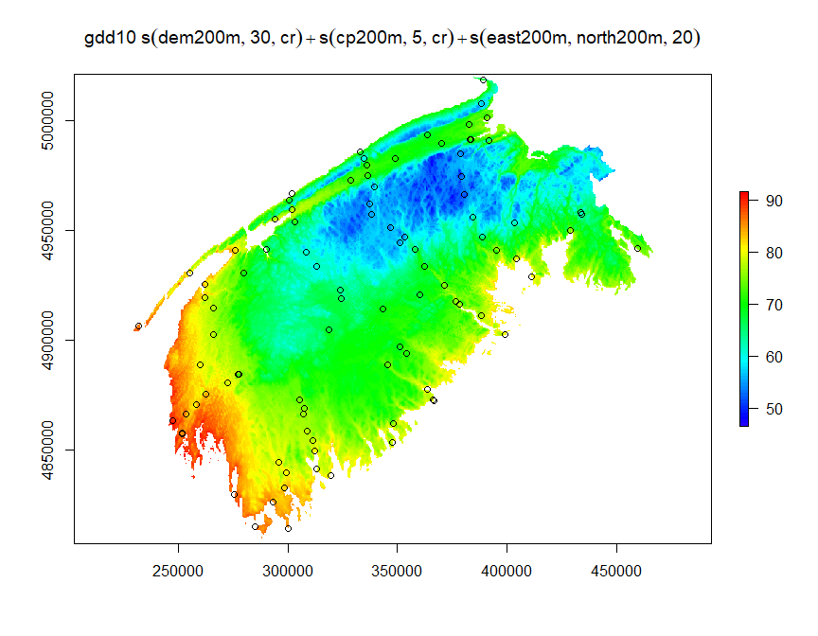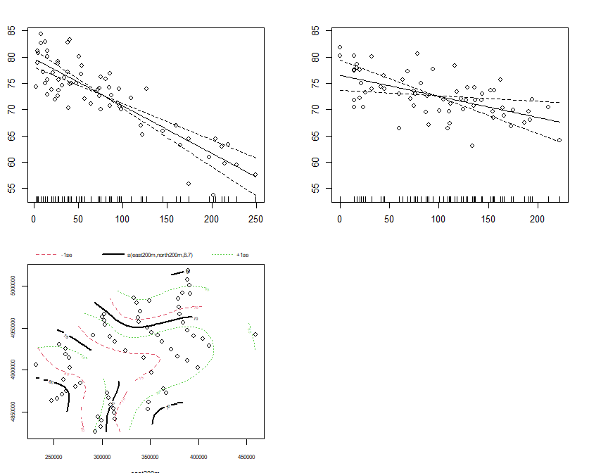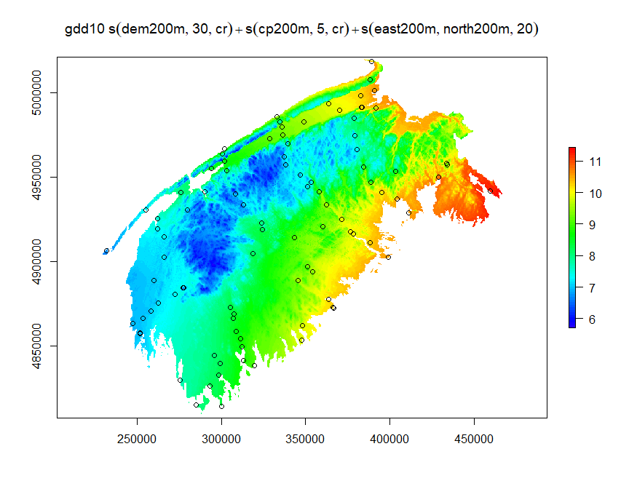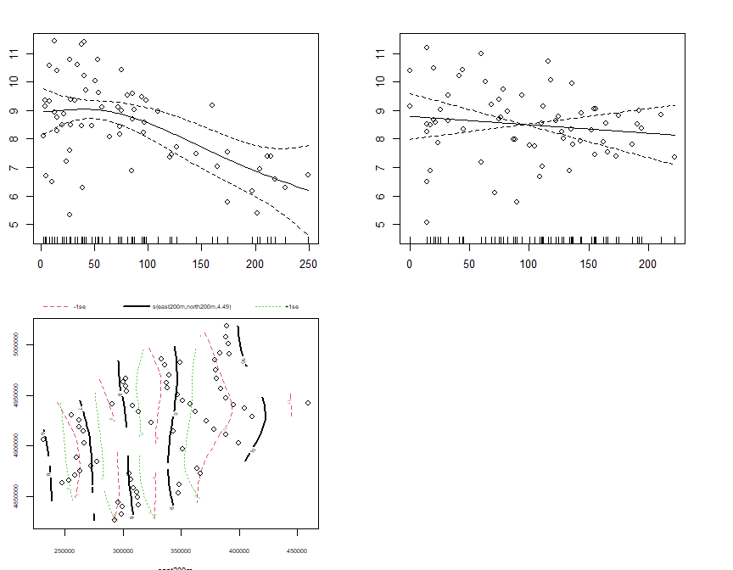

sum_raster_brick <- brick(gam_rasters)  
sum_rasters[[w]] <- raster::calc(sum_raster_brick, sum)  
plot(sum_rasters[[w]], main=m$formula, col=rev(rainbow(100)[1:70]))

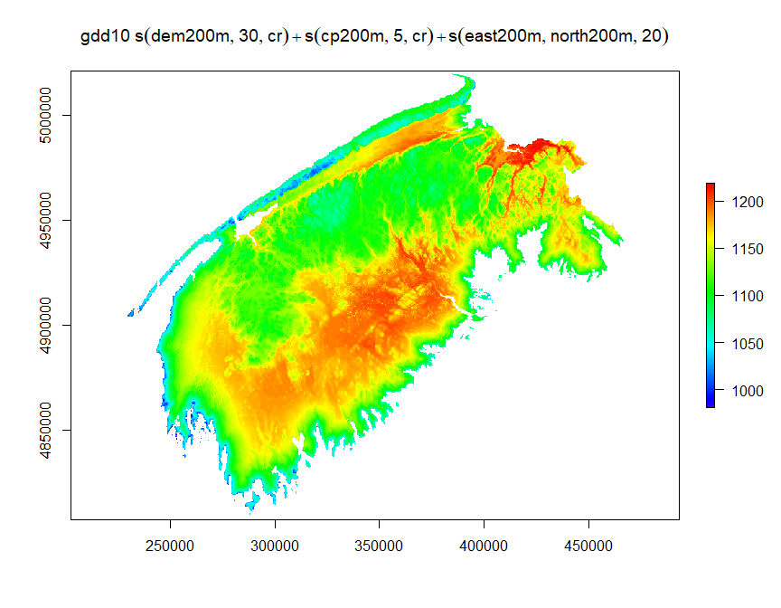

w <- w +1

2013

months <- df_13$month %>% unique()  
  
m_list <- list()  
c = 1  
for(month in months){  
 df_month <- df_13 %>% dplyr::filter(month== !!month)  
 m_list[[c]] <- gam(gdd10~s(dem200m,k=30,bs='cr')+s(cp200m,k=5,bs='cr')+s(east200m,north200m,k=20),data=df_month,method='REML',family=gaussian())  
 c <- c+1  
  
}  
gam_rasters <- list()  
j <- 1  
for(m in m_list){  
 gam_rasters[[j]] <- raster::predict(rasters_brick2,m)  
 plot(gam_rasters[[j]], main=m$formula, col=rev(rainbow(100)[1:70]))  
 points(swns_stations_sp)  
 par(mfrow=c(2,2))  
 plot.gam(m, residuals = TRUE, pch = 1, cex = 1, shift = coef(m)[1])  
 par(mfrow=c(1,1))  
 j <- j + 1  
}

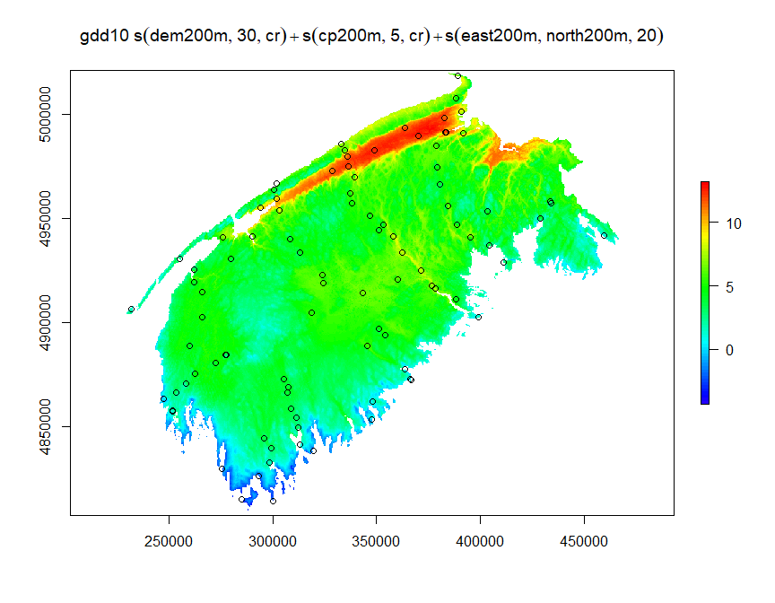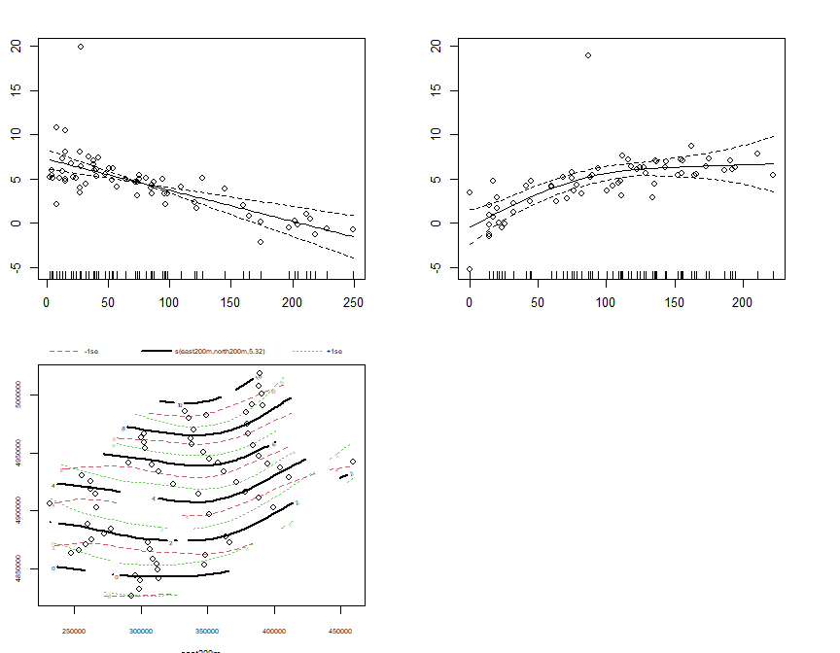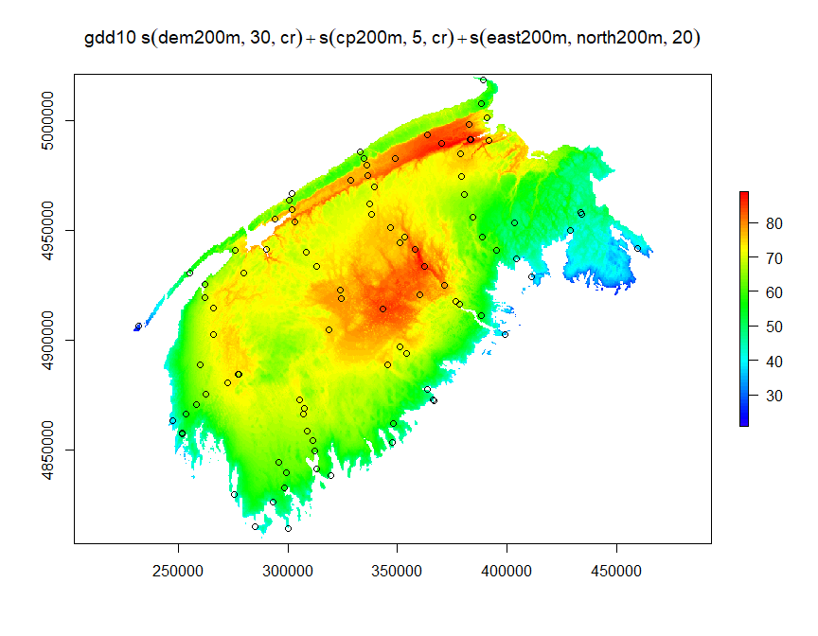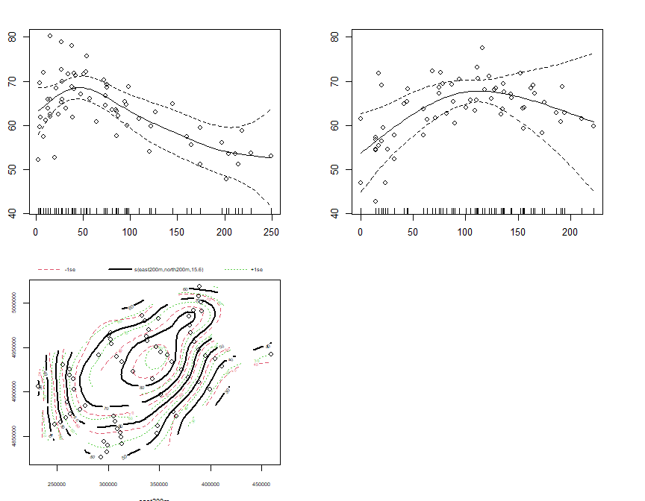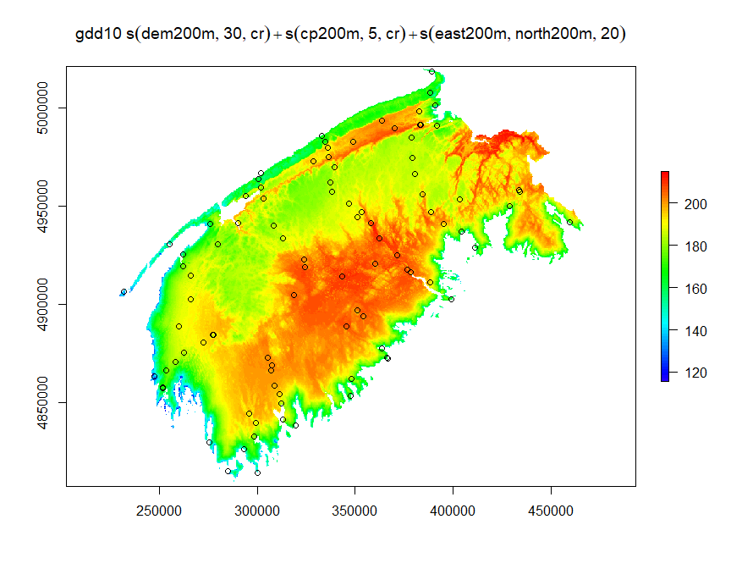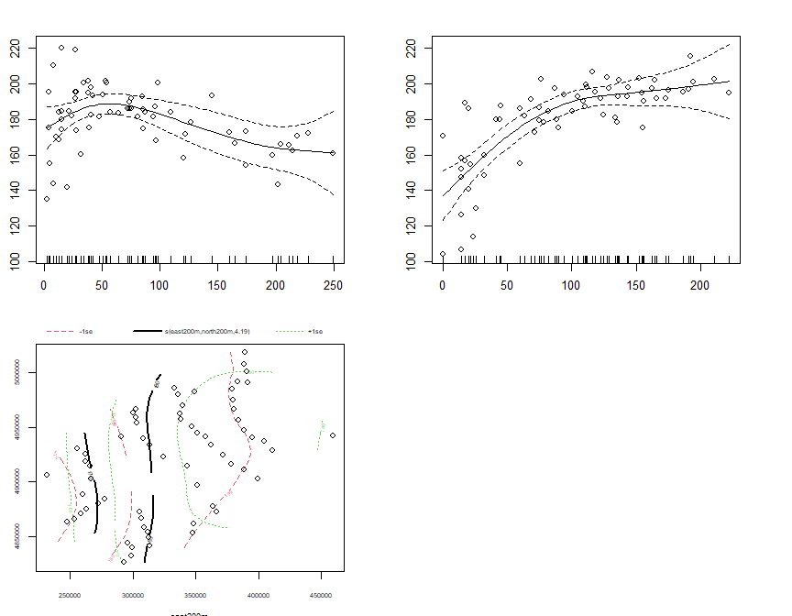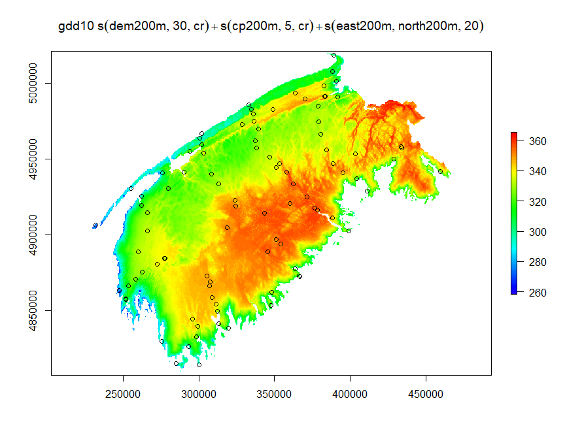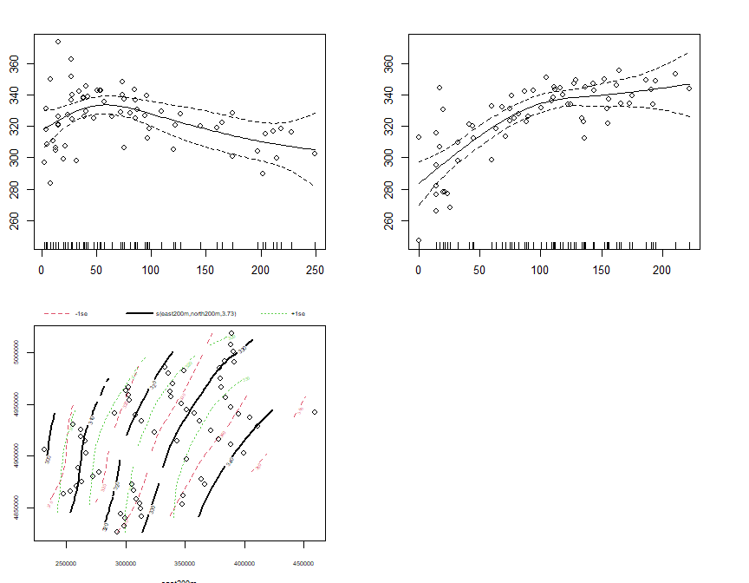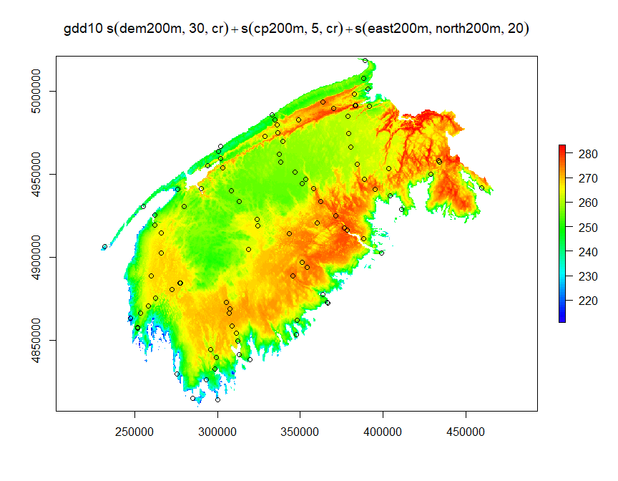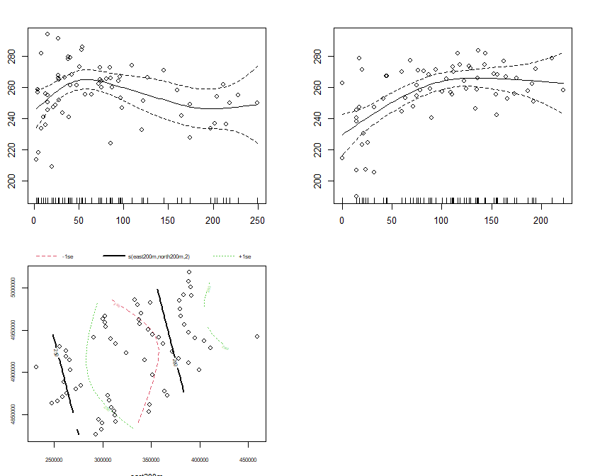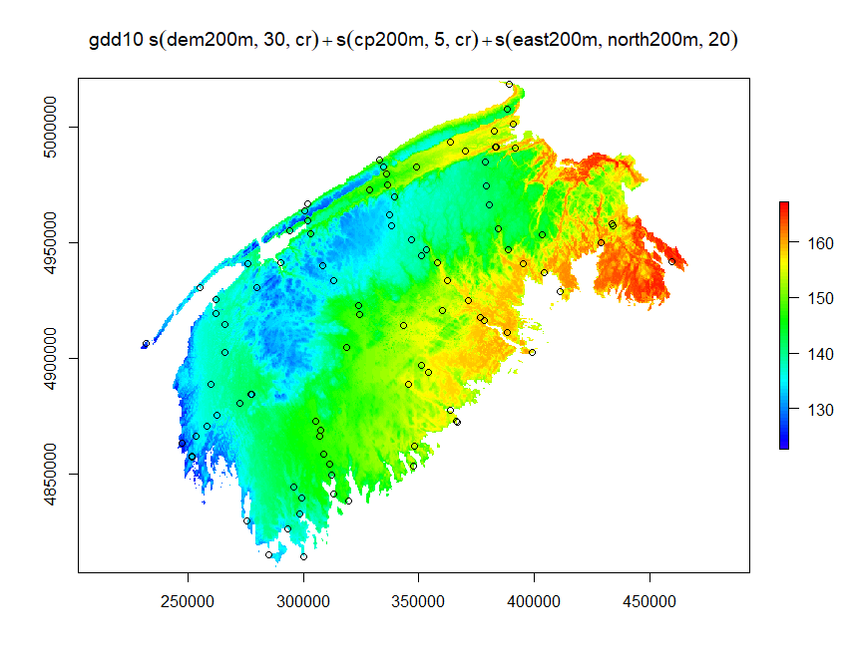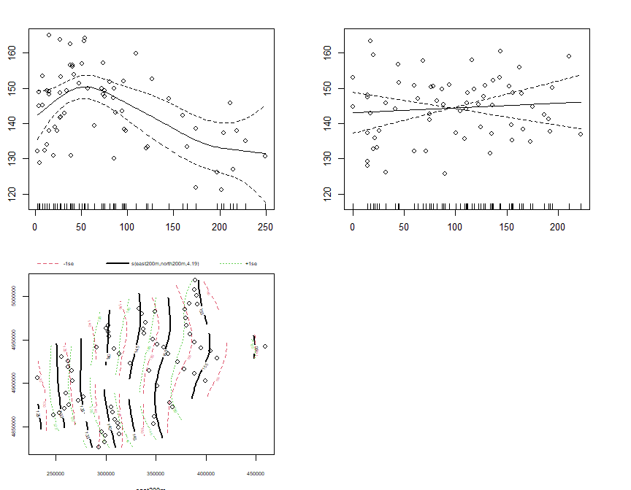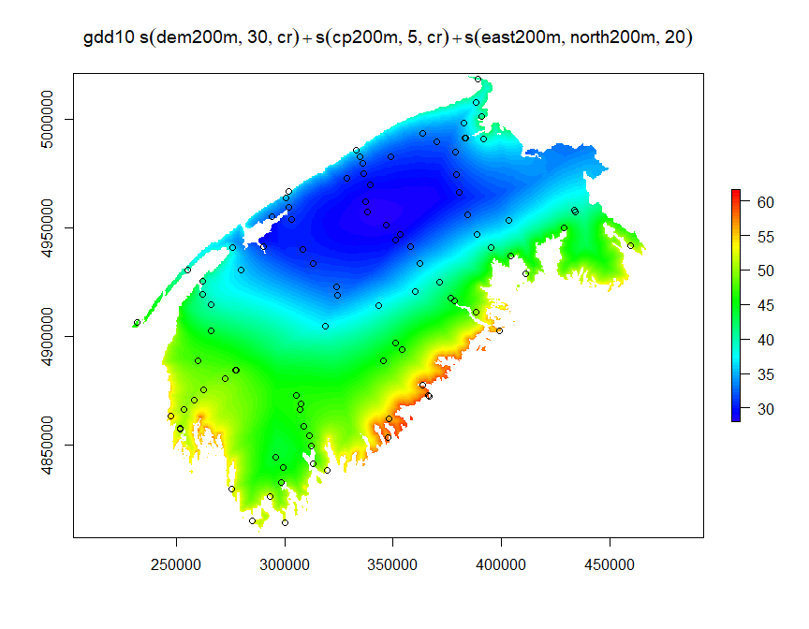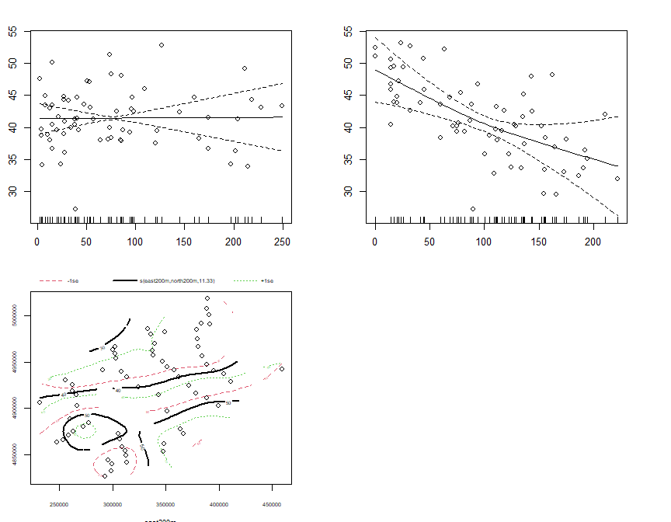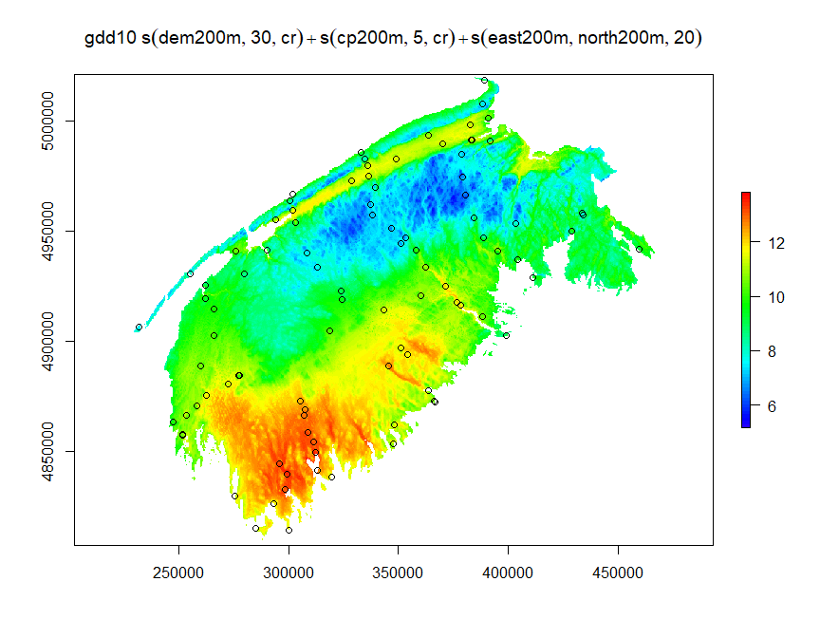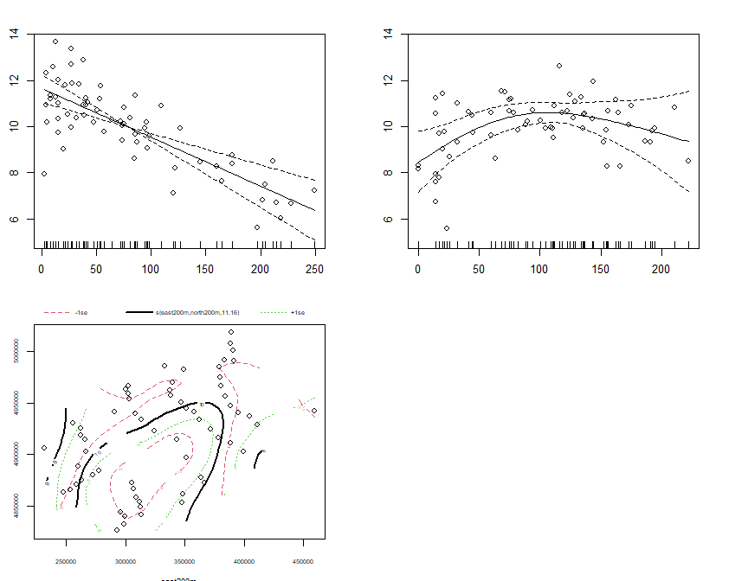

sum_raster_brick <- brick(gam_rasters)  
sum_rasters[[w]] <- raster::calc(sum_raster_brick, sum)  
plot(sum_rasters[[w]], main=m$formula, col=rev(rainbow(100)[1:70]))

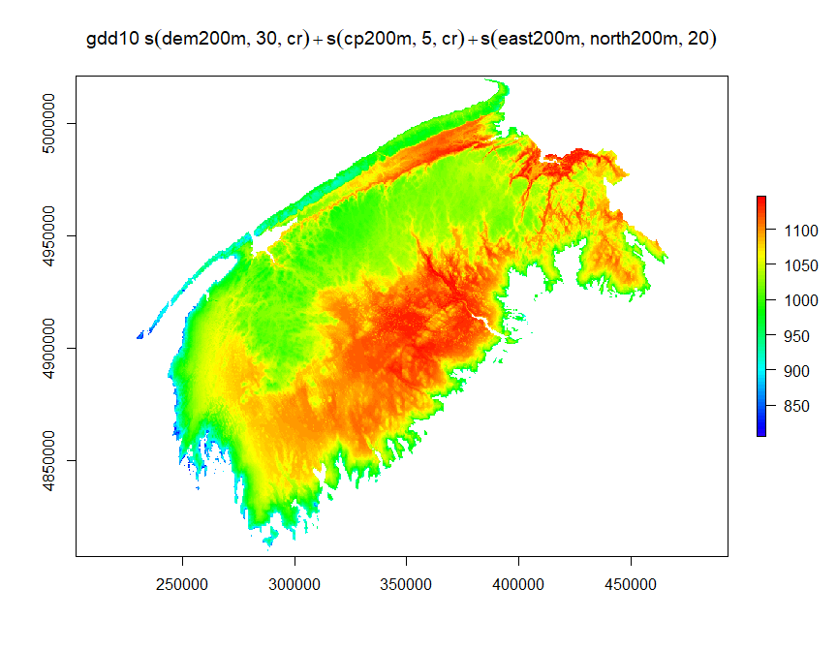

w <- w+1

2014

months <- df_14$month %>% unique()  
  
m_list <- list()  
c = 1  
for(month in months){  
 df_month <- df_14 %>% dplyr::filter(month== !!month)  
 m_list[[c]] <- gam(gdd10~s(dem200m,k=30,bs='cr')+s(cp200m,k=5,bs='cr')+s(east200m,north200m,k=20),data=df_month,method='REML',family=gaussian())  
 c <- c+1  
  
}  
gam_rasters <- list()  
j <- 1  
for(m in m_list){  
 gam_rasters[[j]] <- raster::predict(rasters_brick2,m)  
 plot(gam_rasters[[j]], main=m$formula, col=rev(rainbow(100)[1:70]))  
 points(swns_stations_sp)  
 par(mfrow=c(2,2))  
 plot.gam(m, residuals = TRUE, pch = 1, cex = 1, shift = coef(m)[1])  
 par(mfrow=c(1,1))  
 j <- j + 1  
}

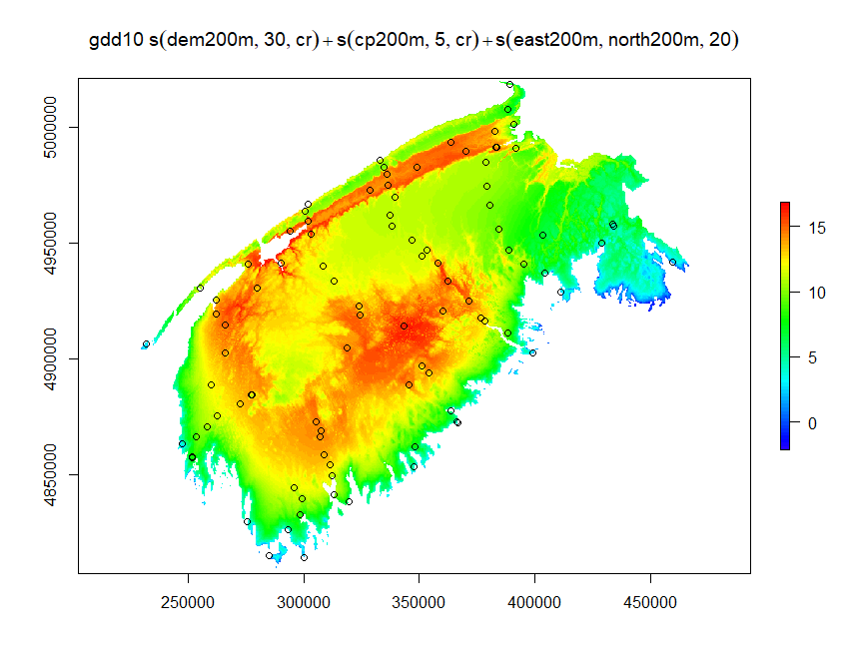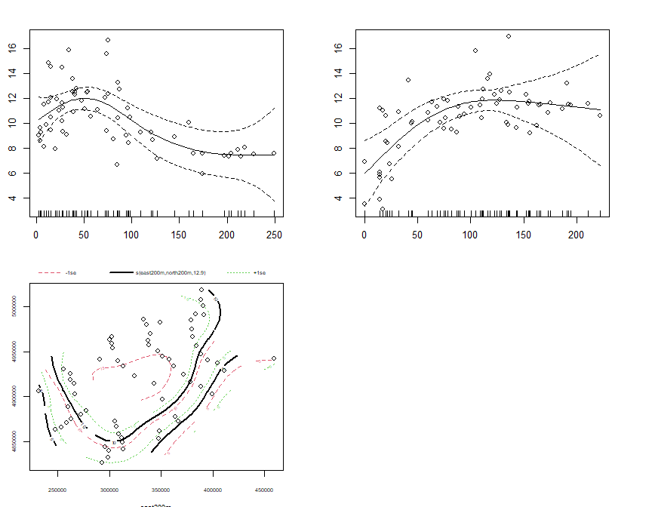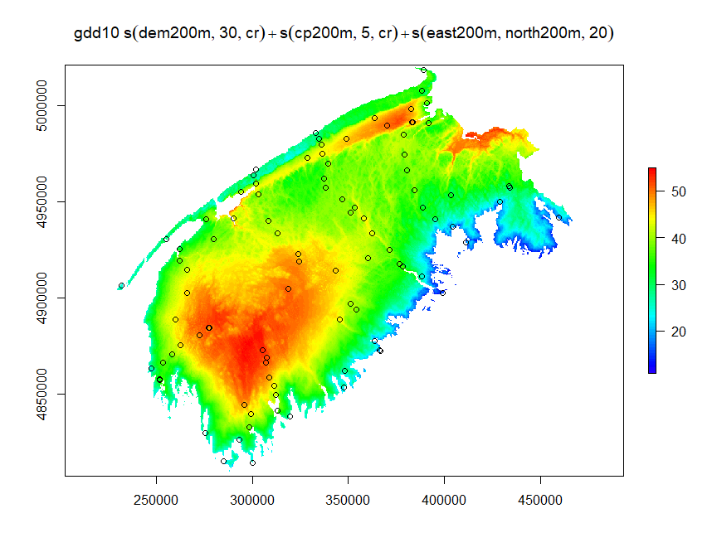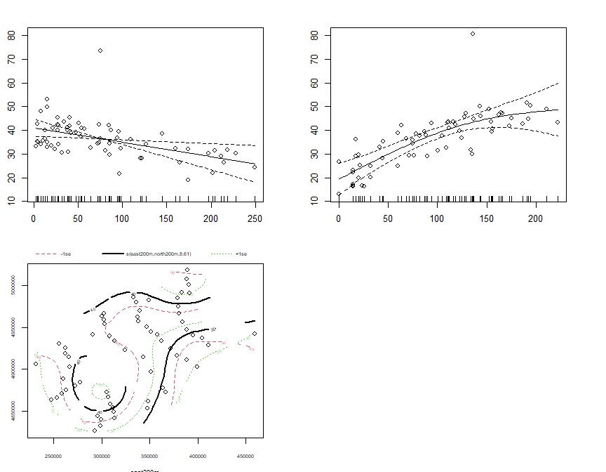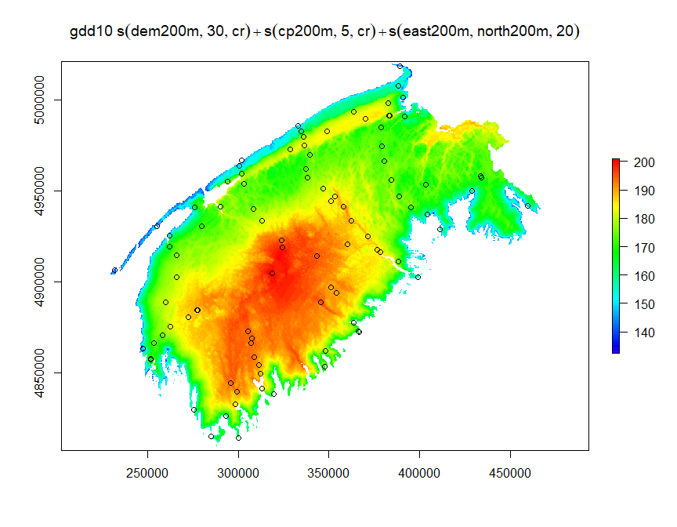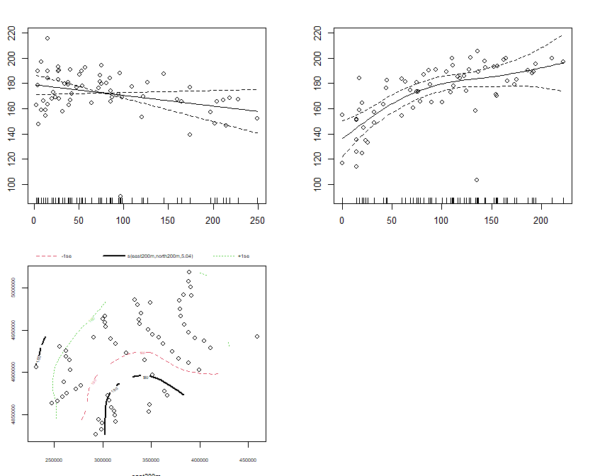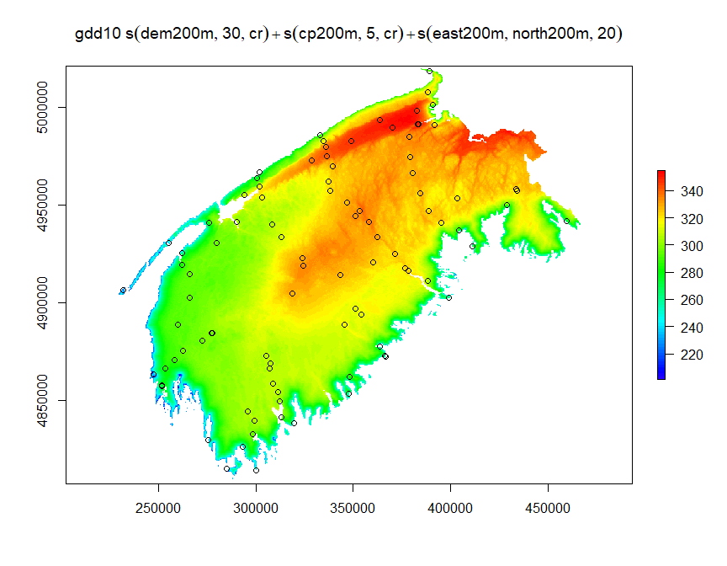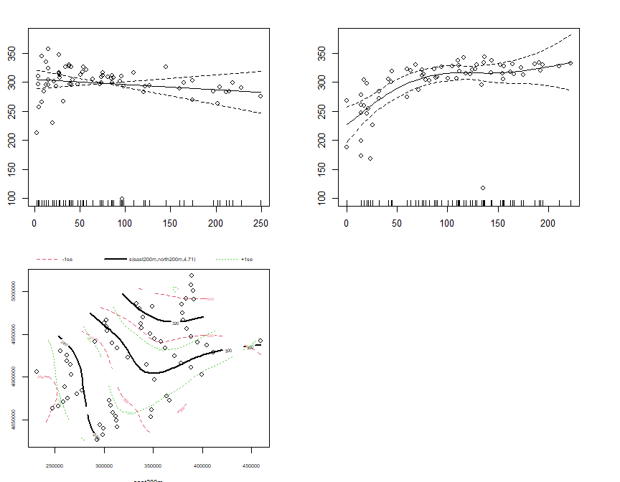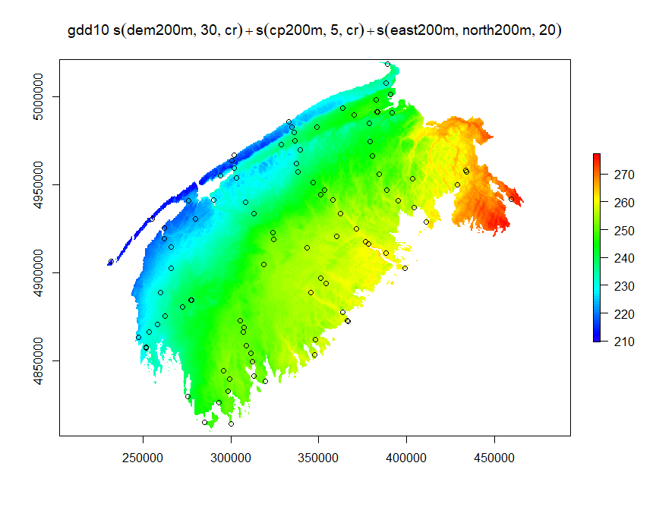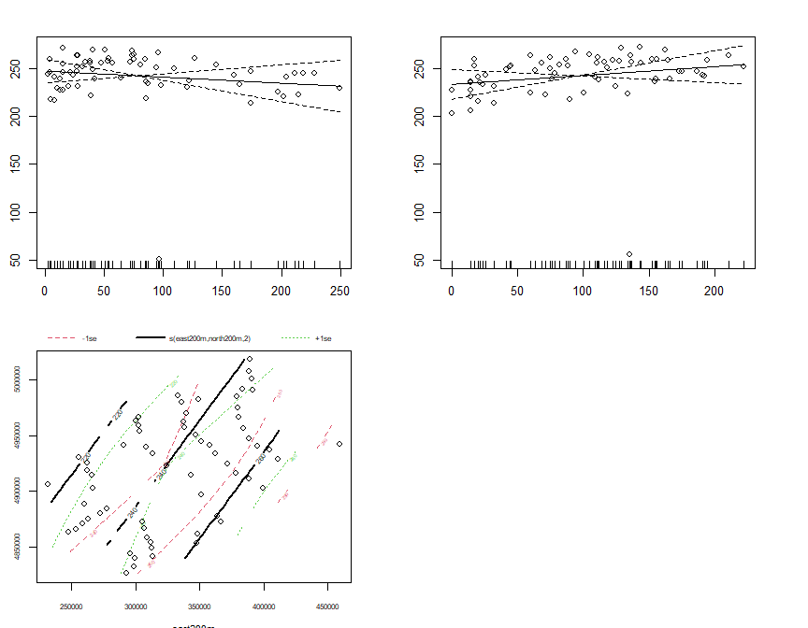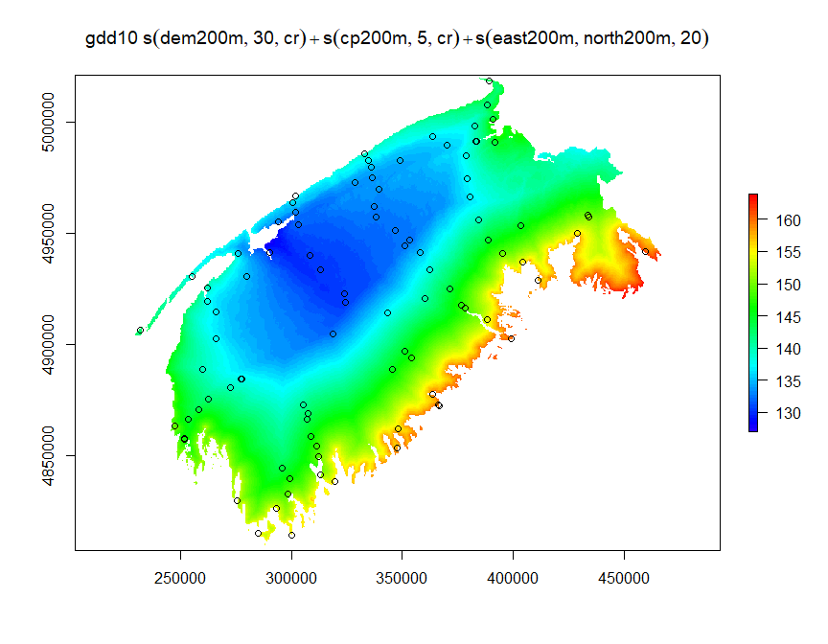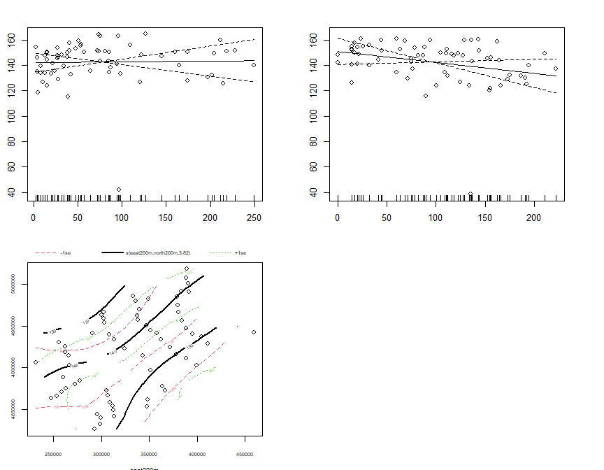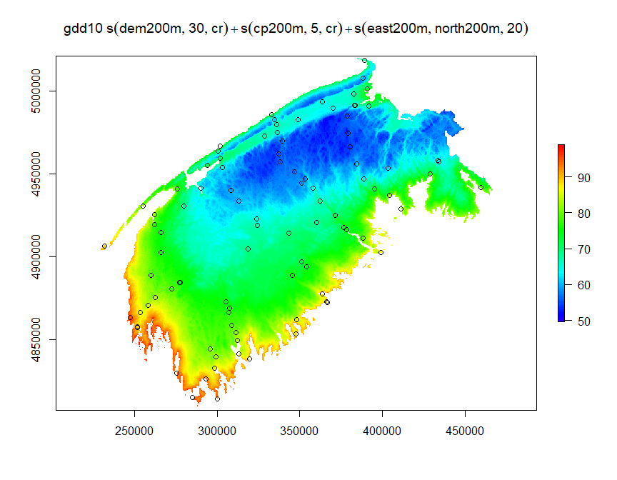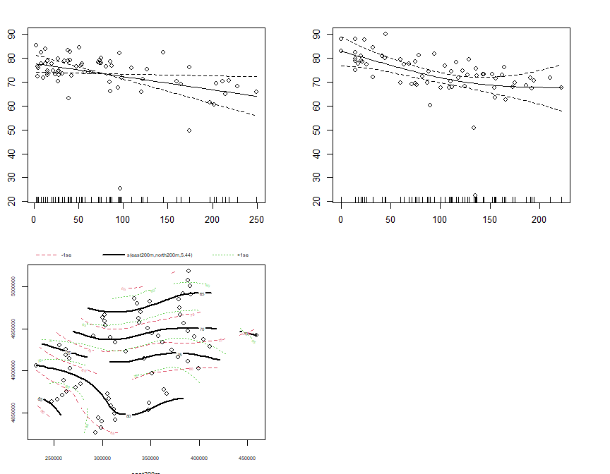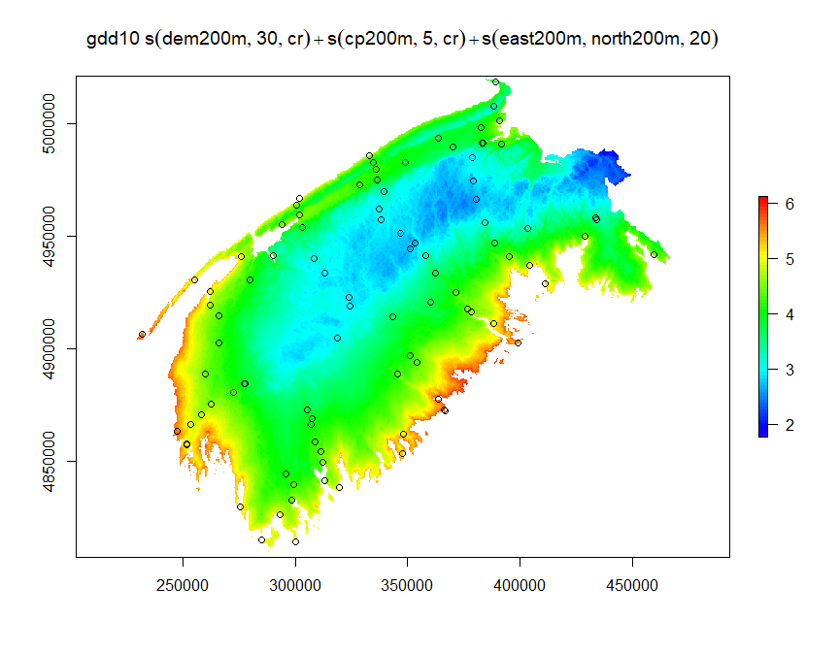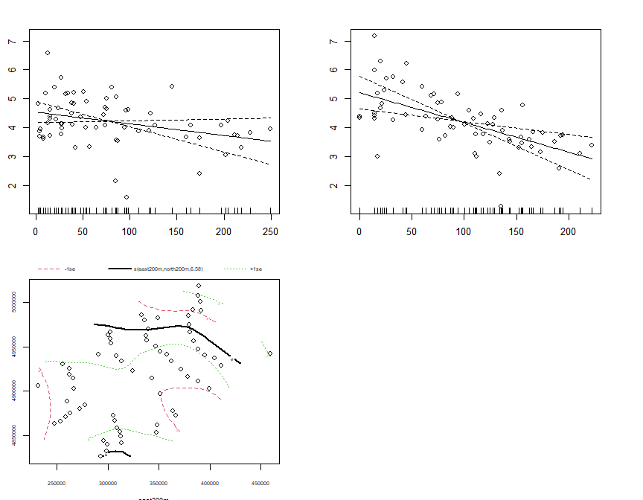

sum_raster_brick <- brick(gam_rasters)  
sum_rasters[[w]] <- raster::calc(sum_raster_brick, sum)  
plot(sum_rasters[[w]], main=m$formula, col=rev(rainbow(100)[1:70]))

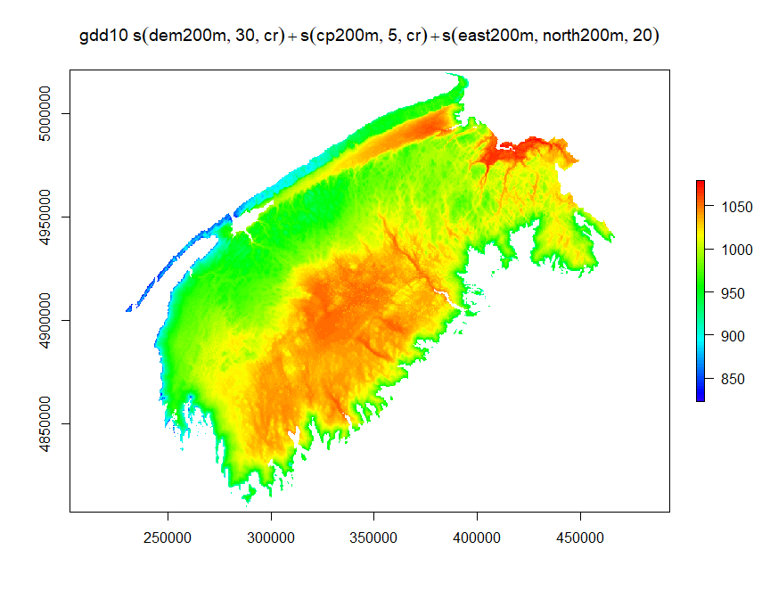

w <- w+1

2015

months <- df_15$month %>% unique()  
  
m_list <- list()  
c = 1  
for(month in months){  
 df_month <- df_15 %>% dplyr::filter(month== !!month)  
 m_list[[c]] <- gam(gdd10~s(dem200m,k=30,bs='cr')+s(cp200m,k=5,bs='cr')+s(east200m,north200m,k=20),data=df_month,method='REML',family=gaussian())  
 c <- c+1  
  
}  
gam_rasters <- list()  
j <- 1  
for(m in m_list){  
 gam_rasters[[j]] <- raster::predict(rasters_brick2,m)  
 plot(gam_rasters[[j]], main=m$formula, col=rev(rainbow(100)[1:70]))  
 points(swns_stations_sp)  
 par(mfrow=c(2,2))  
 plot.gam(m, residuals = TRUE, pch = 1, cex = 1, shift = coef(m)[1])  
 par(mfrow=c(1,1))  
 j <- j + 1  
}

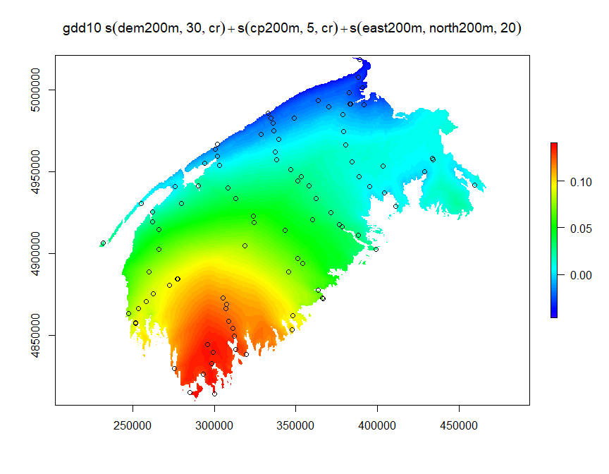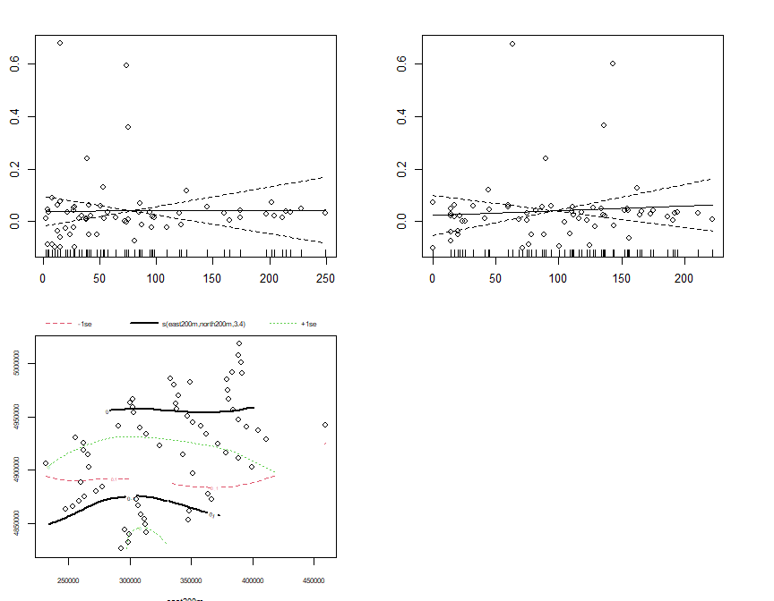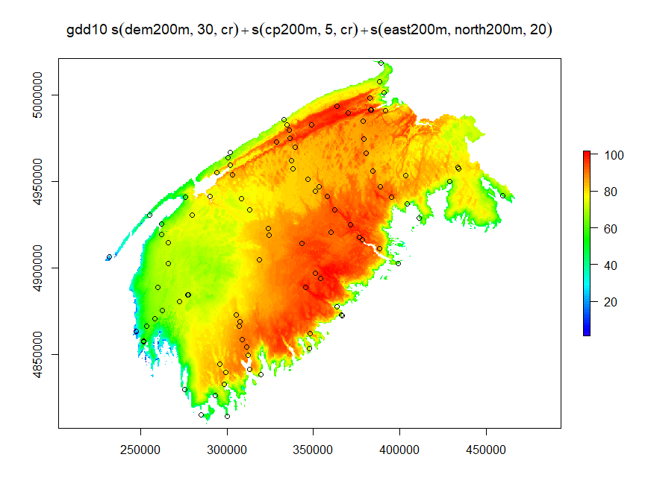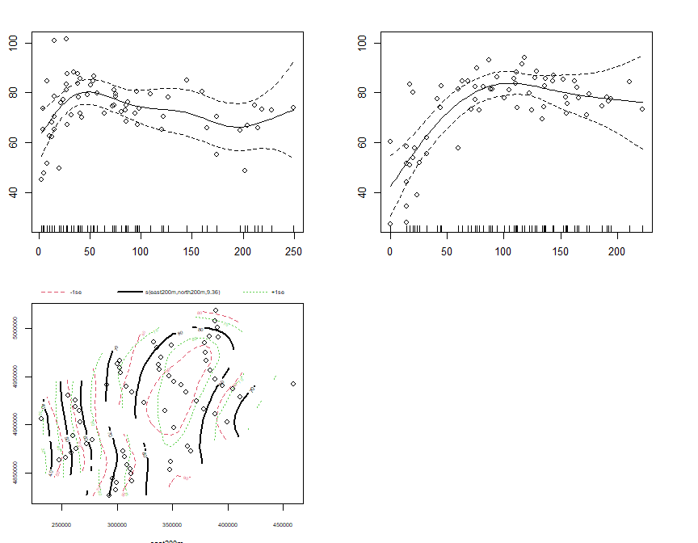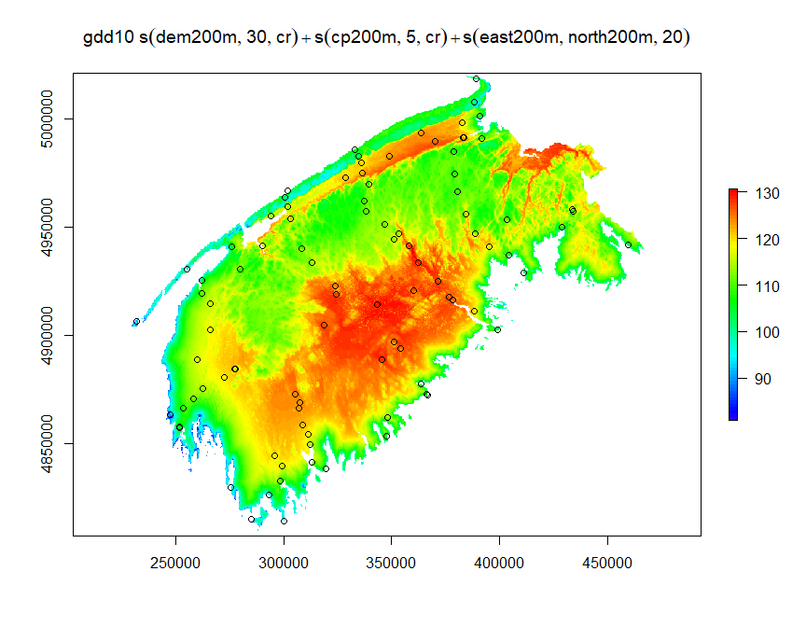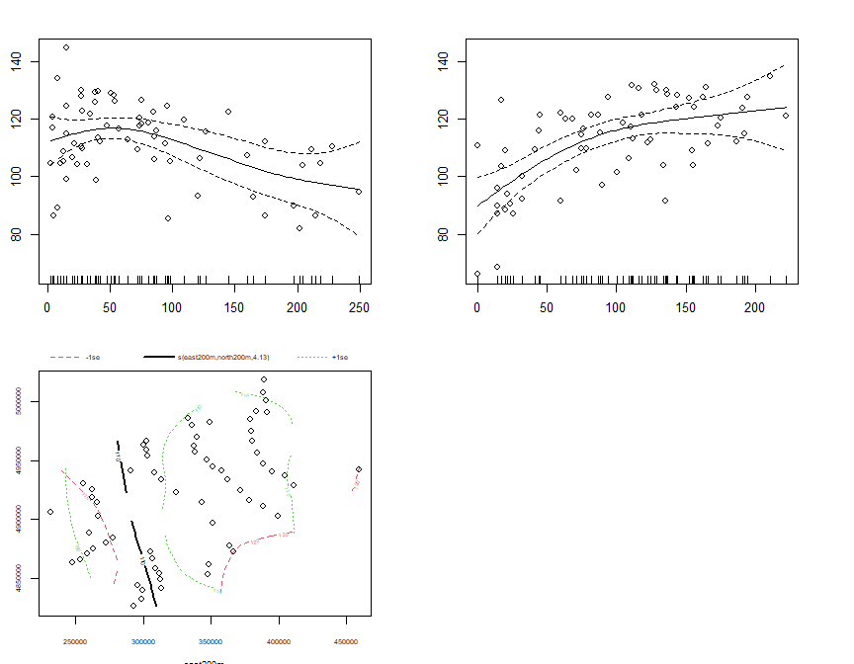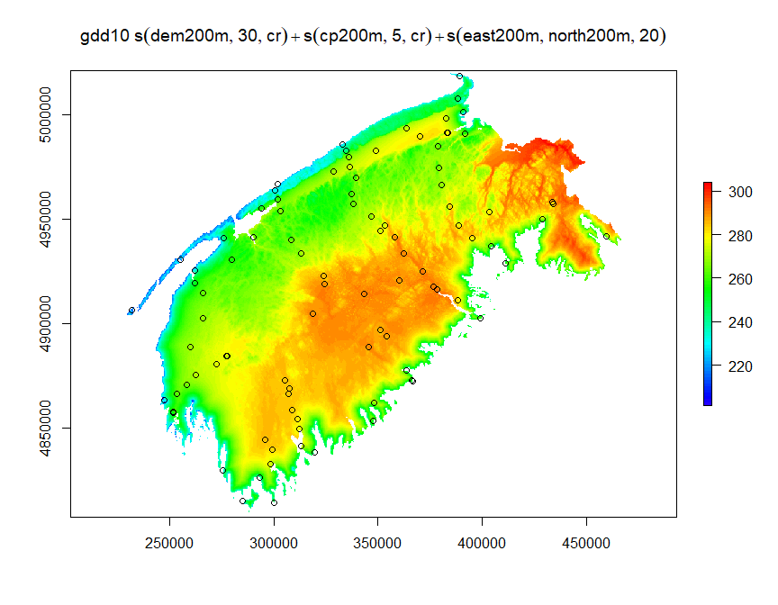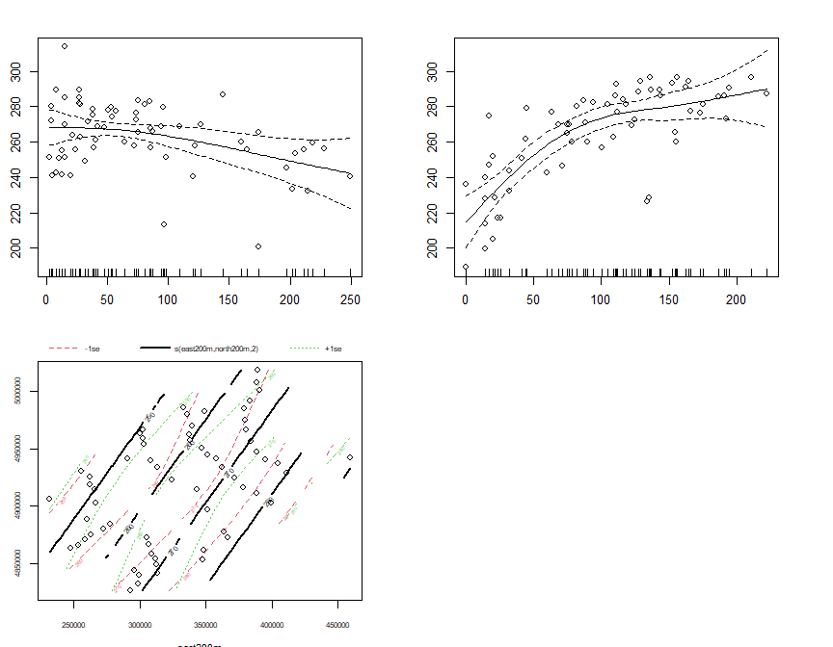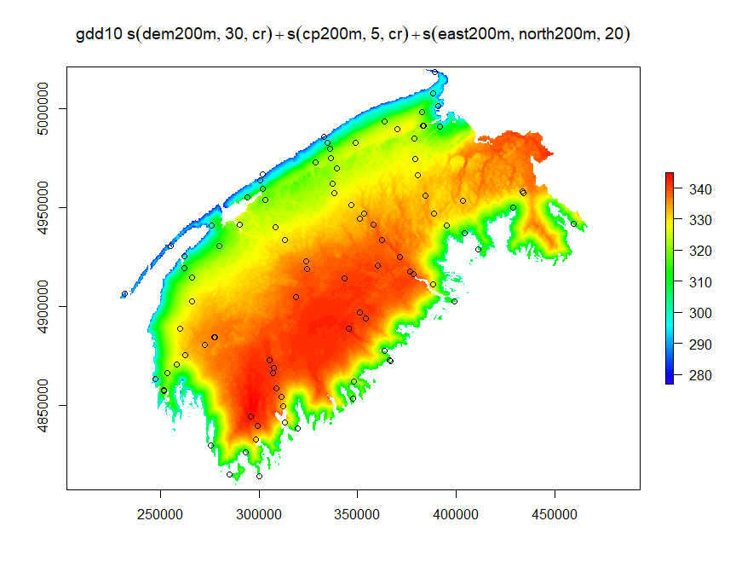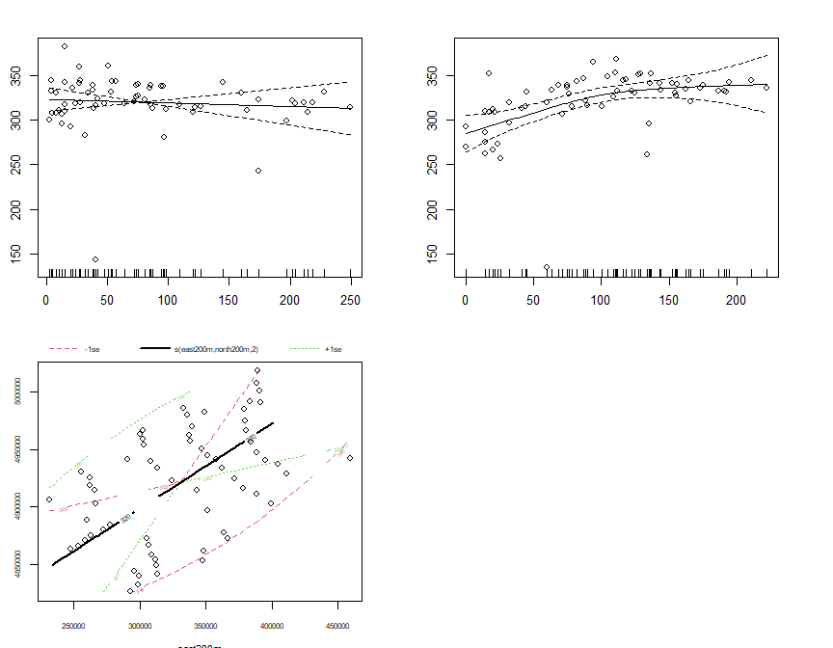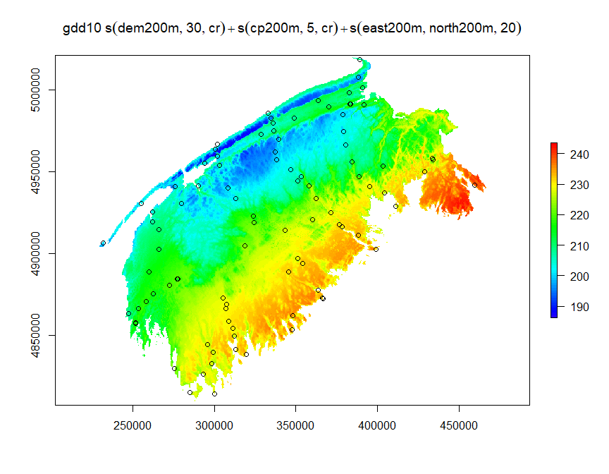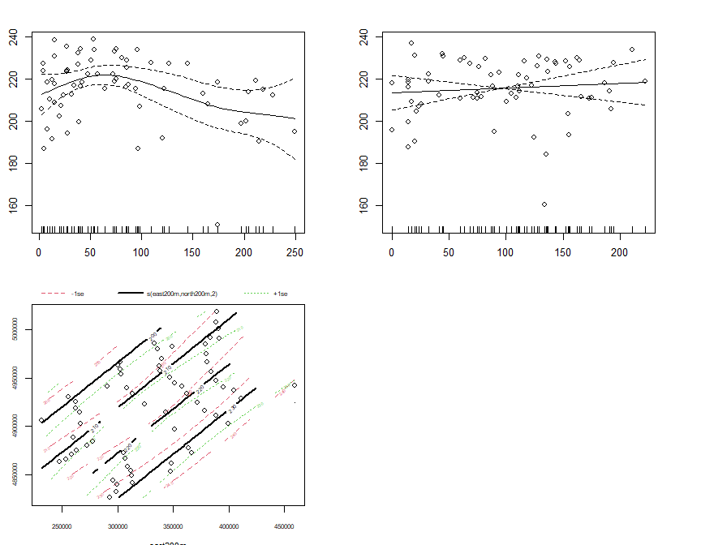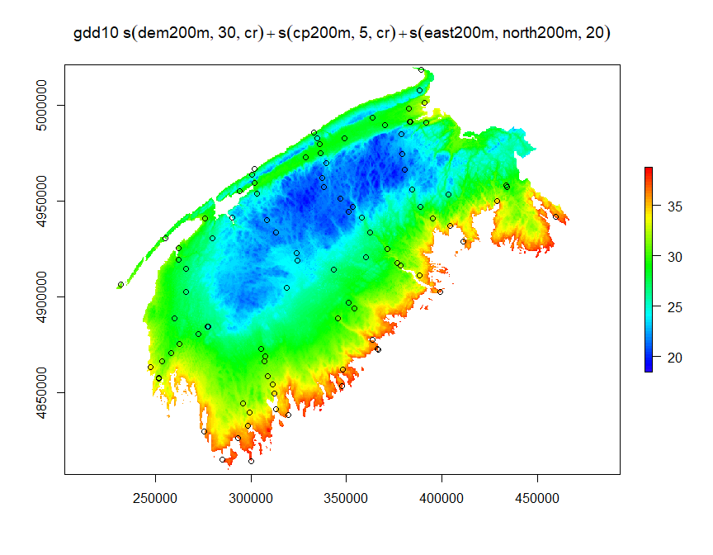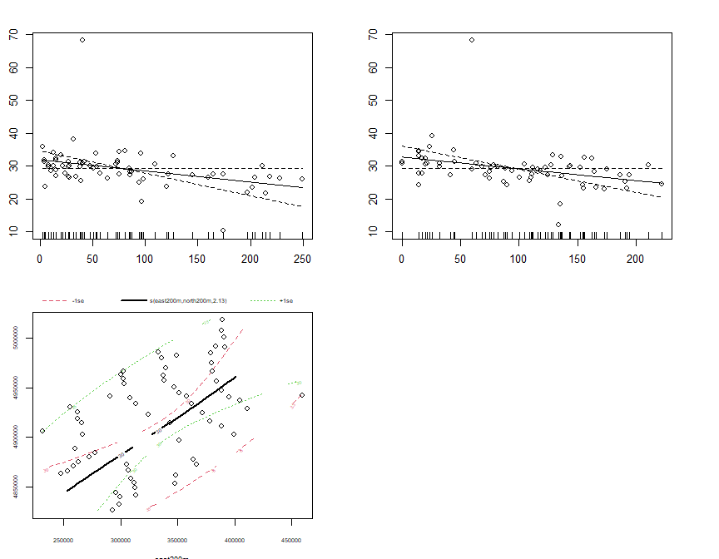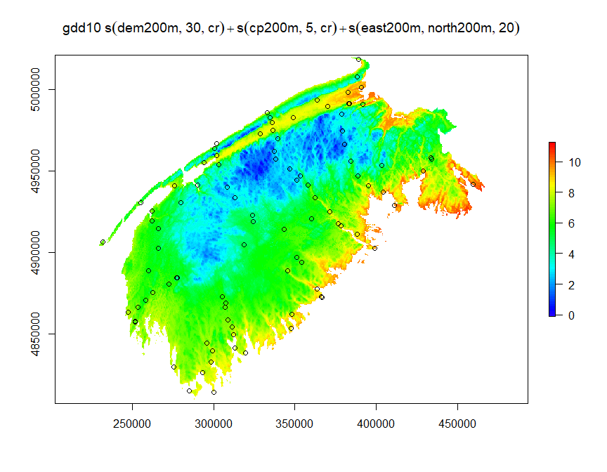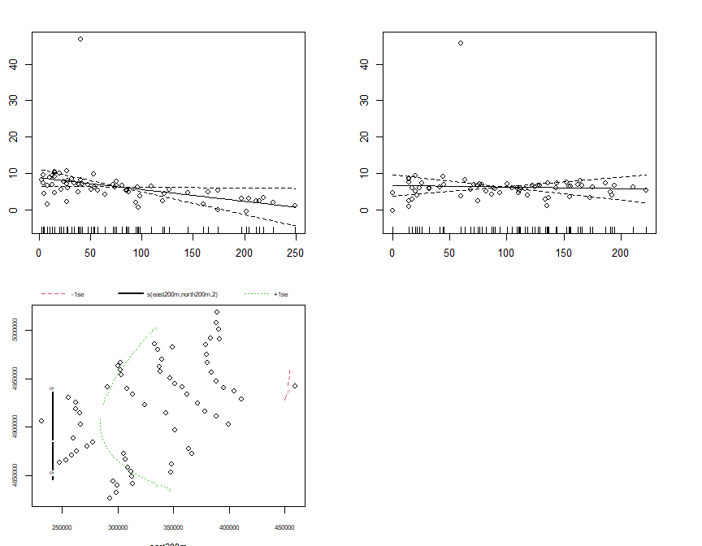

sum_raster_brick <- brick(gam_rasters)  
sum_rasters[[w]] <- raster::calc(sum_raster_brick, sum)  
plot(sum_rasters[[w]], main=m$formula, col=rev(rainbow(100)[1:70]))

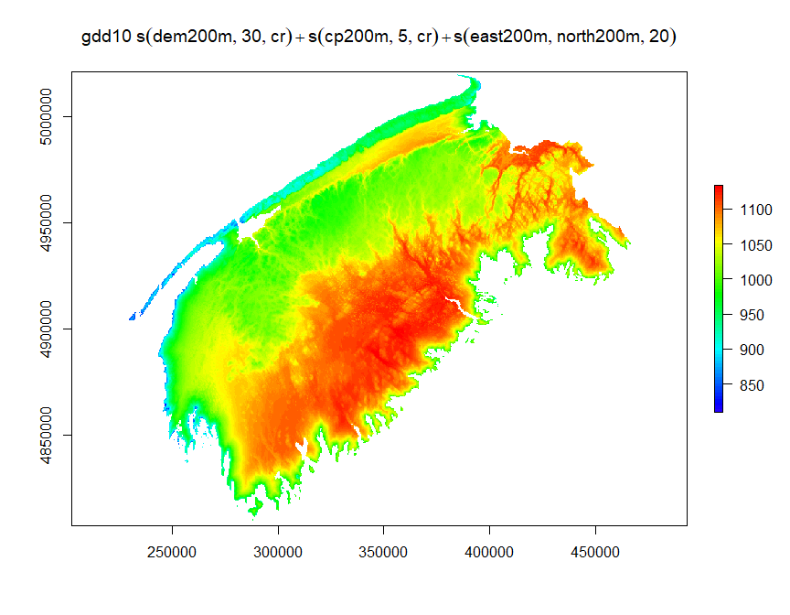

w <- w+1

2016

months <- df_16$month %>% unique()  
  
m_list <- list()  
c = 1  
for(month in months){  
 df_month <- df_16 %>% dplyr::filter(month== !!month)  
 m_list[[c]] <- gam(gdd10~s(dem200m,k=30,bs='cr')+s(cp200m,k=5,bs='cr')+s(east200m,north200m,k=20),data=df_month,method='REML',family=gaussian())  
 c <- c+1  
  
}  
gam_rasters <- list()  
j <- 1  
month_names <- c('April','May','June','July','August','September','October','November')  
for(m in m_list){  
 gam_rasters[[j]] <- raster::predict(rasters_brick2,m)  
 plot(gam_rasters[[j]], main=month_names[[j]], col=rev(rainbow(100)[1:70]))  
 points(swns_stations_sp)  
 par(mfrow=c(2,2))  
 plot.gam(m, residuals = TRUE, pch = 1, cex = 1, shift = coef(m)[1])  
 par(mfrow=c(1,1))  
 j <- j + 1  
}

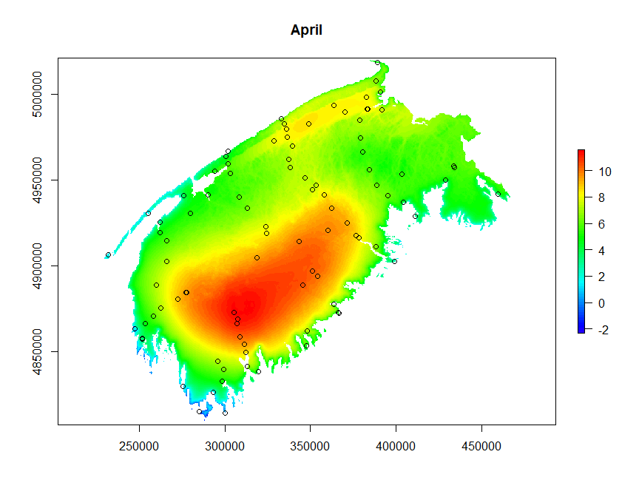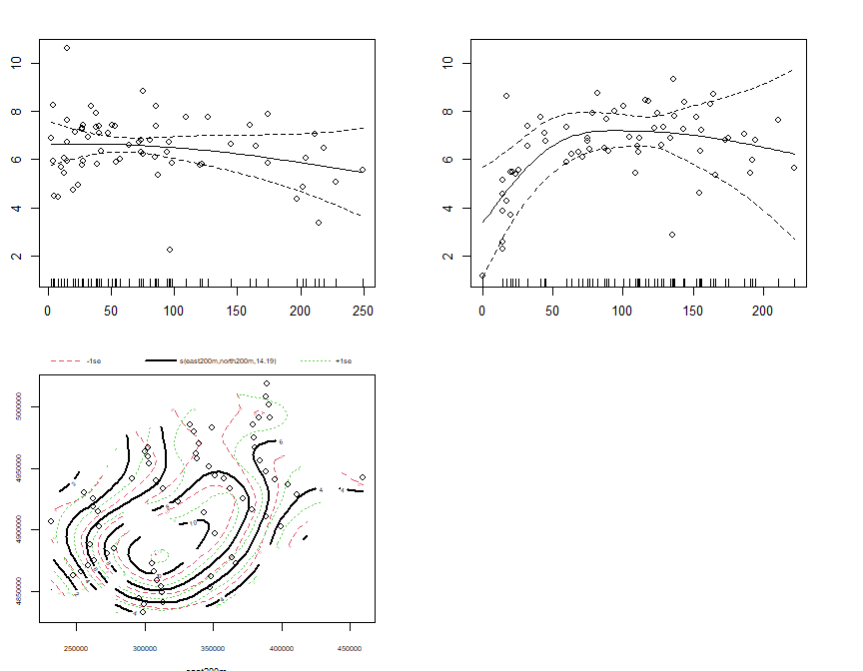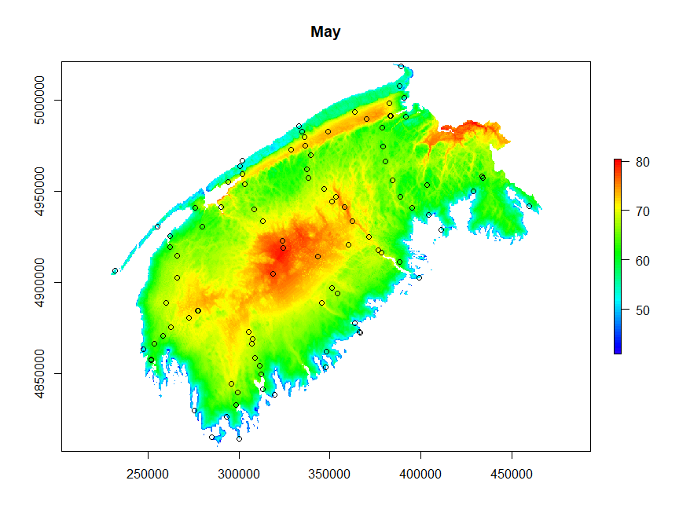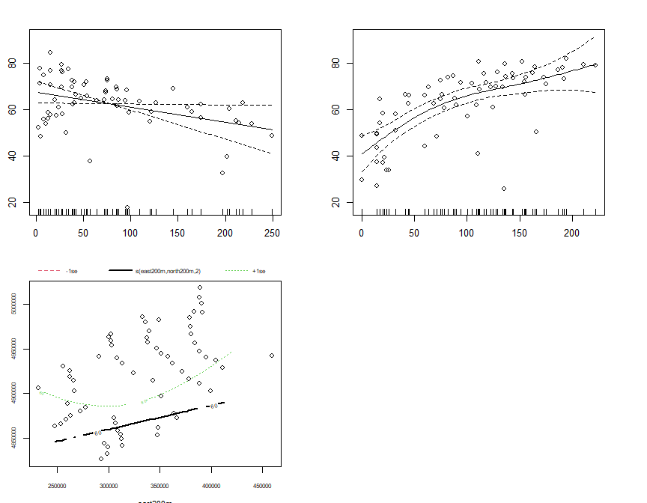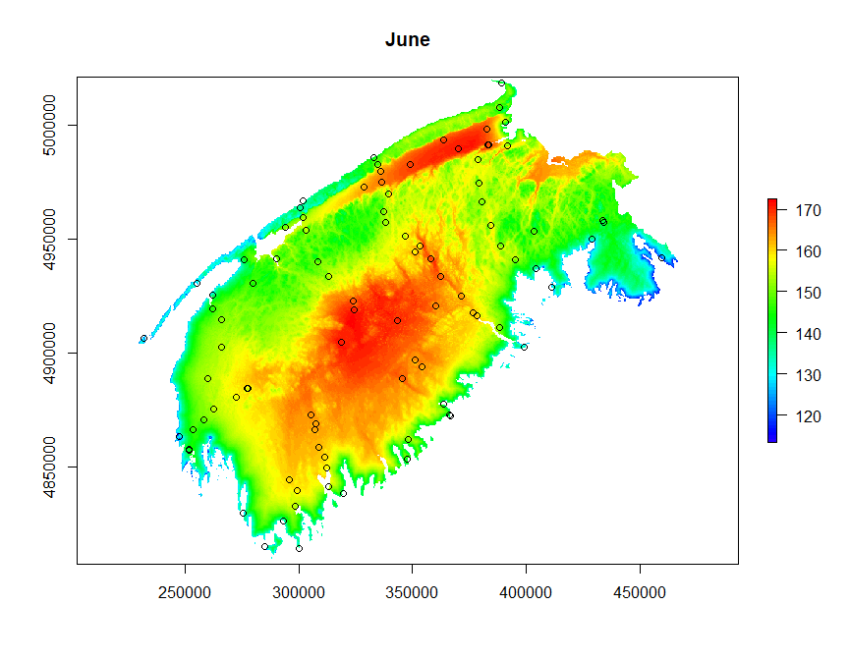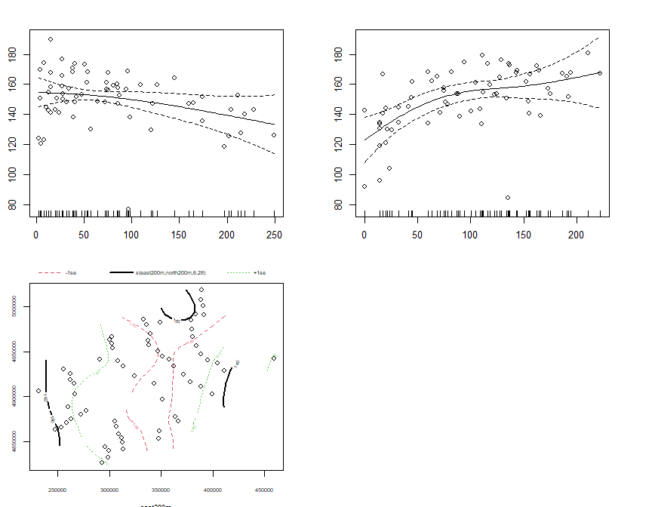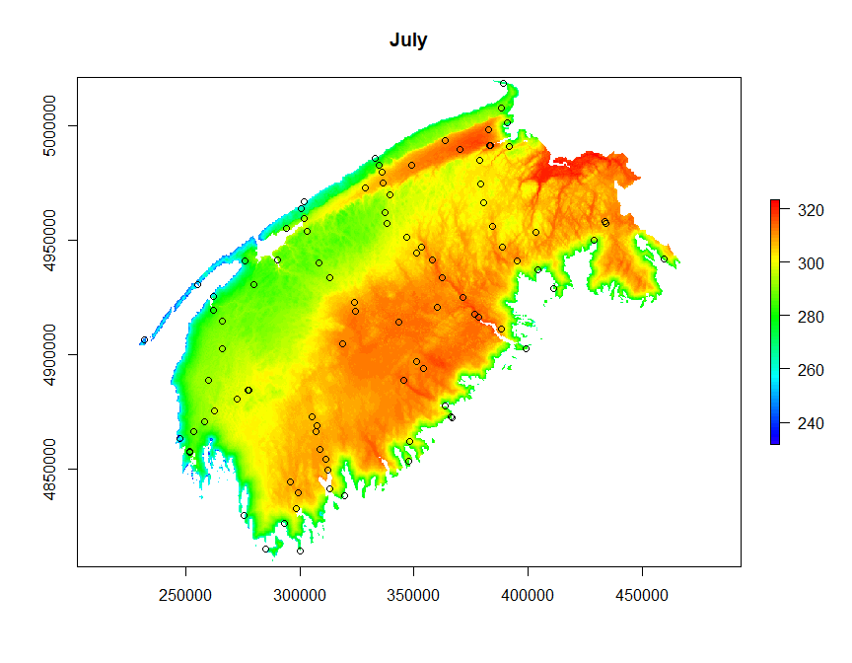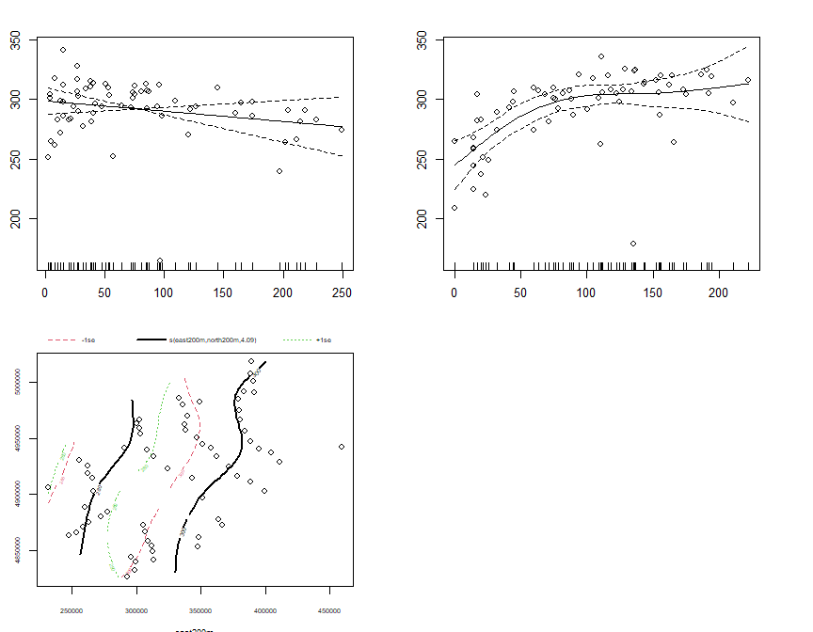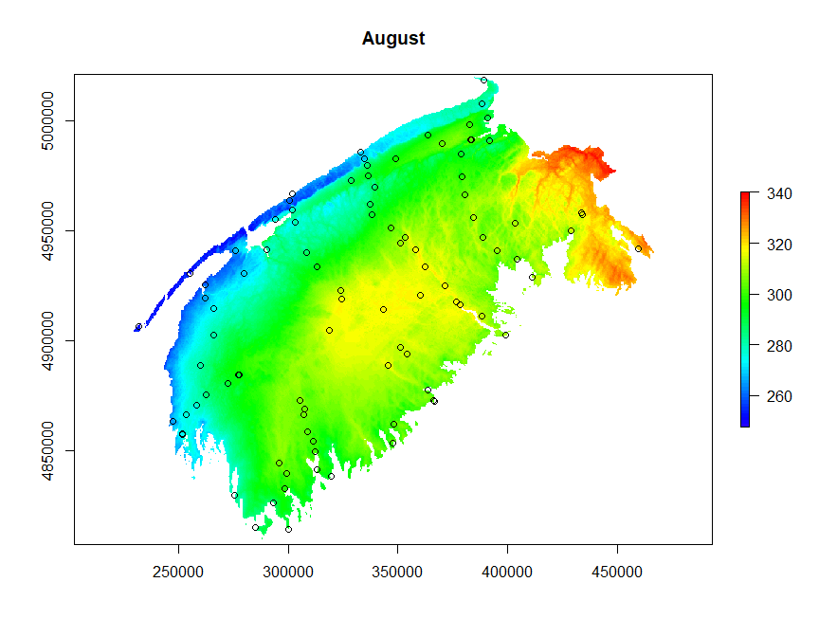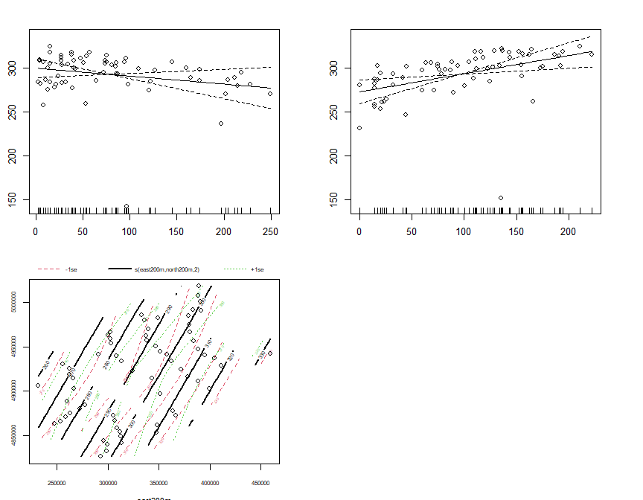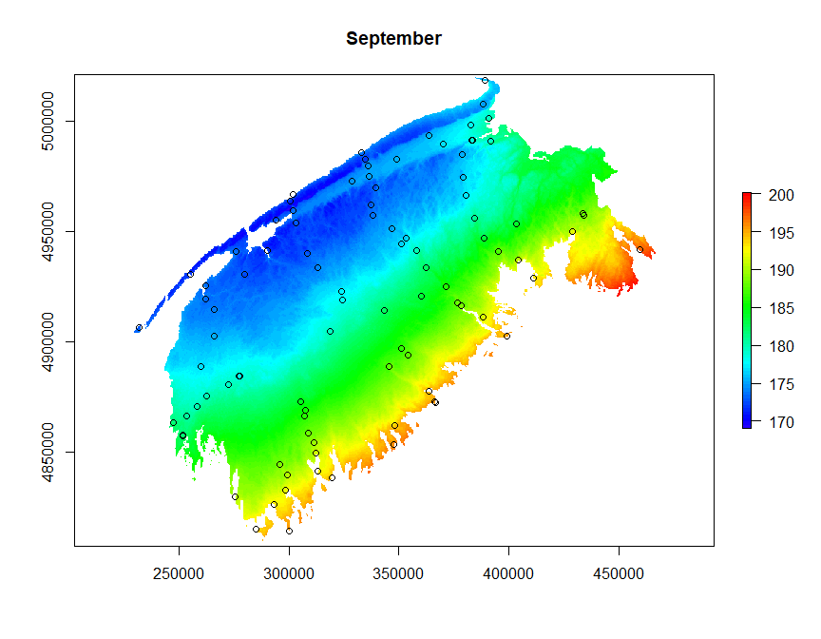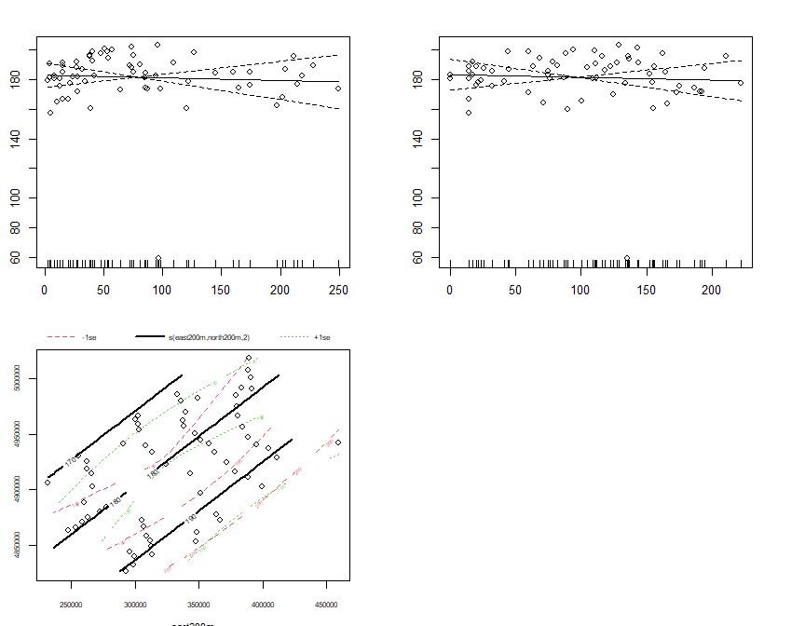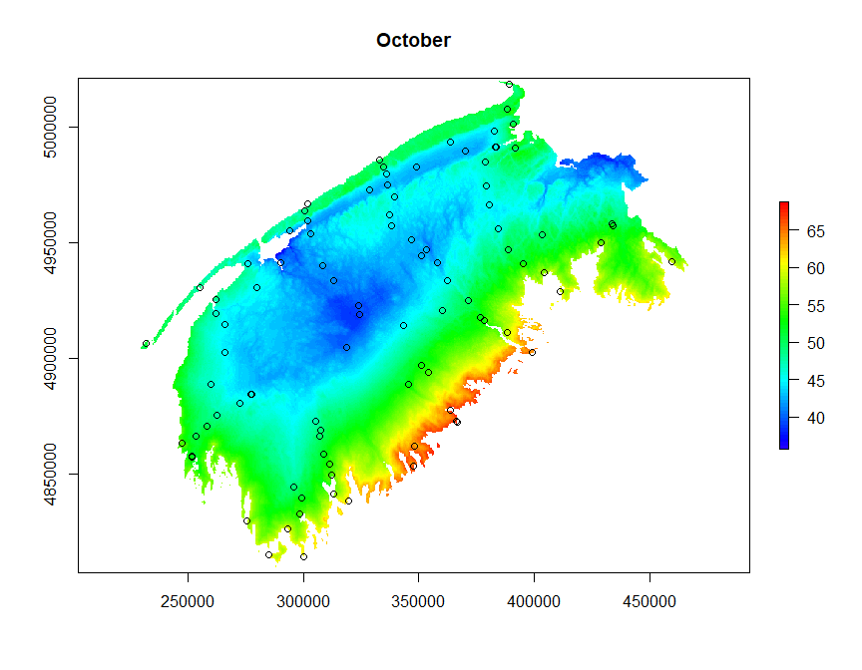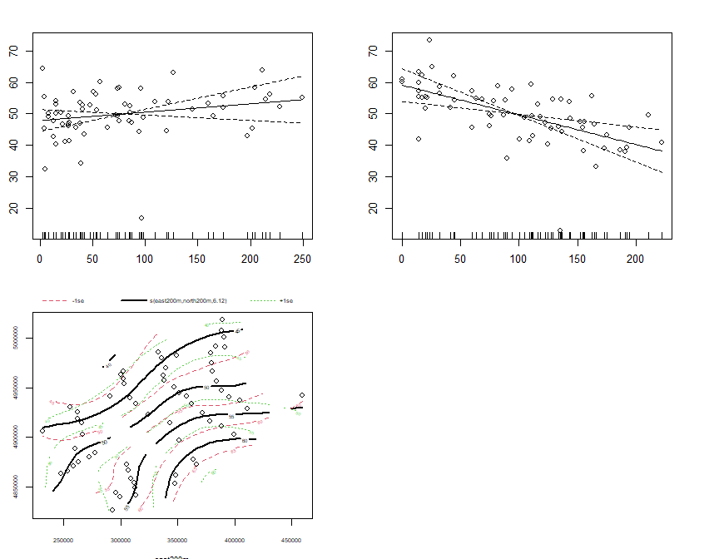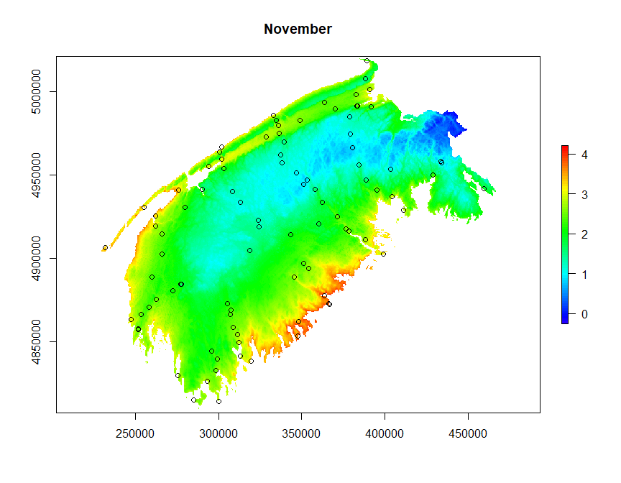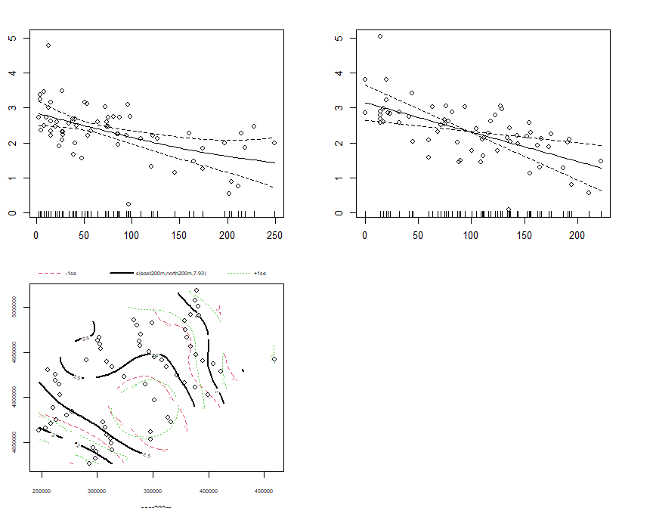

sum_raster_brick <- brick(gam_rasters)  
sum_rasters[[w]] <- raster::calc(sum_raster_brick, sum)  
plot(sum_rasters[[w]], main=m$formula, col=rev(rainbow(100)[1:70]))

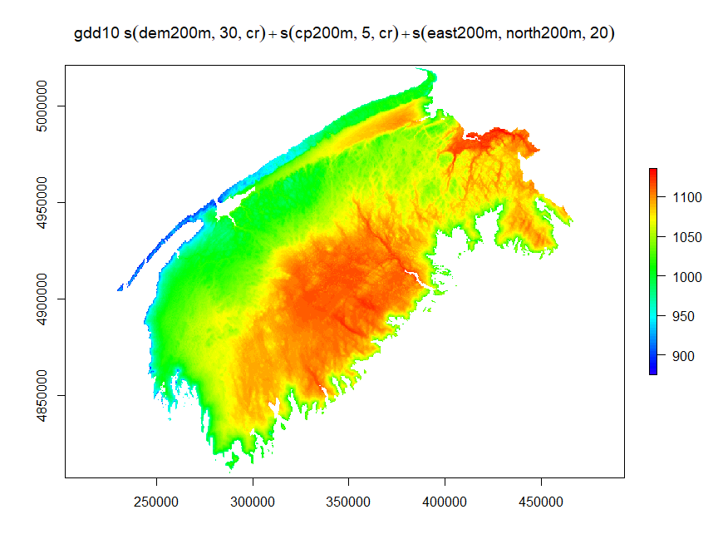

w <- w+1

Five year average

avg_brick <- brick(sum_rasters)  
avg_raster <- calc(avg_brick, mean)  
plot(avg_raster, main=m$formula, col=rev(rainbow(100)[1:70]))

