ResolutionsTesting

Dana Melamed

2023-03-16

# Prepare the data

# Make a list of input rasters  
in_folder <- 'f:\\data\\rasters\\input_rasters_b\\'  
resolution <- 1000  
var_names <- list('dem','cp','east','north','tpi5000m',  
 'asp','slp')  
ext = '.tif'  
rasters_list <- lapply(X=paste0(in_folder,var_names,resolution,'m',ext),FUN=raster::raster)

## Warning in showSRID(SRS_string, format = "PROJ", multiline = "NO", prefer_proj  
## = prefer_proj): Discarded datum NAD83 Canadian Spatial Reference System in Proj4  
## definition

# cp to the proper extent  
cp <- rasters_list[[2]]  
#rasters_list[[2]] <- raster::resample(cp,rasters_list[[1]])   
  
# brick rasters  
rasters_brick <- raster::brick(rasters_list)  
  
  
# transform  
rasters_brick[[2]]<-rasters_brick[[2]]^0.5  
rasters_brick[[6]] <- rasters_brick[[7]]*cos(rasters_brick[[6]])  
  
# names  
names(rasters_brick) <- var_names  
  
# extract rasters to dataframe  
df_in <- stations_df %>%   
 extract_constant_raster_values(var_names,rasters_brick) %>% add_date_columns()  
  
# calculate gdd10 in dataframe  
df <- df_in %>%  
 dplyr::filter(stationid %in% nscc_stations_list|  
 # stationid == '47187' | # halifax  
 stationid == '6354'   
 )%>%  
 dplyr::filter(stationid!='S100') %>% # 2012  
 dplyr::filter(stationid!='S160') %>% # 2012, early in season/cold  
 dplyr::filter(stationid!='S20') %>% #2012  
 dplyr::filter(stationid != 'S60') %>% #2012  
 dplyr::filter(stationid != 'S80') %>% #2012  
 dplyr::filter(stationid != 'CL1')  
modelling_stations <- df %>% filter(date_time == ymd('2012-06-01'))  
coordinates(modelling_stations) <- ~ EASTING+NORTHING  
  
  
df_12 <- df %>% dplyr::filter(year=='2012'&between(month,4,11)) %>%  
 group_by(stationid)%>%  
 dplyr::filter(date_time == max(date_time))

### Predict GDD10

2012 growing season based on modelling at 500m.

m<- gam(gdd10~s(dem,k=30,bs='cr')+s(cp,k=5,bs='cr')+s(east,north,k=20),data=df_12,method='REML')  
  
  
  
   
 gam_raster <- raster::predict(rasters_brick,m)  
 plot(gam_raster,   
 main=paste0('2012: ',paste(deparse(m$formula),collapse='')),   
 col=rev(rainbow(50)[1:42]),  
 breaks = c(gam_raster@data@min,seq(1000,1200,by=5),gam_raster@data@max))  
 points(modelling_stations)

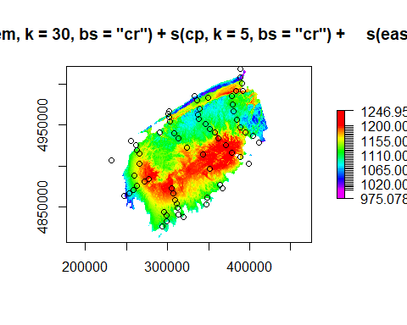

par(mfrow=c(2,2))  
 plot.gam(m, residuals = TRUE, pch = 1, cex = 1, shift = coef(m)[1])  
 par(mfrow=c(1,1))

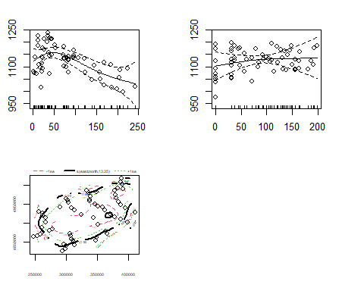

# Prepare the data

# Make a list of input rasters  
in_folder <- 'f:\\data\\rasters\\input_rasters_b\\'  
resolution <- 250  
var_names <- list('dem','cp','east','north','tpi5000m',  
 'asp','slp')  
ext = '.tif'  
rasters_list <- lapply(X=paste0(in_folder,var_names,resolution,'m',ext),FUN=raster::raster)  
  
# cp to the proper extent  
cp <- rasters_list[[2]]  
rasters_list[[2]] <- raster::resample(cp,rasters_list[[1]])   
  
# brick rasters  
rasters_brick <- raster::brick(rasters_list)  
  
  
# transform  
rasters_brick[[2]]<-rasters_brick[[2]]^0.5  
rasters_brick[[6]] <- rasters_brick[[7]]*cos(rasters_brick[[6]])  
  
# names  
names(rasters_brick) <- var_names  
  
# extract rasters to dataframe  
df_in <- stations_df %>%   
 extract_constant_raster_values(var_names,rasters_brick) %>% add_date_columns()  
  
# calculate gdd10 in dataframe  
df <- df_in %>%  
 dplyr::filter(stationid %in% nscc_stations_list|  
 # stationid == '47187' | # halifax  
 stationid == '6354'   
 )%>%  
 dplyr::filter(stationid!='S100') %>% # 2012  
 dplyr::filter(stationid!='S160') %>% # 2012, early in season/cold  
 dplyr::filter(stationid!='S20') %>% #2012  
 dplyr::filter(stationid != 'S60') %>% #2012  
 dplyr::filter(stationid != 'S80') %>% #2012  
 dplyr::filter(stationid != 'CL1')  
modelling_stations <- df %>% filter(date_time == ymd('2012-06-01'))  
coordinates(modelling_stations) <- ~ EASTING+NORTHING  
  
  
df_12 <- df %>% dplyr::filter(year=='2012'&between(month,4,11)) %>%  
 group_by(stationid)%>%  
 dplyr::filter(date_time == max(date_time))

### Predict GDD10

2012 growing season based on modelling at 500m.

m<- gam(gdd10~s(dem,k=30,bs='cr')+s(cp,k=5,bs='cr')+s(east,north,k=20),data=df_12,method='REML')  
  
   
 gam_raster <- raster::predict(rasters_brick,m)  
 plot(gam_raster,   
 main=paste0('2012 : ',paste(deparse(m$formula),collapse='')),   
 col=rev(rainbow(50)[1:42]),  
 breaks = c(gam_raster@data@min,seq(1000,1200,by=5),gam_raster@data@max))  
 points(modelling_stations)

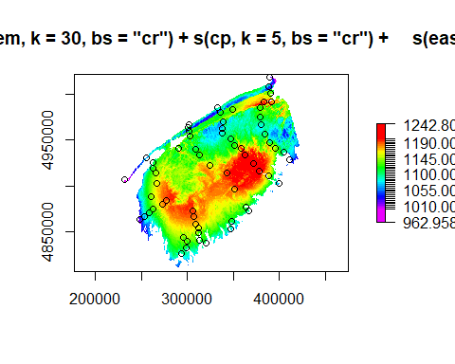

par(mfrow=c(2,2))  
 plot.gam(m, residuals = TRUE, pch = 1, cex = 1, shift = coef(m)[1])  
 par(mfrow=c(1,1))

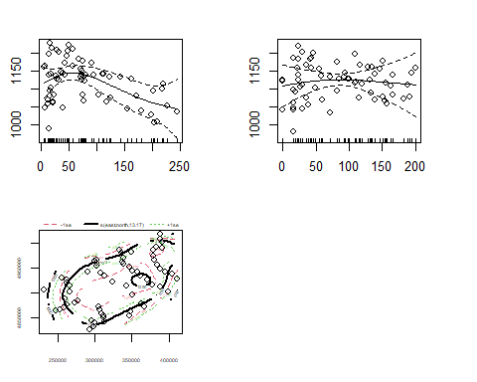

# Prepare the data

# Make a list of input rasters  
in_folder <- 'f:\\data\\rasters\\input_rasters_b\\'  
resolution <- 100  
var_names <- list('dem','cp','east','north','tpi5000m',  
 'asp','slp')  
ext = '.tif'  
rasters_list <- lapply(X=paste0(in_folder,var_names,resolution,'m',ext),FUN=raster::raster)  
  
# cp to the proper extent  
cp <- rasters_list[[2]]  
rasters_list[[2]] <- raster::resample(cp,rasters_list[[1]])   
  
# brick rasters  
rasters_brick <- raster::brick(rasters_list)

## Warning in showSRID(uprojargs, format = "PROJ", multiline = "NO", prefer_proj  
## = prefer_proj): Discarded datum Unknown based on GRS80 ellipsoid in Proj4  
## definition

# transform  
rasters_brick[[2]]<-rasters_brick[[2]]^0.5  
rasters_brick[[6]] <- rasters_brick[[7]]*cos(rasters_brick[[6]])  
  
# names  
names(rasters_brick) <- var_names  
  
# extract rasters to dataframe  
df_in <- stations_df %>%   
 extract_constant_raster_values(var_names,rasters_brick) %>% add_date_columns()  
  
# calculate gdd10 in dataframe  
df <- df_in %>%  
 dplyr::filter(stationid %in% nscc_stations_list|  
 # stationid == '47187' | # halifax  
 stationid == '6354'   
 )%>%  
 dplyr::filter(stationid!='S100') %>% # 2012  
 dplyr::filter(stationid!='S160') %>% # 2012, early in season/cold  
 dplyr::filter(stationid!='S20') %>% #2012  
 dplyr::filter(stationid != 'S60') %>% #2012  
 dplyr::filter(stationid != 'S80') %>% #2012  
 dplyr::filter(stationid != 'CL1')  
modelling_stations <- df %>% filter(date_time == ymd('2012-06-01'))  
coordinates(modelling_stations) <- ~ EASTING+NORTHING  
  
  
df_12 <- df %>% dplyr::filter(year=='2012'&between(month,4,11)) %>%  
 group_by(stationid)%>%  
 dplyr::filter(date_time == max(date_time))

### Predict GDD10

2012 growing season based on modelling at 500m.

m<- gam(gdd10~s(dem,k=30,bs='cr')+s(cp,k=5,bs='cr')+s(east,north,k=20),data=df_12,method='REML')  
  
  
  
   
 gam_raster <- raster::predict(rasters_brick,m)  
 plot(gam_raster,   
 main=paste0('2012 - 250m: ',paste(deparse(m$formula),collapse='')),   
 col=rev(rainbow(50)[1:42]),  
 breaks = c(gam_raster@data@min,seq(1000,1200,by=5),gam_raster@data@max))  
 points(modelling_stations)

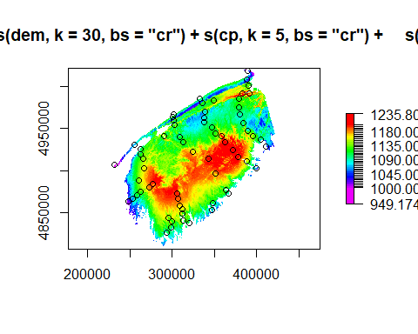

par(mfrow=c(2,2))  
 plot.gam(m, residuals = TRUE, pch = 1, cex = 1, shift = coef(m)[1])  
 par(mfrow=c(1,1))

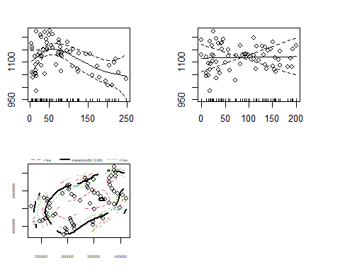

# Prepare the data

# Make a list of input rasters  
in_folder <- 'f:\\data\\rasters\\input_rasters_b\\'  
resolution <- 20  
var_names <- list('dem','cp','east','north','tpi5000m',  
 'asp','slp')  
ext = '.tif'  
rasters_list <- lapply(X=paste0(in_folder,var_names,resolution,'m',ext),FUN=raster::raster)  
  
# cp to the proper extent  
cp <- rasters_list[[2]]  
rasters_list[[2]] <- raster::resample(cp,rasters_list[[1]])   
  
# brick rasters  
rasters_brick <- raster::brick(rasters_list)  
  
  
# transform  
rasters_brick[[2]]<-rasters_brick[[2]]^0.5  
rasters_brick[[6]] <- rasters_brick[[7]]*cos(rasters_brick[[6]])  
  
# names  
names(rasters_brick) <- var_names  
  
# extract rasters to dataframe  
df_in <- stations_df %>%   
 extract_constant_raster_values(var_names,rasters_brick) %>% add_date_columns()  
  
# calculate gdd10 in dataframe  
df <- df_in %>%  
 dplyr::filter(stationid %in% nscc_stations_list|  
 # stationid == '47187' | # halifax  
 stationid == '6354'   
 )%>%  
 dplyr::filter(stationid!='S100') %>% # 2012  
 dplyr::filter(stationid!='S160') %>% # 2012, early in season/cold  
 dplyr::filter(stationid!='S20') %>% #2012  
 dplyr::filter(stationid != 'S60') %>% #2012  
 dplyr::filter(stationid != 'S80') %>% #2012  
 dplyr::filter(stationid != 'CL1')  
modelling_stations <- df %>% filter(date_time == ymd('2012-06-01'))  
coordinates(modelling_stations) <- ~ EASTING+NORTHING  
  
  
df_12 <- df %>% dplyr::filter(year=='2012'&between(month,4,11)) %>%  
 group_by(stationid)%>%  
 dplyr::filter(date_time == max(date_time))

### Predict GDD10

2012 growing season based on modelling at 500m.

m<- gam(gdd10~s(dem,k=30,bs='cr')+s(cp,k=5,bs='cr')+s(east,north,k=20),data=df_12,method='REML')  
  
  
   
 gam_raster <- raster::predict(rasters_brick,m)  
 plot(gam_raster,   
 main=paste0('2012 - 1000m: ',paste(deparse(m$formula),collapse='')),   
 col=rev(rainbow(50)[1:42]),  
 breaks = c(gam_raster@data@min,seq(1000,1200,by=5),gam_raster@data@max))  
 points(modelling_stations)

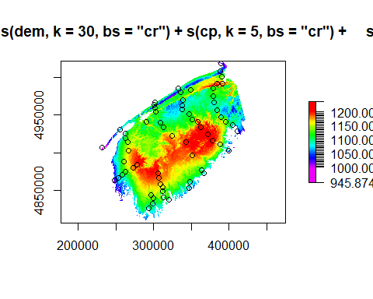

par(mfrow=c(2,2))  
 plot.gam(m, residuals = TRUE, pch = 1, cex = 1, shift = coef(m)[1])  
 par(mfrow=c(1,1))

