ORRE Sample Data

21-Sep-2020

Table of Contents

Chapter 1. Figures

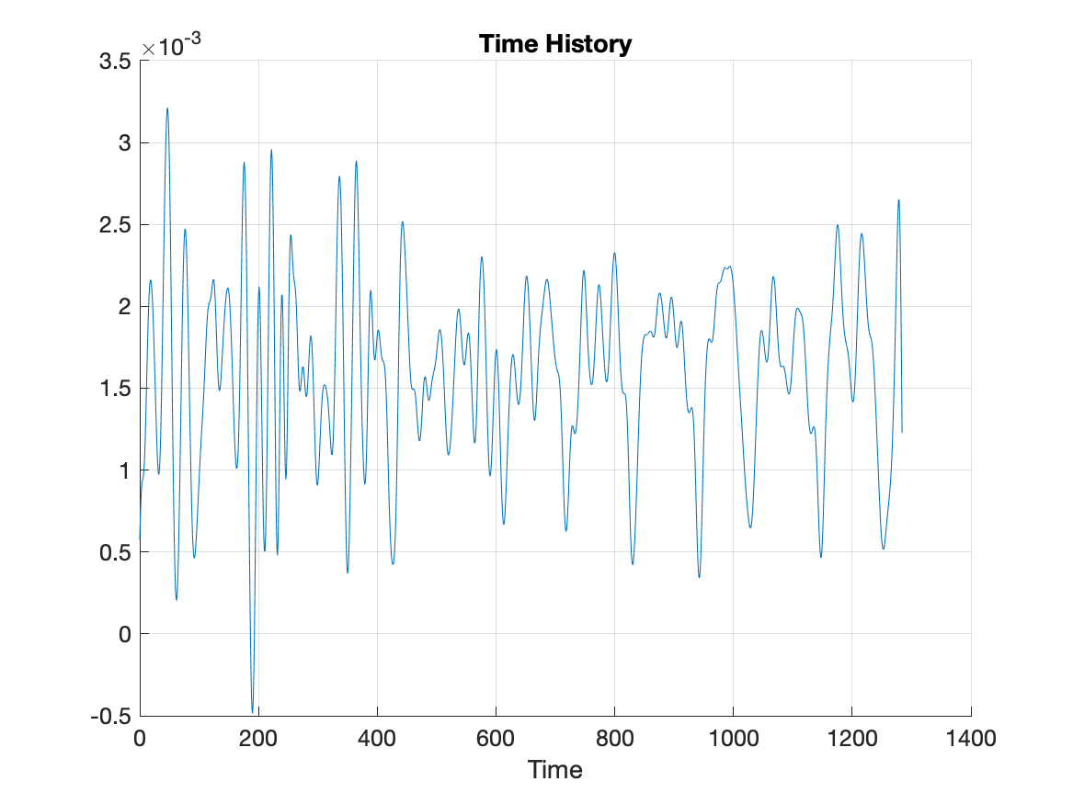

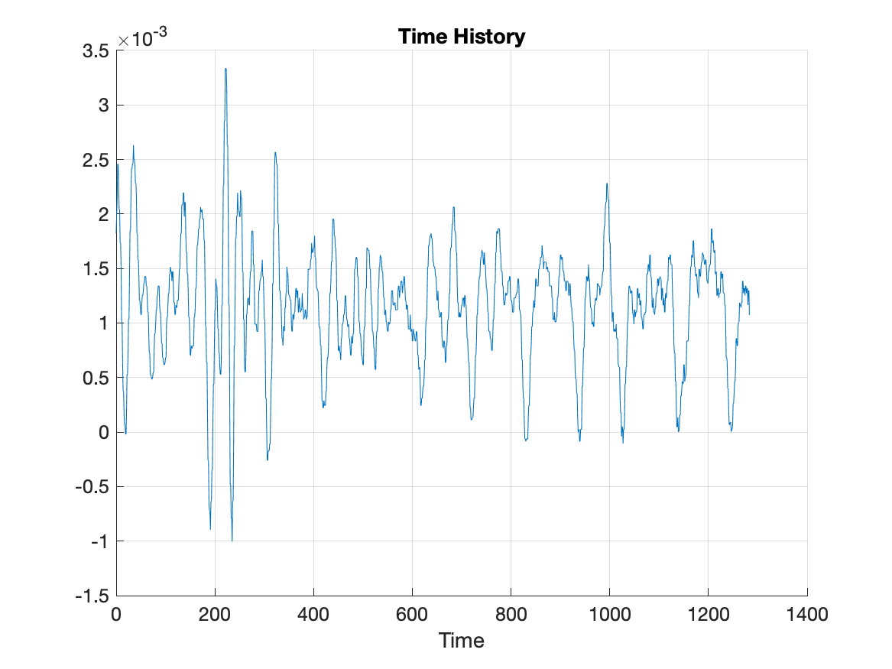

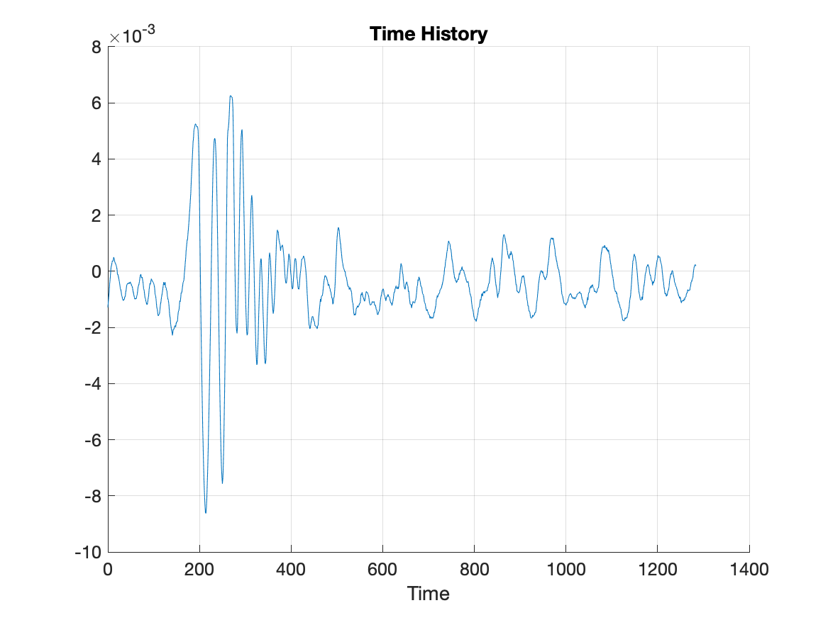

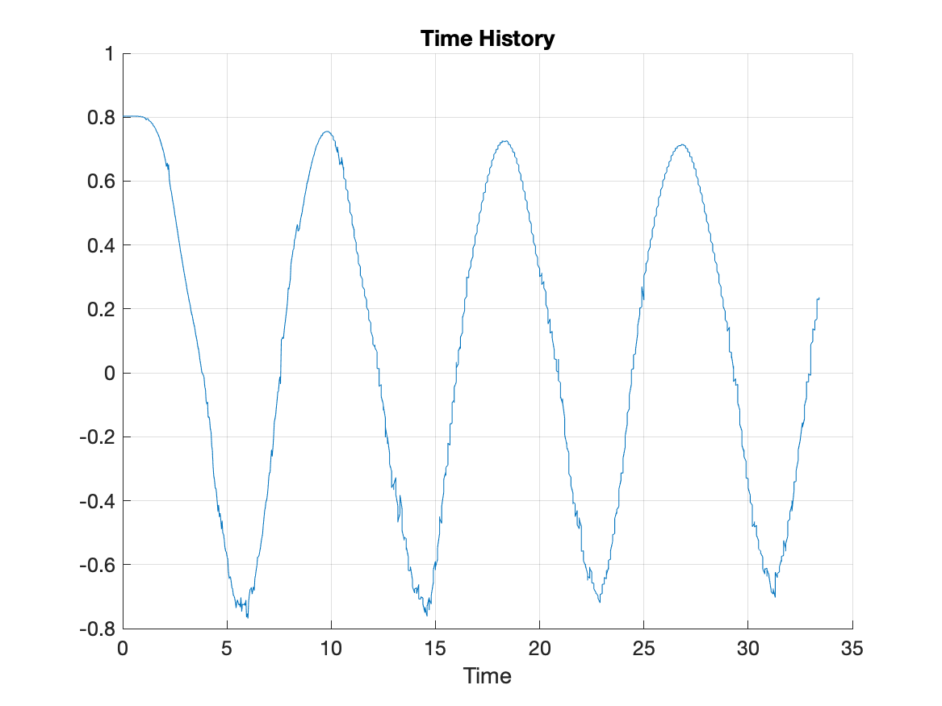

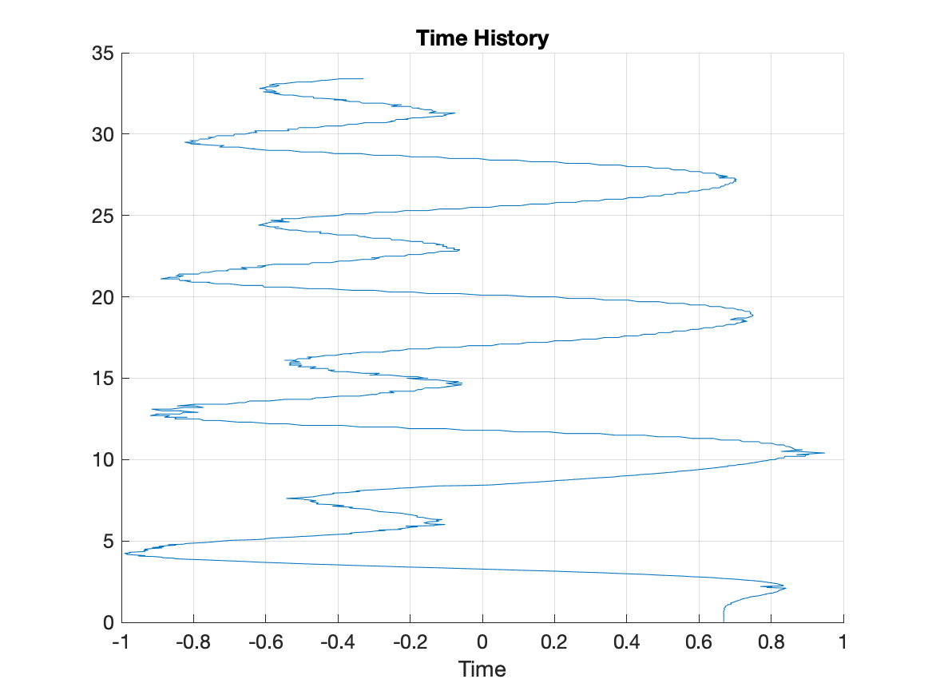

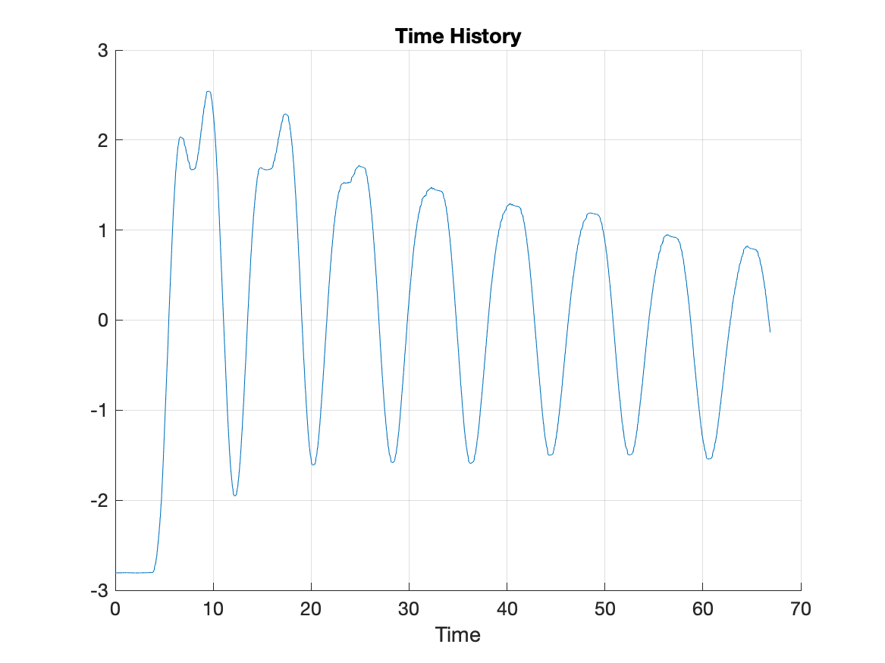

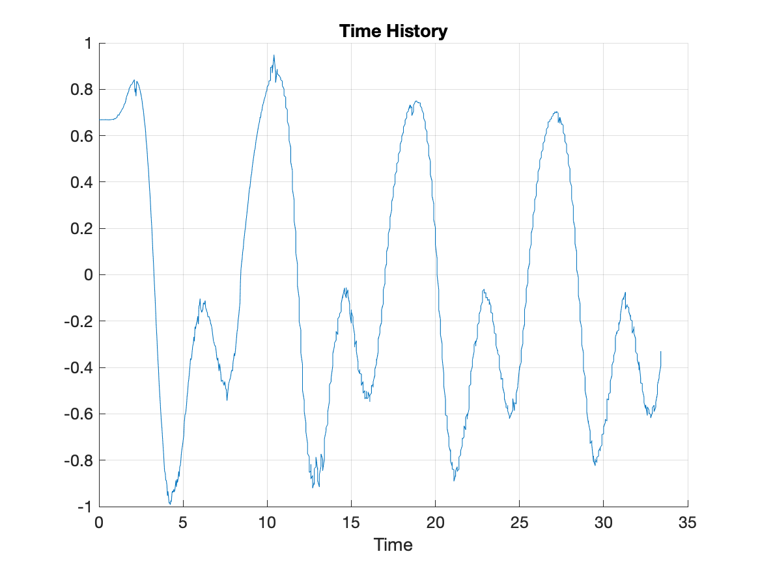

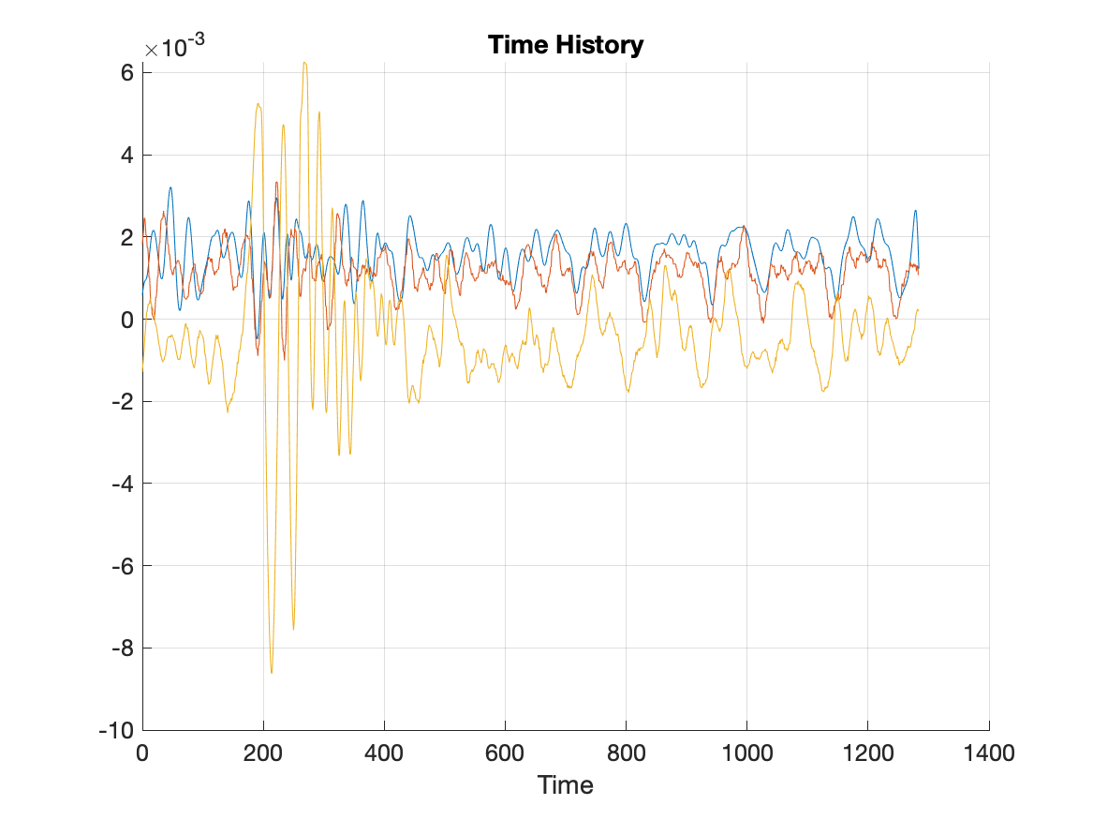



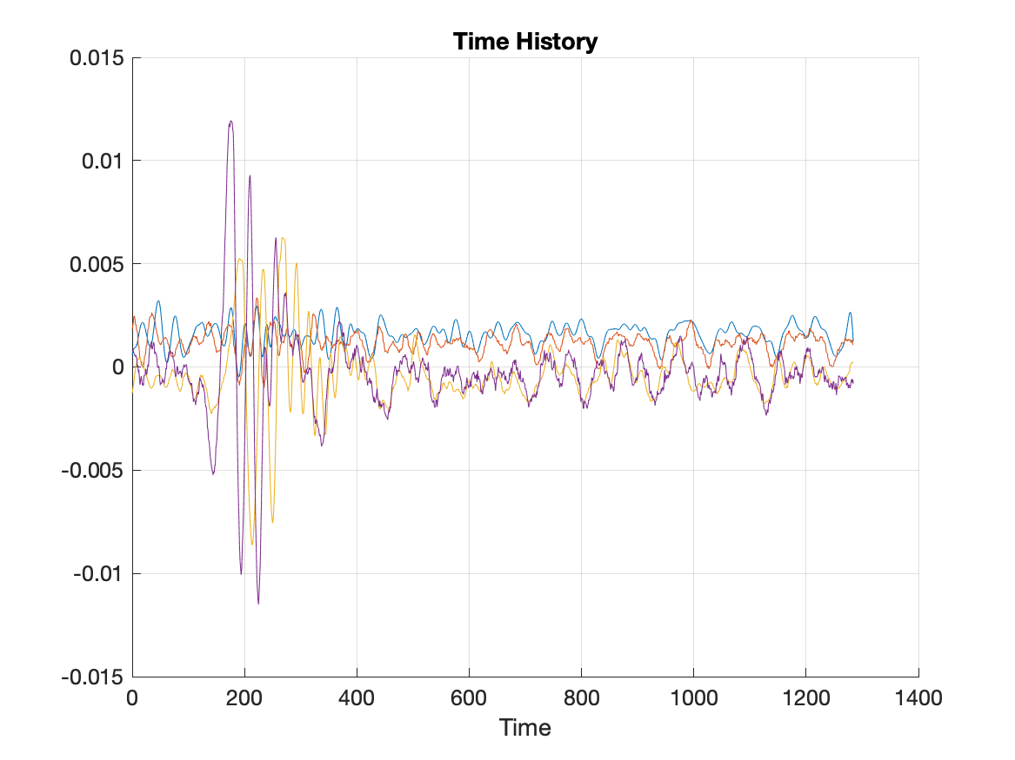

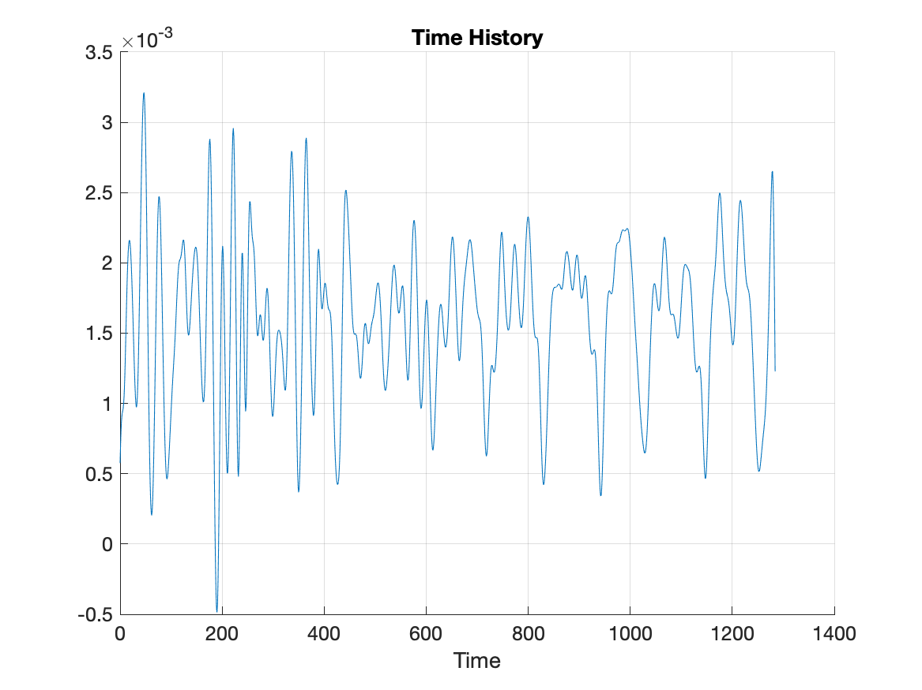

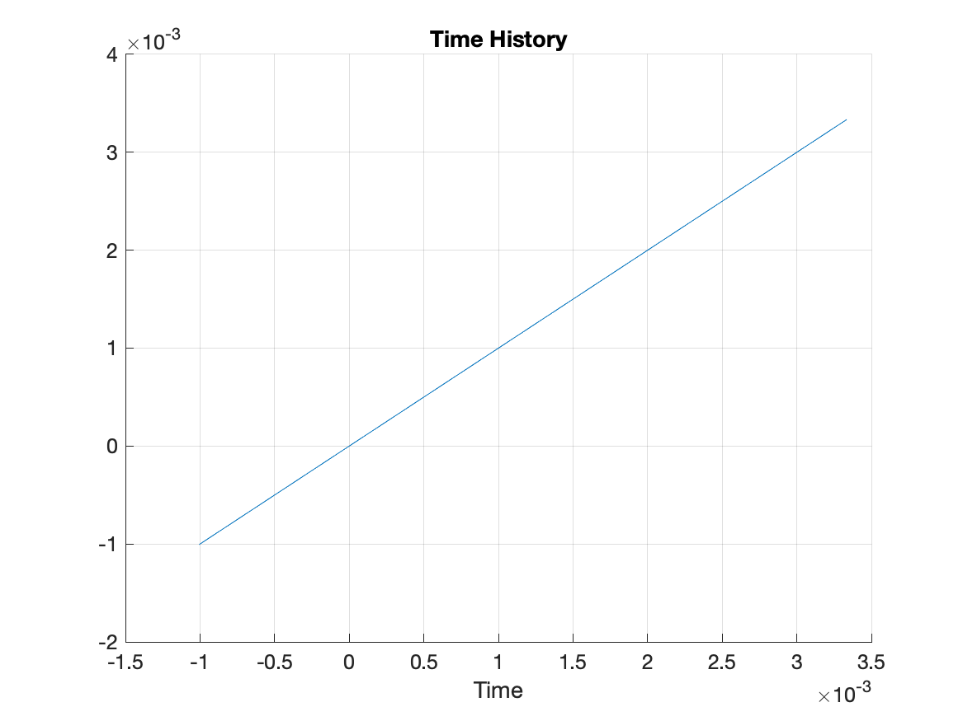

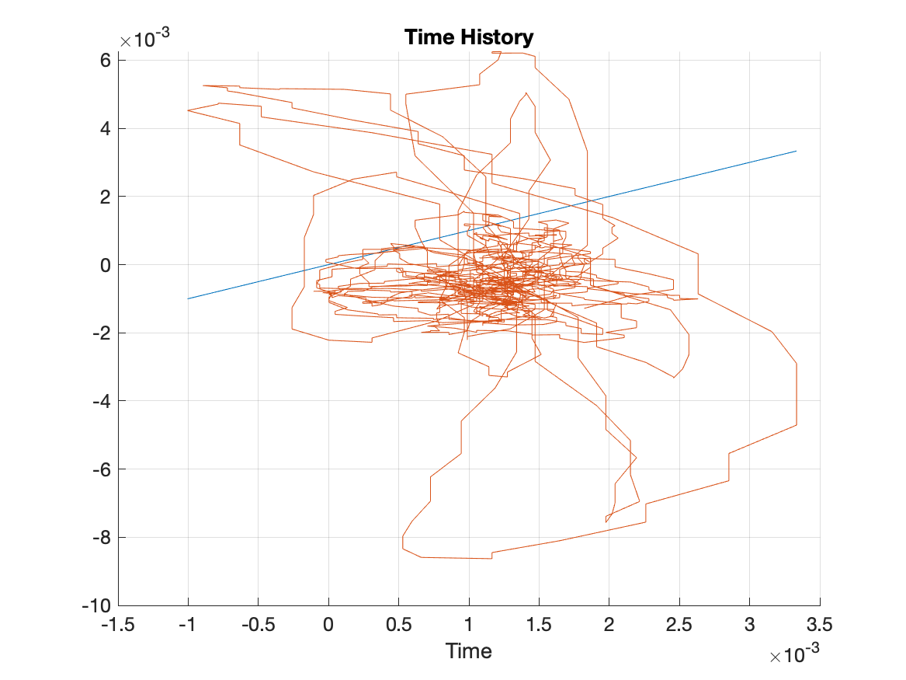

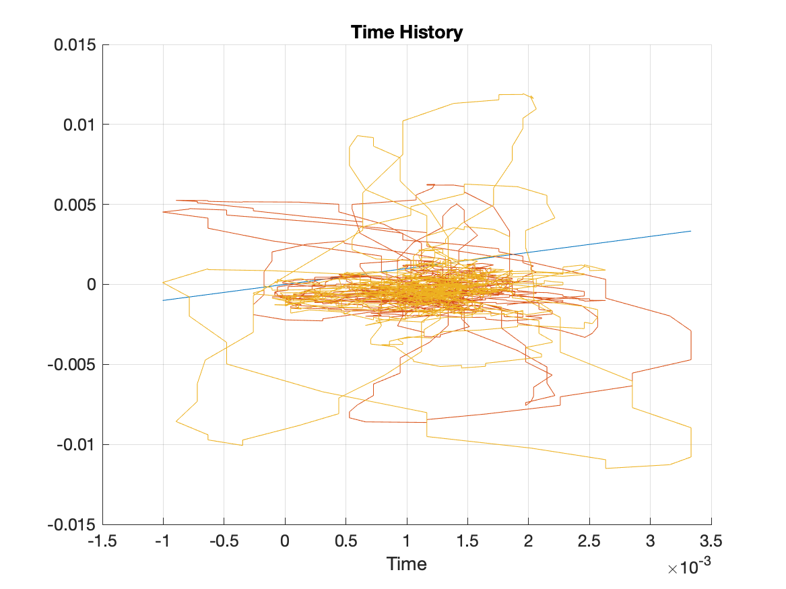

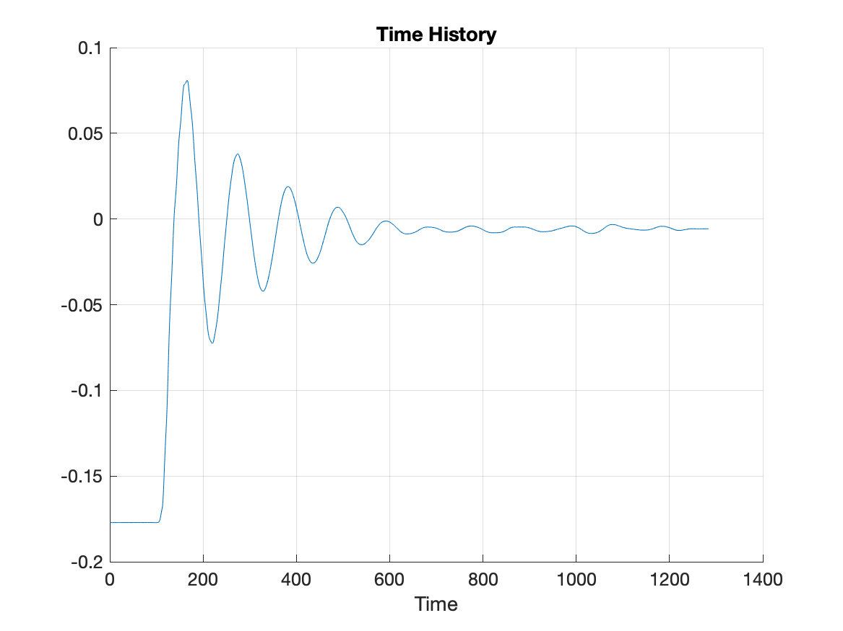

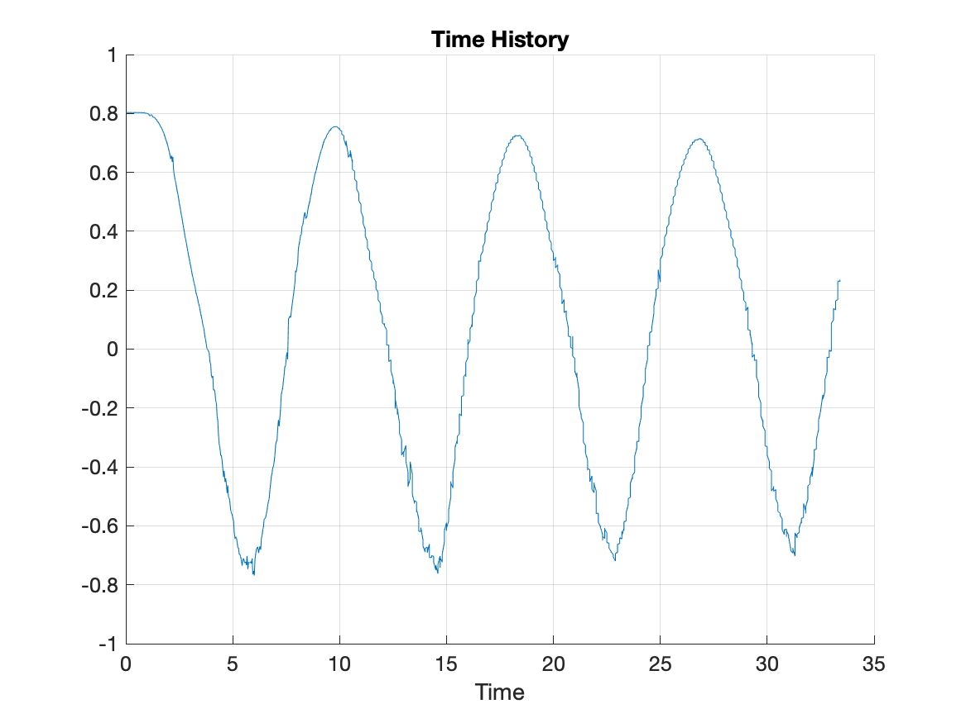



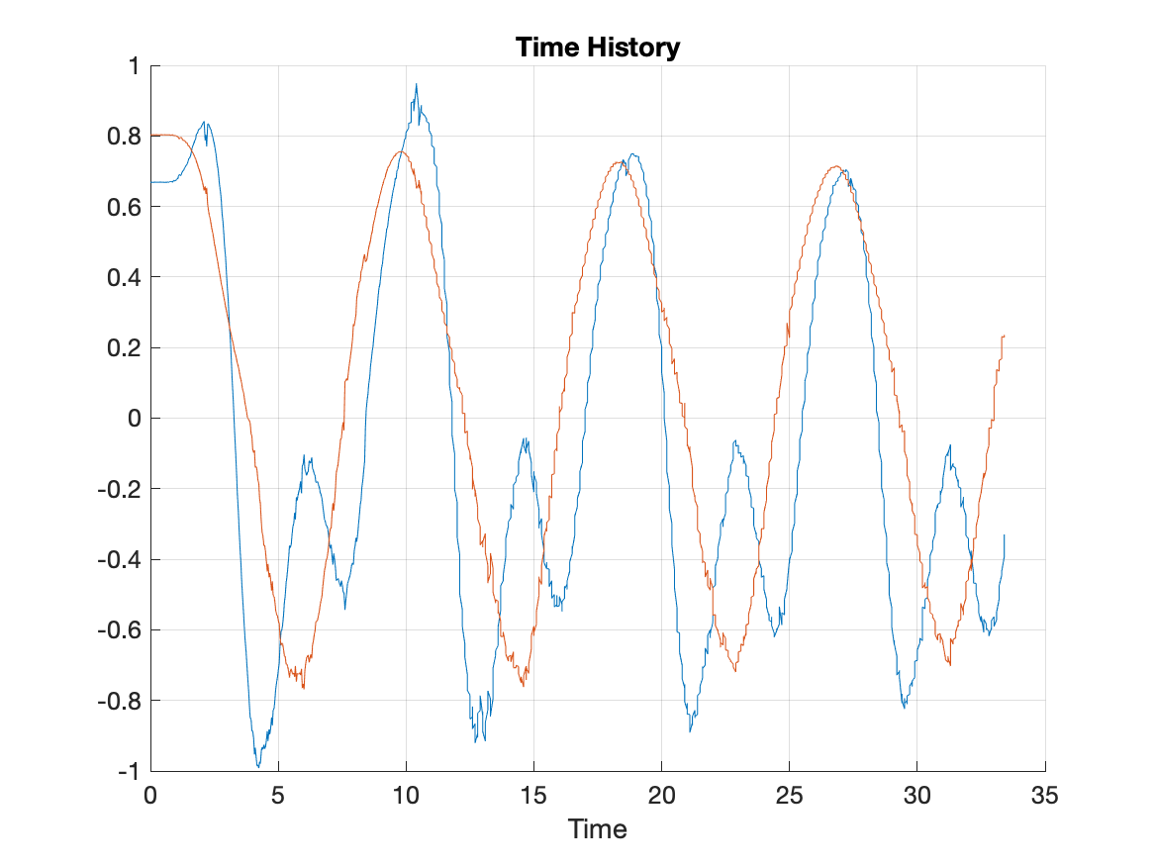

Chapter 1. Statistics

|  |
| --- |
| Statistics Table |
| Ch | Color | Mean | Min | Max | Std Dev |
| 2 |  | 0.0015858374734637731 | -0.0004866408317131152 | 0.00321127566971571 | 0.00055228282771748165 |
| 3 |  | 0.0011500031773385257 | -0.001005368 | 0.003334371 | 0.00055631685702280228 |
| 4 |  | -0.00043915905688015537 | -0.0086296640000000004 | 0.0062600609999999999 | 0.0016446097247393319 |
| 5 |  | -0.00030038394191805455 | -0.01150375 | 0.01193053 | 0.0022186928904041566 |