- SELECT s.rin, s.rcsID, s.first_name, s.last_name, s.alias, s.phone, s.street, s.city, s.state, s.zip
FROM students s
ORDER BY rin asc, last_name asc, rcsID asc, firstname asc;
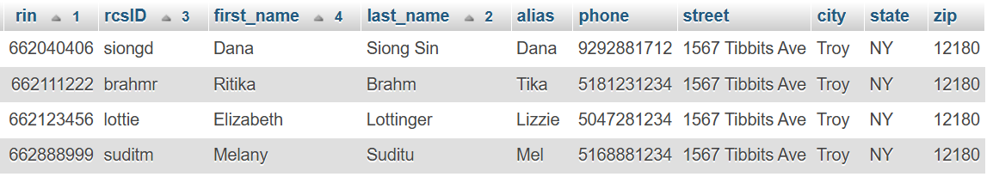

- SELECT g.rin, s.first_name, s.last_name, s.street, s.city, s.state, s.zip
FROM grades g join students s on g.rin = s.rin
WHERE g.grade > 90;
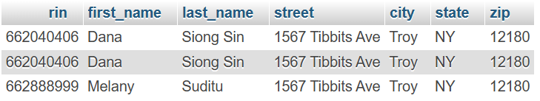
- SELECT avg(g.grade)
FROM grades g
GROUP BY g.crn;
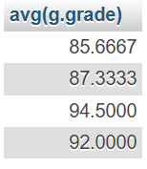
- SELECT c.title, COUNT(DISTINCT g.RIN) AS num_students FROM grades g JOIN courses c ON g.crn = c.crn GROUP BY c.crn;


