**מדעי הנתונים ובינה עסקית – מעבדה 3**

1. Commands:

table <- read.csv("C:\\Users\\Dan\\Desktop\\lab.csv")

plot(x=table$X1, y= table$X2, xlab = "day", ylab = "n of cases", main = "Real Class", data = table, color=factor(table$Class,levels = c(0,1), labels = c("firstclass","secondclass")))

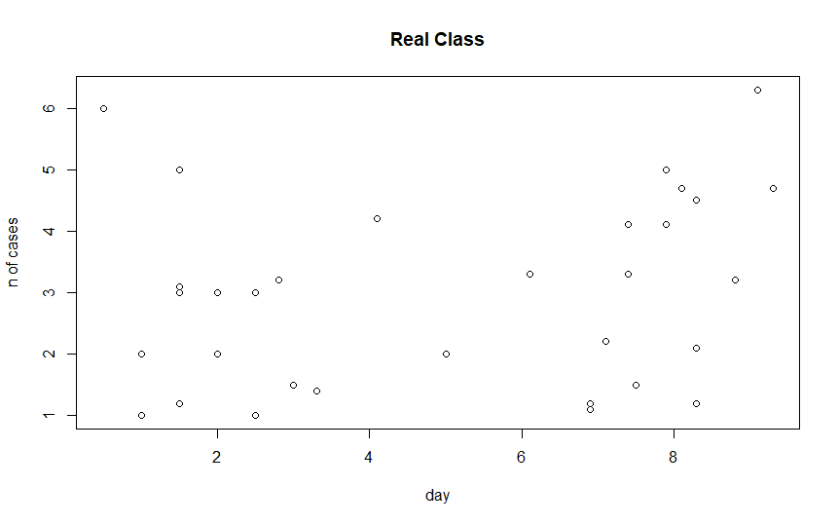Results:

2. Commands:

newTable <- table

newTable <- subset(newTable, select = c("X1", "X2"))

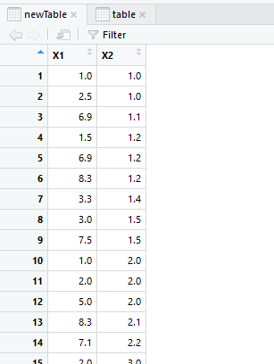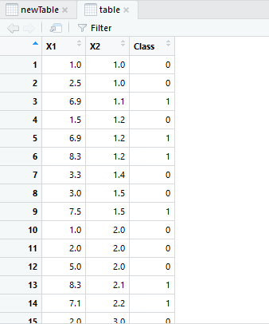Results: