# NLP course Assignment 1: Distributional Similarity

Daniel bazar 314708181

Lior krengel XXXXXXXXX

## Dense vectors (word2vec based similarities)

In this section of the assignment, we explored word-similarities induced by a word-embedding algorithm. We used the ‘*word2vec-google-news-300’* pre-trained vectors, from the *gensim* python package.

we exploreded word similarities in several manners as detailed below:

### Generating lists of the most similar words

We chose 5 words out of the vocabulary, and for each of them, we generated list of the 20 most similar words according to word2vec algorithm. Later on the second part of the assignment we will analyze these lists in comparison to ChatGPT output.

**Our 5 words are: espresso, game, spy, car, smartphone.**

Results:

|  |  |
| --- | --- |
| **word** | **20 most similar words (decreasing order)** |
| espresso | cappuccino, mocha, coffee, latte, caramel_macchiato, ristretto, espressos, macchiato, chai_latte, espresso_cappuccino, caramel_latte, vanilla_latte, brewed_coffee, iced_coffee, nonfat_latte, expresso, espresso_latte, coffees, mocha_latte, Lavazza_coffee |
| game | games, play, match, matchup, agame, ballgame, thegame, opener, matches, tournament, playing, league, Game, scrimmages, fourgame, scrimmage, postseason, playoffs, gme, season |
| spy | spies, spying, espionage, spymaster, CIA, Spy, MI6, spymasters, intelligence, CIA_operative, eavesdropping, covert, persecute_dissidents, counterspy, counterintelligence, supersecret, counterspies, KGB, honeytrap, superspy |
| car | vehicle, cars, SUV, minivan, truck, Car, Ford_Focus, Honda_Civic, Jeep, pickup_truck, Toyota_Camry, scooter, Honda_Accord, sedan, Toyota_Corolla, motorcycle, Nissan_Altima, Ford_Explorer, Ford_Escort, Ford_Mustang |
| smartphone | smartphones, Smartphone, handset, Android_smartphone, smart_phones, Android_phones, Android, Android_smartphones, netbook, Android_OS, touchscreen_smartphone, iPhone, handsets, Smartphones, smartphone_OS, Apple_AAPL_iPhone, Android_handsets, Symbian_smartphone, tablet_PC, smarphone |

### Polysemous Words

Polysemous words are words that have several meanings.  
we asked to find three polysemous such that the top-10 neighbours of each word reflect both word meanings (Group 1), and three polysemous words such that the top-10 neighbours of each word reflect only a single meaning (Group 2).  
we actually found relatively a lot of polysemous words but most of them were belong to group 2. We tried to think about attributes that associate word to group 1 like the sense frequency (maybe if one sense is significantly more frequent, the word vectors might be biased towards that dominant sense) or sense context (for example ‘bank’ represent two meanings but these are both places, in contrast to bass that reflects completely different meanings) but still, most of the words were belong to group 2. So, at the end it was somewhat trial and error.  
in our opinion, the sense frequency (mention above) is reasonable possible explanation for why the second group words neighbours reflect only one sense.   
~~In addition (and from here on these are just assumptions because we don’t know the training settings of the model), both training data and training settings have an influence on the embedding. For example, some settings would prefer morphologically similar words (like plurals, cat->cats) and other settings would consider semantically relevant words (like cat->dog). Different settings\algorithms can also differ in sensitivity to rare and frequent words and that connect to our first explanation.~~

**Group 1**

|  |  |  |
| --- | --- | --- |
| **word** | **possible senses** | **top-10 neighbours** |
| mole | small burrowing mammal, a common type of skin growth, spy, unit in chemistry | moles, pollo_en, freckle, cancerous_mole, birthmark, unibrow, spies, codenamed_Stakeknife, nodule, pube |
| bass | type of fish, low-pitched musical instrument, low voice | crappie, largemouth, largemouths, largemouth_bass, striper, stripers, smallmouth, Spotted_bass, acoustic_bass, upright_bass |
| fall | season (also known as autumn), to drop or descend | falling, falls, drop, tumble, rise, plummet, fell, spring, Fall, sag |

Reflected sense are represented by colors

**Group 2**

|  |  |  |
| --- | --- | --- |
| **word** | **possible senses** | **top-10 neighbours** |
| rock | A relatively hard naturally occurring mineral material, music genre | rock_n_roll, rockers, punk_emo, punk_rock, alt_rock, station_WHJY_FM, rocks, indie_rock, star_Gustavo_Cerati, rock'n'roll |
| bar | drinking establishment, a straight piece (as of wood or metal) that is longer than it is wide (beam\rod) | Bar, bars, tavern, pub, nightspot, nightclub, Pub, bartender, restaurant, Lounge |
| plant | botanical organism (seed), factory | plants, Plant, factory, paperboard_mill, containerboard_mill, factories, megawatt_MW_biomass, refinery, Plants, mill |

Reflected sense are represented by colors

### Synonyms and Antonyms

We asked to find a triplet of words (w1, w2, w3) such that all of the following conditions hold:

1. w1 and w2 are synonyms or almost synonyms.
2. w1 and w3 are antonyms.
3. sim(w1, w2) < sim(w1, w3)

**our words that meet all the conditions are: love, like, hate (w1, w2, w3 respectively)**

This behavior in which the antonyms are more similar than the synonyms can be explained by that in word embeddings, words that are often used in similar contexts are closer. In our example, "love" and "hate" only appear in the context of "feelings" while "like" can appear in context of "similarity" as well.

### The Effect of Different Corpora

In this part we compared two models based on two sources Wikipedia and twitter.

We asked to find 5 words whose top 10 neighbors based on the Wikipedia corpus are very similar to their top 10 neighbors based on the twitter corpus. And vice versa, 5 words whose top 10 neighbors based on the news corpus are substantially different from the top 10 neighbors based on the twitter corpus.our strategy to find those words was thinking about words that in the “twitter world” have different meanings. As we mentioned before, the similarities between words depend on if they appear in the same context so we search for words that in twitter will be in different context.

**Cross corpus similarity**

|  |  |  |
| --- | --- | --- |
| **Word** | **Wikipedia top-10 neighbours** | **Twitter top-10 neighbours** |
| yellow | red, pink, purple, blue, green, bright, colored, orange, black, colour | blue, purple, red, green, pink, white, orange, black, colored, bright |
| morning | afternoon, evening, friday, monday, thursday, night, tuesday, sunday, saturday, wednesday | afternoon, night, good, sunday, day, evening, monday, today, early, mornin |
| dog | dogs, cat, pet, puppy, horse, animal, cats, wolf, hound, pets | dogs, cat, puppy, pet, cats, horse, animal, kitten, little, kid |
| car | cars, vehicle, driver, truck, driving, vehicles, motorcycle, parked, drivers, bus | truck, cars, driving, drive, front, vehicle, bus, bike, cause, house |
| coffee | tea, cocoa, beans, espresso, drinks, drink, beer, wine, starbucks, sugar | tea, starbucks, coffe, beer, drink, iced, breakfast, milk, wine, latte |

**Cross corpus difference**

|  |  |  |  |
| --- | --- | --- | --- |
| **Word** | **Wikipedia top-10 neighbours** | **Twitter top-10 neighbours** | **difference description** |
| umbrella | organisation, organization, organisations, organizations, groups, alliance, grouping, group, non-governmental, non-profit | umbrellas, coat, rain, jacket, raining, parasol, bag, rains, outside, backpack | Wikipedia meaning: association of institutions who work together  Twitter meaning: protection against the rain |
| troll | trolls, monster, witch, doll, ape, mermaid, tentacled, sorcerer, monsters, medusa | trolls, trolling, noob, hacker, fail, bully, pervert, nerd, hack, trolled | Wikipedia meaning: a mythical creature  Twitter meaning: to antagonize others online |
| profile | recent, prominent, profiles, high-profile, attention, publicized, celebrity, political, similar, focus | page, picture, check, website, view, account, pic, click, add, visit | Wikipedia meaning: level of public exposure twitter meaning: user profile in social media |
| mute | deaf, blind, helpless, silent, storks, bedridden, ignorant, swans, cornetts, motionless | refresh, button, disable, delete, deaf, screen, remote, pause, block, muting | Wikipedia meaning: person who have speech disorder  Twitter meaning: function to eliminate sound in apps |
| gaming | gambling, casino, casinos, entertainment, poker, interactive, gamers, bingo, online, multiplayer | xbox, console, playstation, gamer, gamers, videogames, tech, desktop, controller, nintendo | Wikipedia meaning: playing gambling  Twitter meaning:  playing video games |

### Plotting words in 2D - Dimensionality Reduction

In this part we took the first 5000 words in the google model vocabulary, keeping just the words ending with “ed” and “ing” (verbs) and implemented a dimensionality reduction using PCA to transform the 300-dim matrix to 2-d so we can plot it: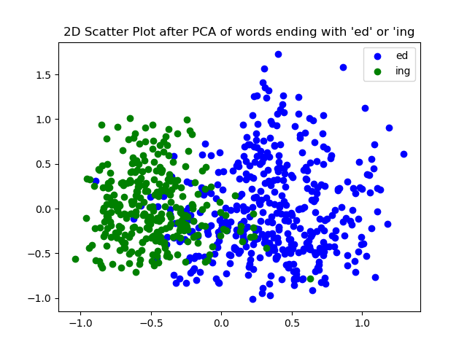

points that correspond to words that end with “ed” are colored in blue and points that correspond to words that end with “ing” in green.

As we can see the two classes are slightly separate, indicates that the model might distinguished tense in words. However, there are quite a few overlapping points. We tried to analyze the controversial points using KNN by looking at points that all their closest neighbors are from different class but it ain’t provided good enough distinction, seems like the words lost most of their meaning. We looked at the percentage of variance explained by each component and we observed that they actually explained very few of it. The variance explained by the first component is around 4.2% and the variance explained by the second component is around 3.4% so the overall percentage of variance explained is just around 7.6%! so by considering only those two components we barely preserve the essential characteristics of the original data. Nevertheless, it could be useful (although, not successful) in terms of classification which suffix the word have.

### Word-similarities in Large Language Model

### Related words

In this part we compared word2vec and ChatGPT word similarity result:

|  |  |  |  |
| --- | --- | --- | --- |
| **Word** | **word2vec 20 most similar words (decreasing order)** | **ChatGPT 20 most similar words (decreasing order)** | **ChatGPT 20 most similar words without phrases (decreasing order)** |
| run | runs, running, drive, ran, scamper, tworun_double, go, twoout, walk, Mark_Grudzielanek_singled, Batterymate_Miguel_Olivo, homerun, threerun, Collin_Salzenstein, basesloaded, fielder's_choice_grounder, Peter_Bourjos_tripled, Casey_Kalenkosky, Scutaro_singled, clubbed_solo_homer | Sprint, Jog, Race, Dash, Rush, Marathon, Gallop, Trot, Pace, Stride, Jogger, Sprinter, Chase, Flee, Escape, Haste, Accelerate, Scamper, Bolt, Dart |  |
| game | games, play, match, matchup, agame, ballgame, thegame, opener, matches, tournament, playing, league, Game, scrimmages, fourgame, scrimmage, postseason, playoffs, gme, season | play, sport, competition, match, fun, entertainment, recreation, activity, challenge, gaming, contest, pastime, amusement, board game, video game, puzzle, strategy, tournament, plaything, recreation | play, sport, competition, match, recreation, activity, challenge, gaming, contest, pastime, amusement, puzzle, strategy, tournament, diversion, entertainment, gamble, plaything, fun, contest |
| spy | spies, spying, espionage, spymaster, CIA, Spy, MI6, spymasters, intelligence, CIA_operative, eavesdropping, covert, persecute_dissidents, counterspy, counterintelligence, supersecret, counterspies, KGB, honeytrap, superspy | espionage, undercover agent, operative, infiltrator, intelligence agent, surveillance, secret agent, informant, sleuth, mole, double agent, spook, counterintelligence, undercover, reconnaissance, covert agent, saboteur, stealth, cipher, codebreaker | Agent, Operative, Infiltrator, Mole, Sleuth, Spook, Informant, Saboteur, Covert, Reconnaissance, Double agent, Espionage, Surveillance, Undercover, Intelligencer, Cipher, Cryptanalyst, Decoder, Decryption, Codebreaker |
| Computer | Computers, computer, Computing, Enterprises_GoGrid_Gomez, computers, Electronics, Genuitec_Gizmox_Glassbox_Global, COMPUTER, Modules_COMs, Information_Technology, Microcomputer, Applied_Computing, Lab_International_Concentsus, Marvell_Plug, Microcomputers, Digital_Forensics, PC, Malicious_Attacks, Software, Laptops | machine, device, laptop, desktop, PC, technology, hardware, software, server, system, workstation, processor, digital, electronic, computing, mainframe, information technology, personal computer, laptop, workstation |  |
| espresso | cappuccino, mocha, coffee, latte, caramel_macchiato, ristretto, espressos, macchiato, chai_latte, espresso_cappuccino, caramel_latte, vanilla_latte, brewed_coffee, iced_coffee, nonfat_latte, expresso, espresso_latte, coffees, mocha_latte, Lavazza_coffee | Coffee, Cappuccino, Latte, Americano, Macchiato, Mocha, Cortado, Ristretto, Affogato, Breve, Doppio, Lungo, Flat White, Turkish Coffee, Café au Lait, Irish Coffee, Red Eye, Vienna Coffee, Frappuccino, Turkish Coffee |  |

In some cases, ChatGPT gave us similar words with phrases, so we asked him again to produce without phrase:

“For the word "game" please don't give similar words that are phrases.”

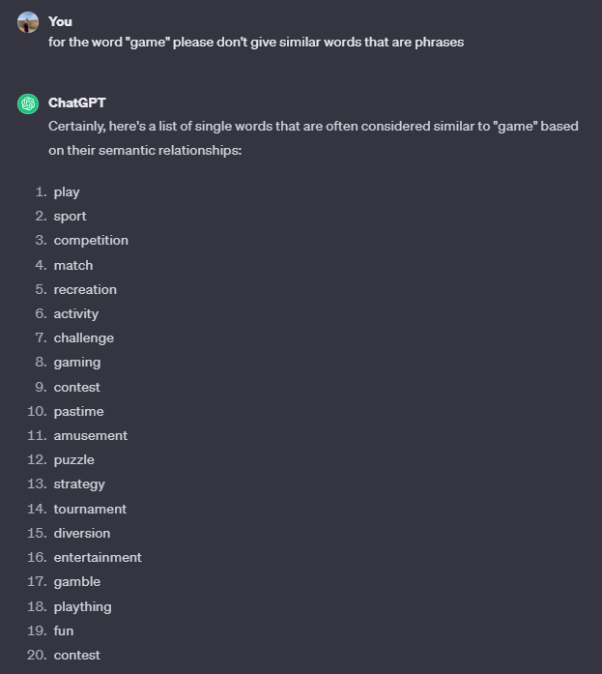

For the word spy it also gave few examples as phrases, but this time it took us 2 times to get the words without phrases:

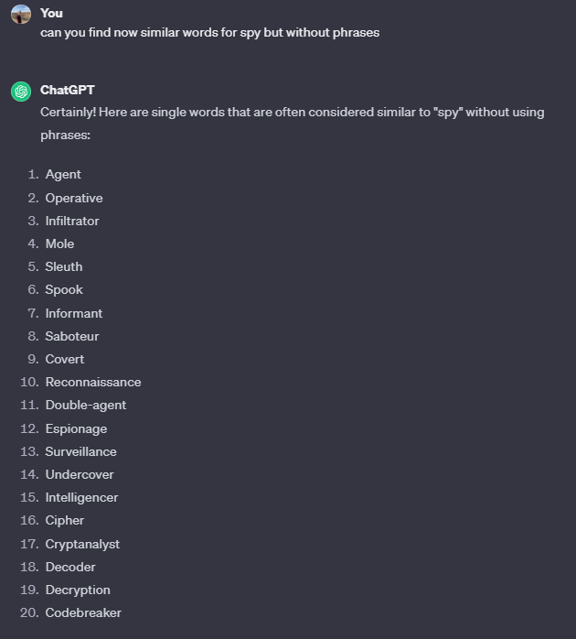

And then we gave a direct instruction for this phrase, and he successfully did it:

Accuracy?

Diversity?

There are few differences in the similar words both models produce us:

1. A big difference between the models was that when asking for a word with initial cap in ChatGPT

it refers to this word as the same word as lower caps, while for word2vec it gives different similar words. For example, we asked for the similar words of Computer for ChatGPT we got the same output but with word2vec for “Computer” we got the words describe the table above and for “computer”:

computers, laptop, laptop_computer, Computer, com_puter, technician_Leonard_Luchko, mainframes_minicomputers, laptop_computers, PC, maker_Dell_DELL.O, laptops, PCs, Computers, Los_Alamos_Natl, software, logs_keystrokes, desktop_computers, view_HealthCast, Surface_tabletop.

2. word2vec used to give us more types of the noun we gave me, for example for the word spy we got types of spies like: MI6, CIA, KGB. ChatGPT gives us only words that describe the word spy and can replace her in context.

3. ChatGPT doesn’t return similar words that are biases of the same word, for example:

for the word “run” using word2vec it returns- runs, running, ran, while GPT doesn’t.

4. ChatGPT sometimes give the same examples of words as their most similar words, for example for the word Computer it gave twice the world “laptop”.

|  |  |  |
| --- | --- | --- |
| Word | **word2vec 100 most similar words (decreasing order)** | **ChatGPT 100 most similar words (decreasing order)** |
| run | runs, running, drive, ran, scamper, tworun_double, go, twoout, walk, Mark_Grudzielanek_singled, Batterymate_Miguel_Olivo, homerun, threerun, Collin_Salzenstein, basesloaded, fielder's_choice_grounder, Peter_Bourjos_tripled, Casey_Kalenkosky, Scutaro_singled, clubbed_solo_homer, Reliever_Macay_McBride, solo_round_tripper, Juan_Uribe_sacrifice_fly, Melisa_Koutz, Amonite, Geoff_Blum_sacrifice_fly, roundtripper, ribbie, blooping_single, Gelalich, Jonathan_Lucroy_singled, Alec_Lowrey, DeSico, Earnest_Rhone, Bucky_Aona, Felix_Fanaselle, Jed_Lowrie_sacrifice_fly, blooped_leadoff, Miguel_Cabrera_belted, Andy_Schutzenhofer, Joey_Swatfager, threerun_homer, Edwin_Encarnacion_sacrifice_fly, suicide_squeeze_bunts, Stack_Babich, Sean_Gusrang, Daniel_Nottebart, Baron_Batch_tacked, Bo_Cogbill, leftcenter, Omar_Infante_sacrifice_fly, Nate_Rolison, sacrifice_fly, leadoff_triple, Jose_Tabata_singled, Christina_Capobianco, reliever_Manny_Parra, Cameron_Seitzer, Ashley_Razey, Micheal_Dabbs, sac_fly, Ronnie_Belliard_singled, Austin_Kearns_grounded, Gemoll, LaNinfa, Rich_Aurilia_singled, clubbed_grand_slam, Kenton_Gedwed, Ronny_Paulino_singled, Grudzielanek_singled, Russell_Branyan_belted, Brian_Shouse_relieved, Jorge_Cantu_sacrifice_fly, Ryan_Uphouse, Wigginton_flied, trot, Span_flied, Markakis_homered, Matt_Untiet, Ted_Zentek, Deivi_Cruz_homered, solo_homer, bullpen_imploded, Yadier_Molina_grounded, sacrifice_fly_plated, Ellsbury_looped, Matt_Wieters_sacrifice_fly, Melvin_Mora_bunted, Jamie_Keltz, Blake_Hurlbutt, Batkoski, sacrfice_fly, Matt_Repec, Slumping_slugger_Carlos_Pena, Hawpe_homered, Hatteberg_singled, Tyler_Doke, Eugenio_Velez_infield, Casey_McGehee_singled, RBI_groundout | sprint, jog, race, dash, rush, marathon, gallop, trot, pace, stride, jogger, sprinter, chase, flee, escape, hasten, accelerate, scamper, bolt, dart, hustle, scurry, lope, canter, amble, saunter, dash, jog, propel, hurtle, zoom, charge, fly, speed, navigate, travel, move, scuttle, barrel, tear, plod, lumber, strut, galumph, amble, meander, trudge, plod, hike, stroll, wander, cruise, traverse, cross, tread, step, saunter, march, amble, roam, journey, progress, proceed, advance, continue, explore, circulate, promenade, patrol, drift, wend, wind, snake, wiggle, ramble, dawdle, linger, shuffle, mosey, tramp, traipse, plow, forge, press, hustle, bustle, bustle, scramble, hustle, bustle, scramble, stir, surge, hustle, bustle, scramble, hustle, bustle, scramble, hasten |
| espresso | Coffee, Cappuccino, Latte, Americano, Macchiato, Mocha, Cortado, Ristretto, Affogato, Breve, Doppio, Lungo, Flat White, Turkish Coffee, Café au Lait, Irish Coffee, Red Eye, Vienna Coffee, Frappuccino, Turkish Coffee, Barista, Crema, Decaf, Froth, Baristress, Brew, Espresso Machine, Shot, Tiramisu, Crema, Mocha, Moka, Italian Roast, Arabica, Robusta, Filter Coffee, French Press, Cold Brew, Pour-over, Chemex, Coffee Bean, Espresso Cup, Coffeehouse, Bar, Blend, Grind, Roast, Barista, Cupping, Siphon Coffee, French Roast, Frother, Brewmaster, Coffee Roaster, Single Origin, Espresso Shot, Coffee Press, Coffee Pot, Demitasse, Coffee Connoisseur, Crema, Espresso Bar, Coffee Filter, Coffee Scoop, Coffee Grinder, Espresso Beans, Coffee Mill, Coffee Creamer, Coffee Syrup, Coffee Spoon, Coffee Napkin, Coffee Tumbler, Coffee Stirrer, Coffee Canister, Coffee Sack, Coffee Subscription, Coffee Sampler, Coffee Tasting, Coffee Fest, Coffee Roasting, Coffee Brewing, Coffee Culture, Coffee Ritual, Coffee Trade, Coffee Origin, Coffee Plantation, Coffee Harvest, Coffee Blend, Coffee Aroma, Coffee Flavor, Coffee Terroir, Coffee Bar, Coffee Break, Coffee Date, Coffee Hour, Coffee Snack, Coffee Dessert, Coffee Pairing, Coffee Moment, Coffee Ritual | cappuccino, mocha, coffee, latte, caramel_macchiato, ristretto, espressos, macchiato, chai_latte, espresso_cappuccino, caramel_latte, vanilla_latte, brewed_coffee, iced_coffee, nonfat_latte, expresso, espresso_latte, coffees, mocha_latte, Lavazza_coffee, Knotty_Bodies, cappuccinos, espresso_machine, Caramel_Macchiato, Espresso, chai_tea_latte, Starbucks_coffee, frappuccino, latté, lattes, freshly_brewed_espresso, soy_latte, barista, Illy_coffee, smoothie, Frappuccino, decaf, mochaccino, espresso_drinks, fresh_brewed_coffee, caramel_mocha, iced_mocha, grande_mocha, skim_latte, Lavazza_espresso, cappuccino_latte, latte_mocha, java, Raspberry_Mocha, liqueur, drip_coffee, White_Chocolate_Mocha, café_latte, espresso_beverages, Iced_Mocha, espressos_lattes, capuccino, café_mocha, squeezed_juices, lattés, java_junkies, cappucino, coffees_lattes, gourmet_coffee, flavored_syrups, Espressos, brewed_coffees, venti, caffe_latte, freshly_brewed_coffee, o_joe, frappuccinos, au_lait, iced_coffees, espresso_beans, frothed_milk, iced_latte, gelato, raspberry_mocha, cappuccinos_lattes, squeezed_orange_juice, macchiatos, mocha_frappuccino, mango_smoothie, flavored_lattes, barristas, Iced_coffee, vanilla_lattes, mocha_lattes, frappucinos, lattes_mochas, Caffe_Mocha, Chai_latte, venti_mocha, crema, chocolate_martini, caramel_macchiatos, cappucinos, caffe_mocha, java_jolt |

For those 2 words with 2 different trends:

For the word “run” we can say that ChatGPT after 30 words starts repeating the same word multiple times while word2vec starts examples of runners.

For the word “espresso” we do see a similar trend that shows multiple types of coffee for both models.

While working with ChatGPT we had to do make some adjustments with our instructions, we started with directing him to our specific topic of NLP programmer and asked for the cosine similarity.

When we did that, we got the wrong answer we were looking for, as it searched for a code to produce it instead of giving the exact words.

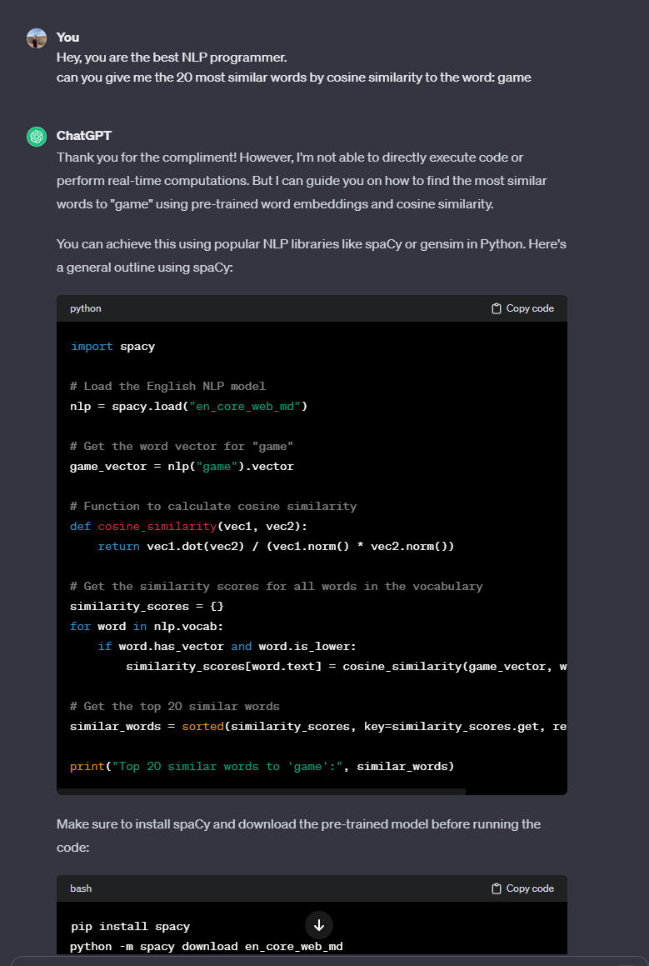

### Synonyms and Antonyms

ChatGPT easily produced us multiple examples of Synonyms and Antonyms words with simple instructions of “Hey, can you give me 5 examples of synonyms words” for synonyms words and “thanks, can you give me now 5 examples of antonyms words?” for antonyms words. It even gave us 5 examples of each type for the same word.

|  |  |  |
| --- | --- | --- |
| Word | Synonyms | Antonyms |
| Happy | Joyful, Content, Pleased, Delighted, Cheerful | Unhappy, Sad, Miserable, Sorrowful, Melancholy |
| Big | Large, Huge, Enormous, Massive, Gigantic | Small, Tiny, Little, Miniature, Petite |
| Smart | Intelligent, Clever, Bright, Sharp, Knowledgeable | Stupid, Dull, Ignorant, Unintelligent, Dim-witted |
| Beautiful | Attractive, Gorgeous, Stunning, Lovely, Pretty | Ugly, Unattractive, Plain, Homely, Repulsive |
| Fast | Quick, Speedy, Rapid, Swift, Fleet | Slow, Sluggish, Leisurely, Gradual, Languid |

Polysemy

For Group 1 (where each word reflects both word meanings), we got the results that we got from word2vec, it did find multiple meaning of the word as the most similar for this word.  
On the other hand when looking at Group 2 (words such that the top-10 neighbours of each word reflect only a single meaning), we see that it indeed gave only one meaning but for 2 out of the we got the other meaning.

|  |  |  |  |
| --- | --- | --- | --- |
| Word | Word Group | **possible senses** | **ChatGPT 10 most similar words (decreasing order)** |
| mole | Group 1 | small burrowing mammal, a common type of skin growth, spy, unit in chemistry | Burrow, Rodent, Tunneler, Dermatologist, Spy, Spot, Blemish, Nevus (a type of skin mole), Underground, Molehill |
| bass | Group 1 | type of fish, low-pitched musical instrument, low voice | Low, Deep, Resonant, Fish, Sound, Musical, Pitch, Notes, Frequency, Double bass |
| fall | Group 1 | season (also known as autumn), to drop or descend | Autumn, Descend, Drop, Plummet, Tumble, Decline, Collapse, Autumnal, Precipitate, Topple |
| rock | Group 2 | A relatively hard naturally occurring mineral material, music genre | Stone, Boulder, Pebble, Cliff, Granite, Mineral, Formation, Geology, Mountain, Limestone |
| bar | Group 2 | drinking establishment, a straight piece (as of wood or metal) that is longer than it is wide (beam\rod) | Pub, Tavern, Saloon, Lounge, Counter, Establishment, Inn, Club, Public house, Watering hole |
| plant | Group 2 | botanical organism (seed), factory | Flora, Greenery, Botanical, Vegetation, Foliage, Herb, Shrub, Flower, Crop, Garden |

Mean Average Precision (MAP) evaluation