Step0: Make Sure your Textures settings look like the following(sRGB, Read/Write, mipmap, Format(no compressed)).
Due to the use of a brute-force algorithm in this tool, Unity may crash if the image size exceeds 1024.
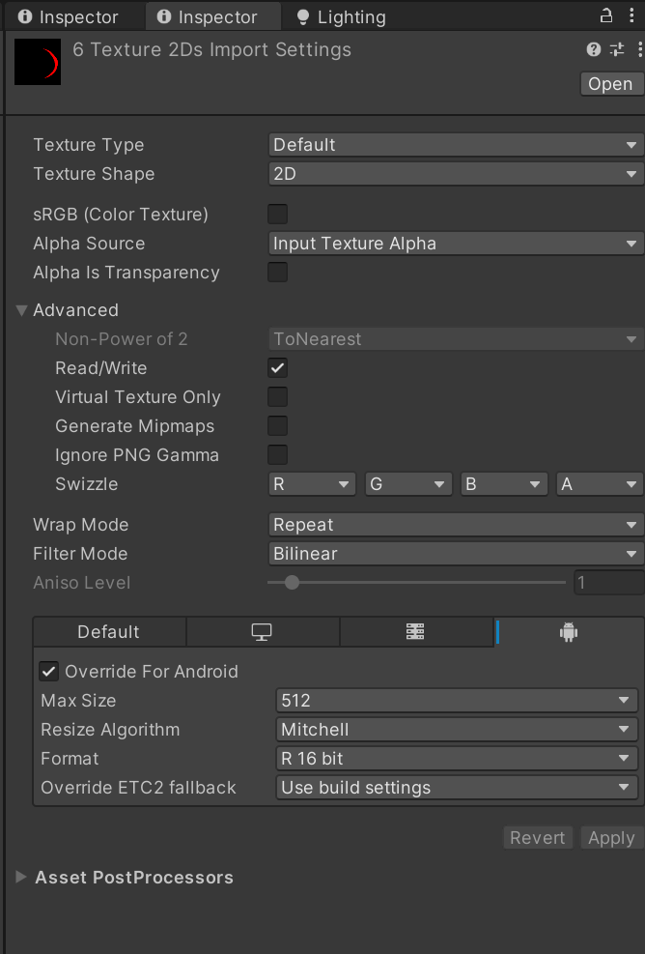

Step1: Drag Textures
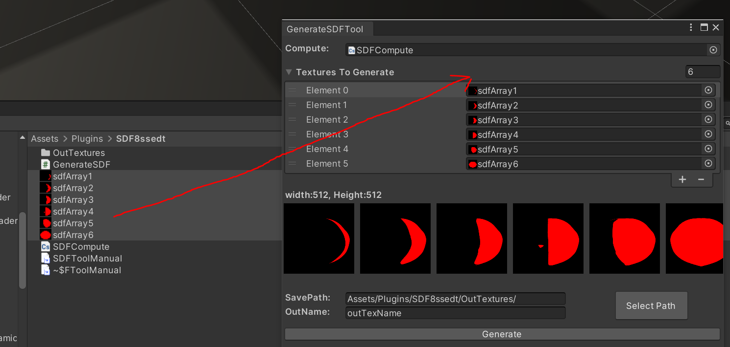

Step2: Select “outTexture” Folder
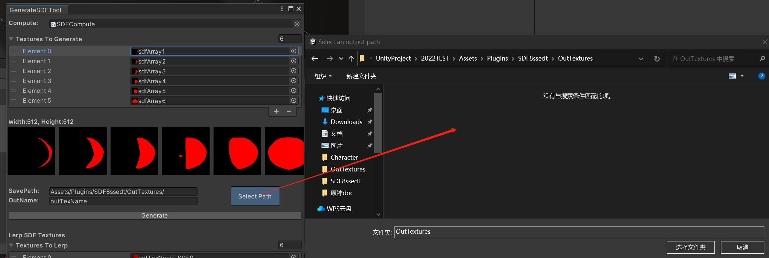

Step3: Generate

Step4: Check SDF Texture and format
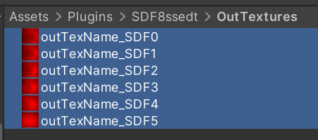

Step5: Drag Textures to Lerp And Generate as before
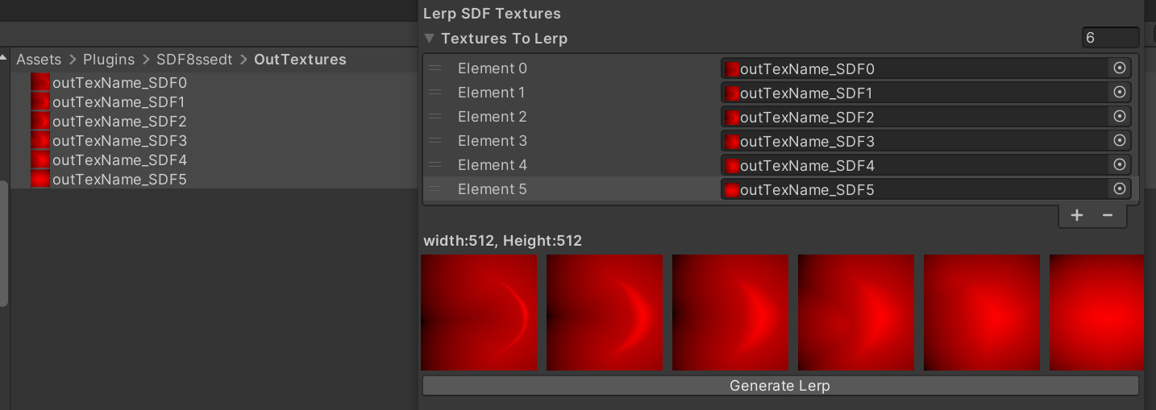

Step6: check lerp SDF result
