Misconception: “Evolution is a theory about the origin of life.”
Response: Evolutionary theory deals mainly with how life changed after its origin. Science does try to investigate how life started (e.g., whether or not it happened near a deep-sea vent, which organic molecules came first, etc.), but these considerations are not the central focus of evolutionary theory. Regardless of how life started, afterwards it branched and diversified, and most studies of evolution are focused on those processes.
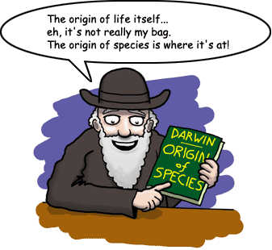

Misconception: “Natural selection involves organisms ‘trying’ to adapt.”
Response: Natural selection leads to adaptation, but the process doesn’t involve “trying.” Natural selection involves genetic variation and selection among variants present in a population. Either an individual has genes that are good enough to survive and reproduce, or it does not—but it can’t get the right genes by “trying.”

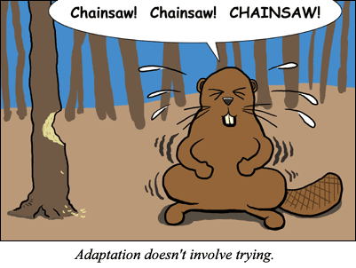

Misconception: “Natural selection gives organisms what they ‘need.’ ”
Response: Natural selection has no intentions or senses; it cannot sense what a species “needs.” If a population happens to have the genetic variation that allows some individuals to survive a particular challenge better than others, then those individuals will have more offspring in the next generation, and the population will evolve. If that genetic variation is not in the population, the population may still survive (but not evolve much) or it may die out. But it will not be granted what it “needs” by natural selection.

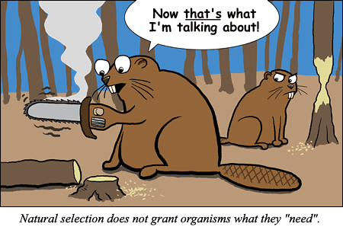

Misconception: “Evolution is a theory in crisis and is collapsing as scientists lose confidence in it.”
Response: Scientists do not debate whether evolution (descent with modification) took place, but they do argue about how it took place. Details of the processes and mechanisms are vigorously debated. Antievolutionists may hear the debates about how evolution occurs and misinterpret them as debates about whether evolution occurs. Evolution is sound science and is treated accordingly by scientists and scholars worldwide.
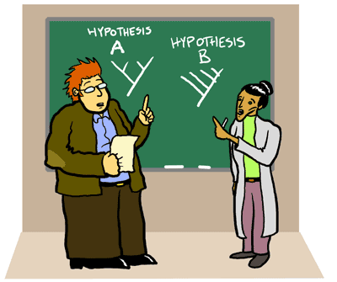
Misconception: “Evolution and religion are incompatible.”
Response: Religion and science (evolution) are very different things. In science, only natural causes are used to explain natural phenomena, while religion deals with beliefs that are beyond the natural world.
The misconception that one always has to choose between science and religion is incorrect. Of course, some religious beliefs explicitly contradict science (e.g., the belief that the world and all life on it was created in six literal days); however, most religious groups have no conflict with the theory of evolution or other scientific findings. In fact, many religious people, including theologians, feel that a deeper understanding of nature actually enriches their faith. Moreover, in the scientific community there are thousands of scientists who are devoutly religious and also accept evolution.


Misconception: “Teachers should teach ‘both sides’ and let students decide for themselves.”
Response: Given the wide variety of religious views about creation, there are not simply "two sides" to be compared — and, in any case, these views are not science and do not belong in a science classroom. In science class, students should have opportunities to discuss the merits of arguments within the scope of science. For example, students might debate exactly where birds branched off of the tree of life: before dinosaurs or from within the dinosaur clade. In contrast, a debate pitting a scientific concept against a religious belief has no place in a science class and misleadingly suggests that a "choice" between the two must be made. The "fairness" argument has been used by groups attempting to insinuate their religious beliefs into science curricula.
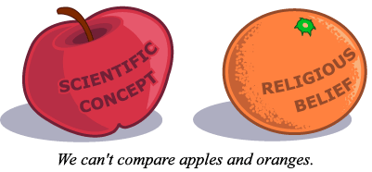

Misconception: “Evolution is itself ‘religious,’ so requiring teachers to teach evolution violates the First Amendment.”
Response: Evolution is science. The study of evolution relies on evidence and inference from the natural world. Thus it is not a religion. Supreme Court and other Federal court decisions clearly differentiate science from religion and do not permit the advocacy of religious doctrine in science (or other public school) classes. Other decisions specifically uphold a school district’s right to require the teaching of evolution.
