Ulstad, Michael
12/20/06
Field Biology

Kincaid’s Lupine Research

Question

The objective of this project is to determine the relationship between the treatment of the soil and the health of the Kincaid’s Lupine plant. For this project, we used two soil treatments. We combined Bi-Mart soil with Rhizobium and Bi-Mart soil with prairie soil. To determine the health of the Kincaid’s Lupine plant, we will find the height, number of leaves, number of flowers, and the size of the leaves on each Kincaid’s Lupine.

Background Research

Native plants are very important to the Willamette Valley ecosystem. Many organisms that are native to the Willamette Valley depend on these native plants for food or places to live. (Wilson 2006) If these plants become endangered these organism species could also become endangered. This is like the relationship between the Fender’s Blue Butterfly and Kincaid’s Lupine. If no action is taken then these plants and butterflies could become extinct. That is why it is so important to keep native plants’ habitats healthy. Non-native plants can cause many problems for Willamette Valley ecosystems. (Wilson 2006) For example, the Himalayan Blackberry grows in many places and takes up places for native plants to grow. Since it is also and aggressive plant, it reproduces quicker and uses up more nutrients. This makes it very hard for the less aggressive native plants to grow. An oak savannah landscape is a prairie with few oak trees. Oak savannah landscapes are so rare because fire is no longer used as a tool to contain the population of the trees. (Wilson) In the times of the Native Americans, these landscapes were burned so that oak savannahs would continue to prosper. Today, burning is looked down upon because of houses and other man made objects. This is why oak trees grow in places they did not used to.

The Fender’s Blue Butterfly is very closely linked to Kincaid’s Lupine. (UCSB 2005) They are linked so close because the Fender’s Blue Butterfly needs to lay its larvae in the Kincaid’s Lupine plant. (Wilson 2005) They need to lay them here because the larvae can only complete their reproductive cycles with this plant. (Wilson) They need this plant to feed off of it. Kincaid’s Lupine plants live in dry upland prairies in and around the Willamette Valley. Fenders’s Blue Butterfly species usually find where these plants are and settle near the area. Kincaid’s Lupine is a part of the pea family. (Wilson 2005)

Rhizobium is soil bacteria which fix nitrogen with the help of a host plant. (Wikipedia 2005). Rhizobium is important as a substitute for nitrogen fertilizer. They live in a symbiotic relationship with legumes. Rhizobium should help the growth of the plants. (Wikipedia 2005).

The plants grown in the Rhizobium and Bi-Mart soil should grow better because the Rhizobium fixes nitrogen. The native soil does not which means that much of the nitrogen is lost. (Wikipedia 2005)

Site Description

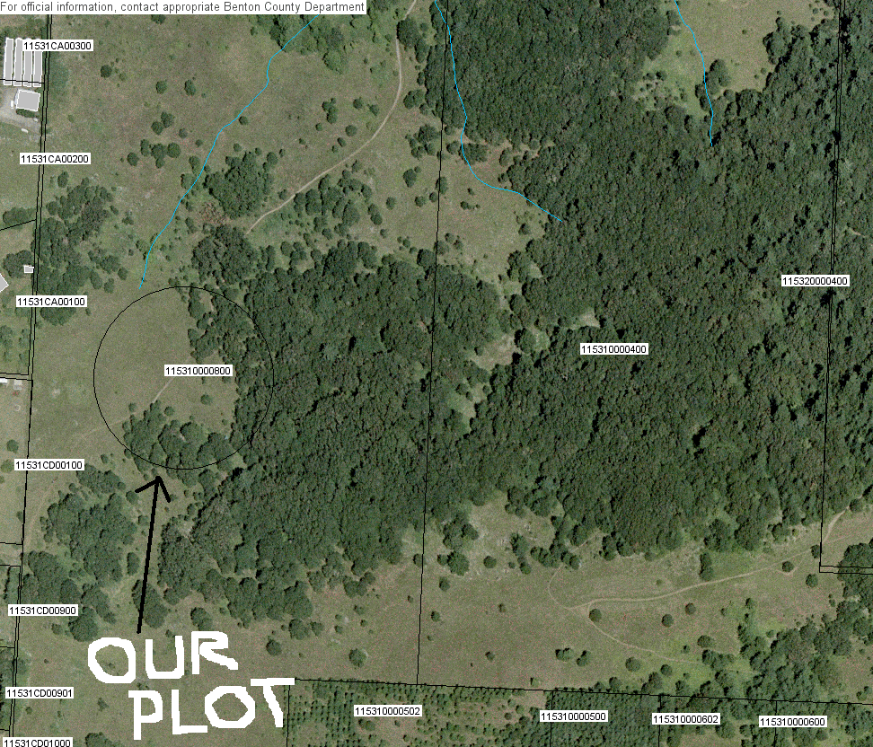

Bald Hill
There is one main type of soil at this site. The soil is Philomath Silty Clay. This site is owned by the city of Corvallis. It is surrounded by trees with a creek just to the north of our plot.
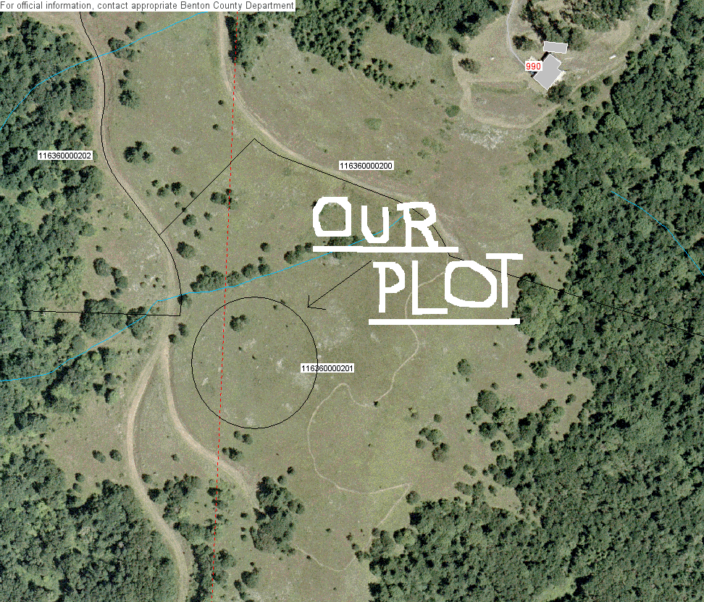

Fitton Green
The soil at this site is Dixonville Silty Clay Loam. The land is owned by the city of Corvallis. This site is almost all prairie. There are a few trees around but the majority of the land is steep sloped prairie.

Hypothesis
I think that the Bi-Mart and Rhizobium soil will work the best because it produces nitrogen. I do not think that the native soil will not have as much nitrogen which means that the soil with Rhizobium should make it grow better.

Citations

Rhizobia. (2005). Retrieved December 20, 2006, from
http://en.wikipedia.org/wiki/Rhizobia

Lupinus sulphureus ssp. kincaidii. (2005). Retrieved December 20, 2006, from
http://oregonstate.edu/~wilsomar/Species/Lusuki.htm

Perspectives: The ecology of Willamette Valley plants (2006). Retrieved October 19,
2006, from http://oregonstate.edu/~wilsomar/Persp_Plants.htm

Endangered Butterfly Needs Proper Habitat, Special Nectar (2005). Retrieved October
19, 2006, from http://www.ia.ucsb.edu/pa/display.aspx?pkey=450

